Australian Capital Territory

Planning and Development (Technical Amendment - Miscellaneous Amendments) Plan Variation 2011 (No 1)*

Notifiable Instrument NI2011-81

Technical Amendment No 2011- 05

made under the

Planning and Development Act 2007, section 89 (Making technical amendments)

This plan variation commences on the day after it is notified.

Variation No. 2011-05 to the Territory Plan has been approved by the Planning and Land Authority.

The variation specifies an omission which will introduces a Franklin Precinct Code at Section 10 of the Territory Plan as identified at Annexure A

Neil Savery
Planning and land Authority

25 February 2011

Planning & Development Act 2007

Technical Amendment
to the Territory Plan
Variation 2011-05

Correct an omission and introduce
Franklin Precinct Code

February 2011

Table of Contents

1 INTRODUCTION 2
Outline of the process 2
2. EXPLANATORY STATEMENT 2
Background 2
Proposed Changes and Reasons 2
Franklin Precinct Code 3
Contents 1

1 INTRODUCTION

Outline of the process
The Commonwealth’s Australian Capital Territory (Planning and Land Management) Act 1988 allows for the Legislative Assembly to make laws to establish a Territory Planning Authority and for that Authority to prepare and administer a Territory Plan. The Planning and Development Act 2007 (the Act) establishes the ACT Planning and Land Authority (ACTPLA) as the Authority which prepares and administers the Territory Plan, including continually reviewing and proposing amendments as necessary. Part 5.4 section 87 of the Act allows for technical amendments to be made to the Territory Plan in a number of circumstances.

This technical amendment is subject to approval of ACTPLA under section 87(a) of the Act. It is not subject to the limited consultation requirements under section 90 of the Act. On approval, the variation will commence in accordance with the commencement notice in the Legislation Register and will be notified in a daily newspaper. The Territory Plan will be updated to reflect the changes that are approved in the technical amendment.

2. EXPLANATORY STATEMENT

Background
Under section 87(a) of the Act, an error variation is defined as a variation that:
(i) would not adversely affect anyone’s rights if approved and
(ii) has as its only object the correction of a formal error in the plan.
A formal error is defined as:
a) a clerical error or
b) an error arising from an accidental slip or omission or
c) a defect of form.

Proposed Changes and Reasons
Franklin precinct code
The Franklin TA2011-01 under S96 land ceases to be in future urban area (which commenced on Friday 11 February 2011) omitted to introduce a Franklin Precinct Code for any ongoing provisions.

For this reason the miscellaneous technical amendment TA2011-05, as defined under section 87(b) of the Act, has been prepared to correct the omission and introduce a Franklin Precinct Code at Section 10 of the Territory Plan as identified at Annexure A.

THIS IS PAGE ONE OF ANNEXURE A
TO NOTIFIABLE INSTRUMENT NI2011–81

Franklin Precinct Code
Covering the Division of Franklin

Contents
Introduction 2
Franklin Precinct Code 3

Introduction

Name
The name of this code is the Franklin Precinct Code.

Application
This Precinct Code applies to the suburb of Franklin. The code identifies individual blocks or areas to which specific provisions apply as defined in the legend of the map attached.

Where more than one type of Code applies to a development, the order of precedence when there is inconsistency of provisions between Codes, as defined by the Act, is Precinct Code, then Development Code, and then General Code.

Purpose of code
Codes provide additional planning, design and environmental controls to support the zone objectives and assessable uses in the Development Tables.
The Codes are used by the Authority to assess development applications. The Codes therefore also provide guidance to intending applicants in designing their developments and preparing their development applications.

Further information
Please refer also to the Franklin Concept Plan for other relevant or applicable planning provisions.

Franklin Precinct Code
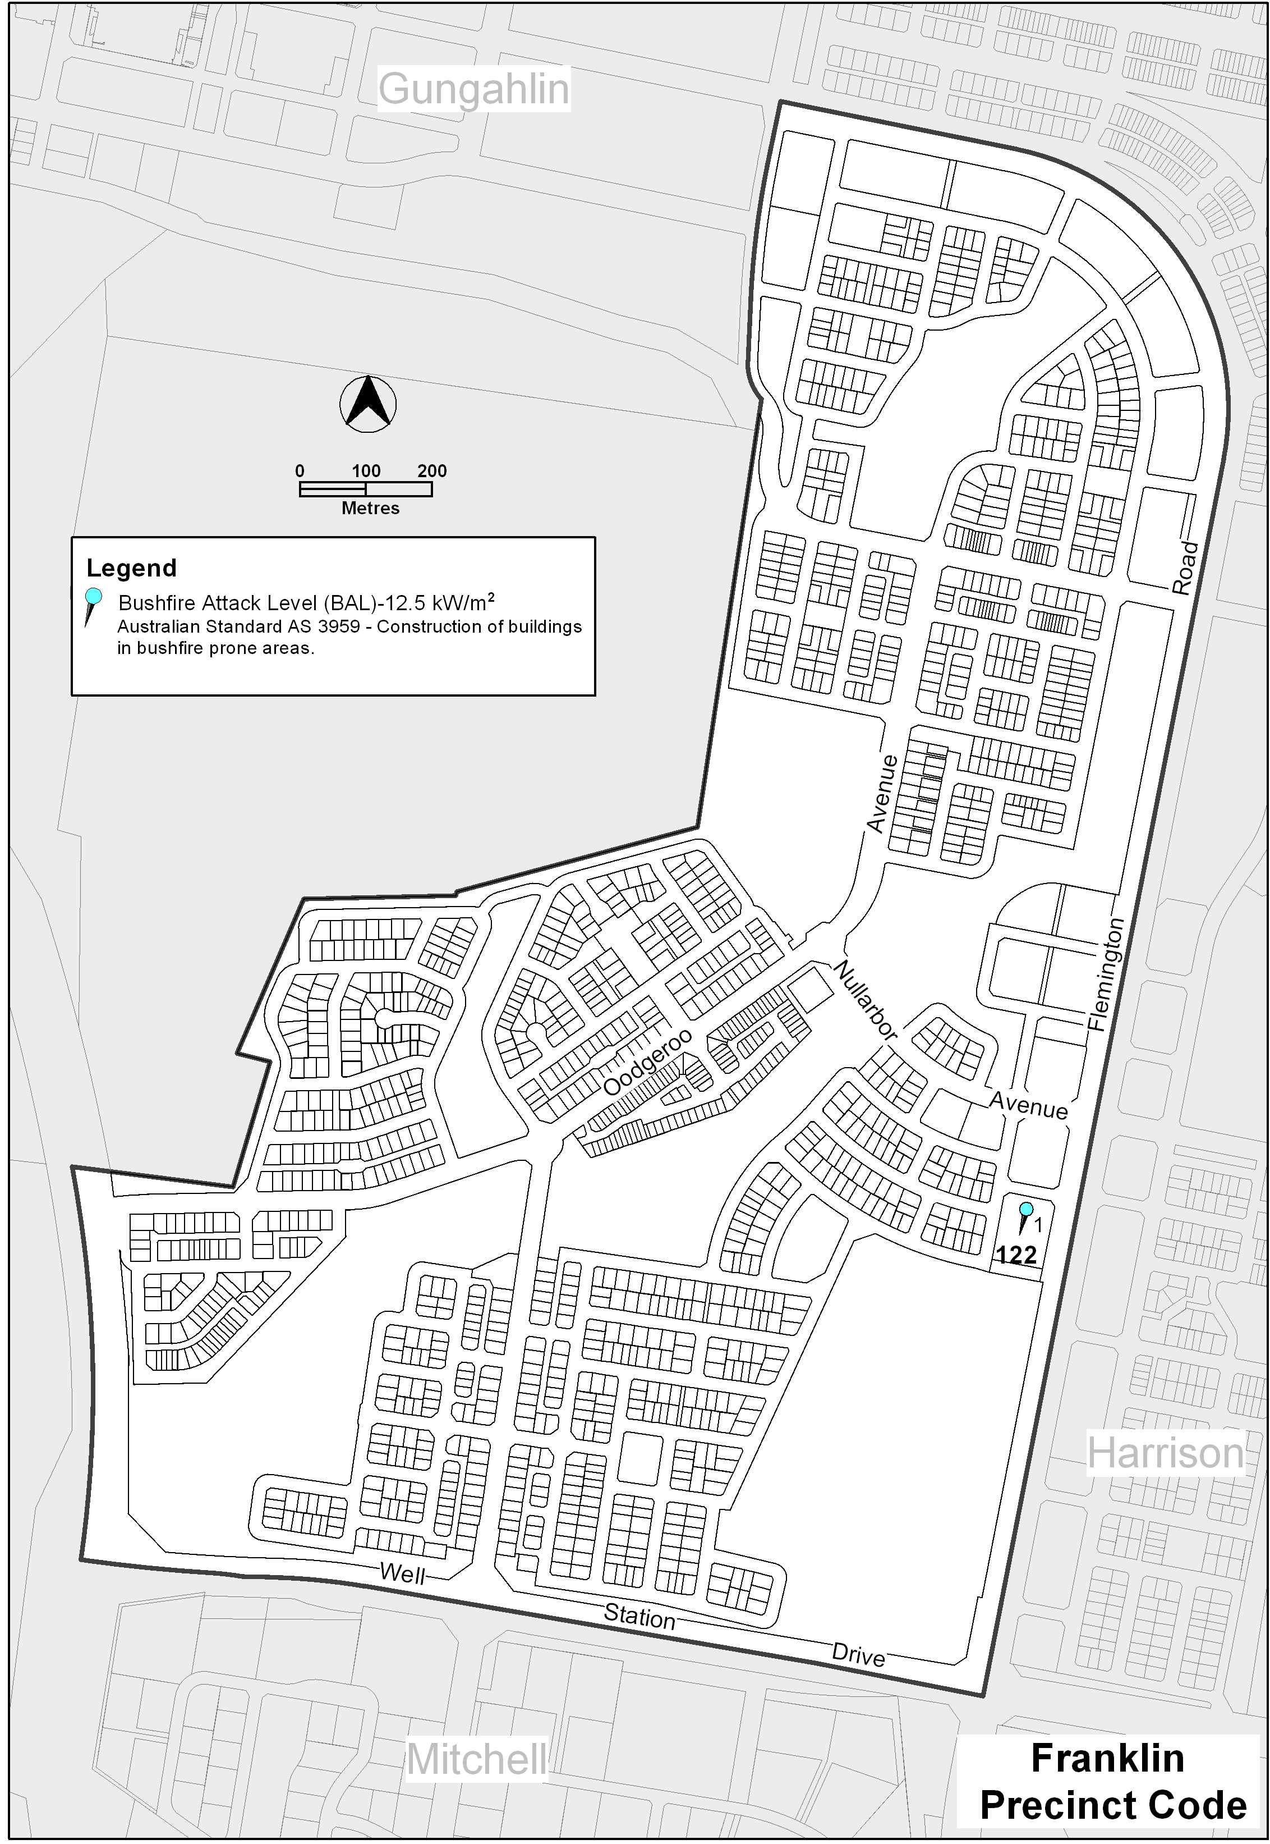

Interpretation service
