Australian Capital Territory

Planning and Development (Technical Amendment—Weston) Plan Variation 2012 (No 1)

Notifiable instrument NI2012—145
Technical Amendment No 2012—12
made under the
Planning and Development Act 2007, section 89 (Making technical amendments) s96 (Land ceases to be in future urban area)

This plan variation commences on the day after it is notified.

Variation No 2012—12 to the Territory Plan has been approved by the Planning and Land Authority.

Variation to the Territory Plan

The Territory Plan map is varied as indicated in Annexure A to identify the zones that apply to the land ceasing to be in a future urban area.

Variation to the Weston Precinct Code

Substitute the page 1 and insert page 3 in the Weston Precinct Code at Annexure B to incorporate ongoing block specific provisions for the area.

Ben Ponton
Delegate of ACT Planning and Land Authority
Date: 8 March 2012

THIS IS PAGE ONE OF ANNEXURE A
TO NOTIFIABLE INSTRUMENT NI2012 – 145

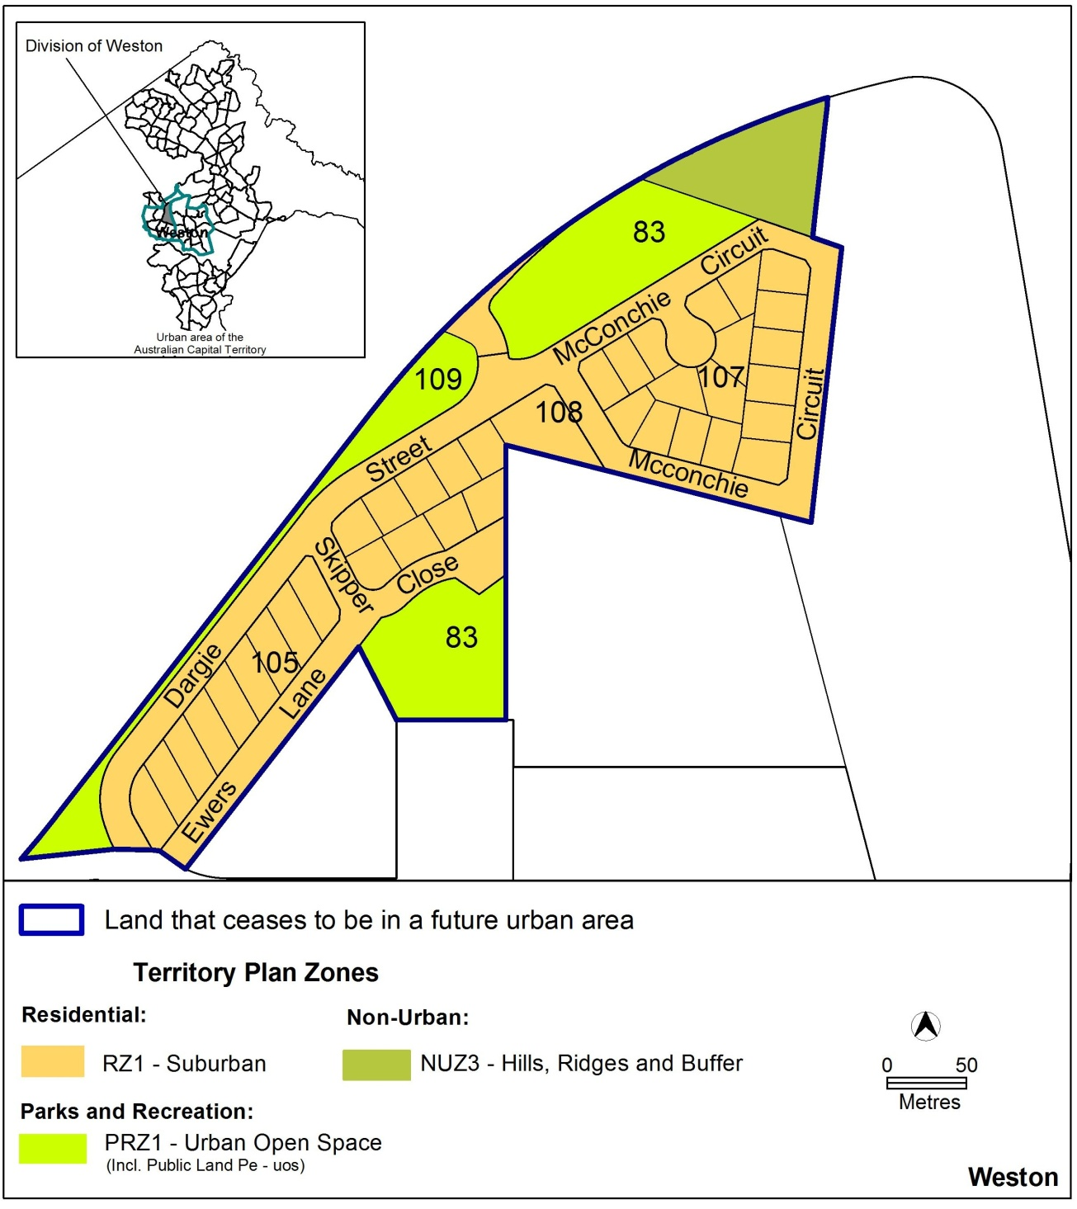

Ben Ponton
Delegate of ACT Planning and Land Authority
Date: 8 March 2012
THIS IS PAGE ONE OF ANNEXURE B
TO NOTIFIABLE INSTRUMENT NI2012 – 145

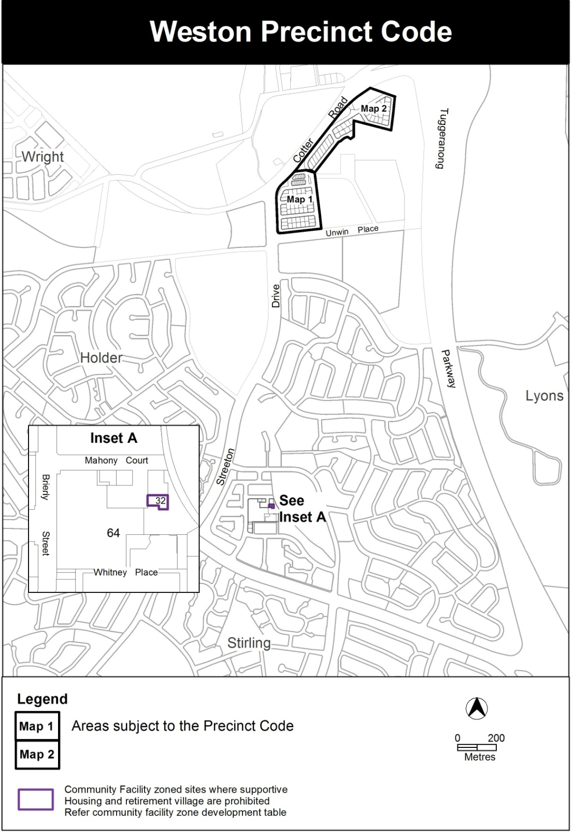

Ben Ponton
Delegate of ACT Planning and Land Authority
Date: 8 March 2012
THIS IS PAGE TWO OF ANNEXURE B
TO NOTIFIABLE INSTRUMENT NI2012 – 145

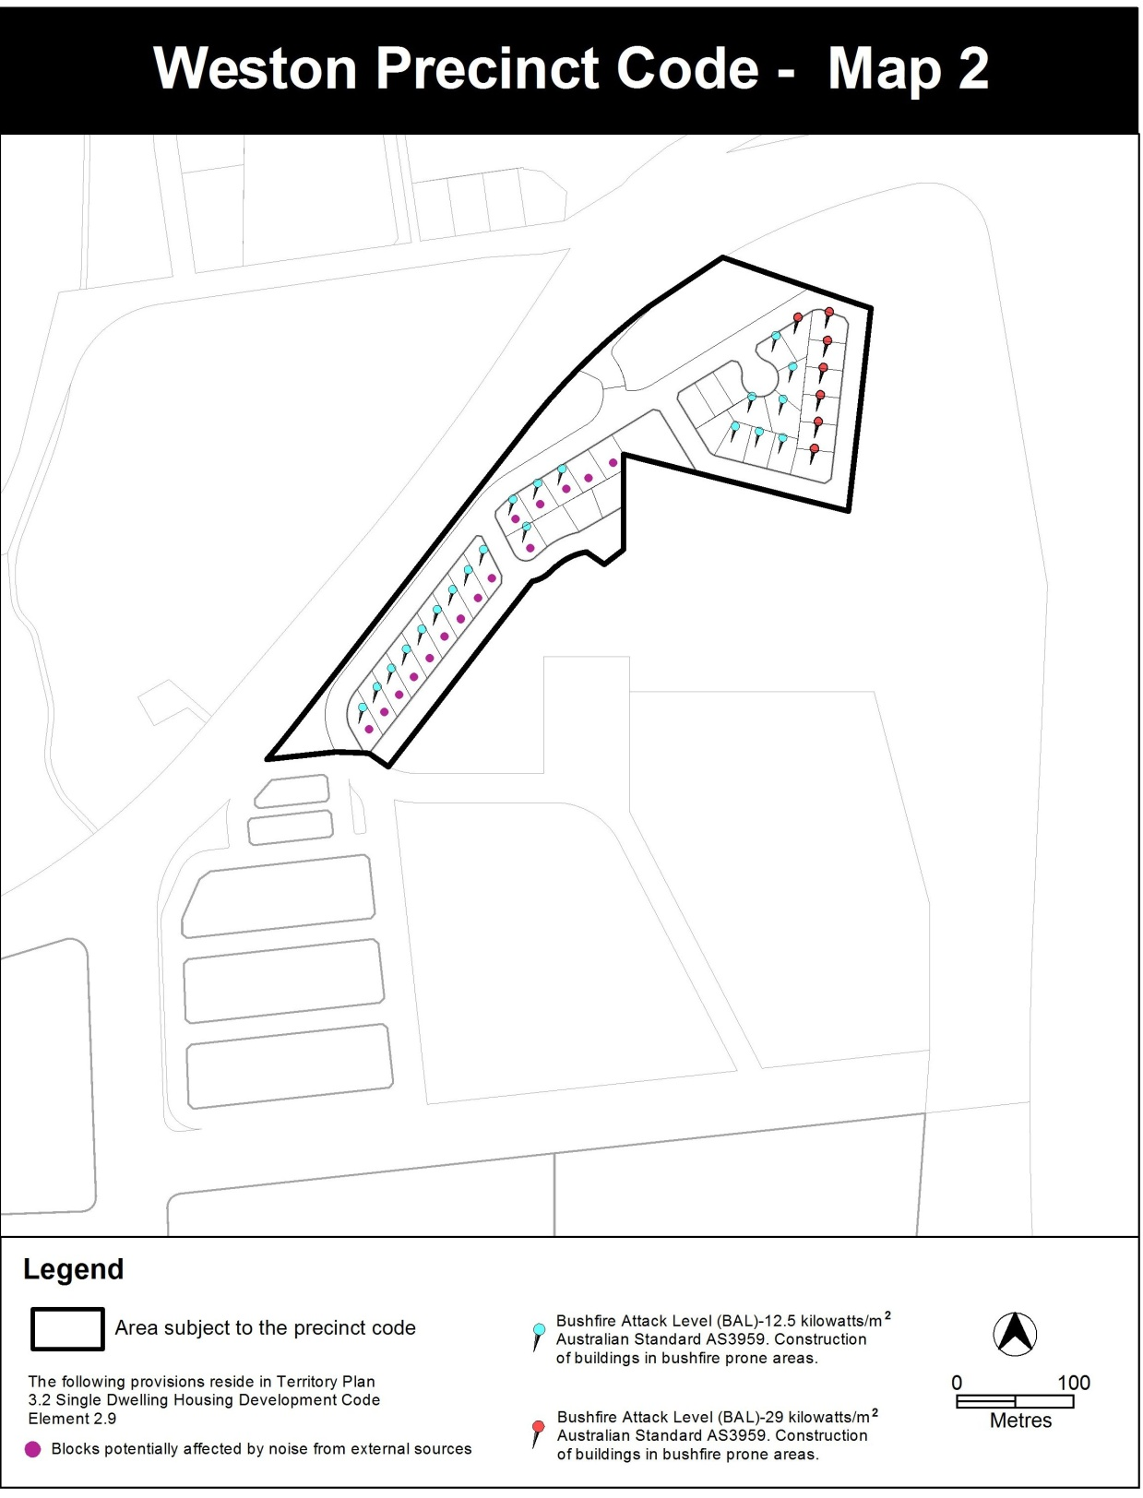

Ben Ponton
Delegate of ACT Planning and Land Authority
Date: 8 March 2012

