Australian Capital Territory

Planning and Development (Technical Amendment— Miscellaneous Amendments and Removal of Redundant Provisions) Plan Variation 2012 (No 1)
Notifiable instrument NI2012—190
Technical Amendment No 2012-18
made under the

Planning and Development Act 2007, section 89 (Making technical amendments)

This Technical Amendment commences on 13 April 2012.

Technical Amendment 2012-18 to the Territory Plan has been approved by the Planning and Land Authority

Ben Ponton
Delegate of Planning and Land Authority

05 April 2012
This page is intentionally blank

Planning & Development Act 2007

Technical Amendment
to the Territory Plan
Variation 2012-18

Miscellaneous amendments and removal of redundant provisions

April 2012

Table of Contents

1. INTRODUCTION 2
Outline of the process 2
2. EXPLANATORY STATEMENT 3
Proposed changes, reasons and compliance with the Planning and Development Act 2007 3
3. TECHNICAL AMENDMENT 5
3.1 Redundancy and miscellaneous amendments ..... 5

INTRODUCTION

Outline of the process

The Commonwealth’s Australian Capital Territory (Planning and Land Management) Act 1988 allows for the Legislative Assembly to make laws to establish a Territory Planning Authority and for that Authority to prepare and administer a Territory Plan.

The Planning and Development Act 2007 (the Act) establishes the ACT Planning and Land Authority as the Authority which prepares and administers the Territory Plan, including continually reviewing and proposing amendments as necessary.

Technical amendments to the Territory Plan are prepared in accordance with the Act. This technical amendment has been prepared in accordance with the following sections of the Act:

A variation under section 87(a) is a technical amendment that:
(i) would not adversely affect anyone’s rights if approved; and
(ii) has as its only object the correction of a formal error in the plan.

A variation under section 87(f) is a technical amendment to omit something that is obsolete or redundant in the Territory Plan.

This technical amendment has been approved by the ACT Planning and Land Authority.

EXPLANATORY STATEMENT

Proposed changes, reasons and compliance with the Planning and Development Act 2007

- Change to endorsing authority for provisions in the Gungahlin town centre precinct code (items 4-9)

Due to the restructuring of the ACT public sector, resulting in the establishment of the Environment and Sustainable Development Directorate, transport planning and nature conservation policy functions are no longer located within the Territory and Municipal Services Directorate. The Gungahlin Town Centre precinct code contains provisions that refer to obtaining ‘endorsement of TAMS’ for parking assessments, public transport routes and stations, and nature conservation matters.

Where appropriate, these references to ‘TAMS’ will be corrected by making reference to the Territory agency with responsibility for transport planning, and the Conservator of Flora and Fauna.

Section of Act | Statement of compliance with Act
s87(a) a variation that -
(i) would not adversely affect anyone’s rights if approved; and | This amendment will not adversely affect anyone’s rights.
(ii) has as its only object the correction of a formal error in the plan | The TAMS directorate is no longer responsible for transport planning and nature conservation policy functions, so the outdated references are corrected.

- Correction to reference to a figure in the Gungahlin town centre precinct code (item 3)

The first sentence under the title ‘Application’ contains an incorrect reference to a figure. It is corrected by making reference to Figure 1.

Section of Act | Statement of compliance with Act
s87(a) a variation that -
(i) would not adversely affect anyone’s rights if approved; and | This amendment will not adversely affect anyone’s rights.
(ii) has as its only object the correction of a formal error in the plan | This amendment will correct the reference to Figure 1.

- Remove Forde concept plan from the Territory Plan (item 10)
The future urban area (FUA) overlay which applied to land within the Forde Concept Plan has been uplifted and no longer applies. The concept plan is now redundant and it will be removed from the Territory Plan.

Section of Act | Statement of compliance with Act
s87(f) a variation to omit something that is obsolete or redundant in the Territory Plan | No land specified within the concept plan remains under FUA and all ongoing area specific provisions have been translated into the Territory Plan, therefore the concept plan is now redundant.

- Correction to the Inner North Precinct Code (item 1)

This change adds a location map to the Inner North precinct code. The Inner North precinct code does not currently contain a map indicating the area subject to the precinct code. This will rectify the omission in the Inner North precinct code.

Section of Act | Statement of compliance with Act
s87(a) a variation that -
(i) would not adversely affect anyone’s rights if approved; and | This amendment will not adversely affect anyone’s rights.
(ii) has as its only object the correction of a formal error in the plan | This amendment will add a location map to the Inner North precinct code, to correct its omission.

- Correction to the numbering in the Inner North Precinct Code (item 2)

This change corrects the numbering of some of the element numbering in the Inner North precinct code.

Section of Act | Statement of compliance with Act
s87(a) a variation that -
(i) would not adversely affect anyone’s rights if approved; and | This amendment will not adversely affect anyone’s rights.
(ii) has as its only object the correction of a formal error in the plan | This amendment will correct the numbering in the Inner North precinct code.

TECHNICAL AMENDMENT
    - Redundancy and miscellaneous amendments

Variation to the Inner North Precinct Code

- Introduction

Insert map at Appendix A before the heading ‘Purpose of codes’

- Part C(4) – O’Connor, Element 4: Building and Site Controls

    - Substitute element heading numbering: Element 4 with 2
    - Substitute section heading numbering: Section 4.1 with 2.1

Variation to Gungahlin Town Centre Precinct Code

- Introduction, Application

Substitute ‘This Precinct Code applies to development on land in Gungahlin
Town Centre in the District of Gungahlin as shown in 0’, with

This Precinct Code applies to development on land in Gungahlin Town Centre in the District of Gungahlin as shown in Figure 1.

- Part A – Land Use and Subdivision, Element 2: Subdivision, 3.4 Pedestrian and cyclist network, criterion C4(d)

Substitute ‘TAMS’ with

the Territory

- Part A – Land Use and Subdivision, Element 2: Subdivision, 3.5 Bushfire protection, rule R5

Substitute e) as underlined below with

Hydrants are to be provided along the perimeter road to the satisfaction of the ACT Emergency Services Agency (ESA)

Substitute first sentence after f) as underlined below with

A bushfire risk assessment plan endorsed by the ACT ESA and the Conservator of Flora and
Fauna is required for any development within or adjacent to the bushfire prone area identified in Figure 5 as a 20m wide Inner Asset Protection Zone (IAPZ) within the Well Station Track reserve.

- Part A – Land Use and Subdivision, Element 2: Subdivision, 3.5 Bushfire protection, criterion C5

Substitute first paragraph as underlined below with

Development within or adjacent to the bushfire prone area identified in Figure 5 is endorsed by the Territory. In making its assessment the Territory will consider all of the following:

- Part B – General Development Controls, Element 3: Built form, 3.2 Public transport stations and adjacent development, criterion C9(c)

Substitute ‘TAMS’ with

the Territory

- Part B – General Development Controls, Element 4: Parking and site access, rule R11(a) and (b)(i)

Substitute ‘TAMS’ with

the Territory agency responsible for transport planning

- Part B – General Development Controls, Element 4: Parking and site access, criterion C11(b)

Substitute ‘TAMS’ with

the Territory

Variation to Forde Concept Plan

- Forde Concept Plan

Omit

Forde Concept Plan

Interpretation service

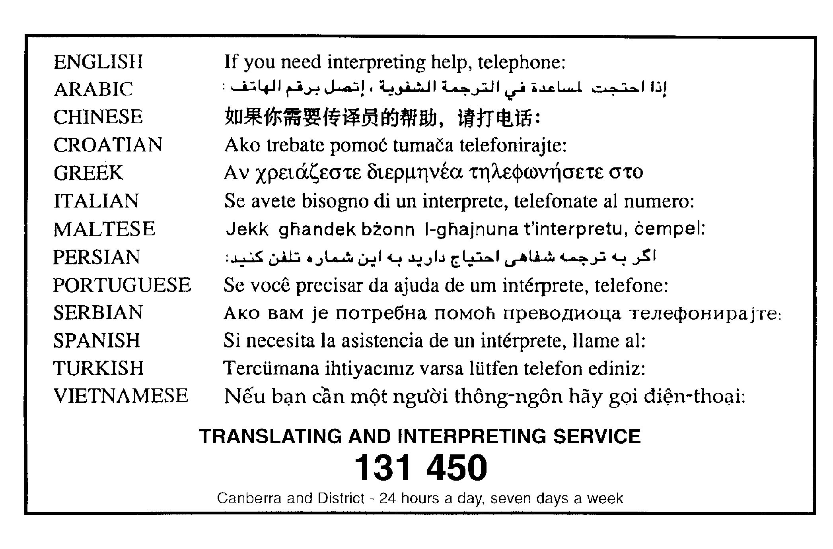

Appendix A – Inner North Precinct Code

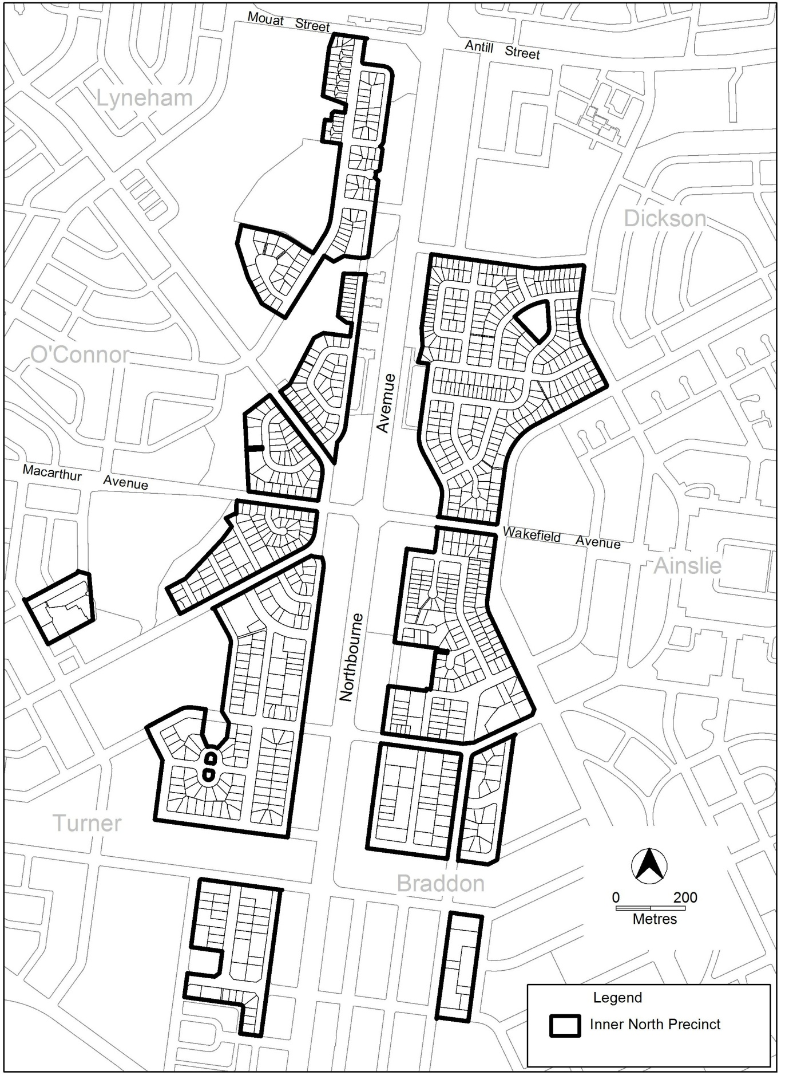

Figure A Area subject to Inner North Precinct Code

