Australian Capital Territory

Planning and Development (Draft Variation No 315) Consultation Notice 2012

Draft Variation 315 - Aranda Fire and Ambulance Station

**Notifiable instrument NI2012—372**

made under the

*Planning and Development Act 2007*, section 63 (Public consultation - notification) and section 64 (Public consultation – notice of interim effect etc)

Draft Variation 315 to the Territory Plan (see ***Annexure A***) has been prepared to enable development of a fire and ambulance station on Bindubi Street near the corner of Belconnen Way, Aranda, section 1 blocks 17, 18, 19 and part of block 24. A block will be created for the site after lodgement of a survey plan. The subject site is currently zoned transport and services TSZ1 transport and parks and recreation PRZ1 urban open space. The zoning for the site will remain unchanged. An e*mergency services facility* is currently prohibited in these zones under the Territory Plan. The draft variation proposes that *emergency services facility* be added as additional merit track development in both zone development tables for the subject site only, and that site specific planning controls are established via a precinct code to guide development on the subject site. The site will also be removed from the public land (Pe urban open space) so land management responsibility can be moved to the Emergency Services Agency.

Written comments from the public are invited by **COB** **Monday** **3 September 2012**.

The draft variation and background documents are available online at **www.act.gov.au/draftvariations** until the closing date for written comments.

Printed copies of the draft variation and background documents are available for inspection and purchase at the Environment and Sustainable Development Customer Service Centre, 16 Challis Street, Dickson, Monday to Friday (except public holidays) between 8:30am and 4:30pm. Please call 6207 1923 to arrange a copy for purchase.

Comments should include reference to the draft variation, your name and contact details, and be addressed to the Territory Plan Variation Unit.

Comments can be:

* emailed to terrplan@act.gov.au
* mailed to Territory Plan Comments, GPO Box 1908, Canberra, ACT 2601
* delivered to ESDD’s Customer Service Centre at the above address

Comments received will be made publicly available 10 working days after the closing date for comment. The comments will be available for no less than 15 working days at ESDD’s customer service centre in Dickson and on ESDD’s website.

Comments made available will include personal contact details unless excluded under section 411 or 412 of the *Planning and Development Act 2007*. A request for exclusion under these sections must be in writing, clearly identifying what you are seeking to exclude and how the request satisfies the exclusion criteria.

**Effect of the draft variation**

The draft variation does not have interim effect and therefore section 65 of the *Planning and Development Act 2007* does not apply. The current Territory Plan will continue to apply while the variation remains in draft form.

Ben Ponton

Delegate of the ACT Planning and Land Authority

17 July 2012

*Planning and Development Act 2007*

Draft

Variation to the

Territory Plan

315

Aranda Fire and Ambulance Station

July 2012

Draft variation for public consultation prepared  
under s60 of the *Planning and Development Act 2007*

*This page is intentionally blank.*

Table of Contents

1. INTRODUCTION 1

1.1 Summary of the Proposal 1

1.2 Outline of the process 1

1.3 This document 3

1.4 Public Consultation 3

1.5 Further Information 3

2. EXPLANATORY STATEMENT 4

2.1 Background 4

2.2 Site Description 5

2.3 Current Territory Plan Provisions 6

2.4 Proposed Changes 7

2.4.1 Proposed Changes to Territory Plan 7

2.4.2 Proposed Changes to Territory Plan 8

2.5 Reasons for the Proposed Draft Variation 8

2.6 Planning Context 9

2.6.1 National Capital Plan 9

2.6.2 Territory Plan 9

2.6.3 Strategic Planning Context 9

2.7 Interim Effect 10

2.8 Consultation with Government Agencies 11

3. DRAFT VARIATION 15

3.1 Variation to the Territory Plan Map 15

3.2 Variation to the Territory Plan 16

Figures

Figure 1: Proposed site for Aranda fire and ambulance station 6

Figure 2: Current Territory Plan map 7

Figure 3: Proposed Territory Plan Zones Map 15

*This page is intentionally blank.*

1. INTRODUCTION
   1. Summary of the Proposal

The intention of the draft variation is to enable development of the Aranda Fire and Ambulance Station on land spanning urban open space and road reserve. This development is currently prohibited in these zones under the Territory Plan. The draft variation proposes that *emergency services facility* be added as additional merit track development in both zone development table and site specific planning controls be established via a precinct code to guide development on the subject site. The site will also be removed from the public land (Pe urban open space) so land management responsibility can be moved to the Emergency Services Agency (ESA).

* 1. Outline of the process

The Commonwealth’s *Australian Capital Territory (Planning and Land Management) Act 1988* allows for the Legislative Assembly to make laws to establish a Territory Planning Authority and for that Authority to prepare and administer a Territory Plan. The *Planning and Development Act 2007* (the Act) establishes the ACT Planning and Land Authority (ACTPLA) as the Authority which prepares and administers the Territory Plan, including continually reviewing and proposing amendments as necessary. The functions of ACTPLA are administered by the Environment and Sustainable Development Directorate.

The Territory Plan is comprised of a written statement and a map. The written statement contains a number of parts, namely governance; strategic directions; zones (including objectives and development tables and zone or centre development codes); precinct codes; general codes; overlays; definitions; structure plans, concept plans and development codes for future urban areas.

The Territory Plan Map graphically represents the applicable land use zones (under the categories of residential, commercial, industrial, community facility, urban parks and recreation, transport and services and non urban), precincts and overlays. The zone, precinct and overlay requirements are detailed in the volumes of the Territory Plan.

Draft variations to the Territory Plan are prepared in accordance with the Act. Following the release of the draft variation under section 63 of the Act, submissions from the public are invited. At the conclusion of the consultation period the ESDD submits a report on consultation and a recommended final variation to the Minister responsible for planning for approval. The Minister has the discretion to determine if referral to the Legislative Assembly standing committee responsible for planning is warranted prior to approval, depending on the nature and significance of the proposal. If the draft variation is referred to the committee by the Minister or otherwise, the Minister must consider the findings of the committee before deciding whether to approve the draft variation. If the Minister approves the variation, the variation and associated documents will be tabled in the Legislative Assembly. Unless disallowed by the Legislative Assembly within five sitting days, the variation commences on a day nominated by the Minister.

* 1. This document

This document contains the background information in relation to the proposed variation. It comprises the following parts

* Part 1 - This Introduction
* Part 2 - An Explanatory Statement, which gives reasons for the proposed variation and describes its effect
* Part 3 - The Draft Variation, which details the precise changes to the Territory Plan that are proposed
  1. Public Consultation

Written comments from the public are invited by **Monday 3 September 2012**.

Comments should include reference to the draft variation, your name and contact details, and be addressed to the Territory Plan Variation Unit.

Comments can be:

* emailed to terrplan@act.gov.au
* mailed to Territory Plan Comments GPO Box 1908 Canberra ACT 2601
* delivered to ESDD’s Customer Service Centre at 16 Challis Street Dickson

Comments received will be made publicly available 10 working days after the closing date. Comments will be available for no less than 15 working days at ESDD’s customer service centre in Dickson and at www.act.gov.au/draftvariations.

Comments made available will include personal contact details unless excluded under section 411 or 412 of the *Planning and Development Act 2007*. A request for exclusion under these sections must be in writing, clearly identifying what you are seeking to exclude and how the request satisfies the exclusion criteria.

* 1. Further Information

The draft variation, and background documents will be available online at www.act.gov.au/draftvariations.

Printed copies of the draft variation (this document) and background documents are available for inspection and purchase at the Environment and Sustainable Development Customer Service Centre 16 Challis Street Dickson from Monday to Friday (except public holidays) between 8:30am and 4:30pm. Please call 6207 1923 to arrange a copy for purchase.

1. EXPLANATORY STATEMENT
   1. Background

As the ACT expands and the population grows, the ACT Emergency Services Agency (ESA) must ensure that its services are able to meet government benchmarks for emergency service response times and coverage. ESA recently completed a Station Upgrade and Relocation Strategy and an Implementation Plan to determine where ambulance and fire stations should be located in the Territory for at least the next 20 years.

The current ambulance and fire stations in Lathlain Street, Belconnen town centre have been operating in that location since the mid 1970’s but are no longer fit for purpose. The surrounding area has become heavily congested and physically constrained through various traffic control measures, which adversely impact on emergency response. In addition, the size, layout and structure of the two existing sites do not meet the needs and requirements of contemporary emergency service facilities.

As part of the Station Upgrade and Relocation Strategy and Implementation Plan, the ESA engaged a UK based research organisation, which specialises in the application of analysis and modelling to support planning for emergency services, to undertake station location modelling and data analysis for the ACT. This exercise identified optimal areas for the location of emergency service facilities.

Based on the findings of the location modelling, the ESA undertook a comprehensive analysis of eight possible sites in the Belconnen area. One of the most important parameters for determining a suitable site for an emergency services facility is its proximity to a major arterial road. Being located close to or on a major arterial road facilitates speedy multidirectional egress. Other considerations included the suitability of the land (i.e. size, shape and topography) and the site constraints and opportunities (e.g. land availability, environmental issues, heritage, adjoining land uses, contamination and infrastructure).

Following the detailed analysis of the eight possible sites, the ESA concluded that the Aranda site (**Figure 1**) is the most suitable location for a collocated fire and ambulance station, based on a rigorously developed network plan which considered community response times.

It is intended that the Aranda facility will replace the existing ambulance and fire stations in Lathlain Street, Belconnen town centre, which will be decommissioned.

The subject site is currently unleased Territory land. The custodian of Aranda, section 1 blocks 17, 18 and 19 is the Territory and Municipal Services Directorate (TAMS). The custodian of Aranda, section 1, block 24 is the Economic Development Directorate – Sport and Recreation. If the draft variation is approved, it is proposed to survey the affected land to determine new cadastral boundaries and property identifiers. This will enable the transfer the custodianship to the Justice and Community Safety Directorate (which incorporates ESA), and allow future tenure arrangements to be finalised.

The Aranda site is currently zoned transport and services TSZ1 transport and parks and recreation PRZ1 urban open space. Under the current zone provisions emergency service facilities are prohibited.

The draft variation to the Territory Plan proposes to amend the Territory Plan to add ‘emergency services facility’ as an additional merit track assessable development by way of amendments to the current Aranda Precinct Code and making consequential amendments to the relevant zone development tables.

This option, whilst allowing for the emergency services facility to be developed, would preclude the site being used for other types of development other than those already assessable under the current zoning.

In addition, the site is urban open space which is currently public land reserve (overlay Pe – an urban open space). To enable the site to be used as an emergency services facility it is proposed to amend the Territory Plan by removing the subject site from public land so land management responsibility can be moved to the ESA.

* 1. Site Description

The subject site is located on the corner of Belconnen Way and Bindubi Street, Aranda, section1 blocks 17 to 19 and part of block 24 (**Figure 1**). The total area of the site is around 6,750m² and currently consists of:

* an area of the Bindubi Street road reserve
* urban open space, which includes a public car park

ESA proposes to relocate the existing public car park to the south of the site.

Surrounding land uses include a nursing home/respite care facility to the south of the site, the Aranda playing fields to the east and the Canberra High School to the west.



Figure 1: Proposed site for Aranda fire and ambulance station

* 1. Current Territory Plan Provisions

The subject site is zoned TSZ1 transport and PRZ1 urban open space (**Figure 2**). The development tables for these zones currently lists *emergency services facility* as prohibited development within these zones.

The site is within urban open space which is currently public land reserve (overlay Pe – an urban open space).

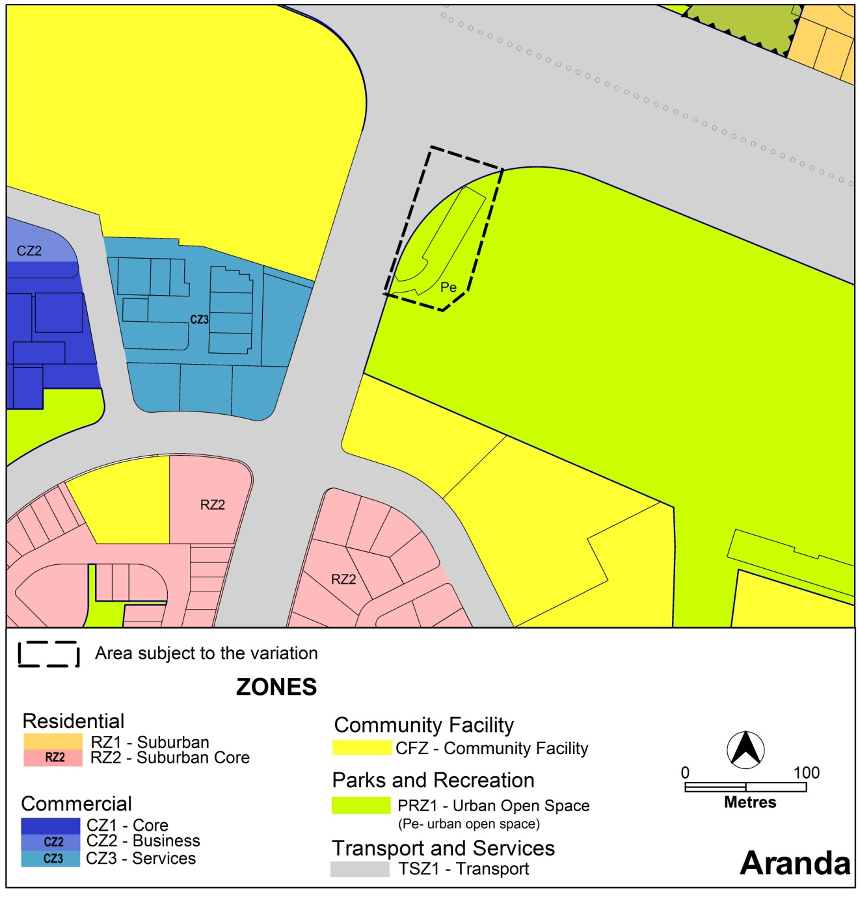

Figure 2: Current Territory Plan map

* 1. Proposed Changes

Proposed Changes to Territory Plan

The proposed changes to the Territory Plan map are indicated in Figure 3 and are detailed as follows:

It is proposed to amend the Territory Plan map by removing the affected part of the subject site from public land and including it as part of Urban Open Space – Not Public Land by placing an X overlay on the map.

The draft variation map indicates the proposed zone boundaries as accurately as possible but may be subject to adjustments following detailed surveys.

Proposed Changes to Territory Plan

The draft variation proposes to amend the current Aranda suburb precinct code to include additional site specific policies for the subject site and to amend the development tables for TSZ1 transport and PRZ1 urban open space zones to include *Emergency services facility* as a merit assessable development within the subject site.

The draft variation also proposes to make changes to the overlays (Overlays, 12.4 Urban Open Space Zones) as a consequence of removing the subject site from public land.

Further details of the proposed changes are detailed in Part 3 of this document.

* 1. Reasons for the Proposed Draft Variation

The reasons for the proposed draft variation are as follows:

* enable the development of an emergency services facility to meet government benchmarks for emergency service response times in the ACT
* the site is considered the best location based on extensive studies of the Belconnen area
* the development of an emergency services facility will enhance network coverage and is expected to reduce emergency services response times to a minimum
* to enable development of an emergency services facility at Aranda, changes are required to the Territory Plan to remove the prohibition for emergency services facility development and make other consequential changes
  1. Planning Context
     1. National Capital Plan

The *Australian Capital Territory (Planning and Land Management) Act 1988* established the National Capital Authority (NCA) with two of its functions being to prepare and administer a National Capital Plan (NCP) and to keep the NCP under constant review and to propose amendments to it when necessary.

The NCP, which was published in the Commonwealth Gazette on 21 January 1990 is required to ensure that Canberra and the Territory are planned and developed in accordance with their national significance. The *Planning and Land Management Act 1988* also required that the Territory Plan is not inconsistent with the NCP.

* + 1. Territory Plan

The proposal is consistent with the Territory Plan’s statement of strategic directions in terms of environmental, economic and social sustainability and spatial planning and urban design principles such as:

* Planning processes and decisions will be focused on the combined achievement of economic vitality, community wellbeing, and environmental quality. Broad community involvement will be a key element in the pursuit of sustainable development, as will complementary regional strategies and agreements.
* Urban development will be planned in a manner that promotes community

vitality and safety, applying principles of crime prevention through

environmental design. Provision will also be made for emergency services infrastructure necessary to ensure a high standard of safety for residents and visitors.

* + 1. Strategic Planning Context

**Canberra Spatial Plan**

The Spatial Plan outlines the strategic direction for growth to achieve social, environmental and economic sustainability for Canberra. This proposal is consistent with the Canberra Spatial Plan and in particular the following:

* GOAL — Create and Maintain a Healthy Community
* OBJECTIVE — Facilitate the equitable distribution of services and facilities, including education and health care, arts and recreational facilities

**Transport for Canberra – Transport for a sustainable city 2012- 2031**

Transport for Canberra is the key policy for transport planning in the ACT. The proposal is consistent with the strategic goals of Transport for Canberra in terms ofthe integration of transport and land use planning.

In determining the preferred site for a new fire station the ESA undertook a detailed analysis of possible sites, which included consideration of the road network and traffic conditions, to ensure that the ESA would be able to achieve the required government performance standards for coverage and response times.

**Draft ACT Planning Strategy**

The proposal supports the following draft strategies and associated targets by providing an emergency services facility in a location that is best able to meet the future needs of the Territory population:

* Strategy: Creating opportunities for increased density and dispersed employment by capitalising on the existing structure of the centres and inter-town transport connections.
  + - Target: 75% of residential urban intensification is to be in established town and group centres and along transit ways.
* Strategy: Improving the city’s resilience by investing in improvements to the development and management of the physical infrastructure.
  + - Target: 10% efficiency increase in ACT annual expenditure on physical infrastructure across Canberra.
  1. Interim Effect

The draft variation does not have interim effect and therefore section 65 of the Act does not apply. The current Territory Plan will continue to apply while the variation remains in draft form.

* 1. Consultation with Government Agencies

The ESDD is required to, in preparing a draft variation under section 61(b) consult with each of the following in relation to the proposed draft variation:

1. the national capital authority
2. the conservator of flora and fauna
3. the environment protection authority
4. the heritage council
5. if the draft variation would, if made, be likely to affect unleased land or leased public land – each custodian for the land likely to be affected

National Capital Authority

The NCA provided the following comments on 15 June 2012:

*“The National Capital Authority (NCA) has no objection to Territory Plan Draft Variations 315 and 316 proceeding. The proposed variations are not inconsistent with the National Capital Plan (the Plan).*

*The NCA previously provided comment on the Draft Planning Report to support DV316. In particular, the NCA advised that the principles and policies for transport within the Plan stated that the arterial road system will generally not provide frontage access to development except where such access meets appropriate design standards and road safety needs.*

*The NCA has reviewed the Traffic Impact Assessment supporting DV316 and notes that the report concludes that the recently upgraded road network will have the capacity to accommodate the small increase in traffic generated by the new station, and that any transport issues can be addressed during the design phase of the project. The NCA concurs with these conclusions, and also supports the proposed access arrangements for both emergency services vehicles and business/staff/services traffic.”*

Response

Noted.

Conservator of Flora and Fauna

The Conservator of Flora and Fauna made the following comments on  
20 June 2012:

*“In accordance with Section 61(b) of the Planning and Development Act 2007, I advise that I have examined Draft Variation to the Territory Plan No. 315 Emergency Services Facility (Fire and Ambulance Station) - Aranda. The variation relates to changes to the Aranda precinct code, and to remove the public land overlay from a small area of urban open space, to facilitate the construction of a new Emergency Services Facility (fire and ambulance stations) on Bindubi Street near the intersection with Belconnen Way.*

*The redevelopment of the site will require the removal of some trees, and impact on approximately 274 sq m of urban open space. As the proposal is adjacent to the Aranda District Playing Fields, the impact on the urban open space is seen to negligible and replacement plantings around the facility can be dealt with as part of the development approval. It is noted that the development will require the relocation of the car park used to access the adjoining playing fields. This can be supported provided that the new car park remains accessible to members of the public.””*

Response

Noted.

Environment Protection Authority

The Environment Protection Authority provided the following comments on  
26 June 2012:

*“Thank you for the opportunity to provide comments on draft Variations 315 and 316 to the Territory Plan. The Environment Protection Authority support the variations and provide the following comments:*

*The sites are currently subject to contamination assessments which have yet to be finalised. Prior to the land being used for any other purposes the sites will need to be verified as suitable for the proposed and permitted uses.*

*The operational aspects of the developments and any environment impacts or management requirements will be assessed by the Environment Protection Authority at the development application stage, including the findings of the contamination assessments.”*

Response

Noted.

Heritage Council

The Heritage Council provided the following comments on 20 June 2012:

*“There are no places registered on the ACT Heritage Register located on the subject blocks.*

*I understand that a heritage survey for the block was undertaken by Navin Officer in 2011, satisfying the heritage requirements for heritage investigations in the specified area. I also understand that no historical sites, features or areas of historical archaeological potential or sensitivity were identified in the study area in the course of the investigation.*

*Consequently, the Heritage Council considers that the proposed change of zoning will not result in detrimental heritage impacts, and therefore does not raise any objection to the proposed variation 315 in its current form. However, it should be noted that an Anticipated and Unanticipated Discovery Protocol will be required to be submitted during development application for the project.”*

Response

Noted.

Land Custodians

The land custodian provided the following comments:

EDD – Sport and Recreation provided the following comments on 18 June 2012:

*“EDD has no objection to the proposals, although it suggests that an alternative approach may be preferable. The proposed variations seeks to permit ‘emergency services facility’ as a ‘merit’ track assessable development for TSZ1/PRZ1 sites in Calwell/Conder and Aranda by way of site-specific policies. Instead, ‘Emergency services facility’ could be made a “merit’ track assessable development across the TSZ1 and PRZ1 zones generally. Such an approach would likely assist in simplifying future processes to locate new emergency services facilities.”*

*“Sport and Recreation Services has worked collaboratively with the Emergency Services Agency on this project. I am on the Project Control Group and have been able to influence the project in support of the interests of the sporting community that use the Aranda district Playing Fields. SRS are supportive of this draft variation.”*

Response

Noted. The subject site in Aranda currently affects a relatively small portion of land in the TSZ1 transport and PRZ1 urban open space zones. The draft variation was prepared to allow for an emergency services facility on the Aranda site while minimising the impact on the affected zones, in particular the playing field.

Applying the provisions more broadly is unnecessary because ESA have not identified any additional sites in these zones for future emergency services facilities. Furthermore a proposal to remove *emergency services facility* from prohibited development in both the TSZ1 and PRZ1 zones would not be consistent with the objectives of those zones.

TAMS provided the following comments on 18 June 2012:

*“TAMS|AA has reviewed the Draft Variations 315 and 316, has no further comments to make and supports the proposal to amend the Territory Plan to allow for the development of emergency services facilities on sites located in Aranda and Calwell/Conder.”*

Response

Noted.

1. DRAFT VARIATION
   1. Variation to the Territory Plan Map

The Territory Plan map is varied as indicated in Figure 3 for the area shown as subject to the variation, to

1. insert the X overlay

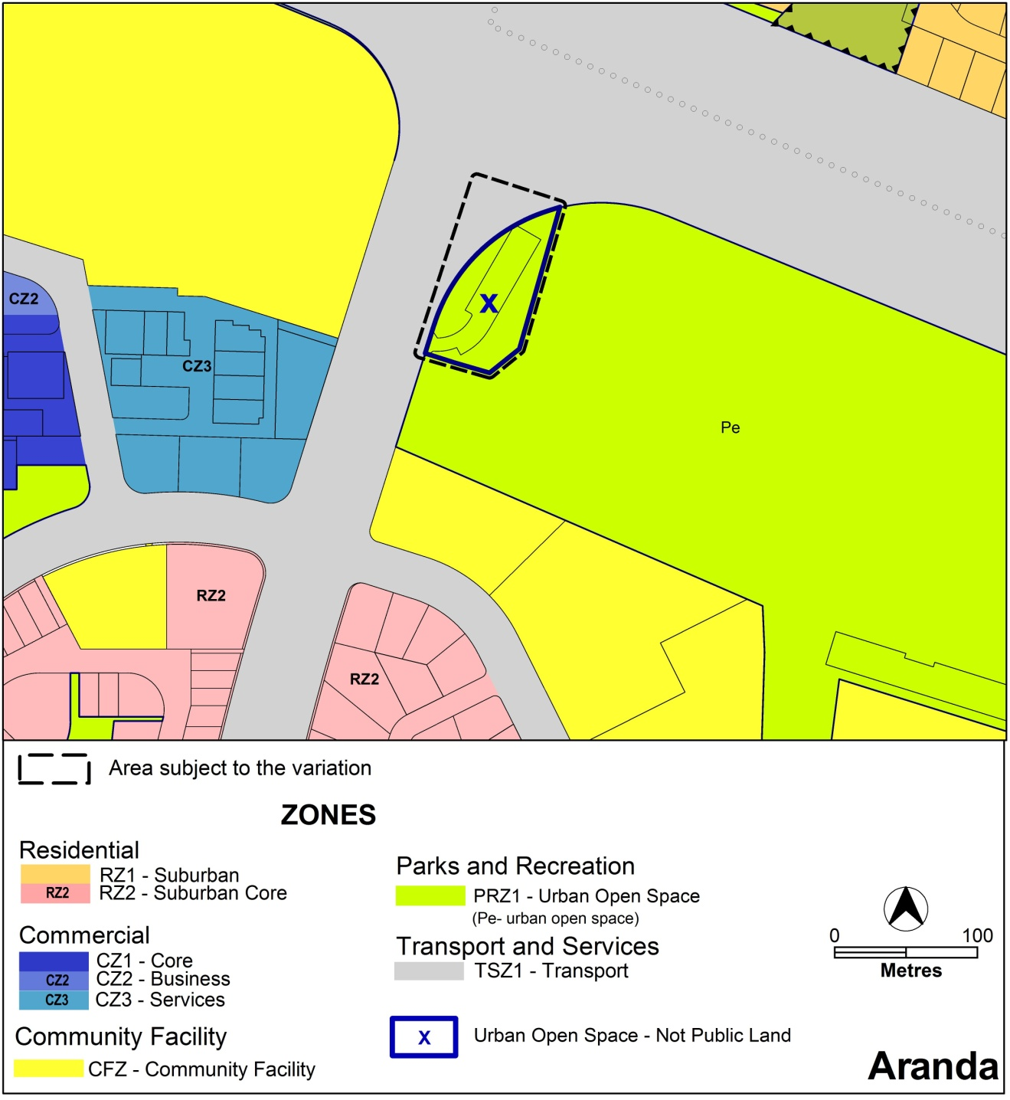

Figure 3: Proposed Territory Plan Zones Map

* 1. Variation to the Territory Plan

The Territory Plan is varied as follows.

Variation to the PRZ1 Urban Open Space Zone

1 7.1 PRZ1 Urban Open Space Zone Development Table, Assessable Development, Minimum Assessment Track Merit

*Insert the following:*

|  |  |  |
| --- | --- | --- |
| **Site Identifier** | **Additional Development** | **Code** |
| Land specified as ‘minimum assessment track merit’ for ‘Emergency services facility’ in a suburb precinct code. Suburb precinct codes are contained within the Territory Plan. | *emergency services facility* | Aranda Precinct Code |

Variation to the TSZ1 Transport Zone Development Table

2 8.1 TSZ1 Transport Zone Development Table, Assessable Development, Minimum Assessment Track Merit

*Insert the following:*

|  |  |  |
| --- | --- | --- |
| **Site Identifier** | **Additional Development** | **Code** |
| Land specified as ‘minimum assessment track merit’ for ‘Emergency services facility’ in a suburb precinct code. Suburb precinct codes are contained within the Territory Plan. | *emergency services facility* | Aranda Precinct Code |

Variation to Precinct Codes

3 10.1 Suburb Precinct Codes

*Substitute* the Aranda Precinct Code withAttachment A.

Variation to Overlays

4 Part 12 Overlays, 12.4 Urban Open Space Zones, Land excluded from Pe (urban open space) Public Land Category

*Insert*

**Figure 4 Aranda**

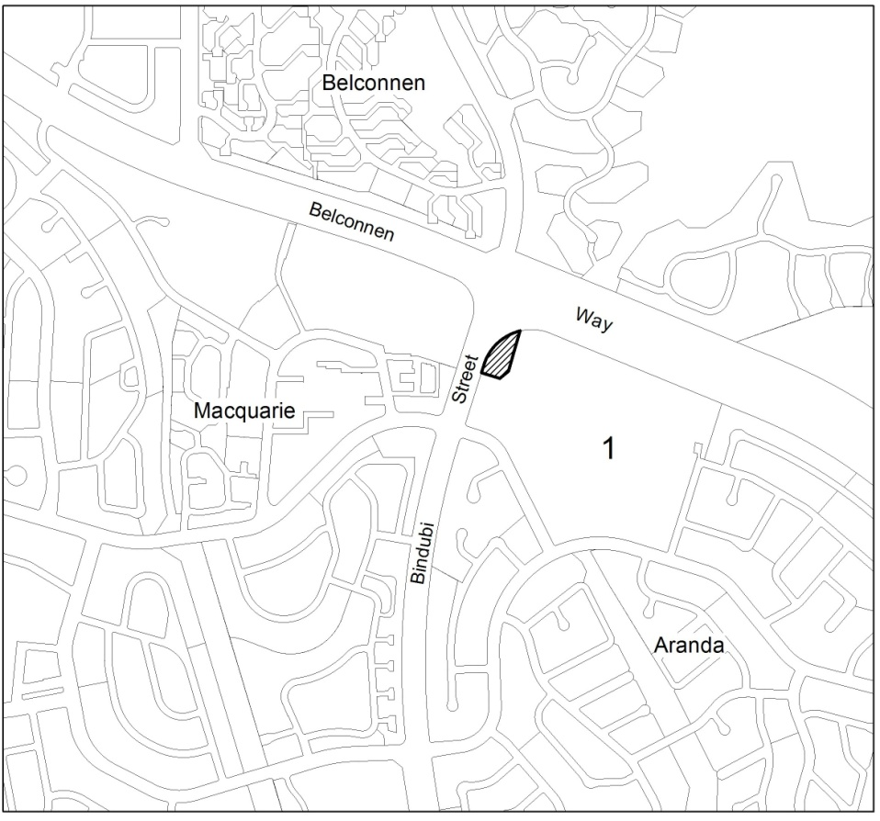

**Interpretation service**

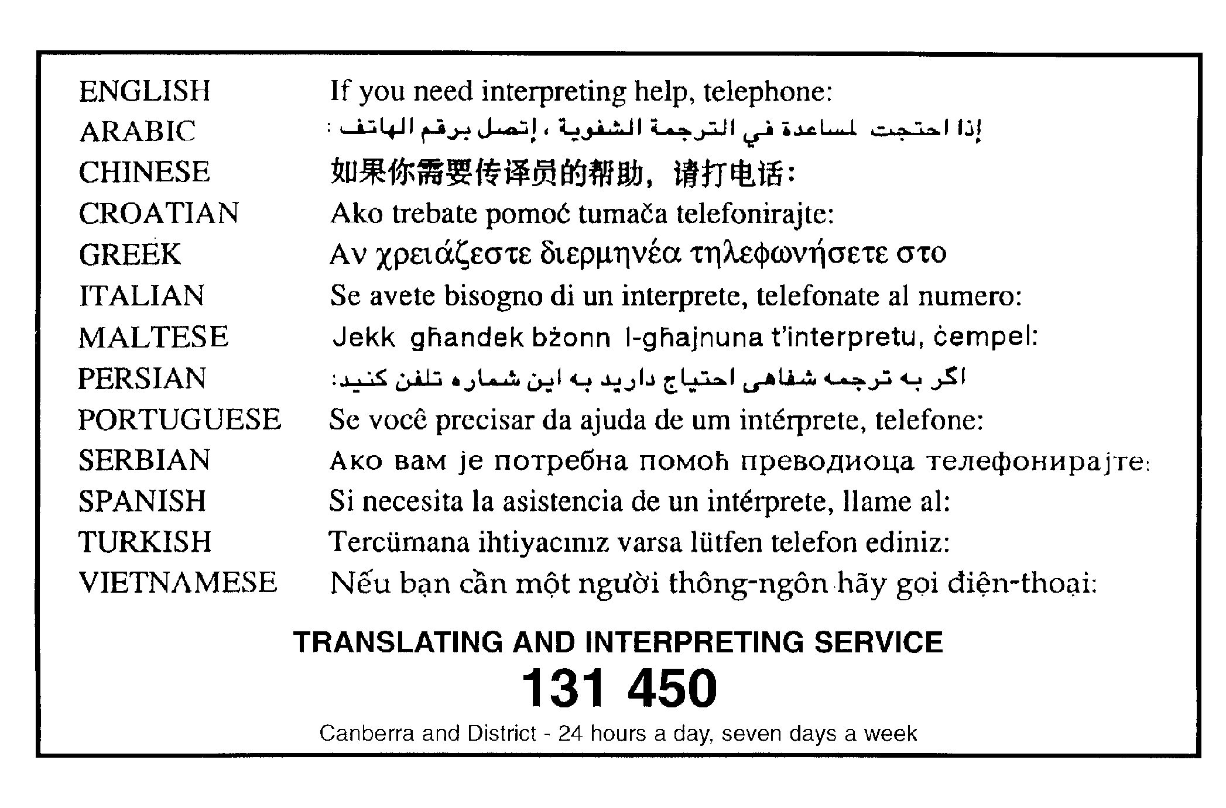

Aranda Precinct Code

*This page is intentionally blank.*

Contents

Introduction 1

Additional rules and criteria 5

Emergency Services Facility – Aranda Fire and Ambulance Station 5

Element 1: Building 5

1.1 Height 5

1.2 Setback 5

1.3 Screening 5

*This page is intentionally blank.*

Introduction

Name

The name of this code is **Aranda Precinct Code**.

Application

The code applies to the Division of Aranda.

Purpose

This code provides additional planning, design and environmental controls for specific areas or blocks and may also contain references to provisions in other codes.

In conjunction with other relevant codes it will be used by the *Authority* to assess development applications and offer guidance to intending applicants in designing developmentproposals and preparing development applications*.*

Structure

This code contains the additional rules and criteria for particular blocks or parcels identified in a precinct map, to be read in conjunction with the relevant development code. It may also contain sub-parts.

Each element has one or more rules and, unless the respective rule is mandatory, each rule has an associated criterion. Rules provide quantitative, or definitive, controls. By contrast, criteria are chiefly qualitative in nature.

In some instances rules are mandatory. Such rules are accompanied by the words “This is a mandatory requirement. There is no applicable criterion.” Non-compliance with a mandatory rule will result in the refusal of the development application. Conversely, the words “There is no applicable rule” is found where a criterion only is applicable.

Code hierarchy

Under the P&D Act, where more than one type of code applies to a development, the order of precedence if there is inconsistency of provisions between codes is: precinct code, development code and general code.

If more than one precinct code applies to the site, the most recent precinct code takes precedence to the extent of any inconsistency.

Definitions

Defined terms, references to legislation and other documents are italicised.

Definitions of terms used in this code are listed in part 13 of the Territory Plan or, for terms applicable only to this code, associated with the respective rule.

Acronyms

Authority Planning and Land Authority within the ACT Environment and Sustainable Development Directorate

EPA ACT Environment Protection Authority

ESA ACT Emergency Services Agency

ESDD ACT Environment and Sustainable Development Directorate

NCA National Capital Authority

P&D Act Planning and Development Act 2007

TAMS ACT Territory and Municipal Services Directorate

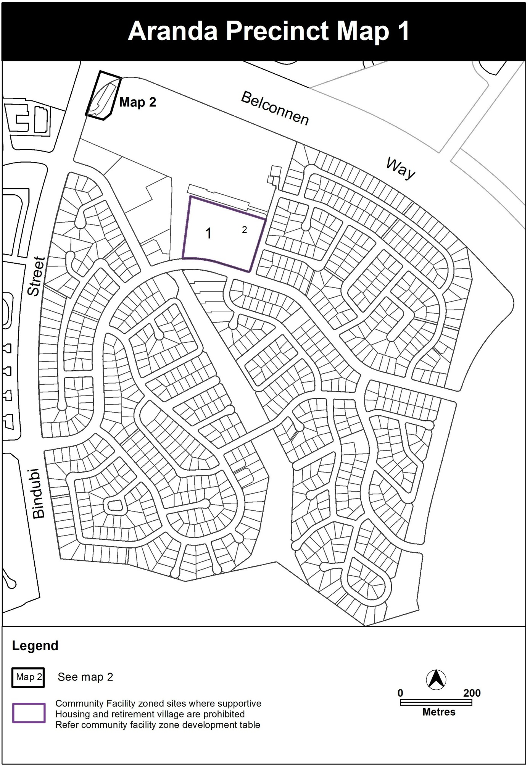

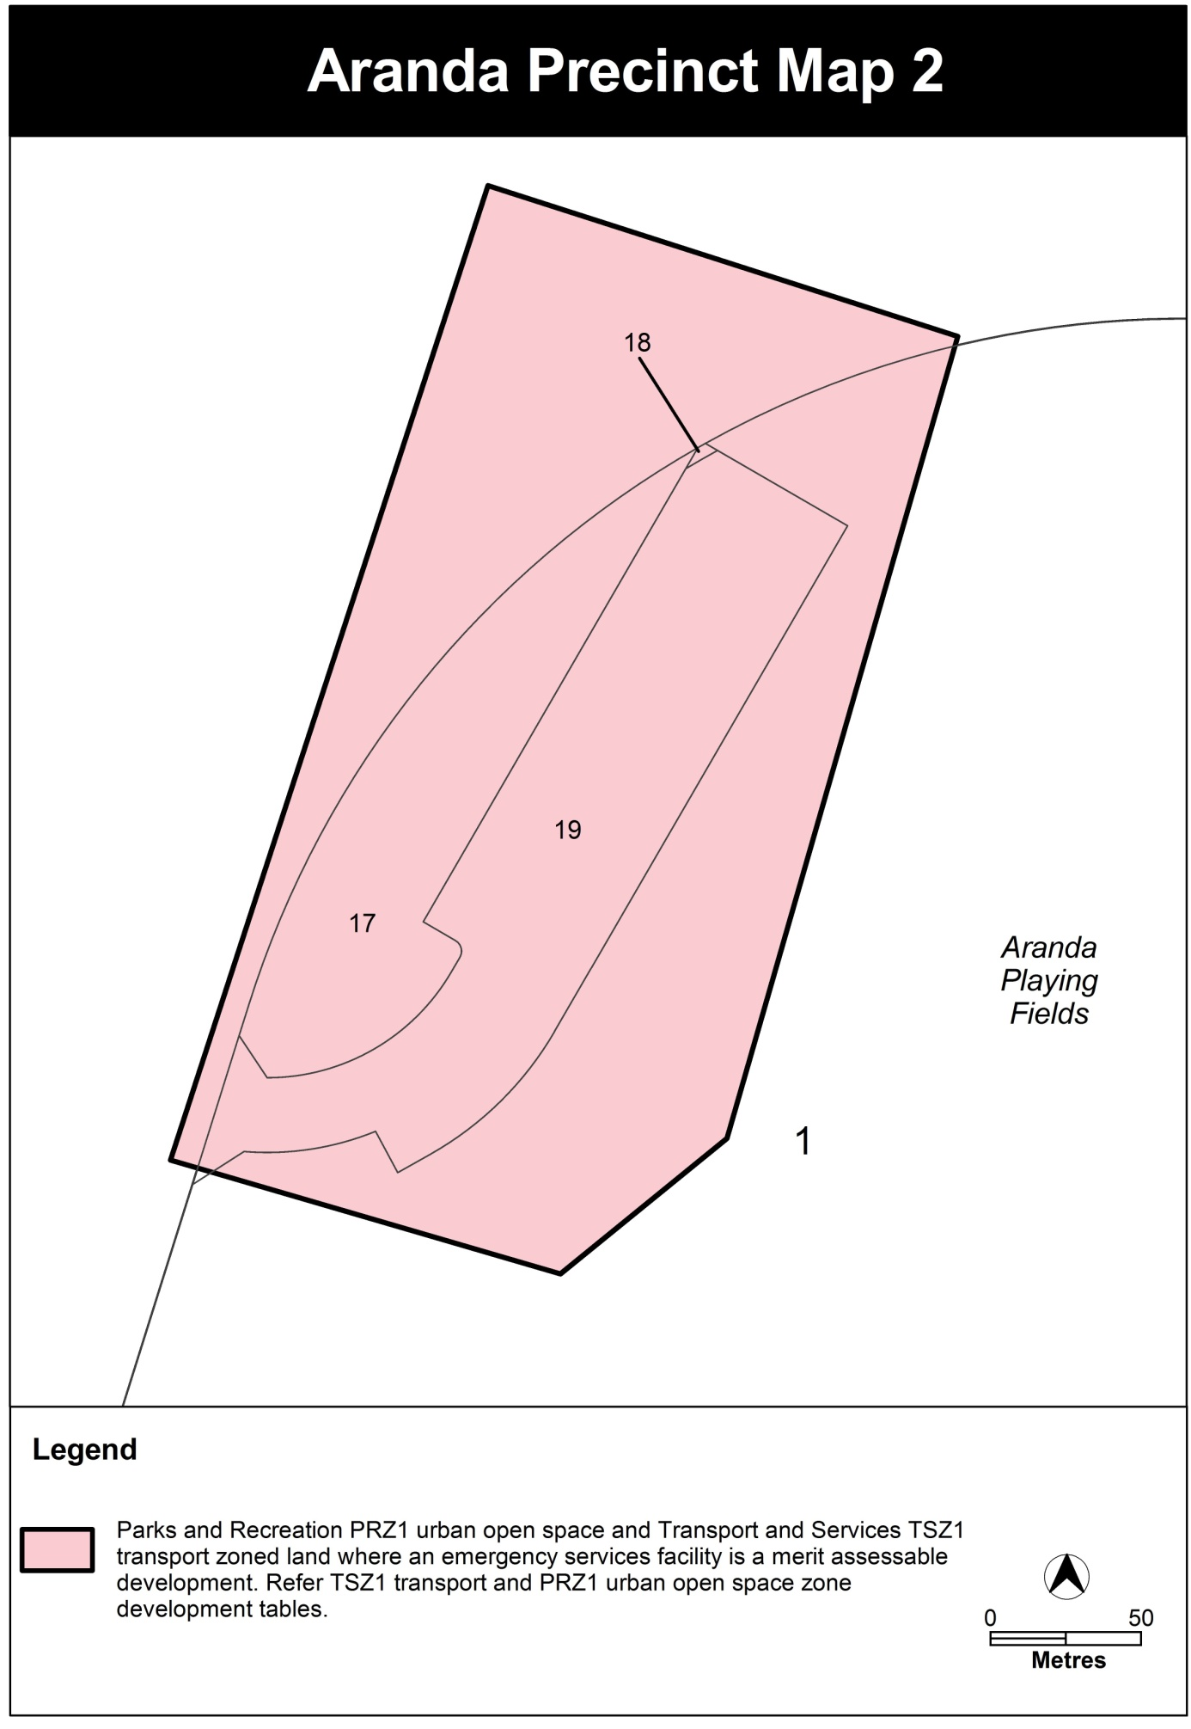

Additional rules and criteria

Emergency Services Facility – Aranda Fire and Ambulance Station

This part applies to blocks and parcels identified in Aranda Precinct Map 2. It should be read in conjunction with the relevant zone development code and related codes.

1. Building

| Rules | Criteria |
| --- | --- |
| * 1. Height | |
| R1  The maximum *height of building*, excludingrooftopplant and equipment, is 9m | This is a mandatory requirement. There is no applicable criterion. |
| 1. Setback |  |
| There is no applicable rule. | C2  *Setback* achieves adequate sight lines for vehicles and pedestrians, especially near street corners and intersections. |
| * 1. Screening | |
| R3  Structures and plant and equipment situated on the roof are not visible from the street frontage or unleased Territory land unless exempt under *Planning and Development Act 2007*. This includes water tanks, solar energy devices, evaporative cooling or air conditioning devices, a radio mast or aerial, or a satellite dish. | C3  Any structures and plant and equipment situated on or visible above the roofline does not significantly impact on the amenity of the streetscape or urban open space. |