Australian Capital Territory

Planning and Development (Technical Amendment—Code and clarification amendment) Plan Variation 2012 (No 2)*
Notifiable instrument NI2012–410
Technical Amendment No 2012-23
made under the
Planning and Development Act 2007, section 89 (Making technical amendments)

This Technical Amendment commences on 10 August 2012.

Technical Amendment Number 2012-23 to the Territory Plan has been approved by the Planning and Land Authority.

Ben Ponton
Delegate of Planning and Land Authority

8 August 2012
This page is intentionally blank

Planning & Development Act 2007

Technical Amendment
to the Territory Plan
Variation 2012-23

Code and clarification amendment, including changes to precinct codes, concept plans and definitions

August 2012

Table of Contents

1. INTRODUCTION 2
Outline of the process 2
2. EXPLANATORY STATEMENT 3
Proposed changes, reasons and compliance with the Planning and Development Act 2007 3
2.1 Code variations 3
2.2 Clarification variations 6
3. TECHNICAL AMENDMENT 8
3.1 Code amendments 8
3.2 Clarification amendments 12

INTRODUCTION

Outline of the process
The Commonwealth’s Australian Capital Territory (Planning and Land Management) Act 1988 allows for the Legislative Assembly to make laws to establish a Territory Planning Authority and for that Authority to prepare and administer a territory plan.
The Planning and Development Act 2007 (the Act) establishes the ACT Planning and Land Authority within Environment and Sustainable Development Directorate (ESDD) as the Authority which prepares and administers the territory plan, including continually reviewing and proposing amendments as necessary.
Technical amendments to the territory plan are prepared in accordance with the Act. This technical amendment has been prepared in accordance with the following two sections of the Act:

A code variation (section 87(b) of the Act) is a technical amendment that
- would only change a code; and
- is consistent with the policy purpose and policy framework of the code; and
- is not an error variation.

A variation under section 87(g) of the Act is a technical amendment that clarifies the language in the Territory Plan, provided it does not change the substance of the plan.

Following the release of the variation under section 90 of the Act, submissions from the public are invited. At the conclusion of the limited consultation period, any representations are considered by the ACT Planning and Land Authority (the Authority). The Authority then determines a day when the code variation is to commence by way of a commencement notice.

EXPLANATORY STATEMENT

Proposed changes, reasons and compliance with the Planning and Development Act 2007
    - Code variations
- Parks and recreation zone development code - change to provisions for municipal depot use (item 1)

The technical amendment proposes to change the provisions restricting municipal depot use for parks maintenance use in the parks and recreation zone development code, by moving part of the criterion and making a mandatory rule. At present this provision is in criterion form only, which does not restrict the use as intended.

Section of Act | Statement of compliance with Act
s87(b) a variation (a code variation) that -
(i) would only change a code; and | Only proposes to make changes to section 1.1 of the parks and recreation zone development code.
(ii) is consistent with the policy purpose and policy framework of the code; and | The purpose of the code is to provide additional planning, design and environmental controls to support the zone objectives and assessable uses in the Development Tables.  The proposed amendment is considered to be consistent with the purpose of the parks and recreation zone development code.
(iii) is not an error variation | Is not a formal error.

- Removal of provisions from Higgins and Kambah suburb precinct codes which prohibit community facility zoned land from being used for retirement village and supportive housing (items 2 and 3)

The technical amendment proposes to remove provisions from the Higgins and Kambah suburb precinct codes which prohibit the specified community facility zoned land being used for retirement village and supportive housing. This proposal refers to the former Urambi primary- and preschool located on block 1 section 239 Kambah, and the former Higgins primary- and preschool located on block 2 section 11 Higgins. Variation 302 in November 2011 established many precinct codes for existing suburbs to show those community facility sites where retirement village and supportive housing are prohibited. The precinct codes to prohibit retirement village and supportive housing on school sites were intended for schools that were operational. The former Urambi primary and preschools were officially closed in December 2010. The former Higgins primary school was closed in December 2008 and the preschool was closed in December 2009. As the schools are now closed, it is proposed to remove the provisions in the relevant suburb precinct codes that prohibit retirement village and supportive housing, to bring it in line with other closed schools like Chifley (Melrose Primary) and Kambah (Village Creek Primary and Preschool) where the land use zone is community facility, but there is no precinct code prohibiting the use for retirement village and supportive housing.

Section of Act | Statement of compliance with Act
s87(b) a variation (a code variation) that -
(i) would only change a code; and | Only proposes to remove the provision relating to block 2 section 11 in the Higgins precinct code map (effectively removing the precinct code) and removing the provision relating to block 1 section 239 in the Kambah precinct code map.
(ii) is consistent with the policy purpose and policy framework of the code; and | The purpose of the suburb precinct codes is to identify site specific provisions prohibiting certain development and/or allowing for certain types of assessable developments.  The proposed amendment is considered to be consistent with the purpose of the suburb precinct codes.  The proposed change is consistent with the objectives for the community facility zone.
(iii) is not an error variation | Is not a formal error.

- Coombs and Wright concept plan - change to conform to the Molonglo Valley Plan for the Protection of Areas of National Environmental Significance (NES Plan) (items 4 & 5)

The technical amendment proposes to change the Coombs and Wright concept plan to include the provision that any new development is not inconsistent with the Molonglo Valley Plan for the Protection of Areas of National Environmental Significance (NES Plan). A new rule will be added to the concept plan to mandate new development to conform to the NES Plan.

Section of Act | Statement of compliance with Act
s87(b) a variation (a code variation) that -
(i) would only change a code; and | Only proposes to make changes to Part A, Element 1 of the Coombs and Wright concept plan.
(ii) is consistent with the policy purpose and policy framework of the code; and | The purpose of the concept plan is to  - guide the design and assessment of estate development plans (subdivision proposals) in Coombs and Wright  - inform the allocation of final zones at the time when a parcel of land ceases to be part of the future urban area following subdivision  - guide the development of individual blocks in concert with other relevant codes under the Territory Plan  - guide the development and management of the public realm.  The proposed amendment is considered to be consistent with the purpose of the Coombs and Wright concept plan, ensuring that matters of national environmental significance are considered when assessing the development of estates.
(iii) is not an error variation | Is not a formal error

    - Clarification variations

- Changes to clarify provisions for location of outdoor storage areas in various development codes (items 6, 9, 12)

The proposed changes to the parks and recreation zone development code, the transport and services zone development code and the industrial zone development code, will clarify references to the location of outdoor storage areas. This change is required to provide clarity and to assist in the development assessment process.

Section of Act | Statement of compliance with Act
s87(g) a variation to clarify the language in the territory plan if it does not change the substance of the plan | The proposed change will clarify references to the location of outdoor storage areas in various development codes.

- Changes to clarify references to compatibility of building materials with adjacent development specified in various development codes (items 7, 10)

The proposed change to the parks and recreation zone development code and the transport and services zone development code will clarify references to the compatibility of building materials with adjacent development. This change is required to provide clarity and to assist in the development assessment process.

Section of Act | Statement of compliance with Act
s87(g) a variation to clarify the language in the territory plan if it does not change the substance of the plan | The proposed change will clarify the reference to compatibility of building materials with adjacent development in various development codes.

- Changes to clarify noise assessment provisions in various development codes (items 8, 11)

The proposed change to the parks and recreation zone development code and the transport and services zone development code will clarify references to noise assessment. The current wording suggests that the noise generated is assessed against a benchmark, however no such benchmark/standard has been provided and it would therefore be difficult to address this in an Assessment of Environmental Effects. This change is required to provide clarity and to assist in the development assessment process.

Section of Act | Statement of compliance with Act
s87(g) a variation to clarify the language in the territory plan if it does not change the substance of the plan | The proposed change will clarify the reference to noise assessment in various development codes.

- Definitions of terms – changes to references of natural ground level (item 13)

The proposed change to the definitions of terms will replace references to natural ground level in the definitions to datum ground level. A new definition of datum ground level was added to the Territory Plan definitions of terms through variation 300 in November 2011, to reflect current best practice height measurement in the ACT. To complete the transition to this new definition it is proposed to change the reference to natural ground level in other definitions to datum ground level.

Section of Act | Statement of compliance with Act
s87(g) a variation to clarify the language in the territory plan if it does not change the substance of the plan | The proposed change will replace references to natural ground level in the definitions of terms with datum ground level to reflect the recent introduction of the new definition of datum ground level.

TECHNICAL AMENDMENT
    - Code amendments

Variation to the parks and recreation zones – parks and recreation zone development code
- Parks and recreation zone development code, Part A – Zone specific controls, Part A(1) – PRZ1 – Urban open space zone, Element 1: Restrictions on use, Section 1.1 – Municipal depot

Substitute with the following

Rules | Criteria
1.1 Municipal depot
R1  Municipal depot may be used only for the purpose of park maintenance depots. | This is a mandatory rule. There is no criterion.
There is no applicable rule. | C1A  Development of a municipal depot for the purpose of park maintenance depot provides landscaping and screen fences around any outside storage area.

Variation to precinct codes
- Precinct codes – Higgins Precinct Code

Omit Higgins precinct code

- Precinct codes – Kambah Precinct Code

Replace Kambah precinct code map with the following

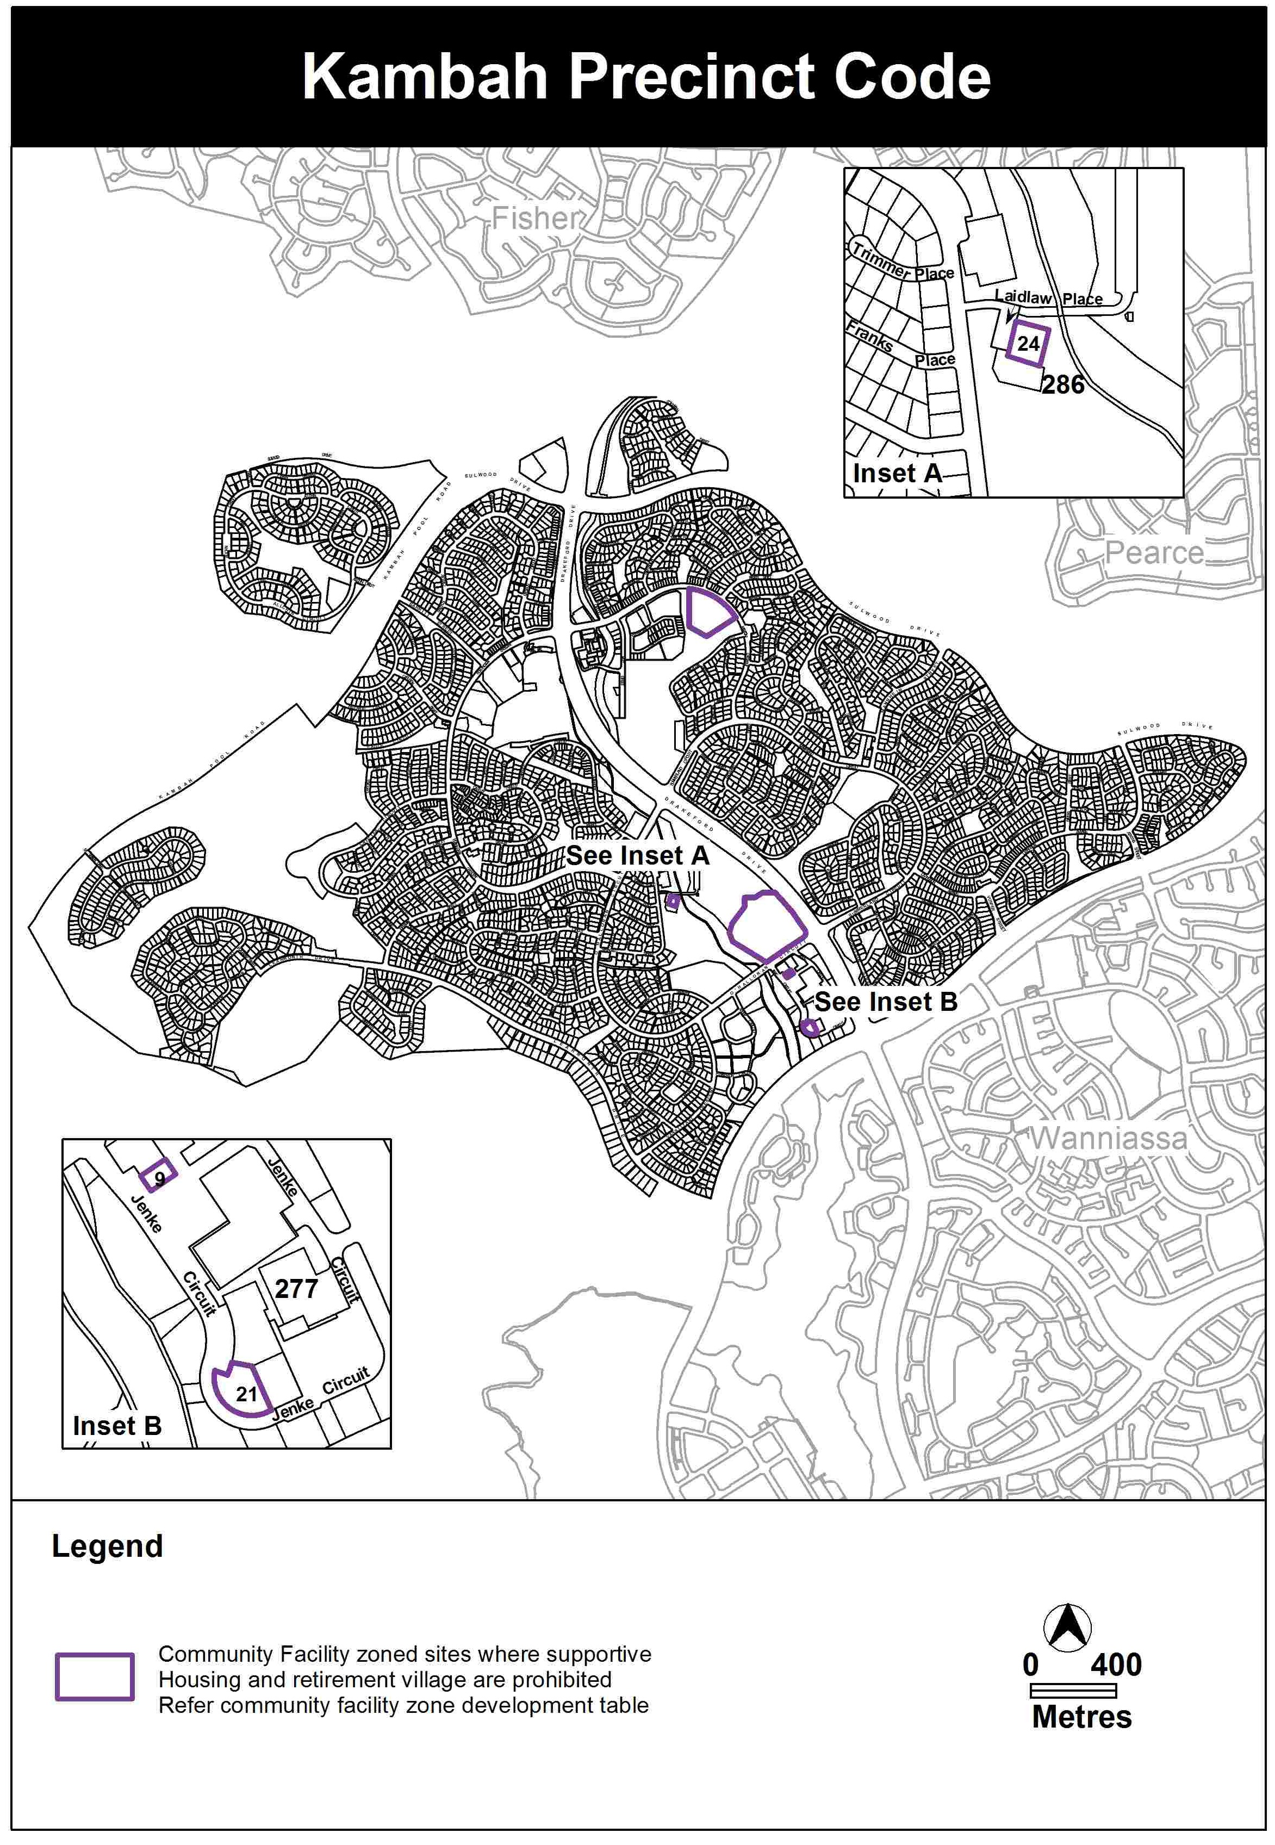

Variation to the Coombs and Wright concept plan

- Introduction; Application

Insert the following after “Part C of this plan applies to the whole of Coombs and Wright, as defined by figure 1.”

Part D of this code applies to the area defined by figure 6.

- Part D – Environment, Element 17: Matters of national environmental significance

Insert the following after Figure A1

Part D – Environment
Element 17: Matters of national environmental significance
Rules | Criteria
R64  This rule applies to the area shown in Figure 6.  Development is not inconsistent with the Molonglo Valley Plan for the Protection of Matters of National Environmental Significance (NES Plan). | This is a mandatory rule. There is no criterion.

Insert the following below Figure 5

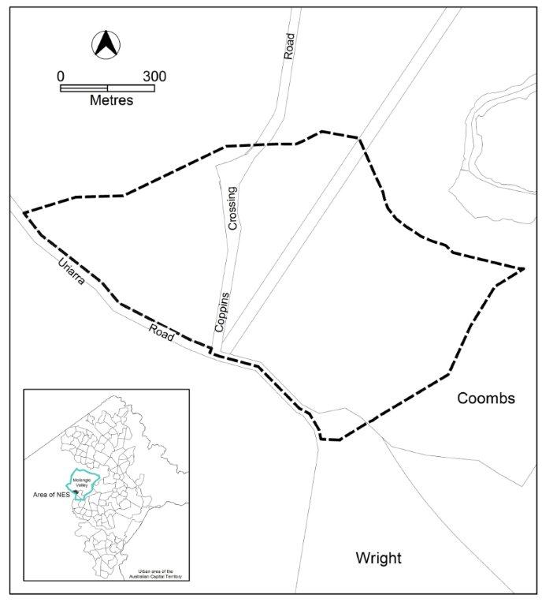
Figure 6: Area affected by the NES Plan

    - Clarification amendments

Variation to the industrial zones – industrial zone development code
- Industrial zone development code, Part B – General development controls, Element 7: Services, Section 7.5 – Storage, Rule R55

- Insert wording as underlined below
- Remove wording crossed out below

R55
Outdoor storage areas do not encroach on required carparking areas spaces, driveways exclusively required for vehicular circulation or landscape areas.

Variation to the parks and recreation zones – parks and recreation zone development code
- Parks and recreation zone development code, Part B – General development controls, Element 3: Built form, Section 3.1 – Materials and finish

- Insert wording as underlined below
- Remove wording crossed out below

Rules | Criteria
3.1 Materials and finish
There is no applicable rule. | C17  The development uses high quality materials that are compatible not incompatible with the character of existing adjacent development and the desired architectural character of the area.

- Parks and recreation zone development code, Part B – General development controls, Element 6: Environment, Section 6.1 – Assessment of environmental effects, Criterion 31

Remove wording crossed out below

i) impacts on the amenity of surrounding land uses, including impacts on air quality, the level of noise generated, overshadowing, privacy, and the level of wind turbulence generated.

- Parks and recreation zone development code, Part B – General development controls, Element 7: Services, Section 7.4 – Storage, Rule R47

- Insert wording as underlined below
- Remove wording crossed out below

R47
Outdoor storage areas do not encroach on required carparking areas spaces, driveways exclusively required for vehicular circulation or landscape areas.

Variation to the transport and services zones – transport and services zone development code
- Transport and services zone development code, Part B – General development controls, Element 3: Built form, Section 3.1 – Materials and finish, Criterion C12

Substitute criterion C12 with the following

C12
The development uses high quality materials that are not incompatible with the character of existing adjacent development and the desired architectural character of the area.

- Transport and services zone development code, Part B – General development controls, Element 6: Environment, Section 6.1 – Assessment of Environmental Effects, Criterion C22

Remove wording crossed out below

h) impacts on the amenity of surrounding land uses, including impacts on air quality, the level of noise generated, overshadowing, privacy, and the level of wind turbulence generated.

- Transport and services zone development code, Part B – General development controls, Element 7: Services, Section 7.4 – Storage, Rule R37

- Insert wording as underlined below
- Remove wording crossed out below

R37
Outdoor storage areas do not encroach on required carparking areas spaces, driveways exclusively required for vehicular circulation or landscape areas.

Variation to the definitions
- Part B – Definitions of Terms

- Omit crossed-out wording below
- Insert wording as underlined below

Basement means a space within a building where the floor level of the space is predominantly below natural datum ground level and where the finished floor level of the level immediately above the space is less than 1.0 metre above natural datum ground level.

Height of building means the vertical distance between natural datum ground level to the highest point or points of the building.

Height of wall means the vertical distance between the natural datum ground level directly beneath the outside face of any external wall and the top of the wall or roof at the wall line, parapet or balustrade (whichever is the higher). In the case of a gable or skillion end, the maximum height of wall shall be measured to a level midway between the ridge line and the top of the eaves or fascia.

Lower floor level (LFL) means a finished floor level which is 1.8 metres or less above natural datum ground level at any point.

Upper floor level (UFL) means a finished floor level, which is greater than 1.8 metres above natural datum ground level at any point.

Interpretation service

