Australian Capital Territory

Planning and Development (Technical Amendment—Crace) Plan Variation 2012 (No 5)

Notifiable instrument NI2012—507
Technical Amendment No 2012—2012-32
made under the
Planning and Development Act 2007, section 89 (Making technical amendments) s96 (land ceases to be in future urban area)

This plan variation commences on the day after it is notified.

Variation No 2012—32 to the Territory Plan has been approved by the Planning and Land Authority.

Variation to the Territory Plan
The Territory Plan map is proposed to be varied as indicated in Annexure A to identify the zones that apply to the land ceasing to be in a future urban area.

Variation to the Precinct Code
The Crace Precinct Code is proposed to be varied by substituting the index map, map 1, map 2 and inserting map 3 with the maps at Annexure B to incorporate ongoing block specific provisions for the area.

Ben Ponton
Delegate of ACT Planning and Land Authority
19 September 2012

THIS IS PAGE ONE OF ANNEXURE A
TO NOTIFIABLE INSTRUMENT NI2012 – 507

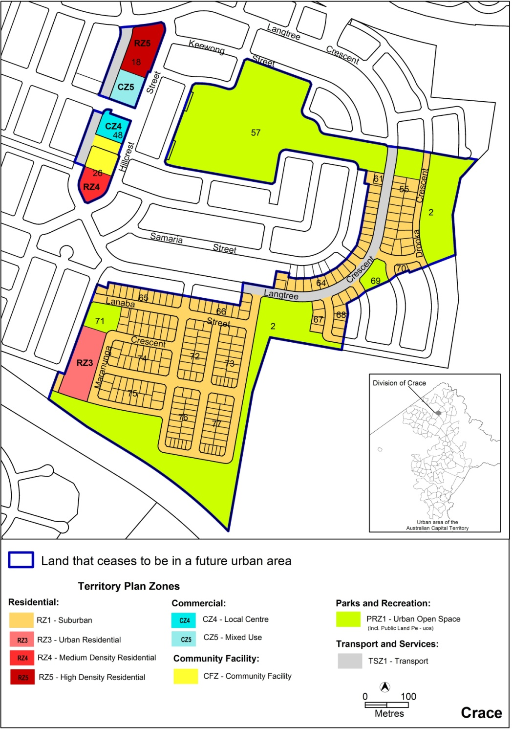

Ben Ponton
Delegate of ACT Planning and Land Authority
19 September 2012
THIS IS PAGE TWO OF ANNEXURE A
TO NOTIFIABLE INSTRUMENT NI2012 – 507

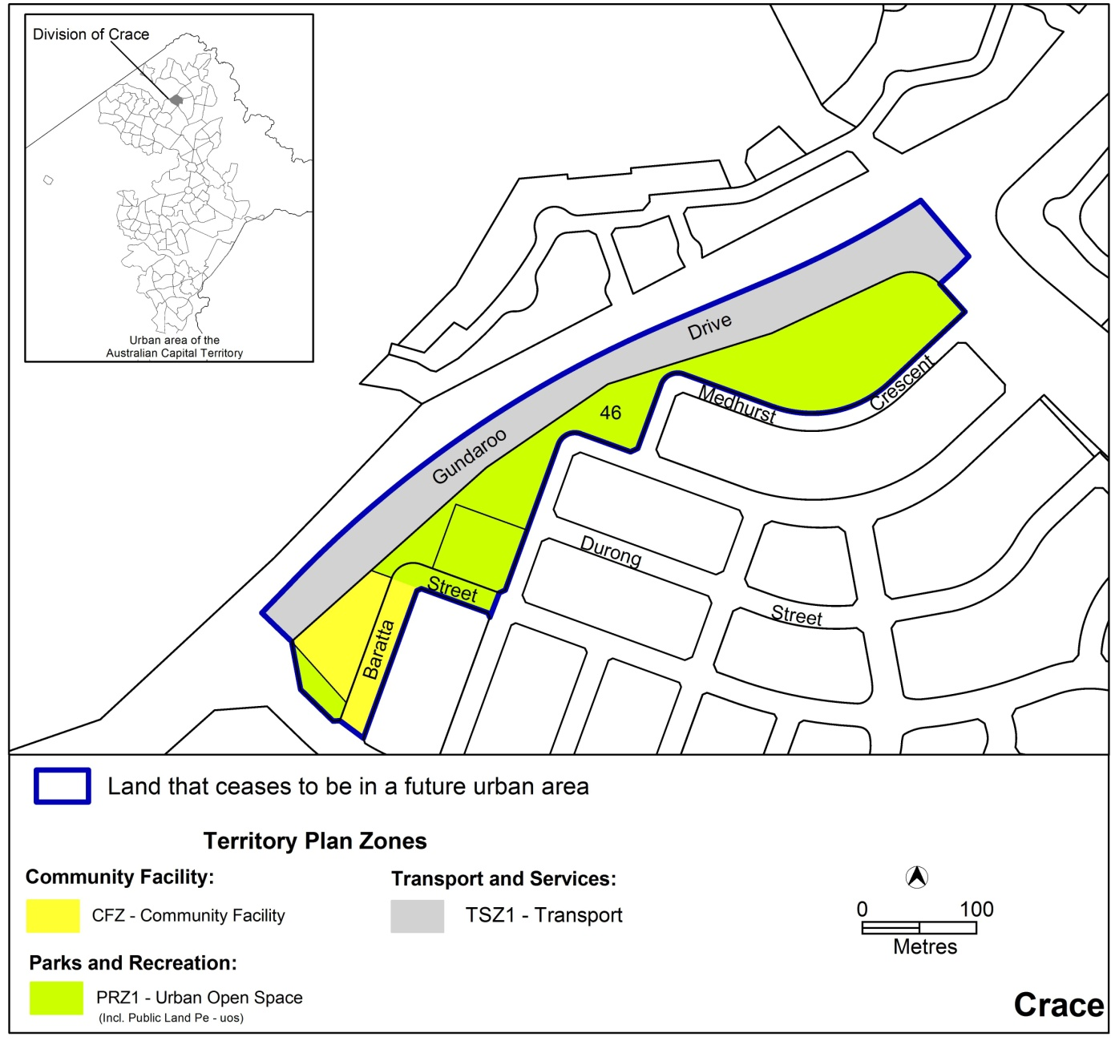

Ben Ponton
Delegate of ACT Planning and Land Authority
19 September 2012
THIS IS PAGE ONE OF ANNEXURE B
TO NOTIFIABLE INSTRUMENT NI2012 – 507

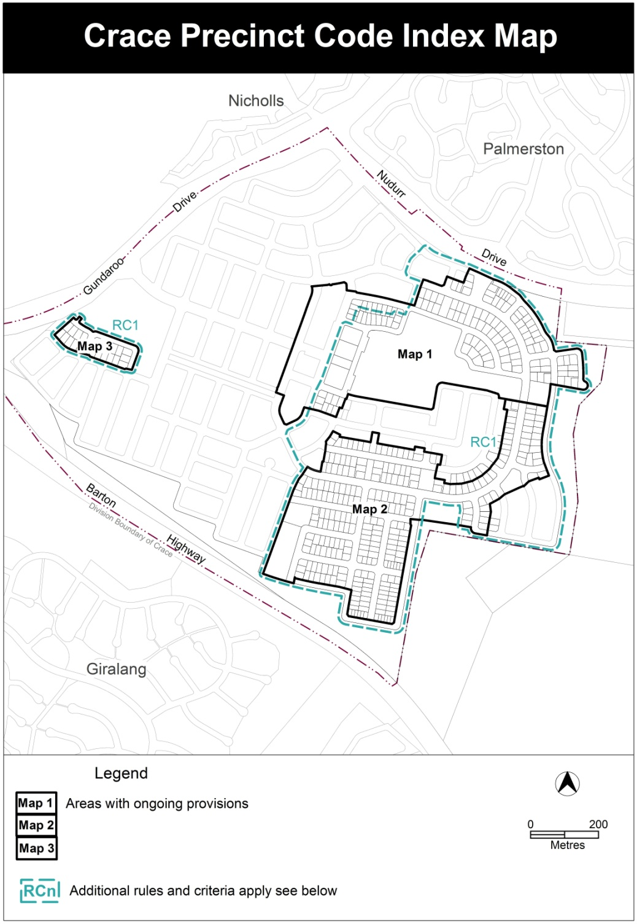

Ben Ponton
Delegate of ACT Planning and Land Authority
19 September 2012

THIS IS PAGE TWO OF ANNEXURE B
TO NOTIFIABLE INSTRUMENT NI2012 – 507

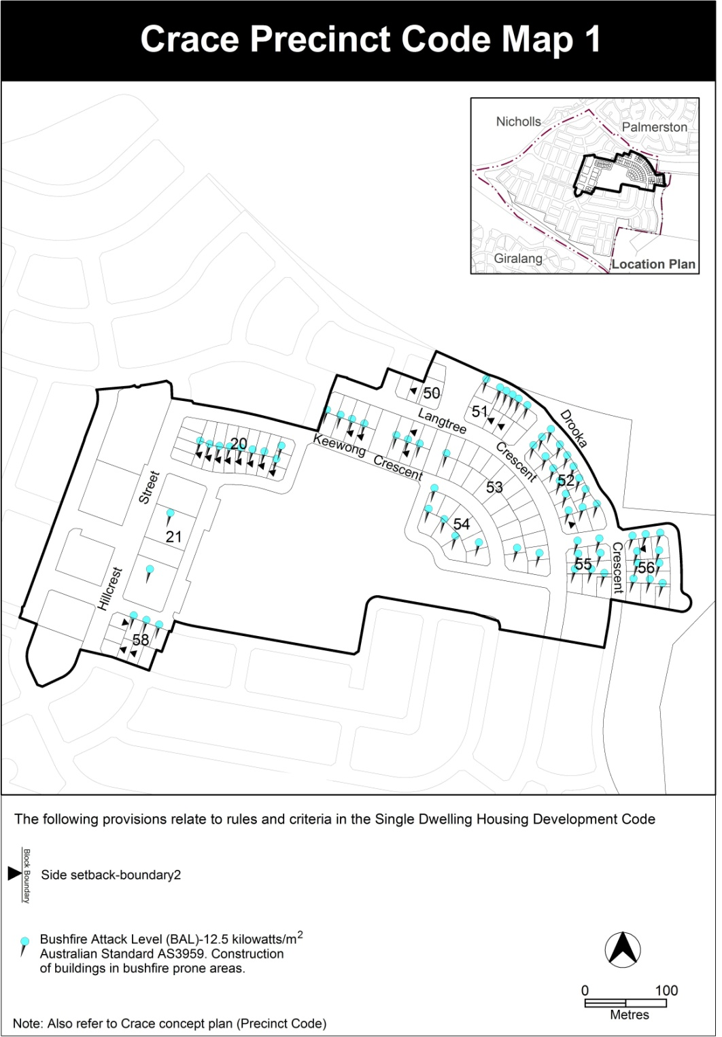

Ben Ponton
Delegate of ACT Planning and Land Authority
19 September 2012

THIS IS PAGE THREE OF ANNEXURE B
TO NOTIFIABLE INSTRUMENT NI2012 – 507

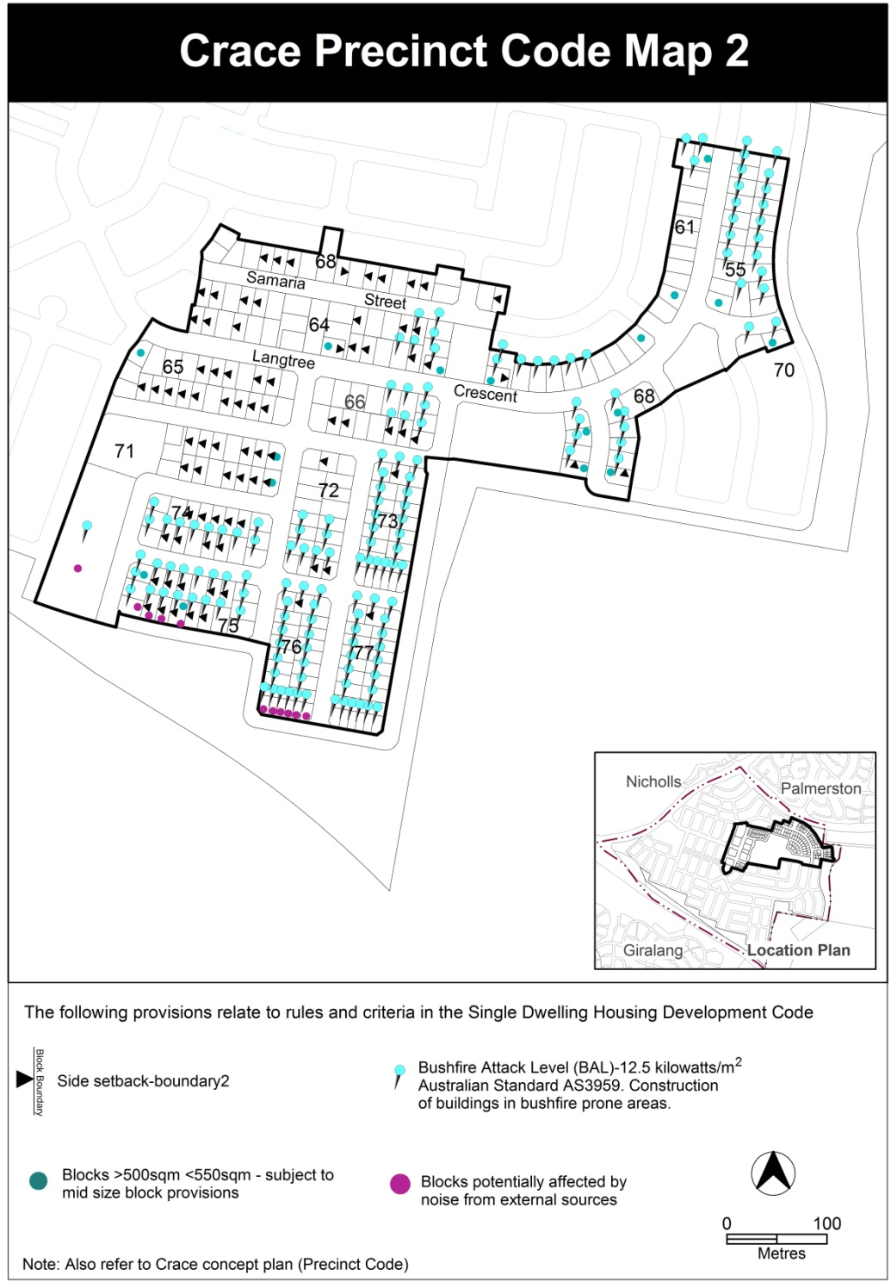

Ben Ponton
Delegate of ACT Planning and Land Authority
19 September 2012

THIS IS PAGE FOUR OF ANNEXURE B
TO NOTIFIABLE INSTRUMENT NI2012 – 507

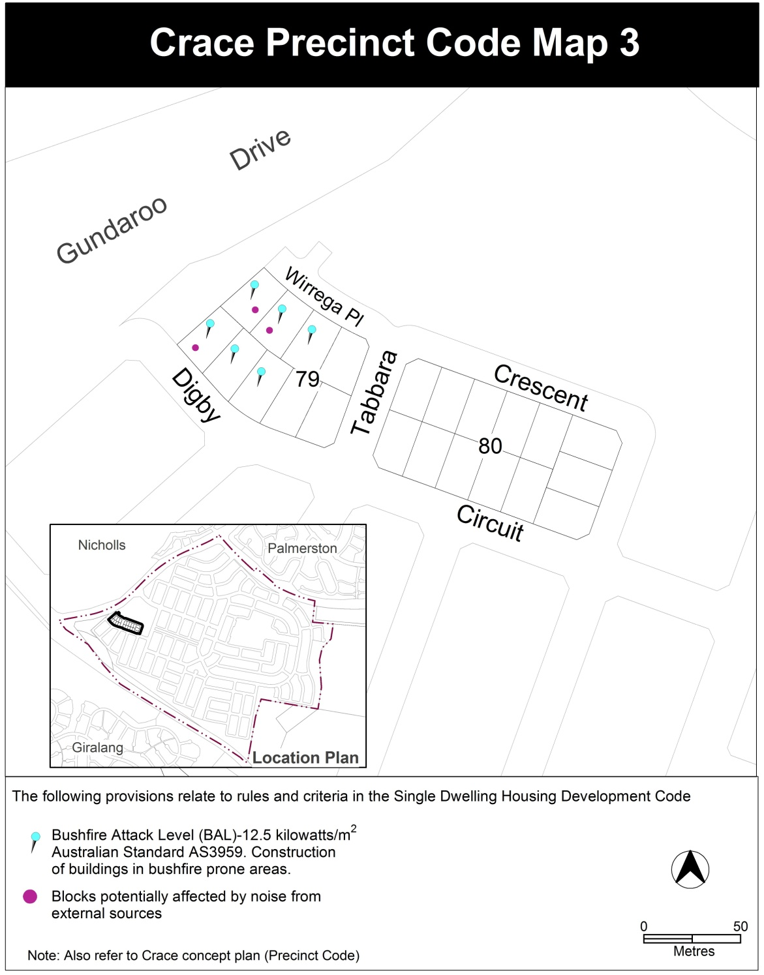

Ben Ponton
Delegate of ACT Planning and Land Authority
19 September 2012

