Australian Capital Territory
Heritage (Decision about Provisional Registration of the ‘Expansion’ Mosaic Mural Wall, Braddon) Notice 2012
Notifiable Instrument NI2012—545
made under the
Heritage Act 2004 section 34 Notice of decision about Provisional Registration

- Name of instrument
This instrument is the Heritage (Decision about the ‘Expansion’ Mosaic Mural Wall, Braddon) Notice 2012.
- Registration details of the place
On 18 October 2012 the ACT Heritage Council decided to provisionally register the ‘Expansion’ Mosaic Mural Wall, Braddon to the ACT Heritage Register. Registration details of the place are at Attachment A: Provisional Register entry for the ‘Expansion’ Mosaic Mural Wall, Braddon.

- Reason for decision
The ACT Heritage Council has decided that the ‘Expansion’ Mosaic Mural Wall, Braddon meets one or more of the heritage significance criteria at s 10 of the Heritage Act 2004. The provisional register entry is at Attachment A.
- Date of Provisional Registration
18 October 2012

- Indication of council's intention
The Council intends to decide whether to register the place under Division 6.2 within
5 months of provisional registration.

- Public consultation period

The Council invites public comment by Wednesday 21 November 2012 on the provisional registration of the ‘Expansion’ Mosaic Mural Wall, Braddon to:

The Secretary

ACT Heritage Council

GPO Box 158

CANBERRA ACT 2601

Jennifer O’Connell
A/g Secretary (as delegate for)
ACT Heritage Council

18 October 2012

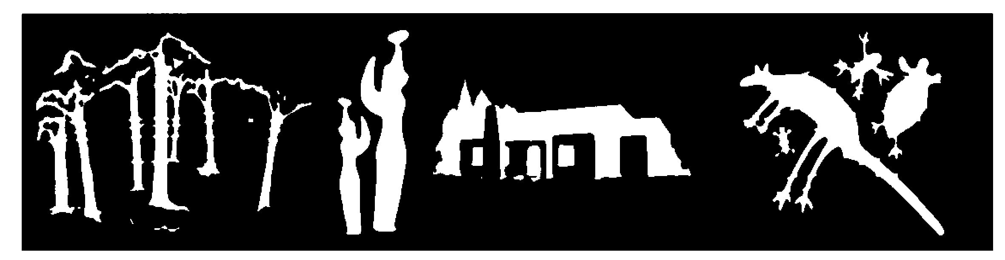  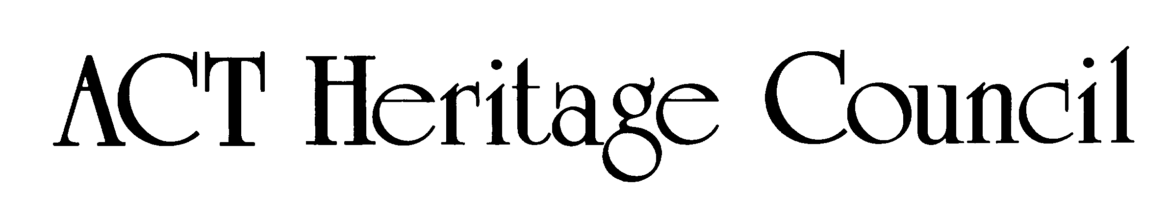 | AUSTRALIAN CAPITAL TERRITORY  HERITAGE REGISTER  (Provisional Registration Details)

For the purposes of s. 33 of the Heritage Act 2004, an entry to the heritage register has been prepared by the ACT Heritage Council for the following place:

‘Expansion’ Mosaic Mural Wall, Braddon

(Part) Block 1 Section 8 Braddon, ACT

DATE OF PROVISIONAL REGISTRATION

18 October 2012 Notifiable Instrument: 2012—545

PERIOD OF EFFECT OF PROVISIONAL REGISTRATION

Start Date: 18 October 2012 End Date: 18 March 2013

Copies of the Register Entry are available for inspection at the ACT Heritage Unit. For further information please contact:

The Secretary
ACT Heritage Council
GPO Box 158, Canberra, ACT 2601

Telephone: 13 22 81 Facsimile: (02) 6207 2229

IDENTIFICATION OF THE PLACE

‘Expansion’ Mosaic Mural Wall, (Part) Block 1 Section 8, Braddon, ACT

STATEMENT OF HERITAGE SIGNIFICANCE

This statement refers to the Heritage Significance of the place as required in s12(d) of the Heritage Act 2004.

The ‘Expansion’ Mosaic Mural Wall (the Mural) is of heritage significance as it demonstrates a high degree of creative achievement and is a notable example of Abstract Expressionist style public art. The Mural has strong associations with the artist, Margo Lewers, and the urban development of Canberra during the 1960s.

The Mural was designed and constructed in 1960 by Margo Lewers, one of Australia’s foremost Abstract Expressionist artists.

The Mural represents one of the earliest examples of a mosaic mural in Abstract Expressionist style in Canberra. Demonstrating a high degree of creative achievement, it is constructed from hand-cut, irregular shaped glass, vitreous and porcelain tiles laid closely on a cartoon. It demonstrates the principle attributes of the Abstract Expressionist style, comprising a range of bright and earthy colour tones and hues and angular and linear shapes.

Representing a cityscape, the Mural has strong associations with the urban development of Canberra during the 1960s. The Canberra Rex Hotel was one of the first multistorey buildings constructed in Canberra and the first post-war hotel. The Mural affixed to the hotel was a significant feature that marked the entrance into the city.

The Mural remains in its original location, alongside the main entrance of the hotel (2012 Canberra Rex Hotel) where it continues to be an important feature as one approaches the city along Northbourne Avenue.

FEATURES INTRINSIC TO THE HERITAGE SIGNIFICANCE OF THE PLACE

The attributes listed below are assessed as features intrinsic to the heritage significance of the place and warrant conservation:
- The original mosaic mural wall consisting of
- hand cut; irregular shaped glass, vitreous and porcelain tiles
- hand painted cartoon underneath the mosaic
- original colour scheme of yellow, grey, black and earthy red, white and brown
- fine black grout
- finish of matt black tiles to each end, the top and base section to ground level
- its location, prominently visible by the public from Northbourne Avenue.
- the open landscaped area between the mural wall and Northbourne Avenue.

APPLICABLE HERITAGE GUIDELINES

Heritage Guidelines adopted under s25 of the Heritage Act 2004 are applicable to the conservation of the ‘Expansion’ Mosaic Mural Wall.

The guiding conservation objective is that the ‘Expansion’ Mosaic Mural Wall shall be conserved and appropriately managed in a manner respecting its heritage significance and the features intrinsic to that heritage significance, and consistent with a sympathetic and viable use or uses. Any works that have a potential impact on significant fabric (and / or other heritage values) shall be guided by a professionally documented assessment and conservation policy relevant to that area or component (i.e. a Statement of Heritage Effects – SHE). Any actions impacting on the significance of the ‘Expansion’ Mosaic Mural Wall are to be based on professional conservation planning.

REASON FOR PROVISIONAL REGISTRATION

The ‘Expansion’ Mosaic Mural Wall has been assessed against the heritage significance criteria and been found to have heritage significance when assessed against three criteria under the Heritage Act 2004 including (a), (g) and (h).

ASSESSMENT AGAINST THE HERITAGE SIGNIFICANCE CRITERIA

Pursuant to s.10 of the Heritage Act 2004, a place or object has heritage significance if it satisfies one or more of the following criteria. Significance has been determined by research as accessed in the references below. Future research may alter the findings of this assessment.

- it demonstrates a high degree of technical or creative achievement (or both), by showing qualities of innovation, discovery, invention or an exceptionally fine level of application of existing techniques or approaches;

The ‘Expansion’ Mosaic Mural Wall meets this criterion.

The Mural demonstrates a high degree of creative achievement through its use and application of tiles, hand-cut into irregular shapes; laid closely spaced in carefully graded tones onto a hand painted cartoon by the artist. The Mural represents one of the earliest examples of a mosaic mural in Abstract Expressionist style in Canberra. The integrity of the Mural and the original fabric is in good condition following comprehensive restoration work in 2010.

- it exhibits outstanding design or aesthetic qualities valued by the community or a cultural group;

The ‘Expansion’ Mosaic Mural Wall does not meet this criterion.

Whilst the Mural exhibits outstanding design qualities, there is insufficient evidence before the Council at this time to demonstrate that they are highly valued by the community or a cultural group.

- it is important as evidence of a distinctive way of life, taste, tradition, religion, land use, custom, process, design or function that is no longer practised, is in danger of being lost or is of exceptional interest;

The ‘Expansion’ Mosaic Mural Wall does not meet this criterion.

Whilst the Mural was created using a design and application distinctive at the time, there is insufficient evidence before the Council at this time to indicate that it is no longer practiced or in danger of being lost.

- it is highly valued by the community or a cultural group for reasons of strong or special religious, spiritual, cultural, educational or social associations;

The ‘Expansion’ Mosaic Mural Wall does not meet this criterion.

Whilst it is recognised that the Canberra Rex Hotel may have some social associations with the development of Canberra in the 1960s, as it was one of the earliest multistorey buildings in Canberra, the first post-war hotel and a significant landmark at that time on Northbourne Avenue, there is insufficient evidence before the Council at this time to demonstrate that the Mural is highly valued by the community or a cultural group.

- it is significant to the ACT because of its importance as part of local Aboriginal tradition

The ‘Expansion’ Mosaic Mural Wall does not meet this criterion.

- it is a rare or unique example of its kind, or is rare or unique in its comparative intactness

The ‘Expansion’ Mosaic Mural Wall does not meet criterion.

- it is a notable example of a kind of place or object and demonstrates the main characteristics of that kind

The ‘Expansion’ Mosaic Mural Wall meets this criterion.

The ‘Expansion’ Mosaic Mural Wall is a notable Canberra public artwork, representing a cityscape. The Mural demonstrates the main qualities of the Abstract Expressionist Style, including a range of colour tones and hues as well as angular and linear shapes. The linear shapes are further complimented through the Mural’s horizontal positioning in association with the main building of the hotel. While other examples are known in the wider Australian context, this is the only example recorded in the ACT.

The ‘Expansion’ Mosaic Mural Wall is recognised as a major work in the oeuvre of the artist.

- it has strong or special associations with a person, group, event, development or cultural phase in local or national history

The ‘Expansion’ Mosaic Mural Wall meets this criterion.

The ‘Expansion’ Mosaic Mural Wall has special associations with the artist, Margo Lewers, and her association with the development of Canberra during the 1960s. She was a pioneering Abstract Expressionist artist in Australia and the Mural is one of the few public commissions she undertook and is her only known solo public artwork in Canberra.

The Mural has strong associations with the urban development of Canberra during the 1960s. Lewers daughters, Darani Lewers and Tanya Crothers (2008), have indicated that the title ‘Expansion’ ‘embodies the spirit of a time of optimism when intense urban and cultural development was occurring in the Nation’s capital’. The Mural’s association with this cultural period is further supported by its context. The Mural is located in front of the Canberra Rex Hotel (2012), one of the earliest multistorey buildings in Canberra which formed part of a precinct that marked the entrance into the national capital along Northbourne Avenue at that time.

- it is significant for understanding the evolution of natural landscapes, including significant geological features, landforms, biota or natural processes

The ‘Expansion’ Mosaic Mural Wall does not meet this criterion.

- it has provided, or is likely to provide, information that will contribute significantly to a wider understanding of the natural or cultural history of the ACT because of its use or potential use as a research site or object, teaching site or object, type locality or benchmark site

The ‘Expansion’ Mosaic Mural Wall does not meet this criterion.

- for a place—it exhibits unusual richness, diversity or significant transitions of flora, fauna or natural landscapes and their elements

The ‘Expansion’ Mosaic Mural Wall does not meet this criterion.

- for a place—it is a significant ecological community, habitat or locality for any of the following:
(i) the life cycle of native species;
(ii) rare, threatened or uncommon species;
(iii) species at the limits of their natural range;
(iv) distinct occurrences of species.

The ‘Expansion’ Mosaic Mural Wall does not meet this criterion.

SUMMARY OF THE PLACE
HISTORY AND PHYSICAL DESCRIPTION

HISTORY
Constructed in 1960, and at six storeys in height, the Canberra Rex Hotel was one of the earliest multistorey buildings in Canberra and the first post-war hotel. The scale and contemporary appearance of the hotel created a new landmark in Canberra which attracted guests from all over the world. Designed by Sydney architects Kann, Finch & Partners, it was the first significant building for visitors driving into the national capital along Northbourne Avenue.

In 1957 artist Margo Lewers was commissioned to design a mural for the wall near the entrance to the Hotel. The Mural was intended to be seen when travelling southbound along Northbourne towards the city. According to Lewers daughters, Tanya Crothers and Darani Lewers (2008), the design of the Mural was inspired by Margo’s exploration of the theme ‘urban landscapes’ and its title, ‘Expansion’ embodies ‘the spirit of a time of optimism when intense urban and cultural development was occurring in the Nation’s capital’. Her husband, Gerald Lewers, was commissioned to design and fabricate a copper fountain to be installed next to the hotel swimming pool. Both of these artworks were completed in 1960.

The Artist

Margo Lewers (1908- 1978) is recognised as one of Australia’s foremost Abstract Expressionist painters working during the decades following WW2. She developed an interest in abstract expression early in her career, making her one of the first abstract painters in Australia.

Lewers won 14 major art awards and received a number of other major public and private commissions. She was a founding member of the NSW Contemporary Art Society.

Although best known as a painter, from the 1950s Lewers began to experiment with other media, such as pottery and tapestry and exhibited her works extensively throughout Australia. She developed an interest in mosaic murals and her first examples were produced at her residence in Emu Plains (Bell 2002). She was commissioned to design and produce two large works, one of which was the mural at the Canberra Rex Hotel. The mural features linear motifs that are indicative of her earlier works. Shortly after completing this commission, she produced an internal mural for the entrance hall at the Faculty of Engineering, University of Western Australia (Bell 2002). In 1968, after the death of her husband, she completed his commission, a copper sculpture titled the ‘Aubusson Tapestry’ and it was placed in the boardroom of the Reserve Bank of Australia in Canberra (Hickey 1982; Crayford, accessed 2 October 2012)

Her residence at Emu Plains (NSW) was converted into a museum after her death and today is managed by the Lewers Bequest, Penrith Regional Art Gallery and the local council, while a number of her works are exhibited in National and State galleries. In 2003, a retrospective was held in her honour at the

S.H. Erwin Gallery.

DESCRIPTION
The ‘Expansion’ Mosaic Mural Wall is situated on the southern side of the main entrance to the Canberra Rex Hotel (2012) and is set approximately 10m back from the main road (Figures 1 and 2). The wall faces Northbourne Avenue and while it is partially concealed by vegetation, including trees, it can be viewed directly in front of the hotel from the road and pathway as one approaches the city travelling south (Figures 2 and 3). The Mural is constructed from hand-cut, irregular shaped glass, vitreous and porcelain tiles and measures 2.3m in height and 12.3m in length.

The Mural’s construction involved the preparation of a full sized painted cartoon onto which Lewers glued each hand-cut irregular shaped glass, vitreous or porcelain tile face down. The colours and tones were selected in response to the hotel’s external colour scheme of yellow, grey and black, to which the artist added earthy reds, white and brown (Figures 4, 5 and 6). The Mural was laid in sections on site under the artist’s supervision.

The tiles have been bedded and grouted with a fine black mortar onto one face of a block work masonry wall. Each end, the top and the base section to ground level has been finished with matt black tiles. The top outer edge has been trimmed with 50mm aluminium angle.

There is a copper foil damp proof course within the block wall. The adjacent pavement slopes downhill to the southern end of the Mural. There is a raised garden bed at the southern end of the wall which may breach the damp proof course.

The Mural is a semi detached screening wall that is tied to the main hotel building with two buttress walls, presumed to have interlocking masonry joints.

Physical condition and integrity
In 2002 and 2009, Conservation Works Pty Ltd prepared two Condition Reports and noted that the Mural was in fair condition given nearly 40 years of external exposure (Conservation Works Pty Ltd 2002; Mitchell 2009).

Major structural damage was observed that included three large vertical structural cracks and one hairline crack across the Mural. In 2009, urgent stabilisation works were recommended to prevent further loss of tiles and extension of drummy areas. In addition, minor structural problems were also observed including minor loss of grout between the tiles across the extent of the Mural, with higher loss in areas of structural cracking, cracked tiles which date from time of manufacture, areas of drummy tiles and areas of chipped and impact damaged tiles. Also, it was observed that the surface of the Mural exhibited applied and incised graffiti, general dirt and cobwebs, extensive paint splatter from repainting of the building and extensive mould and algae staining which was particularly heavy towards the southern end of the Mural.

In 2010, the Mural was restored by Conservation Works Pty Ltd. The treatment comprised the following; the two large cracks were repaired and sealed, its surface was clean, washed with a non-iconic detergent and tap water; the top capping was stabilised, drummy tiles were consolidated and missing tiles, replaced, a cement based black sand grout was used to repair mortar loss, and a tree growing towards the centre of the Mural was removed (Mitchell 2010). In addition, during the treatment it was observed that the footings were ‘partially unsupported’, as the wall is constructed on a slab with a cantilevered edge; however, this is not considered to be the cause of the structural issues. A large void was also filled in with a “standard brickies mortar” mix (Mitchell 2010). These repairs were funded by a grant from the ACT Heritage Unit.

After its restoration, Conservation Works Pty Ltd reported that the Mural was stable and recommended that its condition should be monitored every three years, with the first check to be carried out in 2012.

In 2012, a site visit was undertaken by the ACT Heritage Unit and it was observed that the Mural continues to be stable and is in good condition. Notably, the hotel is currently undergoing significant redevelopment, with the construction of an apartment block on its northern side. No major structural issues in regards to the Mural were observed. The repairs to structural cracks were noted and there is no evidence of deterioration. Hairline cracking of tiles is still observable in the upper register of the Mural itself on its southern end. There are no missing tiles, while minimal mortar loss was noted. Overall, the Mural’s surface is clean.

REFERENCES

Bell, P. 2002. Margo Lewers. Retrospective. National Trust. S.H. Ervin Gallery, 9-19.

Conservation Works Pty Ltd. (2002) Conservation Condition report and Proposal for treatment of Margo Lewers’ Mural ‘Expansion’. A report prepared by Conservation Works Pty Ltd for T. Kean.

Crayford, M. Lewers, Gerald Francis (1905-1962). Australian Dictionary of Biography, National Centre of Biography, Australia National University, http://adb.anu.edu.au/biography/lewers-gerald-francis-1082/text19197, accessed 2 October 2012.

Crothers, T. and D. Lewers (2008). Nomination of Expansion mural to ACT Heritage Register, submitted May 2008.

Hickey, D 1982. Gerald and Margo Lewers. Grasstree Press, Mosman.

Mitchell, G (2009). Condition Report Margo Lewers’ Mural Expansion’. A report prepared by Conservation Works Pty Ltd.

Mitchell, G (2010). Conservation Report. Rex Mosaic. A report prepared by Conservation Works Pty Ltd, 21/06/2010.

ACT Heritage Unit. Site Inspection August and September 2012

SITE PLAN AND IMAGES

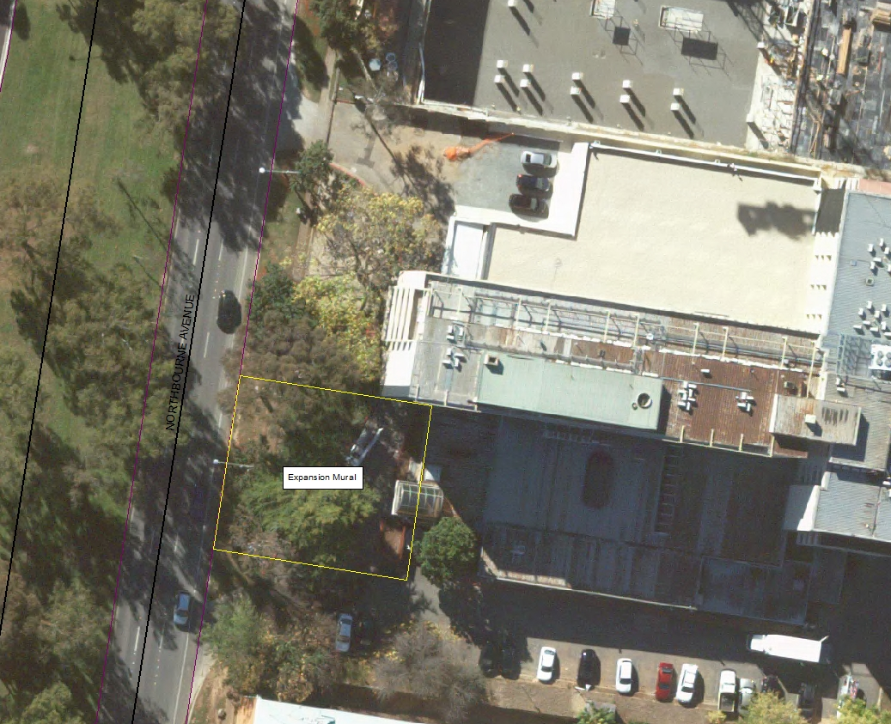
Figure 1. Location of the Mural and open character landscape area between the Mural and Northbourne Avenue, at the Rex Hotel, Northbourne Avenue. Boundary is indicated by yellow line. Map is not to scale.

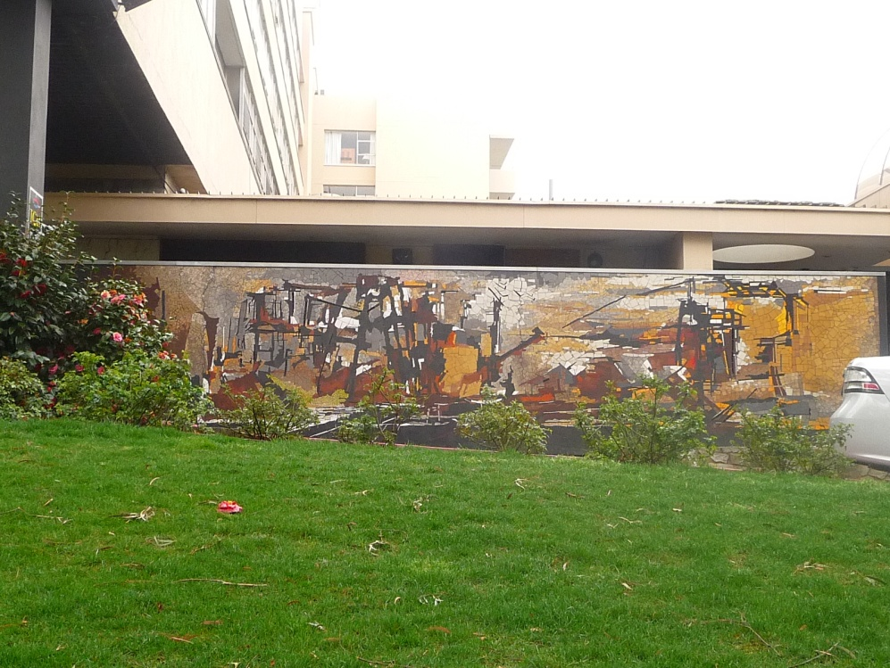
Figure 2. ‘Expansion’ Mosaic Mural Wall as seen from Northbourne Avenue
(ACT Heritage Unit, Sep 2012).

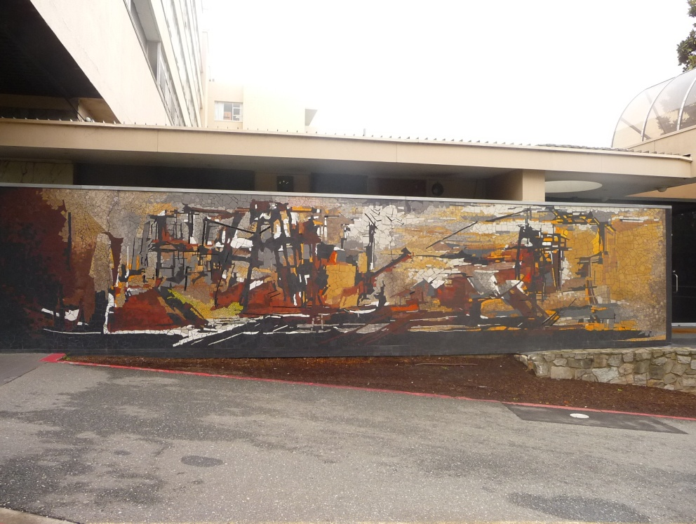
Figure 3. ‘Expansion’ Mosaic Mural Wall as seen from the driveway of the Rex Hotel
(ACT Heritage Unit, Sep 2012).

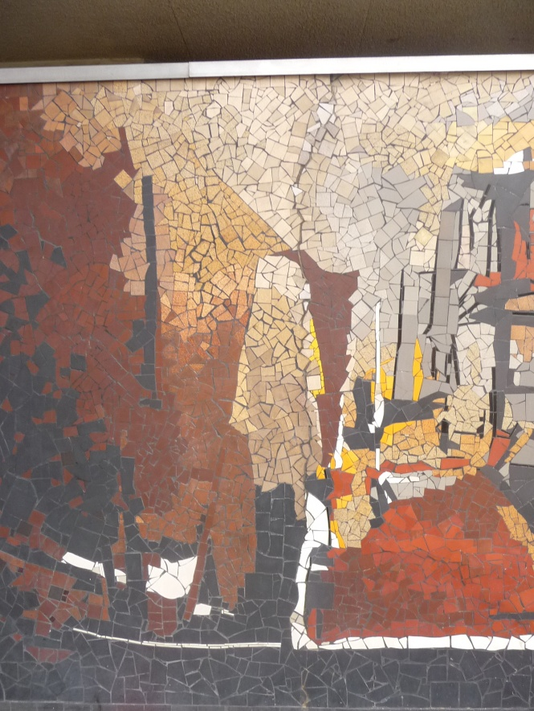
Figure 4. Repaired Structural Crack 1, situated in sections 5 and 6 (ACT Heritage Unit, Sep 2012).

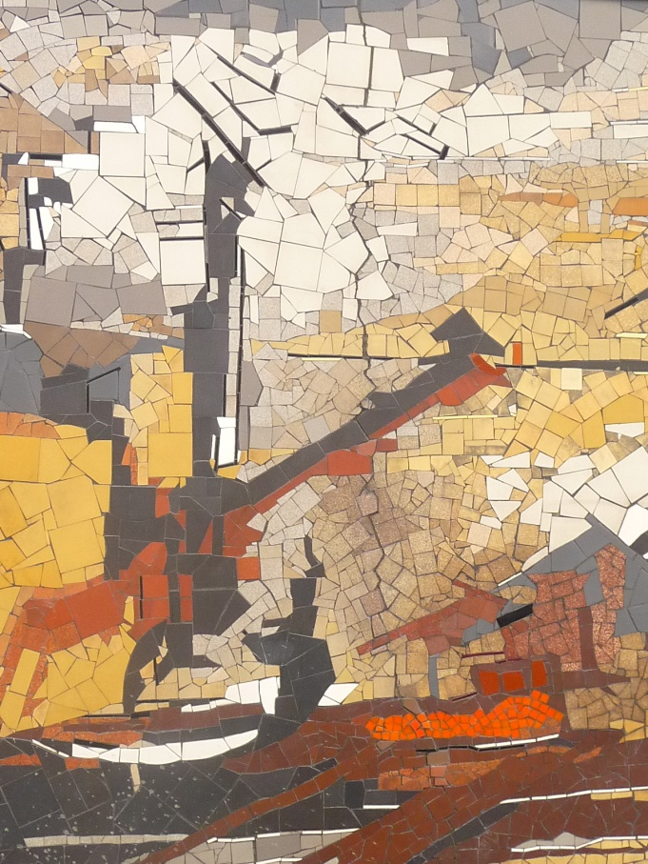
Figure 5. Repaired structural crack of sections 11 and 12 (ACT Heritage Unit, Sep 2012).

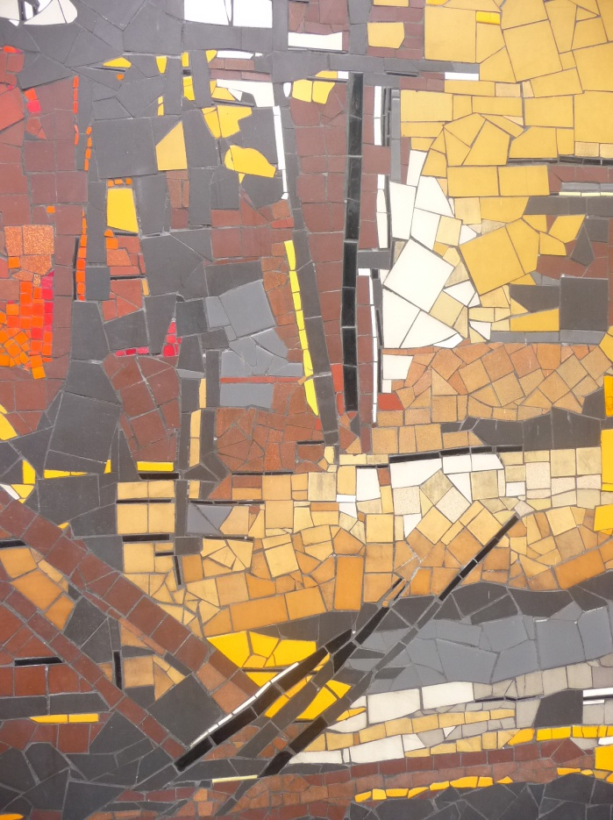
Figure 6. Close up of the Mural, illustrating its abstract form and stark colour combinations of bright and earthy hues, indicative of Margo Lewer’s style (ACT Heritage Unit, Sep 2012).

