Australian Capital Territory

Planning and Development (Technical Amendment—Belconnen) Plan Variation 2012

Notifiable Instrument NI2012—588
Technical Amendment No 2012-38 (1)
made under the
Planning and Development Act 2007, section 89 (Making technical amendments), section 96A (Rezoning – boundary changes)

This plan variation commences on the day after it is notified.

Variation No 2012-38 to the Territory Plan has been approved by the Planning and Land Authority

The variation changes zone boundaries within Block 17 Section 152 in the Division of Belconnen. It effectively eliminates a strip of TSZ1 from the southern boundary of the block, thus making the whole block CZ2.

Area that is affected by this change is identified on the Annexure A.

Jim Corrigan
Delegate of the Planning and Land Authority
14 November 2012
THIS IS PAGE ONE OF ANNEXURE A
TO NOTIFIABLE INSTRUMENT NI2012–588

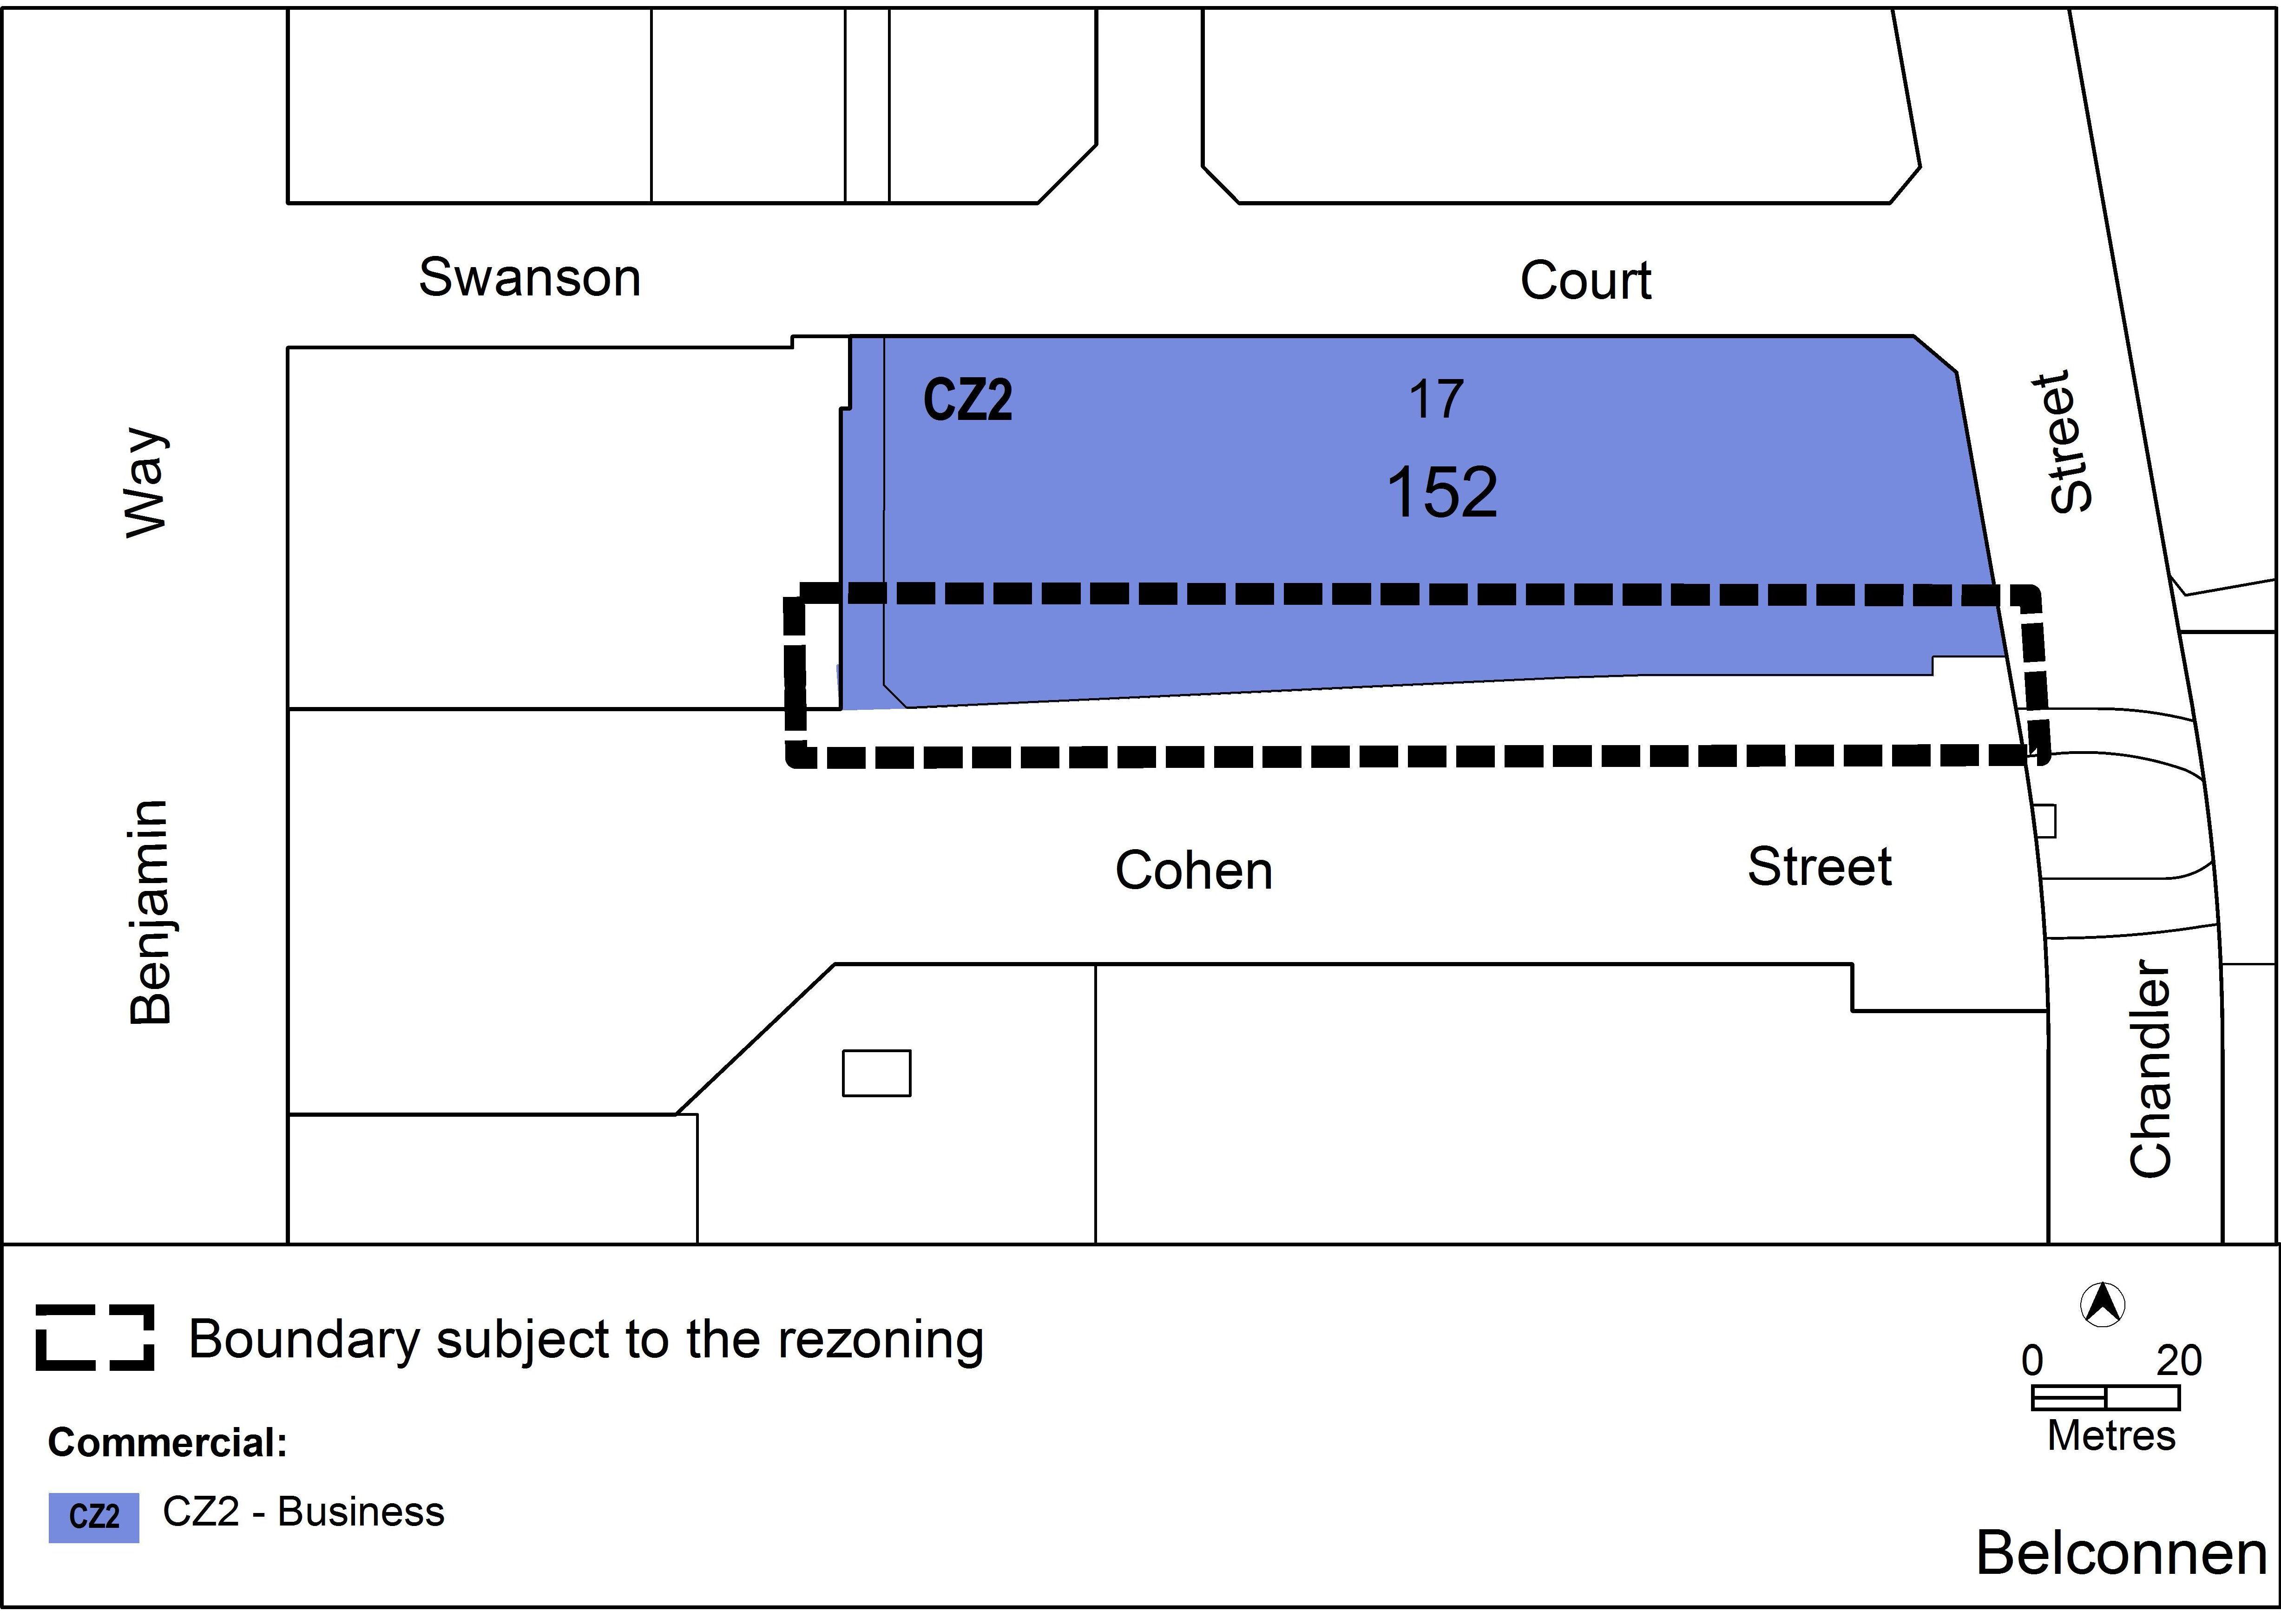

Jim Corrigan
Delegate of Planning and Land Authority
14 November 2012

