Australian Capital Territory

Planning and Development (Technical Amendment—Code and clarification amendment) Plan Variation 2012 (No 4)*
Notifiable instrument 2012 — 631
Technical Amendment No 2012-30
made under the
Planning and Development Act 2007, section 89 (Making technical amendments)

This Technical Amendment commences on 18 December 2012.

Technical Amendment Number 2012-30 to the Territory Plan has been approved by the planning and land authority.

Ben Ponton
Delegate of Planning and Land Authority

11 December 2012

Planning and Development Act 2007

Technical Amendment to the Territory Plan
Variation 2012 – 30

Amendments to various definitions and zone development tables in relation to roads, child care centres, industrial trades and mining industry.
Amendments to the Northbourne Avenue and Inner North Precinct Codes.
Amendments to Residential Zones – Single Dwelling Housing Development Code and Multi Unit Housing Development Code, and Community Facility Development Code.
Deletion of the Bonner Concept Plan.
Amendments to the Greenway Precinct Map and Code (Tuggeranong Town Centre).

December 2012

Contents
1. INTRODUCTION 4
1.1 Purpose 4
1.2 Public consultation 6
1.3 National Capital Authority 6
1.4 Process 6
2. EXPLANATION 7
2.1 Section 13 - Definitions 7
2.2 Zone development tables 9
2.3 Residential Zones – Single Dwelling Housing Development Code 10
2.4 Residential zones - Multi Unit Housing Development Code 12
2.5 Community Facility Zone Development Code 17
2.6 Northbourne Avenue Precinct Code 18
2.7 Inner North Precinct Code 23
2.8 Beard Precinct Map 24
2.9 Parking and Vehicular Access General Code 26
2.10 Bonner Concept Plan 26
2.11 Greenway Precinct Map and Code 27
3. TECHNICAL AMENDMENT 33
3.1 Section 13 - Definitions 33
3.2 Zone development tables 35
3.3 Residential Zones – Single Dwelling Housing Development Code 35
3.4 Residential Zones - Multi Unit Housing Development Code 37
3.5 Community Facility Zone Development Code 41
3.6 Northbourne Avenue precinct code 41
3.7 Inner North Precinct Code 44
3.8 Beard Precinct Map 44
3.9 Parking and Vehicular Access General Code 45
3.10 Bonner Concept Plan 45
3.11 Greenway Precinct Map and Code 46

- INTRODUCTION
  - Purpose
Roads
This technical amendment to the Territory Plan clarifies the treatment of roads under the Territory Plan. Currently “road” is listed as prohibited development in most zones. This appears to be inconsistent with the fact that roads are evident in most zones, including all urban zones.
Despite this apparent prohibition roads are permissible and assessable under the impact track as “minor use”.
Currently
Minor use means the use of land for a purpose that is incidental to the use and development of land in the zone and includes but is not limited to open space; public car parking; community path systems; minor service reticulation; other utility services that do not exclude other uses from the land; public roads (other than major roads); street furniture and the like.
To remedy this potential confusion changes are made to a number of relevant definitions and to the zone development tables, as outlined in section 2 below.

Various definitions
This technical amendment changes the definitions of child care centre, mining industry and residential care accommodation to further clarify the meaning of these definitions.

Residential zones – Single Dwelling Housing Development Code
This technical amendment clarifies the current provision applying to the management of external noise.

Residential zones – Multi unit housing development code
This technical amendment clarifies plot ratio calculations on battleaxe blocks. It also changes R258 of the MUHDC by clarifying plot ratio restriction apply to standard blocks only. This is consistent with the specification for a standard block found in Part D, section 1.6 for Supportive Housing.
Rule 260 of the MUHDC, Part D refers to Australian Standard AS4299 – Adaptable Housing, which is a broad reference. This technical amendment will make this reference more specific by referring to ‘Class C’ of Australian Standard AS4299 – Adaptable Housing.
Current provisions applying to the management of external noise are clarified.

Community Facility Zone Development Code
This technical amendment clarifies the intent of the current provision by substituting the term “surplus ACT Government owned building” with “surplus former ACT Government building” to remove the interpretation that the building must be currently “owned” by the Government for these rules to apply.

Northbourne Avenue Precinct Code
This technical amendment introduces some assessment criteria into certain provisions of the Northbourne Avenue Precinct Code, consistent with the policy purpose and policy framework of the code. These changes relate to front boundary setbacks and building heights adjacent to streets other than Northbourne Avenue and to building heights fronting Northbourne Avenue. The maximum building height of 25m for buildings fronting Northbourne Avenue is retained, although lower buildings are permissible, provided that they are at least three storeys or the equivalent building height.

Inner North Precinct Code
Some limited flexibility is introduced for site coverage in the rear zone where regulated trees can be retained in the course of development.

Parking and Vehicular Access General Code
The technical variation adds a parking rate for child care centres in CZ2 zones outside commercial centres.

Beard precinct map (expected to be introduced through technical amendment 2012-06)
Industrial trades use is added as an additional merit assessable use in the Beard industrial area.

Bonner Concept Plan
The final future urban area in Bonner was uplifted through technical amendment to the Territory Plan 2012-27. This plan is now redundant. Block specific ongoing provisions will be inserted in the Bonner suburb precinct map and code (expected to be introduced through technical amendment 2012-06).

Greenway Precinct Map and Code (expected to be introduced through technical amendment 2012-06)
The boundary of the Tuggeranong Town Centre, as defined in the Greenway Precinct Map (area RC3), has been expanded to correspond with the edge of Lake Tuggeranong south east of Soward Way (opposite Bunnings). Cadastral boundaries, as defined in figure 1 of the Greenway Precinct Code (area c) has correspondingly been expanded and re- defined. Maximum building heights for area c are increased in most cases to allow for greater flexibility, in line with the adopted Tuggeranong Town Centre Master Plan.

  - Public consultation
Under section 88 of the Planning and Development Act 2007 (the Act) this type of technical amendment is subject to limited public consultation. The public was notified through a newspaper notice. At the conclusion of the limited consultation period, any representations are considered by the planning and land authority within the Environment and Sustainable Development Directorate (the Authority). The Authority then determines a day when the code variation is to commence by way of a commencement notice.

  - National Capital Authority
The National Capital Authority has been advised of this technical amendment.

  - Process
This technical amendment has been prepared in accordance with section 87 of the Planning and Development Act 2007 (the Act). Comments received from the public and the National Capital Authority was taken into account before the planning and land authority “made” the technical amendment under section 89 of the Act. The planning and land authority must now notify the public of its decision.
- EXPLANATION
  - Section 13 - Definitions
    - Changes to definitions related to roads
To clarify the way roads, particularly minor roads, are dealt with under the Territory Plan, changes are made to associated definitions found in section 13 and to transfer the definition of road from part A - Definitions of Developments to part B – Definitions of Terms. In addition, amendments to the zone development tables are introduced, as outlined in section 2.2 below.

Current definitions
MAJOR UTILITY INSTALLATION
Major road means a road identified within the Transport Services Zone as shown on the Territory Plan Map.
Major road is listed under the “umbrella” term MAJOR UTILITY INSTALLATION.
Minor use means the use of land for a purpose that is incidental to the use and development of land in the zone and includes but is not limited to open space; public car parking; community path systems; minor service reticulation; other utility services that do not exclude other uses from the land; public roads (other than major roads); street furniture and the like.
Road means any way or street (so called), whether in existence or under reserve, open to the public which is provided and maintained for the passage of vehicles, persons and animals and which may include footpaths, community paths, bus lay-bys and turning areas, or traffic controls.

New definitions
Major road means a road that is an arterial road, parkway, highway, or the like and any road identified within the Transport Services Zone as shown on the Territory Plan Map.
Minor road means a road other than a major road.
Minor use means the use of land for a purpose that is incidental to the use and development of land in the zone and includes but is not limited to open space; public car parking; community path systems; minor service reticulation; other utility services that do not exclude other uses from the land; street furniture and the like.

Note: reference to “public roads (other than major roads)” deleted.

major road is disassociated from MAJOR UTILITY INSTALLATION.

Compliance with the Planning and Development Act 2007
Section | Statement
s87(g) a variation to clarify the language in the territory plan if it does not change the substance of the plan. | Compliant. This amendment clarifies the definitions associated with roads, without changing their substance.

    - Changes to the definition of childcare centre
Recent legislative changes require a revision of the current Territory Plan definition of “child care centre”. Child care centre is currently defined as follows:

Child care centre means the use of land for the purpose of educating, supervising or caring for children of any age throughout a specified period of time in any one day, which is registered under the Children and Young People Act 2008 and which does not include residential care.

The amended definition includes a reference to the Education and Care Services National Law (ACT) Act 2011:

Child care centre means the use of land for the purpose of educating, supervising or caring for children of any age throughout a specified period of time in any one day, which is registered under the Children and Young People Act 2008 or authorised pursuant to the Education and Care Services National Law (ACT) Act 2011 and which does not include residential care.
Compliance with the Planning and Development Act 2007
Section | Statement
s87(g) a variation to clarify the language in the territory plan if it does not change the substance of the plan. | Compliant. This amendment clarifies the definition of childcare centre, without changing their substance.

    - Changes to common terminology for residential care accommodation
Common terminology for Residential Care Accommodation under Definitions includes Retirement Village and Special Dwelling, uses that are independently defined in the Territory Plan. Those uses are excluded from common terminology for residential care accommodation.

Compliance with the Planning and Development Act 2007
Section | Statement
s87(g) a variation to clarify the language in the territory plan if it does not change the substance of the plan. | Compliant. This amendment clarifies the definition of residential care accommodation, without changing their substance.

    - Changes to the definition of mining industry
Mining industry is currently defined in the Territory Plan as follows:

Mining industry means an industry, not being a light, general, hazardous or offensive industry, which extracts minerals, coal, oil, gas or construction materials by such processes as underground or open-cut mining, quarrying, dredging, the operation of wells or evaporation pans, or by recovery from ore dumps or tailings, and includes primary processing operations carried out at or near mine sites as an integral part of the mining operation.

Criterion 54(b) in the non-urban zones development code requires a rehabilitation plan showing progressive restoration at completion of each section of quarrying. At the completion of extraction operations, quarries are often rehabilitated by placing clean fill (VENM) into the existing quarry. However it is not clear if such an activity is covered by the current Territory Plan definition of mining industry.

The definition of mining is amended to facilitate the importation of fill for rehabilitation:

Mining industry means an industry, not being a light, general, hazardous or offensive industry, which extracts minerals, coal, oil, gas or construction materials by such processes as underground or open-cut mining, quarrying, dredging, the operation of wells or evaporation pans, or by recovery from ore dumps or tailings, and includes primary processing operations carried out at or near mine sites as an integral part of the mining operation and works to rehabilitate the site.

Compliance with the Planning and Development Act 2007
Section | Statement
s87(g) a variation to clarify the language in the territory plan if it does not change the substance of the plan. | Compliant. This amendment clarifies the definition of mining industry, without changing their substance.

  - Zone development tables
    - Changes related to roads
The following changes are made to all zone development tables:
- retain MAJOR UTILITY INSTALLATION where currently prohibited
- delete road wherever occurring
- list minor road under the merit track in all zones
- list major road in the same list as MAJOR UTILITY INSTALLATION except TSZ1 where it will be listed under the merit track.
These changes will make it clear that minor roads continue to be permissible in all zones just as minor use (which currently includes minor roads) is permissible in all zones. They will also continue the current prohibitions on major roads where they currently apply.

Compliance with the Planning and Development Act 2007
Section | Statement
s87(g) a variation to clarify the language in the territory plan if it does not change the substance of the plan. | Compliant. This amendment clarifies how major and minor roads are dealt with under the zone development tables, without changing their effect.

  - Residential Zones – Single Dwelling Housing Development Code
    - Noise management provisions
R20C currently provides:
Rules | Criteria
2.9 Acoustic protection from external noise sources
R20C  Where a block is identified in a precinct code as being potentially affected by noise from external sources the building design and construction complies with the relevant sections of all of the following:  - AS/NZS 3671 Acoustics – Road traffic Noise Intrusion, Building Siting and Construction  - AS/NZS 2107 Acoustics – Recommended design sound levels and reverberation terms for building interiors  - ACT Environment Protection Regulation 2005.  A report prepared by a suitably qualified acoustics consultant that is a member of the Australian Acoustic Society and has experience in assessing noise effects demonstrates compliance with this rule. | This is a mandatory requirement. There is no applicable criterion.

The wording of R20C is modified without substantively changing the underlying policy or the related technical references.
Reference to roads with a traffic volume of more than 6,000 vehicles per day has been added, principally to ensure that redevelopment in areas subdivided before blocks affected by external noise were routinely identified in precinct codes are also covered.

Rules | Criteria
2.9 Noise attenuation – external sources
R20C  Where a block has one or more of the following characteristics:  - identified in a precinct code as being potentially affected by noise from external sources  - adjacent to a road carrying or forecast to carry traffic volumes greater than 6,000 vehicles per day  - located in a commercial zone  Dwellings shall be constructed to comply with the relevant sections of all of the following:  - AS/NZS 2107:2000 - Acoustics – Recommended design sound levels and reverberation times for building interiors (the relevant satisfactory recommended interior design sound level)  - AS/NZS 3671 - Acoustics – Road Traffic Noise Intrusion Building Siting and Design.  For other than road traffic noise, compliance with this rule is demonstrated by a noise management plan prepared by a member of the Australian Acoustical Society with experience in the assessment of noise, and endorsed by the EPA. For other than road traffic noise, the noise level immediately adjacent to the dwelling is assumed to be the relevant noise zone standard specified in the ACT Environment Protection Regulation 2005.  For road traffic noise, compliance with this rule is demonstrated by an acoustic assessment and noise management plan, prepared by a member of the Australian Acoustical Society with experience in the assessment of road traffic noise, and endorsed by the Transport Planning & Projects Section in ESDD.  Note: A condition of development approval may be imposed to ensure compliance with the endorsed noise management plan. | This is a mandatory requirement. There is no applicable criterion.

Compliance with the Planning and Development Act 2007
Section | Statement
s87(b) a variation (a code variation) that –  - would only change a code  - is consistent with the policy purpose and policy framework of the code; and  - is not an error variation. | Compliant.

  - Residential zones - Multi Unit Housing Development Code
    - Changes to clarify plot ratio for battleaxe blocks
Rule 8 of the MUHDC currently states:
Rules | Criteria
2.4 Plot ratio
R8*  For dual occupancy housing, on a standard block, the maximum plot ratio does not exceed the calculation determined by the following formula:  P = (140/B + 0.15) x 100  Where:  P is the maximum permissible plot ratio expressed as a percentage  B is the block area in square metres. | This is a mandatory requirement. There is no applicable criterion.
* Note. Where a maximum plot ratio is specified the gross floor area of the development used in the calculation of the plot ratio shall be taken to be the gross floor area of the buildings plus 18m2 for each roofed open car space or car port provided to meet Territory requirements for resident car parking (not including basement car parking) and the area of any balcony that is roofed and substantially enclosed by solid walls.

Rule R8 contains a formula to calculate permissible plot ratio for dual occupancy developments in RZ1 Suburban Zone where ‘B’ is the block area in square metres. Plot ratio is defined in the Territory Plan as “the gross floor area in a building divided by the area of the site”. Site is defined as “...a block, lease or other lawful occupation of land, or adjoining blocks, leases or lawful occupancies in the event of these being used for a single undertaking or operation, but excludes the area of any access driveway or right-of-way”.
The block area for battleaxe blocks would be considerably larger than the site area, which excludes the handle of the battleaxe. This technical amendment adds an additional rule for battle axe blocks to clarify that the driveway would not form part of the calculation of plot ratio.

Compliance with the Planning and Development Act 2007
Section | Statement
s87(g) a variation to clarify the language in the territory plan if it does not change the substance of the plan. | Compliant. This amendment clarifies the plot ratio formula, without changing their substance.

    - Plot ratios applying to standard blocks
R258 of the MUHDC currently states:
Rules | Criteria
1.5 Boarding House, Child Care Centre, Community Activity Centre and Residential Care Accommodation
R258  These uses are permitted only where:  a) there is a maximum of 1 of these uses per section  b) there is a maximum plot ratio of 35%  Exception: These rules are not applicable to childcare centres in Belconnen, Section 55, Block 37, Section 66, Section 67, Block 3, and part Block 2, and Section 88, part Block 1. | C258  To protect the amenity of the areas by restricting the agglomeration of non residential activities and to ensure that the development is of a compatible scale with surrounding residential development.

The technical amendment changes R258 by clarifying plot ratio restriction applies to standard blocks only. This is consistent with the specification for a standard block found in Part D, section 1.6 for Supportive Housing.

Compliance with the Planning and Development Act 2007
Section | Statement
s87(g) a variation to clarify the language in the territory plan if it does not change the substance of the plan. | Compliant. This amendment clarifies plot ratio restriction applies to standard blocks only, without changing their substance.

    - Australian Standard AS4299 – Adaptable Housing
R260 of the MUHDC currently states:
Rules | Criteria
1.6 Supportive Housing
R260  All dwellings for the purpose of supportive housing are designed to meet the relevant Australian Standard for adaptable housing and any relevant considerations in the Access and Mobility General Code. | This is a mandatory requirement. There is no applicable criterion.

R260 of the MUHDC, Part D refers to Australian Standard AS4299 – Adaptable Housing, which is a broad reference. It should refer specifically to Class C of Australian Standard AS4299 – Adaptable Housing, similar to the Community Facility Zone Development Code. This technical amendment inserts a reference to ‘Class C’ into R260.

Compliance with the Planning and Development Act 2007
Section | Statement
s87(g) a variation to clarify the language in the territory plan if it does not change the substance of the plan. | Compliant. This amendment clarifies the reference to Australian Standard AS4299 – Adaptable Housing, without changing their substance.

    - Noise management provisions.
R156 currently provides:
Rules | Criteria
5.6 Acoustic Privacy
R156  Where a block is in one or more of the following categories:  - identified in a precinct code as being potentially affected by noise from external sources  - adjacent to a major road  - located in a commercial zone  the building design and construction complies with the relevant sections of all of the following:  - AS/NZS 3671 Acoustics – Road traffic Noise Intrusion, Building Siting and Construction  - AS/NZS 2107 Acoustics – Recommended design sound levels and reverberation terms for building interiors  - ACT Environment Protection Regulation 2005.  A report prepared by a suitably qualified acoustics consultant that is a member of the Australian Acoustic Society and has experience in assessing noise effects demonstrates compliance with this rule. | This is a mandatory requirement. There is no applicable criterion.

R228 is identical.

The wording of R156 and R228 is modified without substantively changing the underlying policy or the related technical references.
Reference to roads with a traffic volume of more than 6,000 vehicles per day has been added, principally to ensure that redevelopment in areas subdivided before blocks affected by external noise were routinely identified in precinct codes are also covered.

Rules | Criteria
5.6 Noise attenuation – external sources
R156  Where a block has one or more of the following characteristics:  - identified in a precinct code as being potentially affected by noise from external sources  - adjacent to a road carrying or forecast to carry traffic volumes greater than 6,000 vehicles per day  - located in a commercial zone  Dwellings shall be constructed to comply with the relevant sections of all of the following:  - AS/NZS 2107:2000 - Acoustics – Recommended design sound levels and reverberation times for building interiors (the relevant satisfactory recommended interior design sound level)  - AS/NZS 3671 - Acoustics – Road Traffic Noise Intrusion Building Siting and Design.  For other than road traffic noise, compliance with this rule is demonstrated by a noise management plan prepared by a member of the Australian Acoustical Society with experience in the assessment of noise, and endorsed by the EPA. For other than road traffic noise, the noise level immediately adjacent to the dwelling is assumed to be the relevant noise zone standard specified in the ACT Environment Protection Regulation 2005.  For road traffic noise, compliance with this rule is demonstrated by an acoustic assessment and noise management plan, prepared by a member of the Australian Acoustical Society with experience in the assessment of road traffic noise, and endorsed by the Transport Planning & Projects Section in ESDD.  Note: A condition of development approval may be imposed to ensure compliance with the endorsed noise management plan. | This is a mandatory requirement. There is no applicable criterion.

It is proposed to modify R228 in the same way.

Compliance with the Planning and Development Act 2007
Section | Statement
s87(b) a variation (a code variation) that –  - would only change a code  - is consistent with the policy purpose and policy framework of the code; and  - is not an error variation. | Compliant.

  - Community Facility Zone Development Code

R3, R4 and R5 of the CFZDC currently provide:
Rules | Criteria
1.3 Business agency, office, public agency
R3  This rule applies to any of the following:  i) business agency  ii) office  iii) public agency  located within a surplus ACT Government owned building.  The maximum lease term is 5 years. | This is a mandatory requirement. There is no applicable criterion.
R4  This rule applies to any of the following:  i) business agency  ii) office  iii) public agency  located in other than a surplus ACT Government owned building.  The use is conducted only by a not for profit organization. | This is a mandatory requirement. There is no applicable criterion.
R5  This rule applies to any of the following:  i) business agency  ii) office  iii) public agency  located in other than a surplus ACT Government owned building.  The total gross floor area of all such areas does not exceed 400m². | C5  Business agencies, offices and public agencies are small scale.

In each of these rules the term “surplus ACT Government owned building” is substituted with “surplus former ACT Government building” to remove the interpretation that the building must be currently “owned” by the Government for these rules to apply.

Compliance with the Planning and Development Act 2007
Section | Statement
s87(g) a variation to clarify the language in the territory plan if it does not change the substance of the plan. | Compliant. This amendment clarifies the intent of rule R3, R4 and R5 of the CFZDC without changing their substance.

  - Northbourne Avenue Precinct Code
    - Heights of buildings adjacent to residential zones
R10 currently provides:
Rules | Criteria
2.1 Height
R10  Within 20m of any street other than Northbourne Avenue, the maximum building height is 3 storeys and 12m. | C10  Where the height of an existing building exceeds that, alterations or rebuilding up to the height of the existing building is permitted.

The intention of this provision is to provide a transition in building height from development along Northbourne Avenue to any adjoining residential zone. Rule R10 has been reworded to more clearly identify the land to which this rule applies; namely blocks opposite residential zones. Flexibility in the application of front boundary setbacks in these instances is enhanced by adding a criterion.

It is proposed to replace R10/C10 with the following:
Rules | Criteria
2.1 Height
R10  This rule applies to front boundaries that are adjacent to residential zones.  Within 20m of the front boundary the maximum building height is 12m. | C10  Buildings are compatible with the desired character of the adjacent residential zone.
There is no applicable rule. | C10A  This criterion applies to land where a lawfully erected building exceeds the maximum building height specified in the previous rule.  Rebuilding may be permitted provided all of the following are achieved:  - a building height no greater than the previous building  - consistency with the desired character of the adjacent residential zone  - no increase in the extent of shadow cast over any residential block.

C10 has been redrafted as C10A to better achieve its objectives.

Compliance with the Planning and Development Act 2007
Section | Statement
s87(b) a variation (a code variation) that –  - would only change a code  - is consistent with the policy purpose and policy framework of the code; and  - is not an error variation. | Compliant.

    - Front setbacks to streets other than Northbourne Avenue
R15 and R16 currently provide:
Rules | Criteria
2.5 Front Setbacks – Buildings on Other Streets
R15  For buildings up to 3 storeys, front setbacks are as specified in Table 1. | This is a mandatory requirement. There is no applicable criterion.
R16  Buildings, or parts of buildings, over 3 storeys have a minimum front setback of 20m. | This is a mandatory requirement. There is no applicable criterion.

Rule R15 has been reworded to more clearly identify the land to which this rule applies; namely blocks opposite residential zones. Flexibility in the application of front boundary setbacks in these instances is enhanced through the introduction of a criterion.
R16 is deleted because it duplicates R10 and is therefore redundant.

Rules | Criteria
2.5 Front Setbacks – Buildings on Other Streets
R15  This rule applies to front boundaries that are adjacent to residential zones  Front setbacks are as specified in Table 1. | C15  Front boundary setbacks achieve all of the following:  - consistency with the desired character  - reasonable amenity for residents  - sufficient space for street trees to grow to maturity.

Compliance with the Planning and Development Act 2007
Section | Statement
s87(b) a variation (a code variation) that –  - would only change a code  - is consistent with the policy purpose and policy framework of the code; and  - is not an error variation. | Compliant.
s87(f) a variation to omit something that is obsolete or redundant in the territory plan. | Compliant. R16 is redundant.

    - Building height fronting Northbourne Avenue
R21 and R22 in part B currently provide:
Rules | Criteria
2.1 Height
R21  For new buildings:  - the minimum height is three storeys  - the maximum height of the building parapet is a horizontal plane 25m above natural ground level measured at the Northbourne Avenue building frontage.  The maximum height excludes rooftop plant  where they are set back and screened. | C21  Where the height of an existing building exceeds 25 m, alterations or rebuilding to the existing building height may be considered.
R22  Buildings facing Northbourne Avenue have a mandatory parapet height of as close as practicable, but not exceeding: 25 m. | C22  Where the height of an existing building exceeds 25 m, alterations or rebuilding to the existing building height may be considered.

These changes relate to building heights fronting Northbourne Avenue. The maximum building height of 25m for buildings fronting Northbourne Avenue is retained, although the perceived inconsistency between R21 and R22 is eliminated. R22 is expanded to allow for buildings of at least three storeys, but specifying that any building higher than 3 storeys has a parapet height as close to 25m as practicable. Finally, C21 is relocated to R22A:

2.1 Height
R21  For new buildings:  - The minimum height of building is 3 storeys  - The maximum height of building is a horizontal plane 25m above datum ground level measured at the Northbourne Avenue front boundary  For this rule height of building excludes rooftop plant provided they are set back and screened. | This is a mandatory requirement. There is no applicable criterion.
R22  Any part of a building fronting Northbourne Avenue with more than 3 storeys has a parapet height as close as practicable to 25m.  For this rule the height of the parapet is measured from datum ground level at the Northbourne Avenue front boundary. | This is a mandatory requirement. There is no applicable criterion.
R22A  Despite the previous two rules rule, alterations or rebuilding up to the height of any lawfully erected building on the block is permitted. | This is a mandatory requirement. There is no applicable criterion.

Compliance with the Planning and Development Act 2007
Section | Statement
s87(b) a variation (a code variation) that –  - would only change a code  - is consistent with the policy purpose and policy framework of the code; and  - is not an error variation. | Compliant.

    - Side and rear boundary setbacks for buildings with more than 3 storeys
R26 in part B currently provides:
Rules | Criteria
2.4 Setbacks – Side and Rear Boundary
R26  For buildings taller than three storeys, the following minimum side and rear setbacks apply:  a) To any northern boundary: 5 m  b) To any southern boundary: 5 m, provided a minimum of 2 hours of direct sunlight between 9am–4pm is afforded to all habitable rooms in adjoining residential or commercial accommodation developments  c) To any west or east boundary: 10 m.  d) For Lyneham section 50 block 24:  i) the minimum setback to the western boundary is 3m.  ii) the minimum setback to the northern boundary is 4m. | This is a mandatory requirement. There is no applicable criterion.

R26 is expanded to three rules (R26, R26A and R26B). Criteria are added to introduce flexibility to R26 and R26B and notes added for clarity, as follows:
Rules | Criteria
2.4 Setbacks – Side and Rear Boundary
R26  This rule applies to buildings with more than three storeys.  Minimum side and rear setbacks are:  a) to any northern or southern boundary - 5m  b) to any western or eastern boundary - 10m  Note: These setbacks apply to the whole building, not just that part of the building over three storeys. | C26  Side and rear boundary setbacks achieve all of the following:  - consistency with the desired character  - reasonable solar access and privacy for residents.
R26A  This rule applies to buildings with more than three storeys.  Buildings do not reduce the hours of direct sunlight between 9am–4pm to any habitable room in any adjoining residential or commercial accommodation developments to less than 2. | This is a mandatory requirement. There is no applicable criterion.
R26B  This rule applies to buildings with more than three storeys on Lyneham section 50 block 24.  Despite any other rule in this element the minimum side and rear setbacks are:  - to the western boundary - 3m  - to the northern boundary - 4m  Note: These setbacks apply to the whole building, not just that part of the building over three storeys. | C26B  Side and rear boundary setbacks achieve all of the following:  - consistency with the desired character  - reasonable solar access and privacy for residents.

Compliance with the Planning and Development Act 2007
Section | Statement
s87(b) a variation (a code variation) that –  - would only change a code  - is consistent with the policy purpose and policy framework of the code; and  - is not an error variation. | Compliant.

  - Inner North Precinct Code
R13 in part A of the Inner North Precinct Code is currently mandatory, as follows:
Rules | Criteria
2.6 Site Coverage
R13  Maximum site coverage in the Rear Zone does not exceed 30%.  Braddon Sections 15, 16, 58 and 59 are exempt from this rule.  O’Connor Section 40 is exempt from this rule.  Lyneham Section 46 Block 1 and 2 are exempt from this rule.  Note: A basement structure that projects into the Rear Zone is included in calculations of site coverage. | This is a mandatory requirement. There is no applicable criterion.

This rule retains sufficient space at the rear of affected blocks for deep rooted trees and shrubs; thereby retaining and embellishing the urban forest. A number of recent development proposals have highlighted the desirability of adding some flexibility to this rule, particularly when regulated trees that happen to be in the primary building zone. Because proponents seek to maximise development potential, these trees are more likely to be retained if some concessions to the site coverage provisions in the rear zone are available. The addition of a criterion will allow for some flexibility, as follows:

Rules | Criteria
2.6 Site Coverage
R13  Site coverage in the rear zone does not exceed 30%.  This rule does not apply to:  - Braddon Sections 15, 16, 58 and 59  - O’Connor Section 40  - Lyneham Section 46 Block 1 and 2.  Note: A basement structure that projects into the Rear Zone is included in calculations of site coverage. | C13  This criterion applies only to a site where at least one regulated tree is proposed to be retained within the primary building zone. In all other cases the rule is mandatory.  Sufficient space on the block is provided to retain or introduce large-canopy trees and create a treed backdrop to development.  Compliance with this criterion is demonstrated by a report from a suitably qualified person.  A regulated tree is defined under the Tree Protection Act 2005.

R13 has been reworded for clarity.

Compliance with the Planning and Development Act 2007
Section | Statement
s87(b) a variation (a code variation) that –  - would only change a code  - is consistent with the policy purpose and policy framework of the code; and  - is not an error variation. | Compliant.

  - Beard Precinct Map
The Beard Precinct Map and Code is expected to be introduced through technical amendment to the Territory Plan 2012-06 (TA2012-06). This may be viewed at the ESDD website.
This amendment broadens the merit assessable uses for the division of Beard (also known as Harman Industrial Estate) in the Beard Precinct Map, by adding industrial trades. Under the Territory Plan, the suburb of Beard is zoned as Non Urban - NUZ1 - Broadacre. The area is also subject to specific provisions attributable to the Harman Industrial Area, and the National Capital Plan (NCP).

Industrial trades is defined in the Territory Plan as
...the use of land for the selling, hiring or servicing of goods or materials for industrial, agricultural, construction, transport or like purposes where:
a) a large area for handling, storage or display is required; and/or
b) the activity carried out has the potential to have an environmental impact similar to industry in terms of traffic and parking generation, noise and air pollution, and visual impact.

Some common terminology includes:
Agricultural supplier; Agricultural machinery sales and service; Builders' supplies; Display of building materials; Industrial machinery sales and service; Timber yard; Vehicle repair and maintenance.

The National Capital Plan policies for Broadacre Areas specifically restrict Industries to the Harman Industrial Area, subject to environmental assessment.

The NCP defines Industry as :
The use of land for the principal purpose of manufacturing, assembling, altering, repairing, renovating, ornamenting, finishing, cleaning, washing, winning of minerals, dismantling, processing, or adapting of any goods or any articles.

Industrial trades are not defined in the NCP.

“Industrial trades” is considered to be consistent with the general intent of the land zoning of the Division of Beard (Harman Industrial estate) and would complement the other land uses.

Compliance with the Planning and Development Act 2007
Section | Statement
s87(g) a variation to clarify the language in the territory plan if it does not change the substance of the plan. | Compliant. This amendment clarifies the intent of the land zoning of the Division of Beard, without changing their substance.

  - Parking and Vehicular Access General Code
The parking and vehicular access general code specifies vehicle access and parking requirements for development. It includes schedules stating the parking provision rates relating to each of the Territory Plan’s zones. The relevant parking provision rates form the basis for determining the required amount of parking to be provided. Schedule 2 lists parking provision rates for commercial zones. However, the schedule is currently silent on parking provision rates for child care centres in CZ2 zones outside centres, although community use is an assessable use in this zone. The following wording is inserted in schedule 2 for child care centres in CZ2 zones outside centres (similar to the provision for COMMUNITY USE in CZ2 zones outside centres):
“As per community facility zone schedule”

Compliance with the Planning and Development Act 2007
Section | Statement
s87(b) a variation (a code variation) that –  - would only change a code  - is consistent with the policy purpose and policy framework of the code; and  - is not an error variation. | Compliant.

  - Bonner Concept Plan
The final future urban area in Bonner was uplifted on 1 August 2012 through technical amendment to the Territory Plan 2012-27. This plan is now redundant.

Compliance with the Planning and Development Act 2007
Section | Statement
s87(f) a variation to omit something that is obsolete or redundant in the territory plan. | Compliant. Bonner Concept Plan is redundant.

  - Greenway Precinct Map and Code
The Greenway Precinct Map and Code is expected to be introduced through technical amendment to the Territory Plan 2012-06 (TA2012-06). This may be viewed at the ESDD website.

    - Greenway precinct map
The current Greenway Precinct Map is:

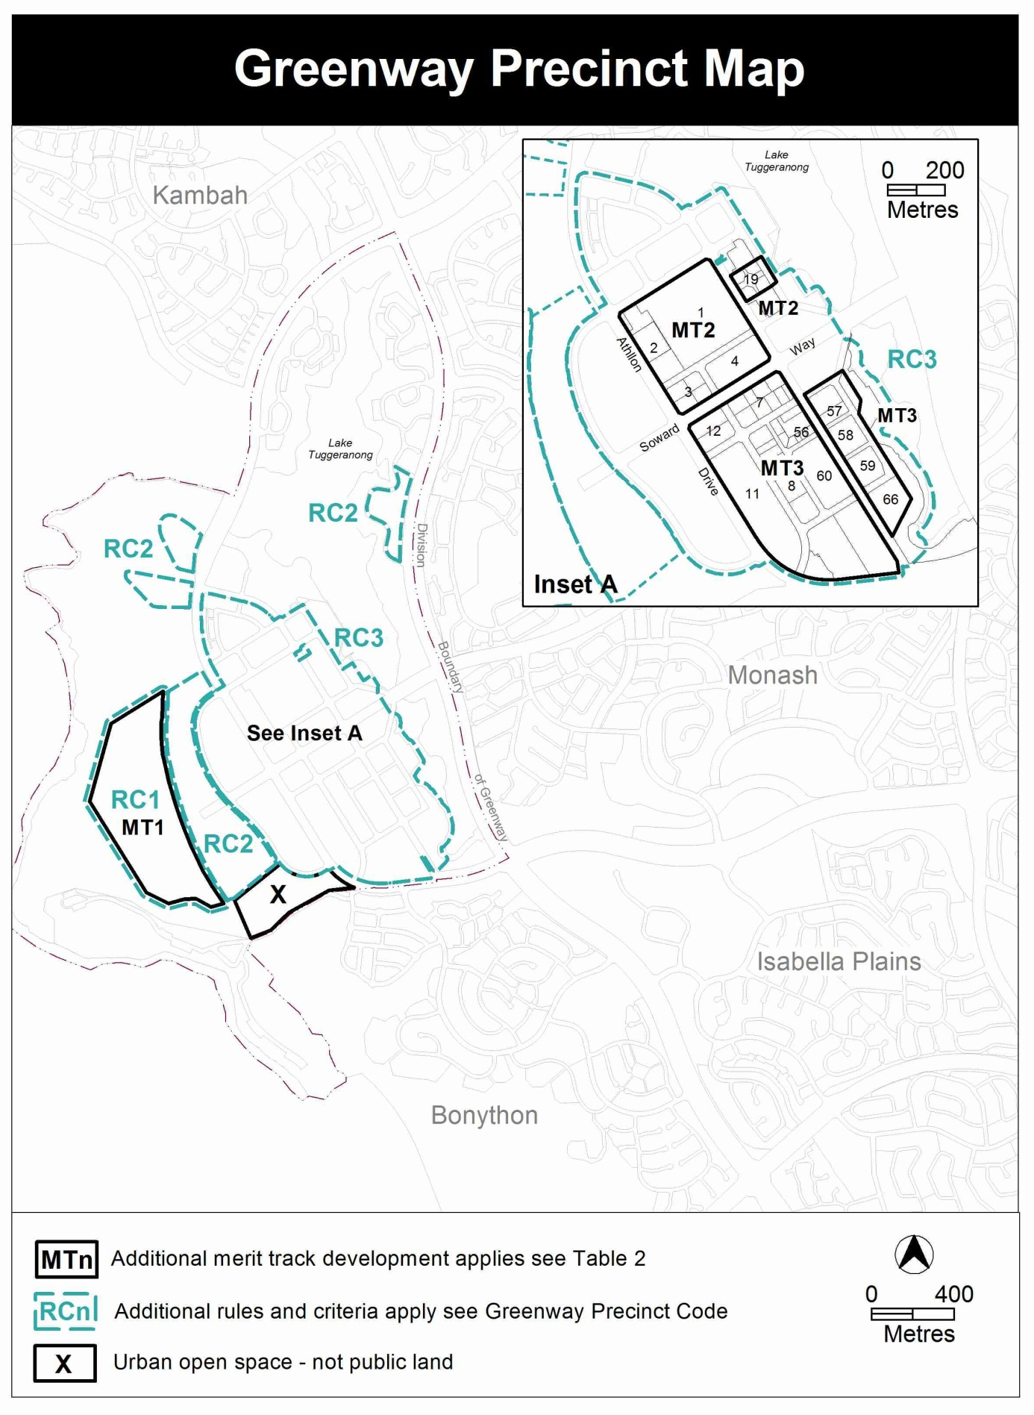

The current map is substituted with the map below to better define the functional edge of the Tuggeranong Town Centre.

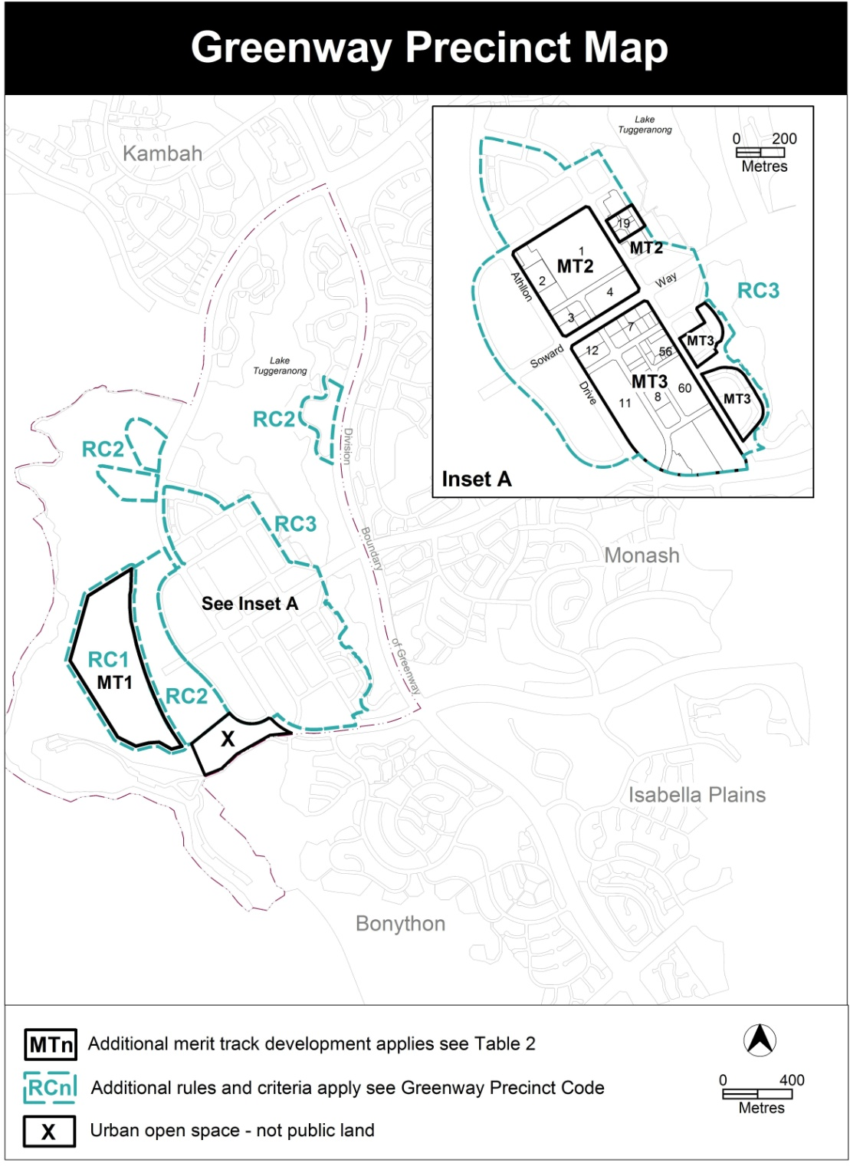

    - Changes to Figure 1 in the Greenway Precinct Code
Figure 1 currently provides:
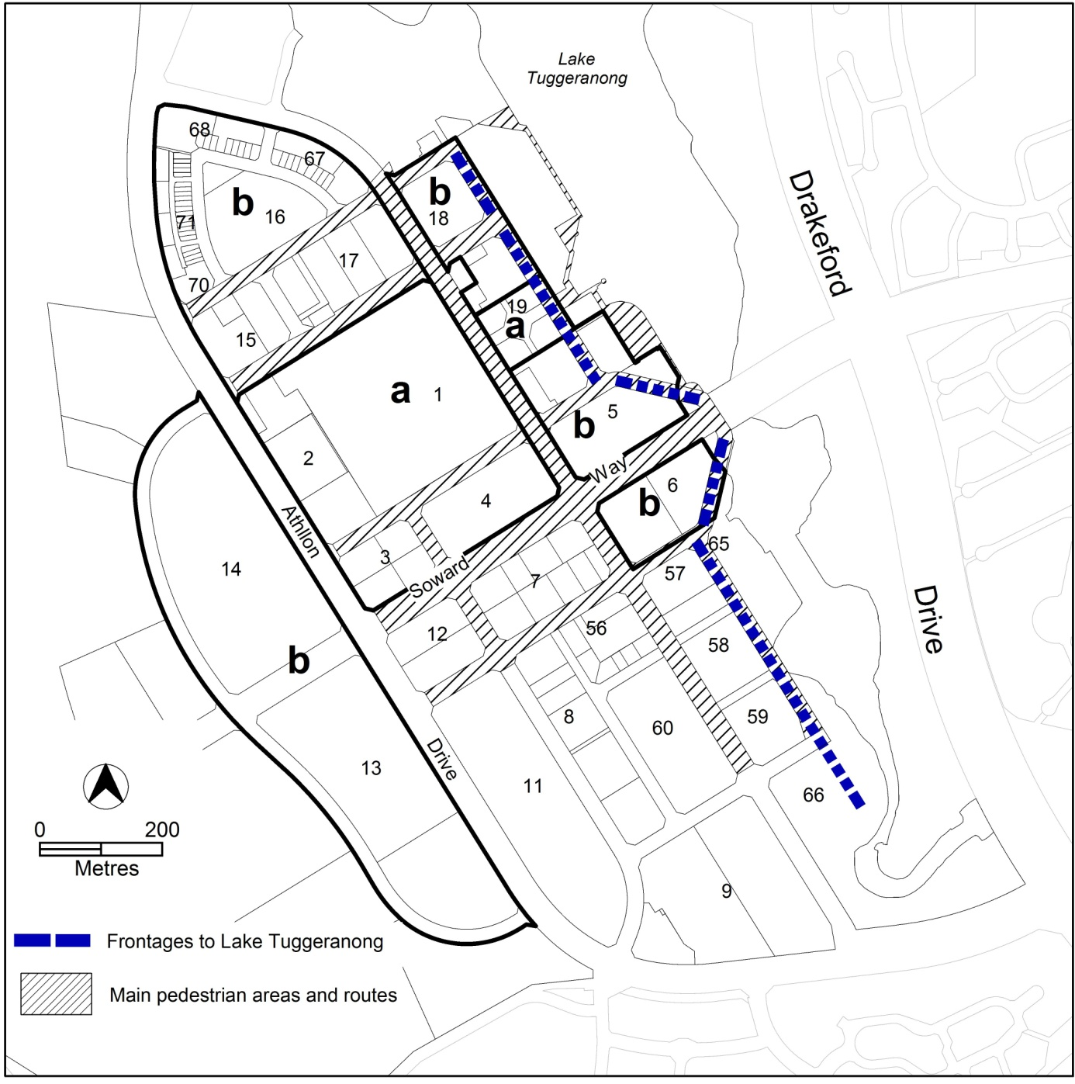

The elements indicating frontages to Lake Tuggeranong, and main pedestrian areas and routes are changed to correspond with the edge of Lake Tuggeranong south east of Soward Way (opposite Bunnings). Some of the cadastral boundaries are adjusted south east of Soward Way to better define the functional edge of the town centre. The proposed figure is as follows:

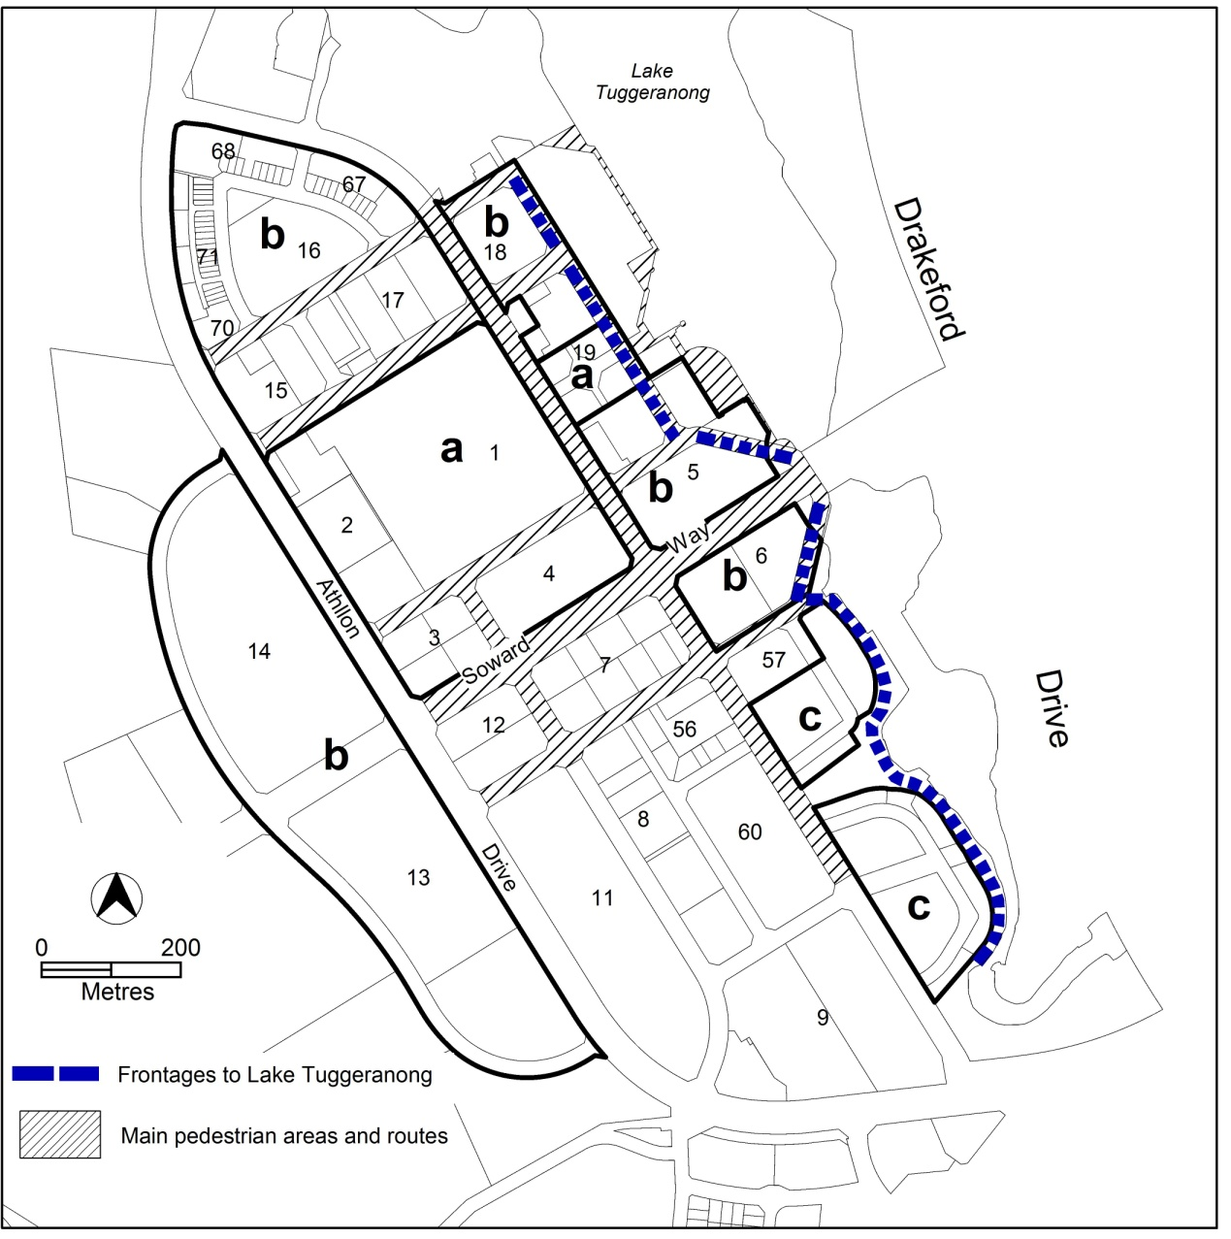

    - Building heights in Tuggeranong Town Centre CZ3 – Lakeside Development Area
The Town Centres Development Code currently provides for buildings up to 2 storeys in the CZ3 zone. If consistency with the desired character of the area can be demonstrated, higher buildings may be allowed through the application of the associated criterion. The Tuggeranong Town Centre Master Plan defines the desired character of the lakeside precinct, notably in relation to building heights. The maximum building height in the Lakeside Development Area (area c shown on figure 1) is increased consistent with recommendations of the master plan.
Accordingly, the following figure, rule and criterion are added to the Greenway Precinct Code:

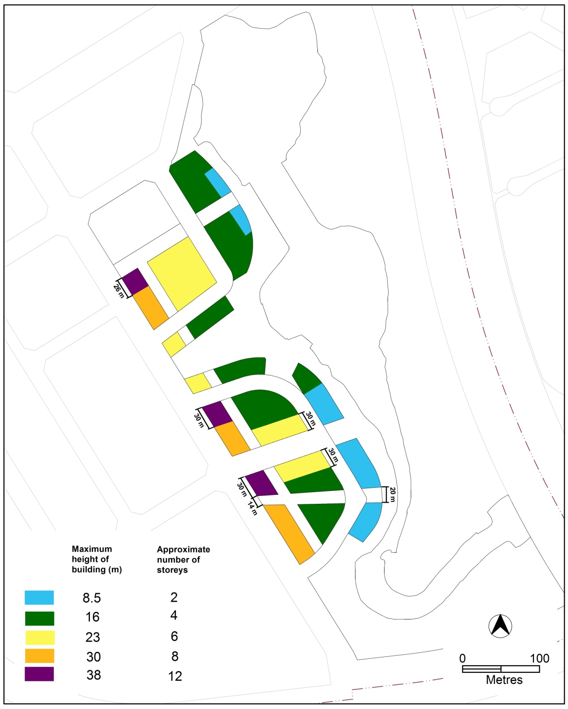
Figure 2 Building Heights – Lakeside Development Area

Rules | Criteria
5.1 Height of Buildings
R9A  This rule applies to area c shown on figure 1.  The maximum height of building is shown on figure 2. | C9A  Buildings achieve all of the following:  - consistency with the desired character  - scale appropriate to the function of the use  - minimal detrimental impacts including overshadowing and excessive scale.  Compliance with this criterion will be demonstrated through drawings and documentation including, but not restricted to the documentary requirement associated with the rule.

Compliance with the Planning and Development Act 2007
Section | Statement
s87(b) a variation (a code variation) that –  - would only change a code  - is consistent with the policy purpose and policy framework of the code; and  - is not an error variation. | Compliant.

- TECHNICAL AMENDMENT
  - Section 13 - Definitions
- Part A – Definitions of Development – Road

omit

- Part B – Definitions of Terms – Road

insert
Road means any way or street (so called), whether in existence or under reserve, open to the public which is provided and maintained for the passage of vehicles, persons and animals and which may include footpaths, community paths, bus lay-bys and turning areas, or traffic controls.

- Part A – Definitions of Development – Major road

insert
in the column headed “Development” without association with the “Umbrella Term” MAJOR UTILITY INSTALLATION,
Major road means a road that is an arterial road, parkway, highway, or the like and any road identified within the transport services zone.

- Part A – Definitions of Development – Umbrella Term – MAJOR UTILITY INSTALLTION

omit
from the column headed “Development” associated with the “Umbrella term” MAJOR UTILITY INSTALLATION,
Major road

- Part A – Definitions of Development – Minor road

insert
in the column headed “Development”
Minor road means a road other than a major road.

- Part A – Definitions of Development – Minor use

substitute
Minor use means the use of land for a purpose that is incidental to the use and development of land in the zone and includes but is not limited to open space; public car parking; community path systems; minor service reticulation; other utility services that do not exclude other uses from the land; street furniture and the like.

- Part A – Definitions of Development – COMMUNITY USE - Child care centre

substitute
Child care centre means the use of land for the purpose of educating, supervising or caring for children of any age throughout a specified period of time in any one day, which is registered under the Children and Young People Act 2008 or authorised pursuant to the Education and Care Services National Law (ACT) Act 2011 and which does not include residential care.

- Part A – Definitions of Development – Mining industry

substitute
Mining industry means an industry, not being a light, general, hazardous or offensive industry, which extracts minerals, coal, oil, gas or construction materials by such processes as underground or open-cut mining, quarrying, dredging, the operation of wells or evaporation pans, or by recovery from ore dumps or tailings, and includes primary processing operations carried out at or near mine sites as an integral part of the mining operation and works to rehabilitate the site.

- Section 13 – Part A – Definitions of Development – Residential care accommodation – common terminology

omit
special dwelling, retirement village

  - Zone development tables
- All zone development tables

omit
the term “road” wherever appearing.

- All zone development tables

insert
the term “minor road” in the merit track assessment list in every zone development table.

- All zone development tables – other than TSZ1 – major road

insert
the term “major road” in the same list containing the term “MAJOR UTILITY INSTALLATION” in every relevant zone development table.

- Zone development tables – TSZ1 – major road

insert
the term “major road” in the merit track assessment list in the zone development table.

  - Residential Zones – Single Dwelling Housing Development Code
- Part B, Element 2 – Building and Site Controls, R20C

substitute
Rules | Criteria
2.9 Noise attenuation – external sources
R20C  Where a block has one or more of the following characteristics:  - identified in a precinct code as being potentially affected by noise from external sources  - adjacent to a road carrying or forecast to carry traffic volumes greater than 6,000 vehicles per day  - located in a commercial zone  - located within 50m of a commercial zone.  Dwellings shall be constructed to comply with the relevant sections of all of the following:  - AS/NZS 2107:2000 - Acoustics – Recommended design sound levels and reverberation times for building interiors (the relevant satisfactory recommended interior design sound level)  - AS/NZS 3671 - Acoustics – Road Traffic Noise Intrusion Building Siting and Design.  For other than road traffic noise, compliance with this rule is demonstrated by a noise management plan prepared by a member of the Australian Acoustical Society with experience in the assessment of noise, and endorsed by the EPA. For other than road traffic noise, the noise level immediately adjacent to the dwelling is assumed to be the relevant noise zone standard specified in the ACT Environment Protection Regulation 2005.  For road traffic noise, compliance with this rule is demonstrated by an acoustic assessment and noise management plan, prepared by a member of the Australian Acoustical Society with experience in the assessment of road traffic noise, and endorsed by the Transport Planning & Projects Section in ESDD.  Note: A condition of development approval may be imposed to ensure compliance with the endorsed noise management plan. | This is a mandatory requirement. There is no applicable criterion.

  - Residential Zones - Multi Unit Housing Development Code
- Part A(1), Element 2: Building and site controls, Section 2.4: Plot ratio

insert
Rules | Criteria
R8b*  For dual occupancy housing, on a standard battleaxe block, the maximum plot ratio does not exceed the calculation determined by the following formula:  P = (140/B + 0.15) x 100  Where:  P is the maximum permissible plot ratio expressed as a percentage  B is the site area in square metres, and excludes the area of any access driveway or right-of-way. | This is a mandatory requirement. There is no applicable criterion.

- Part C(3), Element 5: Amenity, R156

substitute
Rules | Criteria
5.6 Noise attenuation – external sources
R156  Where a block has one or more of the following characteristics:  - identified in a precinct code as being potentially affected by noise from external sources  - adjacent to a road carrying or forecast to carry traffic volumes greater than 6,000 vehicles per day  - located in a commercial zone.  Dwellings shall be constructed to comply with the relevant sections of all of the following:  - AS/NZS 2107:2000 - Acoustics – Recommended design sound levels and reverberation times for building interiors (the relevant satisfactory recommended interior design sound level)  - AS/NZS 3671 - Acoustics – Road Traffic Noise Intrusion Building Siting and Design.  For other than road traffic noise, compliance with this rule is demonstrated by a noise management plan prepared by a member of the Australian Acoustical Society with experience in the assessment of noise, and endorsed by the EPA. For other than road traffic noise, the noise level immediately adjacent to the dwelling is assumed to be the relevant noise zone standard specified in the ACT Environment Protection Regulation 2005.  For road traffic noise, compliance with this rule is demonstrated by an acoustic assessment and noise management plan, prepared by a member of the Australian Acoustical Society with experience in the assessment of road traffic noise, and endorsed by the Transport Planning & Projects Section in ESDD.  Note: A condition of development approval may be imposed to ensure compliance with the endorsed noise management plan. | This is a mandatory requirement. There is no applicable criterion.

- Part C(5), Element 5: Amenity, R228

substitute
Rules | Criteria
5.5 Noise attenuation – external sources
R228  Where a block has one or more of the following characteristics:  - identified in a precinct code as being potentially affected by noise from external sources  - adjacent to a road carrying or forecast to carry traffic volumes greater than 6,000 vehicles per day  - located in a commercial zone  - located within 50m of a commercial zone.  Dwellings shall be constructed to comply with the relevant sections of all of the following:  - AS/NZS 2107:2000 - Acoustics – Recommended design sound levels and reverberation times for building interiors (the relevant satisfactory recommended interior design sound level)  - AS/NZS 3671 - Acoustics – Road Traffic Noise Intrusion Building Siting and Design.  For other than road traffic noise, compliance with this rule is demonstrated by a noise management plan prepared by a member of the Australian Acoustical Society with experience in the assessment of noise, and endorsed by the EPA. For other than road traffic noise, the noise level immediately adjacent to the dwelling is assumed to be the relevant noise zone standard specified in the ACT Environment Protection Regulation 2005.  For road traffic noise, compliance with this rule is demonstrated by an acoustic assessment and noise management plan, prepared by a member of the Australian Acoustical Society with experience in the assessment of road traffic noise, and endorsed by the Transport Planning & Projects Section in ESDD.  Note: A condition of development approval may be imposed to ensure compliance with the endorsed noise management plan. | This is a mandatory requirement. There is no applicable criterion.

- Part D, Element 1: Restrictions on use, R258

substitute
Rules | Criteria
1.5 Boarding House, Child Care Centre, Community Activity Centre and Residential Care Accommodation
R258  These uses are permitted only where:  - there is a maximum of 1 of these uses per section  - on a standard block (or a block resulting from the consolidation of these blocks), the maximum plot ratio is 35%  Exception: These rules are not applicable to childcare centres in Belconnen, Section 55, Block 37, Section 66, Section 67, Block 3, and part Block 2, and Section 88, part Block 1. | C258  To protect the amenity of the areas by restricting the agglomeration of non residential activities and to ensure that the development is of a compatible scale with surrounding residential development.

- Part D, Element 1: Restrictions on use, R260

substitute
Rules | Criteria
1.6 Supportive Housing
R260  All dwellings for the purpose of supportive housing are designed to comply with Class C of Australian Standard AS4299 – Adaptable Housing and any relevant considerations in the Access and Mobility General Code. | This is a mandatory requirement. There is no applicable criterion.

  - Community Facility Zone Development Code

- General Development Controls – Element 1 Restrictions on Use, R3, R4 and R5

substitute the term “surplus ACT Government owned building” with “surplus former ACT Government building”.

  - Northbourne Avenue precinct code

- Part A(5), Element 2: Building and Site Controls, section 2.1

substitute
Rules | Criteria
2.1 Height
R10  This rule applies to front boundaries that are adjacent to residential zones.  Within 20m of the front boundary the maximum building height is 12m. | C10  Buildings are compatible with the desired character of the adjacent residential zone.
There is no applicable rule. | C10A  This criterion applies to land where a lawfully erected building exceeds the maximum building height specified in the previous rule.  Rebuilding may be permitted provided all of the following are achieved:  - a building height no greater than the previous building  - consistency with the desired character of the adjacent residential zone  - no increase in the extent of shadow cast over any residential block.

- Part A(5), Element 2: Building and Site Controls, section 2.5

substitute
2.5 Front Setbacks – Buildings on Other Streets
R15  This rule applies to front boundaries that are adjacent to residential zones.  Front setbacks are as specified in Table 1. | C15  Front boundary setbacks achieve all of the following:  - consistency with the desired character  - reasonable amenity for residents  - sufficient space for street trees to grow to maturity.

- Part A(5), Element 2: Building and Site Controls, R16

omit

- Part B, Element 2: Building and Site Controls, section 2.1

substitute
2.1 Height
R21  For new buildings  - The minimum height of building is 3 storeys  - The maximum height of building is a horizontal plane 25m above datum ground level measured at the Northbourne Avenue front boundary  For this rule height of building excludes rooftop plant provided they are set back and screened. | This is a mandatory requirement. There is no applicable criterion.
R22  Any part of a building fronting Northbourne Avenue with more than 3 storeys has a parapet height as close as practicable to 25m.  For this rule the height of the parapet is measured from datum ground level at the Northbourne Avenue front boundary. | This is a mandatory requirement. There is no applicable criterion.
R22A  Despite the previous two rules rule, alterations or rebuilding up to the height of any lawfully erected building on the block is permitted. | This is a mandatory requirement. There is no applicable criterion.

- Part C, Element 2: Building and Site Controls, section 2.4

substitute
R26  This rule applies to buildings with more than three storeys.  Minimum side and rear setbacks are:  a) to any northern or southern boundary - 5m  b) to any western or eastern boundary - 10m  Note: These setbacks apply to the whole building, not just that part of the building over three storeys. | C26  Side and rear boundary setbacks achieve all of the following:  - consistency with the desired character  - reasonable amenity for residents
R26A  This rule applies to buildings with more than three storeys.  Buildings do not reduce the hours of direct sunlight between 9am–4pm to any habitable room in any adjoining residential or commercial accommodation developments to less than 2. | C26A  Reasonable solar access for adjoining residential or commercial accommodation developments is achieved.
R26B  This rule applies to buildings with more than three storeys on Lyneham section 50 block 24.  Despite any other rule in this element the minimum side and rear setbacks are:  - to the western boundary - 3m  - to the northern boundary - 4m  Note: These setbacks apply to the whole building, not just that part of the building over three storeys. | C26B  Side and rear boundary setbacks achieve all of the following:  - consistency with the desired character  - reasonable amenity for residents.

  - Inner North Precinct Code

- Part A, Element 2: Building and Site Controls, R13

substitute
R13  Site coverage in the rear zone does not exceed 30%.  This rule does not apply to:  - Braddon Sections 15, 16, 58 and 59  - O’Connor Section 40  - Lyneham Section 46 Block 1 and 2.  Note: A basement structure that projects into the Rear Zone is included in calculations of site coverage. | C13  This criterion applies only to a site where at least one regulated tree is proposed to be retained within the primary building zone. In all other cases the rule is mandatory.  Sufficient space on the block is provided to retain or introduce large-canopy trees and create a treed backdrop to development.  Compliance with this criterion is demonstrated by a report from a suitably qualified person.  A regulated tree is defined under the Tree Protection Act 2005.

  - Beard Precinct Map

- Precinct Codes, Suburb Precinct Maps and Codes, Beard Precinct Map and Code, Beard Precinct Map, Assessment Tracks, Table 2,

Insert the following in the Development column, below incineration facility
industrial trades

  - Parking and Vehicular Access General Code

- 3.2 Commercial zones, 3.2.5 Schedules of parking provision rates for commercial zones, Schedule 2 – Parking rate provisions for commercial zones

insert
the following in the column headed CZ2 zones outside centres and Northbourne Avenue precinct for the row development: child care centres
As per community facility zone schedule

  - Bonner Concept Plan

- Bonner Concept Plan

omit

  - Greenway Precinct Map and Code

- Greenway Precinct Map

substitute
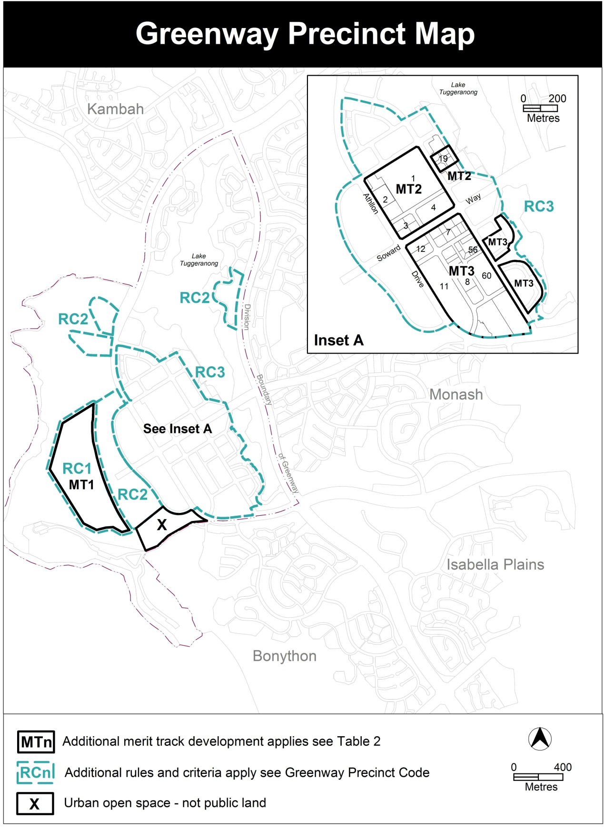
- Greenway Precinct Code, RC3 – Tuggeranong Town Centre

Substitute Figure 1
Figure 1

Insert
Figure 2 Building heights – Lakefront Development Area

- Greenway Precinct Code, RC3 – Tuggeranong Town Centre, Element 5: Buildings

insert after R9

R9A  This rule applies to area c shown on figure 1.  The maximum height of building is shown on figure 2. | C9A  Buildings achieve all of the following:  - consistency with the desired character  - scale appropriate to the function of the use  - minimal detrimental impacts including overshadowing and excessive scale.

Interpretation service
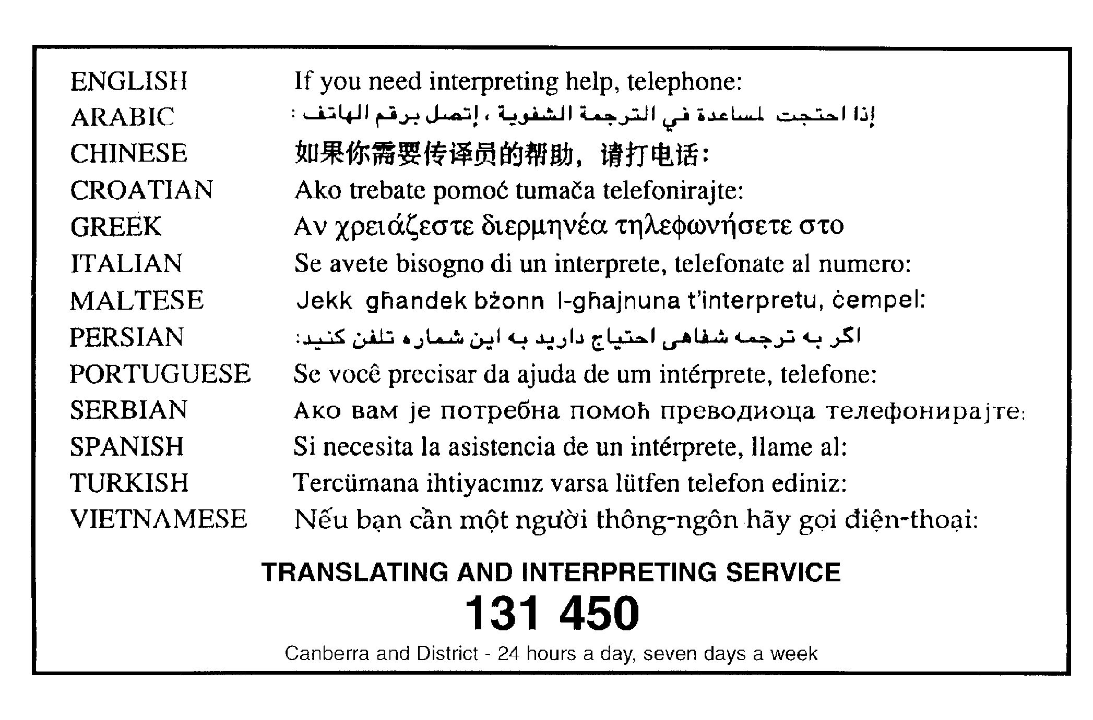

Virgin excavated natural material (eg clay, gravel, sand, soil and rock) that is not mixed with any other waste and that: (a) has been excavated from areas that are not contaminated, as a result of industrial, commercial, mining or agricultural activities, with manufactured chemicals and that does not contain sulphidic ores or soils, or (b) consists of excavated natural materials that may be approved by the EPA.

