Australian Capital Territory
Planning and Development (Draft Variation No 313) Consultation Notice 2012*

Calvary Hospital Car Parking
Notifiable instrument NI2012—99
Made under the
Planning and Development Act 2007, section 63 (Public consultation—notification) and section 64 (Public consultation—notice of interim effect etc)

Draft Variation 313 to the Territory Plan (see Annexure A) proposes to change the zoning of Bruce, section 110 block 1 (part) from NUZ3 hills, ridges and buffer zone to CFZ community facility zone. The proposed variation will enable the formalisation of car parking to service the Calvary Hospital and on-site facilities.
Written comments from the public are invited by COB Monday 16 April 2012.

Comments should include reference to the draft variation, your name and contact details and be:
- emailed to terrplan@act.gov.au
- mailed to Territory Plan Comments, Environment and Sustainable Development Directorate GPO Box 1908, Canberra, ACT 2601, or
- delivered to ESDD’s Customer Service Centre at the above address

Comments received will be made available for public inspection for a period of no less than 15 business days at ESDD’s customer service centre in Dickson the day after the closing date for submissions and on ESDD’s website 10 business days after the closing date for submissions.

Comments made available will include personal contact details unless excluded under section 411 of the Planning and Development Act. A request for exclusion under section 411 must be in writing and clearly identify what you are seeking to exclude and how the request satisfies the exclusion criteria.
The draft variation does not have interim effect and therefore section 65 of the Planning and Development Act does not apply. The current Territory Plan will continue to apply while the variation remains in draft form.

Ben Ponton
Delegate of the ACT Planning and Land Authority
27 February 2012

Planning & Development Act 2007

Draft Variation to the
Territory Plan
313

Calvary Hospital Car Parking

Bruce, Section 110 Block 1 (part)
Change of zoning from non urban NUZ3 hills, ridges and buffer to CFZ community facility zone

March 2012

Table of Contents
1. INTRODUCTION 1
1.1 Summary of the Proposal 1
1.2 Outline of the process 1
1.3 This document 2
1.4 Public Consultation 2
2. EXPLANATORY STATEMENT 3
2.1 Background 3
2.2 Site Description 3
2.2.1 Current Territory Plan Provisions 4
2.3 Proposed Changes 6
2.3.1 Proposed Changes to the Territory Plan Map 6
2.4 Reasons for the Proposed Draft Variation 6
2.5 Planning Context 6
2.5.1 National Capital Plan 6
2.5.2 Territory Plan 7
2.5.3 Planning Strategy for the ACT 7
2.6 Interim Effect 8
2.7 Consultation with Government Agencies 8
3. DRAFT VARIATION 11
3.1 Variation to the Territory Plan Map 11

- INTRODUCTION
  - Summary of the Proposal
The intention of the draft variation is to change the zone of the land from the non urban NUZ3 hills, ridges and buffer to the CFZ community facility zone to recognise the role of the site for car parking purposes for Calvary Hospital and other on-site uses.

  - Outline of the process
The Commonwealth’s Australian Capital Territory (Planning and Land Management) Act 1988 allows for the Legislative Assembly to make laws to establish a Territory Planning Authority and for that Authority to prepare and administer a Territory Plan. The Planning and Development Act 2007 (the Act) establishes the ACT Planning and Land Authority (ACTPLA) as the Authority which prepares and administers the Territory Plan, including continually reviewing and proposing amendments as necessary.

The Territory Plan is comprised of the written statement and a map. The written statement contains a number of parts, namely Governance; Strategic Directions; Zones; Precinct Codes; General Codes; Overlays; Definitions; Structure Plans, Concept Plans and Development Codes for Future Urban Areas.

The Territory Plan Map graphically represents the applicable land use zones (under the categories of Residential, Commercial, Industrial, Community Facility, Urban Parks and Recreation, Transport and Services and Non Urban), precincts and overlays. The zone, precinct and overlay requirements are detailed in the volumes of the Territory Plan.

Draft variations to the Territory Plan are prepared in accordance with the Act. Following the release of the draft variation under section 63 of the Act, submissions from the public are invited.

At the conclusion of the consultation period the ACTPLA submits a report on consultation and a recommended final variation to the Minister for Environment and Sustainable Development for approval. The Minister has the discretion to determine if referral to the Legislative Assembly Standing Committee on Planning, Public Works and Territory and Municipal Services is warranted prior to approval, depending on the nature and significance of the proposal.

If the draft variation is referred to the Committee by the Minister or otherwise, the Minister must consider the findings of the Committee before deciding whether to approve the draft variation.

If the Minister approves the variation, the variation and associated documents will be tabled in the Legislative Assembly. Unless disallowed by the Legislative Assembly within five sitting days, the variation commences on a day nominated by the Minister.
This document
This document contains the background information in relation to the proposed variation. It comprises the following parts
- Part 1 - This Introduction
- Part 2 - An Explanatory Statement, which gives reasons for the proposed variation and describes its effect
- Part 3 - The Draft Variation, which details the precise changes to the Territory Plan that are proposed

  - Public Consultation
Comments from the public are invited on the draft variation. Subject to consideration of responses received, ACTPLA proposes to submit this draft variation to the Minister for Environment and Sustainable Development in accordance with the Act.

The draft variation and background documents relating to this draft variation are available online at www.environment.act.gov.au until the closing date for written comments. Printed copies of the draft variation are available for inspection and purchase at the Environment and Sustainable Development Customer Service Centre, 16 Challis Street, Dickson, Monday to Friday between 8:30am and 4:30pm. Please call 6207 1923 to arrange a copy for purchase.

Written comments from the public are invited on the draft variation by COB Monday 16 April 2012.

Comments should include reference to the draft variation, a return postal address, and be addressed Territory Plan Variation Unit, Territory Plan Variation and Implementation Section.

Comments can be:
- emailed to terrplan@act.gov.au
- mailed to Territory Plan Comments, GPO Box 1908, Canberra, ACT 2601
- delivered to ESDD’s customer service centre at the above address

Comments received will be made available for public inspection (unless exempted under section 411 of the Act) for a period of no less than 15 business days at ESDD’s customer service centre in Dickson the day after the closing date for submissions and on ACTPLA’s website 10 business days after the closing date for submissions.

Comments made available will include personal contact details unless excluded under section 411 of the Planning and Development Act 2007. A request for exclusion under s411 must be in writing and clearly identify what you are seeking to exclude and how the request satisfies the exclusion criteria.

- EXPLANATORY STATEMENT
  - Background
In 2004 Calvary Health Care ACT commenced formal assessments of both existing and future requirements for car parking facilities at the Calvary Hospital. It was found that the demand for parking exceeded supply and more spaces would be required to accommodate future development of the site. To address this problem, a number of options were proposed which included off-site locations for provision of car parking facilities.

Calvary Health Care ACT subsequently prepared a planning study to consider the merits of a proposed variation to the Territory Plan to rezone a small portion of adjoining land on the northern boundary of the Hospital. It is estimated that this area can accommodate approximately 100 car spaces.

The proposed site comprises an area of approximately 4,335m² and is currently zoned non urban NUZ3 hills, ridges and buffer. A car park is more appropriately located in the community facility zone, hence the proposed rezoning.

The proposed site is currently unleased Territory land. The ACT Government has agreed to the direct sale of this land to Calvary Health Care Pty Ltd, subject to the outcome of the draft variation.

  - Site Description
The site proposed for rezoning is located at Bruce section 110 block 1 (part) (Figure 1).

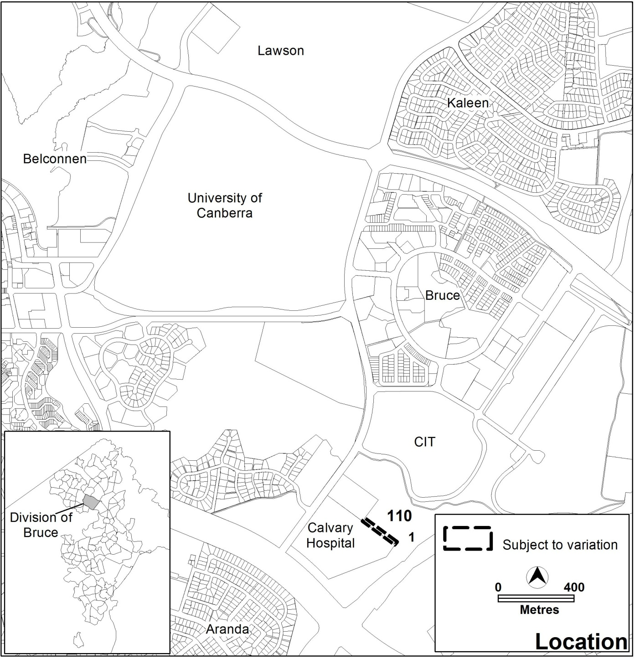
Figure 1 Site location

    - Current Territory Plan Provisions
The Territory Plan map zone for the area subject to this variation is shown in Figure 2. The site is located within the Canberra Nature Reserve with the hospital located on the adjoining southern and western sides.

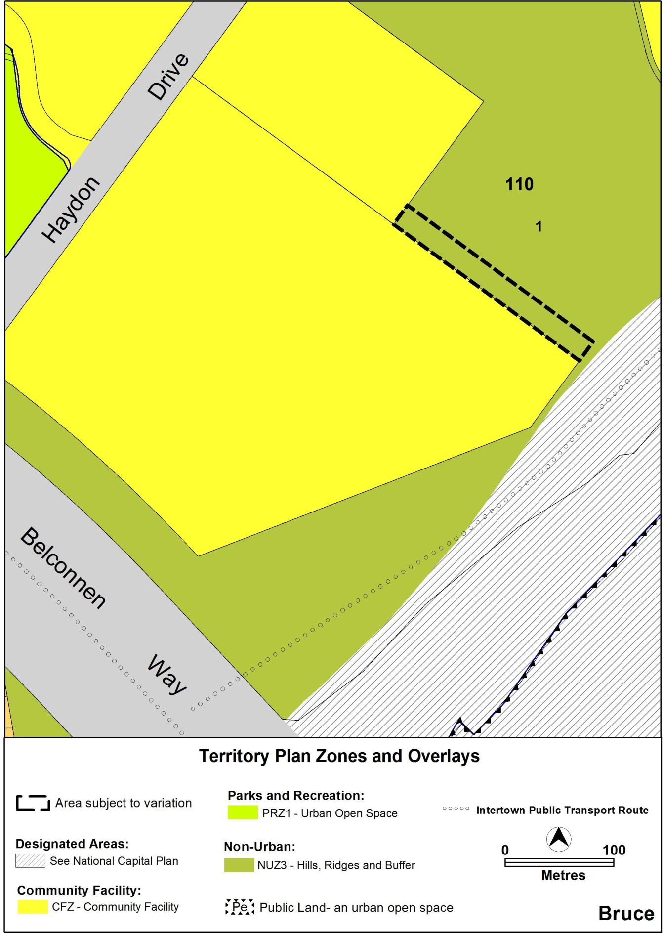
Figure 2 Current Territory Plan map

  - Proposed Changes
    - Proposed Changes to the Territory Plan Map
The proposed changes to the Territory Plan map are indicated in Figure 3 at Part 3 of this document and consist of rezoning Bruce section 110 block 1 (part) from the non urban NUZ3 hills, ridges and buffer to the CFZ community facility zone.
The draft variation map indicates the proposed zone boundaries as accurately as possible but may be subject to adjustments following detailed surveys.

  - Reasons for the Proposed Draft Variation
The reasons for the proposed rezoning are presented in detail in the planning report and are summarised as follows:

- The proposal seeks to ensure adequate and formalised car parking for uses within the community facility zone, enabling convenient access to the on-site facilities.

- In recent years, new facilities have been developed at Calvary which has generated greater demand for car parking.

- The first objective of the community facility zone is the most relevant to the proposal:
Ensure that adequate sites are available to meet community needs for community services and facilities in appropriate and convenient
locations, close to public transport routes and other community
facilities

- Formalising the car parking will have a relatively low ecological impact, especially since the area has been largely disturbed by informal parking over an extended period of time.

- The planning study has considered the requirements for a formalised car park, which include appropriate layout, access, security, landscaping, safe pedestrian movement and lighting.

  - Planning Context
    - National Capital Plan
The Australian Capital Territory (Planning and Land Management) Act 1988 established the National Capital Authority (NCA) with two of its functions being to prepare and administer a National Capital Plan (NCP) and to keep the NCP under constant review and to propose amendments to it when necessary.
The NCP, which was published in the Commonwealth Gazette on 21 January 1990 is required to ensure that Canberra and the Territory are planned and developed in accordance with their national significance. The Planning and Land Management Act 1988 also required that the Territory Plan is not inconsistent with the NCP.

    - Territory Plan
The Statement of Strategic Directions sets out the principles for giving effect to the main objectives of the Territory Plan as required by the Planning and Development Act 2007. The proposal supports the following key principles in the strategic directions:

1.17 In planning future development and redevelopment , particular emphasis will be placed on cost-effective provision and
management of existing and new infrastructure and services, taking
into account whole-of-life and whole-of-system costs, including the
ecological footprint of proposed developments and activities.

1.22 Urban development will be planned in a manner that promotes community vitality and safety, applying principles of crime
prevention through environmental design. Provision will also be
made for emergency services infrastructure necessary to ensure a
high standard of safety for residents and visitors.

2.13 Clearance zones will be established where necessary around major facilities to protect the operational efficiency of those facilities and
to minimise adverse environmental impacts.

    - Planning strategy for the ACT

The Canberra Spatial Plan and Sustainable Transport Plan comprise the current planning strategy under the Planning and Development Act 2007. On 17 October 2011, a draft planning strategy was released on public consultation. The existing planning strategy remains in place until the revised planning strategy has been finalised.

      - Canberra spatial plan
The Spatial Plan outlines the strategic direction for growth to achieve social, environmental and economic sustainability for Canberra. One of the Plan’s objectives is to facilitate the equitable distribution of services and facilities, including education and healthcare, arts and recreational facilities.

The need to ensure better services and facilities at Calvary Hospital, including improved parking provision, is consistent with the Canberra Spatial Plan.

      - Sustainable Transport Plan
The Canberra Spatial Plan is integrated with the Sustainable Transport Plan and seeks to achieve a more sustainable transport system for Canberra over the next 25 years. This plan establishes the framework for a more sustainable transport system that retains high levels of accessibility to essential services.

Better public transport access to Calvary Hospital through improvements to the bus system is consistent with the aims of the Sustainable Transport Plan, and may help to reduce parking pressures at the Hospital in the longer term. However, it will not address the immediate parking needs.

  - Interim Effect
The draft variation does not have interim effect and therefore section 65 of the Act does not apply. The current Territory Plan will continue to apply while the variation remains in draft form.

  - Consultation with Government Agencies
ACTPLA is required to, in preparing a draft variation under section 61(b) consult with each of the following in relation to the proposed draft variation
- the national capital authority
- the conservator of flora and fauna
- the environment protection authority
- the heritage council
- if the draft variation would, if made, be likely to affect unleased land or leased public land – each custodian for the land likely to be affected

National Capital Authority
The NCA provided the following comments on 7 November 2011:
Please note that the National Capital Authority has no objection to Draft Variation 313 proceeding. Block 1 Section 110 Bruce is within Urban Areas as illustrated in the National Capital Plan. The intended use of the land for car parking is not inconsistent with the principles and policies for Urban Areas.

Response

Noted.

Conservator of Flora and Fauna
The Conservator of Flora and Fauna made the following comments on 29 November 2011:
In accordance with Section 61(b) of the Planning and Development Act 2007, I advise that I have examined Draft Variation to the Territory Plan No.313 to change the zoning of part Block 1Section 110 Bruce from non urban NUZ3, Hills Ridges and Buffer, to CFZ, Community Facility Zone to legitimise an area used for overflow car parking at Calvary Hospital.
There are no significant biodiversity issues associated with this proposal as the area is already functioning as a car park, which has resulted in the destruction of virtually the entire understorey and a degradation of the health of trees through soil compaction. The variation can be supported provided the new boundary is fenced to ensure that no more illegal incursions can occur into the adjoining areas of high conservation values.

Response
The comments regarding a boundary fence have been referred to the Merit Assessment section of ESDD, for consideration at the development assessment stage.

Environment Protection Authority
The Environment Protection Authority provided the following comments on 28 November 2011:
The EPA has considered DV 313 and has no comment.

Response
Noted.

Heritage Council
The Heritage Council provided the following comments on 24 November 2011:
I refer to your electronic mail dated 4 November 2011 and associated documentation in relation to draft variation 313 to the Territory Plan for the Calvary Hospital car parking.
I understand that the intention of the draft variation is to change the zone of part of the land comprising Bruce Section 1I 0 Block 1, from the non urban NUZ3 hills, ridges and buffer, to the community facility zone for the purposes of recognising the role of the site for car parking.
I understand that a survey for the block was undertaken by Archaeological Heritage Surveys in 2004, satisfying the heritage requirements for heritage investigations in the specified area. I also understand that there is a low potential for heritage material within the proposed car park however the findings of that survey are considered to be current.
Consequently, the Heritage Council considers that the proposed change of zoning will not result in detrimental heritage impacts, and therefore does not raise any objection to the proposed draft variation 313 in its current form. However, it should be noted that an Anticipated and Unanticipated Discovery Protocol will be required to be submitted during development application for the project. The Heritage Unit can assist the proponent in drafting this document.

Response
Noted.

Land custodian
The land custodian made the following comments on 28 November 2011:
In response to Terrplan email 4 November 2011, TAMS has reviewed the Draft Variation to the Territory Plan 313 – Calvary Hospital and the Planning Report and can support the changes to the zone of part of the land as proposed.

Response
Noted.

- DRAFT VARIATION
  - Variation to the Territory Plan Map
The Territory Plan map is varied as indicated in Figure 3:
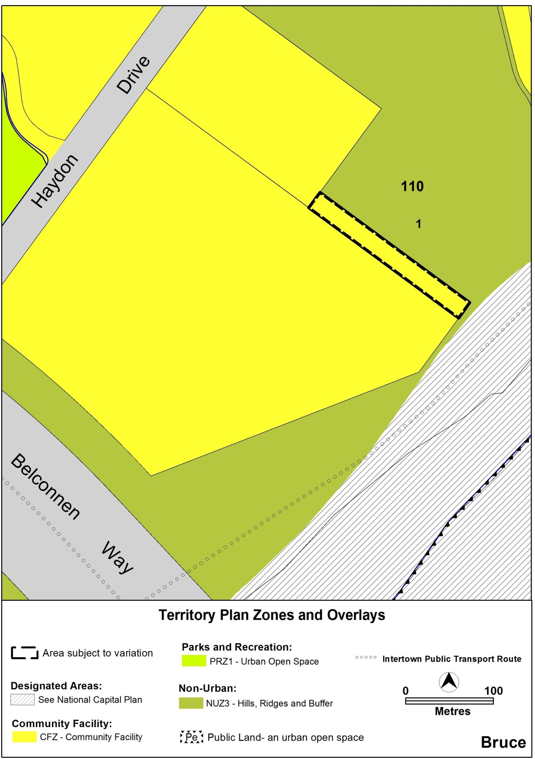

Figure 3 Proposed Territory plan map for the area subject to the variation

Interpretation service
