Australian Capital Territory

Planning and Development (Technical Amendment—Districts of Tennent and Booth) Plan Variation 2013 (No 1)*

Notifiable Instrument NI2013—124
Technical Amendment No 2012—40
made under the
Planning and Development Act 2007, section 89 (Making technical amendments) (s96A Rezoning – boundary changes)

This plan variation commences on the day after it is notified.

Variation No 2012—40 to the Territory Plan has been approved by the Planning and Land Authority.

Variation to the Territory Plan

The Territory Plan map is varied as indicated in Annexure A. The zones have been removed to give clarity to the map.

Jim Corrigan
Delegate of ACT Planning and Land Authority
18 March 2013

THIS IS PAGE ONE OF ANNEXURE A
TO NOTIFIABLE INSTRUMENT NI2013 – 124

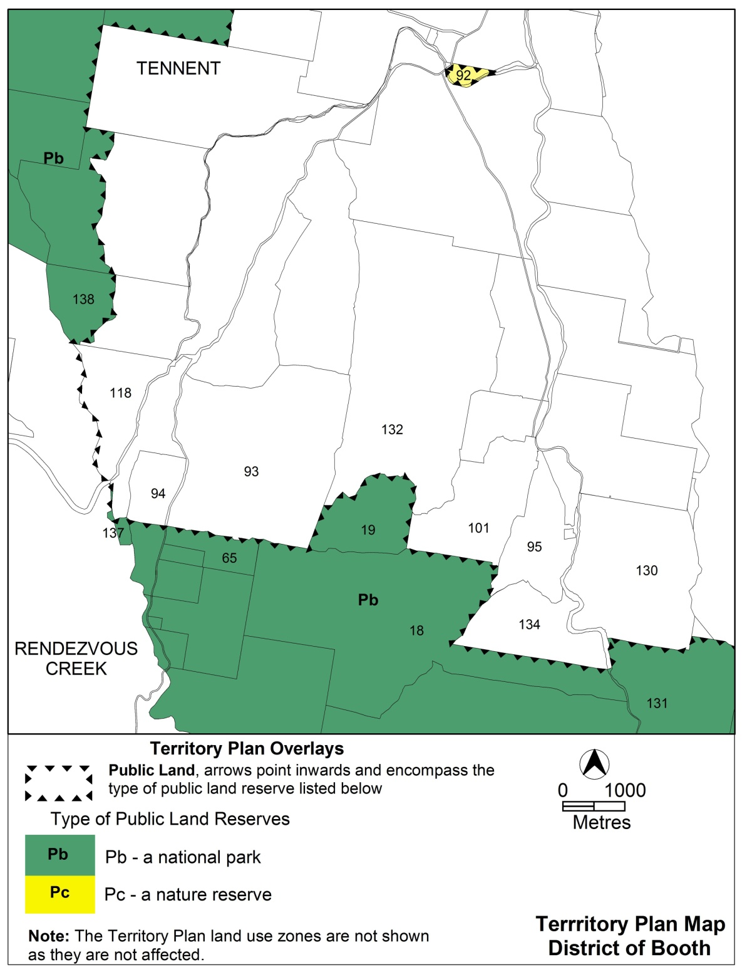

Jim Corrigan
Delegate of ACT Planning and Land Authority
18 March 2013
THIS IS PAGE TWO OF ANNEXURE A
TO NOTIFIABLE INSTRUMENT NI2013 – 124

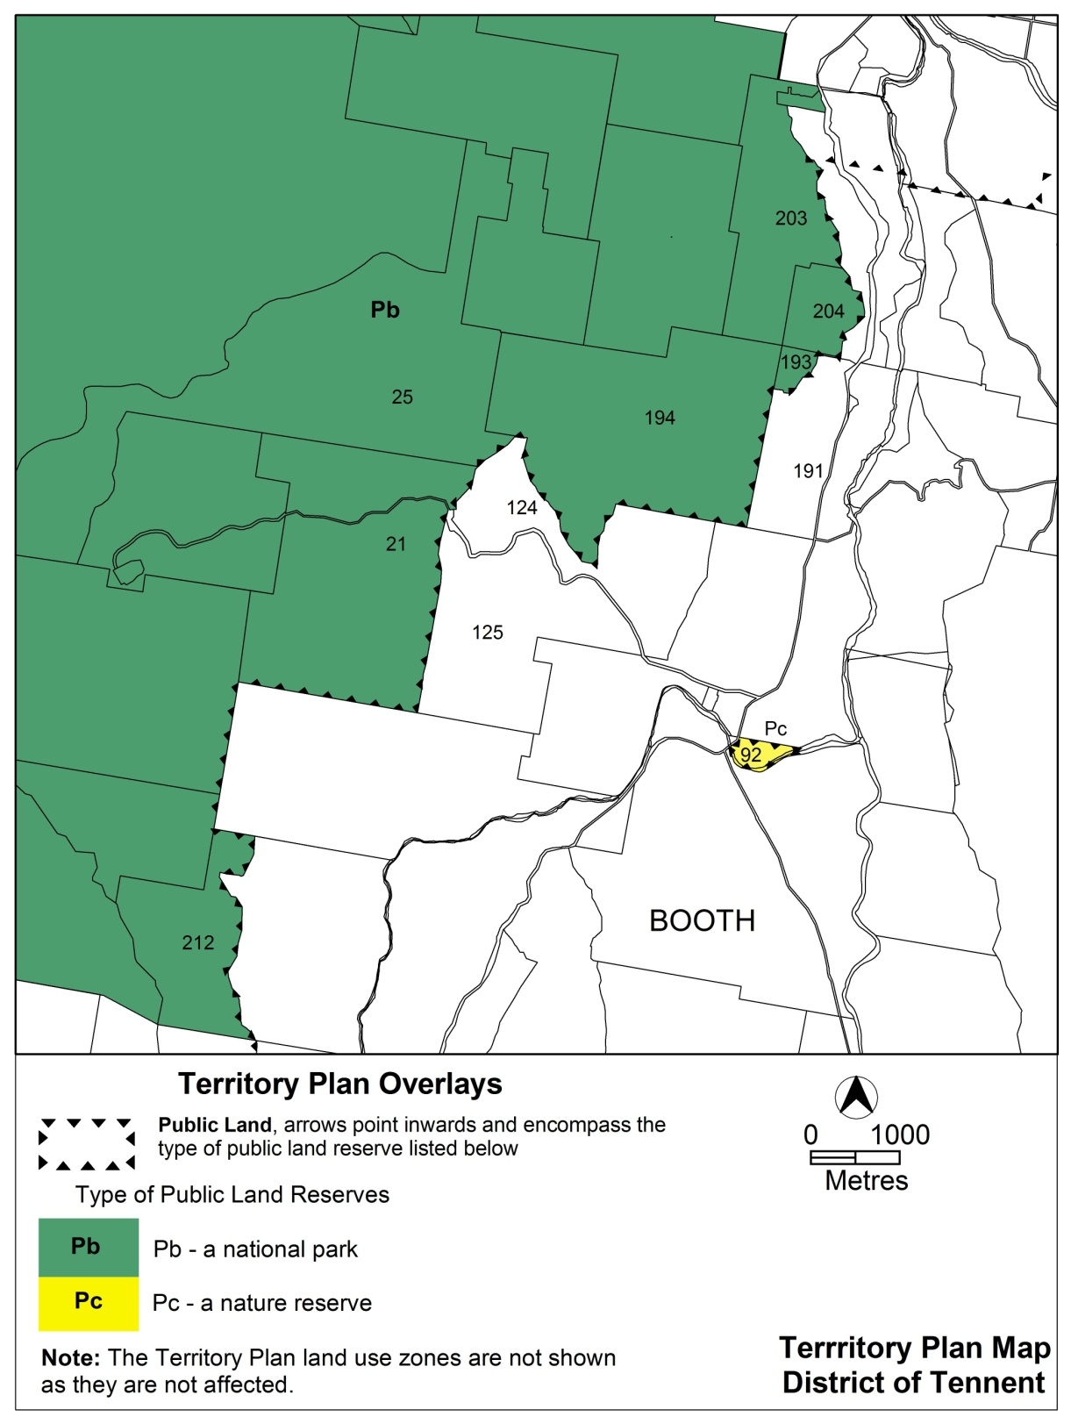

Jim Corrigan
Delegate of ACT Planning and Land Authority
18 March 2013

