Australian Capital Territory

Planning and Development (Technical Amendment—Ngunnawal) Plan Variation 2013 (No 1)*

Notifiable Instrument NI2013—146
Technical Amendment No 2013—04
made under the
Planning and Development Act 2007, section 89 (Making technical amendments) s96 (land ceases to be in future urban area)

This plan variation commences on the day after it is notified.

Variation No 2013—04 to the Territory Plan has been approved by the Planning and Land Authority.

Variation to the Territory Plan
The Territory Plan map is varied as indicated in Annexure A to identify the zones that apply to the land ceasing to be in a future urban area.

Variation to the Precinct Map and Code
Replace the Ngunnawal Precinct Map with Ngunnawal Precinct Map and Code as indicated in Annexure B to incorporate ongoing block specific provisions for the area.

Jim Corrigan
Delegate of the Planning and Land Authority
28 March 2013

THIS IS PAGE ONE OF ANNEXURE A
TO NOTIFIABLE INSTRUMENT NI2013 – 146

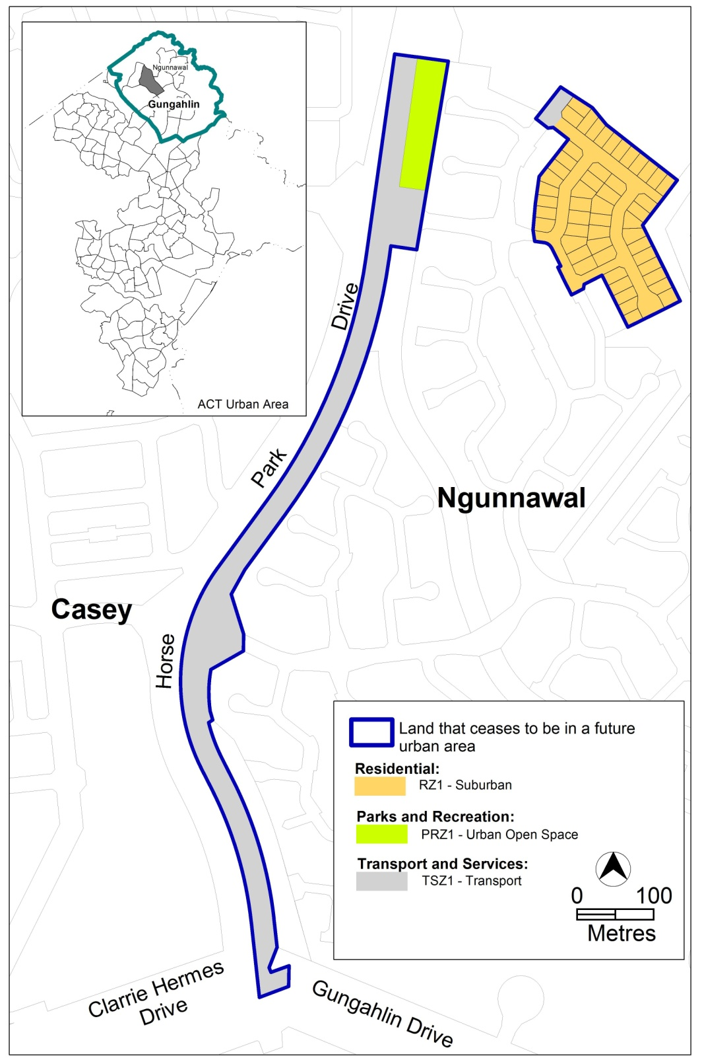

Jim Corrigan
Delegate of the Planning and Land Authority
28 March 2013
THIS IS PAGE ONE OF ANNEXURE B
TO NOTIFIABLE INSTRUMENT NI2013 – 146

Ngunnawal Precinct Map and Code

Jim Corrigan
Delegate of the Planning and Land Authority
28 March 2013

Annexure B

Ngunnawal Precinct Map and Code

This page is intentionally blank

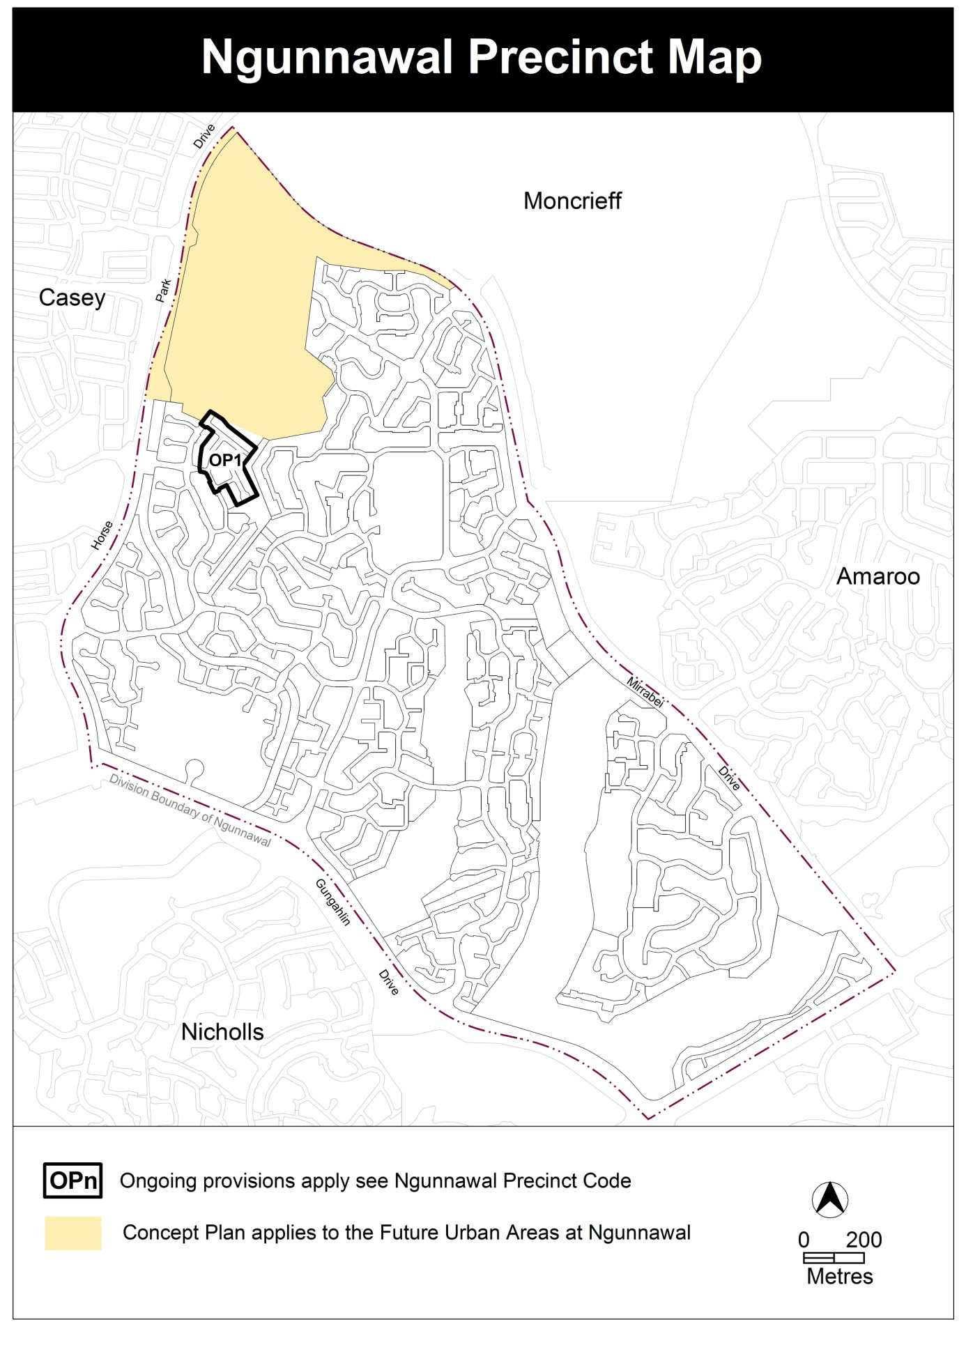

Assessment Tracks

No additional provisions apply

Ngunnawal Precinct Code

Contents
Introduction 2
Ongoing provisions 4
OP1 – Ngunnawal residential area 1 4

Figures
Figure 1 Ngunnawal residential area 1 4

Introduction
Name
The name of this code is Ngunnawal Precinct Code.
Application
The code applies to the Division of Ngunnawal.
Purpose
This code provides additional planning, design and environmental controls for specific areas or blocks and may also contain references to provisions in other codes.
In conjunction with other relevant codes it will be used by the Authority to assess development applications and offer guidance to intending applicants in designing development proposals and preparing development applications.
Structure
This code contains additional rules and/or criteria for particular blocks or parcels identified as areas RCn on the precinct map, to be read in conjunction with the relevant development code. It may also contain sub-parts.
Each element has one or more rules and, unless the respective rule is mandatory, each rule has an associated criterion. Rules provide quantitative, or definitive, controls. By contrast, criteria are chiefly qualitative in nature.
In some instances rules are mandatory. Such rules are accompanied by the words “This is a mandatory requirement. There is no applicable criterion.” Non-compliance with a mandatory rule will result in the refusal of the development application. Conversely, the words “There is no applicable rule” is found where a criterion only is applicable.
Code hierarchy
Under the Planning and Development Act 2007, where more than one type of code applies to a development, the order of precedence if there is inconsistency of provisions between codes is: precinct code, development code and general code.
If more than one precinct code applies to the site, the most recent precinct code takes precedence to the extent of any inconsistency.
Definitions
Defined terms, references to legislation and other documents are italicised.
Definitions of terms used in this code are listed in part 13 of the Territory Plan or, for terms applicable only to this code, associated with the respective rule.

Acronyms
ACTPLA Planning and Land Authority within the ACT Environment and Sustainable Development Directorate
EPA ACT Environment Protection Authority
ESA ACT Emergency Services Agency
ESDD ACT Environment and Sustainable Development Directorate
NCA National Capital Authority
P&D Act Planning and Development Act 2007
TAMS ACT Territory and Municipal Services Directorate

Ongoing provisions
This part applies to blocks and parcels identified as ongoing provisions (OPn) in the Ngunnawal Precinct Map. It should be read in conjunction with the relevant zone development code and related codes.
OP1 – Ngunnawal residential area 1
This part applies to blocks and parcels identified in area OP1 shown on the Ngunnawal Precinct Map.

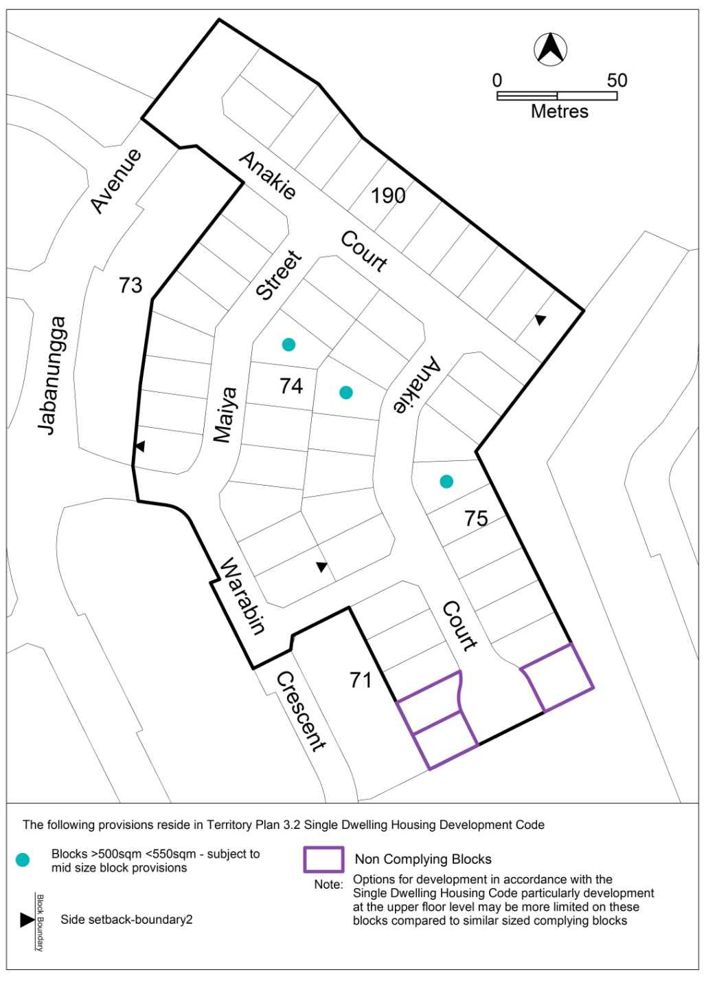
Figure 1 Ngunnawal residential area 1

