Australian Capital Territory

Planning and Development (Plan Variation No 311) Notice 2013
Notifiable Instrument NI2013–208
made under the

Planning and Development Act 2007, section 76(3)

1 Name of instrument
This instrument is the Planning and Development (Plan Variation No 311) Notice 2013.

2 Plan Variation No 311
On 29 April 2013 the Minister for the Environment and Sustainable Development approved the attached plan variation to the Territory Plan under s 76 (3).

Jim Corrigan
Delegate of the Planning and Land Authority
1 May 2013

Planning and Development Act 2007

Variation to the
Territory Plan No 311

Dickson Group Centre –
Amendments to the
Dickson precinct map and code
and zone changes together with the introduction of a Pe Public Land overlay

Final variation prepared under s76 of the
Planning and Development Act 2007

This page is intentionally blank.

Contents

1. EXPLANATORY STATEMENT 1
1.1 Background 1
1.2 Summary of the Proposal 1
1.3 The National Capital Plan 2
1.4 Site Description 2
1.5 Current Territory Plan Provisions 4
1.6 Changes to the Territory Plan 5
1.7 Consultation on the Draft Variation 5
1.8 Revisions to the Variation Recommended to the Minister 5
2. VARIATION 8
2.1 Variation to the Territory Plan 8
2.1.1 Variation to the map 8
2.1.2 Variation to the written document 9

This page is intentionally blank.

- EXPLANATORY STATEMENT
  - Background
The variation to the Territory Plan No 311 (V311) Dickson Group Centre implements the Dickson centre master plan, which is available at www.act.gov.au/dickson. The master plan was prepared by the planning and land authority, within the Environment and Sustainable Development Directorate (ESDD), following the completion of the Dickson centre urban planning and design framework, including community consultation during 2009 and 2010. The ACT Government endorsed the Dickson centre master plan in May 2011.

  - Summary of the Proposal
V311 varies the zoning of land at Dickson group centre, introduces a Pe public land overlay on part of a block and amends the Dickson precinct map and code. The changes include establishing new provisions to guide future development at the centre in a manner consistent with the master plan and rezoning the car park adjoining The Tradies Club.
The following changes to the Territory Plan were identified from the master plan:
- change the zone of an existing, sealed surface level car park
- nominate an area for an area of parkland where buildings would be restricted
- amend the Dickson precinct code to include planning controls on land use, design and siting of buildings, parking and amenity
The rezoning and precinct code make provision for the following:
- development of active uses (including retail and entertainment) at the ground floor level fronting the northern east to west pedestrian connection
- maintain active uses (including restaurants and entertainment) at the ground floor level in Woolley Street
- development of new road and laneway connections to ensure future development respects the centre’s existing road geometry
- new pedestrian connections across the centre to improve pedestrian flow and access
- increase to the height of buildings in many areas while protecting the scale and character of key precincts
- provide the opportunity for residential development on land adjoining pedestrian routes to increase passive surveillance
  - The National Capital Plan
The Australian Capital Territory (Planning and Land Management) Act 1988 established the National Capital Authority (NCA) with two of its functions being to prepare and administer a National Capital Plan (NCP) and to keep the NCP under constant review and to propose amendments to it when necessary.
The NCP, which was published in the Commonwealth Gazette on 21 January 1990 is required to ensure that Canberra and the Territory are planned and developed in accordance with their national significance. The Planning and Land Management Act 1988 also required that the Territory Plan is not inconsistent with the NCP.
In accordance with section 10 of the Australian Capital Territory (Planning and Land Management) Act 1988, the National Capital Plan defines the planning principles and policies for Canberra and the Territory, for giving effect to the object of the NCP and sets out the general policies to be implemented throughout the Territory, including the range and nature of permitted land uses.
It also sets out the detailed conditions of planning, design and development for areas that have special significance to the National Capital known as designated areas and identifies special requirements for the development of some other areas.
  - Site Description
Dickson group centre is one of the largest and most diverse group centres in Canberra. It is recognised as a social hub and the convenience retail centre for north Canberra as well as a destination of metropolitan significance for dining and entertainment activities. The centre is characterised by its diversity, the unique form of the retail core and its multicultural atmosphere. Dickson group centre is located in inner north Canberra adjacent to Antill Street, approximately 4 km north of the Civic centre (Post Office to Post Office, by road) and 4 km south of the industrial area of Mitchell.
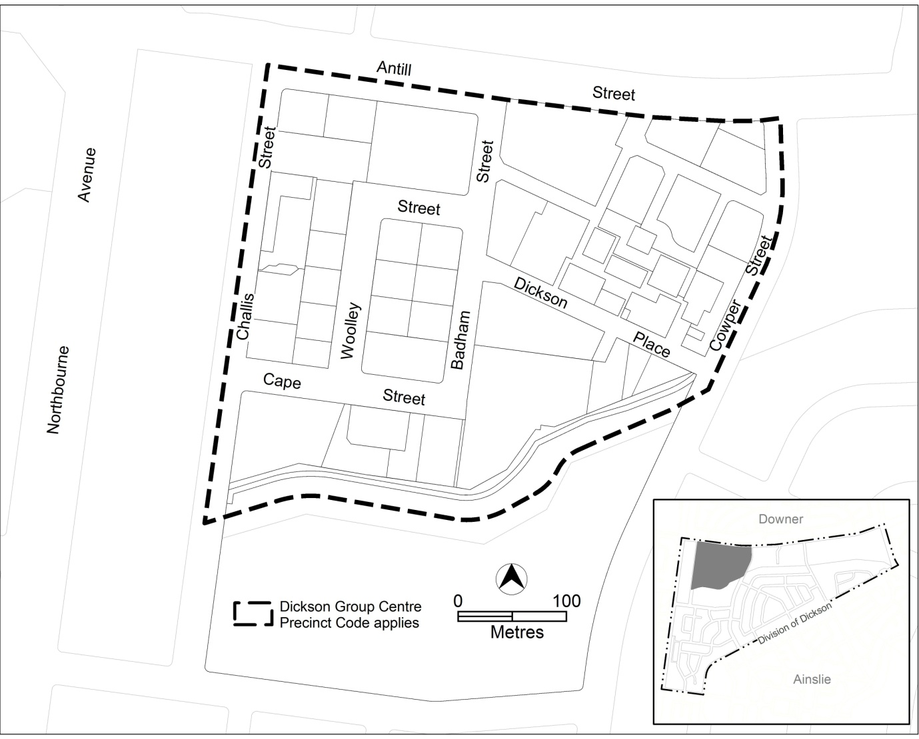
Figure 1 Location plan of Dickson group centre

  - Current Territory Plan Provisions
The Territory Plan map zones for the area subject to this variation are shown in Figure 2. Dickson group centre is comprised a mixture of commercial zones including CZ1 core, CZ2 business and CZ3 services. Additionally, Community Facility zone applies to part of section 30.
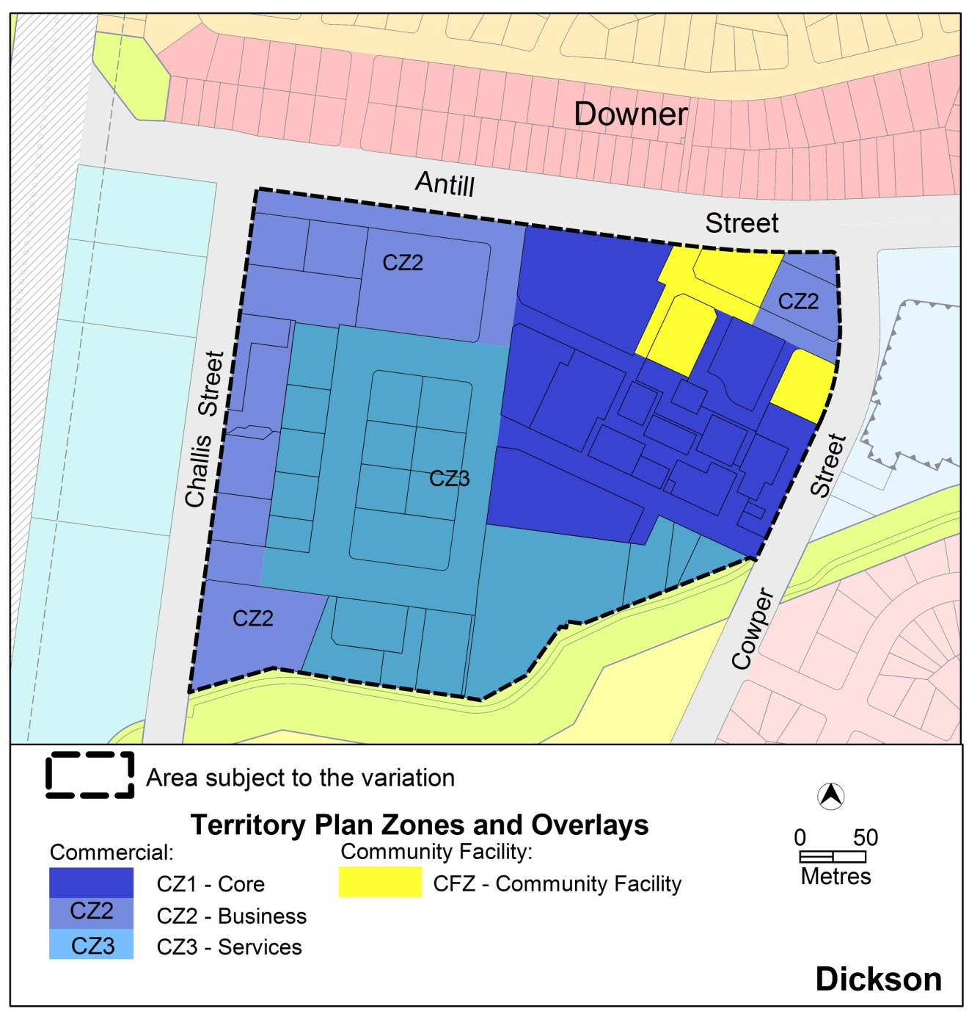
Figure 2 Territory Plan Map

  - Changes to the Territory Plan
Detailed changes to the Territory Plan are noted in section 2 of this document.
  - Consultation on the Draft Variation
Draft Variation 311 was released for public comment between 27 July 2012 and 10 September 2012. A consultation notice under section 63 of the Planning and Development Act 2007 (P&D Act) was published on the ACT Legislation Register on 26 July 2012 and in The Canberra Times on 28 July 2012.
A total of nine written submissions were received from the public as a result of the consultation process. Two submissions were on behalf of organisations while the remainder were individual submissions.
Main issues raised by submitters included:
- the location, scale and appropriateness of the proposed park on the corner of Dickson Place and Badham Street
- controls on future development of the nominated car parking sites, which are the subject of the ACT Government land release program, including the requirement to develop the Cape Street extension to Dickson Place and the restriction on vehicle access to the car park site directly from Antill Street
- concern about the loss of surface car parking at the centre
- protection of public areas from development of enclosed malls and the treatment of some areas of the centre, for instance Dickson Place
The above issues were considered and are detailed in a report on consultation. The report is available online at www.act.gov.au/recommendedvariations.
Changes were informed by the issues raised. The outcomes of consultation were considered by the Minister responsible for planning prior to approval of this variation.

  - Revisions to the Variation Recommended to the Minister
The draft variation was revised after consideration of public submissions and comments received from ACT Government agencies.
Following the establishment of the Commercial Zones Development Code and precinct maps and codes throughout the ACT by TA2012–06 in December 2012, references to the Group Centres Development Code and the Dickson precinct code have been omitted from V311. Certain existing provisions have generally been retained from existing policy including additional site specific uses combined with a structured car park on CZ1 zoned land. Nonetheless the proposed rezoning of block 20 section 34 Dickson from CZ1 to CZ3 has removed these additional uses as such development would not be consistent with the policy direction.
In addition to minor editorial amendments and corrections, the following changes were made:
Changes to the rezoning of block 20 section 34 Dickson
- block 20 section 34 is to be zoned CZ3 and a public land overlay ‘Pe urban open space’ has been included over the same area as the proposed park
Changes to Dickson Group Centre precinct map and code
Desired character
- a statement of desired character, which is called up in criterion for building design, plot ratio and setbacks, has been included
Pedestrian plaza (refer to rule R24 of the revised code)
- a detailed provision for the pedestrian plaza has been introduced to provide a sizeable area of publicly–accessible space. It is supported by separate requirements for active uses at the ground floor level adjoining the space, while allowing basement parking and retaining a deep root planting for existing trees. Development in this area will have to meet TAMS standards.
Main pedestrian areas and routes
- various provisions have been included to ensure the main pedestrian areas in Dickson, particularly in CZ1 commercial core area, remains unenclosed and publicly accessible at all times and to remove the possibility of a mall development at the centre. These controls are considered sufficient to protect view corridors shown in the earlier code, which have been omitted.
- the provisions for new pedestrian routes and expansion of existing pedestrian areas (refer to figure 2 of the revised code) have been clarified to ensure the design and construction meets the required Territory standards. The widening of pathways, including block 25 section 34, is to be achieved by the application of building setbacks to adjacent blocks (refer to rule R12 of the revised code).
- allowance has been included for a reduction in the awning depth where the pedestrian area is narrow or to allow for the retention of existing trees
- clarification that the trans-section pedestrian routes would be required for development applications involving subdivision or an increase in building height above two storeys
- provision to minimise overshadowing of public areas has been retained as a standalone provision
Vehicle access from Antill Street:
- the restriction on vehicle access included in the public consultation version of the precinct code has been revised to provide the opportunity for delivery vehicles to access block 21 section 30 on condition that the road design and impacts on traffic in Antill Street have been endorsed by the relevant Territory agency
Proposed Cape Street extension:
- the requirements and conditions that trigger development of the road extension to Cape Street have been clarified
Other changes to the code:
- restrictions on ground floor uses in Woolley Street have been retained to maintain its restaurant character, while restriction on use in Badham Street have been removed
- a number of provisions and figures have been consolidated for clarity
- maximum permitted building heights have been increased by one metre to ensure recommended number of floors described in the masterplan are achievable, and ancillary structures such as plant room and lift overruns are permitted above the maximum building height provided they are set back from the building facade

- VARIATION
  - Variation to the Territory Plan
    - Variation to the map
The map is varied as shown in Figure 3.

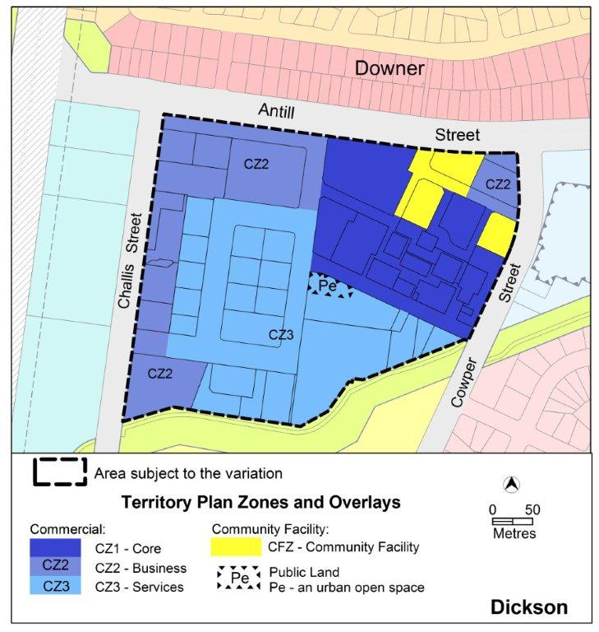
Figure 3 Proposed Territory Plan map
    - Variation to the written document
The Territory Plan written document is varied as follows:

Variation to the Dickson precinct code
- Precinct Maps and Codes, Dickson Precinct Map and Code
Substitute all of the following with the nominated attachment
Dickson Precinct Map—Attachment A
Dickson Precinct Code, RC1 – Dickson Group Centre—Attachment B
Note: The precinct code’s contents page will require updating.
Interpretation service
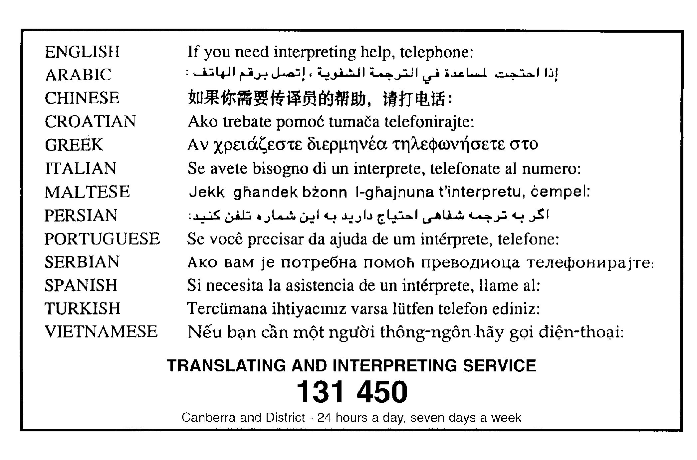

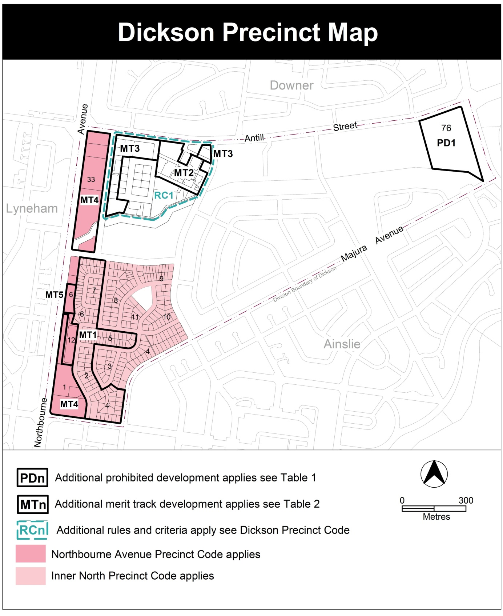
Additional rules and criteria
This part applies to blocks and parcels identified in the Dickson Precinct Map (RCn). It should be read in conjunction with the relevant zone development code and related codes.
RC1 – Dickson Group Centre
This part applies to the Dickson Group Centre shown as RC1 in the Dickson precinct map. RC1 includes the Dickson Group Centre.
Desired character
- vibrant mixed use development
- solar access to active public spaces within the core area
- restaurant and entertainment focus on the ground floor along Woolley Street
- open and accessible pedestrian access through the centre
- high quality finishes with interesting, articulated building facades
- active frontages along main pedestrian routes
- fine grain shopfronts along main pedestrian areas
- generally consistent building setbacks, with small indents to provide interest and active uses
- the centre to retain the open character with pedestrian walkways
- provision of an open, permanently accessible pedestrian plaza at the corner of Badham Street and Dickson Close
- landscaped areas that contribute to the amenity of the centre
- Use
Rules | Criteria
  - Ground floor use
This rule applies to sites with frontage to main pedestrian areas and routes in CZ1.  Only the following uses are permitted at the ground floor level:  - business agency  - club  - COMMUNITY USE  - drink establishment  - financial establishment  - hotel  - indoor entertainment facility  - indoor recreation facility  - public agency  - restaurant  - SHOP | This is a mandatory requirement. There is no applicable criterion.
This rule applies to blocks along frontages to Woolley Street in CZ2 and CZ3.  The following uses are permitted in buildings at the ground floor level  - club  - drink establishment  - hotel  - indoor entertainment facility  - indoor recreation facility  - restaurant  - SHOP | Buildings incorporate uses on the ground floor that generate activity in the public space.
  - Office – floor area limit
This rule applies in CZ1, CZ2 and CZ3.  The maximum gross floor area for office is:  - section 30 – 4000m² per lease  - sections 31, 32 and 34 – all of the following:  - 4000m² per lease  - 1500m² at ground floor level | This is a mandatory requirement. There is no applicable criterion.
  - Residential use – ground floor
This rule applies in CZ2 and CZ3.  RESIDENTIAL USE is not permitted at the ground floor level except at area A shown in figure 1.  RESIDENTIAL USE at the ground floor level complies with Australian Standard AS4299 Adaptable housing and the Access and Mobility General Code. | This is a mandatory requirement. There is no applicable criterion.

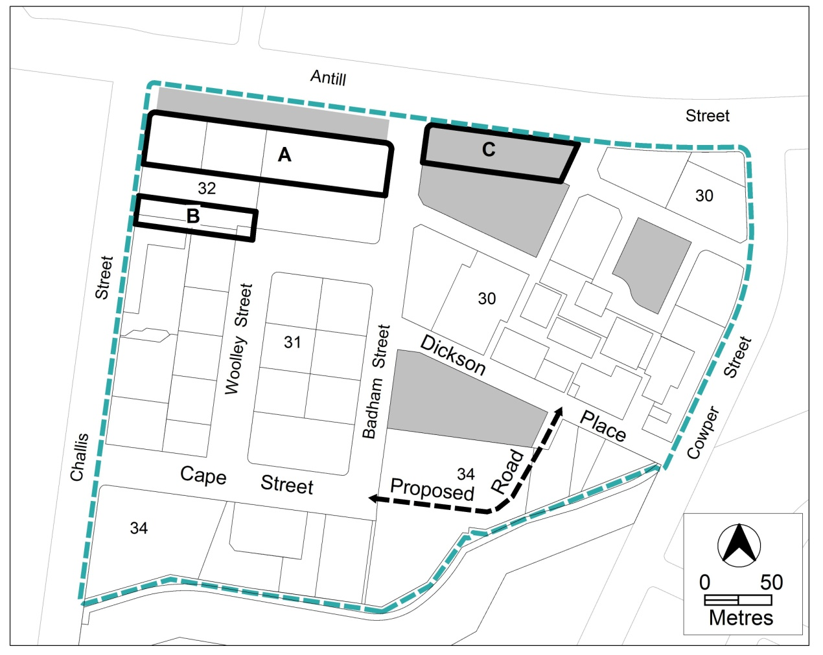
Figure 1 Dickson group centre

Rules |  | Criteria
  - Industrial trades, municipal depot, store
This rule applies in CZ1.  One or more of the following uses are permitted only in the shaded areas shown in figure 1 and only in association with a structured car park:  - industrial trades  - municipal depot  - store. | This is a mandatory requirement. There is no applicable criterion.
  - Development on nominated car parking
This rule applies to the shaded areas shown in figure 1.  Development complies with all of the following:  - the existing number of car parking spaces is retained on the site and made available for public use at all times  - provides car parking that is generated by the development on site in accordance with the Parking and Vehicular Access General Code in addition to the spaces required by item a) | Development achieves all of the following:  - any additional parking provision requirements (under the Parking and Vehicular Access General Code) for the development  - makes a substantial contribution to the long term publicly accessible parking supply for the group centre

- Buildings
Rules |  | Criteria
  - Building heights
This rule applies in CZ1, CZ2 and CZ3.  The maximum height of buildings, is:  - section 30 – the lesser of 12m or RL587 except in area C shown in figure 1 – 24m  - sections 31, 32 and 34 – the lesser of 21m or 6 storeys  Building height measurement excludes all of the following:  - roof top plant  - lift overruns  - antennas  - photovoltaic panels  - air conditioning units  - chimneys, flues and vents  The minimum setback of these excluded items from the building facade of the floor immediately below is 3m. |  | This is a mandatory requirement. There is no applicable criterion.
  - Building design
This rule applies in CZ1, CZ2 and CZ3.  The minimum floor to ceiling height at ground floor level is 3.6m. |  | The ground floor level of buildings is adaptable for commercial uses.
There is no applicable rule. |  | Building design achieves all of the following:  - corner buildings contain focal points providing architectural interest and variety to the building design  - entrances to common areas for residential use provide strong visual connection to the street and ensure a high level of surveillance  - driveways and pedestrian entrances to the site are visible from the block boundary  - west-facing facades incorporate sun shading into building designs  - consistency with the desired character
There is no applicable rule. |  | This criterion applies to development that exposes a blank facade of an adjoining building.  Exposed facade is to achieve a visually interesting architectural treatment.  Note: Treatments may include the use of colour, articulation, materials and shadows.
  - Plot ratio
There is no applicable rule. | Plot ratio achieves consistency with the desired character.
  - Setback
This rule applies in CZ3 to development adjoining the western boundary of block 25.  Development complies with all of the following:  - setback to front boundary is a minimum of 2.5m, except for basement and/or awnings  - setback area is finished  - at the level of the pedestrian pathway  - in hard paved surface  - setback area is publicly accessible at all times  Note: Identified building setbacks do not include basement car parking. |  | This is a mandatory requirement. There is no applicable criterion.
  - Main pedestrian areas and routes
This rule applies in CZ1, to the proposed trans-section connection in figure 2 and area B shown in figure 1.  Pedestrian areas and connections are to remain unenclosed and publicly accessible at all times. |  | This is a mandatory requirement. There is no applicable criterion.
This rule applies to pedestrian areas, including new trans-section routes shown in figure 2.  Development is to provide pedestrian areas and pedestrian trans-section routes that comply with all of the following:  - minimum unobstructed width is 4m  - for new trans–section routes – signage at each end identifying the connection provided  Note: A condition of approval may be imposed regarding the tenure pedestrian routes. |  | The width and scale of new pedestrian trans-section routes reflect their function, and provides sufficient width for pedestrian movement.
At the location of pedestrian areas shown in figure 2, redevelopment and/or subdivision will:  - provide the proposed pedestrian routes and pedestrian trans-section routes  - retain the existing pedestrian routes. |  | Redevelopment and/or subdivision are consistent with the pattern of existing and proposed pedestrian routes and pedestrian trans-section routes at the locations shown in figure 2.
This rule applies to blocks that are traversed by proposed trans–section routes on figure 2.  Where subdivision and or development include building where the number of storeys is 3 or more, the trans-section connection is provided. |  | This is a mandatory requirement. There is no applicable criterion.
This rule applies in CZ1 in section 30.  Buildings do not overshadow the hatched pedestrian area identified in figure 2 beyond the shadow cast by a notional 9m high wall measured from the datum ground level at the boundary adjoining the public realm. |  | Buildings do not unreasonably shadow pedestrian areas.
This rule applies to area B identified in figure 1.  Redevelopment and/or subdivision provides all of the following:  - pedestrian access is provided from Challis Street to Woolley Street with a minimum unobstructed width of 5m  - development over the pedestrian access is limited to awnings and/or balconies |  | This is a mandatory requirement. There is no applicable criterion.

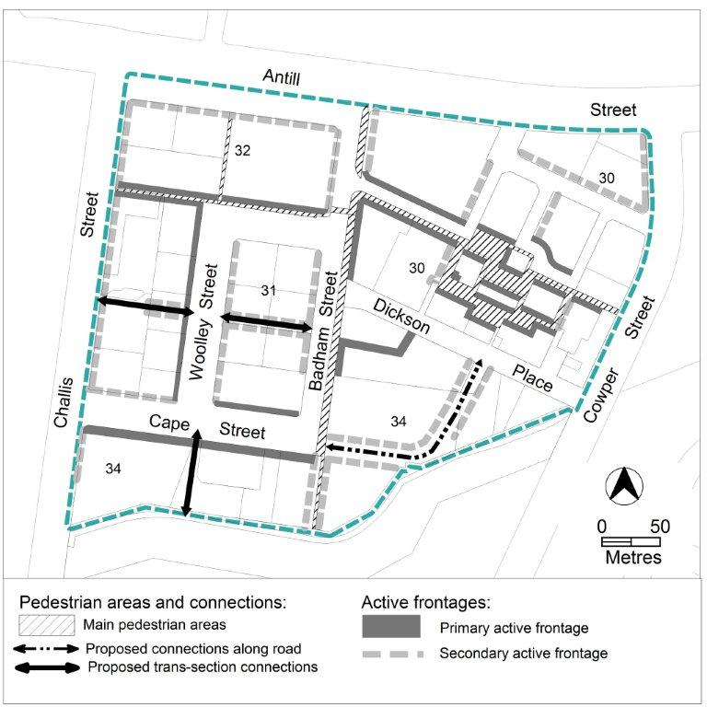
Figure 2 Main pedestrian areas and active frontages
Rules | Criteria
  - Active frontages
For buildings located along primary active frontage areas identified in figure 2, frontages and building design comply with all of the following:  - buildings incorporate clear display windows and/or shop fronts at the ground floor level  - buildings incorporate direct pedestrian access at grade with the verge level for access and egress for persons with disabilities  - tenancies at ground floor level that occupy more than a total of 20m of the street frontage present as more than one tenancy  - any small areas of walls without windows contain display windows, showcases and/or public art, with a maximum of 30% blank frontage per tenancy. | This is a mandatory requirement. There is no applicable criterion.
For buildings located along secondary active frontage areas identified in figure 2, frontages and building design comply with all of the following:  - buildings incorporate clear display windows and shop fronts at the ground floor level  - buildings incorporate direct pedestrian access at grade with the verge level for access and egress for persons with disabilities | Development at ground floor level achieves all of the following:  - is adaptable for shops  - where building access is provided, direct pedestrian access at street level  - provide opportunities for views into and out of the building
There is no applicable rule. | Extensive lengths of blank facades, open structured car parks, loading docks, substations and other service infrastructure are not located along primary active frontage areas, and do not dominate secondary active frontage areas identified in figure 2.
  - Awnings
This rule applies in CZ1, CZ2 and CZ3 to buildings fronting primary active frontage areas shown in figure 2.  Awnings comply with all of the following:  - cantilevered awnings for the full extent of the building frontage  - awnings are to be a minimum height of 3m above finished pavement or ground level of the verge  - awnings are to be integrated into the building design at the first floor level  - awnings are to be a minimum of 3m in cantilever depth, except  - where opposing primary active frontages are 6m apart or less, awning depth may be reduced to ensure awnings are separated by 0.5m  - awning depth may be reduced to retain existing tree plantings and the like | This is a mandatory requirement. There is no applicable criterion.
  - Driveway access to Antill Street – CZ1
This rule applies to section 30.  Applications for driveway access and egress to Antill Street includes all of the following:  - design that achieves all of the following  - access is restricted to left in and/or left out only  - no break in the Antill Street median  - access is restricted to service, delivery and/or emergency vehicles only  - traffic report supporting the vehicle access arrangement | This is a mandatory requirement. There is no applicable criterion.
  - Cape Street road extension – section 34
This rule applies to blocks that are traversed by proposed road shown on figure 1.  Where subdivision and or development include building where the number of storeys is 3 or more, the proposed road is provided. | This is a mandatory requirement. There is no applicable criterion.
  - Development on nominated car parking site – section 34
This rule applies to the area covered by the public land overlay Pe.  Development of a pedestrian plaza complies with all of the following:  - located on the corner of Badham Street and Dickson Place  - minimum size of 1300m² where the boundaries have the following alignment:  - southern side – southern edge of the proposed trans-section route shown in figure 2 between Woolley Street and Badham Street  - south-eastern side – north-western boundary of block 4 Section 30  - publicly-accessible at all times  - vehicle access is not permitted, except emergency vehicles  - a deep root planting zone is provided at the corner of Badham Street and Dickson Place.  - one or more of the following is permitted:  - landscaping  - public art  - unenclosed shade structures  - street furniture  - awnings  - signage  - basement parking | This is a mandatory requirement. There is no applicable criterion.
  - Dickson library buffer area
No new building, except basement, is permitted within the ‘library buffer area’ shown in figure 3.  The ‘library buffer area’ is defined as the area measured from any point on each boundary of block 13 section 30 Dickson for a minimum distance of 10 metres. | This is a mandatory requirement. There is no applicable criterion.

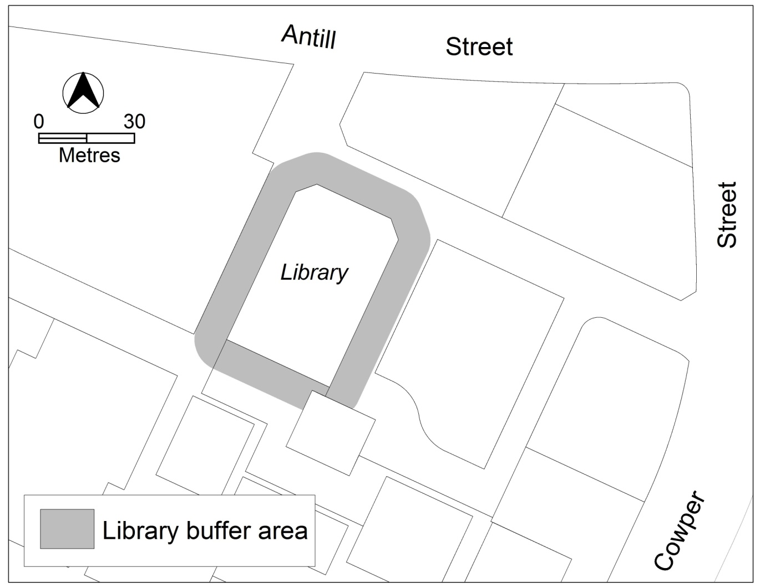
Figure 3 Dickson library buffer area

- Environment
Rules | Criteria
  - Landscaping
Landscaping associated with capital works and pedestrian routes achieves all of the following:  - quality space for pedestrians  - provision for on-site infiltration of stormwater run-off  - Water Sensitive Urban Design (WSUD) principles are applied to all landscape treatments  - drought tolerant plant species are used to contribute to a high quality landscape character | This is a mandatory requirement. There is no applicable criterion.

- Entity (Government agency) endorsement
Rules | Criteria
The following matters are to be endorsed by the nominated agency  - Territory and Municipal Services Directorate  - landscaping  - footpaths  - cycle paths  - pedestrian connections, including trans-section routes and setback area to block 25 section 34  - driveway access to Antill Street  - roads  - pedestrian plaza, including the deep root planting zone, in consultation with Conservator of Flora and Fauna  Note: TAMS will endorse a plan if it complies with the relevant TAMS standard. TAMS may endorse departures.  - ACT Government with responsibility for transport planning  - parking studies | This is a mandatory requirement. There is no applicable criterion.

