Australian Capital Territory

Planning and Development (Draft Variation No 314) Consultation Notice 2013

Notifiable Instrument NI2013—291
made under the
Planning and Development Act 2007, section 63 (Public consultation - notification) and section 64 (Public consultation – notice of interim effect etc)

Draft Variation Number 314 to the Territory Plan – Kingston Group Centre (Annexure A) proposes to change planning controls at Kingston Group Centre to guide future development on the Eyre Street public car park, increase building heights in parts of the centre up to 8 storeys and various other changes. Part of block 15 section 20 is to be rezoned to commercial CZ2 business zone.
The draft variation is available online at www.act.gov.au/draftvariations until the closing date for written comments. Background documents are available at www.act.gov.au/kingston.
Printed copies of the draft variation are available for inspection and purchase at the Environment and Sustainable Development Customer Service Centre, 16 Challis Street, Dickson, Monday to Friday (except public holidays) between 8:30am and 4:30pm. Please call 6207 1923 to arrange a copy for purchase.
Written comments from the public are invited by Monday 26 August 2013.
Comments should include reference to the draft variation, your name and contact details and be addressed to the Territory Plan Variation Unit.
Comments can be:
- emailed to dv.comments@act.gov.au
- mailed to Territory Plan Comments, GPO Box 1908, Canberra, ACT 2601
- delivered to ESDD’s Customer Service Centre at the above address
Comments received will be made publicly available 10 working days after the closing date for no less than 15 working days at ESDD’s customer service centre in Dickson and may be published on ESDD’s website.
Comments made available will include personal contact details unless excluded under section 411 or 412 of the Act. A request for exclusion under this section must be in writing, clearly identifying what you are seeking to exclude and how the request satisfies the exclusion criteria.
Effect of the draft variation
Section 65 of the Act applies to the draft variation. This means that, in addition to the Territory Plan, the provisions of the draft variation apply to development applications lodged on or after 28 June 2013. The draft variation is part of the Territory Plan for a period of up to one year unless the draft variation is commenced, is withdrawn or rejected by the Legislative Assembly. During this period, the ACT Government must not do or approve anything that would be inconsistent with the Territory Plan.
Jim Corrigan
Delegate of the ACT Planning and Land Authority
25 June 2013

Planning and Development Act 2007

Draft
Variation to the
Territory Plan
314

Kingston Group Centre
Zone changes and amendments to the Kingston precinct map and code

June 2013

Draft variation for public consultation prepared
under s60 of the Planning and Development Act 2007

This page is intentionally blank.

Table of Contents
1. INTRODUCTION 1
1.1 Summary of the Proposal 1
1.2 Outline of the process 1
1.3 This document 2
1.4 Public Consultation 2
1.5 Further Information 3
2. EXPLANATORY STATEMENT 4
2.1 Background 4
2.2 Site Description 5
2.3 Current Territory Plan Provisions 6
2.4 Proposed Changes 7
2.4.1 Proposed changes to the Territory Plan map 7
2.4.2 Proposed changes to the Territory Plan 7
2.5 Reasons for the Proposed Draft Variation 8
2.6 Planning Context 8
2.6.1 National Capital Plan 8
2.6.2 Territory Plan 8
2.7 Interim Effect 9
2.8 Consultation with agencies 10
3. DRAFT VARIATION 13
3.1 Variation to the Territory Plan map 13
3.2 Variation to the Territory Plan written document 14

This page is intentionally blank.

- INTRODUCTION
  - Summary of the Proposal
Draft Variation to the Territory Plan No 314 proposes to change the zone of land at the Kingston Group Centre and amend the Kingston precinct map and code to guide future development of the centre.
It provides an opportunity to encourage the revitalisation of Kingston shopping centre through the inclusion of findings of the Kingston Centre master plan. The changes would enable the ACT Government to deliver a mixed use development with additional retail and supermarket on the existing car parking site. The precinct code changes would enhance the amenity and character of Green Square and adjacent shopping centre, whilst improving pedestrian access through the centre.
  - Outline of the process
The Commonwealth’s Australian Capital Territory (Planning and Land Management) Act 1988 allows for the Legislative Assembly to make laws to establish a Territory Planning Authority and for that Authority to prepare and administer a Territory Plan. The Planning and Development Act 2007 (the Act) establishes the ACT Planning and Land Authority (ACTPLA) as the Authority which prepares and administers the Territory Plan, including continually reviewing and proposing amendments as necessary. The functions of ACTPLA are administered by the Environment and Sustainable Development Directorate (ESDD).
The Territory Plan is comprised of a written statement and a map. The written statement contains a number of parts, namely governance; strategic directions; zones (including objectives and development tables and zone or centre development codes); precinct codes; general codes; overlays; definitions; structure plans, concept plans and development codes for future urban areas.
The Territory Plan Map graphically represents the applicable land use zones (under the categories of residential, commercial, industrial, community facility, urban parks and recreation, transport and services and non urban), precincts and overlays. The zone, precinct and overlay requirements are detailed in the volumes of the Territory Plan.
Draft variations to the Territory Plan are prepared in accordance with the Act. Following the release of the draft variation under section 63 of the Act, submissions from the public are invited. At the conclusion of the consultation period the ESDD submits a report on consultation and a recommended final variation to the Minister responsible for planning for approval.
The Minister has the discretion to determine if referral to the Legislative Assembly standing committee responsible for planning is warranted prior to approval, depending on the nature and significance of the proposal.
If the draft variation is referred to the committee by the Minister or otherwise, the Minister must consider the findings of the committee before deciding whether to approve the draft variation. If the Minister approves the variation, the variation and associated documents will be tabled in the Legislative Assembly. Unless disallowed by the Legislative Assembly within five sitting days, the variation commences on a day nominated by the Minister.
  - This document
This document contains the background information in relation to the proposed variation. It comprises the following
Part 1. This Introduction
Part 2. An Explanatory Statement, which gives reasons for the proposed variation and describes its effect
Part 3. The Draft Variation, which details the precise changes being proposed to the Territory Plan
  - Public Consultation
Written comments from the public are invited by COB Monday 26 August 2013.
Comments should include reference to the draft variation, your name and contact details, and be addressed to the Territory Plan Variation Unit.
Comments can be:
- emailed to dv.comments@act.gov.au
- mailed to Territory Plan Comments, GPO Box 1908, Canberra, ACT 2601
- delivered to ESDD’s Customer Service Centre at 16 Challis Street, Dickson
Comments received will be made publicly available 10 working days after the closing date for no less than 15 working days at ESDD’s customer service centre in Dickson and may be published on ESDD’s website.
Comments made available will include personal contact details unless excluded under section 411 or 412 of the Planning and Development Act 2007. A request for exclusion under these sections must be in writing, clearly identifying what you are seeking to exclude and how the request satisfies the exclusion criteria.
  - Further Information
The draft variation, fact sheets and background documents are available online at www.act.gov.au/draftvariations until the closing date for written comments.
Printed copies of the draft variation (this document) and background documents are available for inspection and purchase at the Environment and Sustainable Development Customer Service Centre, 16 Challis Street, Dickson, Monday to Friday (except public holidays) between 8:30am and 4:30pm. Please call 6207 1923 to arrange a copy for purchase.

- EXPLANATORY STATEMENT
  - Background
The Kingston Group Centre was developed as the first commercial centre in Canberra in the 1920’s, and is both a retail centre and a significant dining/entertainment hub. The centre is characterised by a strong sense of place, an active public realm and a distinctive built form.
The government funded Kingston Centre Planning Project was undertaken by Purdon Associates and Cox Humphries Moss from August 2009 to September 2010. The project was undertaken in response to population growth, changes to the demographics, development pressures in the centre and research findings that identified the requirement for additional supermarket space in inner south Canberra. The project report noted that the population catchment of the group centre is growing but that the centre had not benefitted from this, likely due to residents utilising other commercial centres at the expense of Kingston.
The planning project culminated in the Kingston Centre master plan, which was released on June 2011 (refer to www.act.gov.au/kingston). The master plan sets out a vision for the future of the centre and aims to guide growth and change in a way that will meet the needs of residents, visitors, lessees and businesses and to ensure the centre’s future sustainability. As part of the implementation of the master plan, the Kingston precinct map and code will be amended in response to the key findings of the master plan to guide further development at the centre.
  - Site Description
The Kingston Group Centre is generally bounded by Giles Street to the north, Kennedy Street to the west, Jardine Street to the east and Eyre Street to the south as described in Figure 1. The Kingston Group Centre is closely connected to the adjoining residential zoned areas, as part of the commercial zone crosses over the streets, with commercial blocks adjoining high density residential zoned blocks, resulting in a ‘close knit’ and unique character to the centre.
The CZ1 core commercial area surrounds Green Square, a focal point for the centre highly prized by the community for the unique landscape character it provides the centre, and is currently generally limited to two storeys in height, with awnings along the major pedestrian walkways and a central service lane, Highgate Lane.
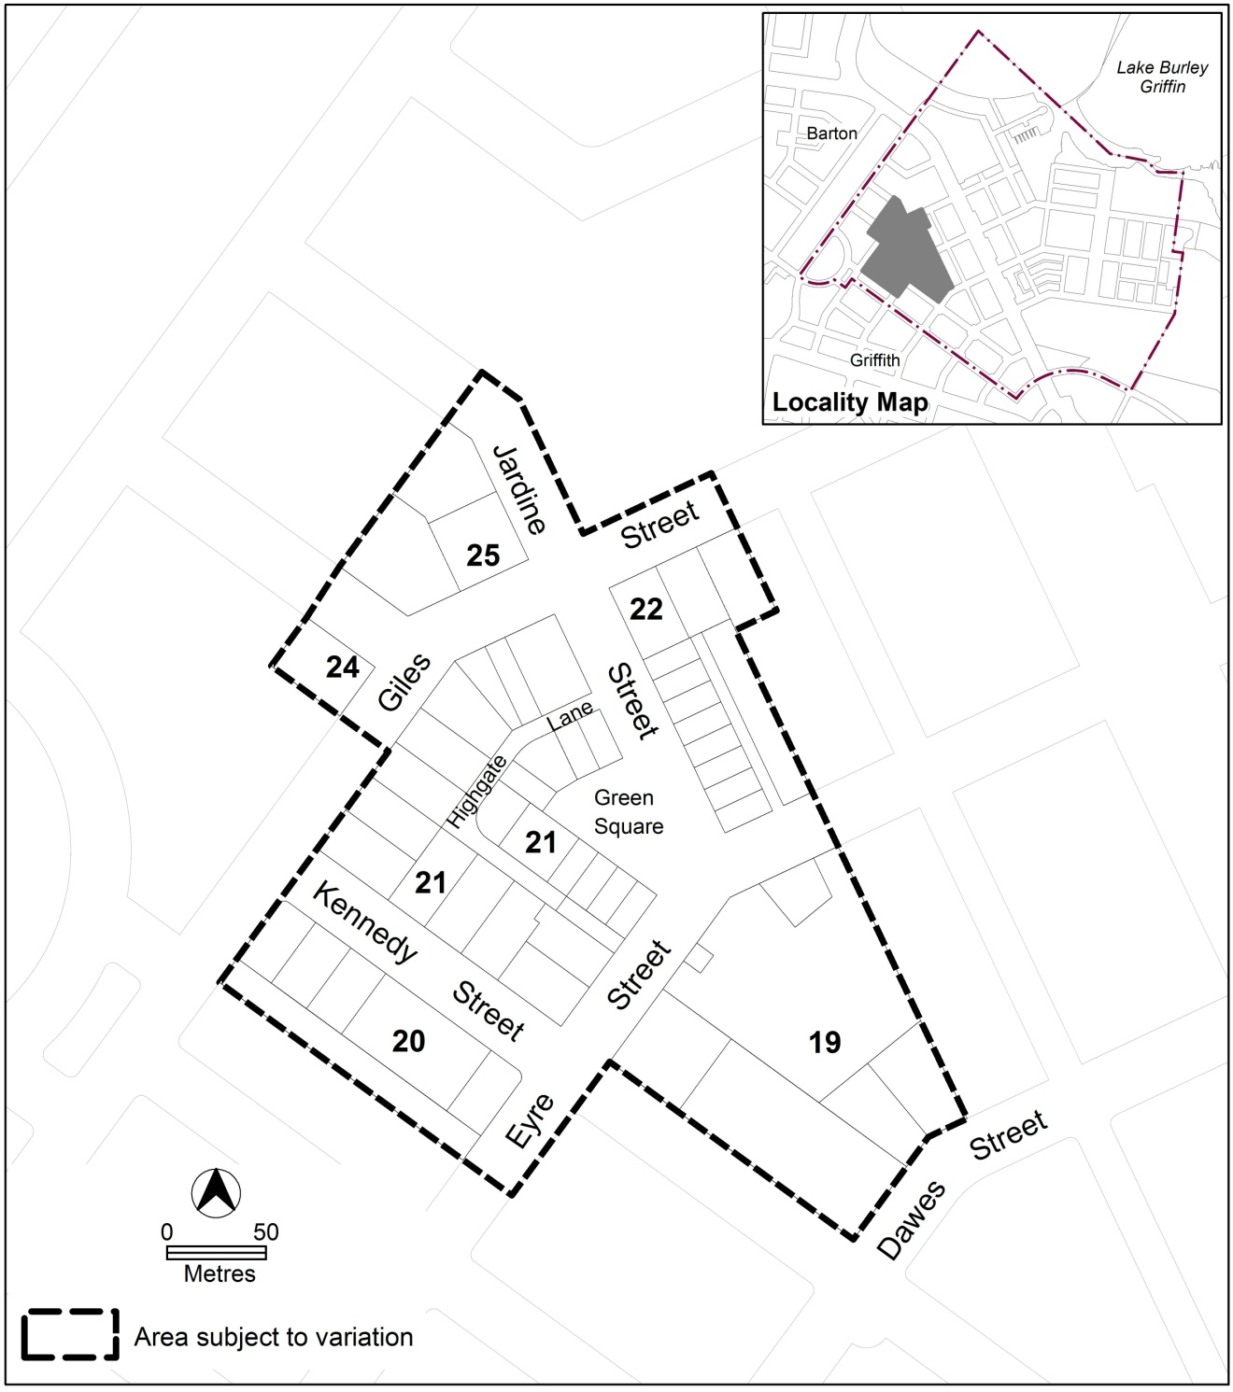
Figure 1 Location plan of the area subject to this draft variation
  - Current Territory Plan Provisions
The Kingston Group Centre has an area of urban open space PRZ1 zone over Green Square. This area is surrounded by the commercial CZ1 zone covering section 21 and blocks 29, 47 and 48 in section 19, which in turn is surrounded by CZ2 business zone upon parts of sections 19, 20, 22, 24 and 25. The Territory Plan map zones for the area subject to this variation are shown in Figure 2, which includes block 15 section 20 that has both CZ2 and residential RZ5 high density residential zone.
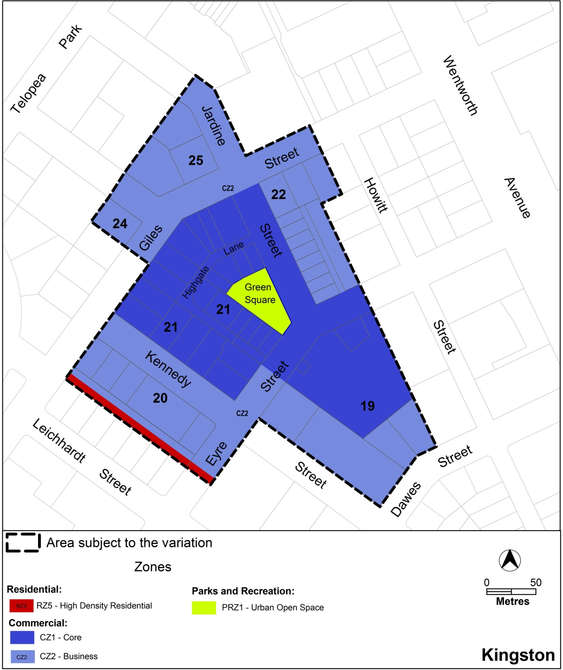
Figure 2 Existing zones for Kingston Group Centre
Development on land within the commercial zone is subject to the provisions of the Commercial Zones Development Code and the Kingston precinct map and code. Additional controls for certain development are included in separate development codes such as the multi unit housing development code, used to assess residential development proposals.
  - Proposed Changes
    - Proposed changes to the Territory Plan map
The proposed change to the Territory Plan map are indicated in figure 3 and involves the rezoning of part block 15 section 20 from RZ5 to CZ2. This change provides an opportunity to establish a rear laneway vehicle access for businesses at section 20 and to remove driveway access directly from Kennedy Street.
    - Proposed changes to the Territory Plan
It is proposed to amend the Kingston precinct code to:
- increase building heights in parts of the centre, while retaining the existing building heights in Green Square and Jardine Street
- provide improved pedestrian connections through the centre to Highgate Lane
- require weather protection over the main pedestrian areas
- guide development on the existing large surface car park in Eyre Street
Additional matters include:
- the building envelope for development on the existing car park in section 19 has been modified by providing a maximum RL rather than number of storeys
- building heights along key street frontages to the shopping centre have been restricted for 20m from the front boundary to Giles and Kennedy Streets and only four storeys beyond that point
- a higher building element on Eyre Street up to 27m above street level
- provisions have been included to ensure that individual blocks do not become undevelopable where adjoining blocks are redeveloped
- allows either laneways or internal arcades at the shopping centre
- primary and secondary active frontages have specific design requirements
  - Reasons for the Proposed Draft Variation
The reasons for the proposed draft variation include providing all of the following:
- greater opportunities for retail development within the Kingston Group Centre while conserving the shopping centre’s character
- improved pedestrian permeability through the centre and make greater use of Highgate Lane
- the opportunity for a mixed use developments including more residential
- clear guidance on future development drawing from the master plan’s findings.
  - Planning Context
    - National Capital Plan
The Australian Capital Territory (Planning and Land Management) Act 1988 established the National Capital Authority (NCA) with two of its functions being to prepare and administer a National Capital Plan (NCP) and to keep the NCP under constant review and to propose amendments to it when necessary.
The NCP, which was published in the Commonwealth Gazette on 21 January 1990, is required to ensure that Canberra and the Territory are planned and developed in accordance with their national significance. The Planning and Land Management Act 1988 also required that the Territory Plan is not inconsistent with the NCP.
    - Territory Plan
The proposal is consistent with the Territory Plan’s statement of strategic directions in terms of environmental, economic and social sustainability and spatial planning and urban design principles.
The proposal supports the following key principles in the strategic directions:
1.12 Planning policies will facilitate the widest possible range of commercial, retail, industrial, rural, tourism, and other forms of economic activity in order to promote new investment and a more diversified economy, to underpin employment growth, and to respond to changing economic opportunities.
The proposed amendments to the precinct code support this principle through enabling the Kingston Group Centre to respond to the changes in the needs of the community and provide additional business opportunities in the centre.
1.22 Urban development will be planned in a manner that promotes community vitality and safety, applying principles of crime prevention through environmental design. Provision will also be made for emergency services infrastructure necessary to ensure a high standard of safety for residents and visitors.
This principle is supported through improving pedestrian activity through Highgate Lane, as well as indirectly through the provision of increased building heights along Highgate Lane, improving potential for passive surveillance with future developments.
2.3 Commercial and retail activity will be concentrated in centres and other planned nodes of intensive activity that are well served by public transport to ensure an efficient pattern of development. Primary emphasis will be placed on strengthening and enhancing existing and new centres and nodes, including improved urban design and encouragement of more mixed-use development.
The proposal supports this principle through the encouragement of more mixed use development by increasing the development rights within an established group centre.
2.6 Higher density development will be encouraged within and near major centres, and in other suitable locations that are well served by public transport.
This principle is addressed through the increase in density encouraged by the increased building heights proposed in the precinct code.
  - Interim Effect
Under section 65 of the Act, the draft variation has effect for a period of up to one year from 28 June 2013. During this period, the Territory, the Executive, a Minister or a territory authority must not do or approve the doing of anything that would be inconsistent with the Territory Plan if it were varied in accordance with the draft variation.
This means that when a development application is assessed during the period of interim effect it can only be approved if it is not inconsistent with the Territory Plan (as it is currently) and the Territory Plan if it were varied in accordance with the draft variation. In this way the existing and proposed future policy are both considered at the time of development assessment during the period of effect.
  - Consultation with agencies
The ESDD is required to, in preparing a draft variation under section 61(b) consult with each of the following in relation to the proposed draft variation:
- the national capital authority
- the conservator of flora and fauna
- the environment protection authority
- the heritage council
- if the draft variation would, if made, be likely to affect unleased land or leased public land – each custodian for the land likely to be affected.
National Capital Authority
The NCA provided the following comments on 13 April 2012
Please note that the National Capital Authority has no objection to Draft Variation 314 for the Kingston Group Centre proceeding.
Response
Noted. A further opportunity to comment on the proposal will be provided during the public consultation period.
Conservator of Flora and Fauna
The Conservator of Flora and Fauna made the following comments on
29 March 2012
The documentation has been examined and there are no issues of concern with the proposed variation.
Response
Noted. A further opportunity to consider the draft variation will be provided during public consultation on the draft variation
Environment Protection Authority
The Environment Protection Authority provided the following comments on
29 May 2013
I have reviewed the draft variation and it is supported. I however note that the requirements for a Noise Management Plan as described in Rule 31 in DV 314 is already covered (apart from the use of Motel) by the Commercial Zones Development Code which would apply to Section 20 and 22.
Motel is not a use that has been associated with noisy activities requiring Noise Management Plans by the Environment Protection Authority however it is understood that adjacent residents have specifically raised concerns regarding this use with the Planning Authority.
It is also noted that Indoor Recreation is included twice in Rule 31 and Indoor Entertainment is not included in the list of uses requiring a Noise Management Plan in DV314 but is required in the Commercial Zones Development Code. This appears to be a typographical error.
The rezoning of part of Block 15 Section 20 from Residential Zone 5 to Commercial Zone 2, and the future inclusion of a laneway on this block dividing the residential zone and commercial zones in section 20 is supported due the list of Prohibited Development activities on blocks 1, 5-7 & 16 Section 20 including Club, Drink Establishment, Indoor Entertainment Facility, Indoor Recreation Facility and Restaurant.
Response
Noted. The inclusion of Motel continues existing policy. Former rule R31, now R29 in the proposed code, has been revised to achieve consistency with the provision in the Commercial Zones Development Code. R29 will only apply to part section 22, with the relevant provision in the Commercial Zones Development Code being used to assess potentially noisy uses at section 20.
Heritage Council
The Heritage Council provided the following comments on 20 May 2013
The DA Taskforce of the Heritage Council have reviewed the most recent draft and have stated that without an assessment of the heritage values of Kingston Shopping Precinct, it is difficult to provide comments. However, the following is considered to be preliminary advice.
Council notes that the major change for this revision of DV314 is the removal of development at the east end of Highgate Lane. This is to be replaced by an eight storey or 27 metre height limit on the site immediately to the south of Highgate lane.
While the Cusack site is probably the least sensitive location in the precinct for a higher building and thus allows for some flexibility, they are concerned that the proposed eight storey height provides a far more generous site area than the gross floor area that would otherwise be allowed potentially resulting in an intrusion in the overall scale of the precinct.
Council looks forward to providing further comment when Draft Variation 314 is on public exhibition and when a heritage assessment of the Kingston Shopping Precinct is completed. Council also notes that, if the Kingston Shopping Precinct is included on the ACT Heritage Register, Heritage Guidelines may be prepared that may provide additional controls on development in the precinct.
Response
The nomination of ‘Kingston shopping centre’ to the Heritage Register is noted. ESDD would consider the Heritage Council advice in deciding development proposals within the shopping centre area.
The revision to remove the aerial encroachment over High Gate Lane near Eyre Street and allow for a taller building element was proposed in the urban planning and design framework (2010). This element of the proposal delivers key elements of the framework, including taking up opportunities to encourage residential development, varied building heights throughout the centre, improved attractiveness of the lane. The framework report is being made available as a background document to the draft variation.
Territory and Municipal Services Directorate (land custodian)
The Territory and Municipal Services (TAMS) Directorate provided the following comments on 19 April 2012
TAMS supports the document being released for public consultation.
TAMS requests that the retention of the bus stops on Giles and Eyre Streets be included in the precinct code for the centre.
The following additional comments were provided by TAMS on 29 April 2013
TAMS supports a rezoning of block 15 section 20 Kingston as CZ2 business.
Response
Noted. The bus stops are located within the road reserves of Giles and Eyre Street. The continuation of stops at these locations is supported by the proposed restriction on vehicle access in these areas.

- DRAFT VARIATION
  - Variation to the Territory Plan map
The Territory Plan map is varied as indicated in figure 3.
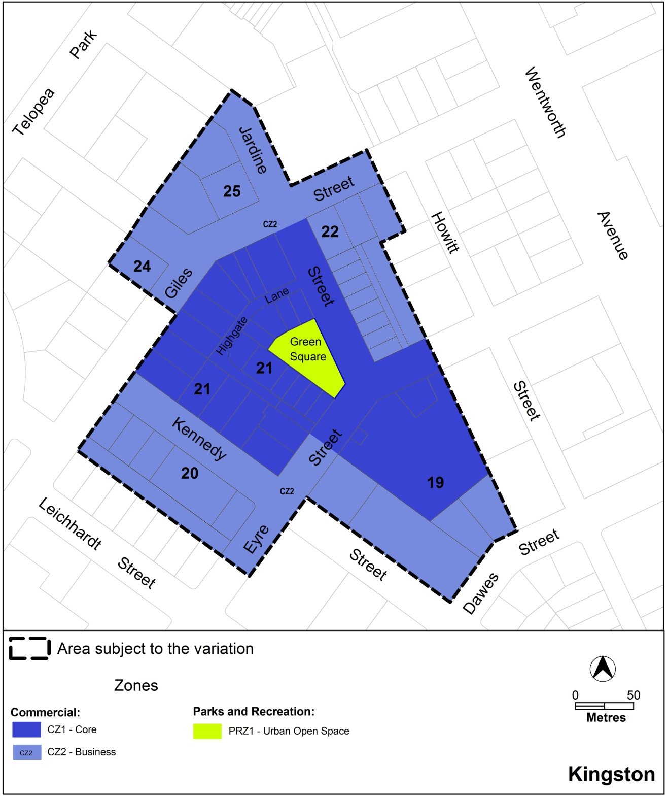
Figure 3 Proposed zones for Kingston Group Centre

  - Variation to the Territory Plan written document
The Territory Plan is varied as follows.

Variation to Kingston precinct code
10. Precinct Maps and Codes, Kingston Precinct Map and Code
Substitute all the following with the nominated attachment
Kingston Precinct Map – Attachment A
Kingston Precinct Code, RC3 – Kingston Group Centre – Attachment B
Note: The precinct code’s contents page, rules, criteria and figure numbering will require updating.

Interpretation service
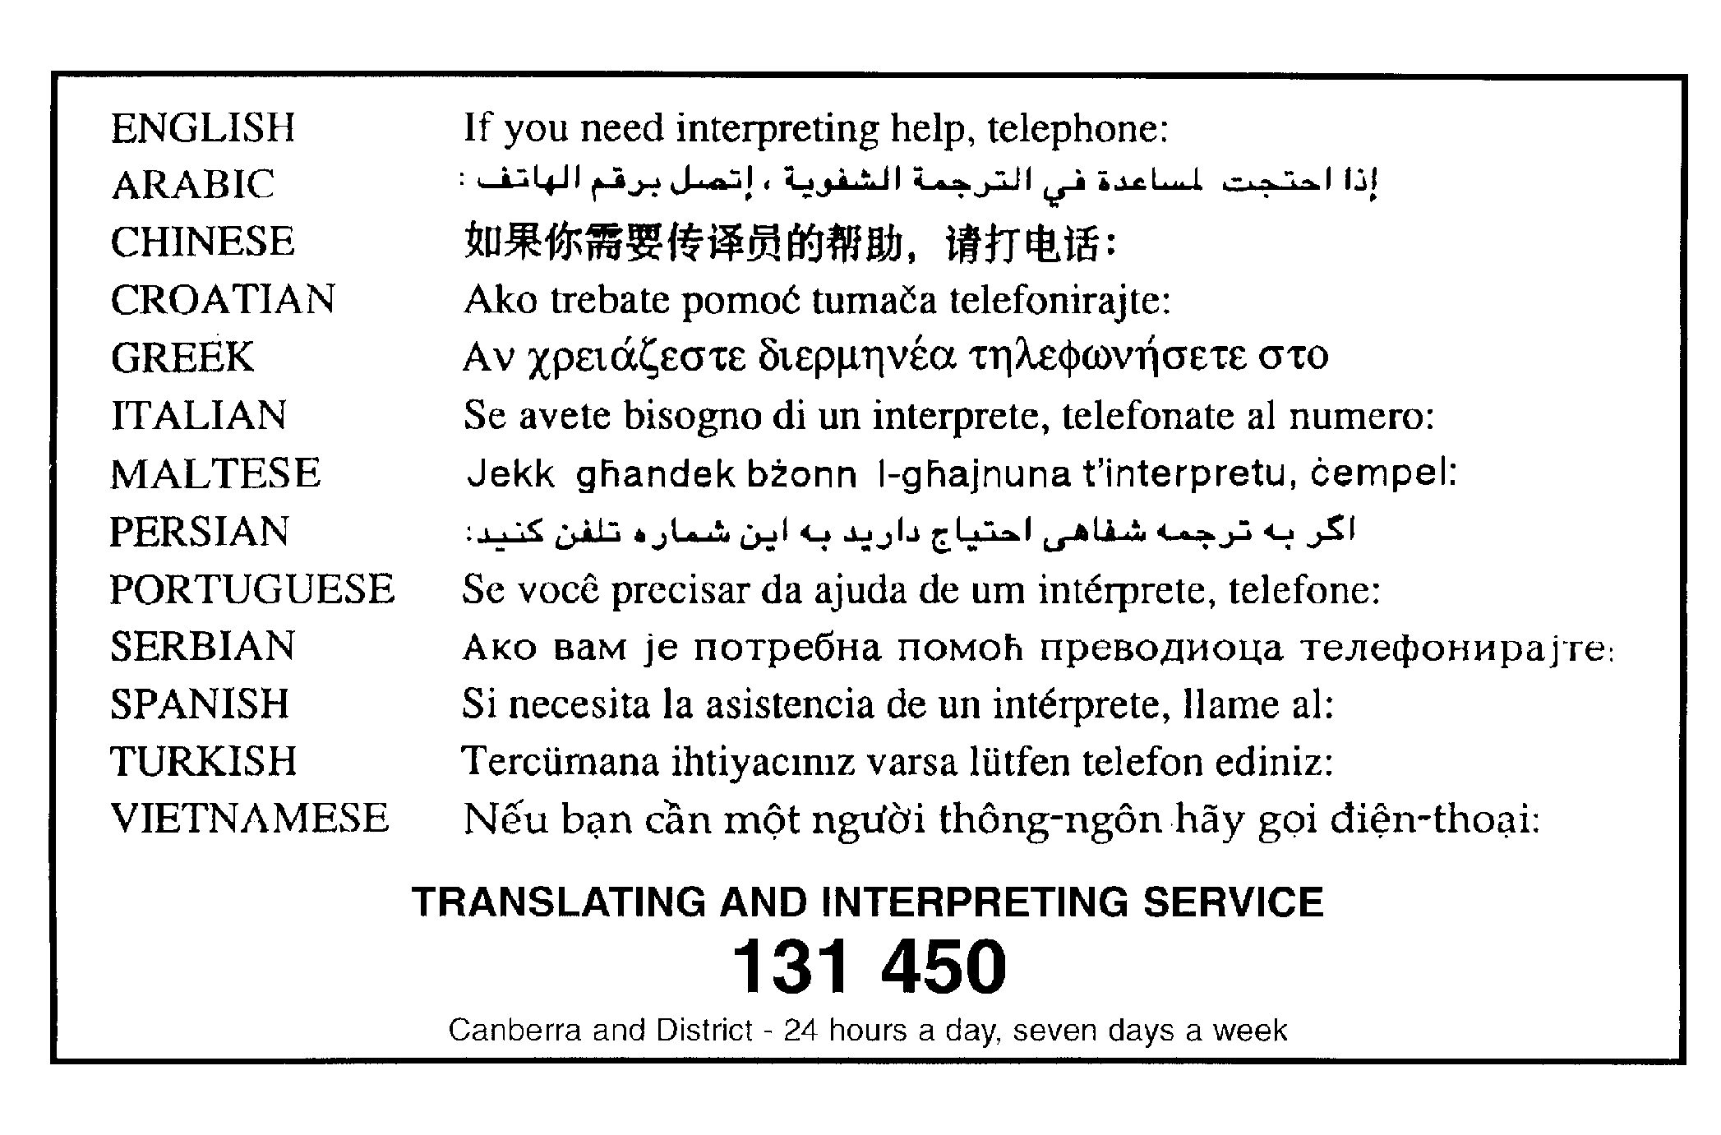

This page is intentionally blank.

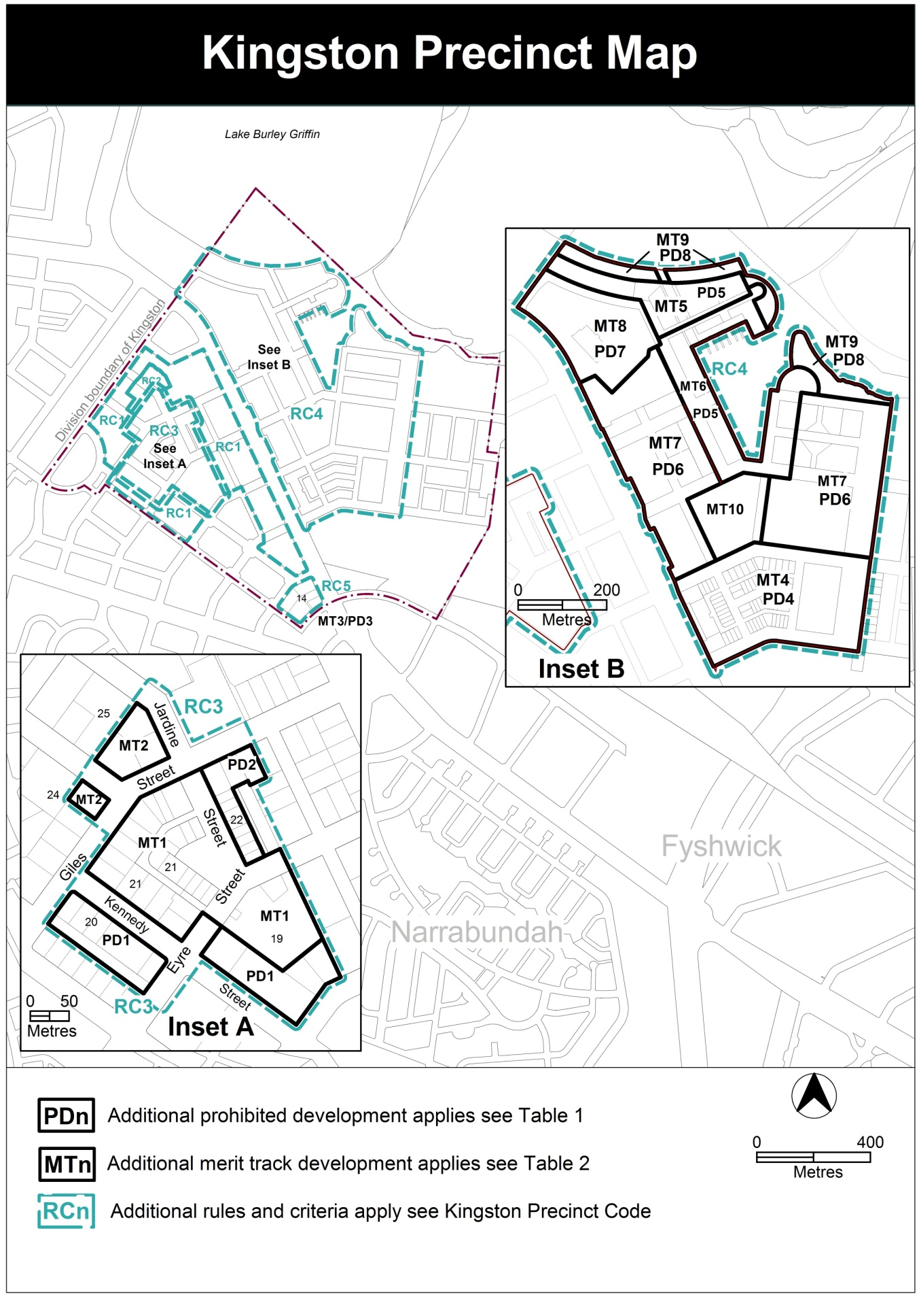

Note: No amendment is being proposed to items listed in the development tables for additional prohibited development (Table 1) and additional merit track development (Table 2). The proposed zone changes of the draft variation are reflected in the Kingston precinct map affecting block 15 section 20 Kingston are shown by the expansion of PD1. The list of uses associated with PDn and MTn can be found by the Kingston Precinct map and code in the Territory Plan at www.legislation.act.gov.au/ni/2008-27/current/default.asp.

RC3 – Kingston Group Centre
This part applies to the Kingston Group Centre shown as RC3 on the Kingston precinct map. RC3 includes the Kingston Group Centre.
Desired character
In addition to the character noted in the relevant zone objectives, the desired character of the Kingston group centre has:
- good pedestrians connections within and to the centre
- fine grain, active shop-fronts facing the street
- commercial developments that encourage activity in Highgate Lane and other laneways
- development that respects the heritage character of the centre

- Use
Rules | Criteria
  - Ground floor uses
This rule applies to sites with frontages to primary active frontages in CZ1 shown in figure 4.  Only the following uses are permitted at the ground floor level:  - business agency  - club  - community activity centre  - drink establishment  - financial establishment  - hotel  - indoor entertainment facility  - indoor recreation facility  - public agency  - restaurant  - SHOP | This is a mandatory requirement. There is no applicable criterion.
There is no applicable rule. | This criterion applies to sites with boundaries to primary active frontage in CZ2 shown in figure 4.  Buildings incorporate uses on the ground floor that generate activity in the public space.
  - SHOP – floor area limit
This rule applies to section 22.  The maximum gross floor area of SHOP is 300m². | This is a mandatory requirement. There is no applicable criterion.
  - Residential use – ground floor
This rule applies in CZ2.  RESIDENTIAL USE is not permitted on ground floor level except on sections 19 and 20.  RESIDENTIAL USE at the ground floor in sections 19 and 20 is designed to comply with the Australian Standard AS4299 – Adaptable housing (class C) and the Access and Mobility General Code. | This is a mandatory requirement. There is no applicable criterion.
  - Industrial trades, municipal depot, store
This rule applies in CZ1.  One or more of the following uses are permitted only in the shaded area shown in figure 1 and only in association with a structured car park:  - industrial trades  - municipal depot  - store | This is a mandatory requirement. There is no applicable criterion.
  - Development on nominated car parking areas
This rule applies to the shaded area shown in figure 1.  Development complies with all of the following:  - the existing number of car parking spaces is retained on the site and made available for public use at all times  - provides car parking that is generated by the development on site in accordance with the Parking and Vehicular Access General Code in addition to the spaces required by item a) | Development achieves all of the following:  - any additional parking provision requirements (under the Parking and Vehicular Access General Code) for the development  - makes a substantial contribution to the long term publicly accessible parking supply at the group centre
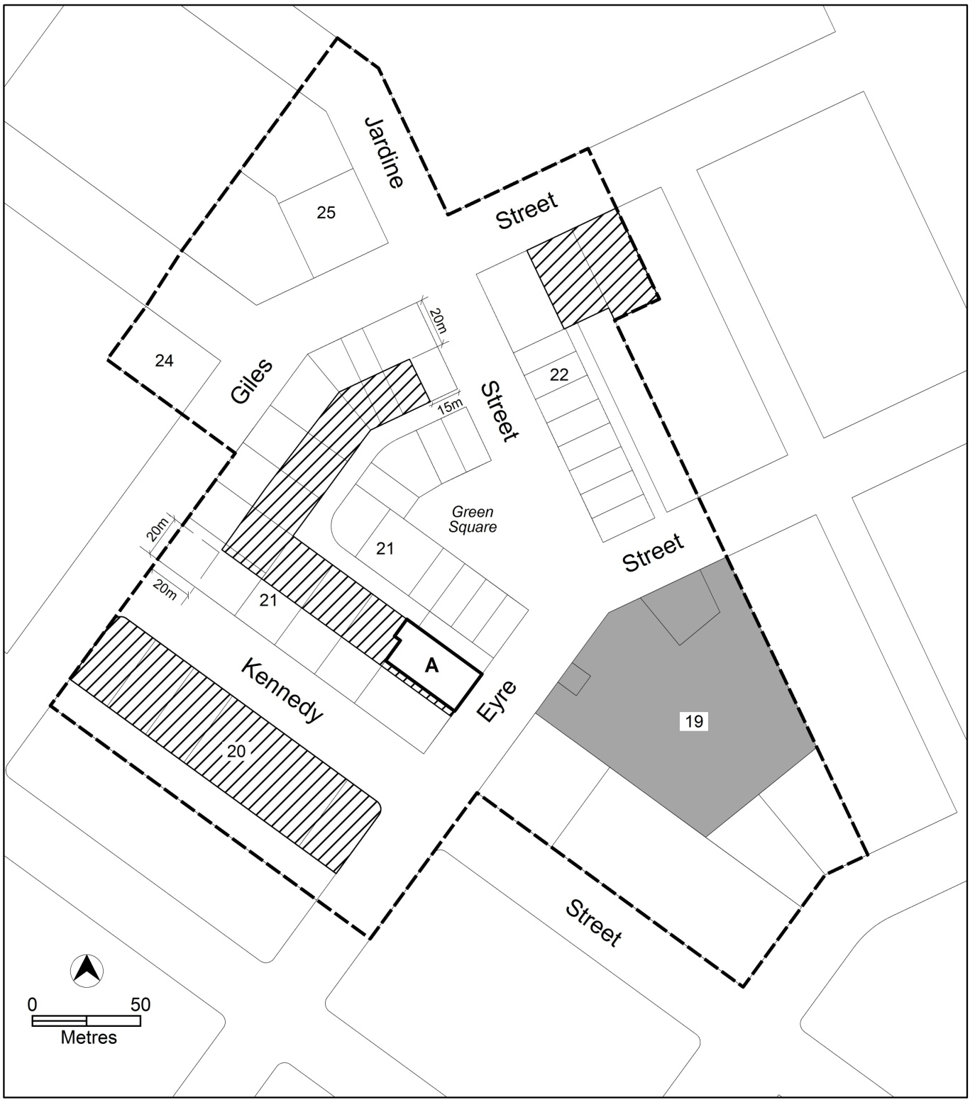
Figure 1: Kingston Group Centre

- Buildings
Rules | Criteria
  - Restriction on development – sections 19 and 21
This rule applies to section 19 in CZ1 zone.  Development of 2 storeys or more is not permitted until the parcels in the shaded area in figure 1 are consolidated into one block. | This is a mandatory requirement. There is no applicable criterion.
This rule applies to section 19 blocks 30 and 31.  Development of 3 storeys or more is not permitted until the blocks are consolidated into one block. | This is a mandatory requirement. There is no applicable criterion.
This rule applies to section 21.  Development of 3 storeys or more ensures adjoining blocks retain vehicle access from Highgate Lane. | This is a mandatory requirement. There is no applicable criterion.
  - Building heights – sections 20, 21 and 22
This rule applies to sections 20, 21 and 22.  The height of buildings is the lesser of 9m above datum ground level (DGL) and 2 storeys, except the following areas shown in figure 1  - hatched area—the lesser of 15m above DGL and 4 storeys  - area ‘A’—the lesser of 27m above DGL and 8 storeys and the building is setback 3m on Eyre Street front boundary above 15m  Building height excludes all of the following:  - roof top plant  - lift overruns  - antennas  - photovoltaic panels  - air conditioning units  - chimneys, flues and vents  Excluded items are setback from the building facade of the floor immediately below a minimum distance of 3m. | This is a mandatory requirement. There is no applicable criterion.

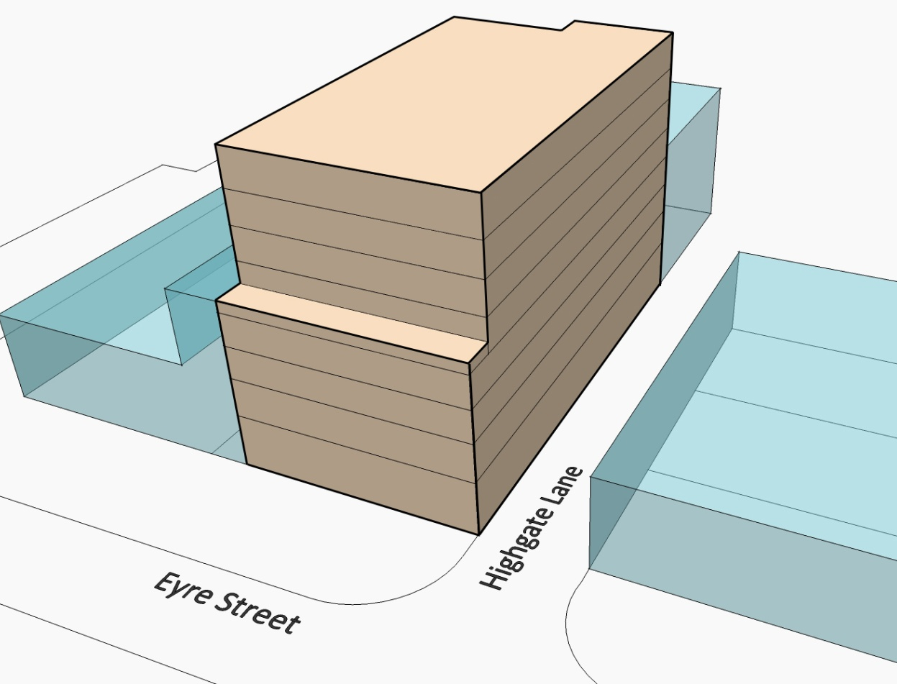
Figure 2: Building envelope of area A from Eyre Street

Rules | Criteria
  - Building envelope – section 19
This rule applies to section 19 shown in figure 3.  Development is contained within an envelope that achieves all of the following:  - No building, except basement and awning, is located within areas A and B.  - Area A is defined from the Eyre Street front boundary by a minimum 30m depth by the distance between the continuation of the front boundary to Green Square of block 13 section 21 and the continuation of front boundary to Jardine Street block 32 section 22  - Area B is the area of CZ1 and CZ2 zoned land that is setback 9m from the southwest side boundary  - In area C, maximum building height is the lesser of RL590 and six storeys and building is setback 3m along Eyre Street front boundary from 15m above datum ground level (DGL)  - Area C is defined from the Eyre Street front boundary by maximum 40m depth by the distance between area ‘B’ and the continuation of the front boundary to Green Square of block 13 section 21  - In area D, maximum building height is the lesser of RL590 and six storeys and building is setback 3m along Eyre Street front boundary from 15m above DGL  - Area D is defined from the Eyre Street front boundary by a maximum 90m depth by the distance between the side boundary and the continuation of the front boundary to Jardine Street of block 32 section 22  - Maximum building height in area E is RL574  - Area E is defined as the CZ1 zoned land after the exclusion of areas A, B C and D.  - Maximum building height in area F is RL579  - Area F is defined as the CZ2 zoned land after the exclusion of area B  Building height in areas ‘C’, ‘D’, ‘E’ and ‘F’ exclude all of the following:  - roof top plant  - lift overruns  - antennas  - photovoltaic panels  - air conditioning units  - chimneys, flues and vents  Excluded items are setback from the building facade of the floor immediately below a minimum distance of 3m.  Notes:  - 4.1 Restrictions on development applies.  - RL590 equates to approximately 21m above datum ground level at the Eyre Street frontage. | This is a mandatory requirement. There is no applicable criterion.
There is no applicable rule. | Development on the block resulting from the consolidation of blocks 29, 47 and 48 incorporates setbacks to the eastern side boundary that provide adequate visual and physical separation from the adjoining residential development.  Notes:  - 4.1 Restrictions on development applies.

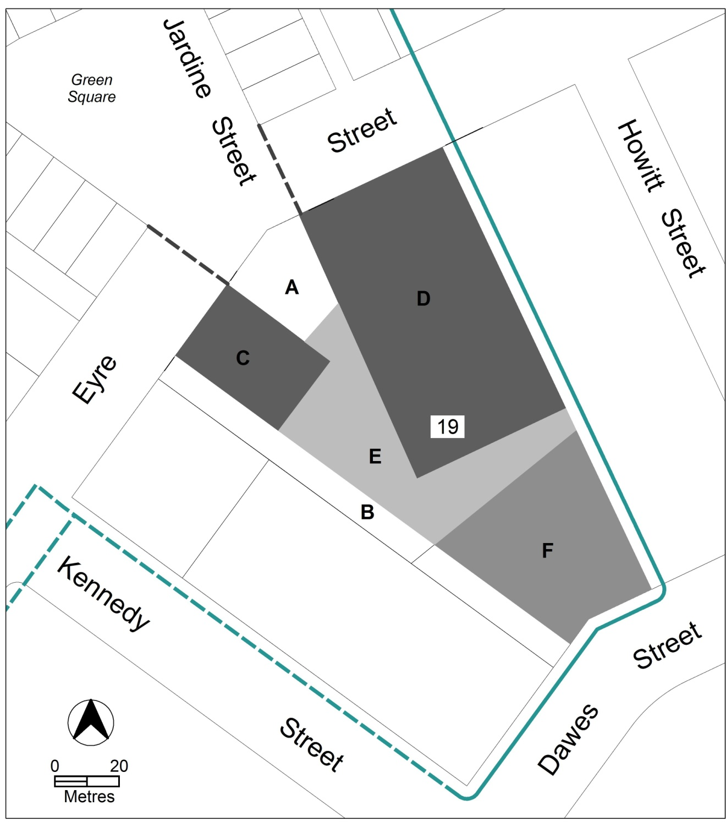
Figure 3: Section 19 – CZ1 zone plus blocks 30 and 31

Rules | Criteria
  - Building design
The minimum ground floor level floor to ceiling height is 3.6m | The ground floor level of buildings is adaptable for commercial uses.
  - Plot ratio
There is no applicable rule. | Plot ratio achieves consistency with the desired character.
  - Setbacks
This rule applies to development in sections 21 and 22.  Buildings are built to the front boundary. | Building achieves all of the following:  - a continuous building facade to the street  - at the ground level along primary active frontages shown in figure 4, building alignment is consistent with active uses  - is consistent with the desired character
  - Solar access
Development retains a minimum 3 hours solar access to the main daytime living areas and main outdoor open space area of adjoining ground floor residential development during 21 June (winter solstice). | Development provides reasonable solar access for adjoining ground floor residential development.
  - Pedestrian connections – sections 19 and 21
This rule applies to land at section 21 and shown in figure 4 with required pedestrian connections.  A publicly accessible laneway or internal arcade is provided between Highgate Lane and the street front boundary as shown in figure 4. | This is a mandatory requirement. There is no applicable criterion.
This rule applies to section 21 shown in figure 4 where pedestrian connections are required.  Pedestrian connections comply with all of the following:  - minimum unobstructed internal width is 3m  - a minimum extent of 30% glazing at the ground floor measured along the length of the pedestrian connection  - access to ground floor commercial tenancies adjoining the pedestrian connection | Pedestrian connections achieve all of the following:  - reasonable public access  - views into and out of adjoining commercial premises  - clearly identifiable entrances  - minimised distances between opposing entrances of pedestrian connections in Highgate Lane
This rule applies in section 19 shown in figure 4 where pedestrian connection is required.  The pedestrian connection from Eyre Street to Dawes Street is to remain unenclosed and publicly accessible at all times. | This is a mandatory requirement. There is no applicable criterion.

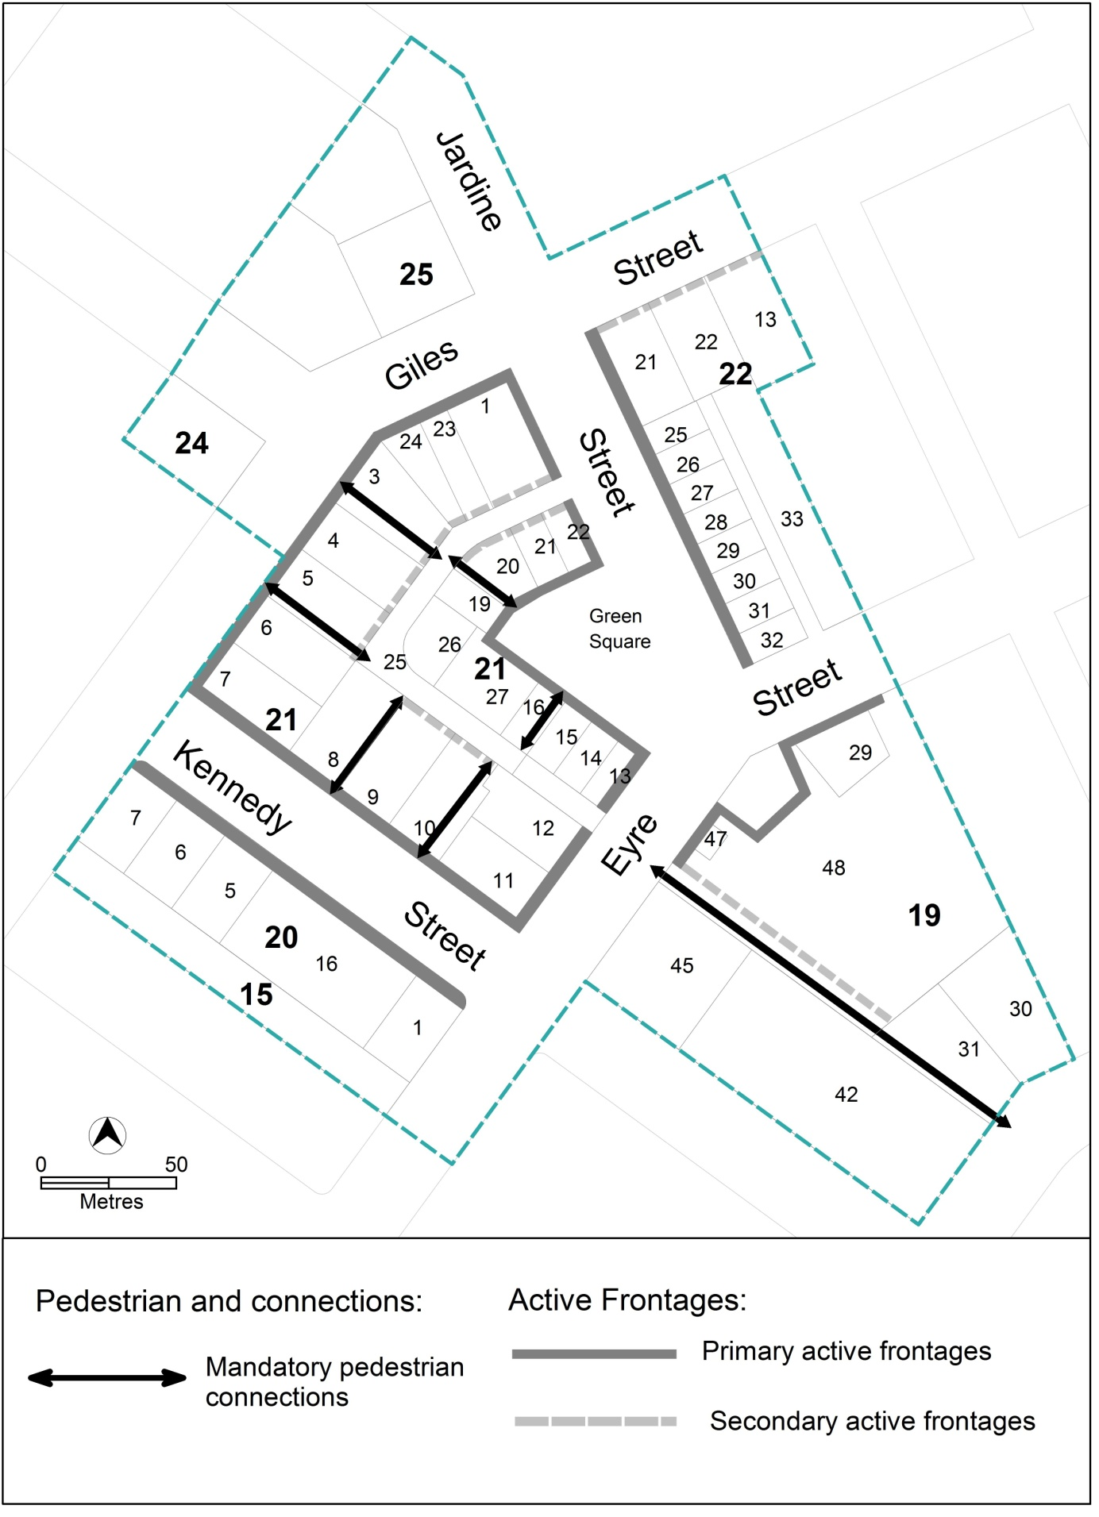
Figure 4 Pedestrian connections and active frontages

Rules | Criteria
  - Active frontages
For buildings located along primary active frontage areas identified in figure 4, frontages and building design comply with all of the following:  - buildings incorporate clear display windows and/or shop fronts at the ground floor level  - buildings incorporate direct pedestrian access at grade with the verge level for access and egress for persons with disabilities  - any small areas of walls without windows contain displays, showcases and/or public art, with a maximum of 30% blank frontage per tenancy  - open structured car parks, loading docks, substations and service infrastructure are not located along the frontage | This is a mandatory requirement. There is no applicable criterion.
For buildings located along primary active frontages identified in figure 4, the maximum distance of a street frontage per tenancy is 6m. | Ground floor tenancies provide fine grain development consistent with the existing character of shops in Green Square and Jardine Street.
For buildings located along secondary active frontage areas identified in figure 4, frontages and building design complies with all of the following:  - buildings incorporate clear display windows and shop fronts at the ground floor level  - buildings incorporate direct pedestrian access at grade with the verge level for access and egress for persons with disabilities  - building facades are not dominated by extensive lengths of blank facades, open structured carparks, loading docks, substations or other service infrastructure | Development at ground floor level achieves all of the following:  - is adaptable for shops  - where building access is provided, direct pedestrian access at street level  - provide opportunities for views into and out of the building
  - Awnings
This rule applies in CZ1 to buildings fronting primary active frontage areas shown in figure 4.  Awnings comply with all of the following:  - cantilevered awnings for the full extent of the building frontage  - awnings are a minimum height of 3m above finished pavement or ground level of the verge  - awnings are integrated into the building design at the first floor level  - awnings are a minimum of 3m in cantilever depth, except  - where opposing primary active frontages are 6m apart or less, awning depth may be reduced to ensure awnings are separated by 0.5m  - awning depth may be reduced to retain existing tree plantings | This is a mandatory requirement. There is no applicable criterion.
  - Vehicle access
This rule applies to development of 3 storeys or more in section 20.  Vehicle access is not permitted from Kennedy Street. | This is a mandatory requirement. There is no applicable criterion.
This rule applies to section 21.  Direct vehicular access is not permitted from Kennedy, Giles, Jardine or Eyre Street. | This is a mandatory requirement. There is no applicable criterion.

- Environment
Rules | Criteria
  - Landscaping
There is no applicable rule. | Landscaping in area A in figure 3 achieve consistency with:  - the existing landscape treatment in Green Square  - the desired character
  - Potentially noisy uses – part section 22
This rule applies to section 22 blocks 21, 25-33.  Development of one or more of the following uses complies with a noise management plan prepared by a suitably qualified person and endorsed by the Environment Protection Authority (EPA):  - club  - drink establishment  - emergency services facility  - hotel  - indoor entertainment facility  - indoor recreation facility  - motel  - outdoor recreation facility  - restaurant  The noise management plan will detail the proposed design, siting and construction methods that will be used to ensure compliance with the Environment Protection Regulation 2005, based on the estimated noise levels when the facility is in use. | This is a mandatory requirement. There is no applicable criterion.

- Entity (Government agency) endorsement
Rules | Criteria
  - Entity endorsement
The following matters are to be endorsed by the nominated agency  - Territory and Municipal Services Directorate  - landscaping  - footpaths  - cycle paths  - pedestrian connections  - driveway access  - Transport planning  - parking study  Note: TAMS will endorse a plan if it complies with the relevant TAMS standard. TAMS may endorse departures. | This is a mandatory requirement. There is no applicable criterion.

