Australian Capital Territory
Road Transport (Mass, Dimensions and Loading) Higher Mass Limits (HML) Exemption Notice 2013 (No 1)
Notifiable instrument NI2013-348
made under the
Road Transport (Mass, Dimensions and Loading) Regulation 2010, section 47 (Higher mass limit notices for eligible vehicles).

1 Name of instrument
This instrument is the Road Transport (Mass, Dimensions and Loading) Higher Mass Limits (HML) Exemption Notice 2013 (No 1).
2 Commencement
This instrument commences on the day after its notification.
3 Vehicle exemption
I exempt a vehicle or combination to which this notice applies under part 1 of schedule 1 from the mass limits set out in section 1.9 of schedule 1 to the Road Transport (Mass, Dimensions and Loading) Regulation 2010 if the vehicle complies with, and is operated in accordance with, the conditions set out in part 2 of the schedule.
4 Declared routes
I declare that a vehicle or combination to which this notice applies may operate on a route mentioned in schedule 1.
5 Displacement of Legislation Act, s 47 (6)
The Legislation Act, section 47 (6) does not apply to this instrument.
Note The text of an applied, adopted or incorporated instrument, whether applied as in force at a particular time or from time to time, is taken to be a notifiable instrument if the operation of the Legislation Act, s 47 (5) or (6) is not disapplied (see s 47 (7)).
6 Revocation
This instrument revokes NI2010-98 and NI2011-418.

Gary Byles
Director-General
Territory and Municipal Services
7 August 2013

Part 1 - Application
1.1 Application
1.1.1 This notice applies to a heavy vehicle or heavy combination that meets the definition of an eligible vehicle defined in section 43 of the Road Transport (Mass, Dimensions and Loading) Regulation 2010 (the Regulation) operated by an operator accredited under a Mass Management Accreditation Scheme within the meaning of section 46 of the Regulation.
1.2.2 An eligible vehicle must also comply with the provisions of any permit or other notice issued under the Regulation which may apply to such a vehicle or combination operating under this notice.
1.2 Mass limits for axles and axle groups
The mass limits specified in section 1.3 of schedule 1 of the Regulation apply to an eligible vehicle operating under this notice.
1.3 Maximum gross mass limits for a vehicle or combination
The maximum gross mass limits for a vehicle or combination specified in section 1.3 of schedule 1 of the Regulation apply to an eligible vehicle operating under this notice.

1.4 Wide single tyres (super singles)

This notice does not apply to those vehicles fitted with wide single tyres, which are used in substitution for dual tyres.

Part 2 – Operation and travel requirements

  - Mass Management Accreditation Scheme

Heavy vehicles and heavy combinations to which this notice applies must comply with section 46 of the Regulation.

Note:
The Australian Capital Territory Road Transport Authority does not offer National Heavy Vehicle Accreditation Scheme (NHVAS) accreditation however ACT operators may apply for accreditation in other jurisdictions.

2.2 Route compliance

Vehicles operating under this notice must meet any route compliance requirements determined by the Road Transport Authority.

Part 3 – Approved Higher Mass Limits Routes

National Highways and Main Roads in the ACT | From | To
Barton Highway | ACT/NSW Border | Federal Highway
Federal Highway | ACT/NSW Border | Barton Highway
Majura Road | Federal Highway | Fairbairn Avenue
Fairbairn Avenue | Morshead Drive | Pialligo Avenue
Morshead Drive | Fairbairn Avenue | Parkes Way
Parkes Way | Morshead Drive | Coranderrk Street
Coranderrk Street | Parkes Way | Cooyong Street
Cooyong Street | Coranderrk Street | Northbourne Avenue
Northbourne Avenue | Cooyong Street | Federal Highway / Barton Highway
Pialligo Avenue | Dairy Road / Morshead Drive | Sutton Road / Yass Road
Dairy Road (southbound only) | Morshead Drive / Pialligo Ave | Monaro Highway
Yass Road | Sutton Road / Pialligo Avenue | ACT/NSW border
Sutton Road | Pialligo Avenue / Yass Road | ACT/NSW Border
Kings Highway | ACT/NSW Border | ACT/NSW border
Monaro Highway | Morshead Drive | Newcastle Street on and off ramps
Monaro Highway | Canberra Avenue on and off ramps | ACT/NSW border
Lanyon Drive | Monaro Highway | ACT/NSW Border
Newcastle Street | Monaro Highway on and off ramps | Ipswich Street
Ipswich Street | Canberra Avenue | Newcastle Street
Canberra Avenue | Monaro Highway on and off ramps | ACT/NSW border
Gungahlin Drive | Barton Highway | Well Station Drive
Flemington Road | Federal Highway | Well Station Drive
Areas where HML vehicles may travel
Mitchell Industrial Estate Area | All roads in the area bounded by and including:  Gungahlin Drive;  Sandford Street;  Well Station Drive; and  Flemington Road  With the exception of Pelle Street and all roads within Gungahlin Cemetery.

ACT Higher Mass Limit Routes
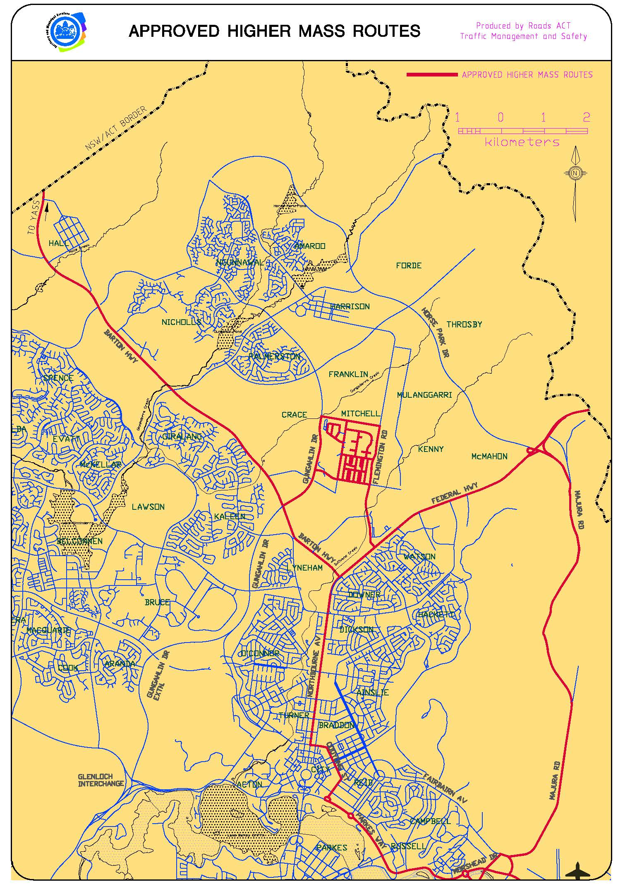

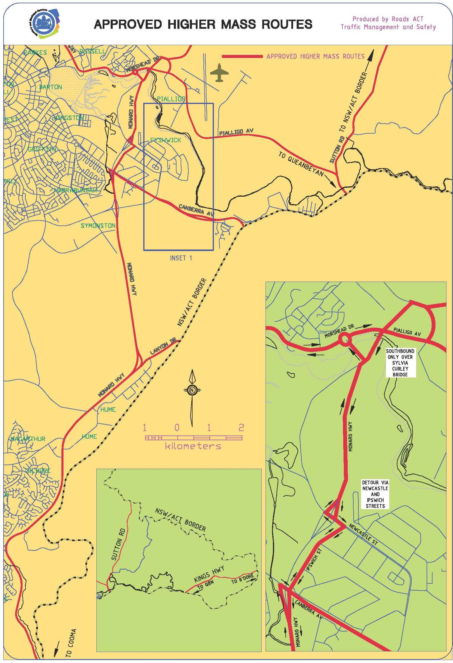

Part 4 – Definitions

For the purpose of this notice:

Mass Management Accreditation Scheme means:
(a) a scheme under the Mass Management Module of the National Heavy Vehicle Accreditation Scheme that is approved by the authority, or
(b) any other scheme (that is not a national scheme) in relation to mass management developed by a body or organisation other than the National Transport Commission that is approved by the authority.

