Australian Capital Territory

Planning and Development (Technical Amendment—Ngunnawal) Plan Variation 2013 (No 2)*

Notifiable Instrument NI2013—435
Technical Amendment No 2013—13
made under the
Planning and Development Act 2007, section 89 (Making technical amendments) s96 (land ceases to be in future urban area)

This plan variation commences on the day after it is notified.

Variation No 2013—13 to the Territory Plan has been approved by the Planning and Land Authority.

Variation to the Territory Plan
The Territory Plan map is varied as indicated in Annexure A to identify the zones and overlays that apply to the land ceasing to be in a future urban area.

Variation to the Precinct Map and Code
Substitute page 1 - Ngunnawal Precinct Map and page 6 – Figure 1 in the Ngunnawal Precinct Map and Code at Annexure B to incorporate ongoing block specific provisions for the area.

Jim Corrigan
Delegate of the Planning and Land Authority
26 September 2013

THIS IS PAGE ONE OF ANNEXURE A
TO NOTIFIABLE INSTRUMENT NI2013–435

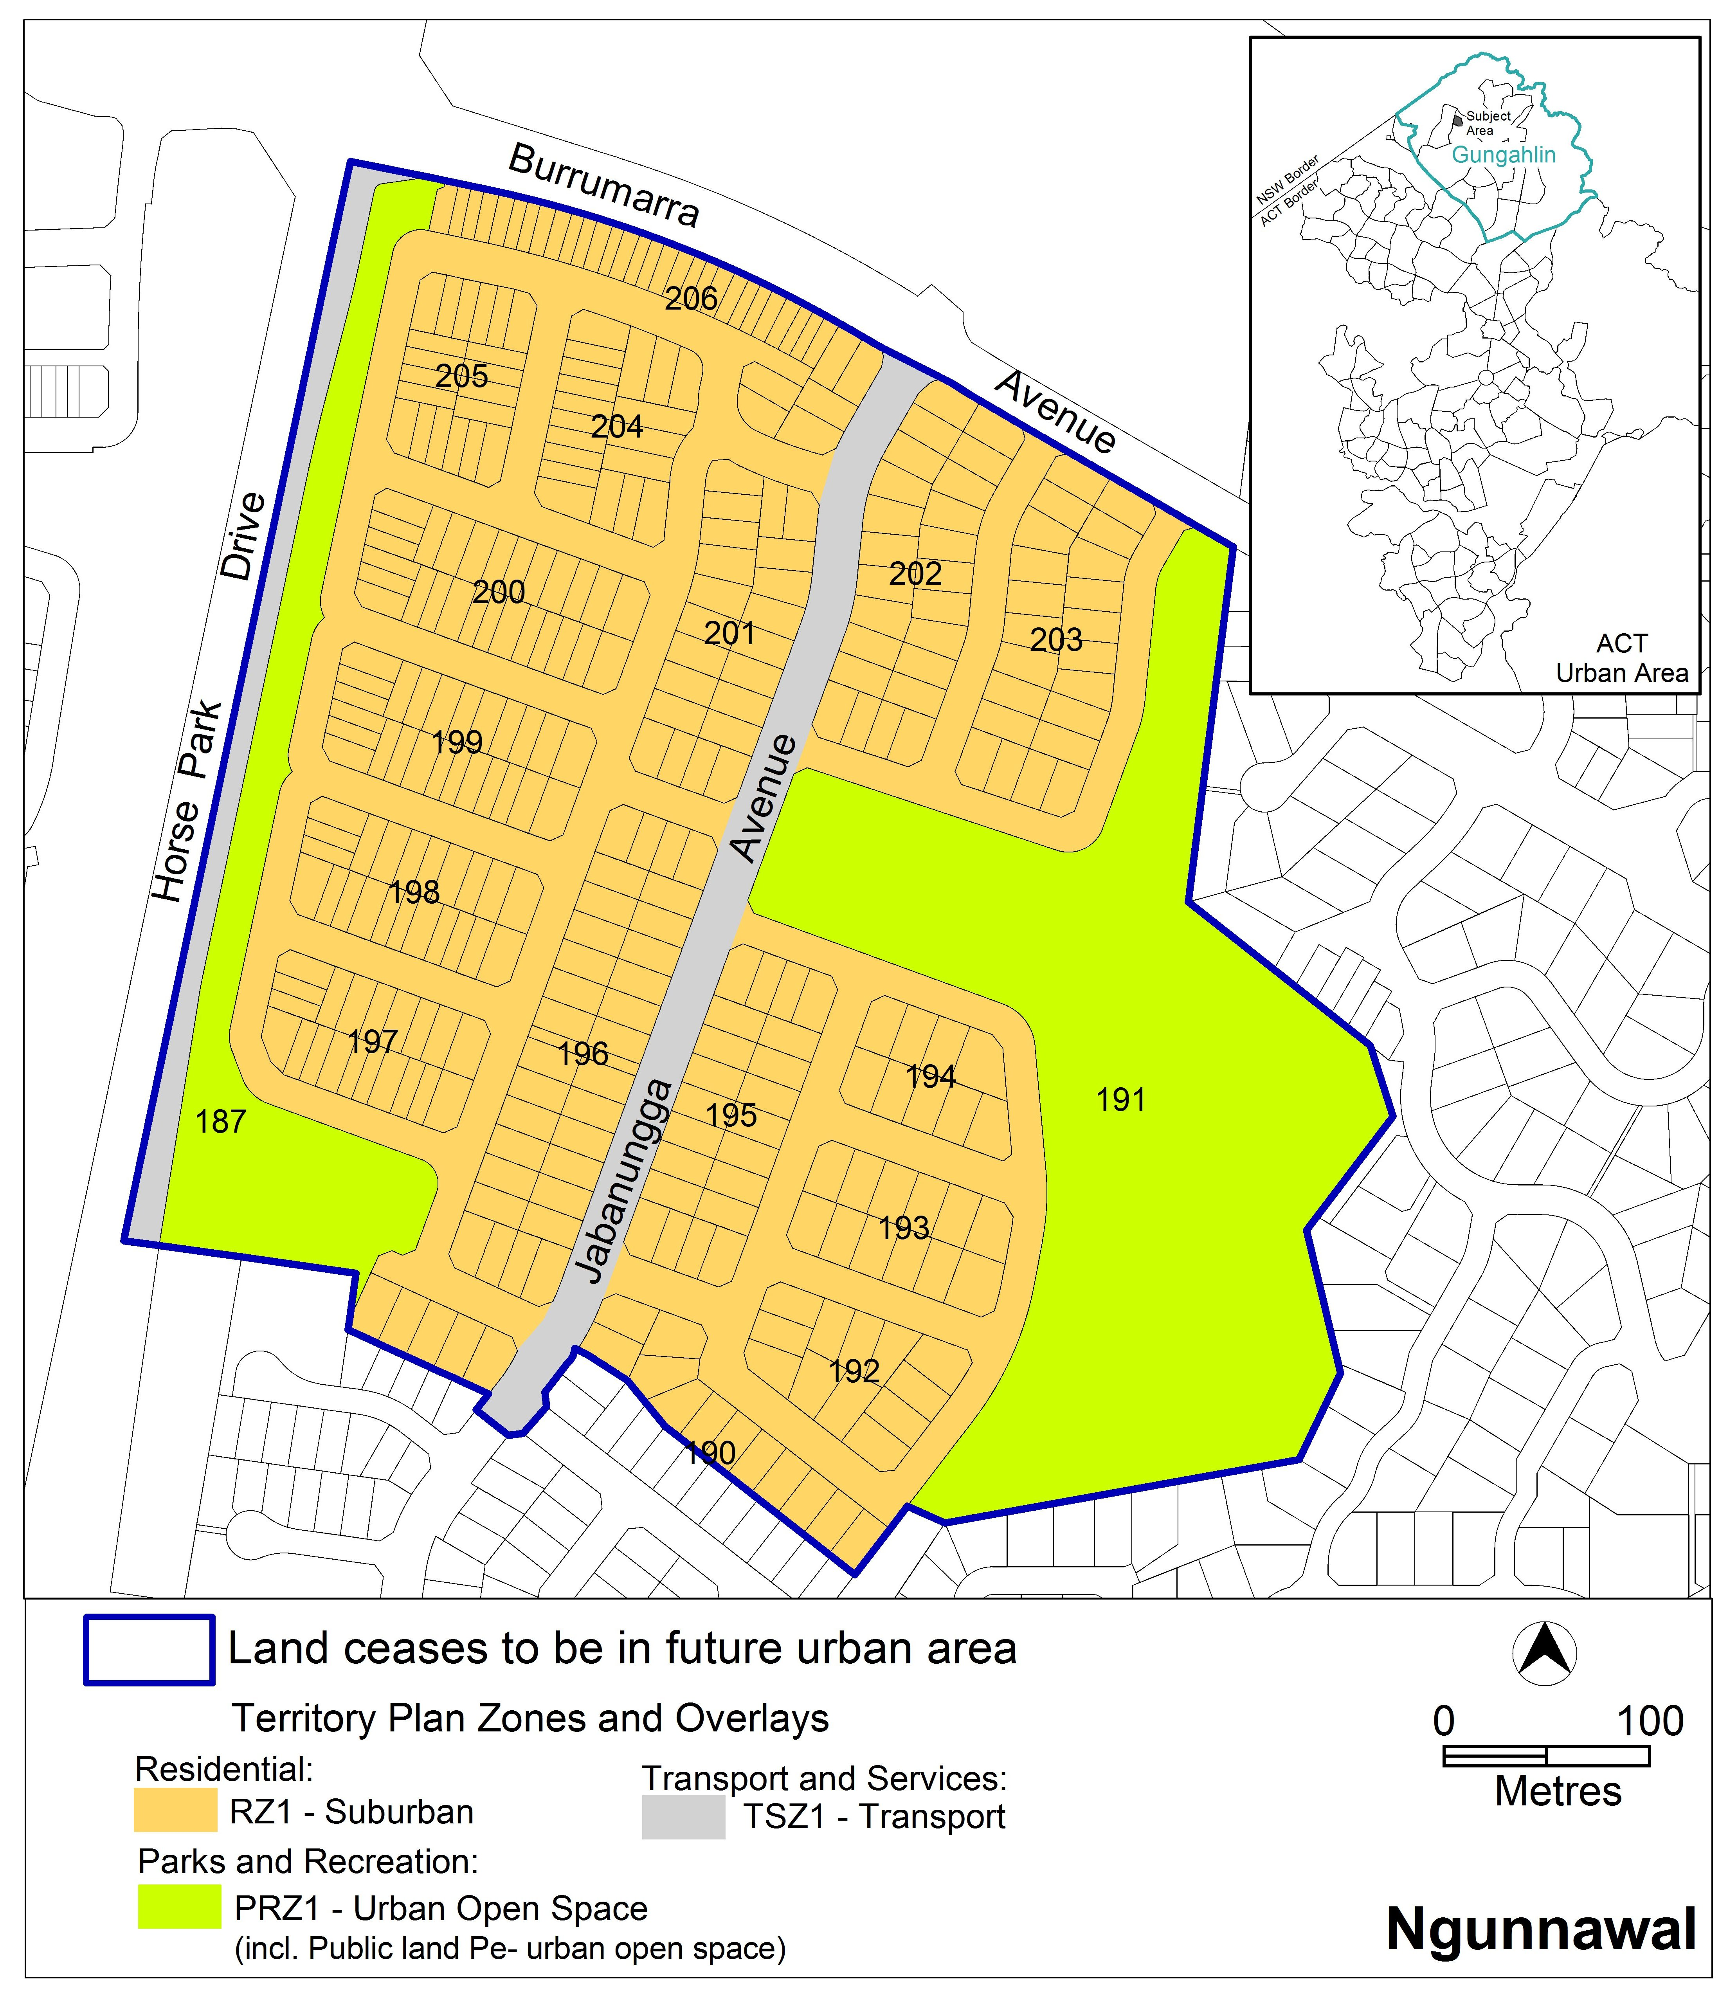

Jim Corrigan
Delegate of the Planning and Land Authority
26 September 2013
THIS IS PAGE ONE OF ANNEXURE B
TO NOTIFIABLE INSTRUMENT NI2013 –435

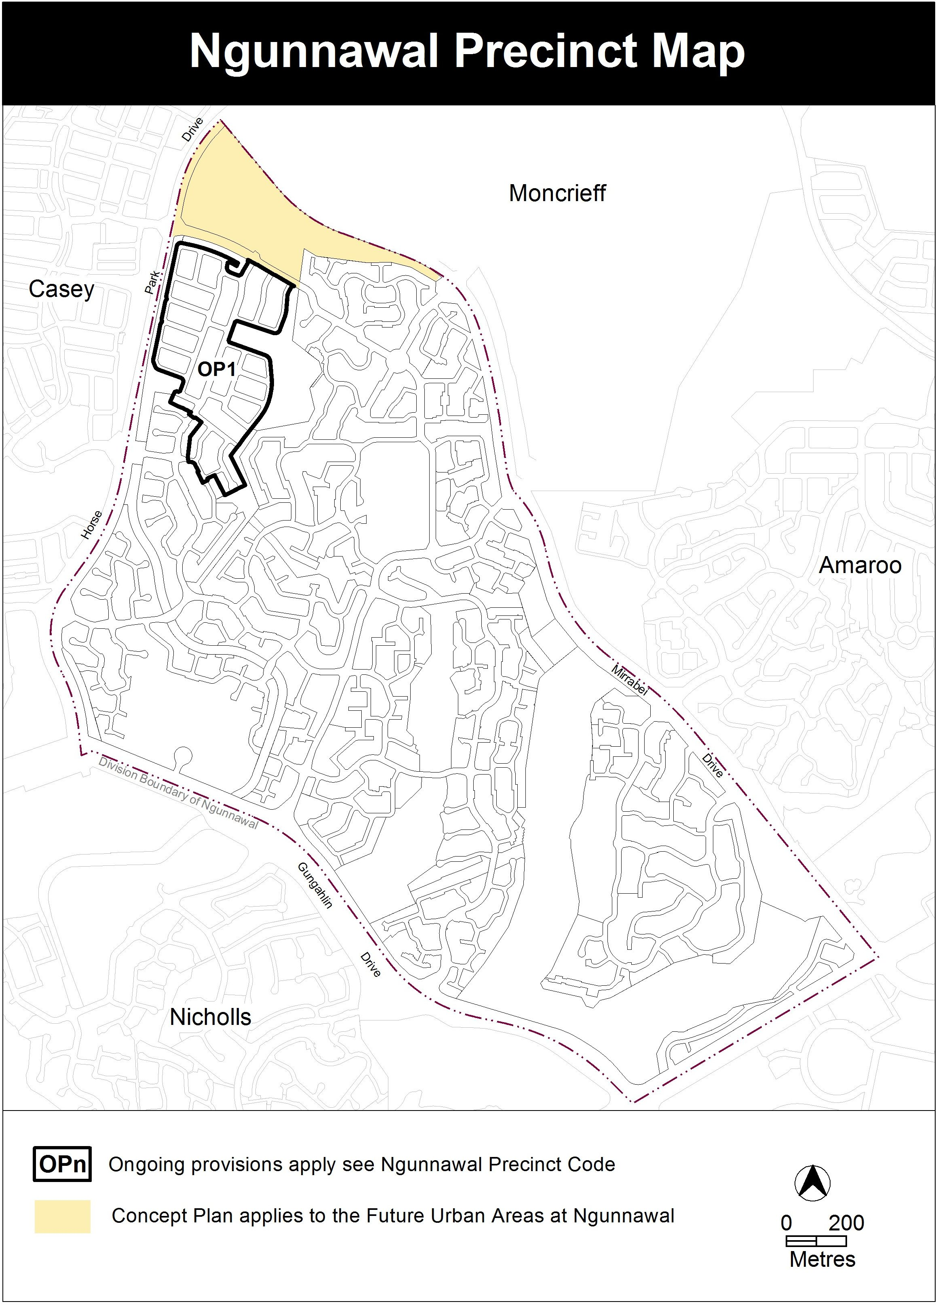

Jim Corrigan
Delegate of the Planning and Land Authority
26 September 2013
THIS IS PAGE TWO OF ANNEXURE B
TO NOTIFIABLE INSTRUMENT NI2013–435

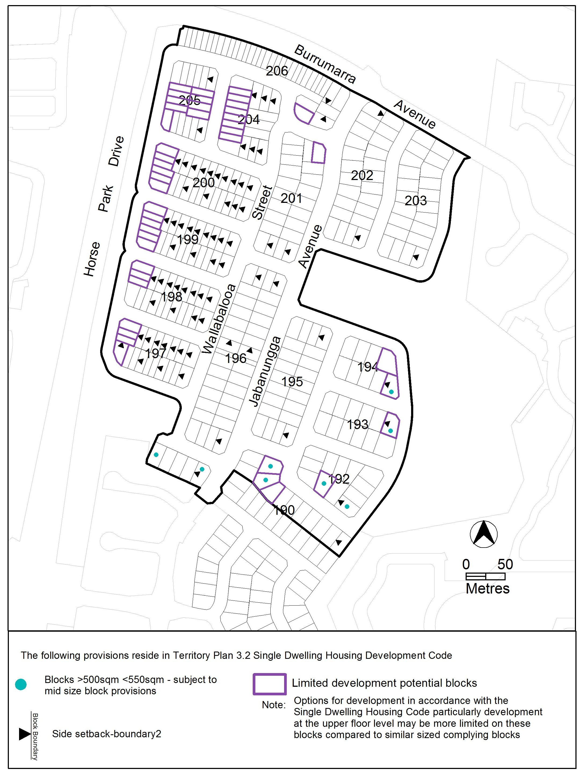

Jim Corrigan
Delegate of the Planning and Land Authority
26 September 2013

