Australian Capital Territory
Planning and Development (Draft Variation No 324) Consultation Notice 2013
Notifiable instrument NI2013—474
made under the
Planning and Development Act 2007, section 63 (Public consultation—notification) and section 64 (Public consultation—notice of interim effect etc)

Under the Planning and Development Act 2007 (the Act), section 63(1), the planning and land authority has prepared Draft Variation No 324 to the Territory Plan – Pialligo section 9 part block 4 and section 12 part block 2 (see Annexure A).
Draft Variation No 324 to the Territory Plan proposes to rezone an area of land comprising approximately 7.8ha in Pialligo, District of Majura on the Western side of Majura Road, opposite Majura Park, from broadacre (NUZ1) to mixed use industrial (IZ2). The variation is proposed in conjunction with the National Capital Authority’s proposed rezoning of the subject land from ‘broadacre’ to ‘urban’ on the National Capital Plan. The proposed rezoning will enable opportunities for large bulky goods retailing, freight transport, warehousing and distribution operations on this site.
The draft variation and background documents are available online at www.act.gov.au/draftvariations until the closing date for written comments.

Printed copies of the draft variation and background documents are available for inspection and purchase at the Environment and Sustainable Development Customer Service Centre, 16 Challis Street, Dickson, Monday to Friday (except public holidays) between 8:30am and 4:30pm. Please call 6207 1923 to arrange a copy for purchase.

Written comments from the public are invited from the public by 29 November 2013.

Comments should include reference to the draft variation, your name and contact details, and be addressed to the Territory Plan Variation Unit.

Comments can be:
- emailed to terrplan@act.gov.au
- mailed to Territory Plan Comments, GPO Box 158, Canberra, ACT 2601
- delivered to ESDD’s Customer Service Centre at 16 Challis Street, Dickson

Copies of written comments will be made publicly available 10 working days after the closing date for no less than 15 working days at ESDD’s Customer Service Centre in Dickson and may be published on ESDD’s website.

Comments made available will include personal contact details unless excluded under section 411 or 412 of the Act. A request for exclusion under these sections must be in writing, clearly identifying what you are seeking to exclude and how the request satisfies the exclusion criteria.

Effect of the draft variation

Section 65 of the Act does not apply in relation to the draft variation so it does not have interim effect. The current Territory Plan will continue to apply while the variation remains in draft form.

Jim Corrigan
Delegate of the ACT Planning and Land Authority
16 October 2013

Annexure A

Planning and Development Act 2007

Draft
Variation to the
Territory Plan
No 324

Industrial Land Supply –
Pialligo section 12 part block 2 and section 9 part block 4

October 2013

Draft variation for public consultation prepared
under s60 of the Planning and Development Act 2007

This page is intentionally blank.

Contents

1. INTRODUCTION 2
1.1 Summary of the Proposal 2
1.2 Outline of the process 2
1.3 This document 2
1.4 Public Consultation 2
2. EXPLANATORY STATEMENT 2
2.1 Background 2
2.2 Site Description 2
2.3 Current Territory Plan Provisions 2
2.4 Proposed Changes 2
2.4.1 Proposed Changes to the Territory Plan Map 2
2.5 Reasons for the Proposed Draft Variation 2
2.6 Strategic Planning Context 2
2.6.1 The Eastern Broadacre Planning Study 2
2.6.2 ACT Planning Strategy 2
2.6.3 Transport for Canberra 2
2.7 Planning Context 2
2.7.1 National Capital Plan 2
2.7.2 Territory Plan 2
2.8 Interim Effect 2
2.9 Consultation with Government Agencies 2
3. DRAFT VARIATION 2
3.1 Variation to the Territory Plan 2

This page is intentionally blank.

- INTRODUCTION
  - Summary of the Proposal
Draft variation to the Territory Plan 324 (DV324) proposes to rezone an area of land comprising approximately 7.8ha on the Western side of Majura Road, opposite Majura Park, from broadacre (NUZ1) to mixed use industrial (IZ2). The NCA is currently circulating a draft NCA amendment to change the land use policy of this area from broadacre to urban on the National Capital Plan. This draft variation will enable opportunities for large bulky goods retailing, freight transport, warehousing and distribution operations to be made available to meet short term demand in this location. It will also ensure that the Territory Plan is in line with the proposed amendment to the National Capital Plan.

  - Outline of the process
The Commonwealth’s Australian Capital Territory (Planning and Land Management) Act 1988 allows for the Legislative Assembly to make laws to establish a Territory Planning Authority and for that Authority to prepare and administer a Territory Plan. The Planning and Development Act 2007 (the Act) establishes the Planning and Land Authority as the Authority which prepares and administers the Territory Plan, including continually reviewing and proposing amendments as necessary. The functions of the Authority are administered by the Environment and Sustainable Development Directorate (ESDD).
The Territory Plan is comprised of a written statement and a map. The written statement contains a number of parts, namely governance; strategic directions; zones (including objectives and development tables and zone or centre development codes); precinct codes; general codes; overlays; definitions; structure plans, concept plans and development codes for future urban areas.
The Territory Plan Map graphically represents the applicable land use zones (under the categories of residential, commercial, industrial, community facility, urban parks and recreation, transport and services and non urban), precincts and overlays. The zone, precinct and overlay requirements are detailed in the volumes of the Territory Plan.
Draft variations to the Territory Plan are prepared in accordance with the Act. Following the release of the draft variation under section 63 of the Act, submissions from the public are invited. At the conclusion of the consultation period the ESDD submits a report on consultation and a recommended final variation to the Minister responsible for planning for approval. The Minister has the discretion to determine if referral to the Legislative Assembly standing committee responsible for planning is warranted prior to approval, depending on the nature and significance of the proposal. If the draft variation is referred to the committee by the Minister or otherwise, the Minister must consider the findings of the committee before deciding whether to approve the draft variation. If the Minister approves the variation, the variation and associated documents will be tabled in the Legislative Assembly. Unless disallowed by the Legislative Assembly within five sitting days, the variation commences on a day nominated by the Minister.

  - This document
This document contains the background information in relation to the proposed variation. It comprises the following parts
Part 1 This Introduction
Part 2 An Explanatory Statement, which gives reasons for the proposed variation and describes its effect
Part 3 The Draft Variation, which details the precise changes to the Territory Plan that are proposed

  - Public Consultation
Written comments about the draft variation are invited from the public by 29 November 2013.
Comments should include reference to the draft variation, your name and contact details, and be addressed to the Territory Plan Variation Unit.
Comments can be:
- emailed to terrplan@act.gov.au
- mailed to Territory Plan Comments, GPO Box 158, Canberra, ACT 2601
- delivered to ESDD’s Customer Service Centre at 16 Challis Street, Dickson
Copies of written comments will be made available (unless excluded) for public inspection for no less than 15 working days starting 10 working days after the closing date for comment. The comments will be available at ESDD’s customer service centre in Dickson and may be published on ESDD’s website.
Comments made available will include personal contact details unless excluded under section 411 or 412 of the Planning and Development Act 2007. A request for exclusion under these sections must be in writing, clearly identifying what you are seeking to exclude and how the request satisfies the exclusion criteria.
Further Information
The draft variation, and background documents are available online at www.act.gov.au/draftvariations until the closing date for written comments.
Printed copies of the draft variation (this document) and background documents are available for inspection and purchase at the Environment and Sustainable Development Customer Service Centre, 16 Challis Street, Dickson, Monday to Friday (except public holidays) between 8:30am and 4:30pm. Please call 6207 1923 to arrange a copy for purchase.

- EXPLANATORY STATEMENT
  - Background
The objective of the proposed amendment is to provide a large, strategically located site to accommodate bulky goods retailing, warehousing, freight transport and distribution services and other commercial uses without jeopardising an adequate supply of industrial land in Canberra. There are currently limited sites large enough within the Canberra urban area to accommodate these uses. The proposed zoning for the site (IZ2 mixed use industrial) would be consistent with the expanding large format commercial business node that adjoins the site on the opposite side of Majura Road. The land forms part of a larger precinct (Precinct C) identified as suitable for development as employment lands in the Eastern Broadacre Study (2009). Site specific constraints can be adequately dealt with at the detailed design stage as part of any future development application.
  - Site Description
The subject land is Part Block 4 Section 9 and Part Block 2 Section 12, Pialligo (see location map in Figure 1). It is an area of approximately 7.8 ha fronting Majura Road, starting at the existing roundabout (Mustang Avenue) opposite Majura Park and extending southwest towards Spitfire Avenue. The Mustang Avenue roundabout services the existing Majura Park commercial and retail precinct on National Land that forms part of the Canberra International Airport Master Plan development.
The area forms part of a larger precinct created between the Majura Parkway currently under construction and the Canberra International Airport. The subject land is unleased Territory land, part of which is currently being used by the Territory and Municipal Services Directorate (TAMSD), ACT Government, to stockpile overburden from the adjoining Majura Parkway.

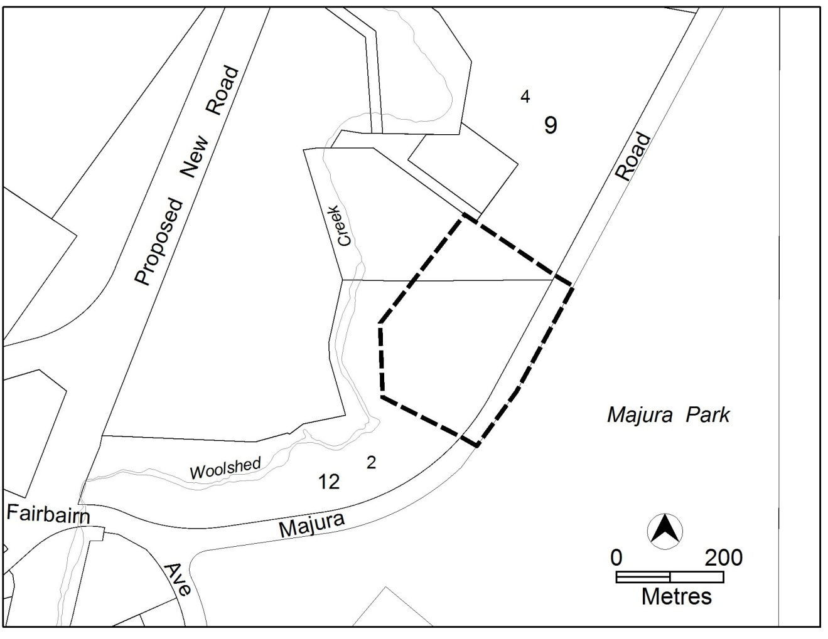
Figure 1 Area Subject to the Draft Variation

  - Current Territory Plan Provisions
The Territory Plan map zone for the area subject to this variation is shown in Figure 2.
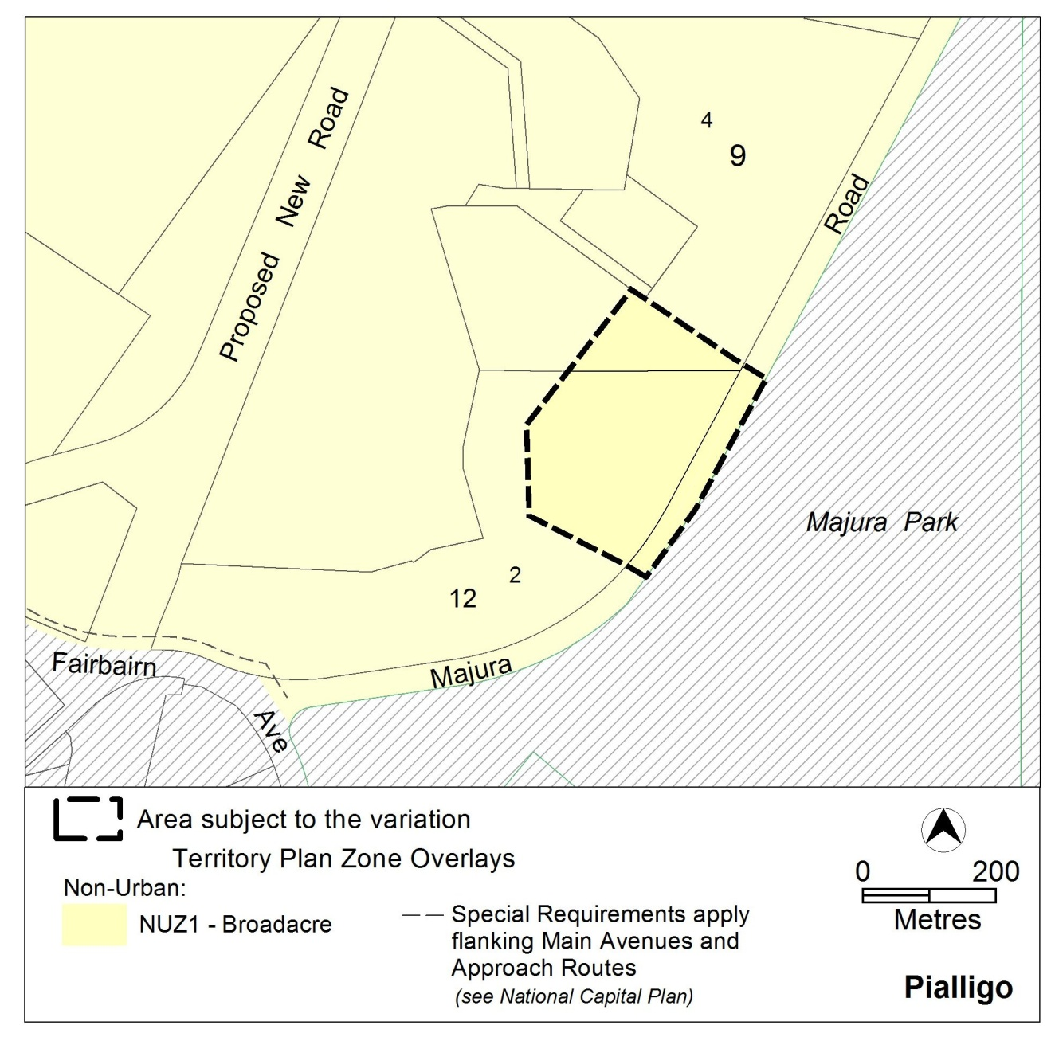
Figure 2 Territory Plan Zones Map

  - Proposed Changes
    - Proposed Changes to the Territory Plan Map
The proposed changes to the Territory Plan map are indicated in Figure 3 at Part 3 of this document and involve changing Part Block 4 Section 9 and Part Block 2 Section 12, Pialligo from broadacre NUZ1 to mixed-use industrial IZ2.
The draft variation map indicates the proposed zone boundaries as accurately as possible but may be subject to adjustments following detailed surveys.

  - Reasons for the Proposed Draft Variation
The proposed draft variation will:
- Supply an urgent need for additional employment lands, particularly in relation to the need for larger sites near the airport to enable the ACT to compete for economic development and to accommodate the necessary growth and diversification in employment
- Provide a large site to accommodate bulky goods retailing, warehousing, freight transport and distribution services and other commercial uses without jeopardising an adequate supply of industrial land
- Deliver a development area that is strategically located to provide good access to transport routes, especially heavy vehicle transport via the upgraded Majura Road, the new Majura Parkway and business transport via the Canberra airport to the south east
- Complement the current and ongoing Majura Park development to the east of the site
- Allow the site to be transitioned from an overburden stockpile site used to facilitate the construction of the Majura Parkway to a suitable site for future employment lands.

  - Strategic Planning Context
    - The Eastern Broadacre Planning Study
The area subject to this draft variation is consistent with the investigations precincts identified by the Eastern Broadacre Planning study. The 2009 ACT Eastern Broadacre Economic and Strategic Direction Study identified parts of the eastern side of the ACT, as a potential future employment, industrial and related uses corridor. The Eastern Broadacre area extends from the Majura Valley to Hume and includes Symonston and the Jerrabomberra Valley.
The area was originally identified in the Canberra Spatial Plan (2004) as a future potential employment corridor, providing for the growth of industrial, broadacre commercial, tourism, recreation and transport related activities. The Eastern Broadacre study identified precincts with development potential following a land capability assessment including ecology, landscape assessment, heritage, infrastructure, and transport reports.
Following completion of the study, the ACT Government refined the precinct boundaries on a range of further investigations (e.g. market analysis, flood studies, traffic & transport studies and ecological investigations) and investigation areas (precincts) were identified as having regard for heritage and ecological values, including Investigation Area – Precinct C which contains the subject land.
The Eastern Broadacre study included extensive consultation within Government and targeted consultation with industry and community stakeholders. This was followed by the release of the Planning the Eastern Broadacre Area – A Discussion Paper in July 2010 and analysis of subsequent submissions. In 2011, the ACT Government following a public consultation process agreed that over the next 20 years, nine areas warranted further detailed investigations into their development potential, including Majura Valley south and west Fyshwick.
Detailed studies are currently being undertaken over the Eastern Broadacre area to refine the boundaries of developable land within the 277ha study area (noting that 124.9ha is currently National land). The ACT Government acknowledges that a range of Commonwealth and ACT statutory processes will be required to rezone the land for employment and industrial uses.

    - ACT Planning Strategy
The draft variation complies with a number of key strategies of the ACT Planning Strategy including advancing planning for employment locations in the Eastern Broadacre area, adding to the industrial land supply program and enabling transport-related economic development near highways and the airport.

    - Transport for Canberra
The draft variation is consistent with the strategic goals of Transport for Canberra by encouraging industrial mixed use development adjacent to major transport routes and the airport.

  - Planning Context
    - National Capital Plan
The Australian Capital Territory (Planning and Land Management) Act 1988 established the National Capital Authority (NCA) with two of its functions being to prepare and administer a National Capital Plan (NCP) and to keep the NCP under constant review and to propose amendments to it when necessary.
The NCP, which was published in the Commonwealth Gazette on 21 January 1990, is required to ensure that Canberra and the Territory are planned and developed in accordance with their national significance. The Planning and Land Management Act 1988 also required that the Territory Plan is not inconsistent with the NCP.
A Draft Amendment to the National Capital Plan was approved by the National Capital Authority in August 2013, to change the land use policy of the subject land from broadacre to urban. Subject to public consultation, and subject to ministerial and parliamentary processes, the Amendment to the National Capital Plan could be approved by December 2013. The Environment and Sustainable Development Directorate (ACT Government) and the National Capital Authority have agreed to undertake joint consultation and advertisement so that a draft variation to the Territory Plan can be progressed at the same time.

    - Territory Plan
Statement of Strategic Directions
The draft variation is consistent with the Territory Plan’s statement of strategic directions in terms of environmental, economic and social sustainability and spatial planning and urban design principles.
The draft variation supports the following key principles in the strategic directions:
1.12 Planning policies will facilitate the widest possible range of commercial, retail, industrial, rural, tourism, and other forms of economic activity in order to promote new investment and a more diversified economy, to underpin employment growth, and to respond to changing economic opportunities.
The proposed amendments to the Territory Plan support this principle through providing a supply of large scale sites in the IZ2 mixed use industrial zone to respond to changing market needs.
1.14 An adequate and diverse supply of industrial land will be maintained to facilitate both conventional and new forms of industry.
The use of the site as a stockpile for overburden from the Majura Parkway has changed the broadacre character of the site. There is currently a limited supply of large scale IZ2 zoned land for a range of uses including bulky good retailing, in proximity to the airport.
2.3 Commercial and retail activity will be concentrated in centres and other planned nodes of intensive activity that are well served by public transport to ensure an efficient pattern of development. Primary emphasis will be placed on strengthening and enhancing existing and new centres and nodes, including improved urban design and encouragement of more mixed-use development.
The draft variation facilitates IZ2 mixed use industrial sites suitable for bulky goods with proximity to major transport routes and the existing airport related development.

2.8 Industrial areas will be in locations accessible to suitable freight services, and where industrial activity is unlikely to have a significant adverse effect on the environment or the amenity of residential areas.
The area of the proposed variation provides good access to transport, especially heavy vehicle transport via the upgraded Majura Road, the Majura Parkway (currently under construction) and business transport via the Canberra airport to the south east. The proposed use would be consistent with the expanding large format commercial business node that adjoins the site on the opposite side of Majura Road. The land forms part of a larger precinct previously identified as suitable for development as employment lands. Any industrial development on the site will need to ensure the necessary protection of Woolshed Creek from sediments and pollutant loads.

  - Interim Effect
Section 65 of the Planning and Development Act 2007 does not apply in relation to the draft variation so it does not have interim effect. The current Territory Plan will continue to apply while the variation remains in draft form.

  - Consultation with Government Agencies
The ESDD is required to, in preparing a draft variation under section 61(b) consult with each of the following in relation to the proposed draft variation:
- the national capital authority
- the conservator of flora and fauna
- the environment protection authority
- the heritage council
- if the draft variation would, if made, be likely to affect unleased land or leased public land – each custodian for the land likely to be affected

National Capital Authority
The National Capital Authority made the following comments on 27 September 2013
I refer to Draft Variation 324 (DV324) submitted to the National Capital Authority (NCA) for consideration on 26 September 2013. The NCA understands that the purpose of DV324 is to rezone land on the western side of Majura Road from broadacre to mixed use industrial. As you are aware, NCA officers have been in discussions with staff of the Environment and Sustainable Development Directorate and the Economic Development Directorate (EDD) regarding the expansion of urban land around Pialligo. Based on these discussions and a formal request from the EDD to amend the National Capital Plan (the Plan), on 16 August 2013 the Authority agreed to the preparation of a draft amendment to the Plan to expand the existing urban area, by changing the land use from broadacre to urban use at Pialligo, West Majura. It was agreed that the draft amendment would occur concurrently with an amendment to the Territory Plan, with joint consultation to occur. We look forward to continuing our work with the ACT Government to facilitate this process, including undertaking dual public consultation.
Response
Noted.

Conservator of Flora and Fauna
The Conservator of Flora and Fauna made the following comments on
2 October 2013
Thank you for providing the boundary of DV324 – Part Block 4 Section 9 and Part Block 2 Section 12 for comment.
The boundary incorporates an area utilised as part of the Majura parkway project as a site for stockpiling soil. The soil is currently being removed, so that most of the revised area now consists of bare dirt. The area now proposed for draft variation 324 does not include native grassland nor any potential habitat of the striped legless lizard, golden sun moth or other significant grassland plants or animals. Thus there are no objections to the proposed rezoning.
There is the potential for striped legless lizard and golden sun moth to utilise the adjacent remaining part of Block 2 Section 12 zoned as a broadacre landuse. It is understood that surveys of this land for these species have recently commenced and will be finalised by the end of the year. Depending on the results of the survey, conditions may need to apply to any actual development on the land to ensure that development does not have significant indirect impacts on threatened fauna. These conditions could relate to the siting of buildings, drainage, fire protection, the route of infrastructure conditions or fencing.

Response
Noted. Any new development proposal for the site would need to go through the mandatory assessment process, and any concerns raised by the Conservator would be addressed at that stage.

Environment Protection Authority
The Environment Protection Authority provided the following comments on 2 October 2013
Environment Protection have reviewed the revised area for comment and provide the following:
An assessment of the potential impacts and required mitigation measures to ensure development does not increase the potential for pollution of the environment including Woolshed Creek and downstream water ways should be undertaken to inform development of the site, particularly considering the Commissioner for the Environment and Sustainability’s recent “Report on the state of the watercourses and catchments for Lake Burley Griffin”.
In relation to the previous uses at the site and potential for land contamination, prior to the EPA supporting a change in the land use, in accordance with the ACT Strategic Plan for Contaminated Sites Management 1995, the findings of the contamination assessment into the suitability of the area for its proposed uses must be reviewed and endorsed by the EPA.

Response
The necessary protection of Woolshed Creek from sediments and pollutant loads during, and after development and the issue of contamination will be further considered as the draft variation progresses and could be dealt with as part of the detailed design for development of the site, at the development application stage.

Heritage Council
The Heritage Council provided the following comments on 1 October 2013
I refer to your electronic mail dated Thursday 26 September 2013, in which you referred Draft Variation to the Territory Plan No. 324 (DV324). DV324 was initially circulated on 16 September 2013. The Heritage Council (the Council) provided advice on the original referral on 24 September 2013, raising no objections subject to the fulfilment of certain conditions.
The revised referral proposes to rezone a reduced portion on land encompassing Section 12 Block 2, and Section 9 Part Block 4 Pialligo, from broadacre (NUZ1) to mixed use industrial (IZ2). It is proposed that DV324 will address an urgent need for additional employment lands, and provide a large, strategically located site to accommodate bulky goods. The majority of the area proposed for rezoning has been utilised for soil stockpile since 2009. The stockpile works were carried out upon completion of detailed cultural heritage studies by Cultural Heritage Management Australia. The studies included an archaeological investigation program, which yielded no cultural heritage material or stratigraphic integrity within the tested soil deposit. Owing to these results, the Council has no objections to DV324 where it relates to land affected by stockpiling.
With regard to land adjacent to the stockpile, the Council would like an early briefing or information on the scope of the initial cultural heritage assessment currently being undertaken across this area. The Council will also require timely access to the assessment to enable further comments to be prepared prior to finalisation of the draft variation. The Council would strongly encourage appropriate heritage studies to be completed prior to any development planning, and that such studies inform planning. This can help to ensure conflicts between heritage and development are avoided or at least minimised.

Response
Any new development proposal for the site would need to go through the mandatory assessment process. Council’s request for further briefing on the cultural heritage assessment is noted. Further investigation of the larger area, including this site is ongoing as part of the Eastern Broadacre project.

Land custodian – Territory and Municipal Services Directorate
TAMSD provided the following comments on 2 October 2013
TAMS supports the release of DV 324 for public consultation.

Response
Noted.
- DRAFT VARIATION
  - Variation to the Territory Plan
The Territory Plan map is varied as shown in Figure 3 for the area shown as subject to the variation.
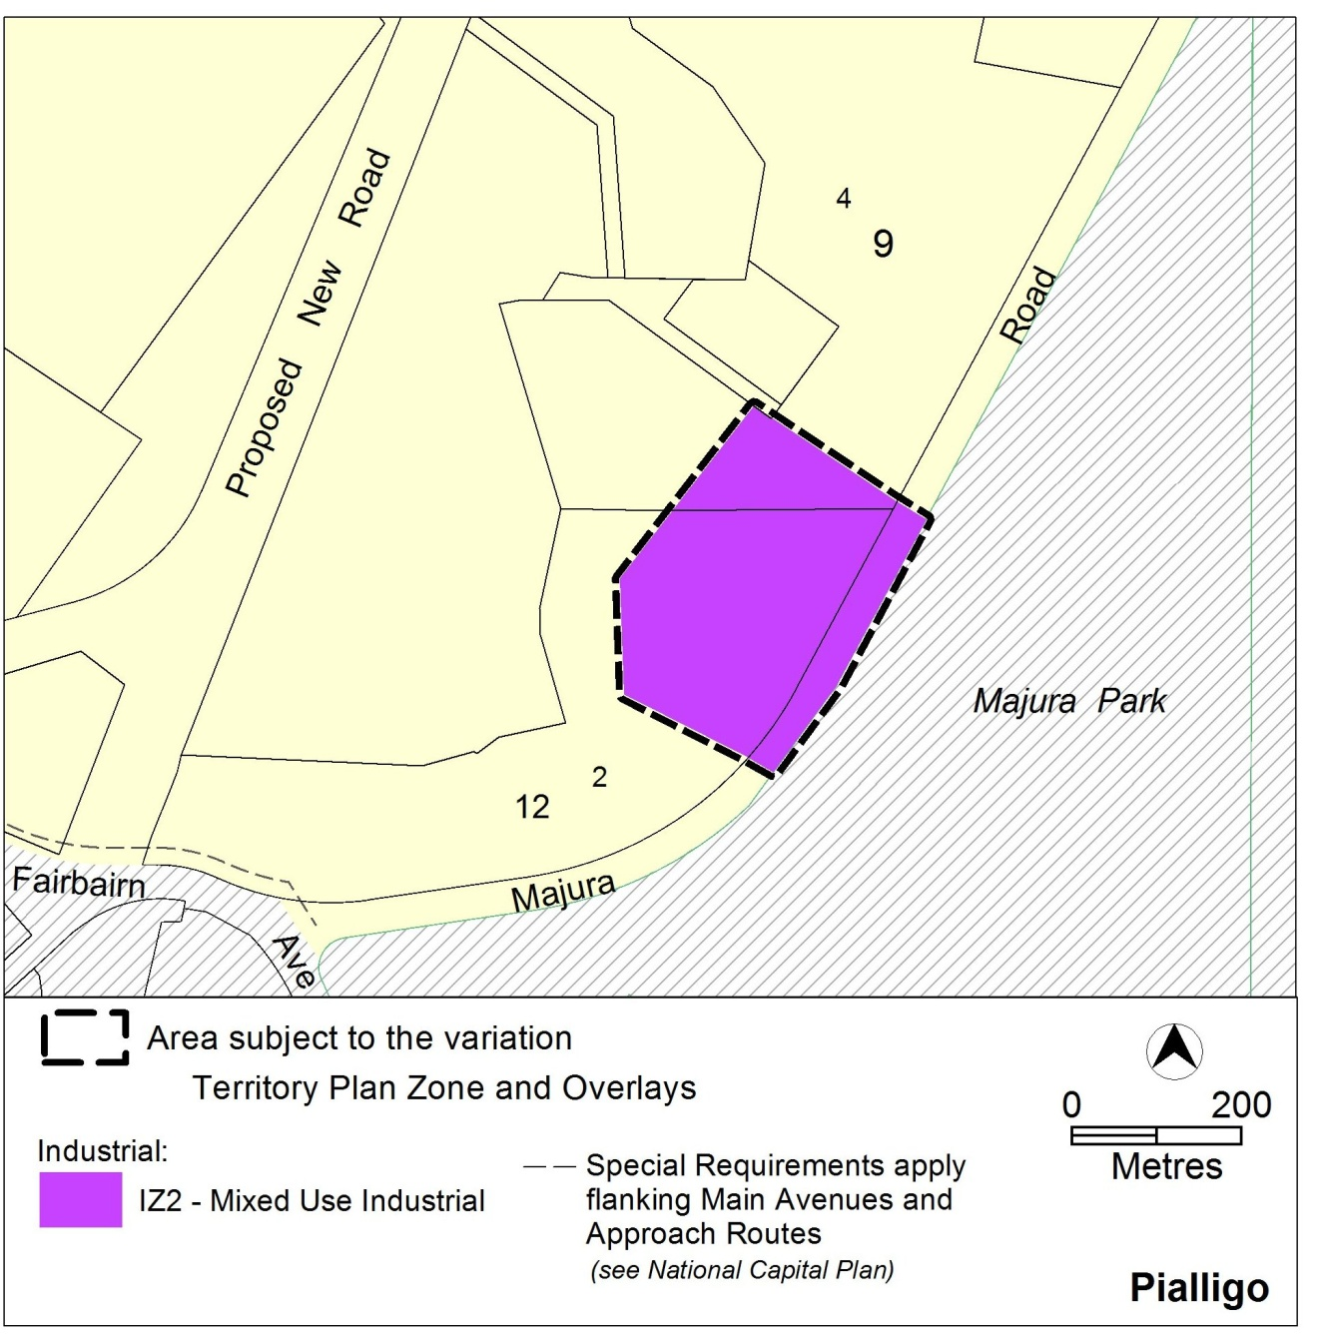
Figure 3 Proposed Territory Plan Provisions

Interpretation service
