Australian Capital Territory

Planning and Development (Technical Amendment—Amaroo) Plan Variation 2013 (No 1)

Notifiable Instrument NI2013—484
Technical Amendment No 2013—18
made under the
Planning and Development Act 2007, section 89 (Making technical amendments) s96 (land ceases to be in future urban area)

This plan variation commences on the day after it is notified.

Variation No 2013—18 to the Territory Plan has been approved by the Planning and Land Authority.

Variation to the Territory Plan
The Territory Plan map is proposed to be varied as indicated in Annexure A to identify the zones that apply to the land ceasing to be in a future urban area.

Introduction of the Precinct Map and Code

Annexure B proposes to introduce the Amaroo Precinct Map and Code for ongoing block specific provisions for this area.

Jim Corrigan
Delegate of the Planning and Land Authority
28 October 2013

THIS IS PAGE ONE OF ANNEXURE A
TO NOTIFIABLE INSTRUMENT NI2013–484

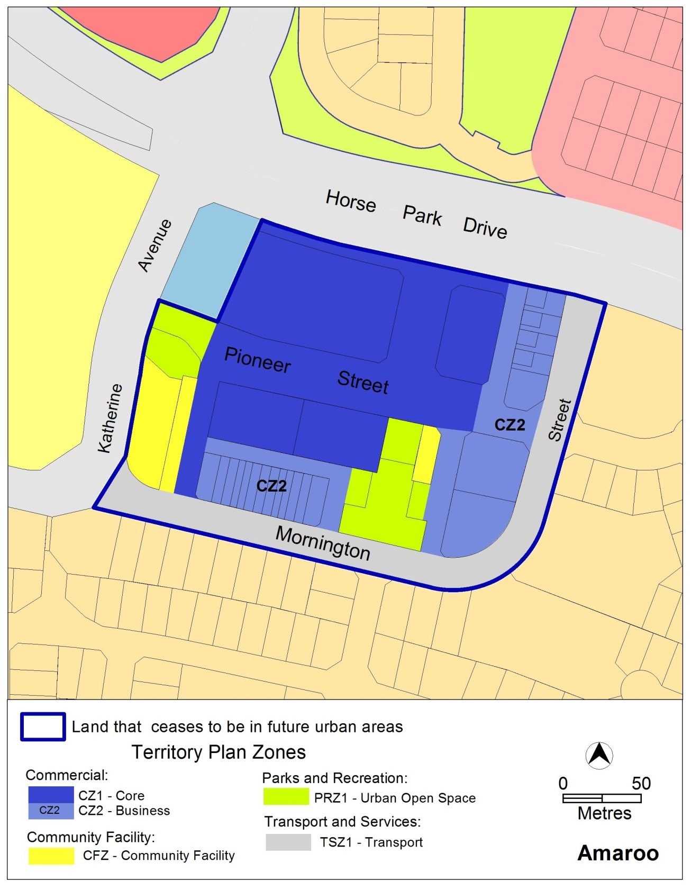

Jim Corrigan
Delegate of the Planning and Land Authority
28 October 2013

THIS IS ANNEXURE B TO
NOTIFIABLE INSTRUMENT NI2013–484

Jim Corrigan
Delegate of the Planning and Land Authority
28 October 2013

Amaroo Precinct Map and Code

This page is intentionally blank.

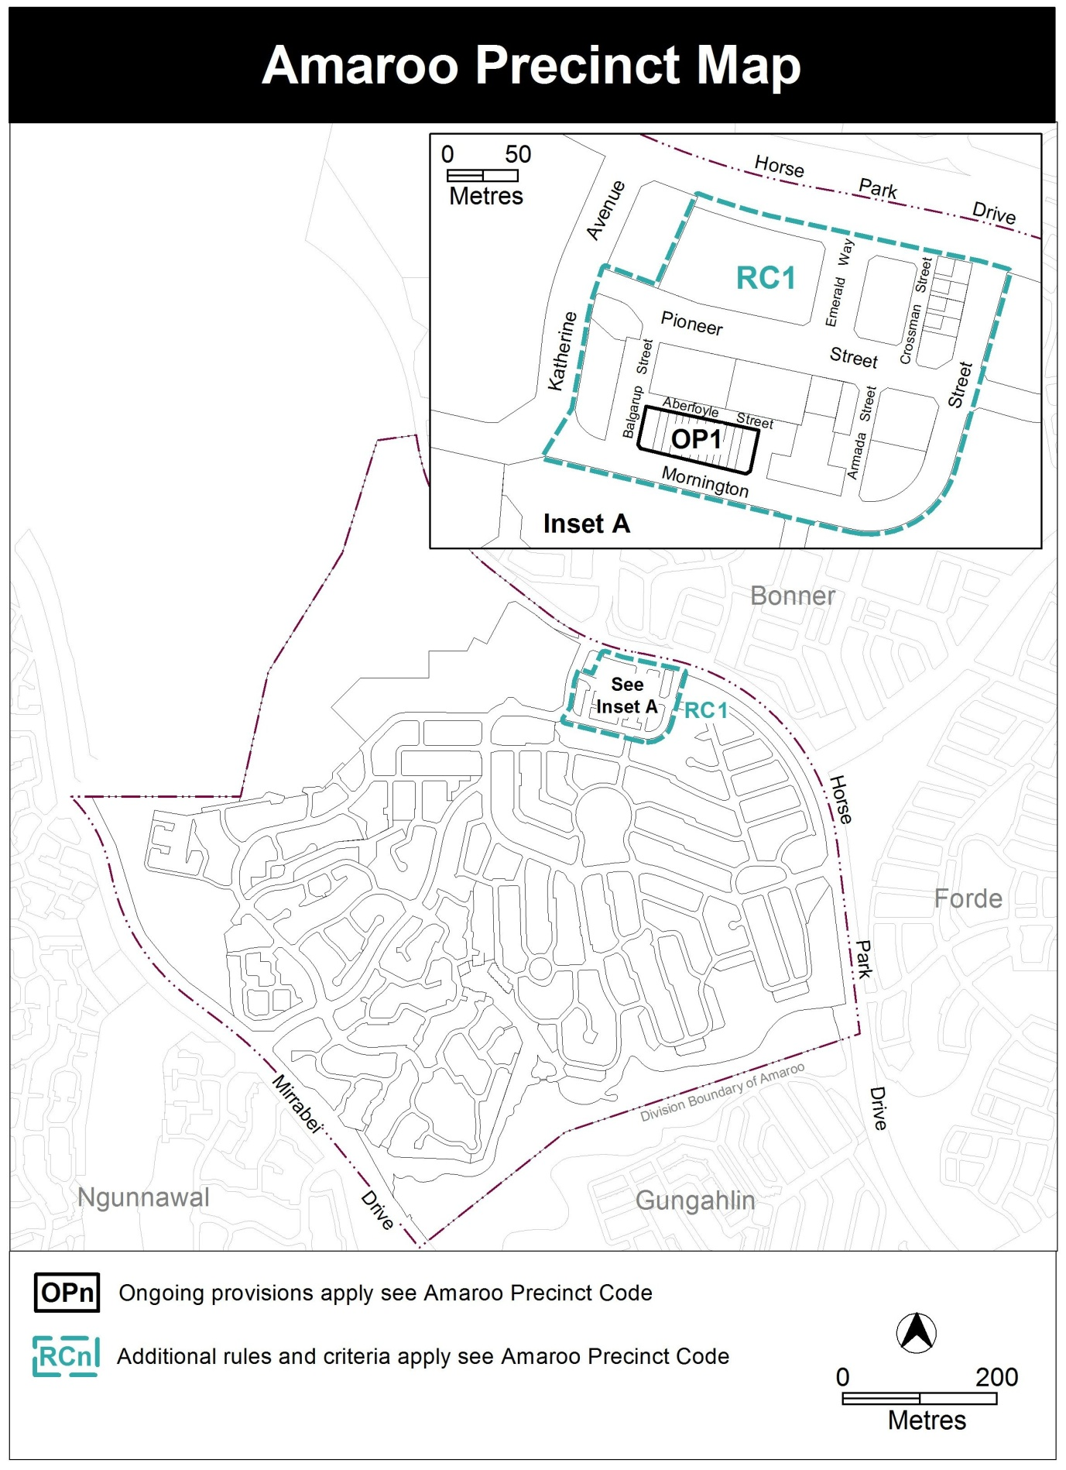

Amaroo Precinct Code

Contents
Introduction 3
Additional rules and criteria 5
RC1 – Amaroo Group Centre 5
Element 1: Building and site controls 5
1.1 Maximum number of storeys 5
1.2 Plot ratios 5
1.3 Setbacks 5
1.4 Ground floor use 6
Element 2: Environment 6
2.1 Deep root planting zones 6
Element 3: Amenity 7
3.1 Noise management plan 7
Other ongoing provisions 10
OP1 – Amaroo Group Centre 10

Figures
Figure 1 Amaroo Group Centre Building heights and plot ratios 8
Figure 2 Setbacks and deep root planting zones 9
Figure 3 Amaroo Group Centre Ongoing Provisions 10

Introduction
Name
The name of this code is the Amaroo Precinct Code.
Application
The code applies to the Division of Amaroo.
Purpose
This code provides additional planning, design and environmental controls for specific areas or blocks and may also contain references to provisions in other codes.
In conjunction with other relevant codes it will be used by the Authority to assess development applications and offer guidance to intending applicants in designing development proposals and preparing development applications.
Structure
This code contains additional rules and/or criteria for particular blocks or parcels identified as areas RCn on the precinct map, to be read in conjunction with the relevant development code. It may also contain sub-parts.
Each element has one or more rules and, unless the respective rule is mandatory, each rule has an associated criterion. Rules provide quantitative, or definitive, controls. By contrast, criteria are chiefly qualitative in nature.
In some instances rules are mandatory. Such rules are accompanied by the words “This is a mandatory requirement. There is no applicable criterion.” Non-compliance with a mandatory rule will result in the refusal of the development application. Conversely, the words “There is no applicable rule” is found where a criterion only is applicable.
Code hierarchy
Under the Planning and Development Act 2007, where more than one type of code applies to a development, the order of precedence if there is inconsistency of provisions between codes is: precinct code, development code and general code.
If more than one precinct code applies to the site, the most recent precinct code takes precedence to the extent of any inconsistency.
Definitions
Defined terms, references to legislation and other documents are italicised.
Definitions of terms used in this code are listed in part 13 of the Territory Plan or, for terms applicable only to this code, associated with the respective rule.

Acronyms
EPA ACT Environment Protection Authority
ESA ACT Emergency Services Agency
ESDD ACT Environment and Sustainable Development Directorate
NCA National Capital Authority
P&D Act Planning and Development Act 2007
TAMS ACT Territory and Municipal Services Directorate

Additional rules and criteria
This part applies to blocks and parcels identified in the Amaroo Precinct Map (RCn). It should be read in conjunction with the relevant zone development code and related codes.
RC1 – Amaroo Group Centre
This part applies to the Amaroo Group Centre identified as RC1 on the precinct map.

- Building and site controls
Rules | Criteria
  - Maximum number of storeys
R1  This rule applies to area A in Figure 1.  The maximum number of storeys is 4. | This is a mandatory requirement. There is no applicable criterion.
R2  This rule applies to area B in Figure 1.  The maximum number of storeys is 3. | This is a mandatory requirement. There is no applicable criterion.
  - Plot ratios
R3  This rule applies to area A in Figure 1.  The maximum plot ratio is 2:1 (200%). | This is a mandatory requirement. There is no applicable criterion.
R4  This rule applies to area B in Figure 1.  The maximum plot ratio is 1.5:1 (150%).  This rule does not apply to part section 114 Amaroo within the Community Facilities (CFZ) Zone | This is a mandatory requirement. There is no applicable criterion.
  - Setbacks
R5  Zero front boundary setbacks apply to lower floor levels of non residential development in locations identified in Figure 2. | This is a mandatory requirement. There is no applicable criterion.
R6  A minimum 3m setback to lower and upper floor levels are provided in the locations identified in Figure 2. | This is a mandatory requirement. There is no applicable criterion.
R7  Zero setbacks to lower floor garage elements are required in the locations identified in Figure 2. | This is a mandatory requirement. There is no applicable criterion.
R8
This rule applies to blocks or parcels in locations identified in Figure 2.
Awnings are provided beyond the block boundary at the lower floor level to all non-residential development with the following minimum widths:
- Blocks in section 114 fronting Balgarup Street and blocks in section 114 fronting the PRZ1 urban open space area: 2.4m
- Blocks in section 106 fronting Pioneer Street and Emerald Way: 3m
- Blocks in Section 110 fronting Pioneer Street and Emerald Way: 3m
- Blocks in Section 114 fronting Pioneer Street: 3m
A minimum 3m vertical clearance above finished ground level is required for all awnings.
  - Ground floor use
R9  The ground floor finished floor level to finished ceiling level height is not less than 3.6m. | C9  Buildings are adaptable to accommodate non-residential uses, including office and retail, at the ground floor.

- Environment
Rules | Criteria
  - Deep root planting zones
R10  This rule applies to blocks or parcels in locations identified in Figure 2.  A minimum 4m deep root planting zone (DRPZ) is provided with a wall or fence located along the block side of the DRPZ to screen service and waste activities from the street. The wall or fence is to be detailed to meet the Crime Prevention Through Environmental Design General Code requirements.  A single commercial driveway crossing of the DRPZ is permitted. | This is a mandatory requirement. There is no applicable criterion.

- Amenity
Rules | Criteria
  - Noise management plan
R11  This rule applies to blocks or parcels in locations identified in Figure 2.  Development will comply with a noise management plan prepared by a suitably qualified person and endorsed by the Environment Protection Authority.  The noise management plan will detail the proposed design, siting and construction methods that will be employed to address potential conflicts arising from commercial/ residential interface with neighbouring blocks. | This is a mandatory requirement. There is no applicable criterion.

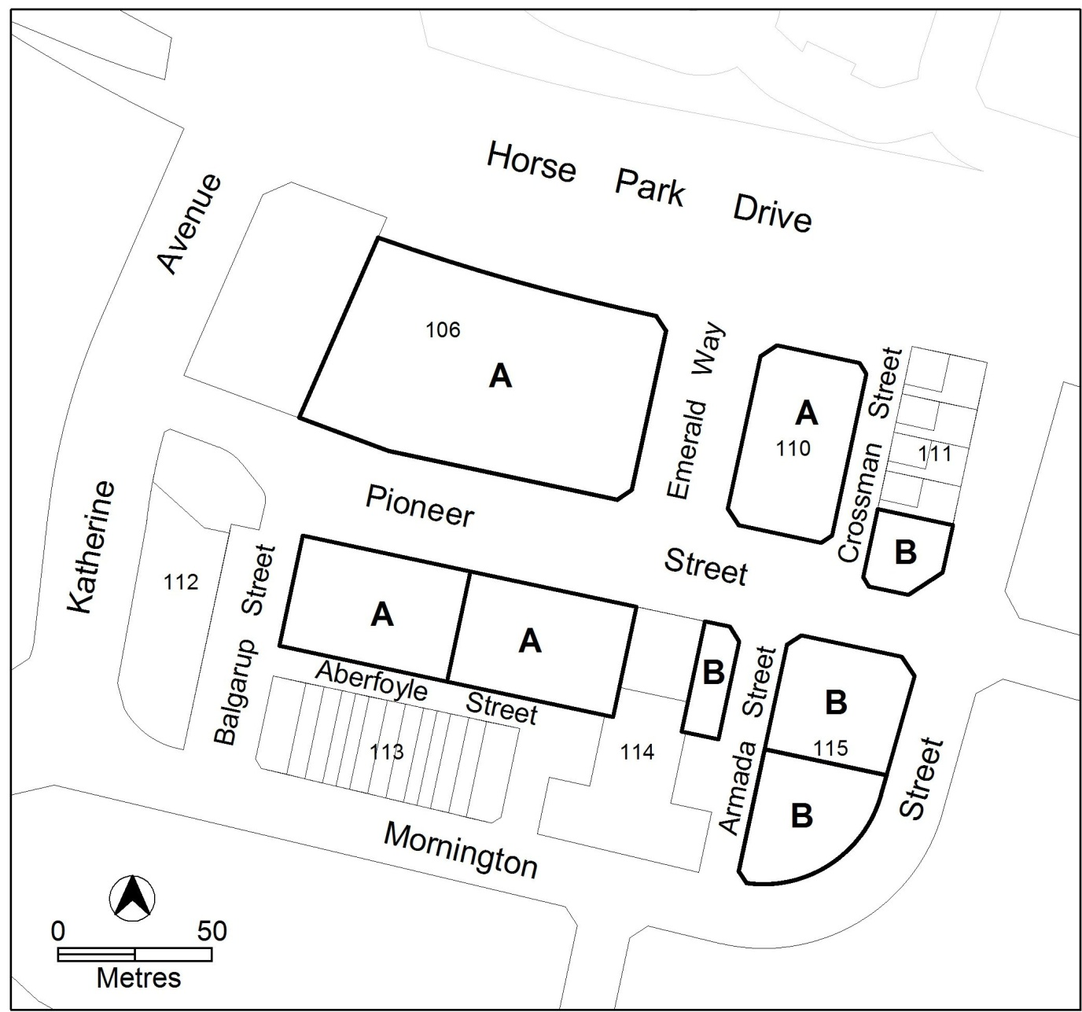
Figure 1 Amaroo Group Centre Building heights and plot ratios

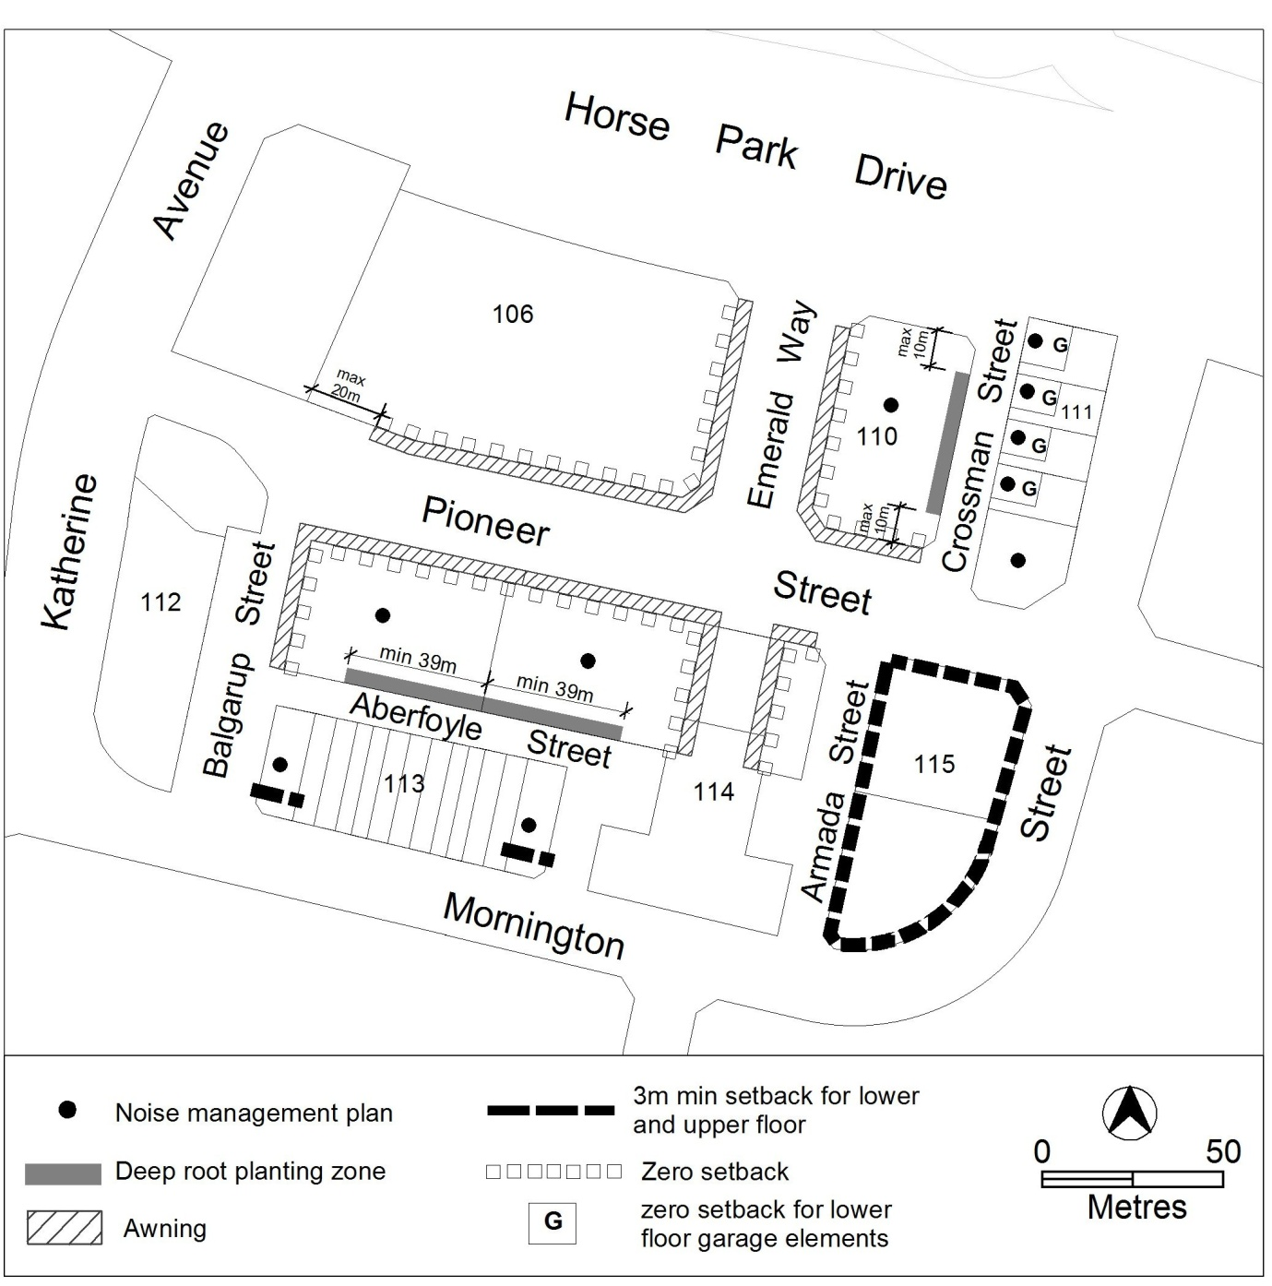
Figure 2 Setbacks and deep root planting zones

Other ongoing provisions
This part applies to blocks and parcels identified as ongoing provisions (OPn) in the Amaroo Precinct Map. It should be read in conjunction with the relevant zone development code and related codes.
OP1 – Amaroo Group Centre
This part applies to blocks and parcels identified in area OP1 shown on the Amaroo Precinct Map.
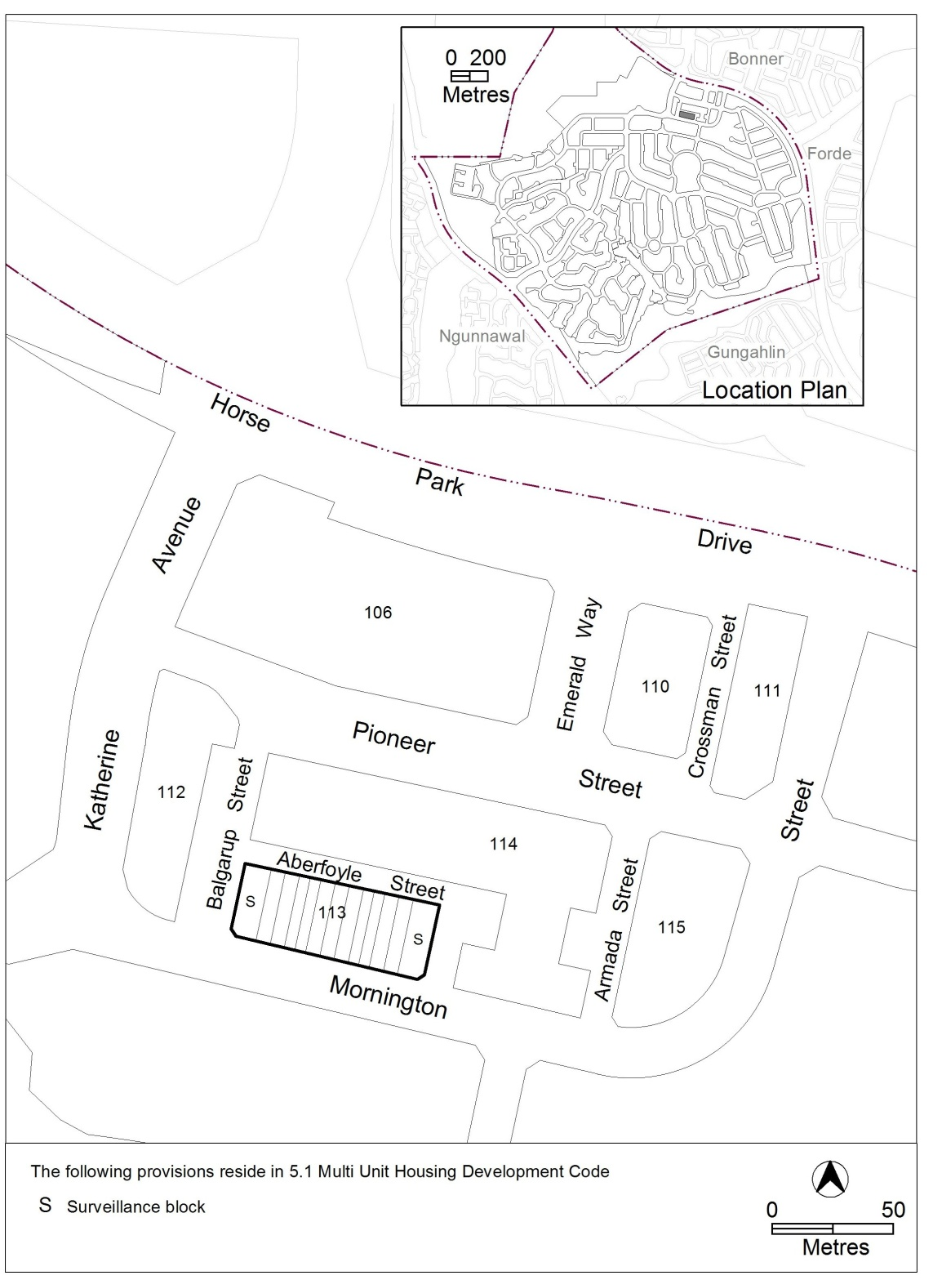
Figure 3 Amaroo Group Centre Ongoing Provisions

