Australian Capital Territory

Planning and Development (Technical Amendment—Coombs) Plan Variation 2013 (No 1)*

Notifiable Instrument NI2013—557
Technical Amendment No 2013—19
made under the
Planning and Development Act 2007, section 89 (Making technical amendments) s96 (land ceases to be in future urban area)

This plan variation commences on the day after it is notified.

Variation No 2013—19 to the Territory Plan has been approved by the Planning and Land Authority.

Variation to the Territory Plan
The Territory Plan map is varied as indicated in Annexure A to identify the zones that apply to the land ceasing to be in a future urban area.

Introduction of the Precinct Map and Code
Annexure B proposes to introduce the Coombs Precinct Map and Code for ongoing block specific provisions for this area.

Jim Corrigan
Delegate of the Planning and Land Authority
10 December 2013

THIS IS PAGE ONE OF ANNEXURE A
TO NOTIFIABLE INSTRUMENT NI2013–557

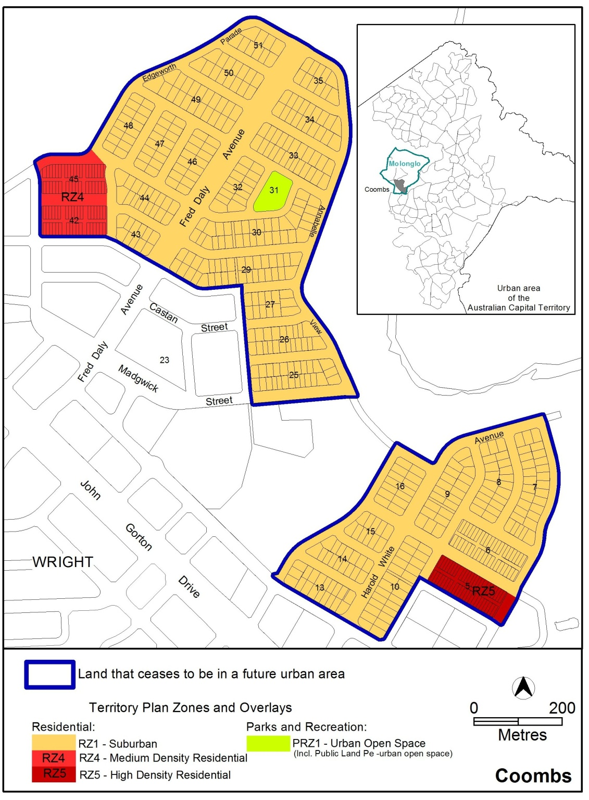

Jim Corrigan
Delegate of the Planning and Land Authority
10 December 2013
THIS IS ANNEXURE B
TO NOTIFIABLE INSTRUMENT NI2013–557

Jim Corrigan
Delegate of the Planning and Land Authority
10 December 2013

Coombs Precinct Map and Code

This page is intentionally blank.

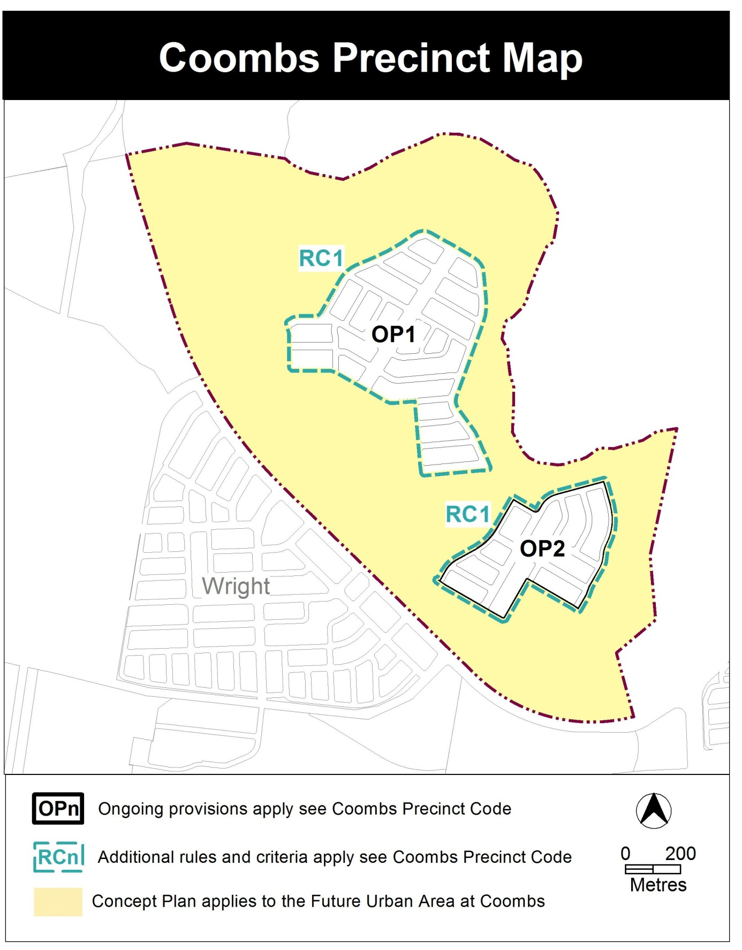

Coombs Precinct Code

Contents
Introduction 3
Additional rules and criteria 5
RC1 – Residential use area 5
Element 1: Building envelope 5
Element 2: Amenity 7
Other ongoing provisions 8
OP1 – Coombs residential area 1 8
OP2 – Coombs residential area 2 9

Figures
Figure 1 Typical Building Envelope 6
Figure 2 Coombs residential area 1 8
Figure 3 Coombs residential area 2 9

Introduction
Name
The name of this code is the Coombs Precinct Code.
Application
The code applies to the Division of Coombs.
Purpose
This code provides additional planning, design and environmental controls for specific areas or blocks and may also contain references to provisions in other codes.
In conjunction with other relevant codes it will be used by the Authority to assess development applications and offer guidance to intending applicants in designing development proposals and preparing development applications.
Structure
This code contains additional rules and/or criteria for particular blocks or parcels identified as areas RCn on the precinct map, to be read in conjunction with the relevant development code. It may also contain sub-parts.
Each element has one or more rules and, unless the respective rule is mandatory, each rule has an associated criterion. Rules provide quantitative, or definitive, controls. By contrast, criteria are chiefly qualitative in nature.
In some instances rules are mandatory. Such rules are accompanied by the words “This is a mandatory requirement. There is no applicable criterion.” Non-compliance with a mandatory rule will result in the refusal of the development application. Conversely, the words “There is no applicable rule” is found where a criterion only is applicable.
Code hierarchy
Under the Planning and Development Act 2007, where more than one type of code applies to a development, the order of precedence if there is inconsistency of provisions between codes is: precinct code, development code and general code.
If more than one precinct code applies to the site, the most recent precinct code takes precedence to the extent of any inconsistency.
Definitions
Defined terms, references to legislation and other documents are italicised.
Definitions of terms used in this code are listed in part 13 of the Territory Plan or, for terms applicable only to this code, associated with the respective rule.
Acronyms
ACTPLA Planning and Land Authority within the ACT Environment and Sustainable Development Directorate
EPA ACT Environment Protection Authority
ESA ACT Emergency Services Agency
ESDD ACT Environment and Sustainable Development Directorate
NCA National Capital Authority
P&D Act Planning and Development Act 2007
TAMS ACT Territory and Municipal Services Directorate

Additional rules and criteria
This part applies to blocks and parcels identified in the Coombs Precinct Map (RCn). It should be read in conjunction with the relevant zone development code and related codes.
RC1 – Residential use area
This part applies to blocks and parcels identified in area RC1 shown on the Coombs Precinct Map.
- Building envelope
Rules | Criteria
  - Building envelope – residential buildings with three storeys or fewer
This rule applies to single dwelling housing or multi unit housing with three storeys or fewer.  Buildings are sited wholly within the building envelope formed by projecting planes over the subject block comprising lines projected at 45º to the horizontal from an infinite number of points on a line of infinite length 3.5m above each side and rear boundary, except for northern boundaries of adjoining residential blocks, which are dealt with by the next rule.  Refer Figure 1. | Buildings achieve all of the following:  a) consistency with the desired character  b) reasonable levels of privacy for dwellings on adjoining residential blocks and their associated private open space..
Buildings are sited wholly within the building envelope formed by projecting planes over the subject block comprising lines projected at Xº to the horizontal from an infinite number of points on a line of infinite length 1.8m above the northern boundary or boundaries of an adjoining residential block. Xº is the apparent sun angle at noon on the winter solstice. For the purposes of this rule values for X are given in Table 1.  Refer Figure 1.  Note: For the purposes of R1, R2, Table 1 and Figure 1, northern boundary means a boundary of a block where a line drawn perpendicular to the boundary outwards is orientated between 45° west of north and 45° east of north | This is a mandatory requirement. There is no applicable criterion

Table 1 – Apparent sun angle (X) at noon on the winter solstice (21 June)
Aspect of northern boundary or north facing window  (bearing of line drawn perpendicular to the boundary or window) | Angle  (X)
North 0<10º East  North 0<10º West | 32 º
North 10<20º East  North 10<20º West | 35 º
North 20<30º East  North 20<30º West | 37 º
North 30<40º East  North 30<40º West | 39 º
North 40-50º East  North 40-50º West | 41 º

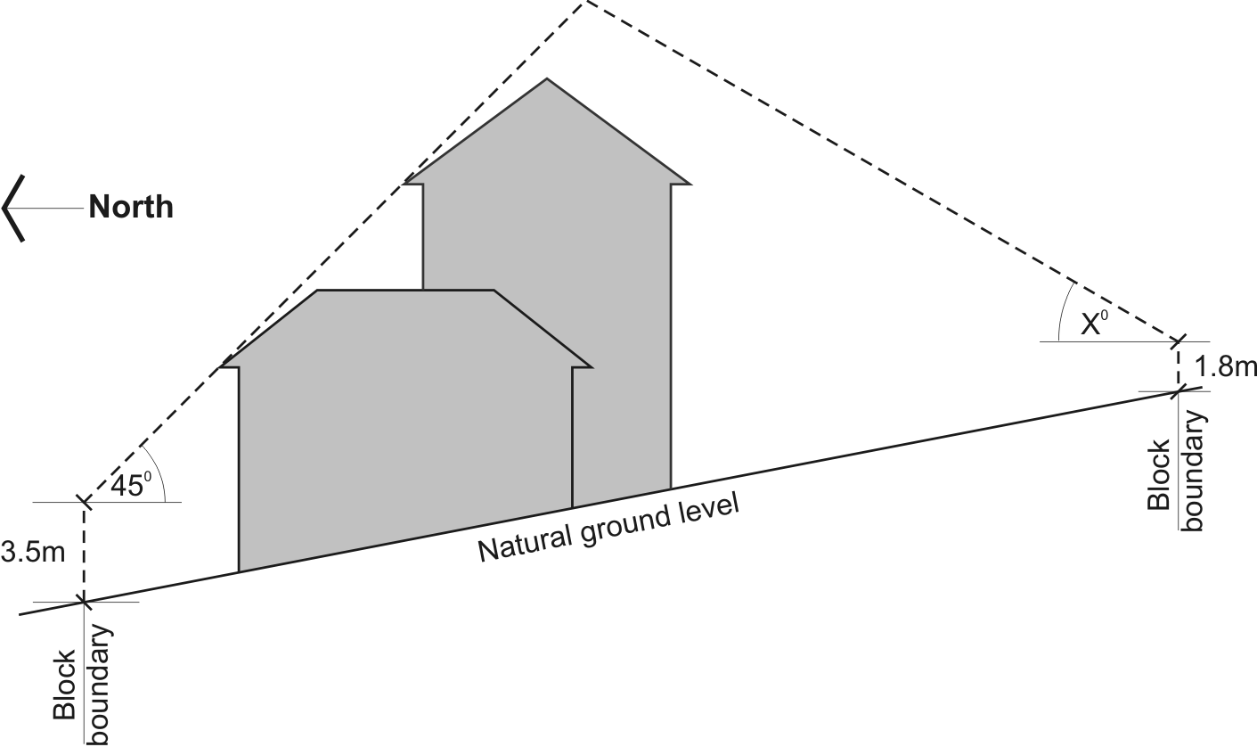

Figure 1 Typical Building Envelope
Note: height of building and boundary setback provisions also apply

- Amenity
Rules | Criteria
  - Boundaries between multi-unit residential and open space
There is no applicable rule. | C3  This criterion applies to urban blocks (other than single residential blocks) which have a common boundary with a block(s) within the PRZ1 Urban Open Space Zone and/or NUZ4 River Corridor Zone  The common boundary between urban blocks (other than single residential block) and urban open space and/or a river corridor achieves all of the following:  - ease of access to urban open space corridors  - surveillance of urban open space corridors  - avoidance of rear boundary fencing  - ground floor dwellings address to urban open space where there is no edge street.

Other ongoing provisions
This part applies to blocks and parcels identified as ongoing provisions (OPn) in the Coombs Precinct Map. It should be read in conjunction with the relevant zone development code and related codes.
OP1 – Coombs residential area 1
This part applies to blocks and parcels identified in area OP1 shown on the Coombs Precinct Map.

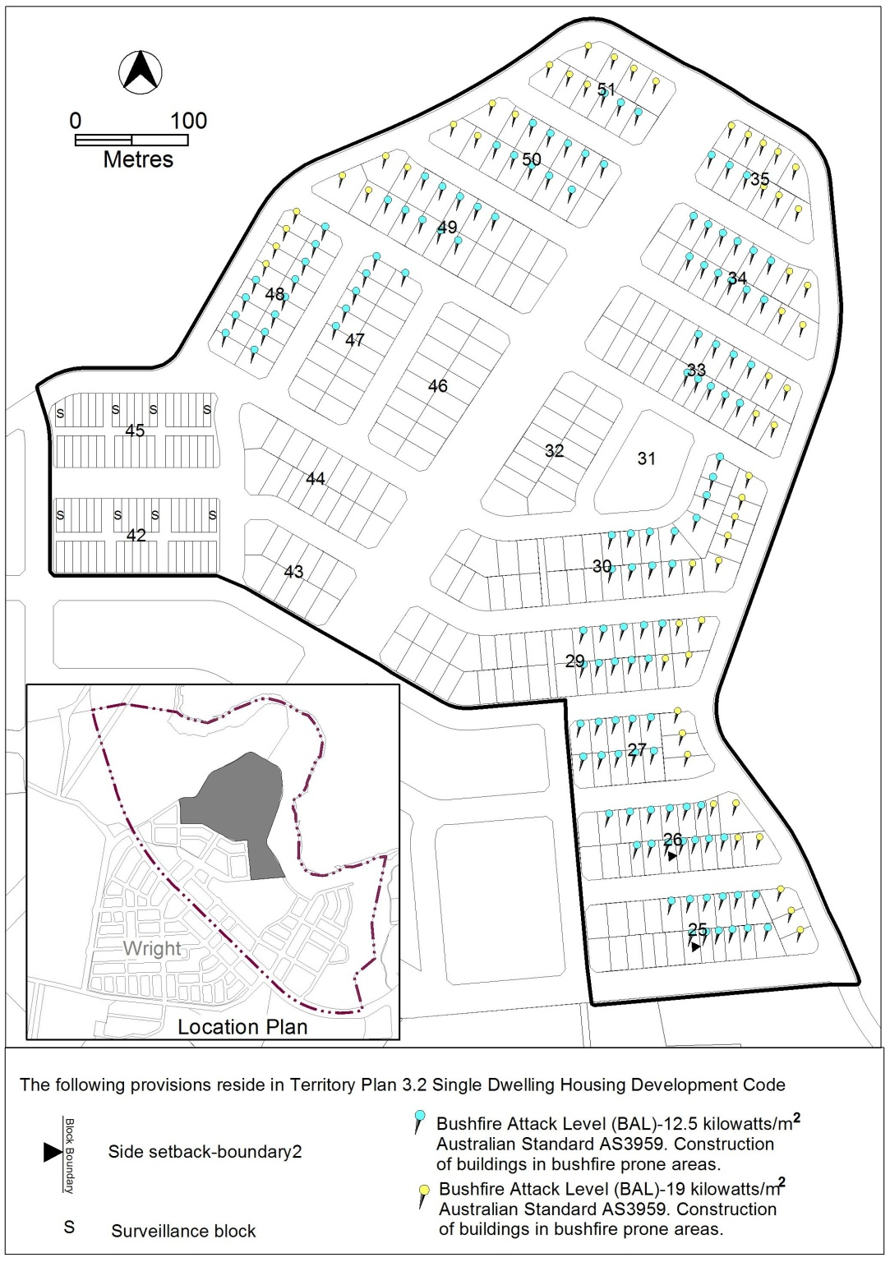
Figure 2 Coombs residential area 1
OP2 – Coombs residential area 2
This part applies to blocks and parcels identified in area OP2 shown on the Coombs Precinct Map.
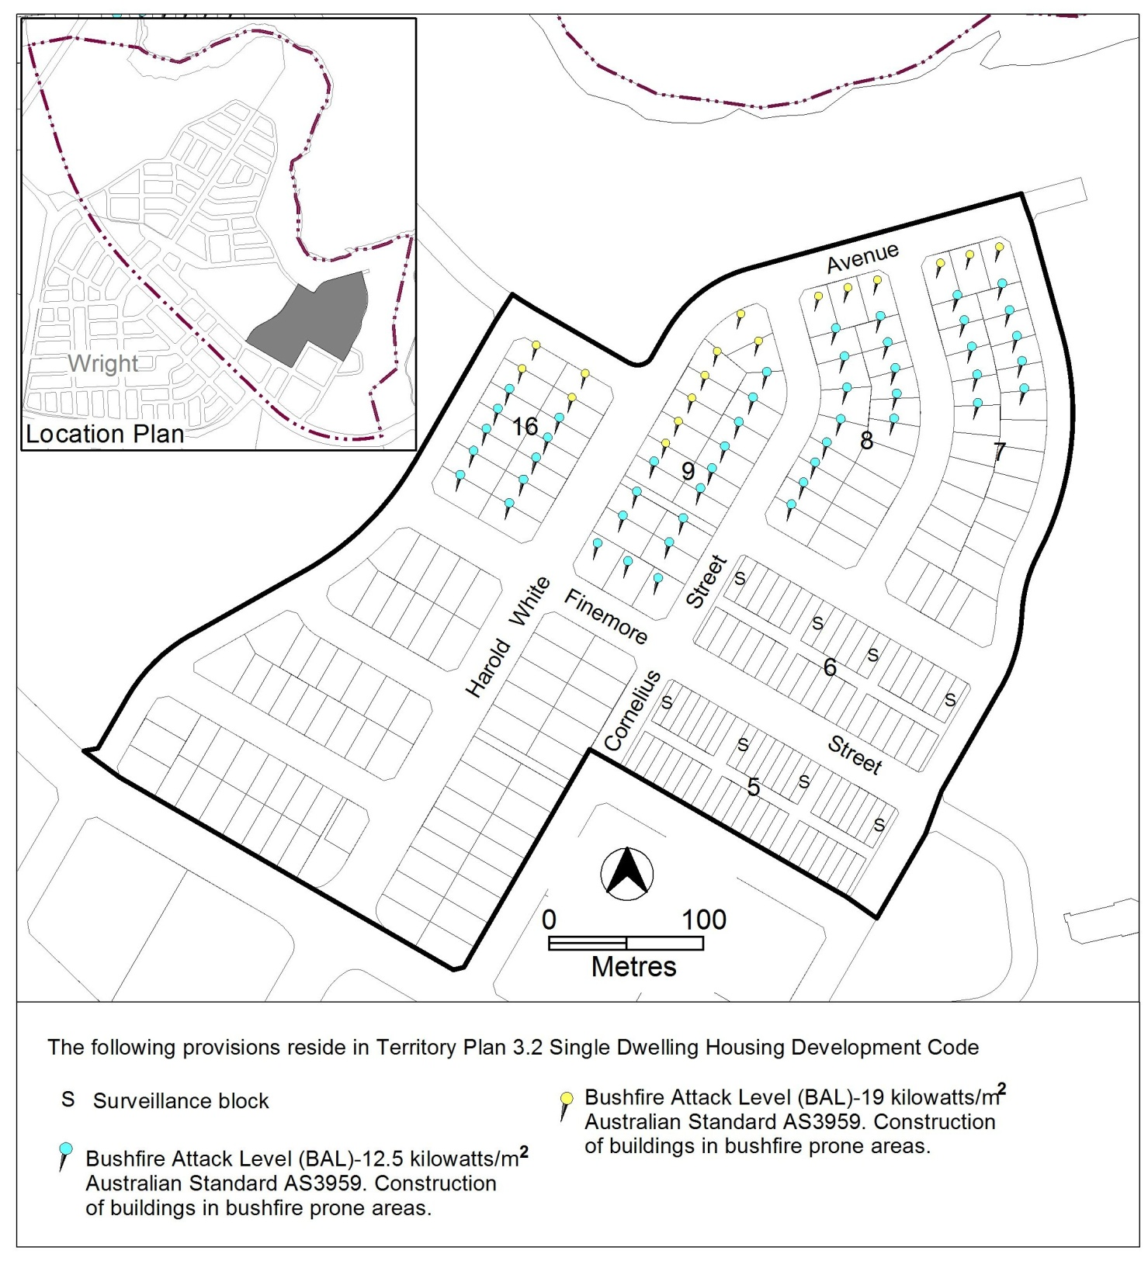
Figure 3 Coombs residential area 2

