Australian Capital Territory
Planning and Development (Plan Variation No 317) Notice 2014
Notifiable Instrument NI2014-137
made under the
Planning and Development Act 2007, section 76(3)

- Name of instrument
This instrument is the Planning and Development (Plan Variation No 317) Notice 2014*.

- Plan Variation No 317
On 25 March 2014, the Minister for Planning approved a draft of the attached plan variation to the Territory Plan (Annexure A) under s76 (3).

Jim Corrigan
Delegate of the Planning and Land Authority
01 April 2014

Planning and Development Act 2007

Variation to the
Territory Plan
No 317

Kambah Group Centre –
Amendments to the
Kambah precinct map and code
and zone changes

March 2014

Final variation prepared
under s76 of the Planning and Development Act 2007

This page is intentionally blank.

Contents

1. EXPLANATORY STATEMENT 1
1.1 Background 1
1.2 Summary of the proposal 1
1.3 The National Capital Plan 1
1.4 Site Description 2
1.5 Current Territory Plan Provisions 3
1.6 Changes to the Territory Plan 5
1.7 Consultation on the Draft Variation 6
1.8 Revisions to the Draft Variation Placed on Consultation 6
2. VARIATION 9
2.1 Variation to the Territory Plan Map 9
2.2 Variation to the written document 10
The Territory Plan written document is varied as follows. 10

This page is intentionally blank.

- EXPLANATORY STATEMENT
  - Background
Variation to the Territory Plan No 317 (V317) Kambah Group Centre implements key recommendations of the Kambah Group Centre master plan, which is available at www.act.gov.au/kambah. The master plan was prepared by the planning and land authority, within the Environment and Sustainable Development Directorate (ESDD), following the completion of the Kambah centre urban planning and design framework, including community consultation between March and October 2011. The plan was endorsed by the ACT Government in July 2012.

  - Summary of the proposal
Variation to the Territory Plan No 317 amends the land use policies at the Kambah Group Centre consistent with the ACT Government endorsed Kambah Group Centre master plan.
The following changes to the Territory Plan were identified from the master plan:
- Extend the commercial core zoning to adjoin the stormwater swale to the east
- Amend the Kambah precinct code to include planning controls on land use, design and siting of buildings, parking and amenity
The changes in V317 include zoning changes to land adjoining the stormwater swale that traverses the centre and commercial zoned land adjoining Kett Street. New provisions to guide future development at the centre are introduced into the Kambah Group Centre precinct code.
The variation includes specific provision for all of the following:
- Development of active uses at the ground floor level fronting main pedestrian areas
- Identification and protection of existing major pedestrian connections through the centre
- Identification of new and altered road layouts to improve vehicle circulation
- A moderate increase in height of buildings in some areas while retaining solar access to main public areas
- Identification of a desirable character for the group centre

  - The National Capital Plan
The Australian Capital Territory (Planning and Land Management) Act 1988 established the National Capital Authority (NCA) with two of its functions being to prepare and administer a National Capital Plan (the Plan) and to keep the NCP under constant review and to propose amendments to it when necessary.
The Plan, which was published in the Commonwealth Gazette on 21 January 1990, is required to ensure Canberra and the Territory are planned and developed in accordance with their national significance. The Australian Capital Territory (Planning and Land Management) Act 1988 also requires the Territory Plan is not inconsistent with the Plan. The area covered by this variation is within urban areas identified in the Plan.

  - Site Description
The Kambah group centre was the first group centre to be developed in Tuggeranong, opening in 1976. Initially the centre was supported by six local centres for residents’ day to day needs, though only three of these local centres are still open today.
The Kambah group centre is one of the six group centres in Tuggeranong. The role of the group centre is to provide the opportunity for weekly shopping and services for the surrounding population. The higher order retailing needs are intended to be primarily met by the town centres.
The centre displays a distinct style of architecture, suggestive of Kambah’s history and association with the Kambah station and woolshed, however it is recognised that the centre is in need of a refurbishment to encourage new development in the centre and improve the usability for visitors.
Kambah group centre consists of three separate commercial areas divided by roads and open space. The core area is located on the corner of Drakeford Drive and Marconi Crescent and bounded by Primmer Court on all sides. The core area contains surface parking along with a central pedestrian courtyard, and is well vegetated with mature eucalyptus trees. A service station on commercial zoned land is located to the north of the core area across Marconi Crescent, while to the east is a line of commercial zoned blocks divided from the core area by a grassed stormwater swale. To the west is Drakeford Drive, while to the south lies public open space.

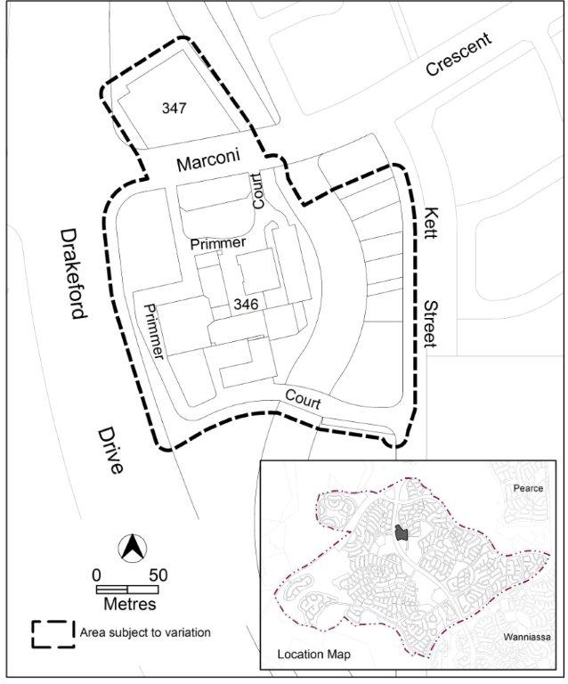
Figure 1: Kambah group centre

  - Current Territory Plan Provisions
The core of the Kambah group centre is zone CZ1 – commercial core, while the service station to the north and the line of commercial blocks to the east are zoned CZ3 – services zone. The stormwater swale between the core area and the services area is zoned PRZ1 – urban open space.
The Territory Plan map for the area subject to this variation is shown in Figure 2.

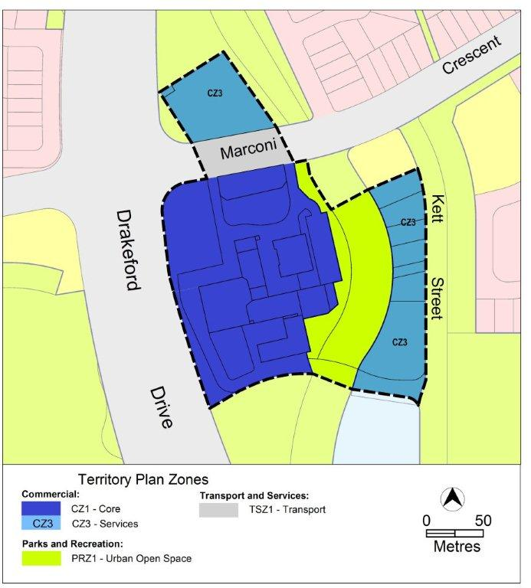Figure 2: Current Territory Plan provisions for Kambah group centre

  - Changes to the Territory Plan
1.6.1 Changes to the Territory Plan Map
The changes to the Territory Plan map are indicated in figure 3 at Part 2 of this document and are detailed as follows:
- a section of PRZ1 located between the existing CZ1 core commercial area of the Kambah group centre and the grassed stormwater swale is rezoned to CZ1 core zone
- the CZ3 services zone on the eastern side of the group centre is rezoned to CZ2 business zone
The variation map indicates the proposed zone boundaries as accurately as possible but may be subject to adjustments following detailed surveys.
Detailed changes to the Territory Plan are noted in section 2 of this document.

1.6.2 Changes to the Territory Plan
The Kambah Precinct Code in the Territory Plan is amended to:
- nominate active frontage areas where activity generating uses will be permitted
- identify the location of proposed road connections
- increase the maximum building heights to 4 storeys on nominated sites
- retain key design characteristics of the centre, such as the awnings with posts over most of the pedestrian areas and pitched roofs, are to be excluded from the calculation of building height.

  - Consultation on the Draft Variation
Draft Variation No 317 (DV317) was released for public comment between 22 March 2013 and 20 May 2013. A consultation notice under section 63 of the Planning and Development Act 2007 (P&D Act) was published on the ACT Legislation Register on 21 March 2013 and in The Canberra Times on 23 March 2013.
A total of four written submissions were received, which included submissions from three commercial operators and one individual.
Main issues raised by submitters included:
- The alignment of Primmer Court as shown in the proposed precinct code is not consistent with the Kambah group centre master plan
- The release and location of blocks which are inconsistent with the Kambah group centre master plan
- Development of existing parking area rules force underground parking to be required making site economically unfeasible to develop.
- Active frontage rule of the proposed precinct code may cause confusion due to the way it is written and illustrated
- Rezoning CZ3 to CZ2 along Kett Street would allow a retail centre (i.e. supermarket) to be setup in isolation from the main Kambah Centre
- Wording of certain rules, particularly R10, R11, R12, R13, R18 and R20 of the proposed precinct code are repeated or are too subjective.

The above issues were considered and responses to these issues are detailed in a report on consultation, which is available at www.act.gov.au/recommendedvariations. Changes were informed by the issues raised.

  - Revisions to the Draft Variation Placed on Consultation
In addition to minor editorial amendments and corrections the changes to the draft variation outlined in the following Table 1, changes have been made primarily in response to the issues raised in the public submissions.

Table 1: Summary of changes to V317
DV317 (public release version) | V317 (approved version) | Change
- | Desired character dot point added | Desired character relating to awning providing shelter from the environmental elements (statement 2). Included so setbacks and building design can be more readily assessed against the desired character.
Desired character dot points 4, 5 and 6 | Removed | Removed as the statements do not inform any of the criteria which they are subject to.
Desired character dot point 7 | Amended (dot point 5) | Desired character statement amended slightly to improve ease of assessment.
- | Desired character new dot point 3 added | Desired character statement added so plot ratio and building design can be more readily assessed.
Desired character dot point 8 | Removed | Removed as the statement was similar to another desired character statement. The substance of this item has been amended into another desired character point as seen below.
Desired character dot point 10 | Included in dot point 7 | This desired character was amended to include aspects of the ideas in the removed desired character stated above. This was done to improve clarity of the document.
N/A | R3 (new rule) | R3 was introduced after it was noted that a separate draft variation (DV304) increased the permissible gross floor area for SHOP in CZ2 generally, meaning that the rezoned commercial area east of the main centre could potentially be used for supermarkets, which would undermine the intention to keep large retail in the core centre. The gross floor area was limited; however, due to a consequential change by DV304 it lifted restrictions on this zone. The rule states 100m² GFA limit for shop to retain the existing restriction prior to DV304 having interim effect.
R3 | Now R4 | No substantive change.
R4 | Now R5 | Amended to the standard rule and criteria for nominated car parks.
R5 | Deleted | Not required. Other provisions have been included in the code regarding the proposed road to the east of the core area.
R6 | R6 | No substantive change to the rule, though it now refers to a new figure which was added for clarity.
R7 | Now R8 | Wording amended for clarity.
N/A | R7 (new rule) | Provisions to describe the design of the proposed road between the core area and the open space (stormwater swale) to the east.
Figure 1 | Figure 1 | Figure simplified to show nominated car parks, proposed road to the east, and area A (ex area D).
R8 | Now R9 | Rule amended for clarity, and refers to (new) figure 2.
R9 | Now R10 | No substantive change.
N/A | Figure 2 (new) | New figure to describe heights, and with a hatched area associated with rule R6.
C10 | Deleted | C10 was removed as the intent of the criteria was duplicated by C11 (consultation version).
C11, C12, C13, R14, R15 | C11, C12, C13, R14, R15 | No substantive change.
Figure 2 | Now Figure 3 | Figure amended to indicate required secondary frontage as part of any future development to the north of the existing supermarket.
R16, R17, C18, R19 | R16, R17, C18, R19 | No substantive change.
R20 | Deleted | Repetition of criterion C18.
C21 | Now C20 | No substantive change.

- VARIATION
  - Variation to the Territory Plan Map
The Territory Plan map is varied as indicated in figure 3
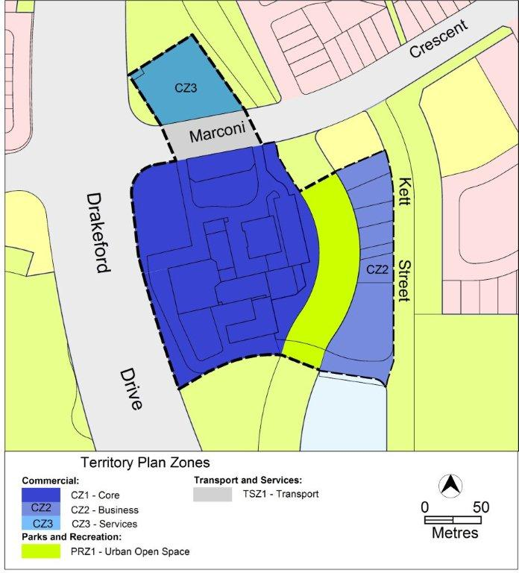
Figure 3: New Territory Plan provisions for the Kambah Group Centre

  - Variation to the written document
The Territory Plan written document is varied as follows.

Variation to Kambah precinct code
- Precinct maps and codes, Kambah precinct map and code

Substitute all of the following with the nominated attachment
Kambah precinct map – Attachment A
Kambah precinct code, RC1 – Kambah Group Centre – Attachment B
Note: The precinct code’s contents page will require updating.
Interpretation service
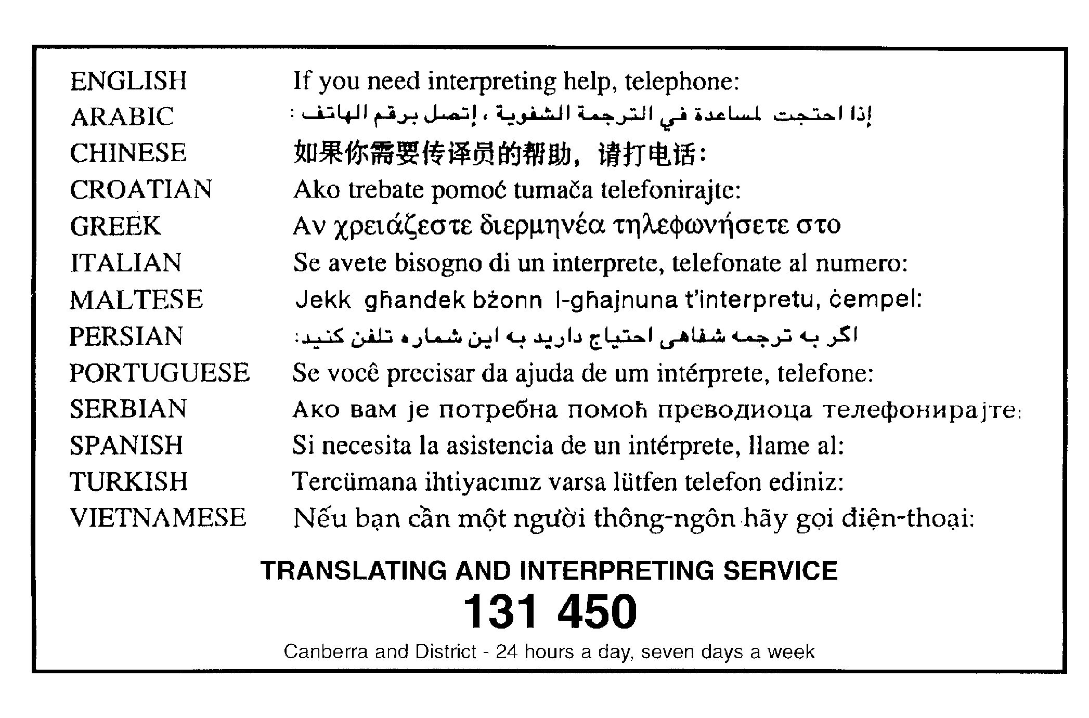

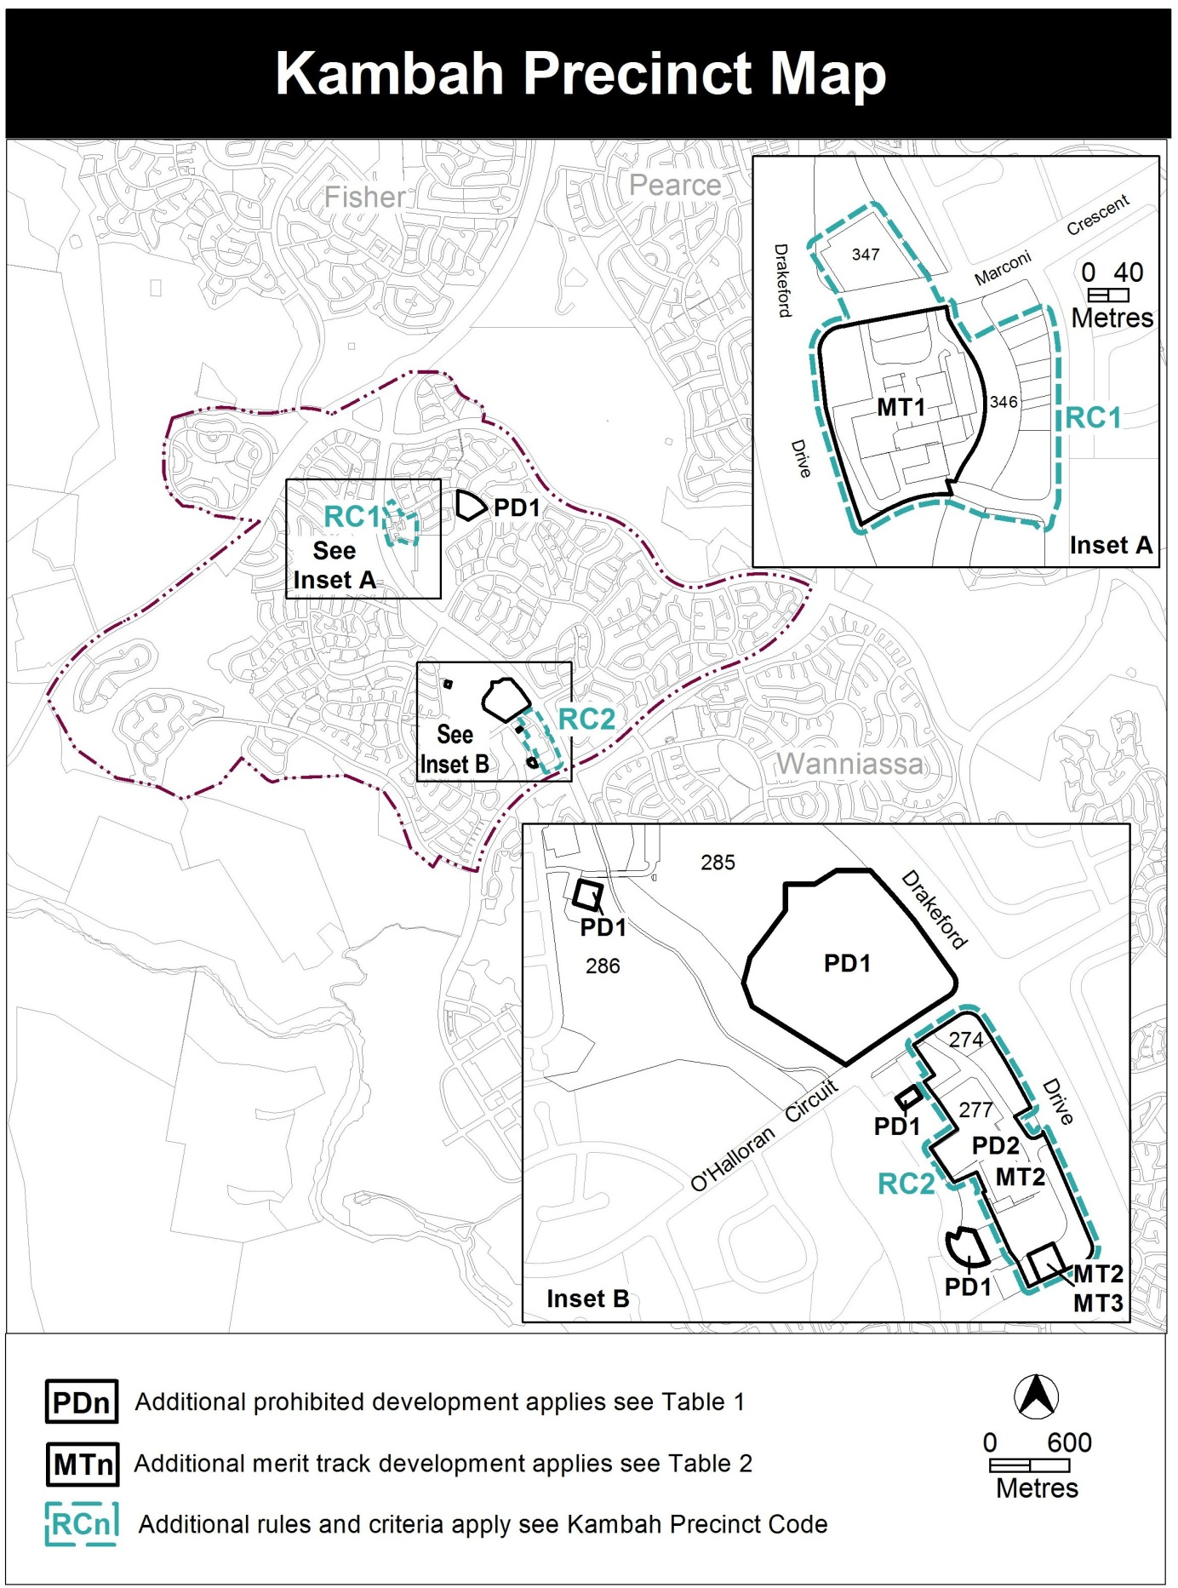

This page is intentionally blank

RC1 – Kambah Group Centre
This part applies to blocks and parcels identified in area RC1 shown on the Kambah Precinct Map. RC1 includes the Kambah Group Centre.
Desired character
- distinctive pitched roofs, awnings with posts where within the block boundaries or cantilevered awnings where over unleased land
- overhangs and awnings provide space for pedestrian activity and shelter from environmental elements
- buildings of a scale and character which complement their surroundings
- existing large trees retained with development protecting the form and habit of existing trees
- pedestrian environment and permeability maintained or improved throughout the centre
- a range of building heights that encourage a variety of uses and allow for good solar access onto public spaces, particularly the central courtyard
- development and active uses focussed on to the central courtyard and open spaces, promoting community and outdoor activity

- Use
Rules | Criteria
  - Ground floor uses
This rule applies to land in CZ1 with frontage to main pedestrian areas and routes shown in figure 3.  Only the following uses are permitted at the ground floor level:  - business agency  - club  - COMMUNITY USE  - drink establishment  - financial establishment  - hotel  - indoor entertainment facility  - indoor recreation facility  - public agency  - restaurant  - SHOP | Buildings incorporate uses on the ground floor that generate activity in the public space.

Rules | Criteria
  - Residential use
The following uses are not permitted on ground floor level, except in area ‘A’ in figure 1:  - RESIDENTIAL USE  - serviced apartment | This is a mandatory requirement. There is no applicable criterion.
  - SHOP – floor area limit
This rule applies to blocks in CZ2.  The maximum gross floor area for SHOP on any lease is 100m². | This is a mandatory requirement. There is no applicable criterion.
  - Industrial trades, municipal depot, store
One or more of the following uses are permitted only in the shaded area shown in figure 1 and only in association with a structured car park:  - industrial trades  - municipal depot  - store | This is a mandatory requirement. There is no applicable criterion.
  - Development on nominated car parking areas
This rule applies to the shaded areas shown in figure 1.  Development complies with all of the following:  - the existing number of car parking spaces are retained on site and made available for public use at all times  - provides car parking that is generated by the development on site in accordance with the Parking and Vehicular Access General Code in addition to the spaces required by a) | Development achieves all of the following:  - any additional parking provision requirements (under the Parking and Vehicular Access General Code) for the development  - makes a substantial contribution to the long term publicly accessible parking supply at the group centre
  - Vehicular circulation and access
Development of all or a portion of the hatched area identified in figure 2 maintains Primmer Court vehicular access around the western side of the centre. | This is a mandatory requirement. There is no applicable criterion.
The design of the proposed road in figure 1 complies with all of the following:  - In a location consistent with figure 1  - Complies with R5/C5 where relevant  - Provides on street parking  - Road design and on street car parking is to the satisfaction of TAMSD  Note: The Kambah group centre master plan must be considered in the assessment of the location of the proposed road and on street parking. | This is a mandatory requirement. There is no applicable criterion.
Direct vehicular access is not permitted from the proposed road shown in figure 1 to adjoining blocks. | This is a mandatory requirement. There is no applicable criterion.
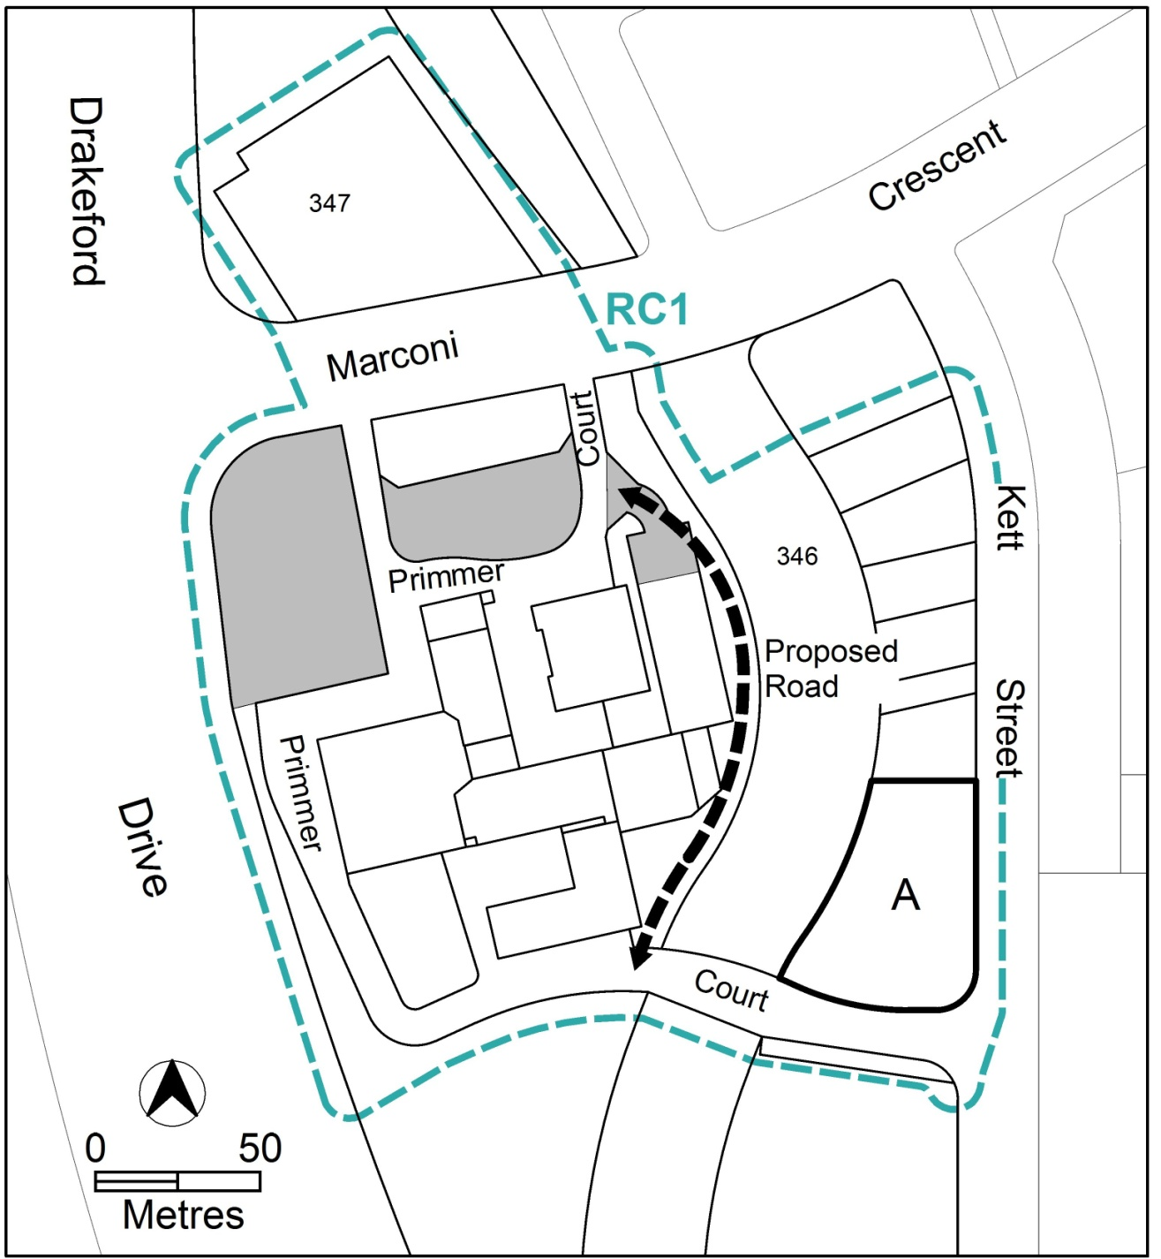Figure 1 Parking and permitted uses

- Buildings
Rules | Criteria
  - Heights
This rule applies to areas identified in figure 2.  The maximum height of building is as follows:  - in area ‘A’ – 16m  - in area ‘B’ – 12m  - in area ‘C’ – 9m  Building height measurement excludes all of the following:  - roofs with a pitch not more than 36°  - roof top plant  - lift overruns  - antennas  - photovoltaic panels  - air conditioning units  - chimneys, flues and vents  The minimum setback of excluded items b) to g) from the building facade of the floor immediately below is 3m. | This is a mandatory requirement. There is no applicable criterion.
  - Building design
This rule applies to development in CZ1.  The minimum floor to ceiling height at ground floor level is 3.6m. | The ground floor level of buildings is adaptable for commercial uses.
There is no applicable rule. | Development complies with all of the following:  - entrances to common areas for residential use provide strong visual connection to the street or main pedestrian route and ensure a high level of surveillance  - ensures the retention of a reasonable level of solar access to the central courtyard and other public spaces between the hours of 9am to 3pm on 21 June  - west-facing facades incorporate sun shading into building designs  - consistent with the relevant desired character

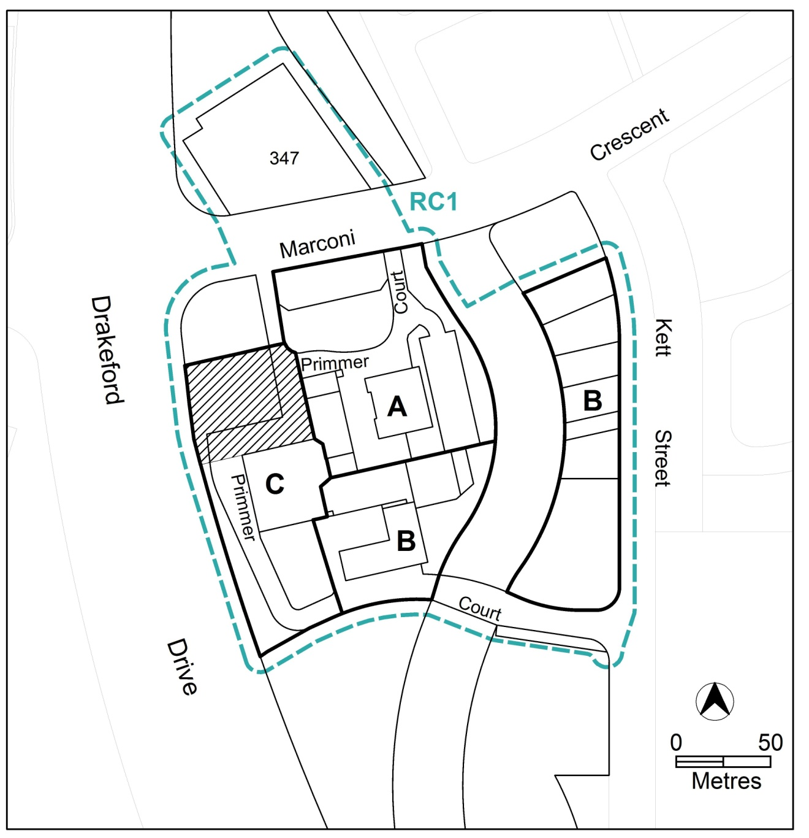Figure 2 Heights and vehicular circulation

Rules | Criteria
  - Plot ratio
There is no applicable rule. | Plot ratio achieves consistency with the relevant desired character.
  - Setbacks
There is no applicable rule. | Building setbacks and alignment are consistent with the relevant desired character.
This rule applies in CZ1.  Buildings do not overshadow the central courtyard beyond the shadow cast by a notional 10m high wall measured from the datum ground level at the boundary adjoining the public realm. | Buildings adjoining the northern boundary of the central courtyard minimise overshadowing of the central courtyard area.
  - Main pedestrian areas
This rule applies in CZ1 to the main pedestrian area shown in figure 3.  Main pedestrian areas achieve all of the following:  - publicly accessibility at all times  - minimum unobstructed width of 5m | This is a mandatory requirement. There is no applicable criterion.
  - Active frontages
For buildings located along primary active frontage areas identified in figure 3, frontages and building design comply with all of the following:  - buildings incorporate clear display windows and shop fronts at the ground level  - buildings incorporate direct pedestrian access at grade with the verge level for access and egress for persons with disabilities  - tenancies at ground floor level that occupy more than a total of 10m of the frontage articulate the facade to present as more than one tenancy  - any small areas of walls without windows contain displays, showcases and/or public art, with a maximum of 30% blank frontage per tenancy  - development with a frontage to the central courtyard provide one or more public entrances to the courtyard | This is a mandatory requirement. There is no applicable criterion.

Rules | Criteria
For buildings located along secondary active frontage areas identified in figure 3, frontages and building design complies with all of the following:  - buildings incorporate clear display windows and shop fronts at the ground floor level  - buildings incorporate direct pedestrian access at grade for access and egress for persons with disabilities | Development at ground level achieves all of the following:  - is adaptable for shops  - where building access is provided, direct pedestrian access at street level  - provide opportunities for views into and out of the building
There is no applicable rule. | Extensive lengths of blank facades, open structured car parks, loading docks, substations and other service infrastructure are not located along primary active frontage areas, and do not dominate secondary active frontage areas identified in figure 3.
  - Awnings
This rule applies to buildings fronting primary active frontage areas shown in figure 3.  Awnings comply with all of the following:  - a minimum height of 2.7m above the finished pavement or ground level  - a minimum of 3m depth  - integrated into the building design at the first floor level  - contained wholly within block boundaries  - have posts at 3m intervals along the outside edge of the awning  - extend the full facade of the building | Awnings provide continuous all weather pedestrian shelter and activity in a form compatible with existing awnings, and are contained wholly within the block boundaries.

- Services
Rules | Criteria
  - Screening
There is no applicable rule. | Waste collection areas are screened from public view.

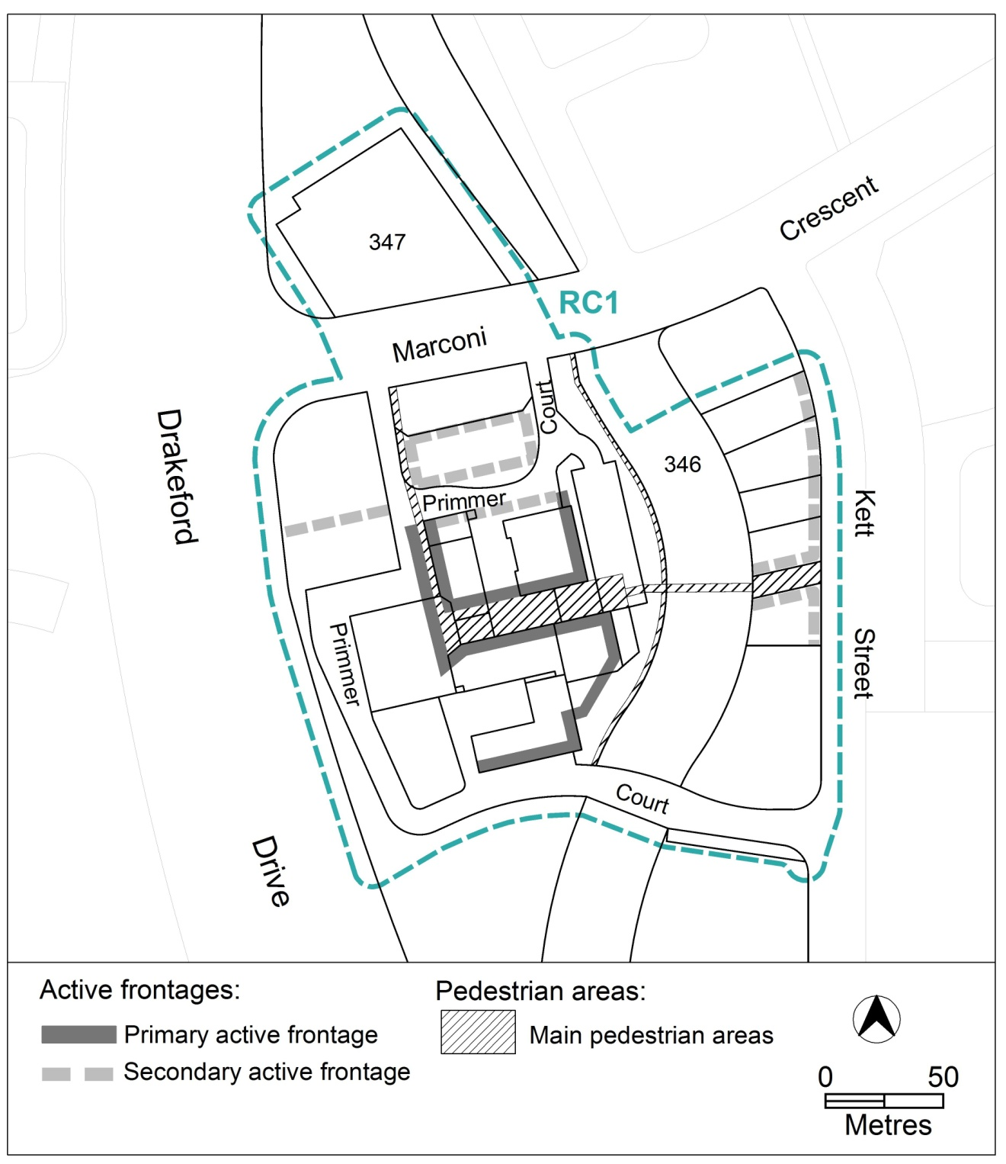
Figure 3 Main pedestrian areas and active frontages

