Australian Capital Territory

Planning and Development (Technical Amendment—Lawson) Plan Variation 2014 (No 2)*

Notifiable Instrument NI2014—149
Technical Amendment No 2014—05
made under the
Planning and Development Act 2007, section 89 (Making technical amendments) s96 (land ceases to be in future urban area)

This plan variation commences on the day after it is notified.

Variation No 2014-05 to the Territory Plan has been approved by the Planning and Land Authority.

Variation to the Territory Plan
The Territory Plan map is proposed to be varied as indicated in Annexure A to identify the zones that apply to the land ceasing to be in a future urban area.

Variation to the Precinct Map and Code
Replaces page 1, Figure 1, Figure 2 and Figure 3 of the Lawson Precinct Map and Code at Annexure B to incorporate ongoing block specific provisions for the area.

Jim Corrigan
Delegate of the Planning and Land Authority
09 April 2014

THIS IS PAGE ONE OF ANNEXURE A
TO NOTIFIABLE INSTRUMENT NI2014 –149

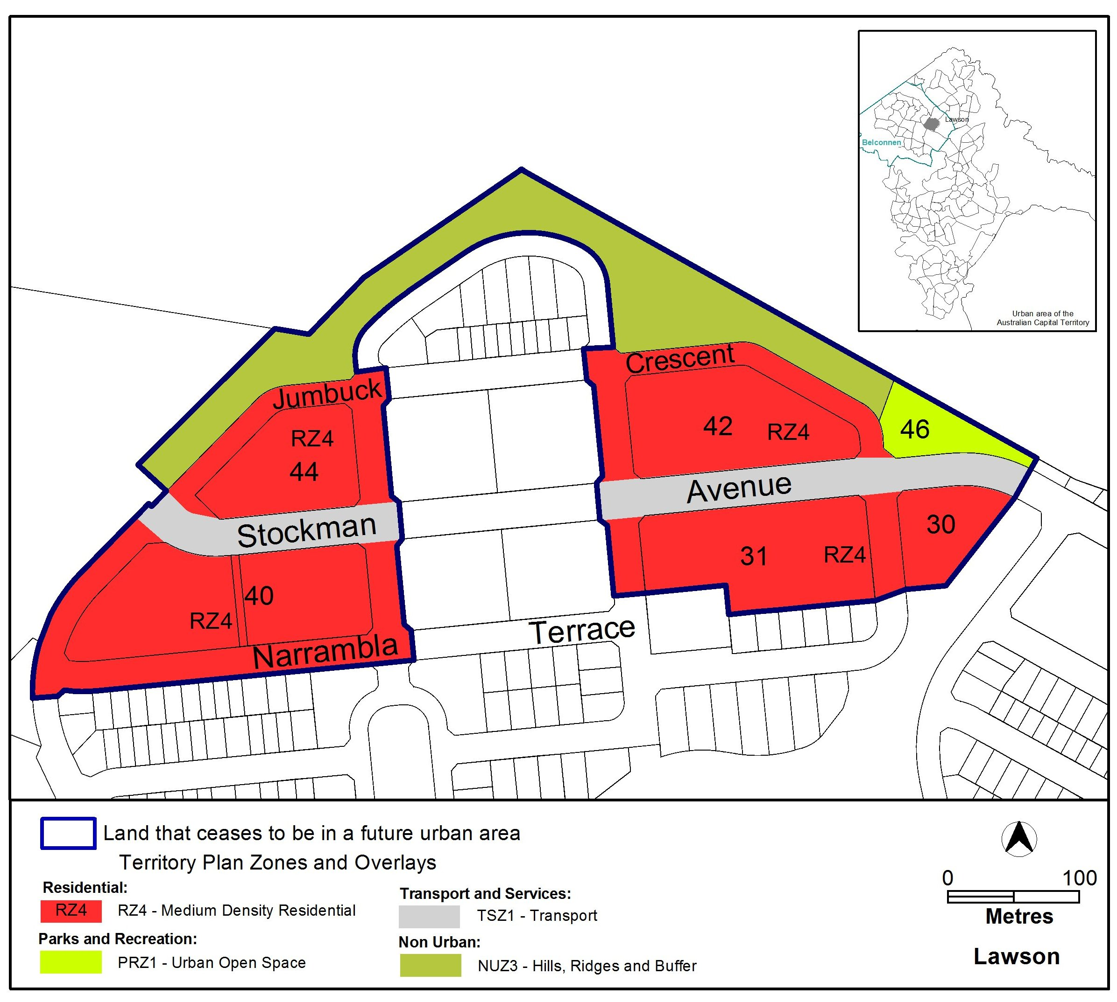

Jim Corrigan
Delegate of the Planning and Land Authority
09 April 2014
THIS IS PAGE ONE OF ANNEXURE B
TO NOTIFIABLE INSTRUMENT NI2014–149

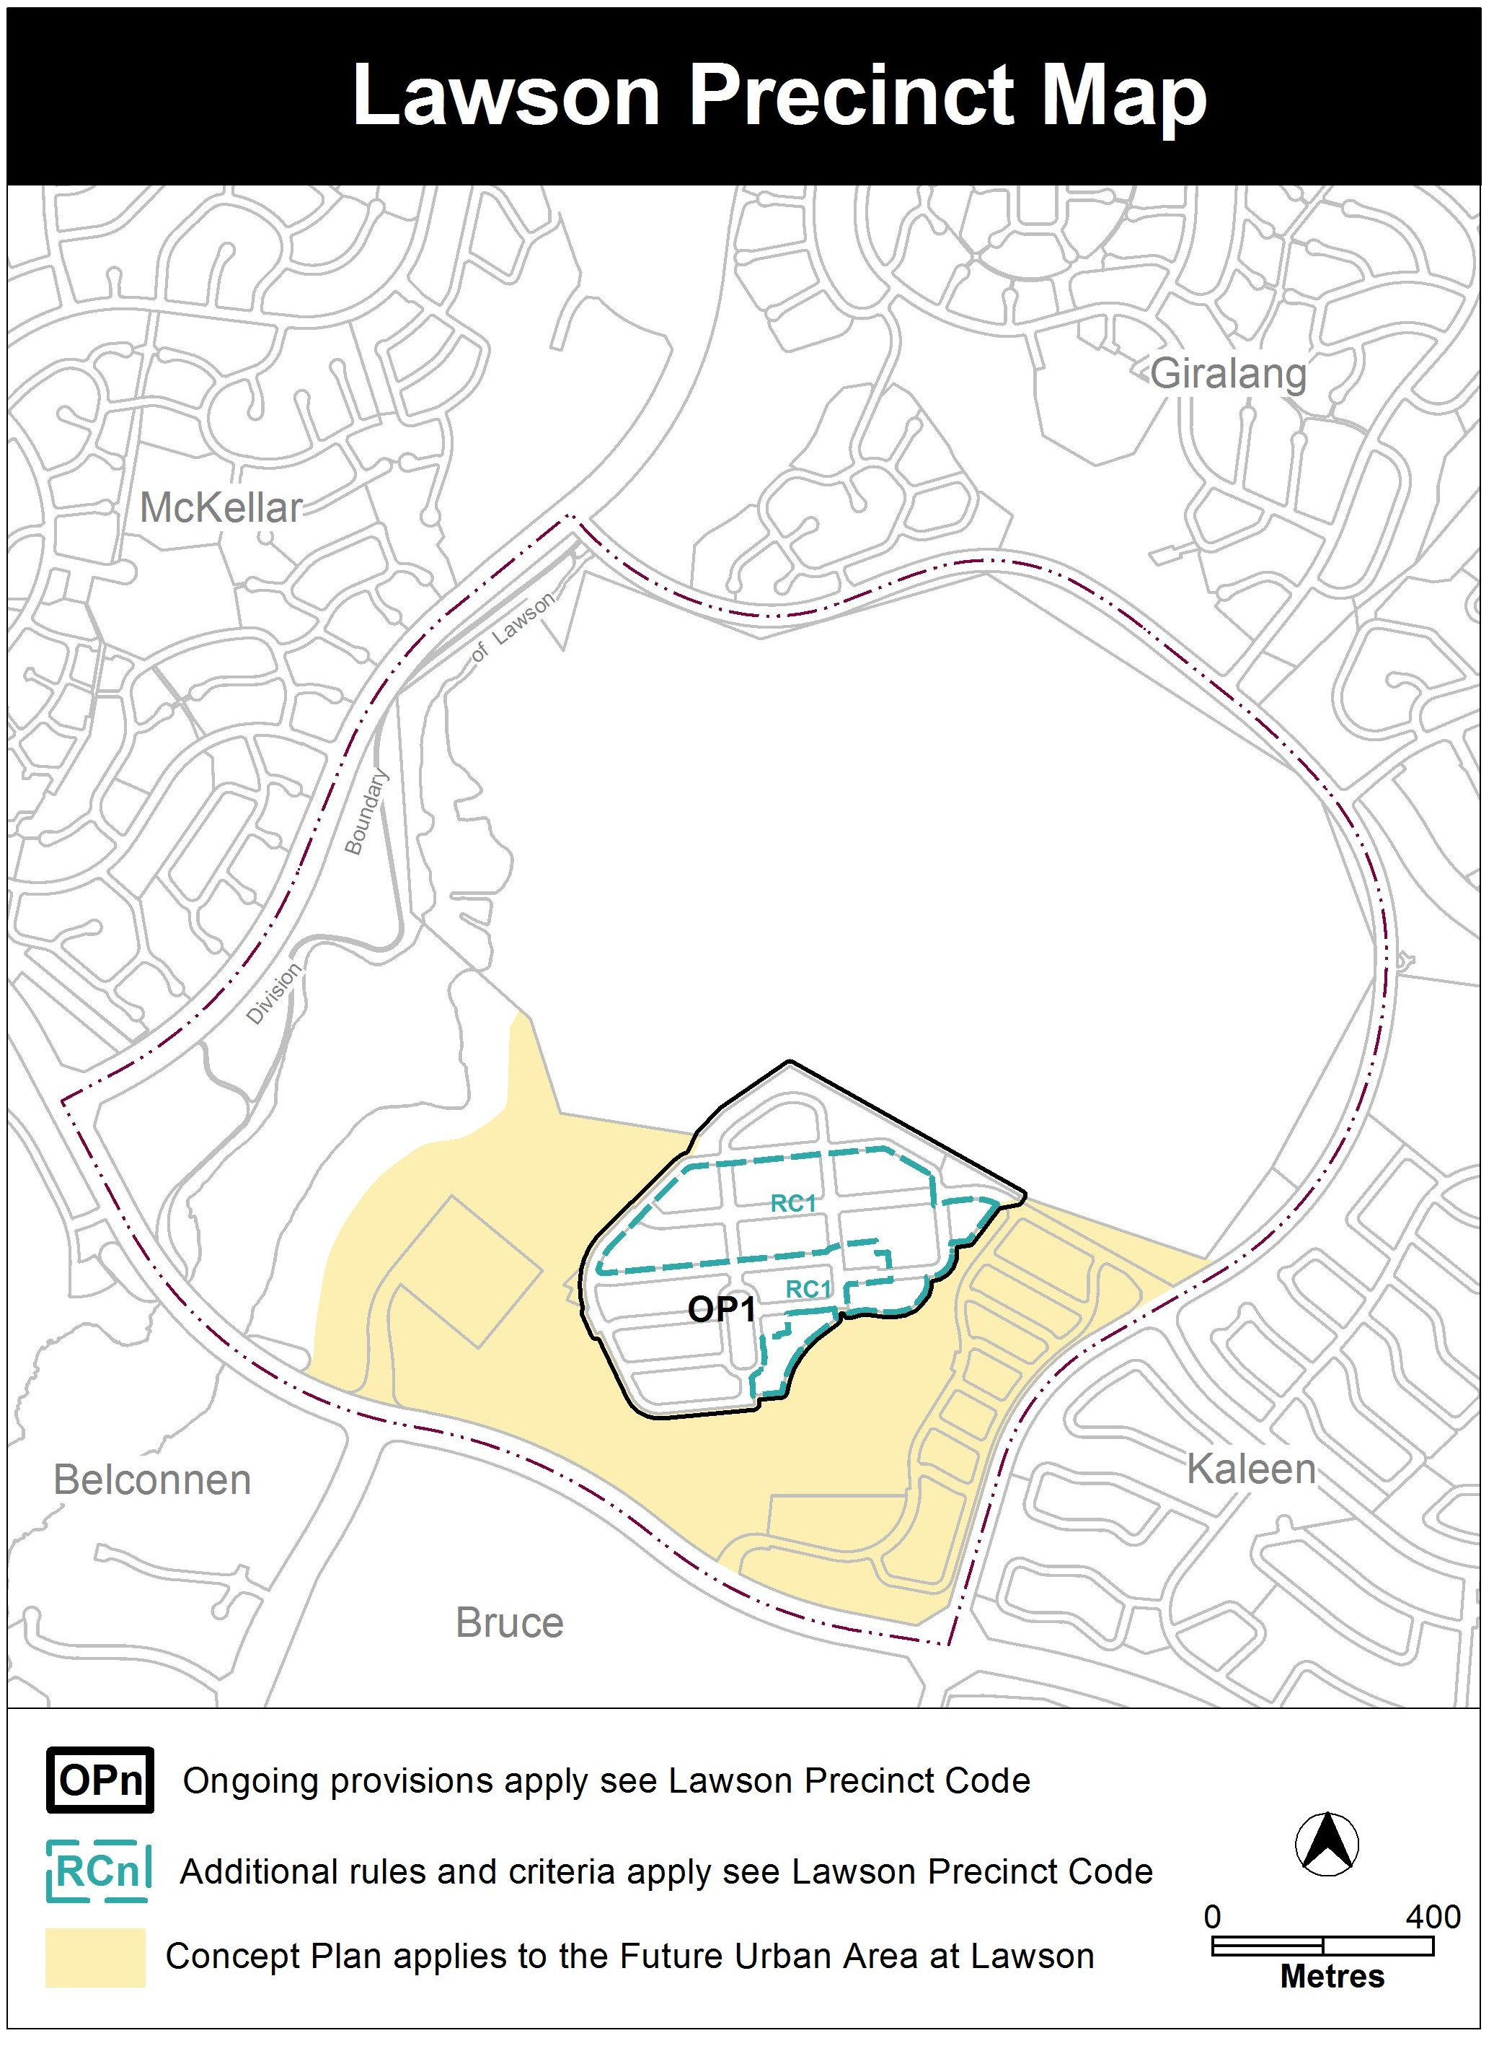

Jim Corrigan
Delegate of the Planning and Land Authority
09 April 2014
THIS IS PAGE TWO OF ANNEXURE B
TO NOTIFIABLE INSTRUMENT NI2014–149

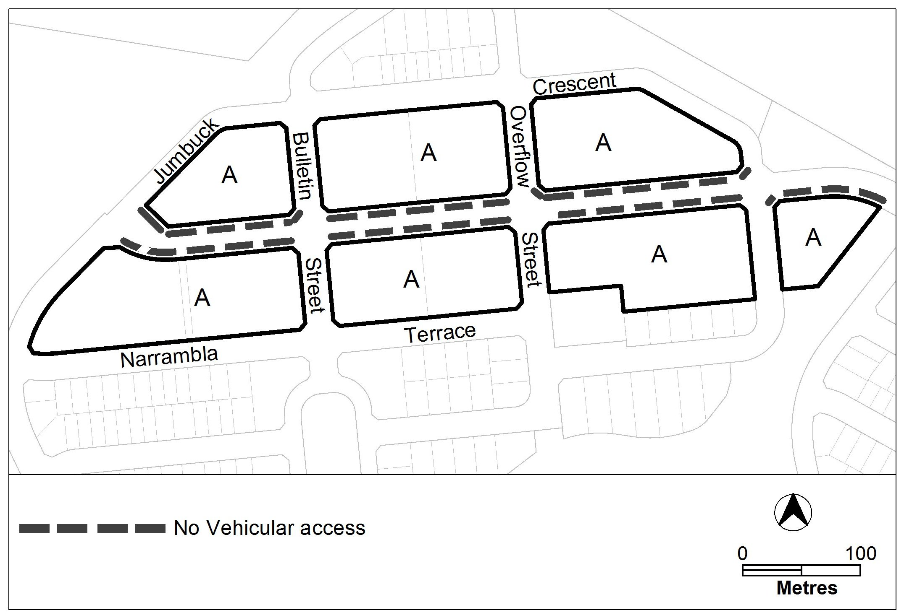
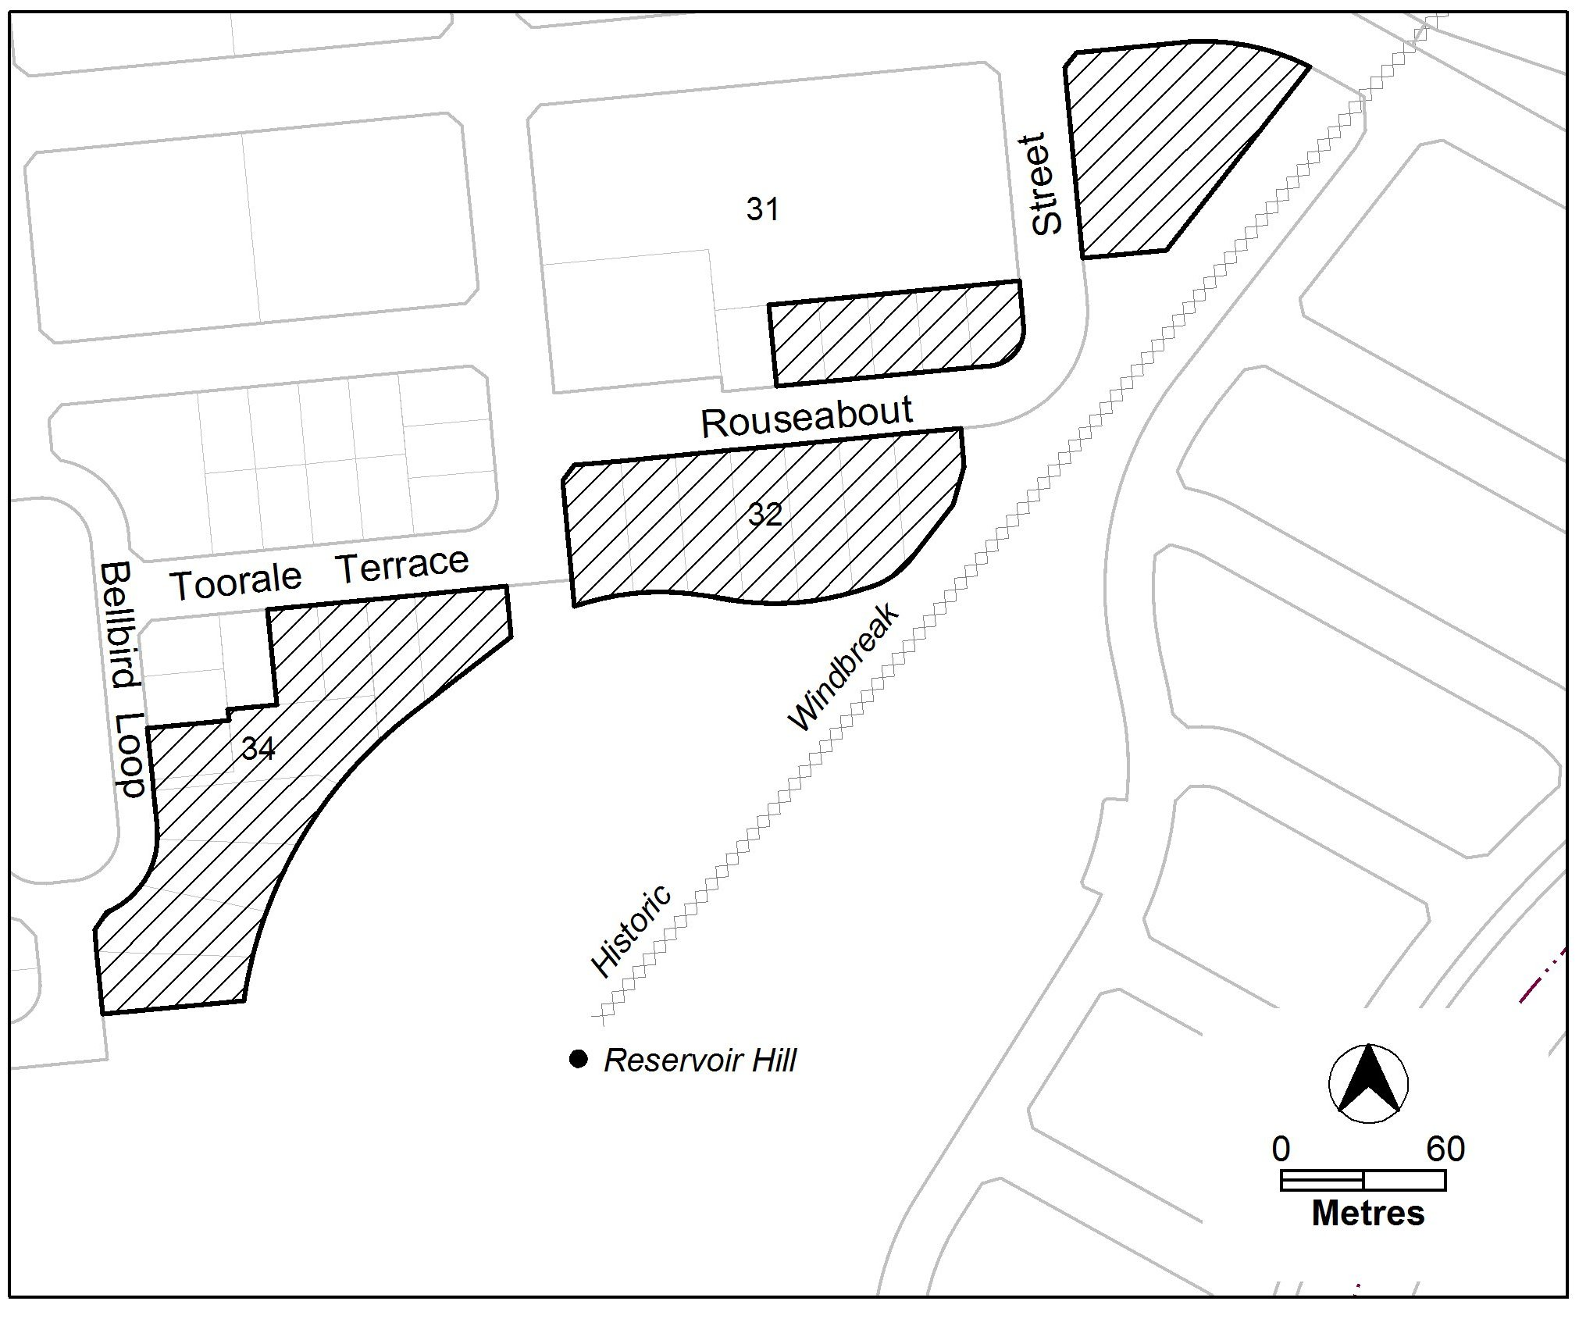

Jim Corrigan
Delegate of the Planning and Land Authority
09 April 2014
THIS IS PAGE THREE OF ANNEXURE B
TO NOTIFIABLE INSTRUMENT NI2014–149
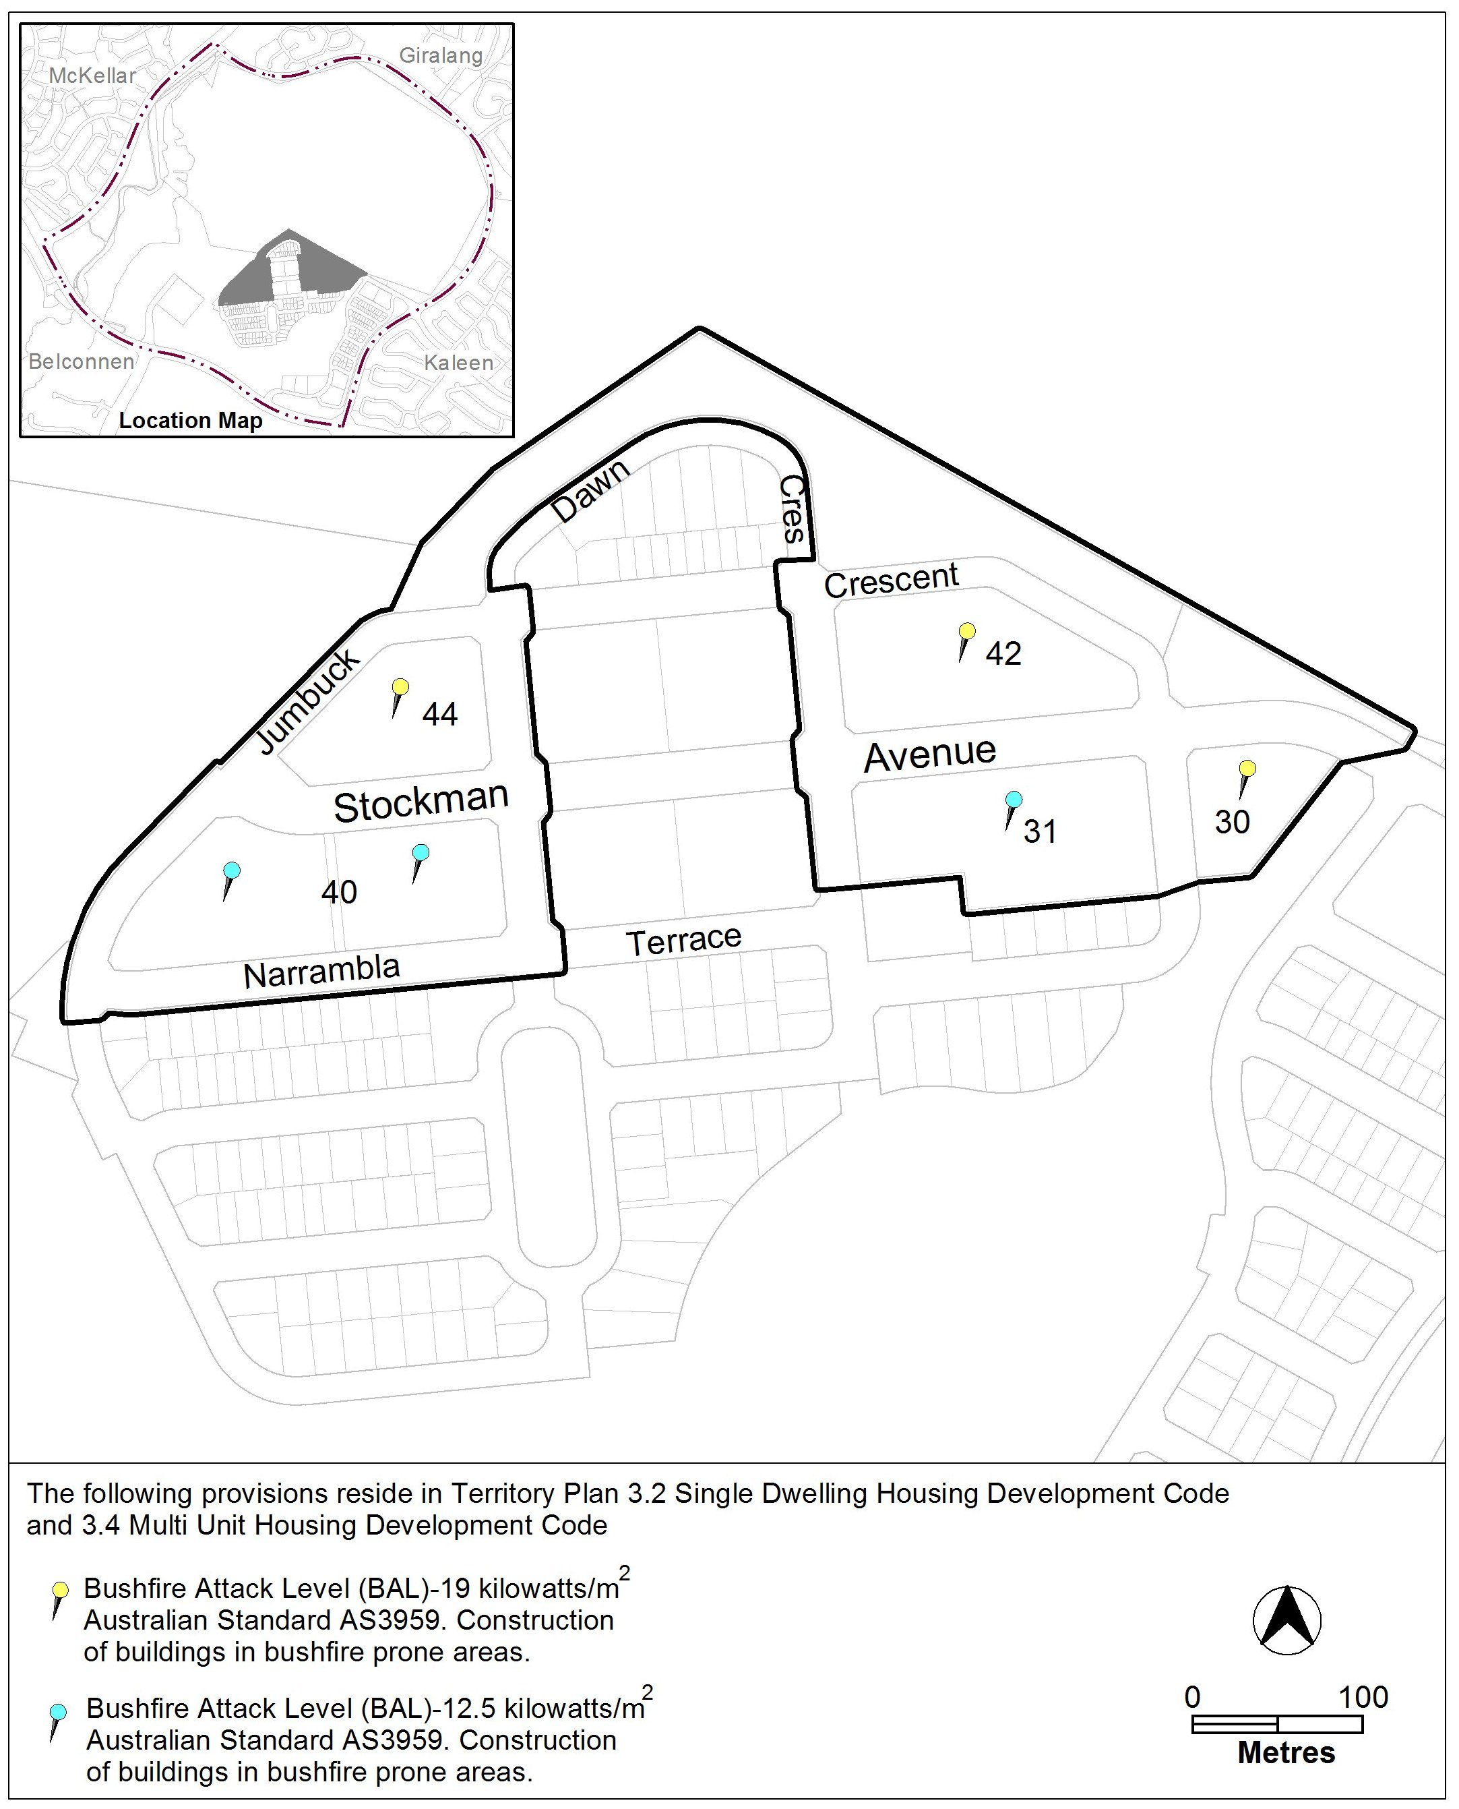

Jim Corrigan
Delegate of the Planning and Land Authority
09 April 2014

