Australian Capital Territory

Planning and Development (Draft Variation No 320) Consultation Notice 2014
Notifiable instrument NI2014—178
made under the
Planning and Development Act 2007, section 63 (Public consultation - notification) and section 64 (Public consultation – notice of interim effect etc)

Draft Variation Number 320 to the Territory Plan – Erindale Group Centre and surrounding community and recreation areas (Annexure A) proposes to amend the planning controls at Erindale group centre and surrounding community facility and recreation lands to guide future development in the area through moderate increase in building heights in parts of the centre to 5 storeys, defining new road and pedestrian connections and various other changes. A number of sites are to be rezoned to identify new development opportunities and to ensure the zones reflect the existing or proposed uses.
The draft variation is available online at www.act.gov.au/draftvariations until the closing date for written comments. Background documents are available at www.act.gov.au/erindale.
Printed copies of the draft variation are available for inspection and purchase at the Environment and Sustainable Development Customer Service Centre, 16 Challis Street, Dickson, Monday to Friday (except public holidays) between 8:30am and 4:30pm. Please call 6207 1923 to arrange a copy for purchase.
Written comments are invited by Friday 13 June 2014.
Comments should include reference to the draft variation, your name and contact details and be addressed to the Territory Plan Unit.
Comments can be:
- emailed to dv.comments@act.gov.au
- mailed to Territory Plan Comments, GPO Box 158, Canberra, ACT 2601
- delivered to ESDD’s Customer Service Centre at the above address
Comments received will be made publicly available 10 working days after the closing date for no less than 15 working days at ESDD’s customer service centre in Dickson and may be published on ESDD’s website.
Comments made available will include personal contact details unless excluded under section 411 or 412 of the Act. A request for exclusion under this section must be in writing, clearly identifying what you are seeking to exclude and how the request satisfies the exclusion criteria.
Effect of the draft variation
Section 65 of the Act applies to the draft variation. This means that, in addition to the Territory Plan, the provisions of the draft variation apply to development applications lodged on or after 2 May 2014. The draft variation is part of the Territory Plan for a period of up to one year unless the draft variation is commenced, is withdrawn or rejected by the Legislative Assembly. During this period, the ACT Government must not do or approve anything that would be inconsistent with the Territory Plan.
Jim Corrigan
Delegate of the ACT Planning and Land Authority
28 April 2014

Planning and Development Act 2007

Draft Variation to the
Territory Plan
No 320

Erindale Group Centre and surrounding community and recreation lands:
Zone changes and amendments to the Wanniassa precinct map and code.

May 2014

Draft variation for public consultation prepared
under s63 of the Planning and Development Act 2007

This page is intentionally blank.

Contents

1. INTRODUCTION 1
1.1 Summary of the Proposal 1
1.2 Outline of the process 1
1.3 This document 2
1.4 Public Consultation 2
1.5 Further Information 3
2. EXPLANATORY STATEMENT 4
2.1 Background 4
2.2 Site Description 5
2.3 Current Territory Plan Provisions 7
2.4 Proposed Changes 8
2.4.1 Proposed Changes to the Territory Plan Map 8
2.4.2 Proposed Changes to Territory Plan 9
2.5 Reasons for the Proposed Draft Variation 10
2.6 Planning Context 10
2.6.1 National Capital Plan 10
2.6.2 Territory Plan 11
2.7 Interim Effect 12
2.8 Consultation with Government Agencies 12
3. DRAFT VARIATION 15
3.1 Variation to the Territory Plan map 15
3.2 Variation to the Territory Plan 16

This page is intentionally blank.

- INTRODUCTION
  - Summary of the Proposal
Draft Variation No 320 (DV320) Erindale Group Centre and surrounding community and recreation lands proposes to amend the requirements for development in the Erindale Group Centre, and parts of the surrounding community facility and recreation lands, in the Wanniassa precinct map and code. The changes are drawn from the recommendations of the Erindale Group Centre master plan and will guide future development through rezoning of a number of areas within the centre, increasing maximum permitted building heights on selected sites, and amending road layouts and pedestrian routes. The proposed changes are intended to promote Erindale centre as a thriving business and community hub, with employment opportunities, facilities and services for the surrounding population catchment while improving vehicle and pedestrian access through the centre.
  - Outline of the process
The Commonwealth’s Australian Capital Territory (Planning and Land Management) Act 1988 allows for the Legislative Assembly to make laws to establish a Territory Planning Authority and for that Authority to prepare and administer a Territory Plan. The Planning and Development Act 2007 (the Act) establishes the planning and land authority as the Authority which prepares and administers the Territory Plan, including continually reviewing and proposing amendments as necessary. The functions of the planning and land authority are administered by the Environment and Sustainable Development Directorate (ESDD).
The Territory Plan is comprised of a written statement and a map. The written statement contains a number of parts, namely governance; strategic directions; zones (including objectives and development tables and zone or centre development codes); precinct codes; general codes; overlays; definitions; structure plans, concept plans and development codes for future urban areas.
The Territory Plan Map graphically represents the applicable land use zones (under the categories of residential, commercial, industrial, community facility, urban parks and recreation, transport and services and non urban), precincts and overlays. The zone, precinct and overlay requirements are detailed in the volumes of the Territory Plan.
Draft variations to the Territory Plan are prepared in accordance with the Act. Following the release of the draft variation under section 63 of the Act, submissions from the public are invited. At the conclusion of the consultation period the ESDD submits a report on consultation and a recommended final variation to the Minister responsible for planning for approval.
The Minister has the discretion to determine if referral to the Legislative Assembly standing committee responsible for planning is warranted prior to approval, depending on the nature and significance of the proposal. If the draft variation is referred to the committee by the Minister or otherwise, the Minister must consider the findings of the committee before deciding whether to approve the draft variation.
If the Minister approves the variation, the variation and associated documents will be tabled in the Legislative Assembly. Unless disallowed by the Legislative Assembly within five sitting days, the variation commences on a day nominated by the Minister.
  - This document
This document contains the background information in relation to the proposed variation. It comprises the following parts
Part 1 This Introduction
Part 2 An Explanatory Statement, which gives reasons for the proposed variation and describes its effect
Part 3 The Draft Variation, which details the precise changes to the Territory Plan that are proposed
  - Public Consultation
Written comments are invited by 13 June 2014.
Comments should include reference to the draft variation, your name and contact details, and be addressed to the Territory Plan Unit.
Comments can be:
- emailed to DV.Comments@act.gov.au
- mailed to Territory Plan Comments, GPO Box 158, Canberra, ACT 2601
- delivered to ESDD’s Customer Service Centre at 16 Challis Street, Dickson
Copies of written comments will be made available (unless excluded) for public inspection for no less than 15 working days starting 10 working days after the closing date for comment. The comments will be available at ESDD’s customer service centre in Dickson and may be published on ESDD’s website.
Comments made available will include personal contact details unless excluded under section 411 or 412 of the Planning and Development Act 2007. A request for exclusion under these sections must be in writing, clearly identifying what you are seeking to exclude and how the request satisfies the exclusion criteria.
  - Further Information
The draft variation and background documents are available online at www.act.gov.au/draftvariations until the closing date for written comments.
Printed copies of the draft variation (this document) and background documents are available for inspection and purchase at the Environment and Sustainable Development Customer Service Centre, 16 Challis Street, Dickson, Monday to Friday (except public holidays) between 8:30am and 4:30pm. Please call 6207 1923 to arrange a copy for purchase.

- EXPLANATORY STATEMENT
  - Background
Draft Variation to the Territory Plan No 320 (DV320) Erindale Group Centre draws on the recommendations of the Erindale group centre master plan, which is available at www.act.gov.au/erindale. The master plan was prepared by the planning and land authority, within the Environment and Sustainable Development Directorate (ESDD), and included a number of community consultation periods from November 2010 through to February 2012. The master plan was endorsed by the ACT Government in September 2012.
A significant issue in the development of the master plan was the constraints imposed by the layout of the centre, including the road and pedestrian connections. The master plan addressed these issues through nominating new and amended road connections through the centre and identifying main pedestrian areas and links. A number of these have been incorporated into DV320 to ensure that development of new sites, and redevelopment of existing blocks accommodates future connections identified in the master plan.
Another issue raised during community consultation of the Erindale master plan was the parking difficulties faced by users of the centre. The master plan identified a number of measures to address the parking issues within the centre, and while a number of these rely on future infrastructure works not associated with the draft variation, DV320 ensures that the existing parking areas will be required to replace existing parking spaces if and when they are developed in the future.
The master plan contains restrictions on the location of future residential development in response to concerns raised during consultation, with a subsequent emphasis on the development of community facilities and commercial services within and around the centre. This has been followed through in the development of DV320, with the potential for future residential development generally restricted to the south eastern corner of the subject area.
The Erindale Group Centre master plan considered development potential over the next 30 years, and while DV320 has incorporated aspects of the longer term recommendations, it is anticipated that the provisions will be reviewed in five to ten years to ensure the centre is developing in accordance with the desired outcomes of the master plan.
  - Site Description
Erindale Group Centre is centrally located within the Tuggeranong district, and surrounded largely by community facility land, urban open space and suburban residential development. Erindale centre provides a wide range of services, including three schools, medical centres, a sports club, gymnastics centre, a number of restaurants and other food services as well as two service stations and a wide range of community facilities. Due to the high level of services available, Erindale centre is one of the busiest group centres in Canberra, with resultant pressures on the road network and parking facilities.
Erindale centre is fragmented into a number of disparate areas by busy roads running through the centre. McBryde Crescent runs east to west, separating the core retail area and community facilities area in the north from the commercial services area containing sporting facilities, restaurants and personal service businesses in the south. Comrie Street The centre is generally bounded by Ashley Drive to the east, Erindale Drive to the south, Sternberg Crescent to the north, and playing fields to the west.
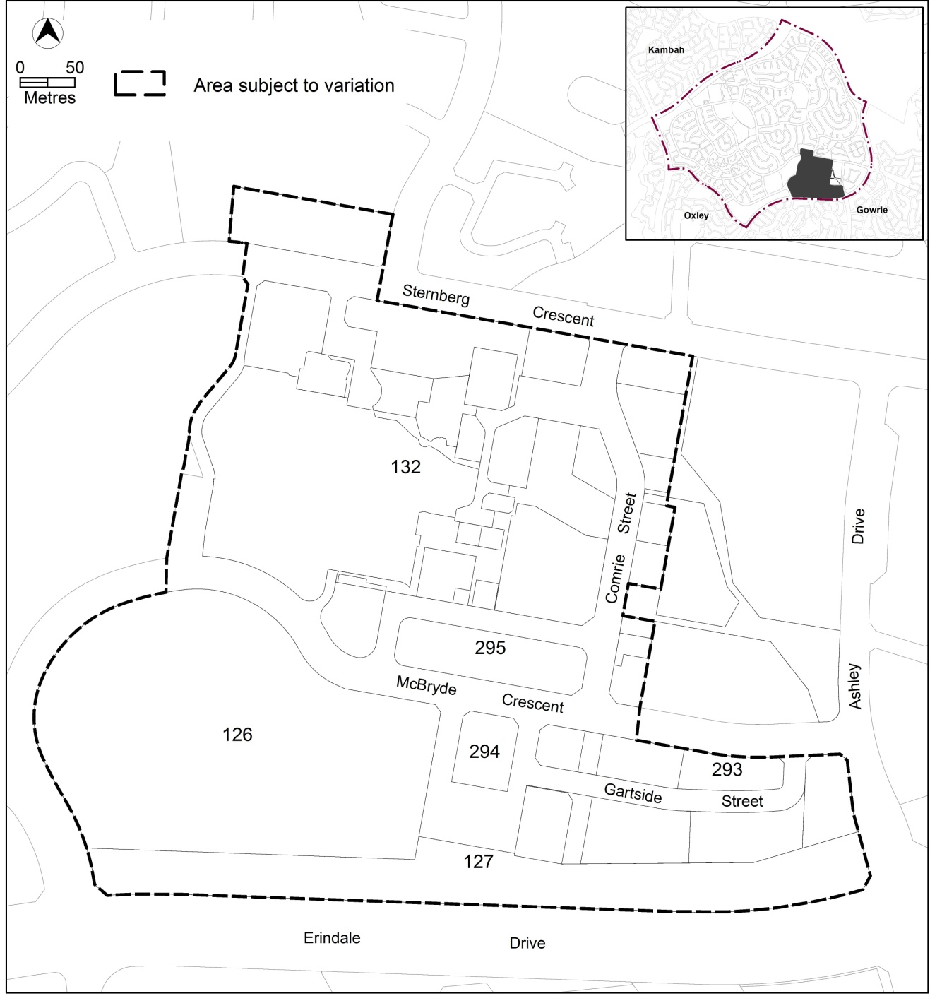
Figure 1: Erindale group centre and surrounding community and recreation lands

  - Current Territory Plan Provisions
The Territory Plan map zones for the area subject to this variation are shown in Figure 2.
The core commercial area (CZ1) is located at the corner of Comrie Street and McBryde Crescent, with relatively small areas of commercial business zone (CZ2) located to the north and east of the core area. To the west lies a large area of community facility zone (CFZ) containing a number of community facilities including Erindale College. A commercial services zone (CZ3) is located to the south east between McBryde Crescent and Erindale Drive. The Vikings club is located on entertainment, accommodation and leisure (CZ6) and restricted access recreation (PRZ2) zoned land to the south west.
The commercial zones are subject to the Commercial Zones Development Code, while the residential zones are subject to the Residential Zones Development Code and Multi Unit Housing Development Code. The Community Facility Development Code covers development in the community facility zones, and the Parks and Recreation Zone Development Code applies to development in the PRZ2 zone. Development in the TSZ1 zone is assessed against the Transport and Services Development Code.
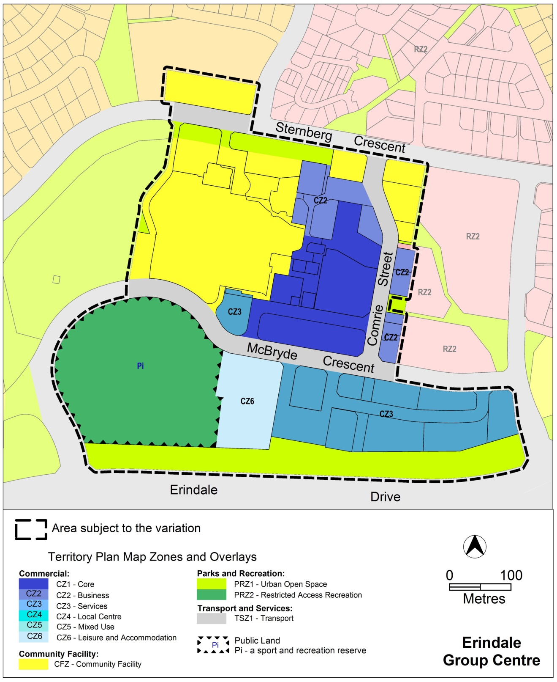Figure 2: Current Territory Plan Zones Map
  - Proposed Changes
    - Proposed Changes to the Territory Plan Map
The proposed changes to the Territory Plan map are indicated in Figure 3 at Part 3 of this document and are detailed as follows:
- part of the CZ2 business zone north of the existing CZ1 commercial core zone will be rezoned to CZ1 core zone;
- the area of CFZ community facility zone between block 51 section 132 (Erindale College) and Sternberg Crescent will be rezoned to CZ2 business zone;
- the sport and recreation reserve (Pi) overlay covering the northern carpark area within the PRZ2 restricted access recreation zone oval adjoining the Vikings club will be removed;
- the carpark bounded by Sternberg Crescent, Comrie Street and Grattan Court will be rezoned from CZ2 business zone to CFZ community facility zone; and
- part of the PRZ1 urban open space zone adjoining Erindale Drive will be rezoned to CZ3 services zone.
The draft variation map indicates the proposed zone boundaries as accurately as possible but may be subject to adjustments following detailed surveys.
    - Proposed Changes to Territory Plan
It is proposed to amend the Wanniassa precinct map and code in the Territory Plan to:
- identify proposed road connections and the location of the future bus interchange;
- nominate active frontage areas where activity generating uses will be required;
- increase the maximum building heights to between three and five storeys on nominated sites generally along the southern side of the centre while restricting selected areas within the core area to two storeys;
- identify main pedestrian areas where development will be restricted to ensure open, easily traversed areas are retained through the centre;
- nominate additional commercial uses within selected areas of the community facilities zone;
- specify locations within CZ2 business zone where community facility uses will need to be retained as part of any commercial development unless it can be demonstrated that the uses are no longer required;
- introduce an RC2 area in the precinct map over the CFZ, PRZ2 and CZ6 areas to ensure provisions for these areas remain separate from the commercial group centre provisions; and
- include an MT3 area in the precinct map over the northern carpark of the Vikings oval to permit additional permissible uses over the site, and include Non retail commercial as a permitted use in the development table.
  - Reasons for the Proposed Draft Variation
The reasons for the draft variation are to incorporate a number of recommendations of the Erindale master plan, including:
- rezoning to provide additional development opportunities along the southern boundary of Sternberg Crescent;
- changes to the public land overlay on the playing field to accommodate mixed use commercial development over the existing car parking area;
- amendment to the development table to include non retail commercial as a permissible use on selected community facility sites;
- amendments to the maximum permitted building heights in selected areas to accommodate moderate levels of development;
- nominating proposed road locations and main pedestrian areas through the centre to improve traffic movement and pedestrian access;
- new provisions for selected blocks within the Community Facility zone to encourage limited non retail commercial uses, particularly office development, while retaining community facilities uses;
- to ensure existing community uses are retained where required as part of future redevelopment where zoning has changed;
- the identification of the area nominated for a bus interchange to ensure future development does not interfere with the long term transport strategies for the centre and surrounding area;
- restrictions on the locations where residential development is permitted; and
- ensure the land zoning is appropriate for the existing and proposed uses.
  - Planning Context
    - National Capital Plan
The Australian Capital Territory (Planning and Land Management) Act 1988 established the National Capital Authority (NCA) with two of its functions being to prepare and administer a National Capital Plan (NCP) and to keep the NCP under constant review and to propose amendments to it when necessary.
The NCP, which was published in the Commonwealth Gazette on 21 January 1990 is required to ensure that Canberra and the Territory are planned and developed in accordance with their national significance. The Planning and Land Management Act 1988 also required that the Territory Plan is not inconsistent with the NCP.
    - Territory Plan
The Statement of Strategic Directions sets out the principles for giving effect to the main objective of the Territory Plan as required by the Planning and Development Act 2007. The proposal supports the following key principles in the strategic directions:
1.10 Integrated land use and transport planning will seek to maximise accessibility and transport efficiency, reduce energy consumption, support the preferred pattern of development, promote safety, safeguard environmental quality, and minimise greenhouse gas emissions.
The draft variation is consistent with this principle in accommodating the future development of a park and ride facility within the centre, and identifying main pedestrian areas to facilitate pedestrian movement through the centre. Other provisions will ensure land is retained for the future development of a new bus layover and bus stop close to the main pedestrian area for improved public safety and access.
1.12 Planning policies will facilitate the widest possible range of commercial, retail, industrial, rural, tourism, and other forms of economic activity in order to promote new investment and a more diversified economy, to underpin employment growth, and to respond to changing economic opportunities.
The proposed precinct code supports this principle through enabling the Erindale Group Centre to respond to the changes in the needs of the community and provide additional business opportunities in the centre.
1.20 Planning policies for community facilities and open space will encourage multiple use and flexible design to allow for changing needs.
The draft variation increases the level of mixed uses permissible in parts of the community facility and open spaces areas to accommodate changes in future needs, while protecting the land for its predominant use.
2.3 Commercial and retail activity will be concentrated in centres and other planned nodes of intensive activity that are well served by public transport to ensure an efficient pattern of development. Primary emphasis will be placed on strengthening and enhancing existing and new centres and nodes, including improved urban design and encouragement of more mixed-use development.
The proposal supports this principle through the development of a commercial focus for the centre combined with increased development rights through increased building heights in an existing commercial centre, assisted by the identification and protection of the location for a future bus interchange to improve public transport service to the centre.
2.6 Higher density development will be encouraged within and near major centres, and in other suitable locations that are well served by public transport.
This principle is supported through the provisions for increased building heights and density within the centre, surrounding the future bus interchange location.
  - Interim Effect
Section 65 of the Planning and Development Act 2007 applies to the draft variation. This means that, in addition to the Territory Plan, the provisions of Draft Variation No 320 apply to development applications lodged on or after 2 May 2014.
The effect of section 65 during the defined period means that the ACT Government must not do or approve anything that would be inconsistent with the Territory Plan. Put simply, the provisions of the draft variation are part of the Territory Plan for a period of up to one year from the date of this notice, unless the draft variation commences, is withdrawn or rejected by the ACT Legislative Assembly.
  - Consultation with Government Agencies
The ESDD is required to, in preparing a draft variation under section 61(b) consult with each of the following in relation to the proposed draft variation:
- the national capital authority
- the conservator of flora and fauna
- the environment protection authority
- the heritage council
- if the draft variation would, if made, be likely to affect unleased land or leased public land – each custodian for the land likely to be affected
National Capital Authority
The National Capital Authority provided the following comments on 6 September 2013:
This site is outside designated areas as identified in the National Capital Plan and is situated on Territory Land. The NCA has ‘Nil Comment’ regarding this proposal.
Response
Noted.
Conservator of Flora and Fauna
The Conservator of Flora and Fauna made the following comments on 4 September 2013:
In accordance with Section 61(b) of the Planning and Development Act 2007, I advise that I have examined Draft Variation to the Territory Plan No. 320 Erindale Group Centre and Surrounding Community and Recreation Lands and have determined that there are no issues of concern with the proposed variation as:

- There are no ecological issues of concern,
- there is adequate open space in the vicinity and the proposed changes should not unduly impact on pedestrian or recreation use of the urban open space, and
- The realignment of the public land overlay at the Vikings Club will not impact on the operation of the area as a sport and recreation reserve as the changes relate to the area that is utilised as a car park, with the ovals still being protected
Response
The comments are noted.
Environment Protection Authority
The Environment Protection Authority provided the following comments on 16 October 2013
Thank you for the opportunity to review and provide feedback to the proposed variation to the Territory Plan as outlined in the Draft Variation DV320. The Environment Protection Authority (EPA) has consistently advised the Planning Authority that proposed residential development south of the existing established food businesses on Gartside street would create compatibility issues that would impact the viability of residential development and also put at risk the operations of existing restaurants and businesses on Gartside street.

For example, odour and noise problems will inevitably result in significant amenity issues to residents facing to the north due to noise from commercial vehicle deliveries and associated reverse beepers and refrigeration units, as well as from putrefying food waste in hoppers contributing to odour issues. Therefore the EPA does not support residential development south of the existing Gartside street buildings.

However, complete redevelopment of the existing buildings along Gartside street would enable noise and odour issues to be considered at the design stage rather than having to modify around existing offensive areas. In such a scenario residential development may become appropriate.

Also if changes of use from commercial to more sensitive uses, such as community facility, residential etc are proposed, then an environmental assessment of these sites must be undertaken to ensure that past uses haven’t impacted the sites from a contamination perspective and to ensure the sites are fit for purpose. The assessment must be undertaken by a suitably qualified environmental consultant and the findings endorsed by the EPA prior to the change of use.
Response
Noted. Future development applications in areas affected by the zone change from commercial to more sensitive uses will be required to undertake an environmental assessment of the site at the development stage.
Heritage Council
The Heritage Council provided the following comments on 4 September 2013:
The Heritage Unit advises that there are no nominated or registered heritage places in the area included in this draft variation.
In the light of the above, the Heritage Unit would not raise any heritage concerns in relation to Territory Plan Variation 320.
Response
Noted.
Land Custodian – Territory and Municipal Services Directorate
The land custodian provided the following comments on 20 September 2013:
TAMS supports the release of DV 320 for public consultation.
Response
Noted.
Land Custodian – Sport and Recreation Services
The land custodian provided the following comments on 24 September 2013:
Sport and Recreation Services (SRS) has no direct comments regarding the Draft Variation, noting that it is understood that the Vikings Group will be included as a key stakeholder during the public consultation process. The sportsgrounds in question (Wanniassa: Block 16, Section 126) are owned/maintained directly by the Vikings Group.
Response
Noted.
Land Custodian – Community Services Directorate
The land custodian provided no comments in relation to the proposal.
Response
Noted.

- DRAFT VARIATION
  - Variation to the Territory Plan map
The Territory Plan is varied as indicated in figure 3.

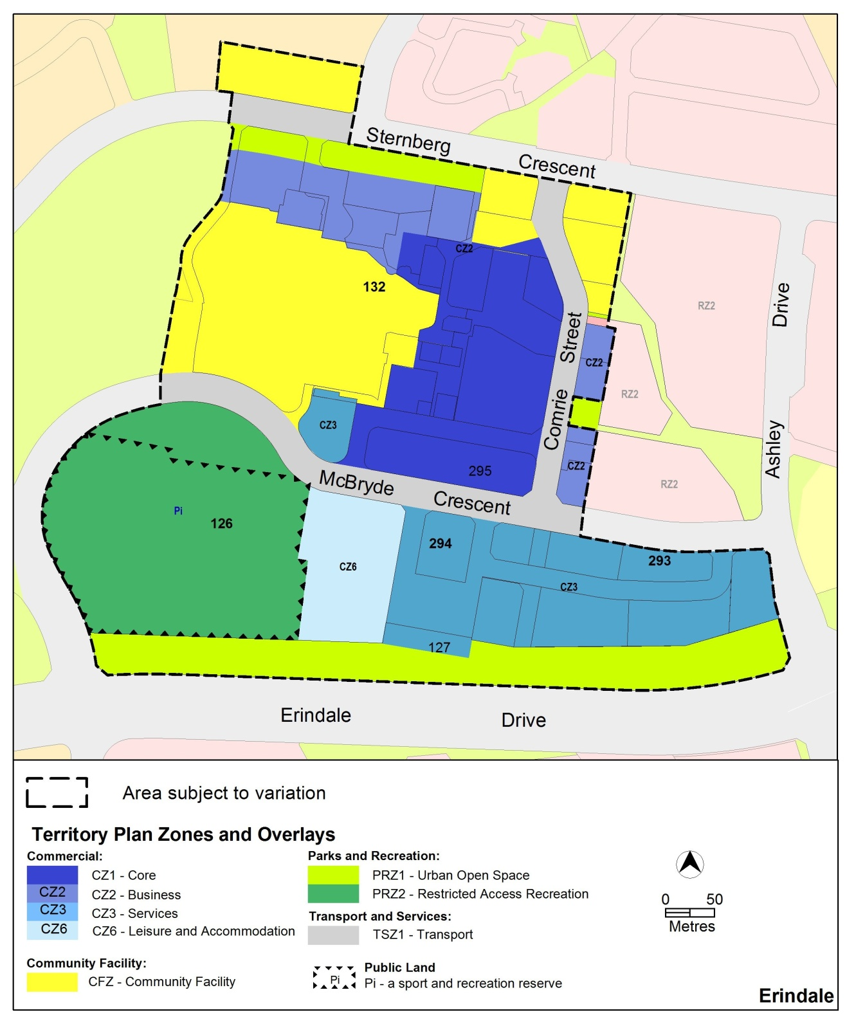
Figure 3: Erindale group centre and surrounding community and recreation lands

  - Variation to the Territory Plan
The Territory Plan is varied as follows:

Variation to the Wanniassa precinct map and code
- Precinct maps and codes, Wanniassa precinct map and code
Substitute the following with the nominated attachment.
Wanniassa Precinct Map and Assessment Tracks tables at Attachment A
Wanniassa Precinct Code, RC1 – Erindale Group Centre at Attachment B
Renumber
RC2 – Wanniassa Group Centre to RC3 – Wanniassa Group Centre
Insert
Wanniassa Precinct Code, RC2 – Erindale Community and Recreation Facilities at Attachment C
Note: The precinct code’s contents page, rules, criteria and figure numbering will require updating.
Interpretation service
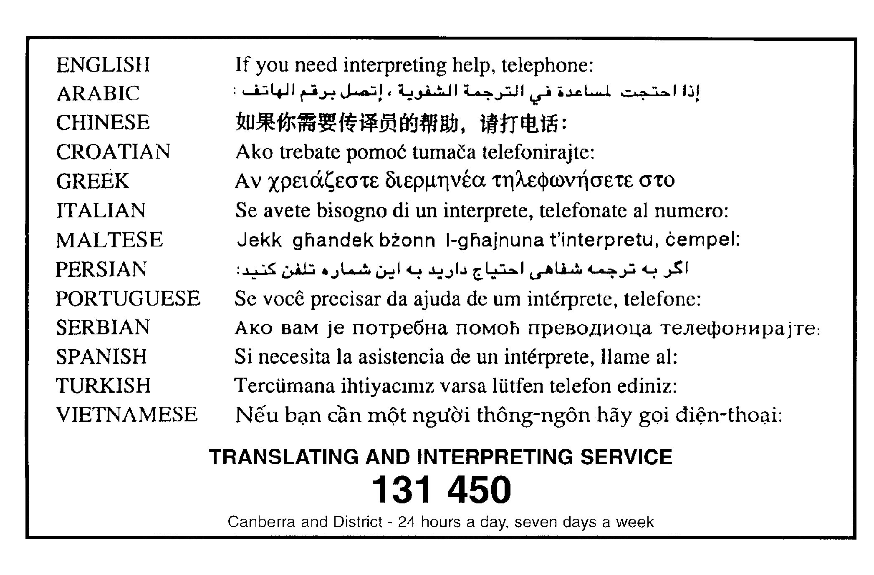

This page is intentionally blank.

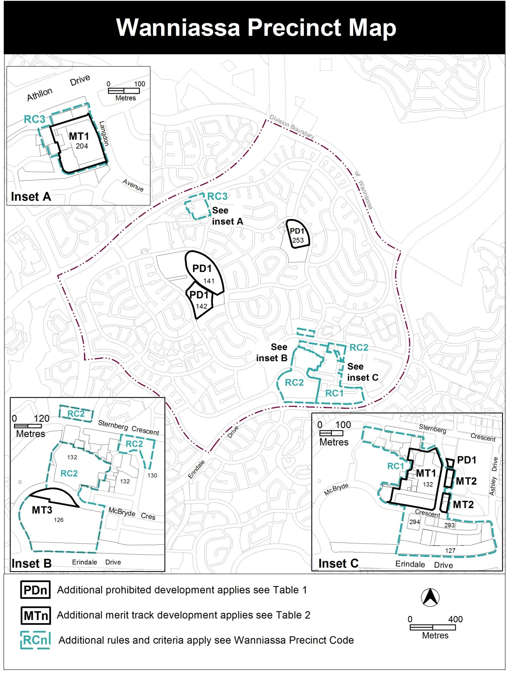

Assessment Tracks
The following tables identify the additional prohibited development and additional merit track development for blocks and parcels shown in the Wanniassa Precinct Map (identified as PDn or MTn). Development that is exempt from requiring development approval, other prohibited development and the minimum assessment track applicable to each development proposal is set out in the relevant zone development table.

The following tables constitute part of the relevant zone development table.

Table 1 – Additional prohibited development
Additional prohibited development
Suburb precinct map label | Zone | Development
PD1 | CFZ | retirement village  supportive housing

Table 2 – Additional merit track development
Additional merit track development that may be approved subject to assessment
Suburb precinct map label | Zone | Development
MT1 | CZ1 | industrial trades  municipal depot  store
MT2 | CZ2 | funeral parlour  light industry  service station  veterinary hospital
MT3 | PRZ2 | NON RETAIL COMMERCIAL

RC1 – Erindale Group Centre
This part applies to blocks and parcels identified in area RC1 shown on the Wanniassa Precinct Map. RC1 includes the Erindale Group Centre.
Desired character
- A high quality landscaped pedestrian spine linking Erindale Drive to Sternberg Crescent, flanked by active building frontage
- development providing a convenient mix of community facilities, services, commercial, recreational facilities and transport opportunities
- a vibrant group centre with high quality open spaces designed with a focus on visibility, safety and accessibility
- a retail core with a central public open space area integrated with public transport and connecting the northern and southern areas
- Development provides interest and activity to the public realm through articulated facades to public spaces, avoiding solid, featureless walls of development

- Use
Rules | Criteria
  - Ground floor use
This rule applies to sites with primary active frontages shown in figure 1.  Only the following uses are permitted at the ground floor level:  - business agency  - club  - community activity centre  - drink establishment  - financial establishment  - hotel  - indoor entertainment facility  - indoor recreation facility  - public agency  - restaurant  - SHOP | This is a mandatory requirement. There is no applicable criterion.
There is no applicable rule. | This criterion applies to sites with secondary active frontages shown in figure 1.  Buildings incorporate uses on the ground floor that generate activity in the public space.

  - Residential use
This rule applies in CZ1, CZ2 and CZ3.  RESIDENTIAL USE is only permitted at area ‘A’ in figure 1 | This is a mandatory requirement. There is no applicable criterion.

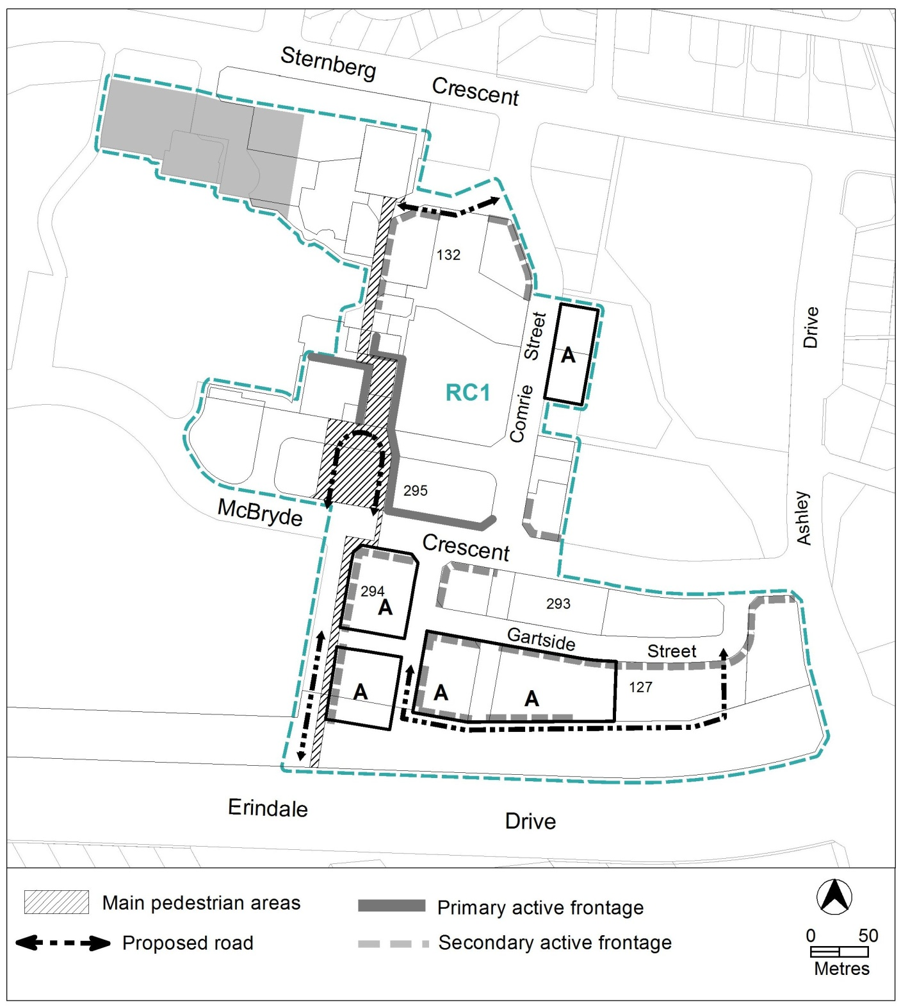

Figure 1: Erindale Group Centre

Rules | Criteria
  - Community uses
This rule applies to the areas shaded grey, shown in figure 1.  Development provides a minimum of 1,400m² gross floor area for community use. | Development application is supported by a report prepared by a suitably qualified person demonstrating that:  - suitable replacement community use facility has been provided or is too be provided elsewhere within the centre, and/or  - the land is no longer required for community use.
  - Industrial trades, municipal depot and store
This rule applies to the areas shaded grey, shown in figure 2.  One or more of the following uses are permitted only in the shaded area and only in association with a structured car park:  - industrial trades  - municipal depot  - store | This is a mandatory requirement. There is no applicable criterion.
  - Development on nominated car parking areas
This rule applies to the areas shaded grey, shown in figure 2.  Development complies with all of the following:  - the existing number of car parking spaces is retained on the site and made available for public use at all times  - provides car parking that is generated by the development on site in accordance with the Parking and Vehicular Access General Code in addition to the spaces required by item a) | Development achieves all of the following:  - any additional parking provision requirements (under the Parking and Vehicular Access General Code) for the development  - makes a substantial contribution to the long term publicly accessible parking supply for the group centre
  - Development on nominated car parking site – section 295
There is no applicable rule. | This criterion applies to the hatched area shown in figure 2.  Development makes provision for a public transport facility in accordance with the proposed Erindale Centre Bus Station Feasibility Study, and endorsed by the relevant authority.

- Buildings
Rules | Criteria
  - Building heights
This rule applies in CZ1, CZ2 and CZ3.  The maximum height of building is 9m, except for the following areas described in figure 2:  - area ‘A’ is the lesser of 12m or 3 storeys  - area ‘B’ is the lesser of 16m or 4 storeys  - area ‘C’ is the lesser of 20m or 5 storeys  Building height measurement excludes all of the following:  - roof top plant  - lift overruns  - antennas  - photovoltaic panels  - air conditioning units  - chimneys, flues and vents  The minimum setback of these excluded items from the building facade of the floor immediately below is 3m. | This is a mandatory requirement. There is no applicable criterion.
  - Building design
This rule applies in CZ1, CZ2 and CZ3.  The minimum floor to ceiling height at ground floor level is 3.6m. | The ground floor level of buildings is adaptable for commercial uses.
There is no applicable rule. | Building design achieves all of the following:  - corner buildings at the intersection of two roads contain focal points providing architectural interest and variety to the building design  - entrances to common areas for residential use provide strong visual connection to the street and ensure a high level of surveillance  - driveways and pedestrian entrances to the site are visible from the block boundary  - west-facing facades incorporate sun shading into building designs  - consistency with the desired character

Rules | Criteria
Development of 2 storeys or more complies with nominated building setbacks as follows:  - development adjoining:  - McBryde Crescent  - extension to Ricardo Street West  - Gartside Street  is built to the boundary adjoining the existing or proposed road reserve  - development adjoining the proposed road between Gartside Street and Erindale Drive is setback a minimum of 2 metres from the boundary adjoining the proposed road reserve | Building setbacks and alignment are consistent with the desired character.  Minor departures from the indicated setbacks in building alignment may be permitted to provide small spaces for active uses along main pedestrian areas and routes, or where alternate setbacks are established by existing adjacent development, in which case setbacks are consistent with the desired character.
  - Plot ratio
There is no applicable rule. | Plot ratio achieves consistency with the desired character.
  - Main pedestrian areas and routes
This rule applies to main pedestrian areas shown in figure 1.  Development ensures pedestrian areas remain unenclosed and publicly accessible at all times  Note: A condition of approval may be imposed regarding the tenure of pedestrian routes. | This is a mandatory requirement. There is no applicable criterion.
  - Proposed roads
There is no applicable rule. | Subdivision of the blocks is generally consistent with the pattern of proposed roads shown in figure 1.
Development in the area shaded grey in figure 1 provides a vehicular access road connecting Wynne Street to the intersection of Sternberg Crescent and Langdon Avenue. | Development in the area shaded grey in figure 1 does not preclude the future provision of an access road connecting Wynne Street to the intersection of Sternberg Crescent and Langdon Avenue.

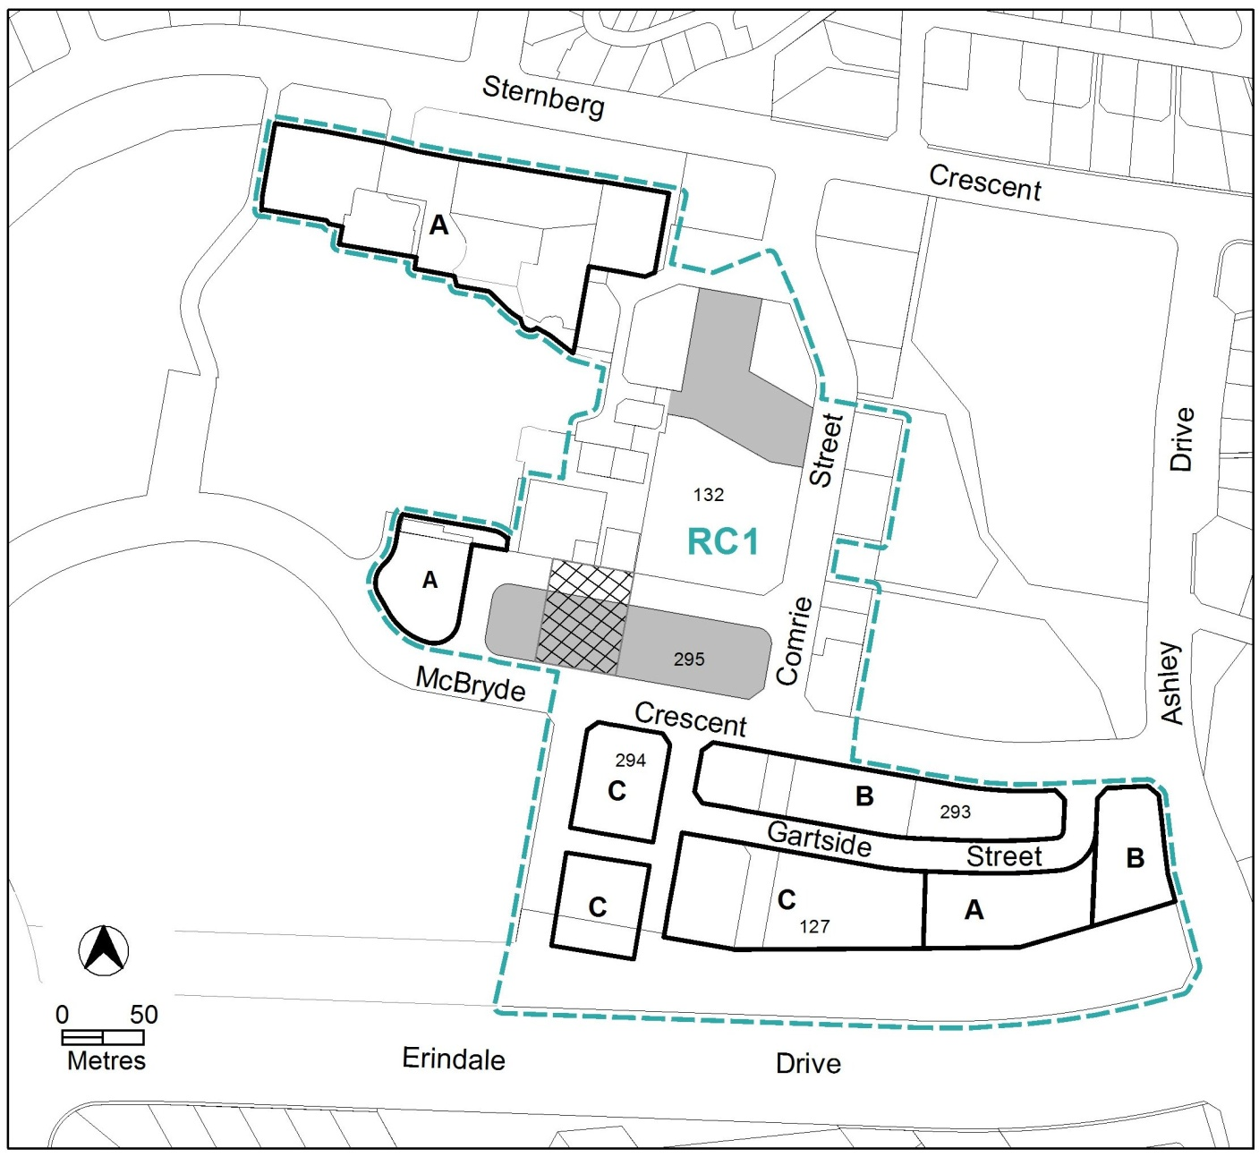

Figure 2: Building heights and nominated parking areas

Rules | Criteria
  - Active frontages
For buildings located along primary active frontage areas shown in figure 1, frontages and building design comply with all of the following:  - buildings incorporate clear display windows and/or shop fronts at the ground floor level  - buildings incorporate direct pedestrian access at grade with the verge level for access and egress for persons with disabilities  - tenancies at ground floor level that occupy more than a total of 20m of the street frontage present as more than one tenancy  - any areas of walls without windows contain displays, showcases and/or public art, with a maximum of 30% blank frontage per tenancy. | This is a mandatory requirement. There is no applicable criterion.
For buildings located along secondary active frontage areas shown in figure 1, frontages and building design comply with all of the following:  - buildings incorporate clear display windows and shopfronts at the ground floor level  - buildings incorporate direct pedestrian access at grade with the verge level for access and egress for persons with disabilities | Development at ground floor level achieves all of the following:  - is adaptable for shops  - direct pedestrian access at street level  - provide opportunities for views into and out of the building
Blank facades, open structured car parks, loading docks, substations and other service infrastructure are not located along primary active frontages shown in figure 1. | This is a mandatory requirement. There is no applicable criterion.
There is no applicable rule. | Extensive lengths of blank facades, open structured car parks, loading docks, substations and other service infrastructure do not dominate secondary active frontage areas shown in figure 1.

This page is intentionally blank.

RC2 – Erindale Community and Recreation Facilities
This part applies to blocks and parcels identified in area RC2 shown on the Wanniassa Precinct Map.
- Use
Rules | Criteria
  - Business agency, office, public agency
This rule applies to any of the following located in area ‘A’ shown in figure 3:  The maximum gross floor area of all of the following uses does not exceed 2000m² per block:  - public agency  - office  - business agency | This is a mandatory requirement. There is no applicable criterion.
  - Non retail commercial
This rule applies to area ‘B’ shown in figure 3.  The maximum gross floor area of NON RETAIL COMMERICAL is 2000m². | This is a mandatory requirement. There is no applicable criterion.
There is no applicable rule. | Development for non retail commercial uses is assessed against the requirements of Part A of the Commercial Zones Development Code.
  - Ancillary uses
There is no applicable rule. | This criterion applies to area ‘B’ shown in figure 3.  Development on the ground floor fronting the oval is ancillary to outdoor recreation facility.

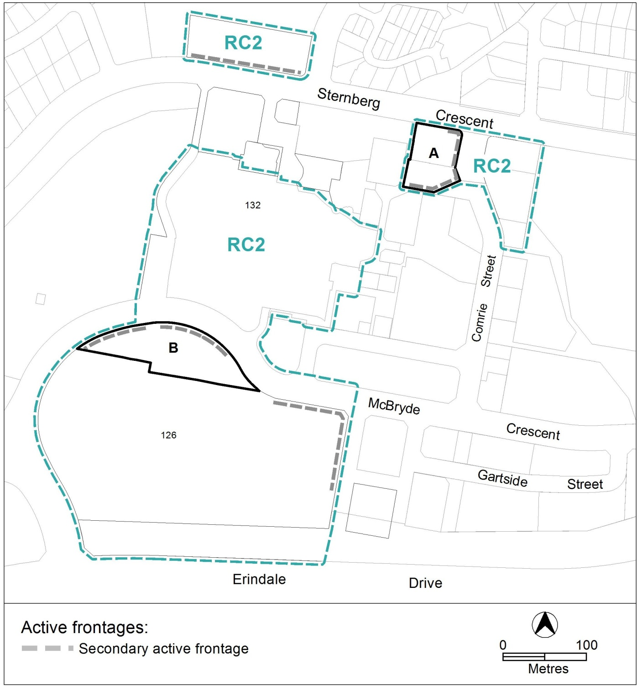

Figure 3: Additional uses and active frontages

- Building
Rules | Criteria
  - Active frontages
There is no applicable rule. | For buildings located along secondary active frontages shown in figure 3, development at ground floor level achieves all of the following:  - direct pedestrian access at street level  - views into and out of the building  - minimise the extent of blank facades
  - Building heights
The maximum height of building for the following areas shown in figure 4:  - area ‘A’ is the lesser of 12m or 3 storeys  - area ‘B’ is the lesser of 16m or 4 storeys  - area ‘C’ is the lesser of 20m or 5 storeys  Building height measurement excludes all of the following:  - roof top plant  - lift overruns  - antennas  - photovoltaic panels  - air conditioning units  - chimneys, flues and vents  The minimum setback of these excluded items from the building facade of the floor immediately below is 3m. | This is a mandatory requirement. There is no applicable criterion.
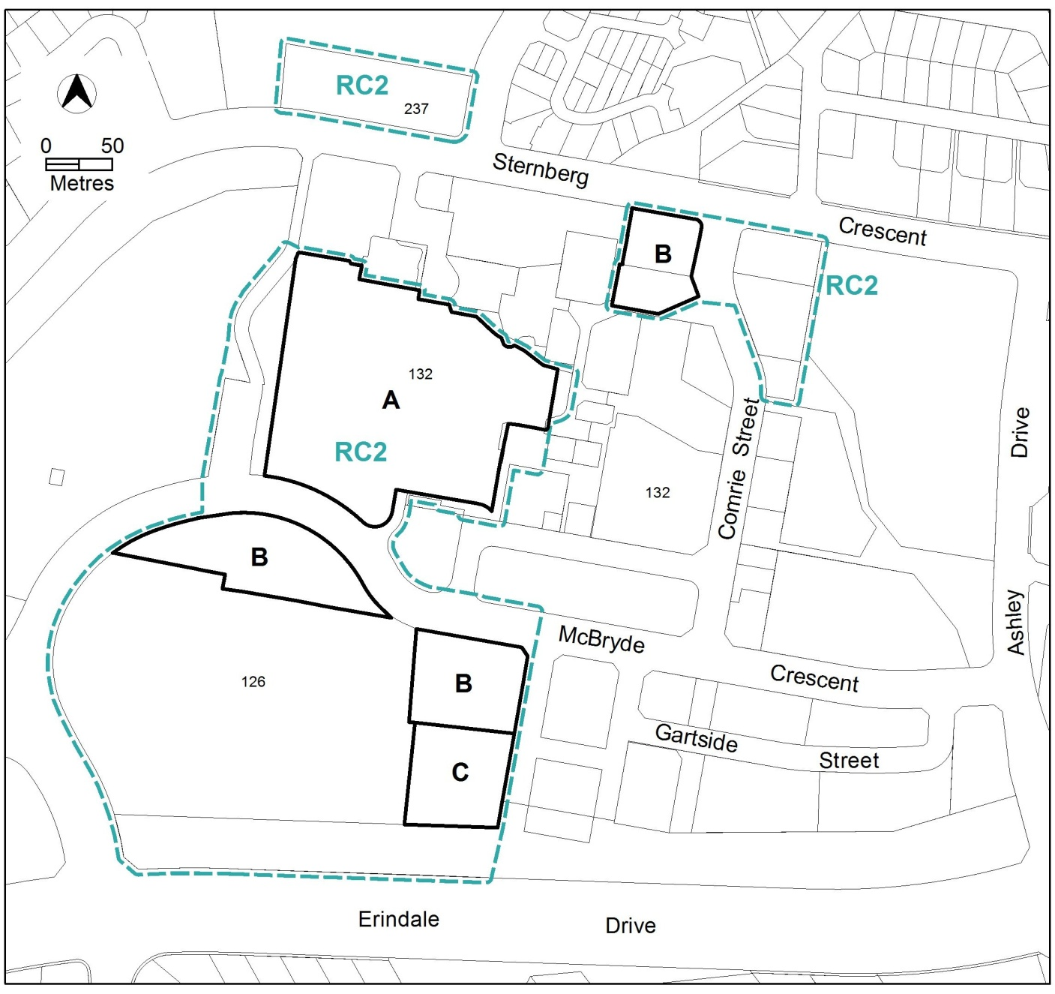
Figure 4: Community and recreation area building heights

