Australian Capital Territory
Planning and Development (Plan Variation No 314) Notice 2014

Notifiable instrument NI2014–187
made under the
Planning and Development Act 2007, section 76(3)

1 Name of instrument
This instrument is the Planning and Development (Plan Variation No 314) Notice 2014.

2 Plan Variation No 314
On 29 April 2013 the Minister for the Environment and Sustainable Development approved the attached plan variation to the Territory Plan under section 76 (3).

Jim Corrigan
Delegate of the planning and land authority
1 May 2014

Planning and Development Act 2007

Variation to the
Territory Plan
No 314

Kingston Group Centre
Zone changes and amendments to the Kingston precinct map and code

May 2014

Final variation prepared
under s76 of the Planning and Development Act 2007

This page is intentionally blank.

Contents

1. EXPLANATORY STATEMENT 2
1.1 Background 2
1.2 Summary of the proposal 2
1.3 The National Capital Plan 2
1.4 Site Description 2
1.5 Current Territory Plan Provisions 2
1.6 Changes to the Territory Plan 2
1.7 Consultation on the Draft Variation 2
1.8 Revisions to the Draft Variation Placed on Consultation 2
2. VARIATION 2
2.1 Variation to the Territory Plan 2

This page is intentionally blank.

- EXPLANATORY STATEMENT
  - Background
The Kingston Group Centre was developed as the first commercial centre in Canberra in the 1920’s, and is both a retail centre and a significant dining/entertainment hub. The centre is characterised by a strong sense of place, an active public realm and a distinctive built form.
The government funded Kingston Centre Planning Project was undertaken by Purdon Associates and Cox Humphries Moss from August 2009 to September 2010. The project was undertaken in response to population growth, changes to the demographics, development pressures in the centre and research findings that identified the requirement for additional supermarket space in inner south Canberra. The project report noted that the population catchment of the group centre is growing but that the centre had not benefitted from this, likely due to residents utilising other commercial centres at the expense of Kingston.
The planning project culminated in the Kingston Centre master plan, which was released on June 2011 (refer to www.act.gov.au/kingston). The master plan sets out a vision for the future of the centre and aims to guide growth and change in a way that will meet the needs of residents, visitors, lessees and businesses and to ensure the centre’s future sustainability. As part of the implementation of the master plan, the Kingston precinct map and code will be amended in response to the key findings of the master plan and planning report to guide further development at the centre.
  - Summary of the proposal
Variation to the Territory Plan No 314 changes the zone of land at the Kingston Group Centre and amends the Kingston precinct map and code.
The changes provide the opportunity to encourage the revitalisation of Kingston shopping centre through the inclusion of findings of the Kingston Centre master plan and planning report. The changes will enable the ACT Government to deliver a mixed use development with additional retail and supermarket on the existing car parking site. The precinct code changes will enhance the amenity and character of Green Square and adjacent shopping centre, whilst improving pedestrian access through the centre.
  - The National Capital Plan
The Australian Capital Territory (Planning and Land Management) Act 1988 established the National Capital Authority (NCA) with two of its functions being to prepare and administer a National Capital Plan (the Plan) and to keep the NCP under constant review and to propose amendments to it when necessary.
The Plan, which was published in the Commonwealth Gazette on 21 January 1990, is required to ensure Canberra and the Territory are planned and developed in accordance with their national significance. The Australian Capital Territory (Planning and Land Management) Act 1988 also requires the Territory Plan is not inconsistent with the Plan. The area covered by this draft variation is within urban areas identified in the Plan.
  - Site Description
The Kingston Group Centre is generally bounded by Giles Street to the north, Kennedy Street to the west, Jardine Street to the east and Eyre Street to the south as described in Figure 1. The Kingston Group Centre is closely connected to the adjoining residential zoned areas, as the commercial zone crosses over a number of streets, with commercial zoned blocks directly adjoining high density residential zoned blocks, resulting in a ‘close knit’ and unique character to the centre.
The CZ1 core commercial area surrounds Green Square, a focal point for the centre highly prized by the community for the unique landscape character it provides the centre, and is currently generally limited to two storeys in height, with awnings along the major pedestrian walkways and a central service lane, Highgate Lane. The CZ1 zone also encompasses a significant area of undeveloped land in the centre, being the Eyre Street surface car park. The Eyre Street car park is bounded on three sides by residential and commercial accommodation development located on RZ5 and CZ2 zoned land.
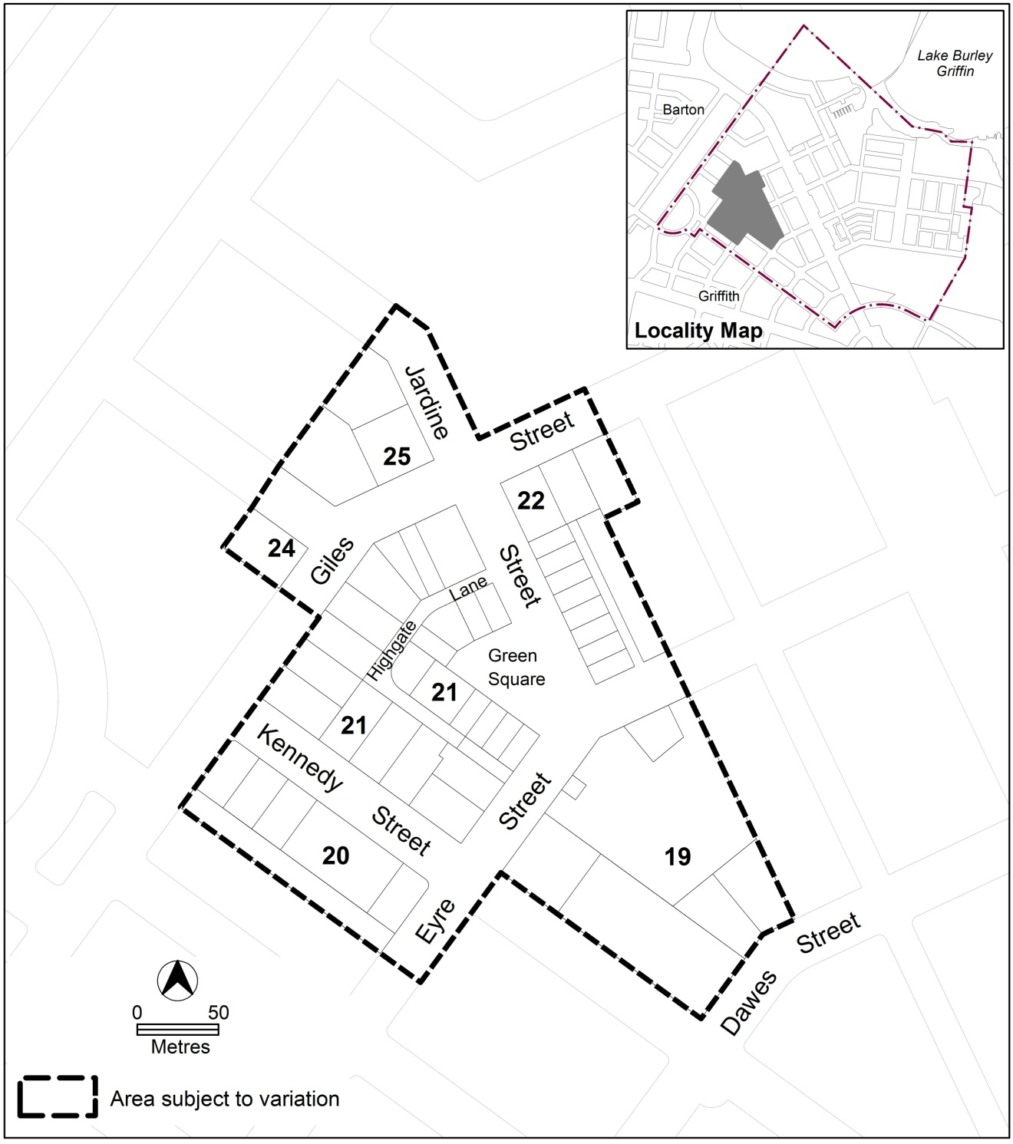
Figure 1: Location plan of the area subject to this variation
  - Current Territory Plan Provisions
The Territory Plan map for the area subject to this variation is shown in Figure 2.
The Kingston Group Centre has an area of unleased urban open space PRZ1 zone over Green Square. This area is surrounded by the commercial CZ1 zone covering section 21 and blocks 29, 47 and 48 in section 19, which in turn is surrounded by CZ2 business zone upon parts of sections 19, 20, 22, 24 and 25. The Territory Plan map zones for the area subject to this variation are shown in Figure 2, which includes block 15 section 20 that has both CZ2 and residential RZ5 high density residential zone.
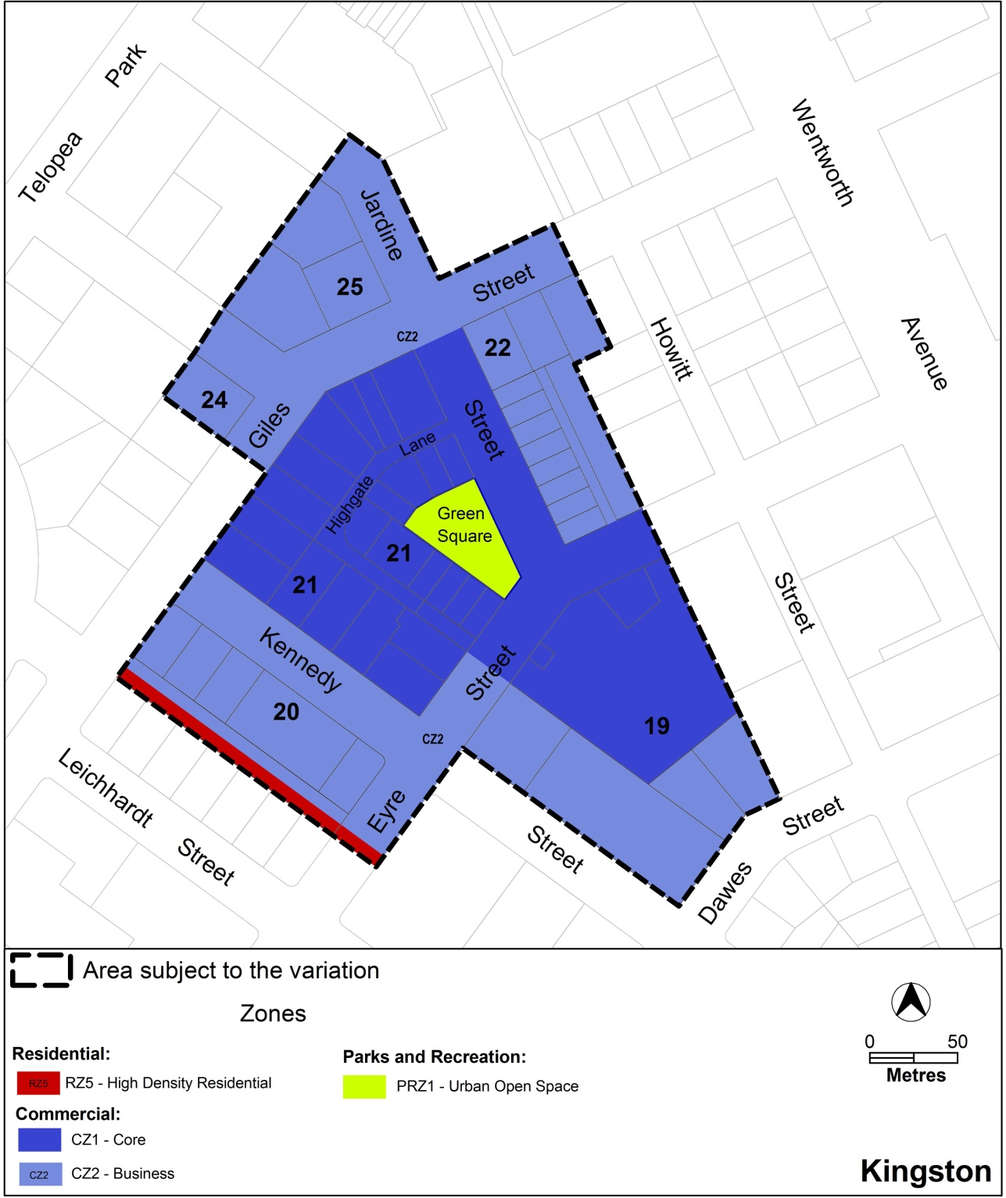
Figure 2: Territory Plan Zones Map
Development on land within the commercial zone is subject to the provisions of the Commercial Zones Development Code and the Kingston precinct map and code. Additional controls for certain development are included in separate development codes such as the Multi Unit Housing Development Code, used to assess residential development proposals.

  - Changes to the Territory Plan
Detailed changes to the Territory Plan are noted in section 2 of this document.
  - Consultation on the Draft Variation
Draft Variation No 314 (DV314) was released for public comment between 28 June 2013 and 26 August 2013. A consultation notice under section 63 of the Planning and Development Act 2007 (P&D Act) was published on the ACT Legislation Register on 28 June 2013 and in The Canberra Times on 29 June 2013.
A total of 27 written submissions were received, which included 18 submissions from residents near or adjoining the centre including one petition with 11 signatories, five submissions from businesses located within the centre, and four from consultants or other parties with commercial interest in development within the centre.
Main issues raised by submitters included:
- concerns with the potential impact of increased building heights on solar access and privacy for adjoining residents
- impact of increased building heights on the village feel and heritage character of the centre
- the change in building heights over what was nominated in the Kingston Centre master plan
- additional residential and/or commercial development is not required as there is already an oversupply in Kingston
- concerns with the consultation process for the Kingston Centre master plan and/or DV314
- increased development will increase traffic and/or parking requirements in the centre
The above issues were considered and are detailed in a report on consultation, which is available at www.act.gov.au/recommendedvariations. Changes were informed by the issues raised.

  - Revisions to the Draft Variation Placed on Consultation
The following changes were made as a result of public consultation:
- the four storey building envelope over blocks 13 and 22 section 22 has been removed in response to concerns raised by adjoining neighbours, and due to identified likely impacts from substantial overshadowing onto the amenity of adjoining dwellings. The blocks will be subject to the existing requirements of the Commercial Zones Development Code, which permits two storey development with criteria for considering higher development provided there are no significant impacts on neighbouring dwellings
- the provision requiring development to retain solar access for adjoining dwellings has been amended to clarify that solar access to the main daytime living area and main area of private open space of dwellings on adjoining blocks is to be protected. The reference to ground floor dwellings has been removed to ensure all dwellings are protected from significant impacts to solar access
- the eight storey building envelope over block 12 section 21 has been amended to:
- reduce the overall height from eight storeys to six storeys or 21 metres
- increase the setback of the higher element to Eyre Street from three metres to six metres
- reduce the setback of the higher element from Kennedy Street to 20 metres, to be in line with the four storey elements along Highgate Lane facing Kennedy Street
- reduce the height of the portion of development permitted to the front boundary from 15 metres above ground level to 9 metres (or two storeys) above ground level in keeping with the two storey heights in the remainder of the section
These changes are to provide a two storey frontage along Eyre Street to match the two storey height limits along Green Square and Kennedy Street for development in section 21, and ensure the overall height is more appropriate to the centre
- the building envelope over the Eyre Street car park has been amended to:
- limit building height within six metres of the front boundary to nine metres (two storeys) above ground level to reflect the surrounding streetscape
- clarify the requirements for the open space reflecting the form of Green Square
- including a provision to ensure public access is maintained to the publicly available parking provided as part of any redevelopment
- including provisions for landscaped buffers where development adjoins dwellings addressing the block
- amendments to the solar access provision to ensure that development retains reasonable solar access to the main daytime living area and areas of private open space of all affected dwellings on adjoining blocks, not just ground floor dwellings
- amendments to the provisions for laneways or arcades through selected blocks adjoining Highgate Lane to provide a measure of flexibility when the laneways/arcades are required to be provided

- VARIATION
  - Variation to the Territory Plan
The Territory Plan map is varied as indicated in figure 3:
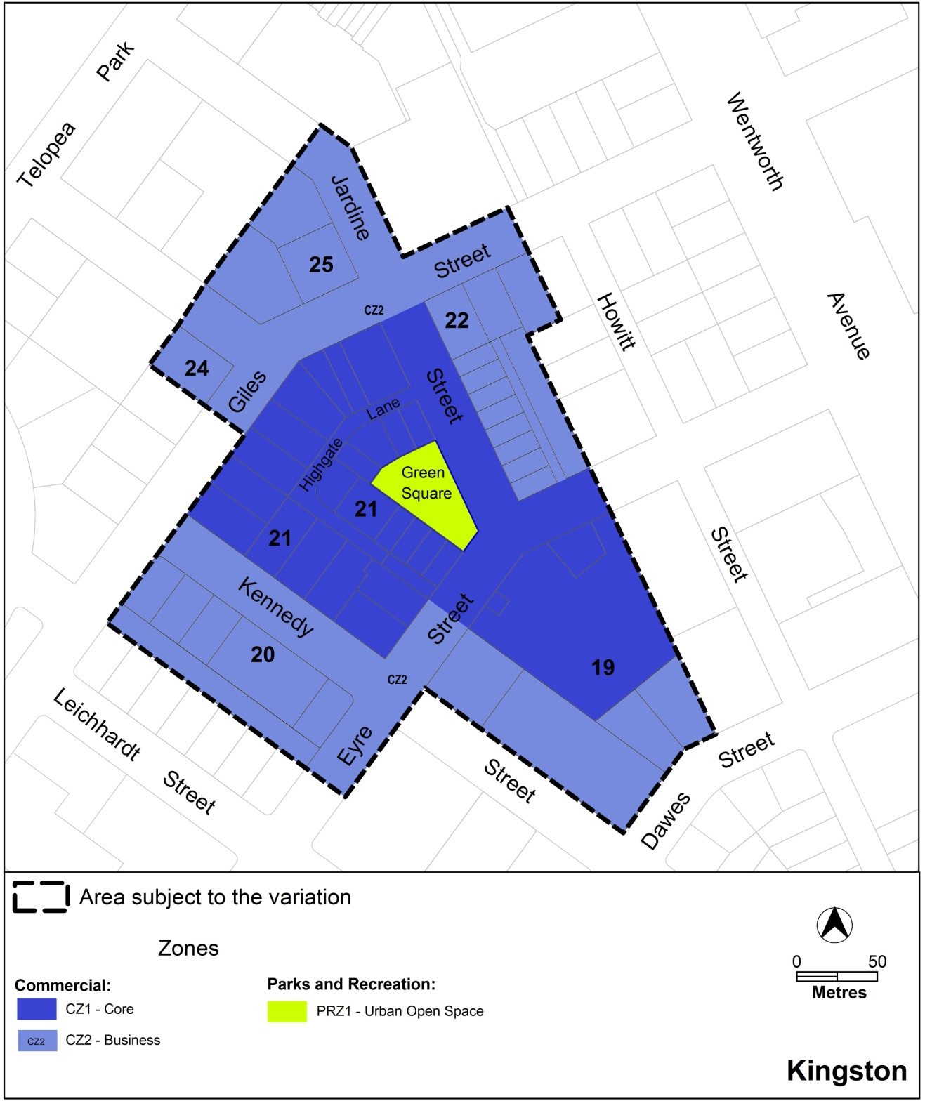
Figure 3 New zones for Kingston Group Centre

Variation to the Kingston Precinct Map and Code
10. Precinct Maps and Codes, Kingston Precinct Map and Code
Substitute all the following with the nominated attachment:
Kingston Precinct Map – Attachment A
Kingston Precinct Code, RC3 – Kingston Group Centre – Attachment B
Note: The precinct code’s contents page, rules, criteria and figure numbering will require updating.

Interpretation service
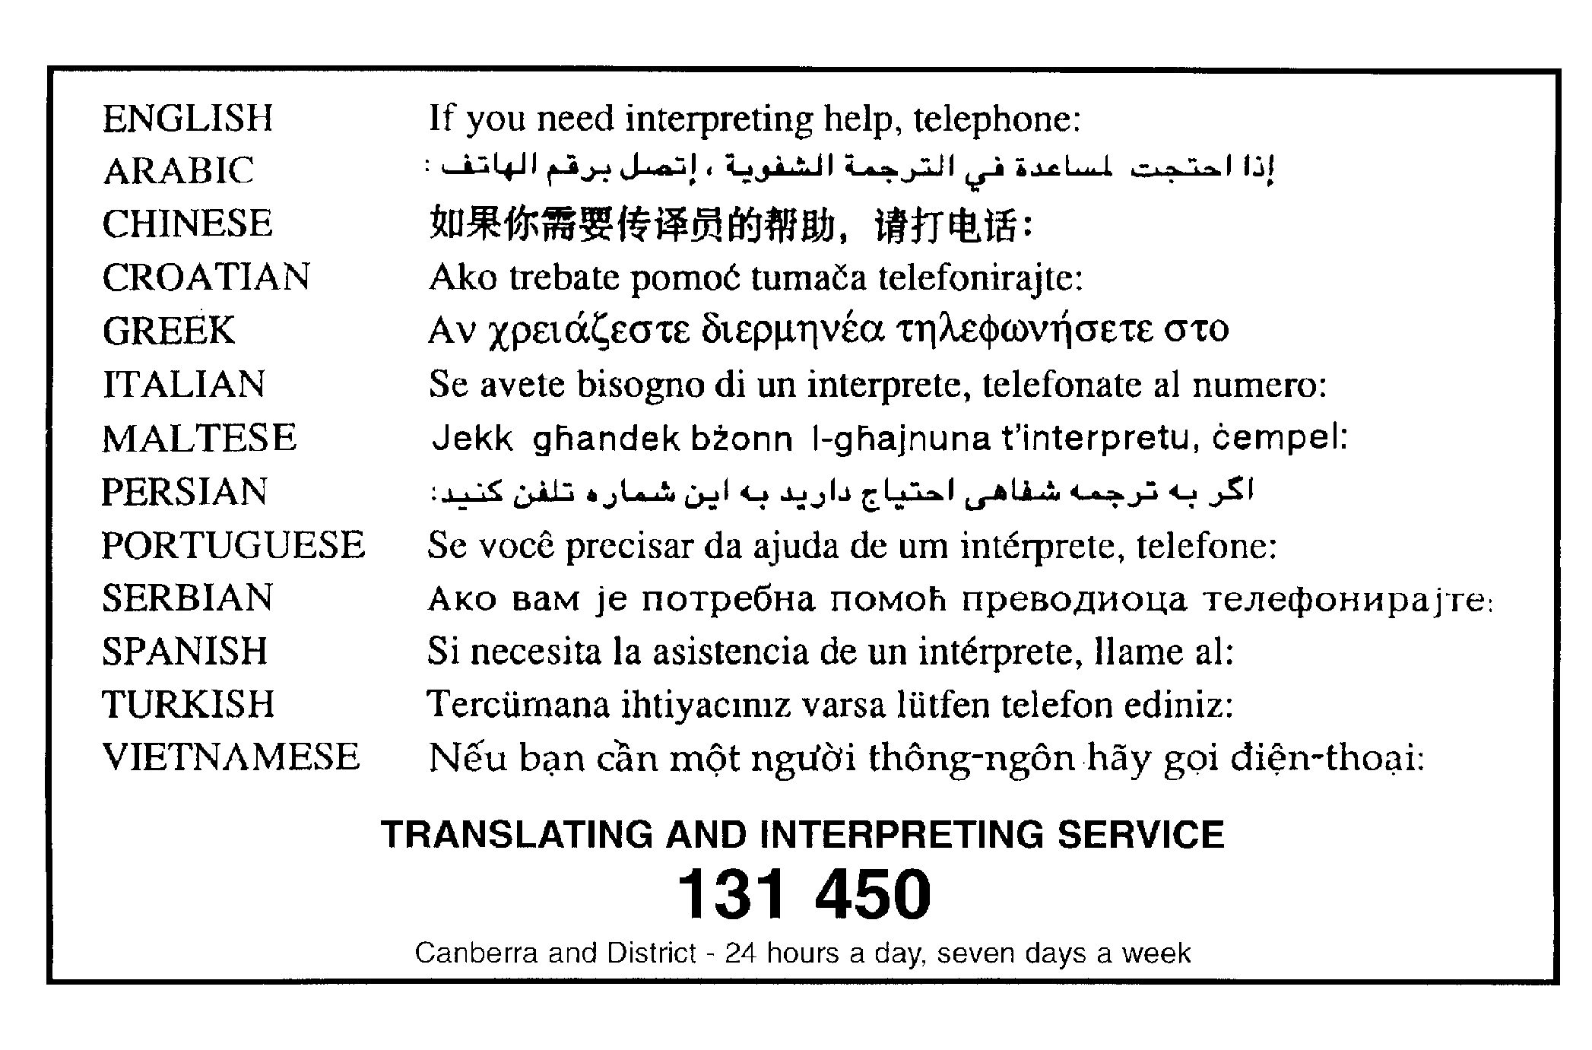

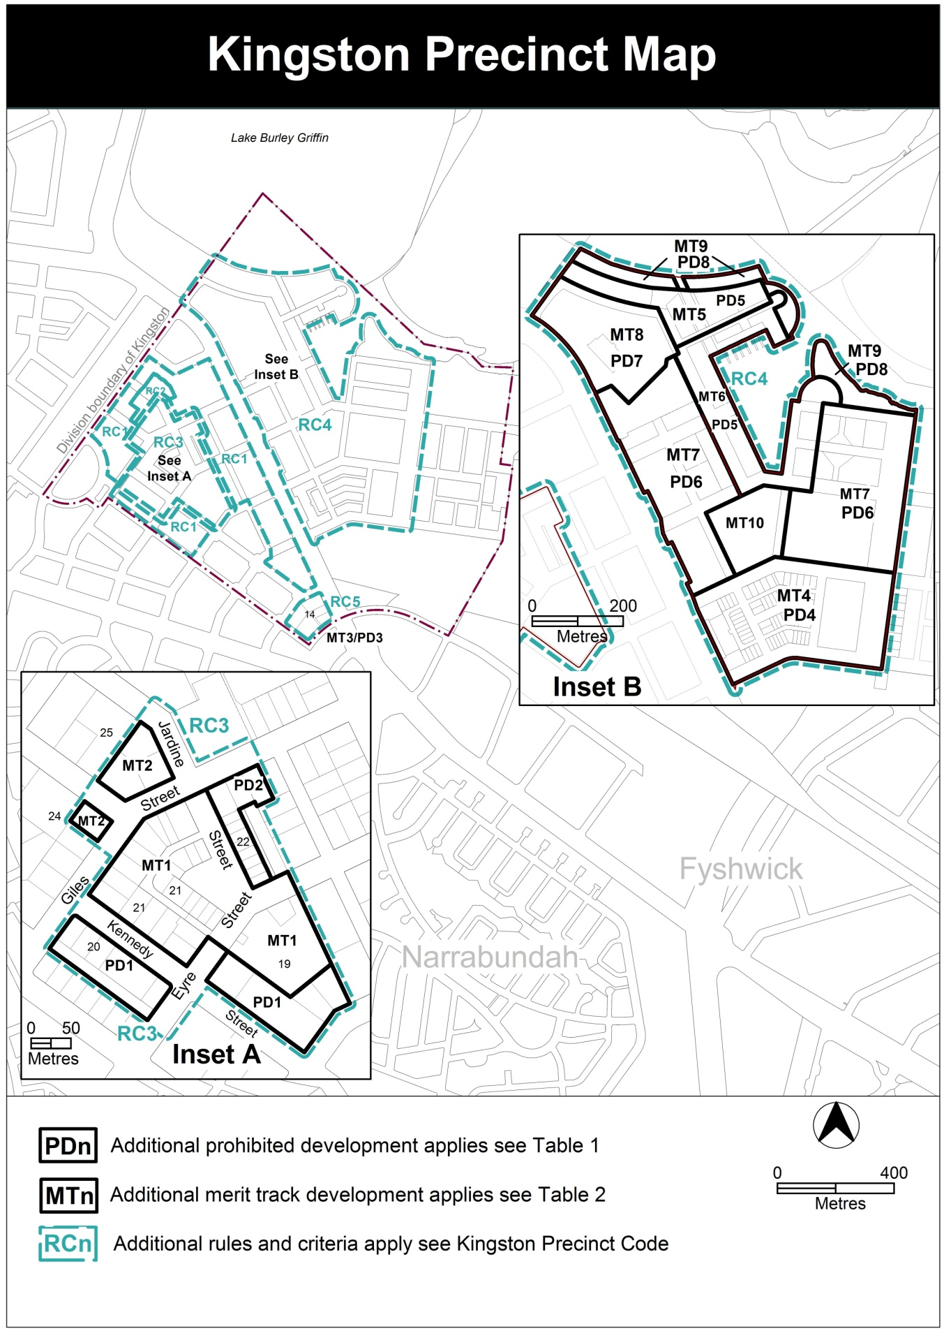

This page intentionally blank

RC3 – Kingston Group Centre
This part applies to the Kingston Group Centre shown as RC3 on the Kingston precinct map. RC3 includes the Kingston Group Centre.
Desired character
In addition to the character noted in the relevant zone objectives, the desired character of the Kingston group centre has:
- good pedestrian connections to and within the centre
- fine grain, active shop-fronts facing the street
- commercial developments that encourage activity in Highgate Lane and other laneways
- development that respects the heritage character of the centre

- Use
Rules | Criteria
  - Ground floor uses
This rule applies to sites with frontages to primary active frontages in CZ1 shown in figure 3.  Only the following uses are permitted at the ground floor level:  - business agency  - club  - community activity centre  - drink establishment  - financial establishment  - hotel  - indoor entertainment facility  - indoor recreation facility  - public agency  - restaurant  - SHOP | This is a mandatory requirement. There is no applicable criterion.
There is no applicable rule. | This criterion applies to sites with boundaries to primary active frontage in CZ2 shown in figure 3.  Buildings incorporate uses on the ground floor that generate activity in the public space.
  - SHOP – floor area limit
This rule applies to section 22.  The maximum gross floor area of SHOP is 300m². | This is a mandatory requirement. There is no applicable criterion.
  - Residential use – ground floor
This rule applies in CZ2.  RESIDENTIAL USE is not permitted on ground floor level except on sections 19 and 20.  RESIDENTIAL USE at the ground floor in sections 19 and 20 is designed to comply with the Australian Standard AS4299 – Adaptable housing (class C) and the Access and Mobility General Code. | This is a mandatory requirement. There is no applicable criterion.
  - Industrial trades, municipal depot, store
This rule applies in CZ1.  One or more of the following uses are permitted only in the shaded area shown in figure 1 and only in association with a structured car park:  - industrial trades  - municipal depot  - store | This is a mandatory requirement. There is no applicable criterion.
  - Development on nominated car parking areas
This rule applies to the shaded area shown in figure 1.  Development complies with all of the following:  - the existing number of car parking spaces is retained on the site and made available for public use at all times  - provides car parking that is generated by the development on site in accordance with the Parking and Vehicular Access General Code in addition to the spaces required by item a) | Development achieves all of the following:  - any additional parking provision requirements (under the Parking and Vehicular Access General Code) for the development  - makes a substantial contribution to the long term publicly accessible parking supply at the group centre
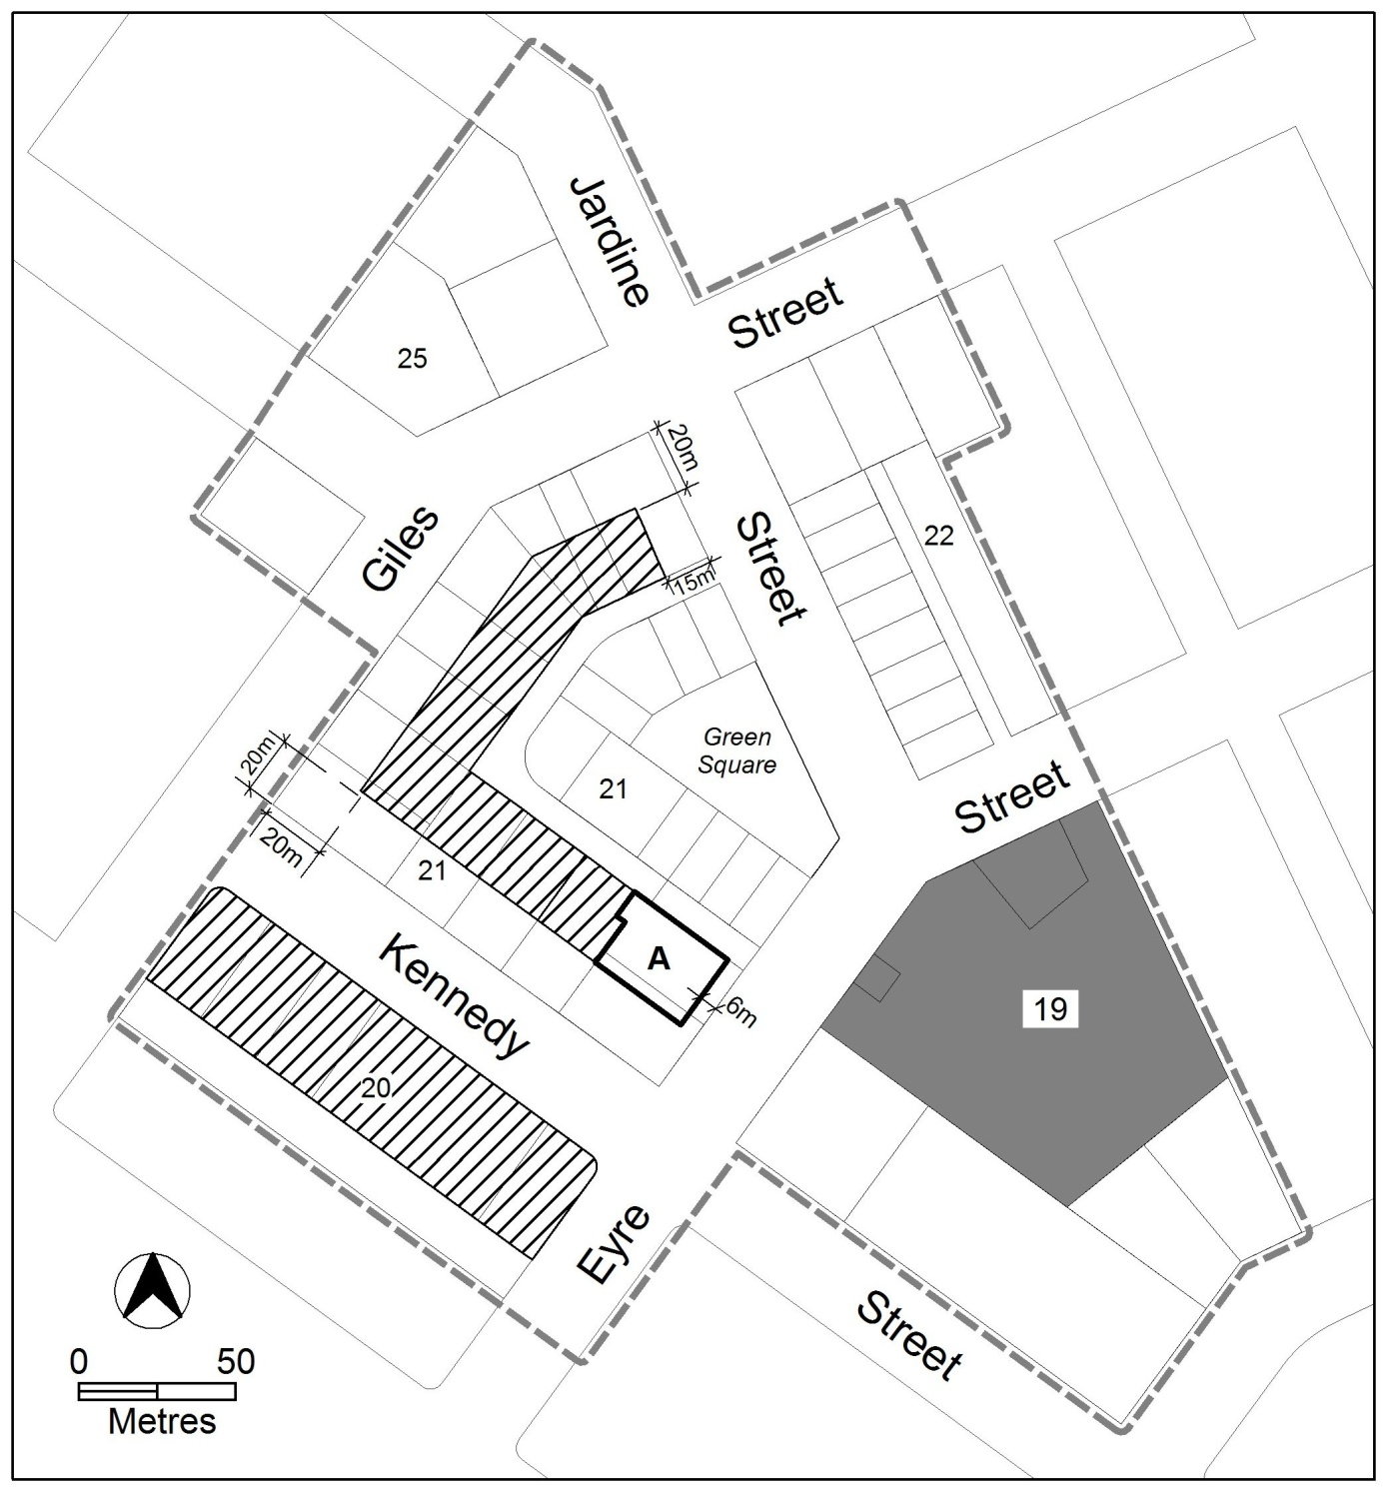
Figure 1: Kingston Group Centre

- Buildings
Rules | Criteria
  - Restriction on development – sections 19 and 21
This rule applies to section 19 in CZ1 zone.  Development of 2 storeys or more is not permitted until the blocks in the shaded area in figure 1 are consolidated into one block. | This is a mandatory requirement. There is no applicable criterion.
This rule applies to section 19 blocks 30 and 31.  Development of 3 storeys or more is not permitted until the blocks are consolidated into one block. | This is a mandatory requirement. There is no applicable criterion.
This rule applies to section 21.  Development ensures adjoining blocks retain vehicle access from Highgate Lane. | This is a mandatory requirement. There is no applicable criterion.
  - Building heights – sections 20, 21 and (part) 22
This rule applies to sections 20 and 21, and blocks in section 22 addressing Jardine Street.  The height of buildings is the lesser of 9m above datum ground level and 2 storeys, except for the following areas shown in figure 1:  - hatched area—the lesser of 15m above datum ground level and 4 storeys  - area ‘A’—the lesser of 21m above datum ground level and 6 storeys  Building height excludes all of the following:  - roof top plant  - lift overruns  - antennas  - photovoltaic panels  - air conditioning units  - chimneys, flues and vents  Excluded items are setback from the building facade of the floor immediately below a minimum distance of 3m. | This is a mandatory requirement. There is no applicable criterion.

Rules | Criteria
  - Building envelope – section 19
This rule applies to section 19 shown in figure 2.  Development is contained within an envelope that achieves all of the following:  - no building, except basement and/or awning, is located within areas A and B  - area ‘A’ is defined by a continuation of the Green Square front boundary of block 13 section 21 and the continuation of the Jardine Street front boundary of block 32 section 22, to a minimum depth of 30m from the Eyre Street front boundary  - area ‘B’ is defined as the area between the south western side boundary and a parallel line drawn 9m distant  - in area C and D maximum height of building, excluding balconies, is 9m above datum ground level where within 6m of the Eyre Street front boundary. Maximum height of building is the lesser of RL590 and six storeys for development setback a minimum of 6m from Eyre Street front boundary  - area C is defined as the area between area B and the continuation of the Green Square front boundary of block 13 section 21 for a maximum depth of 40m from the Eyre Street front boundary  - area D is defined as the area between the north eastern side boundary and the continuation of the Jardine Street front boundary of block 32 section 22 for a maximum depth of 90m from the Eyre Street front boundary  - area E maximum height of building is RL574  - area E is defined as the CZ1 zoned land after the exclusion of areas A, B, C and D  - area F maximum height of building is RL579  - Area F is defined as the CZ2 zoned land after the exclusion of area B  Building height in areas C, D, E and F exclude all of the following:  - roof top plant  - lift overruns  - antennas  - photovoltaic panels  - air conditioning units  - chimneys, flues and vents  Excluded items are setback from the building facade of the floor immediately below a minimum distance of 3m.  Notes:  - 4.1 Restrictions on development applies.  - 4.7 Solar access provisions apply.  - RL590 equates to approximately 23m above datum ground level at the Eyre Street frontage. | This is a mandatory requirement. There is no applicable criterion.
Development in area ‘A’ shown in figure 2 complies with the following:  - remains unenclosed to Eyre Street  - is publicly accessible at all times | Development presents as an extension of Green Square and provides reasonable public access.
This rule applies to development on the block resulting from the consolidation of blocks 29, 47 and 48 section 19.  Development provides a 3m wide landscape buffer to each side and rear boundary where adjoining dwellings have openings addressing the shared boundary | Development incorporates landscaping at the ground floor to each side and rear boundary that provide reasonable visual and physical separation from adjoining residential development.
This rule applies to development on the block resulting from the consolidation of blocks 29, 47 and 48 section 19.  Development provides an unimpeded, permanently open pedestrian path of travel from the front boundary to the public car parking spaces within the development. | This is a mandatory requirement. There is no applicable criterion.
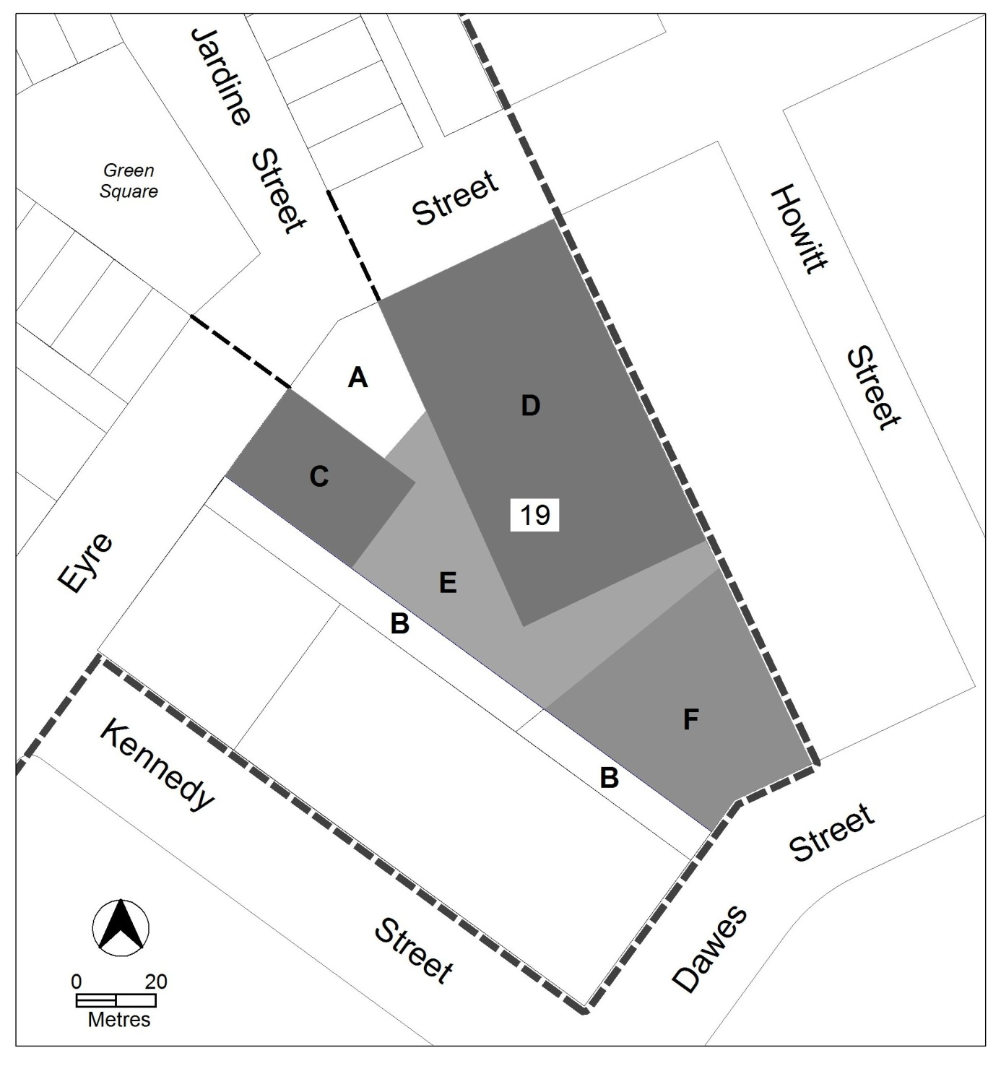
Figure 2: Section 19 – CZ1 zone plus blocks 30 and 31 CZ2

Rules | Criteria
  - Building design
The minimum ground floor level floor to ceiling height is 3.6m | The ground floor level of buildings is adaptable for commercial uses.
  - Plot ratio
There is no applicable rule. | Plot ratio achieves consistency with the desired character.
  - Setbacks
This rule applies to development in sections 21 and 22.  Buildings are built to the front boundary. | Building achieves all of the following:  - a continuous building facade to the street  - at the ground level along primary active frontages shown in figure 3, building alignment is consistent with active uses  - is consistent with the desired character
  - Solar access
Development retains a minimum 3 hours solar access to the main daytime living areas and private open space of dwellings on adjoining blocks between the hours of 9am and 3pm on the winter solstice (21 June). | Development retains reasonable solar access to dwellings on adjoining blocks and their associated private open space.
  - Pedestrian connections – sections 19 and 21
This rule applies in section 19 shown in figure 3 where pedestrian connection is required.  The pedestrian connection from Eyre Street to Dawes Street is to remain unenclosed and publicly accessible at all times. | This is a mandatory requirement. There is no applicable criterion.
This rule applies to land at section 21 and shown in figure 3 with pedestrian connections.  A publicly accessible laneway or internal arcade is provided between Highgate Lane and the street front boundary as shown in figure 3. | Redevelopment of blocks provides opportunities for pedestrian connections between Highgate Lane and the street front boundary.
This rule applies to land in section 21 shown in figure 3 where pedestrian connections are provided.  Pedestrian connections comply with all of the following:  - minimum unobstructed internal width is 3m  - a minimum extent of 30% glazing at the ground floor measured along the length of the pedestrian connection  - access to ground floor commercial tenancies adjoining the pedestrian connection | Pedestrian connections achieve all of the following:  - reasonable public access  - views into and out of adjoining commercial premises  - clearly identifiable entrances  - minimised distances between opposing entrances of pedestrian connections in Highgate Lane

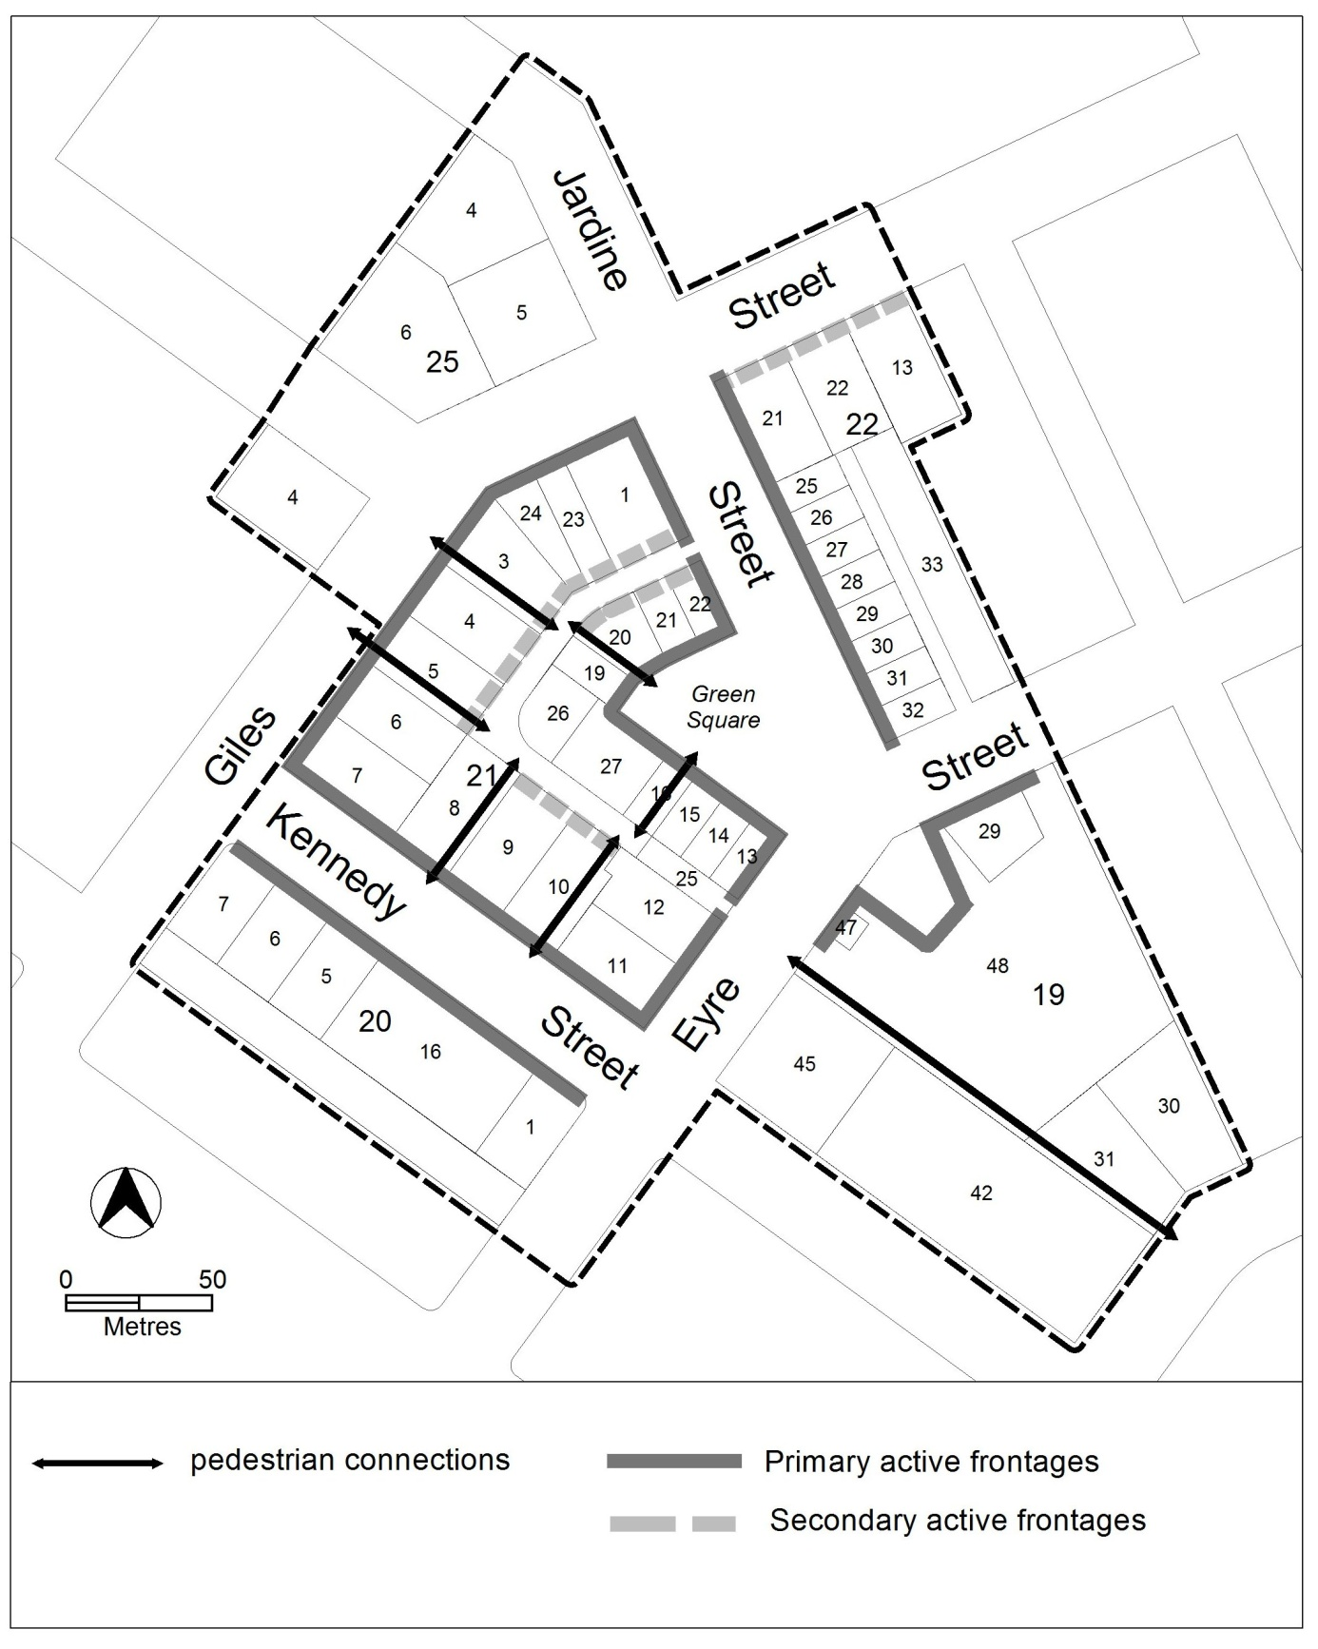
Figure 3 Pedestrian connections and active frontages

Rules | Criteria
  - Active frontages
For buildings located along primary active frontage areas identified in figure 3, frontages and building design comply with all of the following:  - buildings incorporate clear display windows and/or shop fronts at the ground floor level  - buildings incorporate direct pedestrian access at grade with the verge level for access and egress for persons with disabilities  - any small areas of walls without windows contain displays, showcases and/or public art, with a maximum of 30% blank frontage per tenancy  - open structured car parks, loading docks, substations and service infrastructure are not located along the frontage | This is a mandatory requirement. There is no applicable criterion.
For buildings located along primary active frontages identified in figure 3, the maximum distance of a street frontage per tenancy is 6m. | Ground floor tenancies provide fine grain development consistent with the existing character of shops in Green Square and Jardine Street. The appearance of longer facades are broken up through design features to provide consistency with the desired character.
For buildings located along secondary active frontage areas identified in figure 3, frontages and building design complies with all of the following:  - buildings incorporate clear display windows and shop fronts at the ground floor level  - buildings incorporate direct pedestrian access at grade with the verge level for access and egress for persons with disabilities  - building facades are not dominated by extensive lengths of blank facades, open structured carparks, loading docks, substations or other service infrastructure | Development at ground floor level achieves all of the following:  - is adaptable for shops  - where building access is provided, direct pedestrian access at street level  - provide opportunities for views into and out of the building
  - Awnings
This rule applies in CZ1 to buildings fronting primary active frontage areas shown in figure 3.  Awnings comply with all of the following:  - cantilevered awnings for the full extent of the building frontage  - awnings are a minimum height of 3m above finished pavement or ground level of the verge  - awnings are integrated into the building design at the first floor level  - awnings are a minimum of 3m in cantilever depth, except  - where opposing primary active frontages are 6m apart or less, awning depth may be reduced to ensure awnings are separated by 0.5m  - where a reduction in awning depth is required to avoid impacting on existing infrastructure and/or street trees. | This is a mandatory requirement. There is no applicable criterion.
  - Vehicle access
This rule applies to development of 3 storeys or more in section 20.  Vehicle access is not permitted from Kennedy Street. | This is a mandatory requirement. There is no applicable criterion.
This rule applies to blocks in section 21.  Direct vehicular access is not permitted from Kennedy Street, Giles Street, Jardine Street or Eyre Street. | This is a mandatory requirement. There is no applicable criterion.

- Environment
Rules | Criteria
  - Landscaping
There is no applicable rule. | Landscaping in area A in figure 2 achieves consistency with:  - the existing landscape treatment in Green Square  - the desired character
  - Potentially noisy uses – part section 22
This rule applies to section 22 blocks 21, 25-33.  Development of one or more of the following uses complies with a noise management plan prepared by a suitably qualified person and endorsed by the Environment Protection Authority (EPA):  - club  - drink establishment  - emergency services facility  - hotel  - indoor entertainment facility  - indoor recreation facility  - motel  - outdoor recreation facility  - restaurant  The noise management plan will detail the proposed design, siting and construction methods that will be used to ensure compliance with the Environment Protection Regulation 2005, based on the estimated noise levels when the facility is in use. | This is a mandatory requirement. There is no applicable criterion.

- Entity (Government agency) endorsement
Rules | Criteria
  - Entity endorsement
The following matters are to be endorsed by the nominated agency  - Territory and Municipal Services Directorate  - landscaping  - footpaths  - cycle paths  - pedestrian connections  - driveway access  - Transport planning  - parking study  Note: TAMS will endorse a plan if it complies with the relevant TAMS standard. TAMS may endorse departures. | This is a mandatory requirement. There is no applicable criterion.

