Australian Capital Territory
Planning and Development (Plan Variation No 324) Notice 2014
Notifiable Instrument NI2014-20
made under the
Planning and Development Act 2007, section 76(3)

- Name of instrument
This instrument is the Planning and Development (Plan Variation No 324) Notice 2014*.

- Plan Variation No 324
On 10 January 2014, the Minister for Planning approved the attached plan variation to the Territory Plan (Attachment A) under s76 (3).

Jim Corrigan
Delegate of the Planning and Land Authority
20 January 2014

Planning and Development Act 2007

Variation to the
Territory Plan
No 324

Industrial Land Supply –
Pialligo section 12 part block 2 and section 9 part block 4

January 2014

Final variation prepared
under s76 of the Planning and Development Act 2007

This page is intentionally blank.

Contents

1. EXPLANATORY STATEMENT 1
1.1 Background 1
1.2 Summary of the proposal 1
1.3 The National Capital Plan 1
1.4 Site Description 2
1.5 Current Territory Plan Provisions 3
1.6 Changes to the Territory Plan 5
1.7 Consultation on the Draft Variation 5
1.8 Revisions to the Draft Variation recommended to the Minister 6
2. VARIATION 7
2.1 Variation to the Territory Plan 7

This page is intentionally blank.

- EXPLANATORY STATEMENT
  - Background
The objective of the proposed amendment is to provide a large, strategically located site to accommodate bulky goods retailing, warehousing, freight transport and distribution services and other commercial uses without jeopardising an adequate supply of industrial land in Canberra. There are currently limited sites large enough within the Canberra urban area to accommodate these uses. The proposed zoning for the site (IZ2 mixed use industrial) would be consistent with the expanding large format commercial business node that adjoins the site on the opposite side of Majura Road. The land forms part of a larger precinct (Precinct C) identified as suitable for development as employment lands in the Eastern Broadacre Study (2009). Site specific constraints can be adequately dealt with at the detailed design stage as part of any future development application.

  - Summary of the proposal
Variation to the Territory Plan 324 (DV324) proposes to rezone an area of land comprising approximately 7.8ha on the Western side of Majura Road, opposite Majura Park, from broadacre (NUZ1) to mixed use industrial (IZ2). The NCA is currently circulating a draft NCA amendment to change the land use policy of this area from broadacre to urban on the National Capital Plan. This variation will enable opportunities for large bulky goods retailing, freight transport, warehousing and distribution operations to be made available to meet short term demand in this location. It will also ensure that the Territory Plan is in line with the proposed amendment to the National Capital Plan.

  - The National Capital Plan
The Australian Capital Territory (Planning and Land Management) Act 1988 established the National Capital Authority (NCA) with two of its functions being to prepare and administer a National Capital Plan (the Plan) and to keep the NCP under constant review and to propose amendments to it when necessary.
The Plan, which was published in the Commonwealth Gazette on 21 January 1990, is required to ensure Canberra and the Territory are planned and developed in accordance with their national significance. The Australian Capital Territory (Planning and Land Management) Act 1988 also requires the Territory Plan is not inconsistent with the Plan. The area covered by this variation is within urban areas identified in the Plan.

  - Site Description
The subject land is Part Block 4 Section 9 and Part Block 2 Section 12, Pialligo (see location map in Figure 1). It is an area of approximately 7.8 ha fronting Majura Road, starting at the existing roundabout (Mustang Avenue) opposite Majura Park and extending southwest towards Fairbairn Avenue. The Mustang Avenue roundabout services the existing Majura Park commercial and retail precinct on National Land that forms part of the Canberra International Airport Master Plan development.
The area forms part of a larger precinct created between the Majura Parkway currently under construction and the Canberra International Airport. The subject land is unleased Territory land, part of which is currently being used by the Territory and Municipal Services Directorate (TAMSD), ACT Government, to stockpile overburden from the adjoining Majura Parkway.

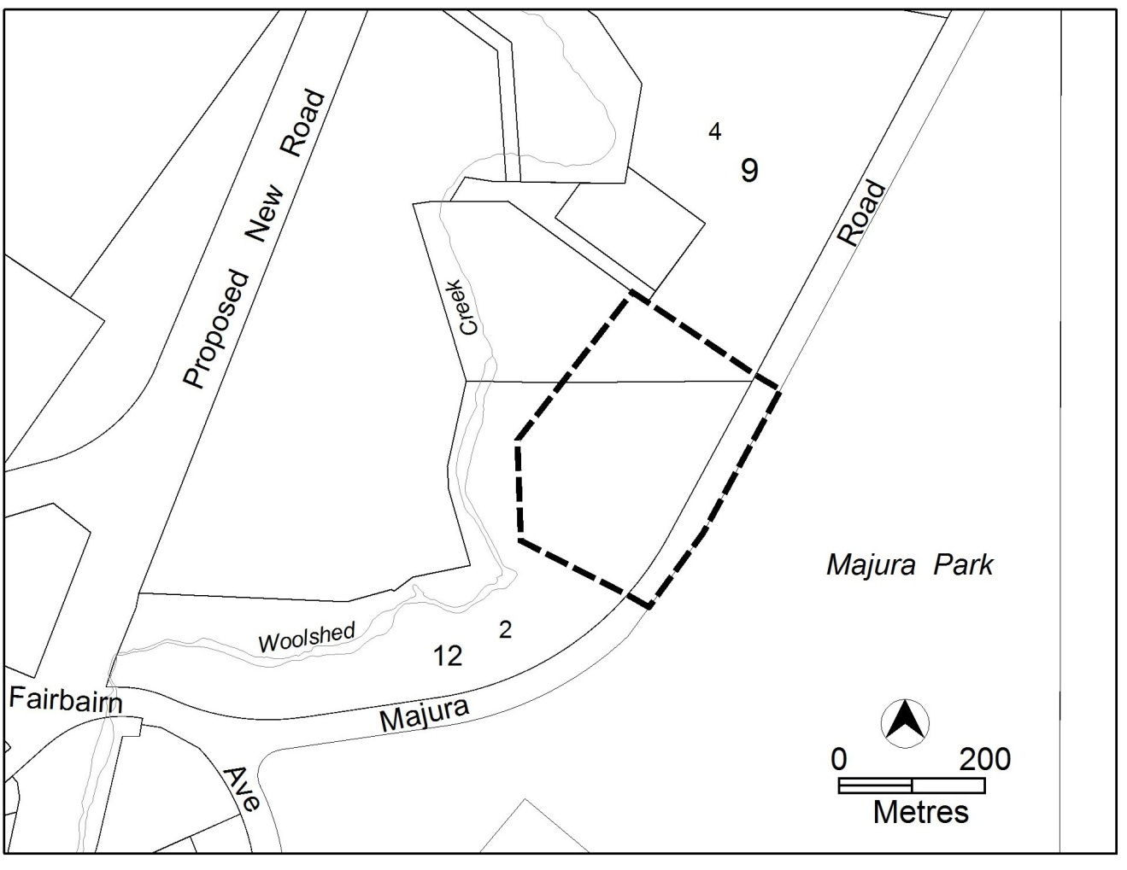
Figure 1: Site Plan

  - Current Territory Plan Provisions
The Territory Plan map for the area subject to this variation is shown in Figure 2.
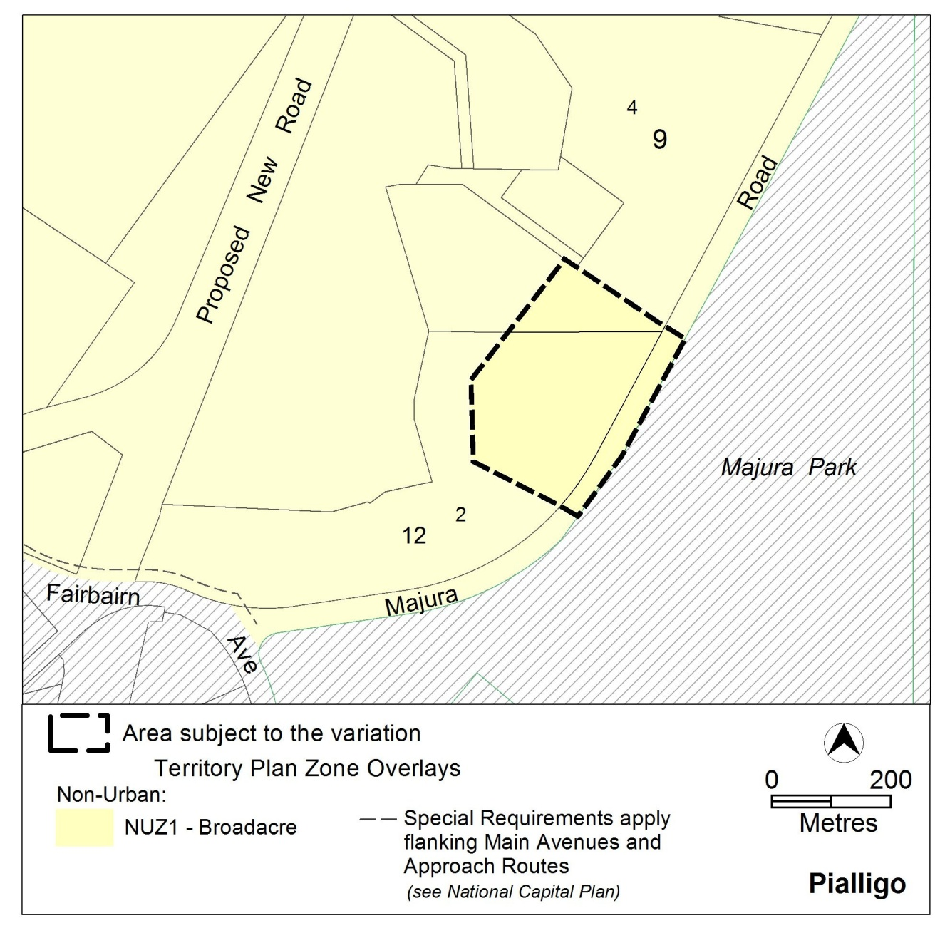
Figure 2 Territory Plan Zones Map

  - Changes to the Territory Plan
Detailed changes to the Territory Plan are noted in section 2 of this document.

  - Consultation on the Draft Variation
Draft Variation No 324 (DV324) was released for public comment between 18 October and 29 November 2013. A consultation notice under section 63 of the Planning and Development Act 2007 (P&D Act) was published on the ACT Legislation Register on 18 October 2013 and in The Canberra Times on 19 October 2013.
A total of eleven written submissions were received, which included submissions from the Canberra Airport, the Pialligo Residents Association and the Majura Valley Land Care Group. Two submissions were in support of the draft variation, one was general advice from the Commonwealth Department of Industry and Regional Development and eight submissions objected to the draft variation. The objections mainly expressed concern about the future loss of the rural aesthetic surrounding the Majura Parkway, the future loss of an attractive approach route to Canberra, and the potential loss of agricultural land in the Majura Valley. There were also calls for the development of a Majura Valley Master Plan.

Main issues raised by submitters included:
- No new urban areas needed
- Other uses for the site
- Transport issues
- Master Plan for Majura Valley
- Major avenues and approach routes to Canberra
- Economic impact
- Transparent and consultative planning
- Upgrading utility infrastructure
- Environmental and heritage concerns
- Food security
- Land ownership
The above issues were considered and are detailed in a report on consultation, which is available at www.act.gov.au/recommendedvariations. No changes were made as a result of consultation. The Minister will consider the outcomes of consultation prior to making a decision on this variation.

  - Revisions to the Draft Variation recommended to the Minister
No changes were made to the draft variation recommended to the Minister.

- VARIATION
  - Variation to the Territory Plan
The Territory Plan map is varied as shown in Figure 3 for the area shown as subject to the variation.

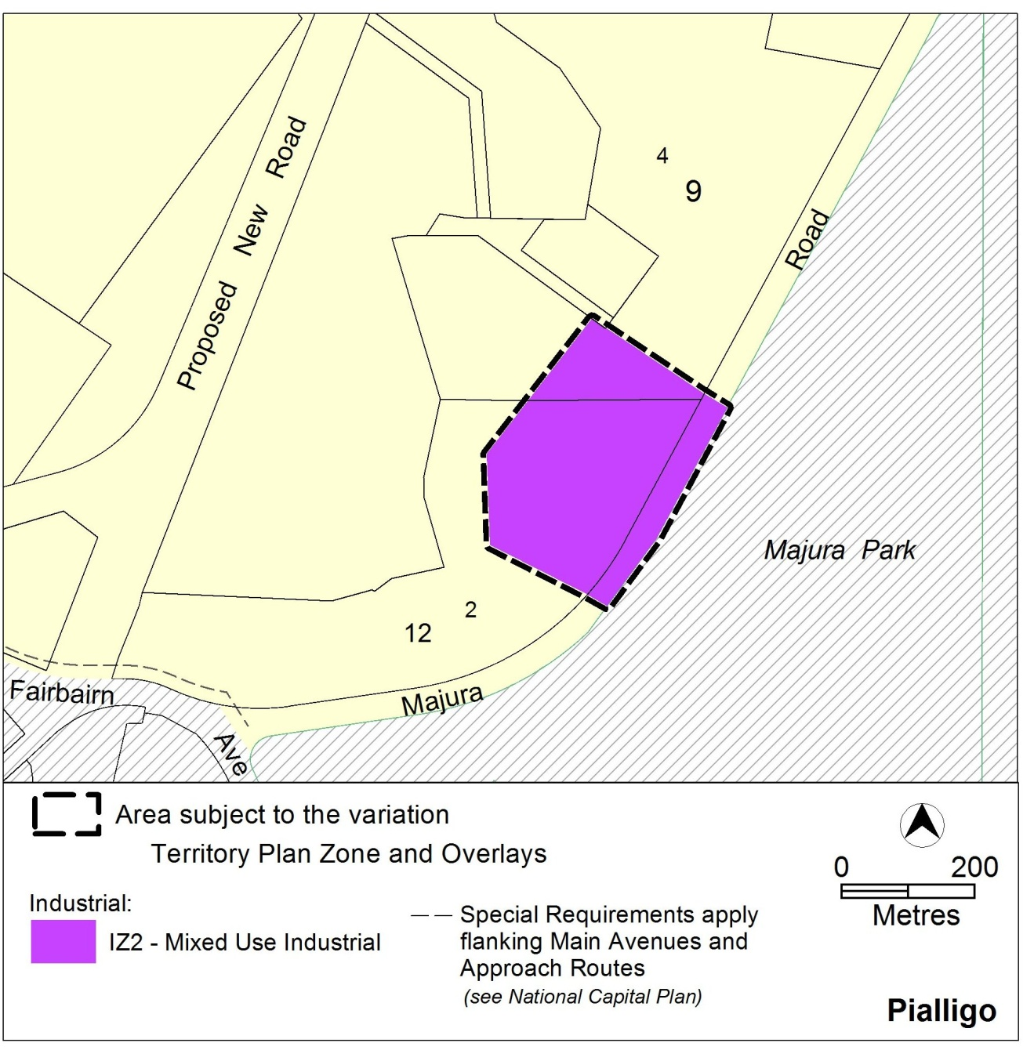
Figure 3 Proposed Territory Plan Provisions

Interpretation service
