Australian Capital Territory
Planning and Development (Plan Variation No 318) Notice 2014
Notifiable Instrument NI2014-294
made under the
Planning and Development Act 2007, section 76(3)

- Name of instrument
This instrument is the Planning and Development (Plan Variation No 318) Notice 2014.*

- Plan Variation No 318
On 5 June 2014, the Minister for Planning approved a draft of the attached plan variation to the Territory Plan (Annexure A) under s76 (3).

Jim Corrigan
Delegate of the Planning and Land Authority
23 June 2014

Annexure A

Planning and Development Act 2007

Variation to the
Territory Plan
No 318

Tuggeranong Town Centre –
Zone changes
Amendment to the Greenway precinct map and code
Amendment to the parking and vehicular access general code

Final variation prepared under s76 of the
Planning and Development Act 2007

This page is intentionally blank.

Contents

1. EXPLANATORY STATEMENT 1
1.1 Summary of the Proposal 1
1.2 The National Capital Plan 1
1.3 Site Description 2
1.4 Current Territory Plan Provisions 3
1.5 Changes to the Territory Plan 4
1.6 Consultation on the Draft Variation 4
1.7 Revisions to the Draft Variation Recommended to the Minister 5
2. VARIATION 6
2.1 Variation to the Territory Plan 6
2.2 Variation to the Territory Plan written statements 7

This page is intentionally blank.

- EXPLANATORY STATEMENT
  - Summary of the Proposal
This variation is the first stage in the implementation of the Tuggeranong town centre master plan 2012. Variation 318 - Tuggeranong town centre (V318) amends the Greenway precinct map and code primarily to increase building heights in strategic locations in the town centre. DV318 also rezones a number of parcels of land to bring it in line with the master plan’s expansion of the retail core area and proposed residential development on the eastern side of Lake Tuggeranong. This is intended to stimulate development and redevelopment in these locations consistent with the master plan.
V318 amends the parking and vehicular access general code to reduce car parking requirements for offices in the Tuggeranong Town Centre consistent with recent surveys of public car park vacancies and public transport access to the town centre. This reduction in car parking requirements also presents an incentive for redevelopment in the town centre consistent with the master plan.

  - The National Capital Plan
The Australian Capital Territory (Planning and Land Management) Act 1988 established the National Capital Authority (NCA) with two of its functions being to prepare and administer a National Capital Plan (NCP) and to keep the NCP under constant review and to propose amendments to it when necessary.
The NCP, which was published in the Commonwealth Gazette on 21 January 1990 is required to ensure that Canberra and the Territory are planned and developed in accordance with their national significance. The Planning and Land Management Act 1988 also required that the Territory Plan is not inconsistent with the NCP.
In accordance with section 10 of the Australian Capital Territory (Planning and Land Management) Act 1988, the National Capital Plan defines the planning principles and policies for Canberra and the Territory, for giving effect to the object of the NCP and sets out the general policies to be implemented throughout the Territory, including the range and nature of permitted land uses.
It also sets out the detailed conditions of planning, design and development for areas that have special significance to the National Capital known as designated areas and identifies special requirements for the development of some other areas.

  - Site Description
The Tuggeranong town centre is located within the suburb of Greenway and is the southern-most town centre in the ACT. The town centre sits between Lake Tuggeranong to the east and the Murrumbidgee River corridor to the west and provides visual and physical access to the surrounding hills and distant mountains. The town centre provides residential, commerce, retail, trade, office, education, community and government services and leisure and entertainment opportunities to the broader Tuggeranong community.

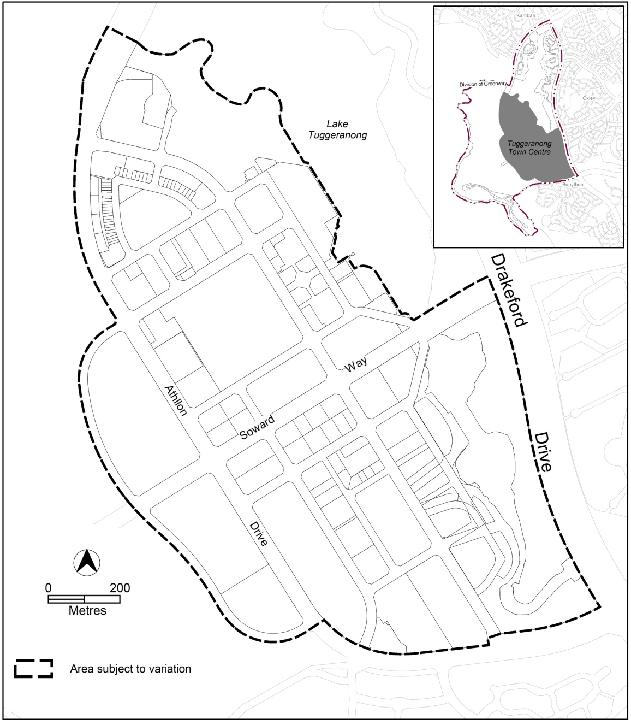
Figure 1 Area subject to V318 –Tuggeranong town centre

  - Current Territory Plan Provisions
The Territory Plan map for the area subject to this variation is shown in Figure 2.
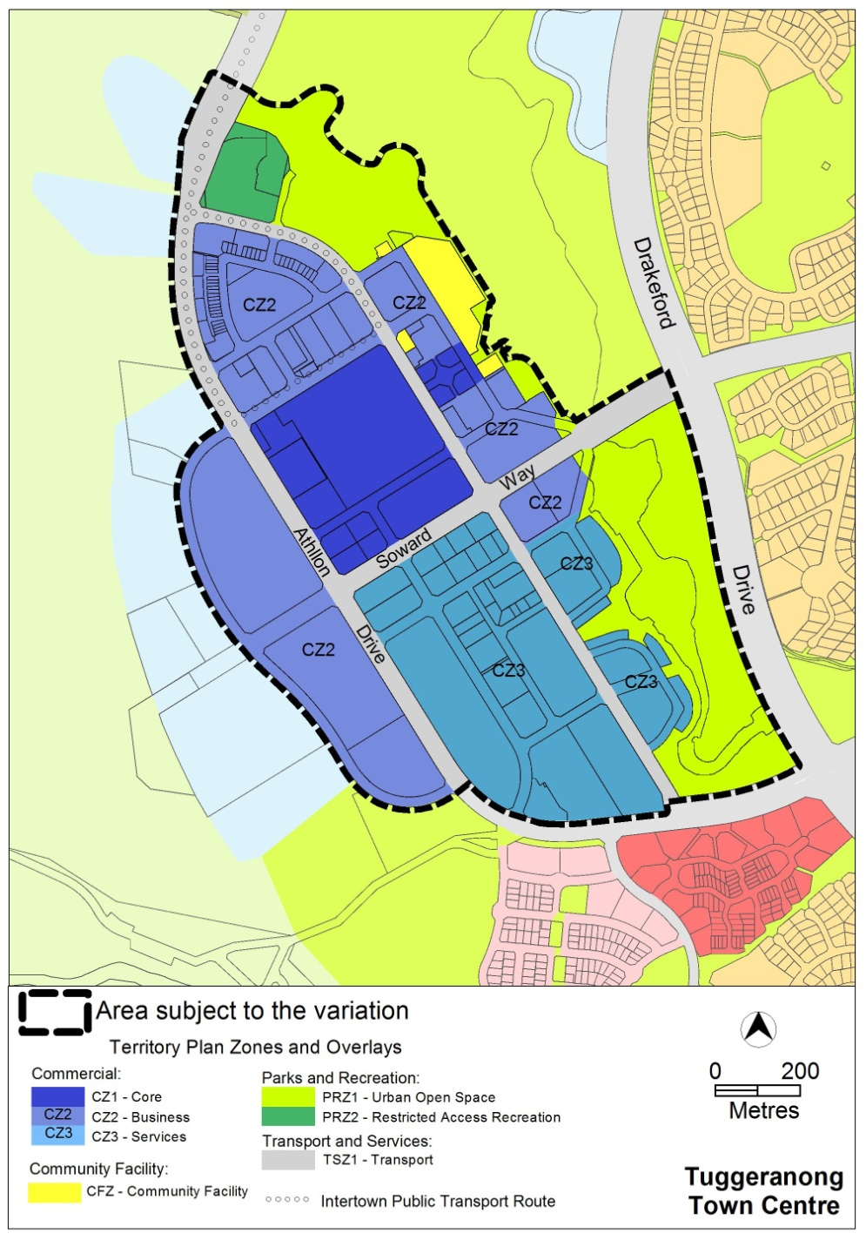
Figure 2 Territory Plan Zones Map

  - Changes to the Territory Plan
Detailed changes to the Territory Plan are noted in section 2 of this document and include:
- Rezoning Greenway part sections 57, 58, 59, 65 and 66 from the commercial CZ3 services zone to commercial CZ2 business zone
- Rezoning Greenway sections 7 and 12 from the commercial CZ3 services zone to the commercial CZ2 business zone.
- Rezoning Greenway section 10, part block 5 from the parks and recreation PRZ1 urban open space zone to the RZ4 medium density residential zone.
- changes to the Greenway precinct map and code to :
  - introduce a statement of desired character
  - apply specific provisions to the land to be rezoned as part of V318
  - increase building heights across the town centre
  - introduce building setbacks in key locations
  - introduce landscape areas in key locations
  - introduce gateway buildings in key locations
  - introduce provisions for commercial adaptability for ground floors in key locations
  - introduce provisions for the lake side residential area
- change the parking and vehicular access general code to bring the car parking rates for offices in Tuggeranong in line with the car parking requirements for other town centres.
  - Consultation on the Draft Variation
Draft Variation No 318 (DV318) was released for public comment between 14 December 2013 and 17 February 2014. A consultation notice under section 63 of the Planning and Development Act 2007 (P&D Act) was published on the ACT Legislation Register on 13 December 1013 and in The Canberra Times on 14 December 2013.
A total of thirteen written submissions were received. There was general acknowledgement of the need to revitalise the town centre. The main issues raised by submitters included:
- Loss of open space through the proposed rezoning of lake side land
- Building heights – comments varied from a submission indicating the buildings were not going high enough, to suggestions that the building heights should be seven storeys, four to six storeys or three to four storeys.
- Car parking reductions resulting in increased pressure on car parking
- There were also comments for site specific provisions.

The above issues were considered and are detailed in a report on consultation. Changes were informed by the issues raised. The outcomes of consultation were considered prior to approval of this variation.

  - Revisions to the Draft Variation Recommended to the Minister
The following changes were made as a result of public consultation:
- The provisions stipulating nine storeys fronting Athllon Drive applying to block 5 section 13 Greenway were removed and replaced with a provision stipulating a maximum of twelve storeys across the entire site.

- VARIATION
  - Variation to the Territory Plan
The Territory Plan map is varied as indicated in Figure 3 for the area shown as subject to the variation.
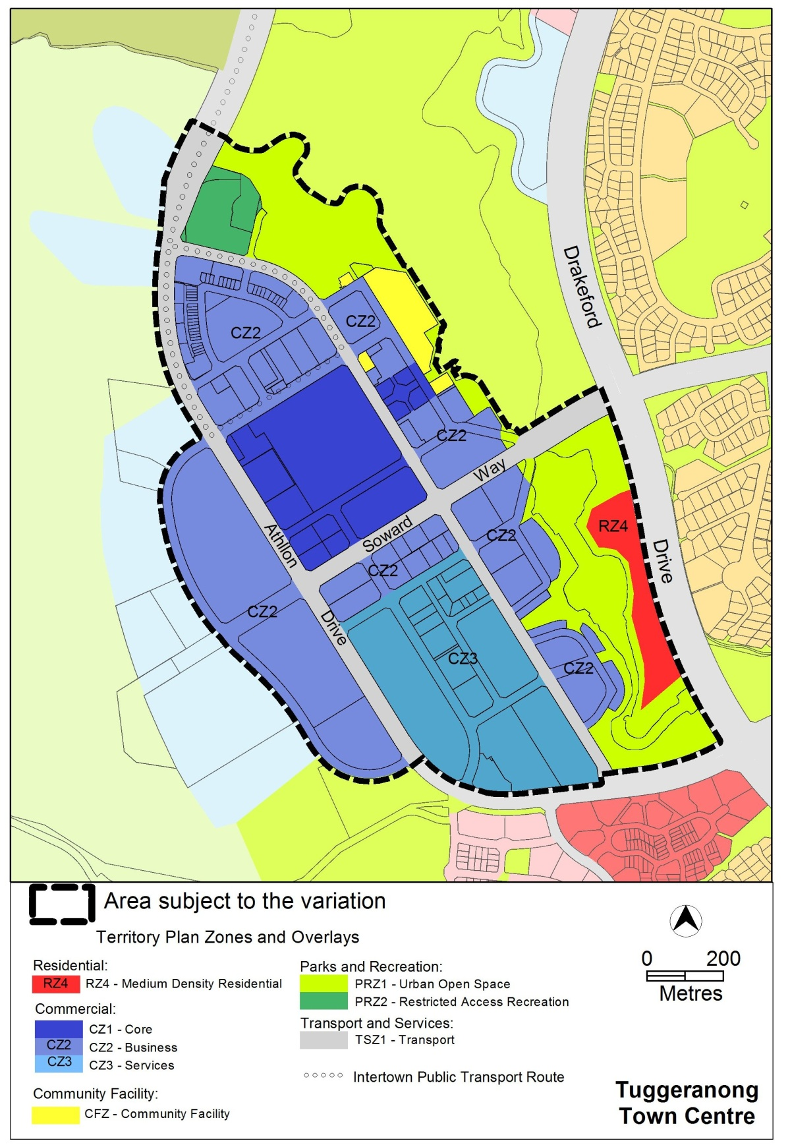
Figure 3: Variation to the Territory Plan map
  - Variation to the Territory Plan written statements

Variation to the Greenway Precinct Map
- MT3 (boundary changes) and new RC4 – Tuggeranong Town Centre -

Substitute the Greenway precinct map with the following Greenway precinct map

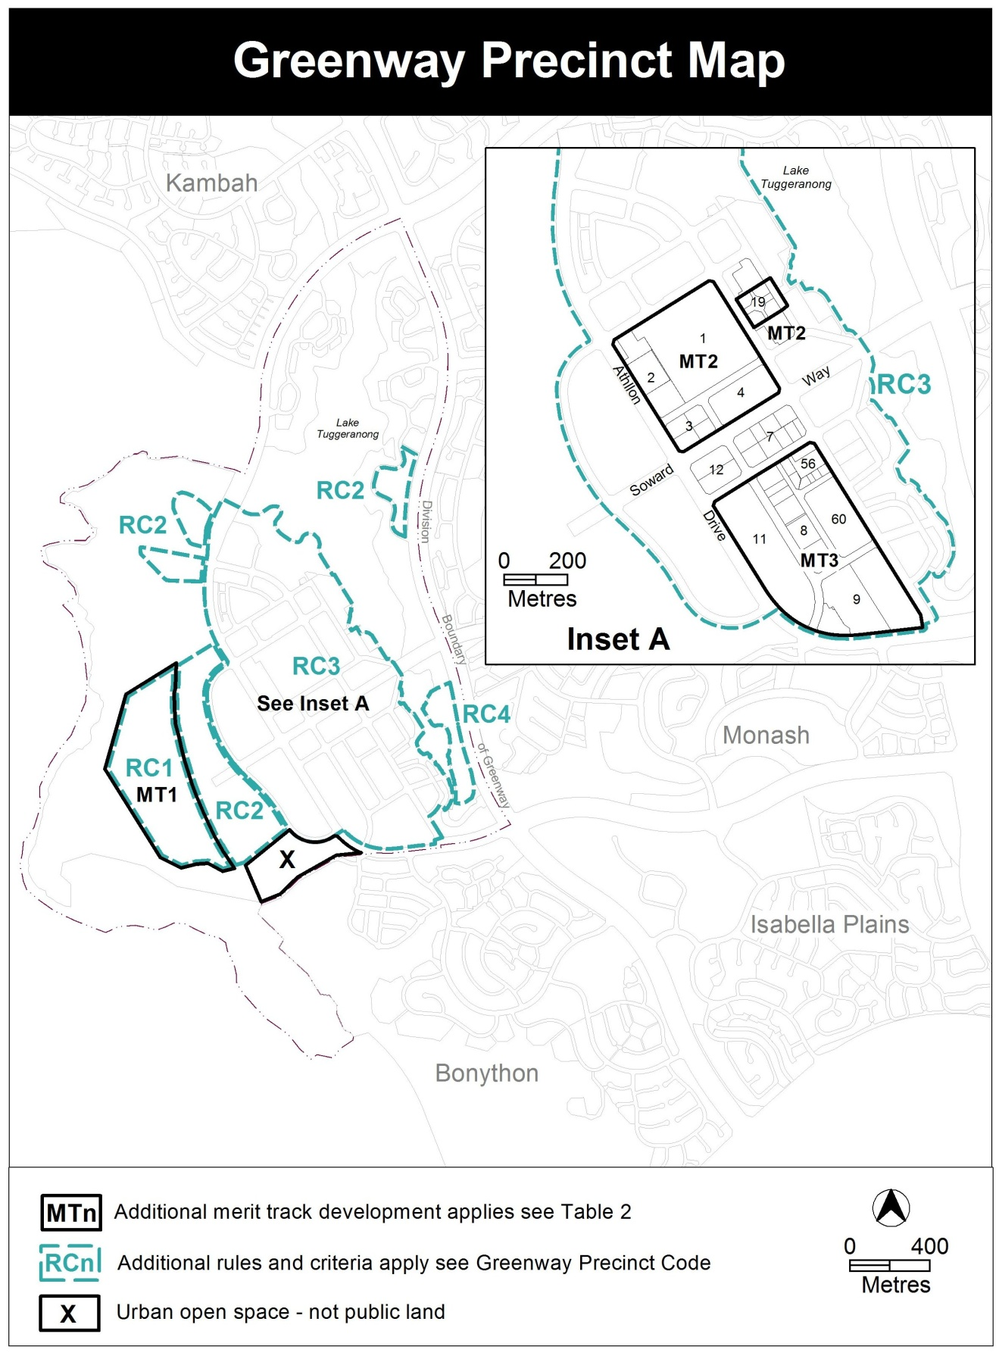

Variation to the Greenway Precinct Code
- RC3 Tuggeranong Town Centre - New Desired Character

Insert the following desired character above Element 4: Use

Desired Character

Settlement Pattern
The Tuggeranong town centre has a strong urban edge whilst maintaining extensive physical and visual connections to the surrounding landscape including the mountains, open space, the river corridor and the lake.

The town centre enjoys a high level of connectedness through a fine grain grid pattern network of roads and pedestrian and cycle thoroughfares.

There is a network of high quality open spaces throughout the urban area of the town centre with links to the lake foreshore, community gardens and other public spaces.

Land use
A substantial component of the town centre is given over to residential development, with a focus on a mix of retail, commercial and other activating uses primarily at ground level and on key frontages.

Built form
There is a modern approach to the pitched red roofs and cream buildings, with a variety of roof forms including roof gardens, flat and skillion roofs.

Precincts
The foreshore area including Anketell Street has the following character:
- Development that embraces the lake through physical and visual connections to the foreshore
- Development that provides vibrancy through activity at the street level and finer grain shop fronts along major pedestrian areas
- Development that provides a pedestrian friendly environment
- Built form that steps down toward the foreshore.

The area along Athllon Drive has the following character:
- Taller building elements to match the taller building elements fronting the lake shore.
- Office buildings which address Athllon Drive to create a continuous building line, without excessive blank walls.
- Framing of the views north along Athllon Drive to distant hills
- A mix of residential uses on the western side of Athllon Drive, located to maximize views of the mountains to the west and access to employment and services in the town centre
- Pedestrian links to the town centre.

The Soward Way area has the following character:
- Taller building elements to create a pedestrian friendly boulevard on Soward Way
- Development frames the views to the mountains to the west
- Development provides a mix of uses with retail at ground level.

- RC3 Tuggeranong Town Centre Figure 1

Substitute Figure 1 with the following:
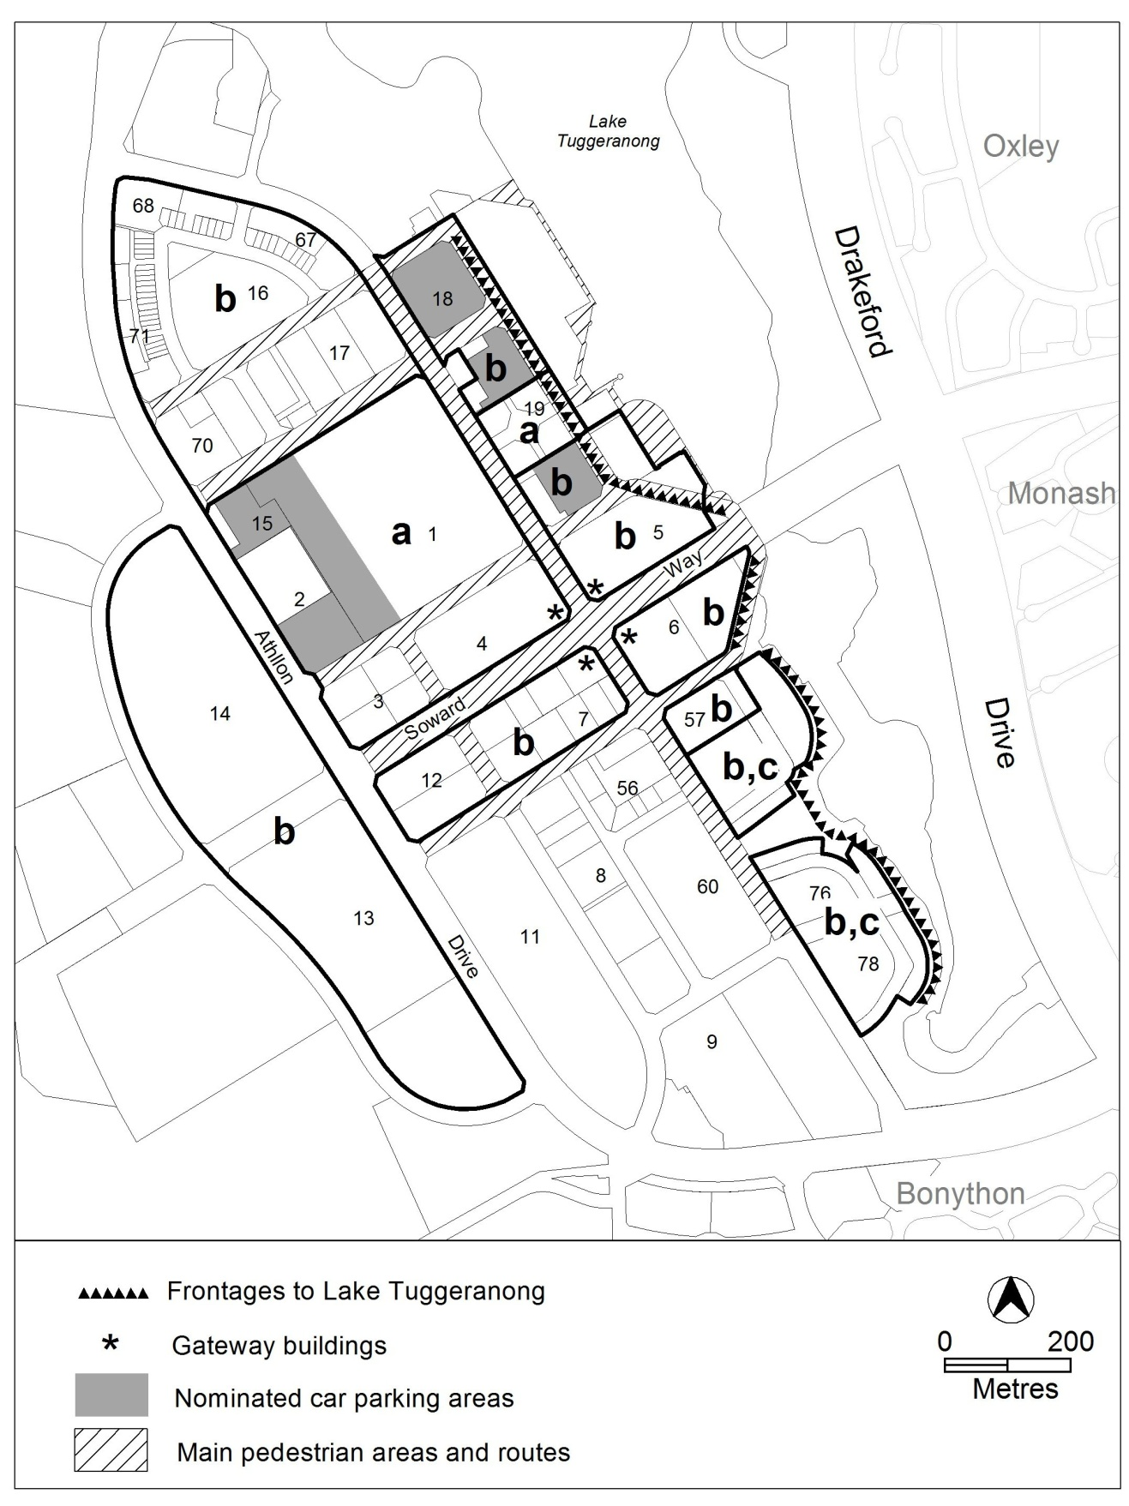
Figure 1 Frontages, car parking, restrictions on use and gateway buildings.
- RC3 Tuggeranong Town Centre - New Figure 3

Insert following new figure 3 after the existing figure 2:
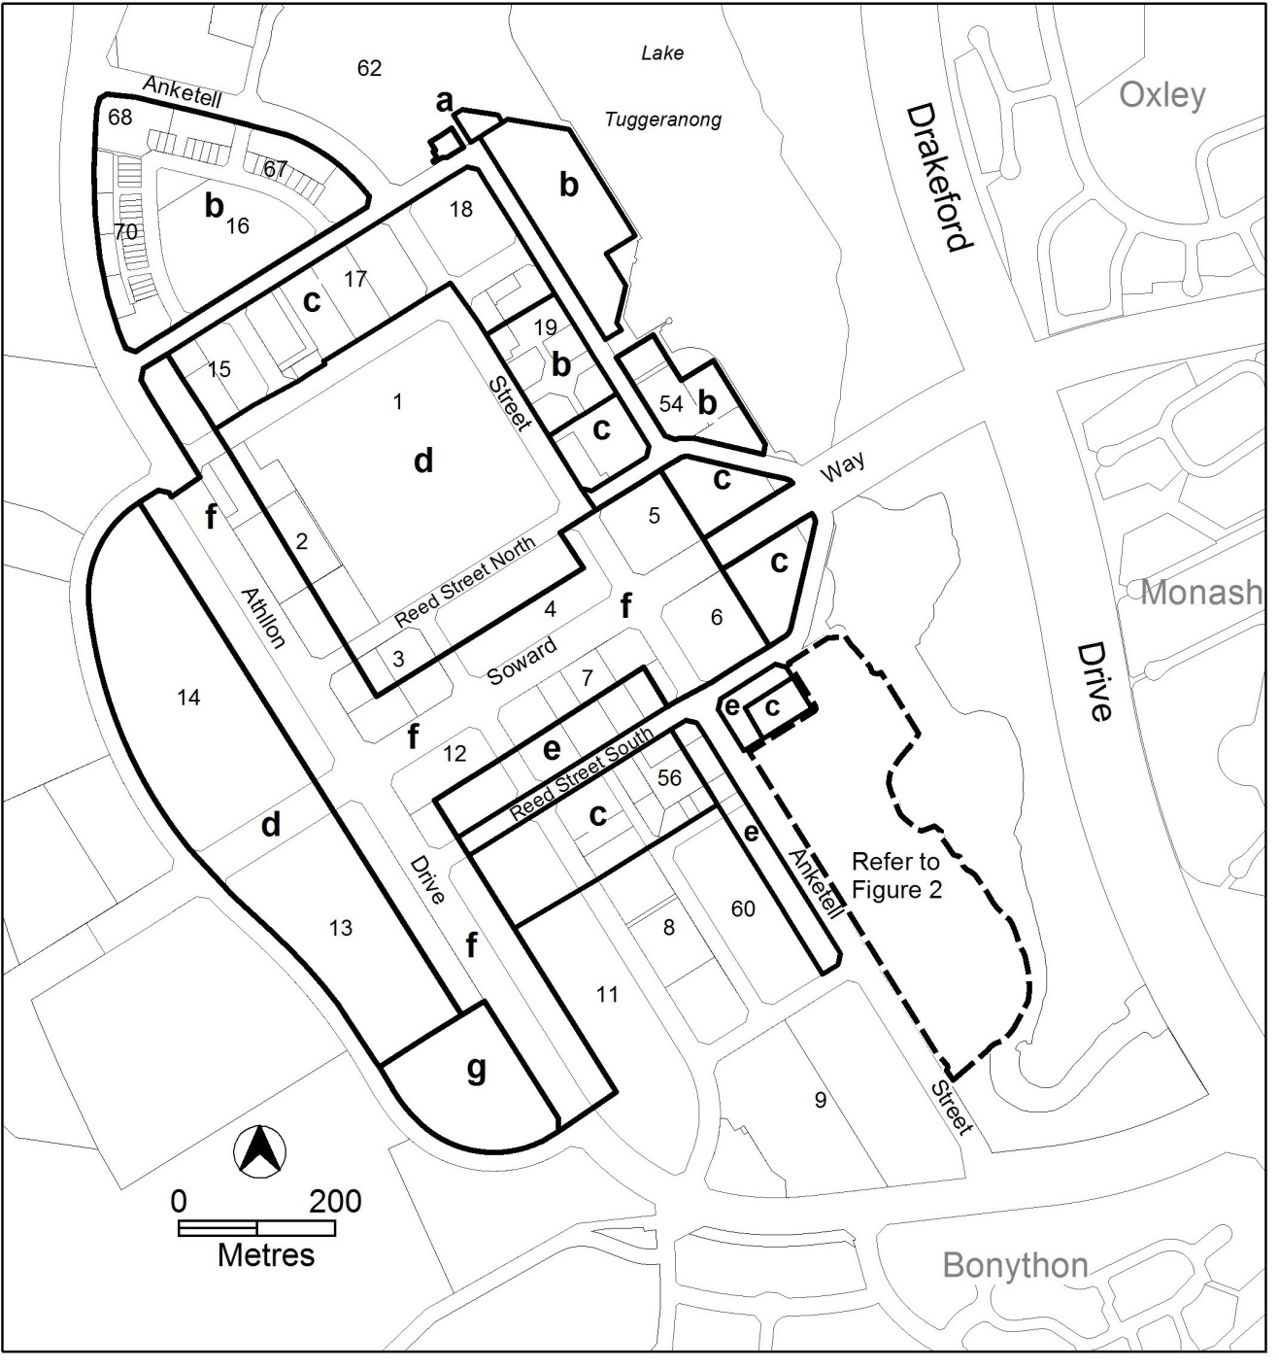
Figure 3 – building heights

- RC3 Tuggeranong Town Centre - 5.1 Height of buildings

Substitute criterion C9 with the following new mandatory rule R9:
This rule applies to areas shown in figure 3.  The maximum height of buildings in the areas shown on figure 3 are as follows:  - in area ‘a’ - 9.5 metres  - in area ‘b’ - 17 metres  - in area ‘c’ - 20.5 metres  - in area ‘d’ - 24 metres  - in area ‘e’ – 24metres. Area ‘e’ is measured as the area up to a maximum of 30 metres from the front boundary with Anketell Street or Reed Street South  - in area ‘f’ - 31 metres. Area ‘f’ is measured as follows:  - the area a maximum of 30 metres from the front boundary for blocks adjoining the western side of Ankertell Street  - the area a maximum of 30 metres from the front boundary of blocks adjoining Soward Way west of Ankertell Street  - the area a maximum of 30 metres from the front boundary of blocks adjoining the eastern side of Athllon Drive  - the area a maximum of 40 metres from the front boundary of blocks adjoining the western side of Athllon Drive.  - in area ‘g’ – 38 metres with a maximum of 12 storeys.  For this rule the building height excludes all of the following:  - roof top plant  - lift overruns  - antennas  - photovoltaic panels  - air conditioning units  - chimneys, flues and vents  Excluded items are setback from the building facade of the floor immediately below a minimum distance of 3m. | This is a mandatory requirement. There is no applicable criterion.

- RC3 Tuggeranong Town Centre - 5.4 Built form

Insert the following C13A and R13B and C13B after R13 and C13:

There is no applicable rule. | C13A  Built form in the town centre achieves all of the following:  - consistency with the desired character  - roofs are articulated to reduce the bulk and scale of the building form  - responds to the street hierarchy  - minimizes blank walls  - creates attractive interfaces with the public domain.
R13B  This rule applies to area ‘I’ shown in figure 4.  The minimum ground floor level, floor to ceiling height is 3.6m | C13B  Building achieve all of the following:  - consistency with desired character  - the ground floor level of buildings is adaptable for commercial uses.

- RC3 Tuggeranong Town Centre - new 5.6, 5.7, 5.8 and figure 4

Insert the following new provisions after 5.5:

5.6 Gateway buildings
This criterion applies to gateway buildings in locations shown on figure 1.  Buildings address the intersection of Anketell Street and Soward Way. | This is a mandatory provision. There is no applicable criterion.
5.7 Building setbacks
This rule applies to buildings in area ‘a’ shown in figure 4  Buildings have a zero setback to Athllon Drive. | Buildings achieve all of the following:  - are consistent with the desired character  - maintain a continuous building line along Athllon Drive  - frame the views of hills along Athllon Drive.
This rule applies to the front setbacks for buildings (excluding basements) in the areas shown on figure 4.  The minimum front setbacks are as follows:  - in area ‘b’ - 12 metres  - in area ‘c’ - 13 metres  - in area ‘d’ - 16 metres. | Buildings achieve all of the following:  - are consistent with desired character  - protect and enhance the views of hills, distant mountains and/or the Tuggeranong Town Park.
5.8 Landscape areas
This rule applies to landscape areas shown in figure 4  Landscape areas are provided with the following minimum dimensions:  - in area ‘e’ 26 metres wide and 40 metres deep  - in area ‘f’ 30 metres wide and 40 metres deep  - in area ‘g’ 52 metres deep from the north western apex of the block.  - In area ‘h’ 25 metres wide and 30 metres deep. | Landscaped areas achieve the following:  - are consistent with desired character  - protect and enhance views of hills, distant mountains and key open spaces  - have no buildings or structures located within the area (excluding basements)  - are publicly accessible  - are landscaped  - receive reasonable solar access  - present a soft landscaped interface to the street.

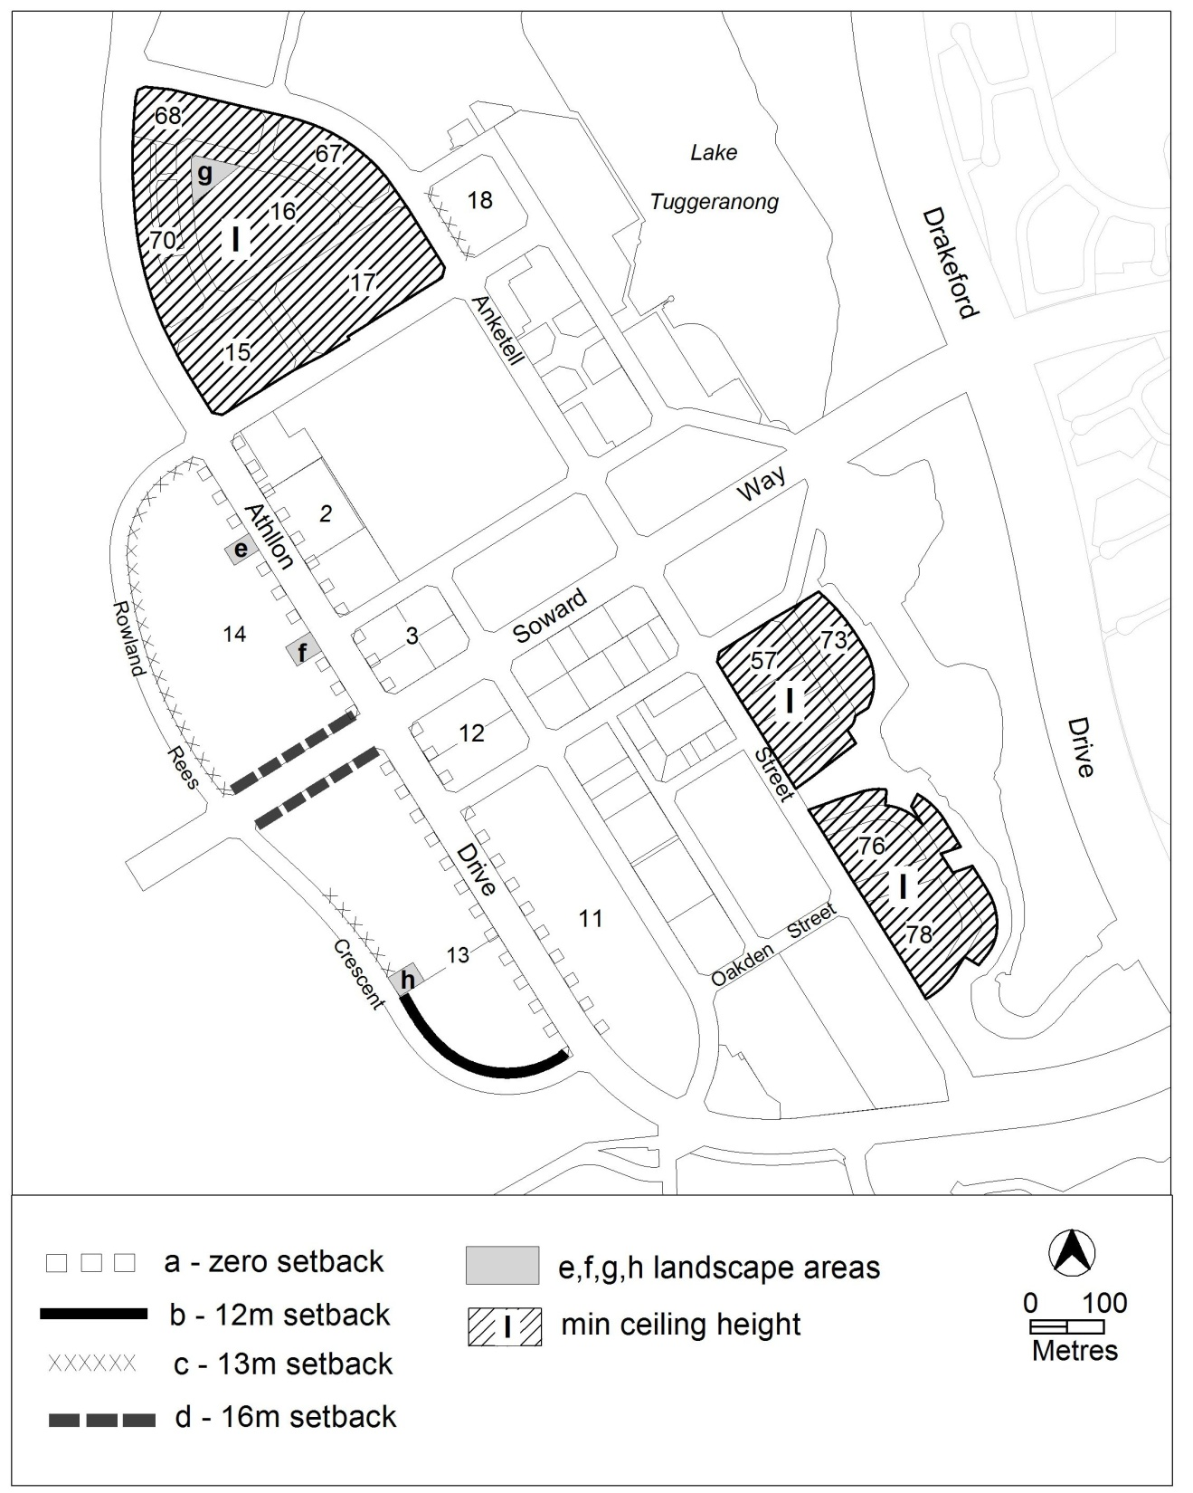
Figure 4 – setbacks and landscape areas

- RC4 Tuggeranong Town Centre - Lake side residential

Insert following new RC4 after RC3:

RC4 – Lake side residential

This part applies to blocks and parcels identified in area RC4 shown on the Greenway Precinct Map. RC4 includes the lake side residential land.
- Built form

Rules | Criteria
  - Height of buildings
This rule applies to areas shown in figure 5.  The maximum height of buildings in the areas shown on figure 5 are as follows:  - in area ‘a’ - 9.5 metres  - in area ‘b’ - 13 metres. Area ‘b’ is measured as a maximum depth of 20 metres.  For this rule the building height excludes all of the following:  - roof top plant  - lift overruns  - antennas  - photovoltaic panels  - air conditioning units  - chimneys, flues and vents  Excluded items are setback from the building facade of the floor immediately below a minimum distance of 3m. | This is a mandatory requirement. There is no applicable criterion.

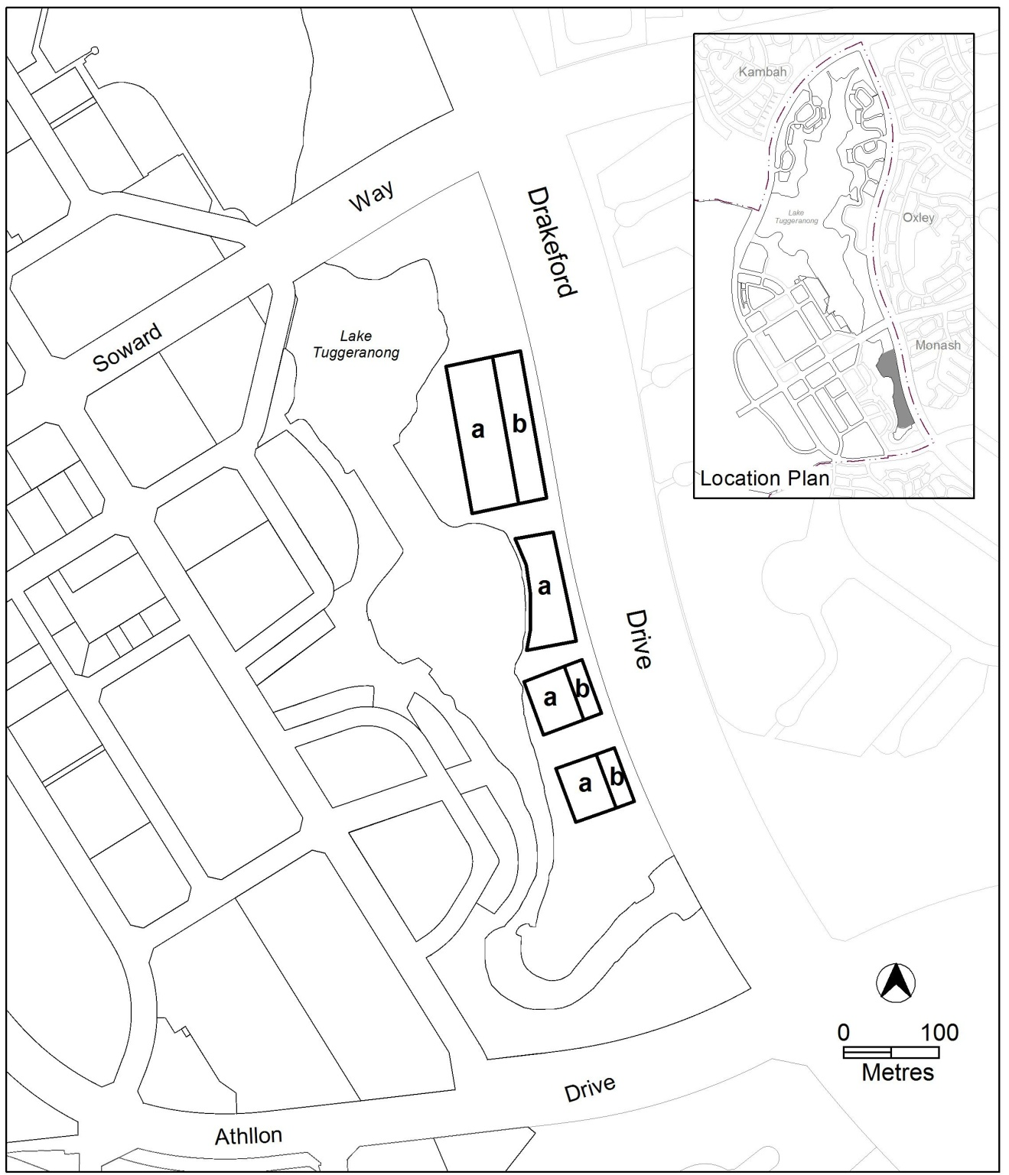
Figure 5 – building heights

Variation to the car parking and vehicular access general code
- Schedule 2 – offices in town centres

Substitute –
Gungahlin & Tuggeranong 2.5 spaces/100m² GFA
With -
Gungahlin 2.5 spaces/100m² GFA
Tuggeranong 2 spaces/100m²GFA

Interpretation service
