Australian Capital Territory

Planning and Development (Technical Amendment—Casey) Plan Variation 2014 (No 1)*

Notifiable Instrument NI2014—33
Technical Amendment No 2013—23
made under the
Planning and Development Act 2007, section 89 (Making technical amendments) s96 (land ceases to be in future urban area)

This plan variation commences on the day after it is notified.

Variation No 2013—23 to the Territory Plan has been approved by the Planning and Land Authority.

Variation to the Territory Plan
The Territory Plan map is proposed to be varied as indicated in Annexure A to identify the zones that apply to the land ceasing to be in a future urban area.

Variation to the Precinct Map and Code
Replace Casey Precinct Map and Code at Annexure B to incorporate ongoing block specific provisions for the area.

Jim Corrigan
Delegate of the Planning and Land Authority
3 February 2014

THIS IS PAGE ONE OF ANNEXURE A
TO NOTIFIABLE INSTRUMENT NI2014–33

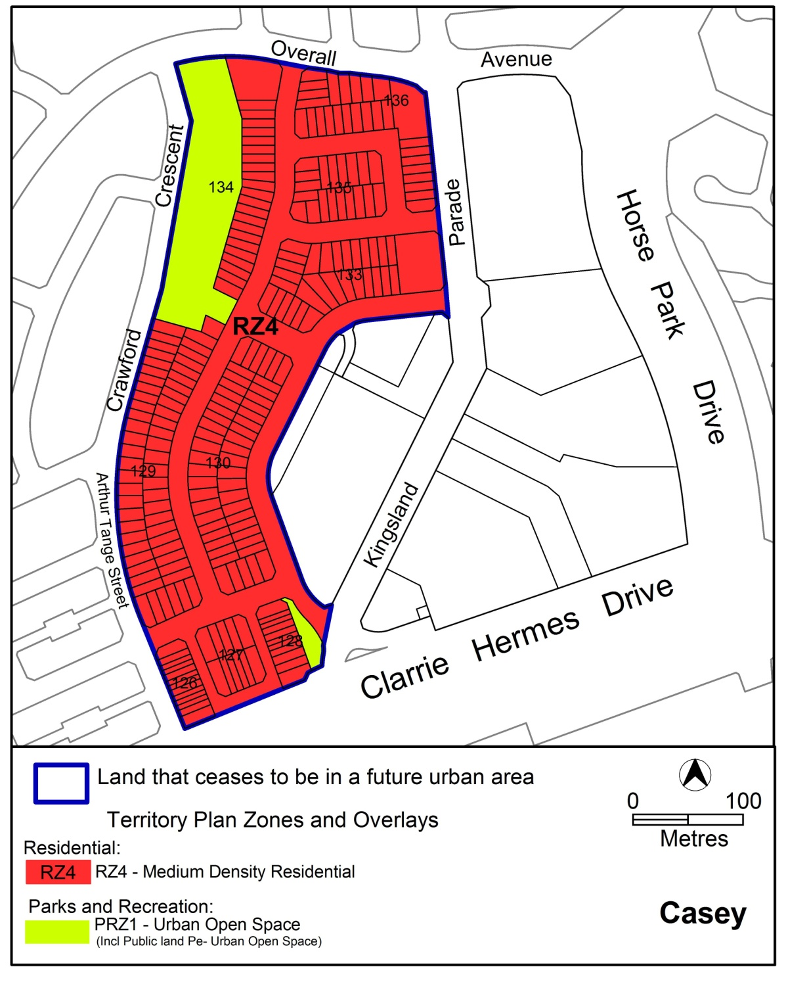

Jim Corrigan
Delegate of the Planning and Land Authority
Date 3 February 2014

THIS IS PAGE ONE OF ANNEXURE B
TO NOTIFIABLE INSTRUMENT NI2014–33

Jim Corrigan
Delegate of the Planning and Land Authority
Date: 3 February 2014

Annexure B

Casey Precinct Map and Code

This page is intentionally blank.

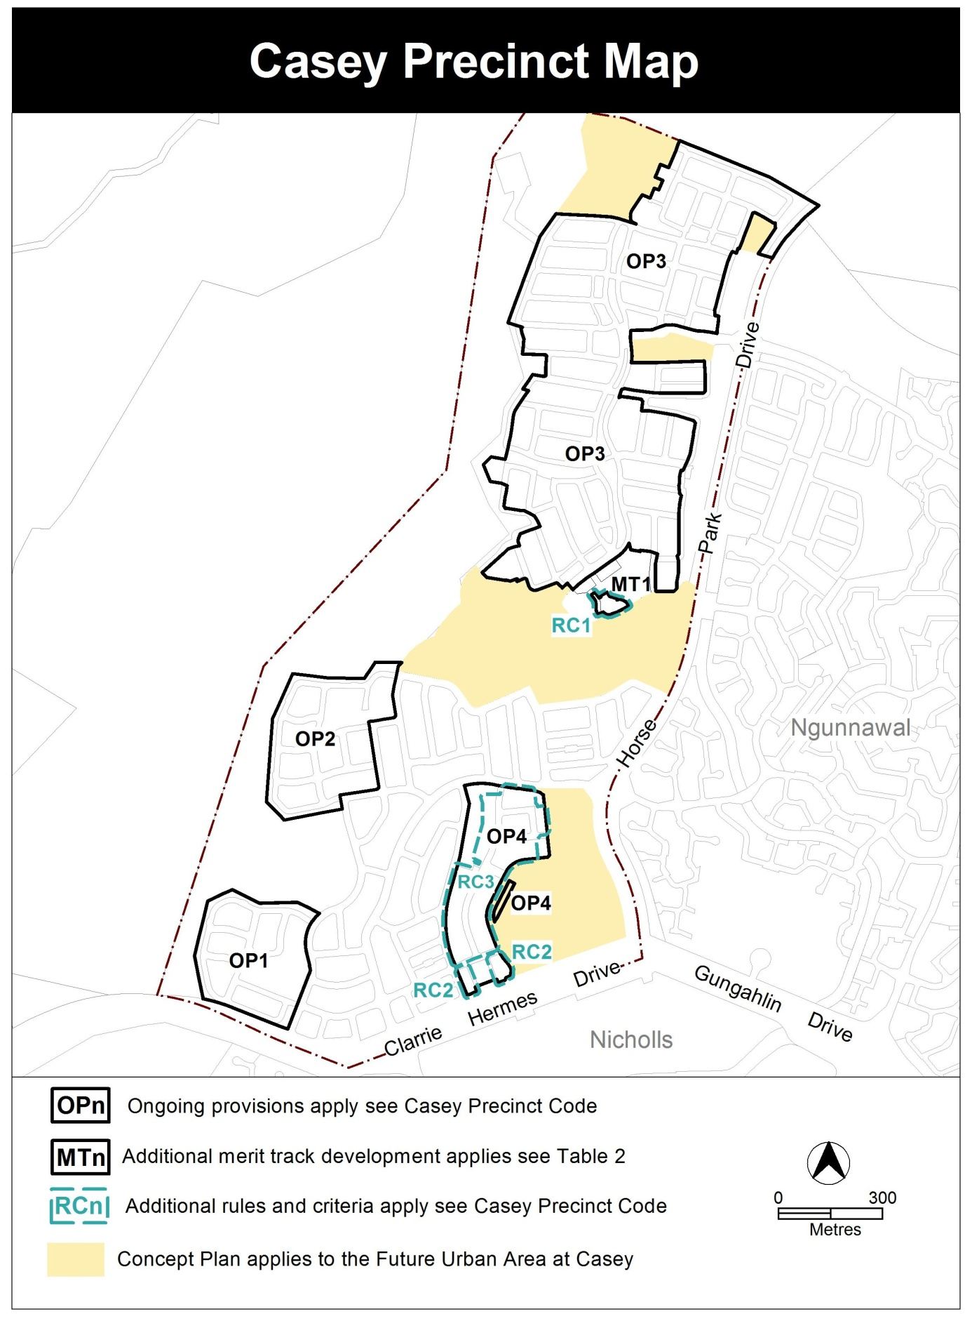

Assessment Tracks

The following tables identify the additional prohibited development and additional merit track development for blocks and parcels shown in the Casey Precinct Map (identified as PDn or MTn). Development that is exempt from requiring development approval, other prohibited development and the minimum assessment track applicable to each development proposal is set out in the relevant zone development table.

The following table constitutes part of the relevant zone development table.

Table 2 – Additional merit track development
Additional merit track development that may be approved subject to assessment
Suburb precinct map label | Zone | Development
MT1 | CZ5 | craft workshop  drink establishment  indoor entertainment facility  tourist resort

Casey Precinct Code

Contents
Introduction 2
Additional rules and criteria 4
RC1 – Mixed Use Commercial Development 4
Element 1: Use 4
1.1 Ground floor use 4
1.2 Ground floor use – floor area limit 4
Element 2: Buildings 5
2.1 Number of storeys 5
RC2 – Residential 6
Element 1: Building and site controls 6
1.1 Number of storeys 6
1.2 Setbacks 6
Element 2: Environment 8
2.1 Planting zone 8
RC3 – Residential 9
Element 3: Maximum Building Zone 9
3.1 Integrated Dwelling Design 9
Other ongoing provisions 10
OP1 – Casey residential area 1 10
OP2 – Casey residential area 2 11
OP3 – Casey residential area 3 12
OP4 – Casey residential area 4 13

Figures
Figure 1 Building Controls 7
Figure 2 Maximum Building Zone 9
Figure 3 Casey residential area 1 10
Figure 4 Casey residential area 2 11
Figure 5 Casey residential area 3 12
Figure 6 Casey residential area 4 13

Introduction
Name
The name of this code is Casey Precinct Code.
Application
The code applies to the Division of Casey.
Purpose
This code provides additional planning, design and environmental controls for specific areas or blocks and may also contain references to provisions in other codes.

In conjunction with other relevant codes it will be used by the Authority to assess development applications and offer guidance to intending applicants in designing development proposals and preparing development applications.
Structure
This code contains additional rules and/or criteria for particular blocks or parcels identified as areas RCn on the precinct map, to be read in conjunction with the relevant development code. It may also contain sub-parts.

Each element has one or more rules and, unless the respective rule is mandatory, each rule has an associated criterion. Rules provide quantitative, or definitive, controls. By contrast, criteria are chiefly qualitative in nature.

In some instances rules are mandatory. Such rules are accompanied by the words “This is a mandatory requirement. There is no applicable criterion.” Non-compliance with a mandatory rule will result in the refusal of the development application. Conversely, the words “There is no applicable rule” is found where a criterion only is applicable.
Code hierarchy
Under the Planning and Development Act 2007, where more than one type of code applies to a development, the order of precedence if there is inconsistency of provisions between codes is: precinct code, development code and general code.
If more than one precinct code applies to the site, the most recent precinct code takes precedence to the extent of any inconsistency.
Definitions
Defined terms, references to legislation and other documents are italicised.
Definitions of terms used in this code are listed in part 13 of the Territory Plan or, for terms applicable only to this code, associated with the respective rule.

Acronyms
ACTPLA Planning and Land Authority within the ACT Environment and Sustainable Development Directorate
EPA ACT Environment Protection Authority
ESA ACT Emergency Services Agency
ESDD ACT Environment and Sustainable Development Directorate
NCA National Capital Authority
P&D Act Planning and Development Act 2007
TAMS ACT Territory and Municipal Services Directorate

Additional rules and criteria
This part applies to blocks and parcels identified in the Casey Precinct Map (RCn). It should be read in conjunction with the relevant zone development code and related codes.
RC1 – Mixed Use Commercial Development
This part applies to blocks and parcels identified in area RC1 shown on the Casey Precinct Map.
- Use
Rules | Criteria
  - Ground floor use
One or more of the following uses are not permitted above the ground floor:  - COMMUNITY USE  - craft workshop  - indoor entertainment facility  - indoor recreation facility  - NON RETAIL COMMERCIAL USE  - restaurant  - SHOP | Noise generating uses are located to minimise impacts on residential or commercial accommodation.
  - Ground floor use – floor area limit
Where development includes one or more of the following:  - COMMUNITY USE  - craft workshop  - indoor entertainment facility  - indoor recreation facility  - NON RETAIL COMMERCIAL USE  - Restaurant  - SHOP  the maximum gross floor area per establishment or tenancy is 200 m² | The scale of leisure, recreation, community and commercial activities included with multi unit housing development achieves all of the following:  - ancillary to RESIDENTIAL USE  - services the local residents only

- Buildings
Rules | Criteria
  - Number of storeys
The maximum number of storeys is 3. | Buildings achieve all of the following:  - compatibility with the desired character  - reasonable solar access to dwellings on adjoining residential blocks and their associated private open space  The maximum number of storeys is 4.

RC2 – Residential
This part applies to blocks and parcels identified in area RC2 shown on the Casey Precinct Map.
- Building and site controls
Rules | Criteria
  - Number of storeys
The minimum number of storeys is 2 for blocks as indicated in Figure 1. | C4  Buildings achieve all of the following:  - compatibility with the desired character  - reasonable solar access to dwellings on adjoining residential blocks and their associated private open space
  - Setbacks
Mandatory build to boundary for blocks as indicated in Figure 1. | This is a mandatory requirement. There is no applicable criterion.
Maximum depth of 15m from front street boundary for blocks as indicated in Figure 1. | This is a mandatory requirement. There is no applicable criterion.
Maximum depth of 15.5m from adjoining open space boundary for blocks as indicated in Figure 1. | This is a mandatory requirement. There is no applicable criterion.
Maximum wall length of 12 metres for blocks as indicated in Figure 1. | This is a mandatory requirement. There is no applicable criterion.

Rules | Criteria
A front setback from the open space boundary of minimum 5m applies to blocks as indicated in Figure 1. | This is a mandatory requirement. There is no applicable criterion.
A front setback of minimum 6m and maximum 7m applies to blocks as indicated in Figure 1. | This is a mandatory requirement. There is no applicable criterion.

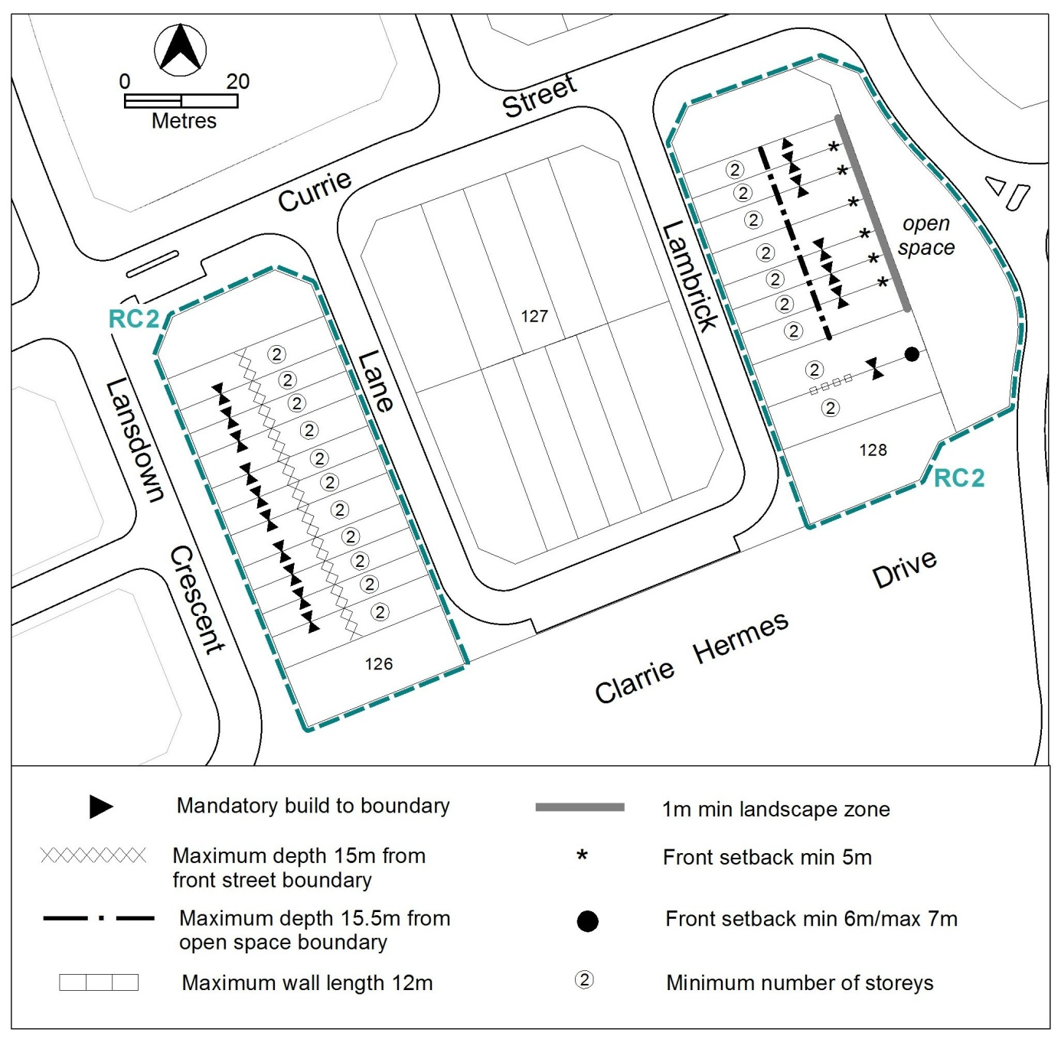 Figure 1 Building Controls

- Environment
Rules | Criteria
  - Planting zone
1 metre minimum landscape zone for blocks indicated in Figure 1. | This is a mandatory requirement. There is no applicable criterion.

RC3 – Residential
This part applies to blocks and parcels identified in area RC3 shown on the Casey Precinct Map.
- Maximum Building Zone
Rules | Criteria
  - Integrated Dwelling Design
Dwellings are designed and sited within the maximum building zone as shown in Figure 2 and any specified height limits as shown in Figure 1.  Note: All dwellings are to be designed and sited in accordance with all relevant requirements of the Single Dwelling Housing Development Code. |  | C12  Dwellings are designed and sited in an integrated manner to achieve passive solar efficiency and direct solar access to principal private open space of the subject and adjoining blocks.
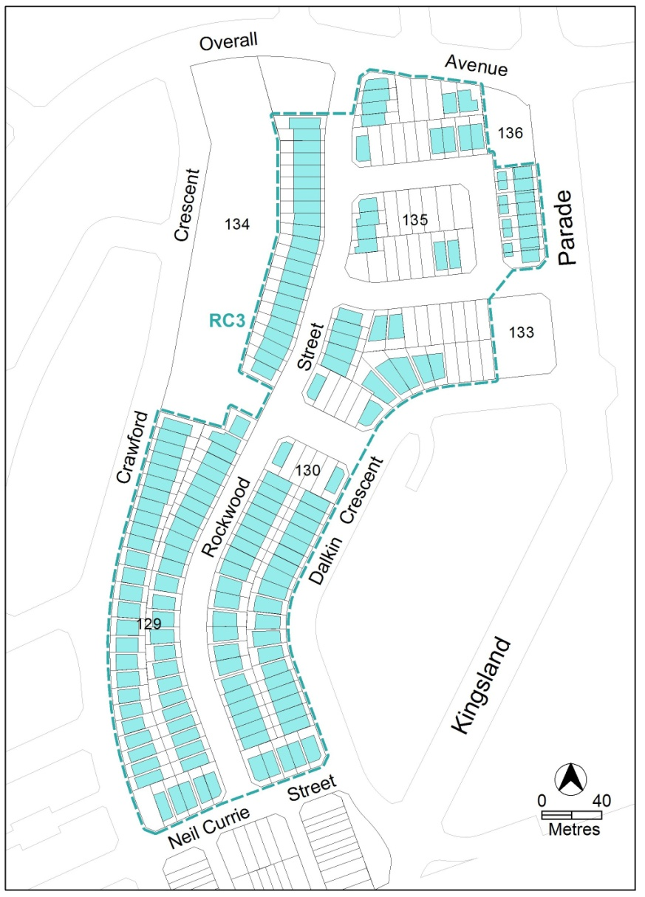
Figure 2 Maximum Building Zone

Other ongoing provisions
This part applies to blocks and parcels identified as ongoing provisions (OPn) in the Casey Precinct Map. It should be read in conjunction with the relevant zone development code and related codes.
OP1 – Casey residential area 1
This part applies to blocks and parcels identified in area OP1 shown on the Casey Precinct Map.
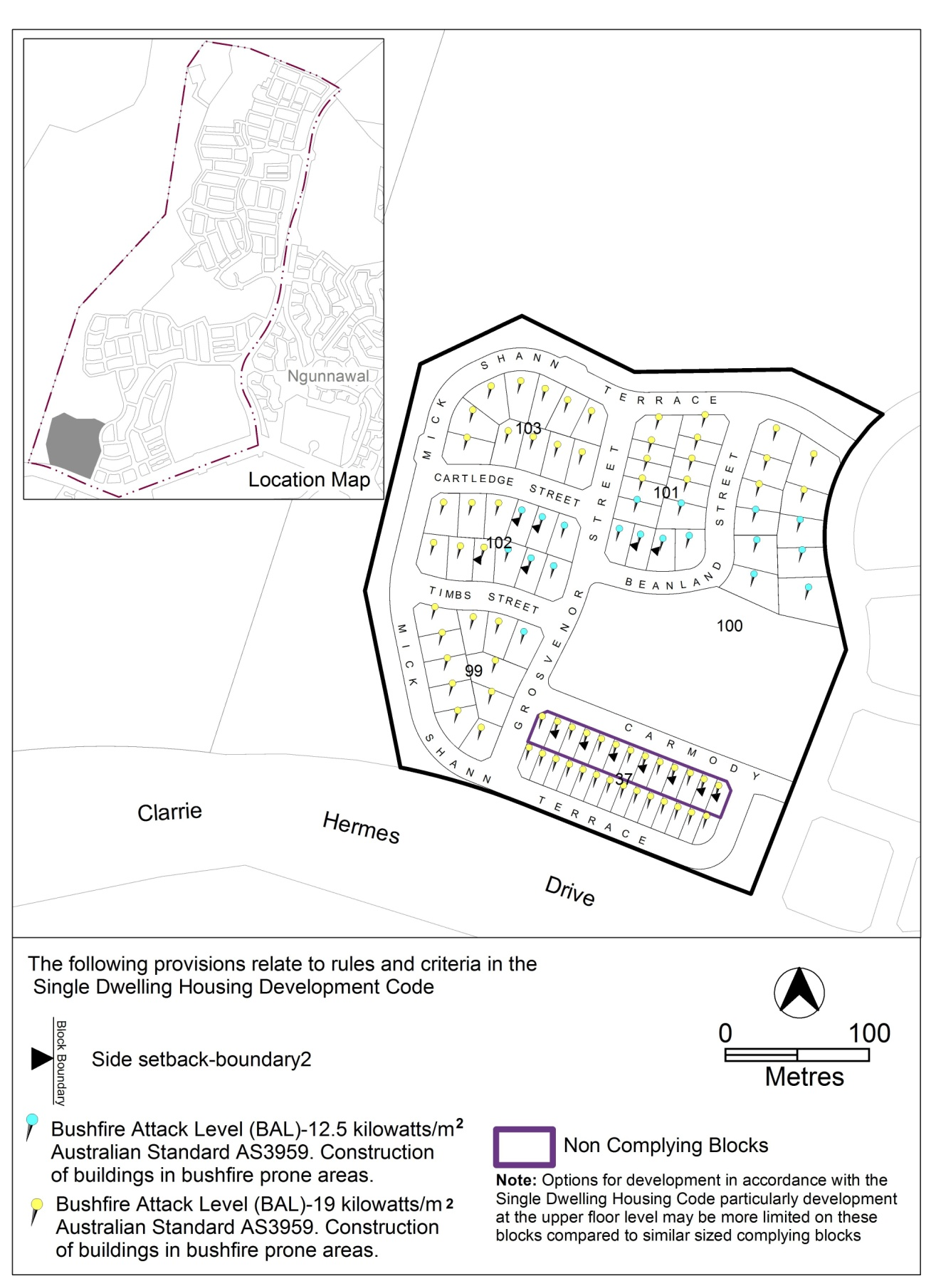
Figure 3 Casey residential area 1

OP2 – Casey residential area 2
This part applies to blocks and parcels identified in area OP2 shown on the Casey Precinct Map.

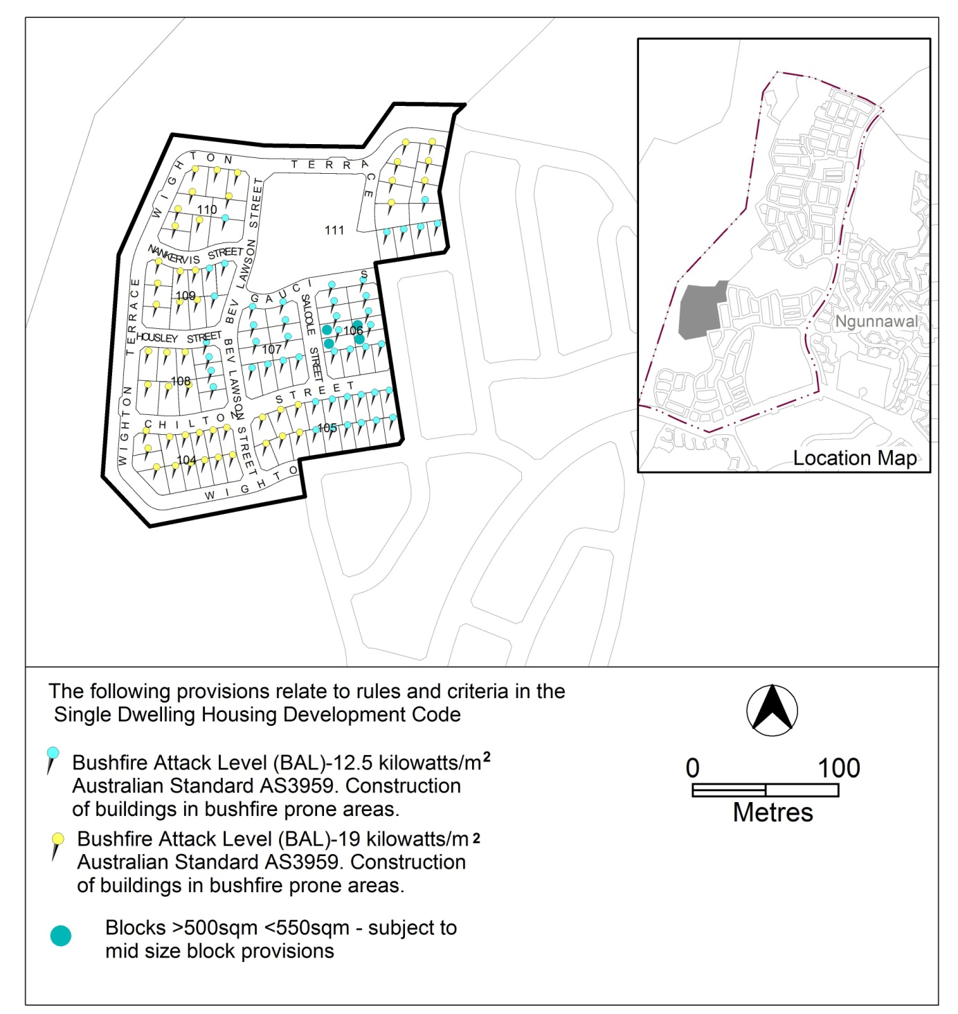
Figure 4 Casey residential area 2

OP3 – Casey residential area 3
This part applies to blocks and parcels identified in area OP3 shown on the Casey Precinct Map.

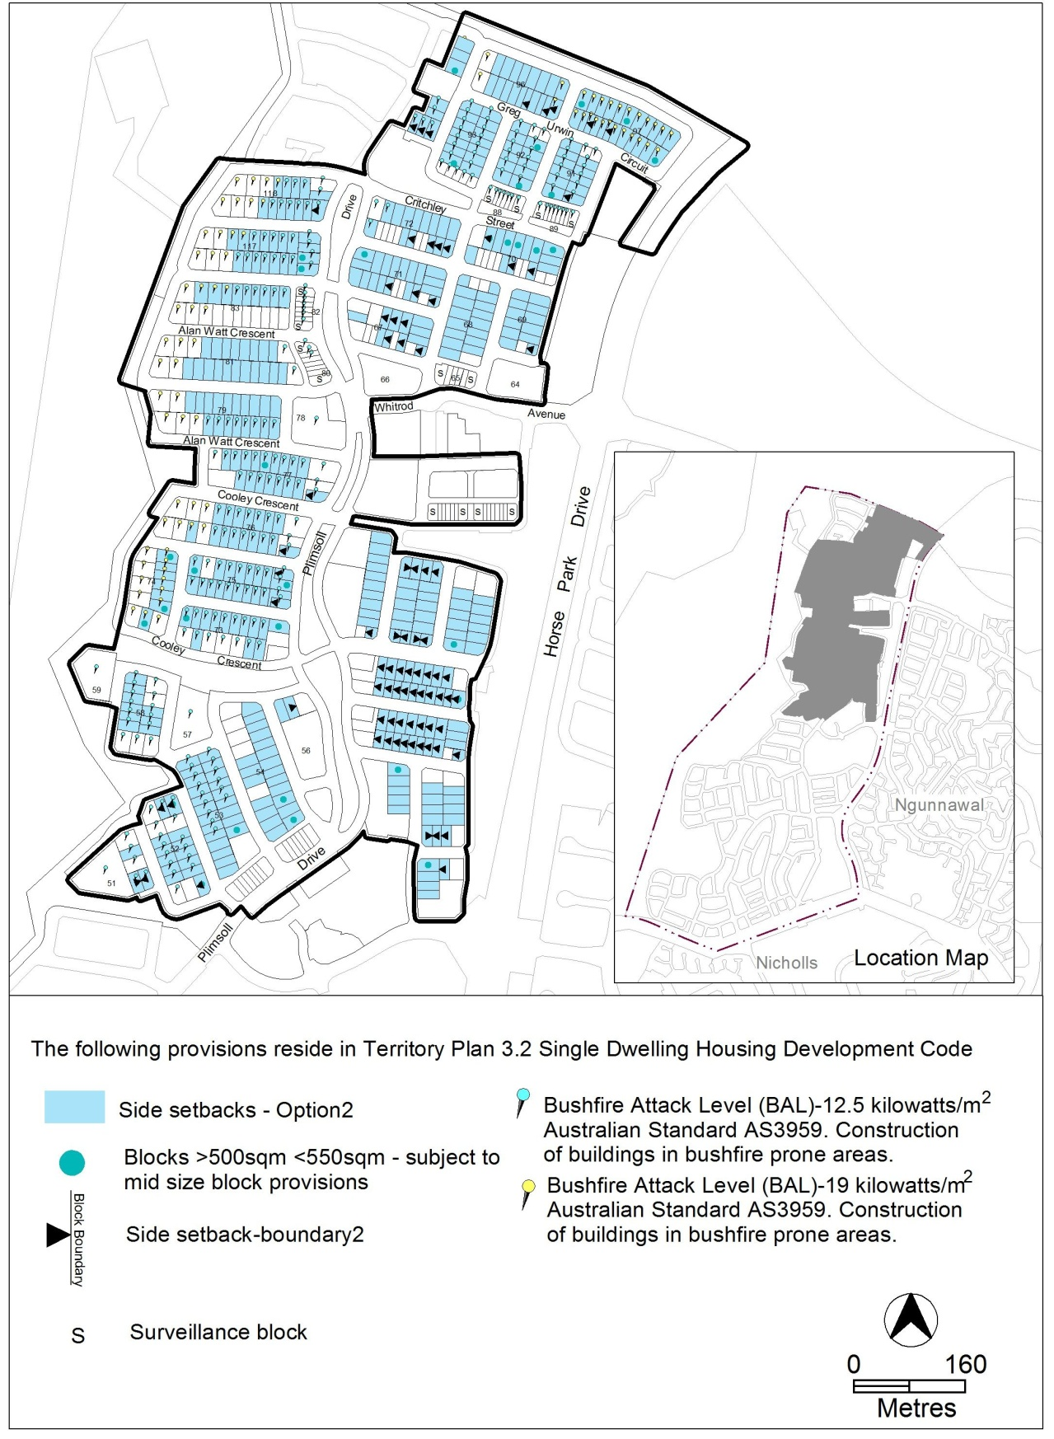
Figure 5 Casey residential area 3

OP4 – Casey residential area 4
This part applies to blocks and parcels identified in area OP4 shown on the Casey Precinct Map.
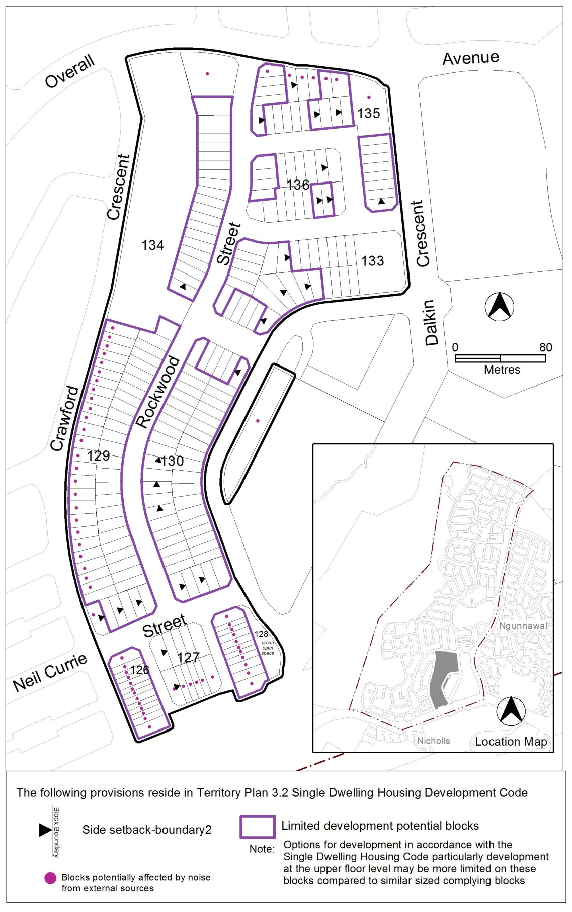
Figure 6 Casey residential area 4

