Australian Capital Territory
Planning and Development (Special Variation No S323 Symonston Mental Health Facility) Special Variation 2014*
Notifiable instrument NI2014–371
made under the
Planning and Development Act 2007, section 85H (Executive may make special variation)

1 Name of instrument
This instrument is the Planning and Development (Special Variation No S323 Symonston Mental Health Facility) Special Variation 2014.
2 Commencement
This instrument commences on the day after it is notified.
3 Variation to the Territory Plan
The Australian Capital Territory Executive makes the special variation as set out in the Schedule.

Note: Under section 85J of the Planning and Development Act 2007, a variation to the Territory Plan that is included in the special variation takes effect on the day the special variation commences.

Mick Gentleman Andrew Barr
Minister Minister
4 August 2014 5 August 2014

This page is intentionally blank.

Planning and Development Act 2007

Special
Variation to the
Territory Plan
No S323

Mental Health Facility
Symonston section 49
part blocks 11 and 14

Final special variation under section 85H of the
Planning and Development Act 2007

This page is intentionally blank.

Contents

1. EXPLANATORY STATEMENT 1
1.1 Introduction 1
1.1.1 Form of the Special Variation 1
1.2 Background 1
1.2.1 National Capital Plan 2
1.3 Content of this special variation 2
1.4 Site Description 3
1.5 Current Territory Plan Provisions 4
1.6 Changes to the Territory Plan 5
1.7 Reasons for the Special Variation 5
1.7.1 Preparation of the Draft Special Variation 5
1.7.2 Statement against Section 85I Criteria 5
1.7.3 Planning and Land Authority Consultation Report 8
2. VARIATIONS TO THE TERRITORY PLAN 9
2.1 Special variation to the Territory Plan 9

This page is intentionally blank.

- EXPLANATORY STATEMENT
  - Introduction
The Executive makes this special variation under section 85H of the Planning and Development Act 2007 (the Act) in a form that differs in some ways from the draft special variation prepared by the planning and land authority under section 85B and placed on public consultation in accordance with section 85C.
    - Form of the Special Variation
The Executive notes that the plan variation in this special variation (Section 2 of this document) is in the same form as in the draft special variation. This explanatory statement and the planning and land authority consultation report (at Attachment A of this document), are related to but outside the variation to the Territory Plan and necessarily differ from the content in the draft special variation.
The above differences between this final special variation and the draft special variation are an inevitable consequence of meeting the requirements of the Act for the finalisation of this instrument, such as the inclusion of the consultation report and the statement of the Executive on its conclusions as required by section 85I of the Act. For the full statement refer to the heading ‘1.7.2 Statement against Section 85I Criterion’ in this document.
The Executive considers that these differences are appropriate, having regard to:
- the consultation report of the planning and land authority under section 85G;
- the requirements of section 85H; and
- the fact that the differences do not effect the content of the variation to the Territory Plan.

The Executive is therefore satisfied that, to the extent that this final special variation can be said to differ from the draft special variation, these differences are consistent with section 85I(2) of the Act.

  - Background
The need for a secure mental health facility in the ACT has been identified for people who require short-to-medium term treatment and placement in a secure mental health facility. The development of the facility is an ACT Government priority and is part of stage one of the ACT Government’s Health Infrastructure Program.
The Planning and Development Act 2007 has been amended to facilitate the development of the mental health facility at Symonston consistent with the ACT Government’s commitment to the project.
In order to facilitate the development of a secure mental health facility at Symonston it is necessary to make changes to the Territory Plan. These changes involve inserting a new definition for a ‘mental health facility’ for the Symonston site into the definitions. A ‘mental health facility’ is added as an additional merit assessable use into the Symonston precinct code. No zoning changes are proposed.
    - National Capital Plan
The Australian Capital Territory (Planning and Land Management) Act 1988 established the National Capital Authority (NCA) with two of its functions being to prepare and administer a National Capital Plan (NCP) and to keep the NCP under constant review and to propose amendments to it when necessary.
The NCP, which was published in the Commonwealth Gazette on 21 January 1990, is required to ensure that Canberra and the Territory are planned and developed in accordance with their national significance. The Australian Capital Territory (Planning and Land Management) Act also requires that the Territory Plan is not inconsistent with the NCP.

  - Content of this special variation
This document is a special variation made by the Territory Executive under section 85H of the Planning and Development Act 2007 (the Act). Section 85H of the Act states:
85H Executive may make special variation
(1) The Executive may make an instrument to vary the territory plan in
relation to the Symonston mental health facility (the special
variation).
(2) The special variation must—
(a) identify the Symonston site; and
(b) include any territory plan variations that are required to implement the special variation; and
(c) state how, in the Executive’s opinion, the area meets the
special variation criteria in section 85I; and
(d) include the consultation report on the draft special variation
prepared by the planning and land authority under section 85G.
(3) The special variation is a notifiable instrument.

This special variation addresses each of the above requirements in section 85H(2) of the Act below.
  - Site Description
Section 85H(2)(a) of the Act requires the Special Variation to identify the Symonston Site.
The subject site (refer to Figure 1 below) is located in the district of Symonston, south of Hindmarsh Drive, with access onto Mugga Lane. It is the site of the former Quamby youth detention centre, which operated between 1962 and 2008. The site is within the non urban area NUZ1 broadacre zone and adjoins a designated area, as defined in the National Capital Plan.
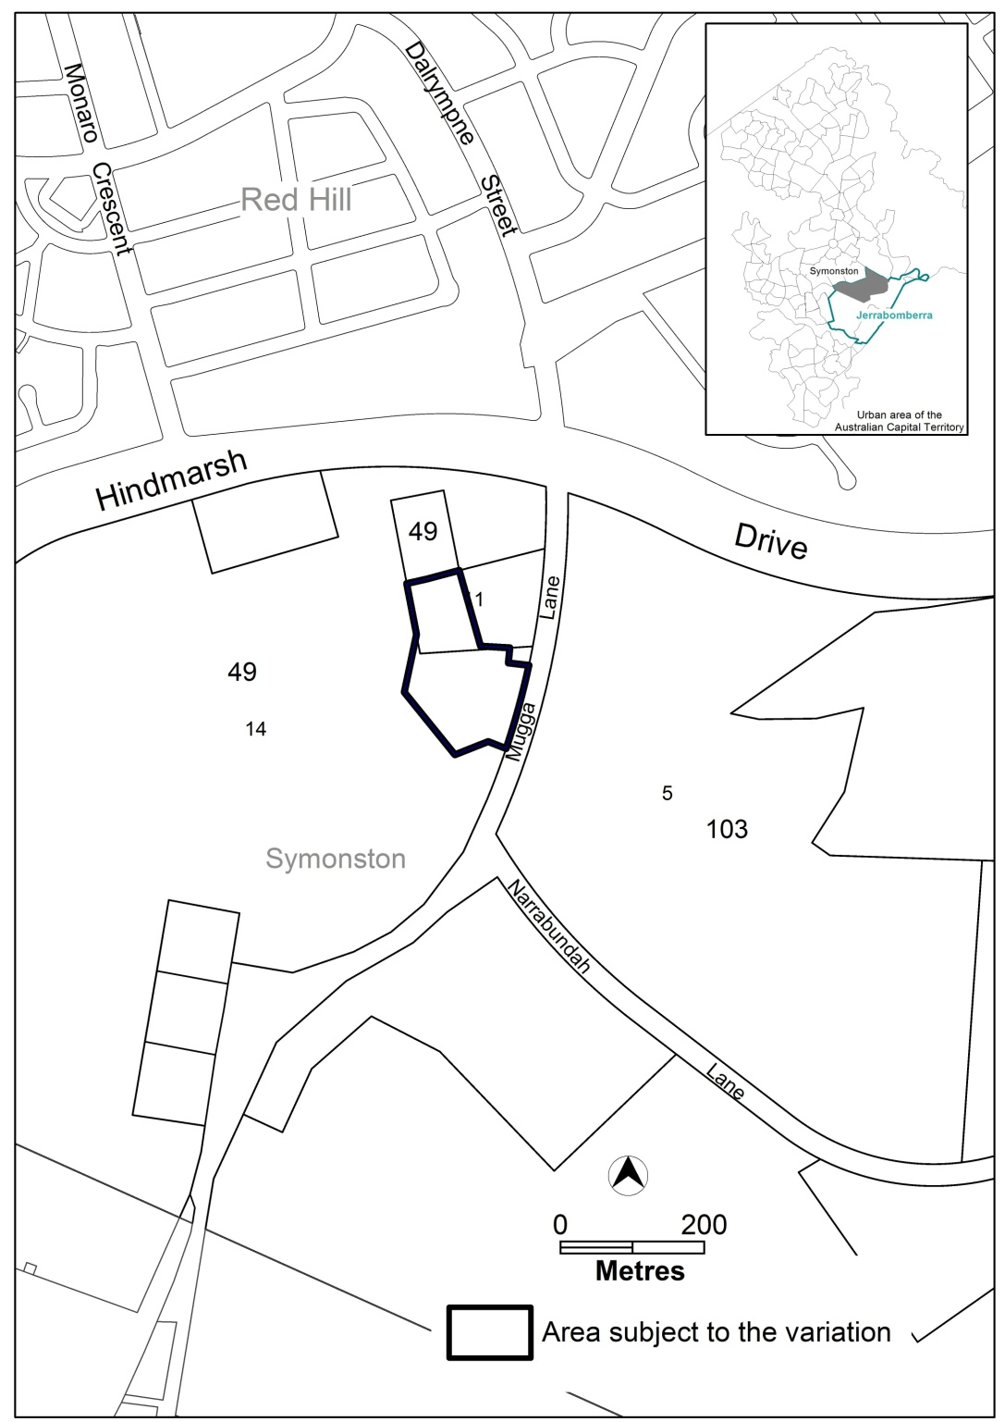
Figure 1 Site Plan

  - Current Territory Plan Provisions
The Symonston precinct map, currently applying to the area subject to this variation is shown in Figure 2.
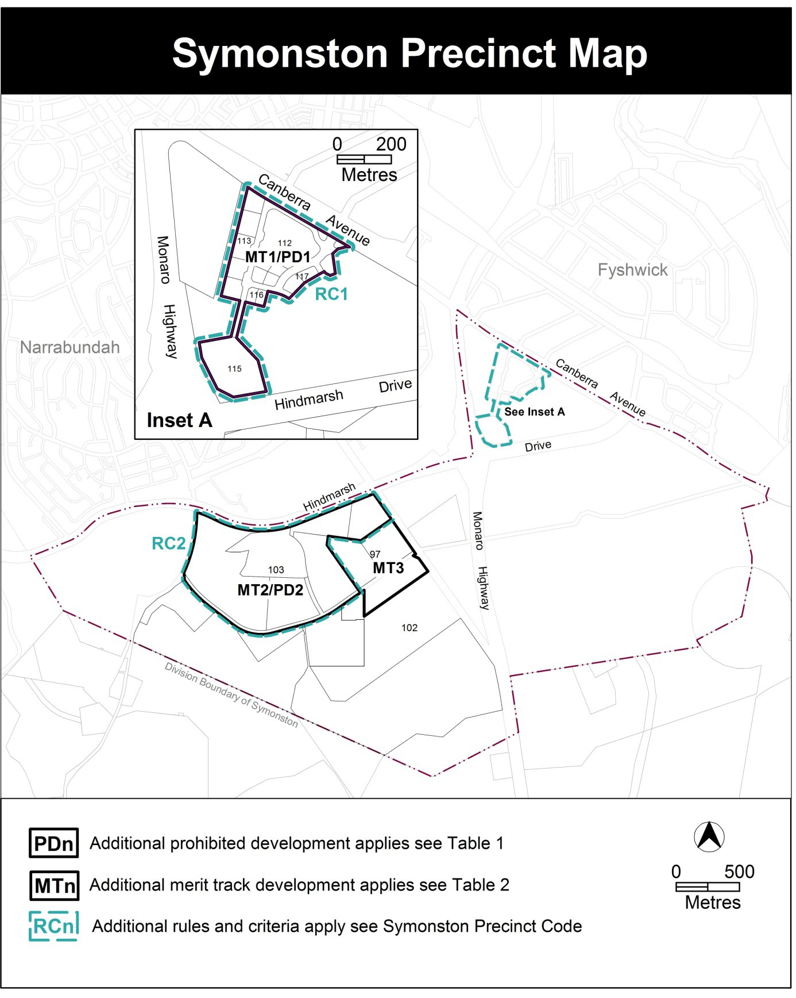Figure 2 Symonston Precinct Map

  - Changes to the Territory Plan
Section 85H(2)(b) of the Act requires the special variation to include any territory plan variations that are required to implement the special variation.
Detailed changes to the Territory Plan are noted in section 2 of this document.

  - Reasons for the Special Variation
Section 85H(2)(c) of the Act requires the special variation to state how, in the Executive’s opinion, the area meets the special variation criteria in section 85I.
    - Preparation of the Draft Special Variation
This special variation is prepared in accordance with section 85H of the Act.

    - Statement against Section 85I Criteria
Under section 85I(1) of the Act the Executive may only make the special variation under section 85H if—
85I(1)(a) the planning and land authority has consulted the national capital authority and the public about the draft special variation in accordance with the requirements in section 85C;

Consultation

A draft special variation (DSV S323) was prepared and made available for the comment of the National Capital Authority and the public consistent with section 85C of the Act. The draft special variation identified the proposed area (proposed site) for the Symonston Mental Health Facility and the required Territory Plan variation changes.
The DSV S323 was available for comments by the National Capital Authority and the public between Friday 20 June and Friday 11 July 2014.
Comments on DSV S323 were received from the National Capital Authority and are detailed in the report on consultation.
Comments were also received from the ACT Heritage Council and ActewAGL and are also detailed in the report on consultation.
No other public comments were received.

Under section 85I(1) of the Act the Executive may only make the special variation under section 85H if—
85I(1) (b) the Executive has considered the planning and land authority’s consultation report provided to the Executive by the authority under section 85G;

Executive consideration of the report on consultation

The Executive has considered the report on consultation dated July 2014, prepared by the planning and land authority in accordance with section 85G of the Act and located at Attachment A to this special variation. The Executive notes the comments made by the National Capital Authority, the ACT Heritage Council and ActewAGL. The Executive considers that the matters raised can be appropriately dealt with at the detailed design stage as part of a development application. On this basis, the Executive considers there are no outstanding issues as a result of consultation.

Under section 85I(1) of the Act the Executive may only make the special variation under section 85H if—
85I(1) (c)(i) the Executive considers— the special variation will facilitate the Symonston mental health facility at the Symonston site;

Facilitation of the Symonston mental health facility at the Symonston site

The Executive is satisfied that this special variation facilitates the Symonston mental health facility at the Symonston site. The Executive, having considered the draft special variation, the consultation report of the planning and land authority, the consultation comments and related matters is satisfied the special variation facilitates the Symonston mental health facility by:
- Creating a new Territory Plan definition of ‘mental health facility’ for the Symonston site by referring to the dictionary definition in the Mental Health (Treatment and Care) Act 1994
- Amending the Symonston precinct map and assessment tracks (table 2) of the Territory Plan such that a mental health facility will be ‘merit assessable’ development on the subject land
Together these amendments confirm that the development of the proposed Symonston mental health facility is assessable under the Territory Plan and will also remove any uncertainty as to which assessment track applies to the relevant development proposal. In doing so, the amendments facilitate the Symonston mental health facility.

Under section 85I(1) of the Act the Executive may only make the special variation under section 85H if—
85I(1) (c)(ii) there is no substantive public policy reason for the development of the Symonston mental health facility not to proceed.

Public policy considerations

The Executive considers that the Symonston mental health facility is consistent with relevant public policy considerations broadly and for the Symonston area including:
- The National Capital Authority has confirmed that the proposal is not inconsistent with the National Capital Plan.
- The proposal is consistent with the ACT Planning Strategy and the Statement of Strategic Directions of the Territory Plan by accommodating the development of a facility which:
  - responds to an identified need for a mental health facility to provide specialist health services for vulnerable members of the Canberra community with complex mental health needs
  - is located on a site and in an area that is:
    - currently surplus to ACT Government requirements and available for redevelopment
    - well located between the Alexander Maconochie Centre and the Canberra Hospital
    - separated from the surrounding built up residential areas
    - of a suitable size for the facility to be designed and sited to create a high quality bush setting offering a pleasant therapeutic environment.
  - The Executive notes that no public comments from private individuals were made on the proposed variation during the relevant public consultation period.
- The Executive notes the comments made by the ACT Heritage Council and ActewAGL. The Executive has assessed these comments and considers that the issues raised in these comments were of a relatively minor nature which can be addressed through the relevant development application and assessment processes and that the comments did not indicate a public policy reason why the proposal should not proceed.
Taking into account the above matters, the Executive is satisfied that there are no public policy reasons why the proposal should not proceed.
    - Planning and Land Authority Consultation Report
Section 85H(2)(d) requires the special variation to include the consultation report on the draft special variation prepared by the planning and land authority under section 85G.
The consultation report of the Planning and Land Authority prepared under section 85G is in Attachment A.

- VARIATIONS TO THE TERRITORY PLAN
  - Special variation to the Territory Plan
Section 85H(2)(b) of the Act requires the special variation to include any territory plan variations that are required to implement the special variation.
The following variations to the Territory Plan are required to implement the special variation:

Variation to the Symonston precinct map
- Precinct Maps and Codes; Symonston Precinct Map and Code; Symonston Precinct Map

Substitute
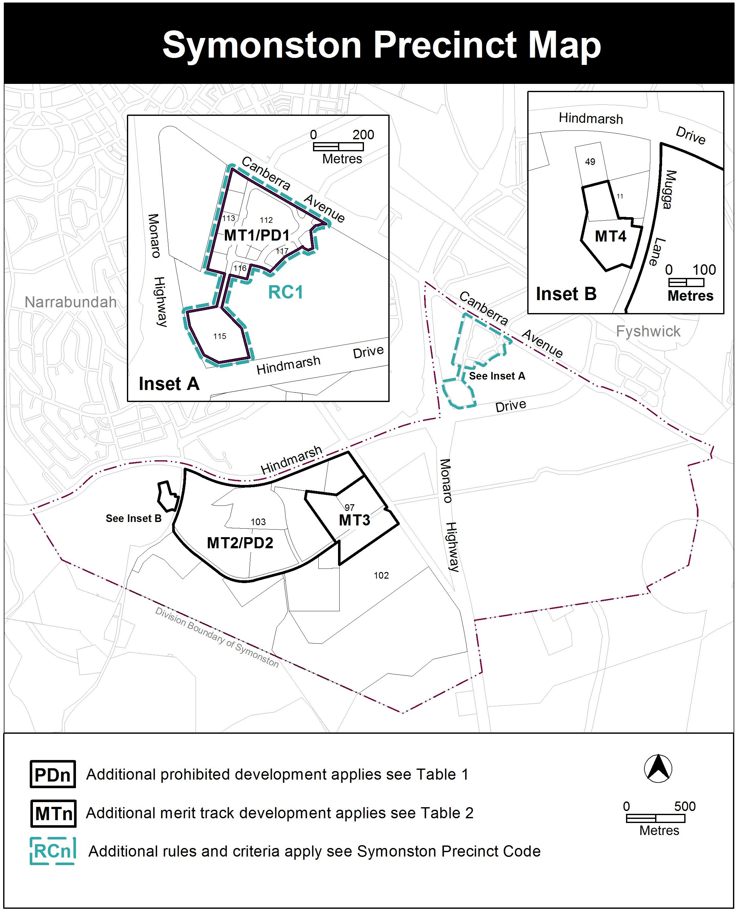

- Precinct Maps and Codes; Symonston Precinct Map and Code; Assessment Tracks; Table 2 – Additional merit track development

Substitute

Additional merit track development that may be approved subject to assessment
Suburb precinct map label | Zone | Development
MT1 | IZ1 | SHOP (excluding bulky goods  retailing)
MT2 | NUZ1 | cultural facility
MT3 | NUZ1 | mobile home park
MT4 | NUZ1 | Mental health facility

- Definitions; Part A – Definitions of Development

Insert
Umbrella Term | Development | Sub-categories | Some Common Terminology
 | Mental health facility has the same meaning as in the Mental Health (Treatment and Care) Act 1994 and this definition is only to be used for the Symonston site as defined in MT4 of the Symonston Precinct Map. |  | Secure mental health facility  Secure mental health unit

Interpretation service

ATTACHMENT A

Planning and Development Act 2007

REPORT ON CONSULTATION

Draft Special Variation
to the Territory Plan
S323

Symonston Mental Health Facility

July 2014

This page is intentionally blank.
Table of Contents
1. INTRODUCTION 1
2. COMMENTS FROM THE NATIONAL CAPITAL AUTHORITY 1
3. DETAILS OF PUBLIC CONSULTATION 2
4. ISSUES RAISED DURING CONSULTATION 2

Appendices

Appendix A – copies of National Capital Authority and other consultation comments

This page is intentionally blank.

- INTRODUCTION
This consultation report was prepared in accordance with s 85G(2) of the Planning and Development Act 2007 (the Act). Section 85G(2) requires that the planning and land authority must give the draft special variation to the Executive, together with a written report setting out –

- comments received from the national capital authority – section 2 of this report refers.
- detail of the public consultations – section 3 of this report refers
- the issues raised in any consultation about the draft special variation – section 4 of this report refers.

- COMMENTS FROM THE NATIONAL CAPITAL AUTHORITY
The National Capital Authority provided the following comments in relation to DSV S323:

Thank you for forwarding draft special variation S323 to the National Capital Authority (NCA). The NCA understands that the planning and land authority within the Environment and Planning Directorate (EPD) is required to prepare an instrument to make a draft variation to the Territory Plan in relation to the Symonston mental health facility. Draft special variation number S323 (DSV323) seeks to amend the Territory Plan in accordance with this legislative requirement.

The subject site is within the ‘Broadacre Areas’ of the General Policy Plan of the National Capital Plan (the Plan). The Plan sets out a number of permitted land uses for Broadacre Areas. A ‘Mental Health Facility’ as defined by the Mental Health (Treatment and Care) Act 1994 (ACT) is considered to be not inconsistent with those uses scheduled in the Plan. It is considered that this definition falls within the broader ‘Community Facility’ use of the Plan.

The subject site is adjacent to the ‘Designated Areas’ of the Plan. The current Block 11 Section 49 Symonston contains parts within the Designated Areas (where detailed planning is the responsibility of the NCA) and outside the Designated Areas. The NCA would prefer if the site proposed for the facility was subdivided [and] had its own unique block to ensure that issues of planning jurisdiction are avoided.

A copy of the National Capital Authority correspondence is attached to this report on consultation at Appendix A.

Response
Noted. The subdivision can be dealt with at the detailed designed stage as part of a development application.

- DETAILS OF PUBLIC CONSULTATION
Draft special variation to the Territory Plan S323 – Symonston mental health facility (DSV S323) was released for public comment between Friday 20 June 2014 and Friday 11 July 2014. A consultation notice was published on the published in the ACT Legislation Register on 20 June 2014, in the Canberra Times on 21 June 2014 and in the Chronicle on Tuesday 1 July 2014.

Consultation undertaken in addition to the requirements of the Act included the following:
- Letters to surrounding lease holders
- Letters to the key community organisations
  - Griffith Narrabundah Community Association
  - Inner South Community Council
  - Old Narrabundah Community Association
  - Red Hill Residents Association

- ISSUES RAISED DURING CONSULTATION
The results of consultation with the National Capital Authority are detailed in section 2 of this report and a copy of the correspondence from the National Capital Authority is attached to this report on consultation at Appendix A.

There were no comments received from the public.

Comments were received from the ACT Heritage Council and ActewAGL. Copies of these comments are attached to this report on consultation at Appendix A, and are outlined as follows:

Heritage
The ACT Heritage Council lodged comments during the public notification period (3 July 2014) indicating that its final comments would be submitted after consideration of a cultural heritage assessment for the area.

The ACT Heritage Council provided final comments on 23 July 2014. The Council advises that it does not object to the special variation provided a construction environmental management plan (CEMP) is prepared and sets out management protocols for the Aboriginal sites identified in the cultural heritage assessment.

Response
Noted. These matters will be considered as part of the detailed design of a project at the time of development application.

Electricity Infrastructure
ActewAGL identified a number of standard requirements to protect existing and future electricity infrastructure.

Response
Noted. This is a matter for the detailed design stage as part of a development application.

Appendix A
Copies of National Capital Authority and other consultation comments

National Capital Authority Comments

Subject: Draft Special Variation S323 - Symonston Mental Health Facility - NCA Response
Date: Thursday, 10 July 2014 11:58:01 AM

Dear Territory Plan Unit

Thank you for forwarding draft special variation S323 to the National Capital Authority (NCA). The NCA understands that the planning and land authority within the Environment and Planning Directorate (EPD) is required to prepare an instrument to make a draft variation to the Territory Plan in relation to the Symonston mental health facility. Draft special variation number S323 (DSV323) seeks to amend the Territory Plan in accordance with this legislative requirement.

The subject site is within the ‘Broadacre Areas’ of the General Policy Plan of the National Capital Plan (the Plan). The Plan sets out a number of permitted land uses for Broadacre Areas. A ‘Mental Health Facility’ as defined by the Mental Health (Treatment and Care) Act 1994 (ACT) is considered to be not inconsistent with those uses scheduled in the Plan. It is considered that this definition falls within the broader ‘Community Facility’ use of the Plan.

The subject site is adjacent to the ‘Designated Areas’ of the Plan. The current Block 11 Section 49 Symonston contains parts within the Designated Areas (where detailed planning is the responsibility of the NCA) and outside the Designated Areas. The NCA would prefer if the site proposed for the facility was subdivided had its own unique block to ensure that issues of planning jurisdiction are avoided.

Regards

Jordan Smith | Planning Officer
National Capital Authority

Heritage Council Comments
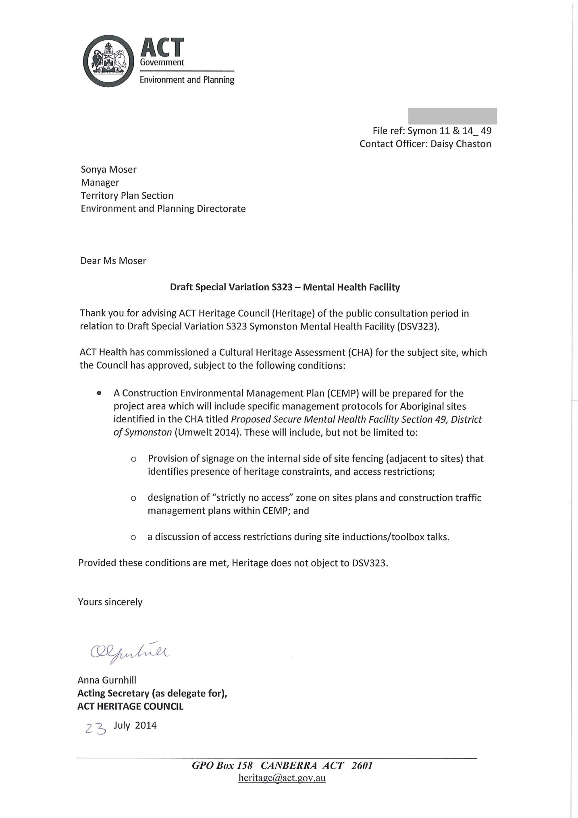

Heritage Council Comments Cont.

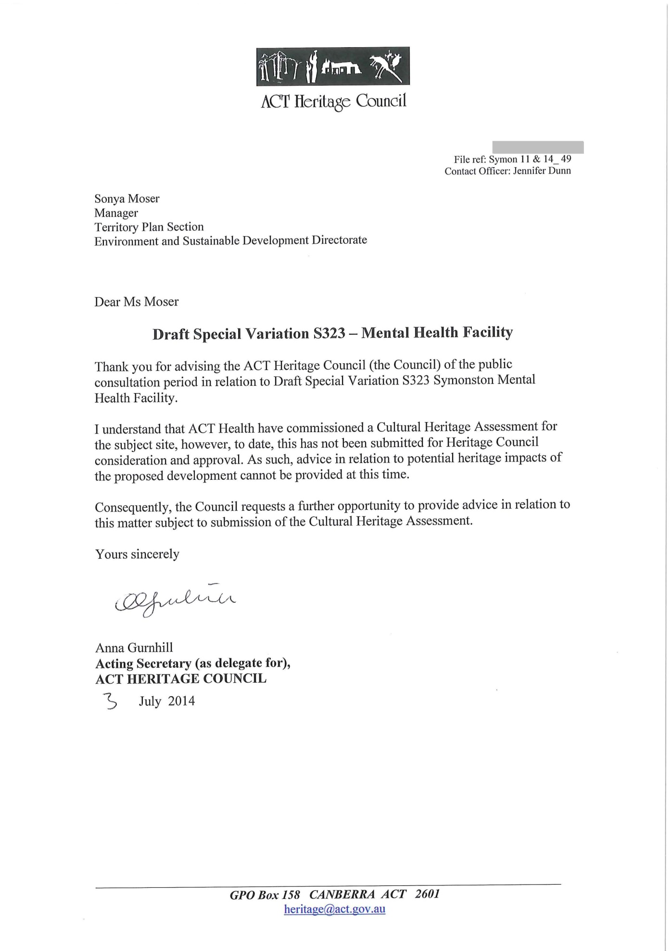

ActewAGL Electrical Network Division Comment

Subject: RE: Public Notification of DSV S323 - Symonston Mental Health Facility
Date: Tuesday, 24 June 2014 4:42:00 PM

Hi

ActewAGL Electrical Network Division has no objection on subjected lease variation for consolidation will following constraints.
. Development is to comply with minimum clearance to O/H assets and minimum separation to underground assets.
. Proponent is required to contact ActewAGL Prior to the commencement of any development activity to negotiate the connection of new/upgrade and /or relocation of existing electricity assets.
. Proponent may be required to provide the space for substation if the existing supply doesn’t meets requirement.
. Proponent may be required to install special earthing (if the substation is found to be within 100 meters of any special location e.g child care, public pool, lake etc) to less than 1 ohm.

Thank you.

Kind Regards Nadeem Azizi

Senior Network Connections Engineer ActewAGL

