Australian Capital Territory
Planning and Development (Plan Variation No 325) Notice 2014
Notifiable Instrument NI2014 - 427
made under the
Planning and Development Act 2007, section 76(3)

- Name of instrument
This instrument is the Planning and Development (Plan Variation No 325) Notice 2014.*

- Plan Variation No 325
On 22 August 2014, the Minister for Planning approved a draft of the attached plan variation to the Territory Plan (Annexure A) under s76 (3).

Jim Corrigan
Delegate of the Planning and Land Authority
27 August 2014

Planning and Development Act 2007

Variation to the
Territory Plan
No 325

Woden Bus Layover
Part Block 13 and Block 14 Section 23 Phillip

Final variation prepared under s76 of the
Planning and Development Act 2007

This page is intentionally blank.

Contents

1. EXPLANATORY STATEMENT 1
1.1 Background 1
1.2 Summary of the Proposal 3
1.3 The National Capital Plan 4
1.4 Site Description 4
1.5 Current Territory Plan Provisions 6
1.6 Changes to the Territory Plan 7
1.7 Consultation on the Draft Variation 7
1.8 Revisions to the Draft Variation Recommended to the Minister 7
2. VARIATION 8
2.1 Variation to the Territory Plan 8
2.2 Variation to the Territory Plan Provisions 9

This page is intentionally blank.

- EXPLANATORY STATEMENT
  - Background
Bus layover - Part Block 13, Section 23 Phillip
The Woden Town Centre Master Plan (2004) provided direction for, among other things, public transport emanating, terminating and passing through the Woden Town Centre. The Woden Town Centre Master Plan’s (the Master Plan) purpose was to review the planning assumptions that were made in the 1960s and ‘70s and to consider future growth of Woden in the context of contemporary planning objectives. These objectives included more sustainable development, higher quality urban design, changing office accommodation needs and demographic changes. The Master Plan also looked at public transport within the Woden Town Centre and included a provision for a bus layover to be located south of Hindmarsh Drive in Phillip.
A discussion paper, relating to a review of the current Woden and Mawson Master Plans, was released to the public on February 2014 for comment. An Estates Development Plan (EDP), which was conditionally approved in November 2013, proposed a raft of bus network changes that were recommended by the current Woden Town Centre Master Plan (2004). The discussion paper identified the proposed bus layover in the same location as this DV (part block 13, section 23 Phillip). Being adjacent to the Rapid Bus Route (changed in the EDP) and future Inter-town Public Transport Route increases its overall efficiency and integration.
The Woden Public Transport Planning Framework (2012) assessed the changing travel demands for public transport that is occurring in the Woden Town Centre. The Woden Public Transport Planning Framework (WPTPF) identified 27 suitable locations for a bus layover; however, most of these sites are slated for future redevelopment. The WPTPF thus recommends Block 13 Section 23 Phillip as the most efficient location for a bus layover within the Woden Town centre.
The area which is to be used for the bus layover occurs generally outside the existing fenced boundary of the enclosed oval (Phillip Oval) and does not impact on the existing area of irrigated grass or its surrounds.
Currently the block contains a public car park. The planning report (background document) and approved EDP states there may be additional short term car parking available when the temporary interchange is relocated from section 7, Phillip. Any removal of parking will be considered during the development application stage for the bus layover. This will need to adequately demonstrate that a reduction or relocation of parking spaces can be supported.

Block 14, Section 23 Phillip
The Woden Public Transport Planning Framework (2012) recommended the most efficient and convenient location for a bus layover development is located at Phillip Oval. This recommendation results in a reduction in the overall size of Phillip Oval. In reviewing the site surrounds it became apparent that Block 14, Section 23 Phillip is well located (and vacant) to be incorporated into the Phillip Oval uses and is to be rezoned accordingly.
Block 14 is also a similar size to the part of Block 13, Section 23 Phillip that is intended to be used for the bus layover facility and thus there is little net change in land zoned PRZ2.

Changes to the Territory Plan Definitions
Currently there is no definitive provision for a bus layover facility in the Territory Plan Definitions. The current definition for public transport facility is as follows:
“...means the use of land for the assembly, transport or dispersal of passengers travelling by any form of public transport, whether or not such public transport is provided by a public or private agency, and excludes any facilities required for the parking, and manoeuvring of any public transport vehicle.”
The definition is worded in such a way so most of the activities undertaken at a public transport facility are active/direct public transport functions. As bus layovers primary function is to increase route efficiency and temporary parking/manoeuvring of public transport vehicles the location and proximity of bus layovers to public transport facilities is key.
Thus by amending the definition of public transport facility to include ‘bus layover’ it will allow closer integration of public transport related uses.
The definition of public transport facility is to be amended as per ‘3.2 Variation to the Territory Plan Code’ of this document.

Changes to the Public Land Overlay
Currently the public land overlay (sports and recreation reserve) encompasses the whole of block 13, section 23 Phillip. As the bus layover is to be developed in the south east corner of this block the public land overlay boundary will need to be realigned to the new boundaries of Philip Oval. Block 14, section 23 Phillip will be rezoned PRZ2 and thus offset the area taken from Philip Oval by the Bus Layover. In this way the public land overlay will surround Philip Oval, excluding the area for the bus layover but will include block 14, section 23 Phillip to allow the correct protection and management of the Philip Oval into the future.

Changes to the Phillip Precinct Map and Code
Currently block 14 section 23 Phillip is within the ‘PD1 area’ of the Phillip Precinct Map and Code. As the site is currently zone CZ2 the ‘PD1 area’ restricts residential use. This variation rezones block 14 section 23 Phillip to PRZ2 Restricted Access Open Space which prohibits residential use. As residential use is not allowed in the new zoning anyway the ‘PD1 area’ restrictions will be removed from block 14 section 23 Phillip.

  - Summary of the Proposal
The variation enables the development of a bus layover near the intersection of Launceston Street and Callam Street (Phillip) by amending the Territory Plan. The variation does the following:
- Rezones part Block 13, Section 23 Phillip from (Parks and Recreation) PRZ2 Restricted Access Recreation to (Transport & Services) TSZ1 Transport.
- Rezones Block 14, Section 23 Phillip from (Commercial) CZ2 Business to (Parks and Recreation) PRZ2 Restricted Access Recreation.
- Varies the boundaries of the Public Land Overlay to reflect the new boundaries of Phillip Oval
- Clarifies the definition of Public Transport Facility to include ‘bus layover’ and ‘driver amenities’.
- Amends the Phillip Precinct Map and Code to remove requirements relating to block 14 section 23 Phillip as they are no longer required due to zone changes above.
  - The National Capital Plan
The Australian Capital Territory (Planning and Land Management) Act 1988 established the National Capital Authority (NCA) with two of its functions being to prepare and administer a National Capital Plan (NCP) and to keep the NCP under constant review and to propose amendments to it when necessary.
The NCP, which was published in the Commonwealth Gazette on 21 January 1990 is required to ensure that Canberra and the Territory are planned and developed in accordance with their national significance. The Planning and Land Management Act 1988 also required that the Territory Plan is not inconsistent with the NCP.
In accordance with section 10 of the Australian Capital Territory (Planning and Land Management) Act 1988, the National Capital Plan defines the planning principles and policies for Canberra and the Territory, for giving effect to the object of the NCP and sets out the general policies to be implemented throughout the Territory, including the range and nature of permitted land uses.
It also sets out the detailed conditions of planning, design and development for areas that have special significance to the National Capital known as designated areas and identifies special requirements for the development of some other areas.

  - Site Description
Variation 325 (V325) includes the south-east portion of Block 13 Section 23 Phillip and Block 14 Section 23 Phillip (see figure 1).
Block 13 comprises of Phillip Oval and associated facilities. V325 rezones the south east portion of block 13 which is currently a public parking area.
Block 14 is bounded by Launceston Street to the south, Spoering Street and Block 17 to the west and Block 13 (Phillip Oval) to the north and east. Block 14 is currently vacant.
Block 13 is zoned PRZ2 Restricted Access Recreation Zone under which a public transport facility was prohibited.
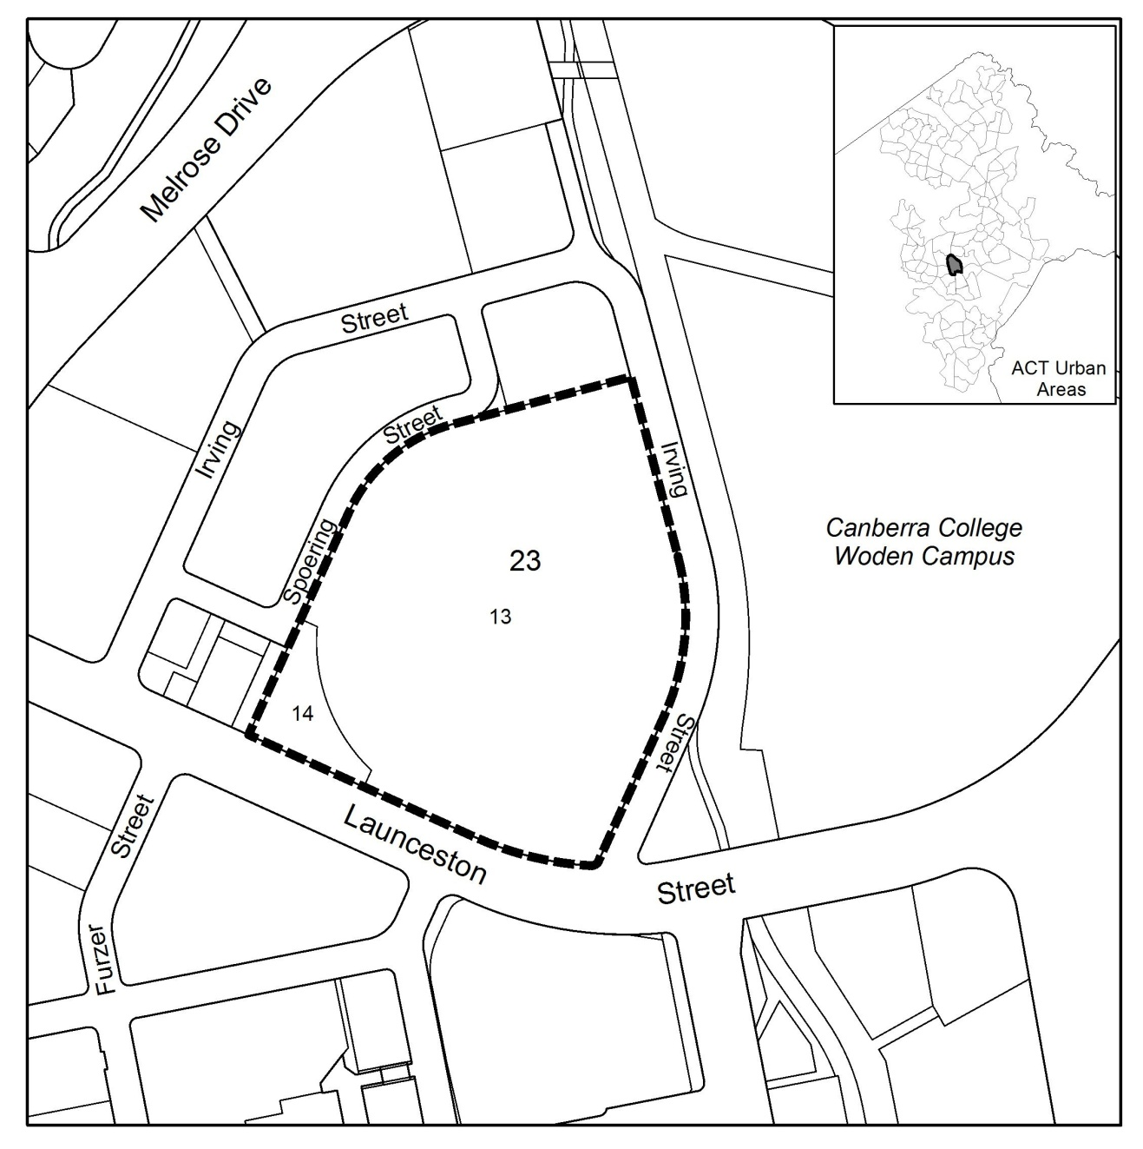 Figure 1: Site Plan
  - Current Territory Plan Provisions
The Territory Plan map zones for the area subject to this variation are shown in Figure 2.

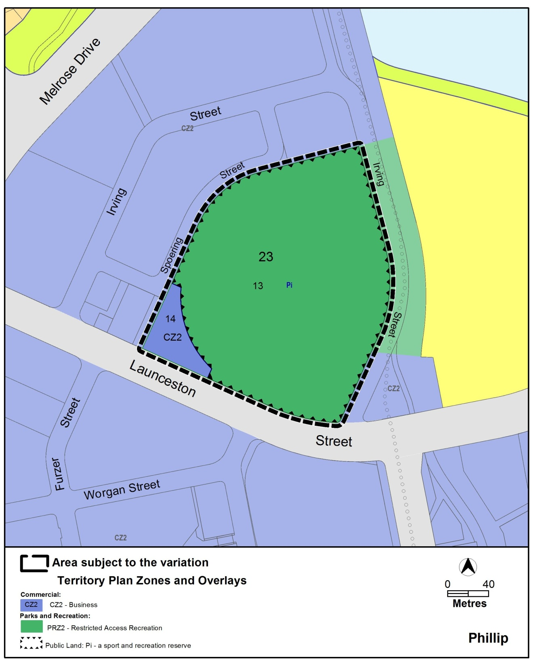FFigure 2 Territory Plan Zones Map

  - Changes to the Territory Plan
Detailed changes to the Territory Plan are noted in section 2 of this document.

  - Consultation on the Draft Variation
Variation No 325 (V325) was released for public comment between 12 April 2014 and 28 May 2014. A consultation notice under section 63 of the Planning and Development Act 2007 (P&D Act) was published on the ACT Legislation Register on 11 April 2014 and in The Canberra Times on 12 April 2014.
A total of one written submission was received, from the Woden Valley Community Council.
The main issue raised by the submitter was that the layover should be developed on a different block in Phillip rather than the block proposed by V325.
The above issue and other issues raised were considered and are detailed in a report on consultation. One change was made as a result of consultation which is discussed below. The outcomes of consultation were considered by the Minister responsible for planning prior to approval of this variation.
The Phillip Precinct Map and Code will be amended to remove block 14 section 23 Phillip from the ‘PD1’ area of the precinct map which restricts residential use. The proposed PRZ2 Restricted Access Recreation Zone prohibits residential use thus there is no reason to keep PD1 area restrictions over block 14 section 23 Phillip.

  - Revisions to the Draft Variation Recommended to the Minister
No changes were made to the draft variation recommended to the Minister.
- VARIATION
  - Variation to the Territory Plan
The Territory Plan map is varied in all of the following ways:

Variation to the Territory Plan map

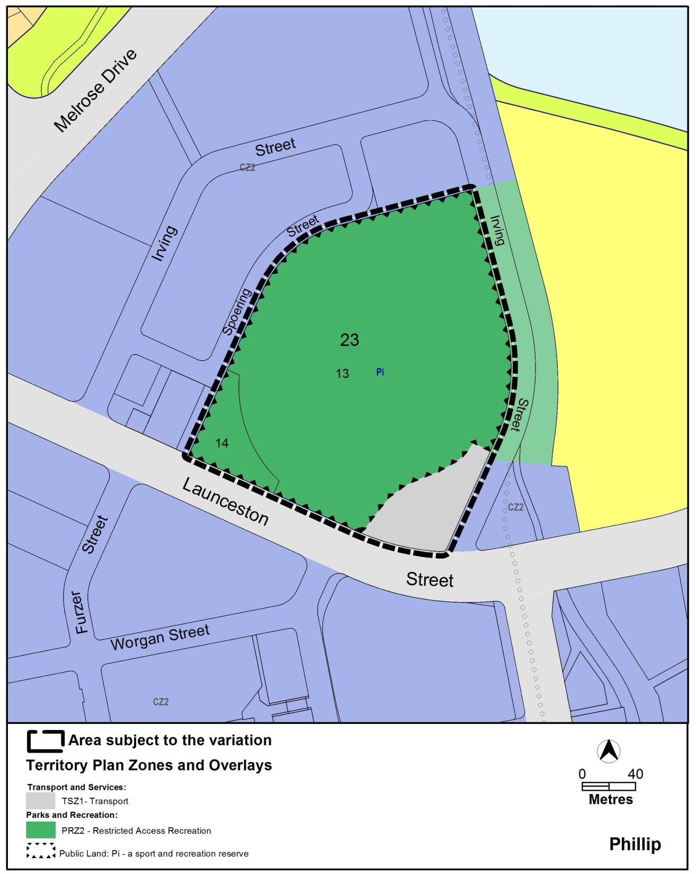
  - Variation to the Territory Plan Provisions
The Territory Plan is varied in all of the following ways:

Variation to the Territory Plan Definitions (13.1)
Definition of Development – Public Transport Facility

Substitute the entire definition of public transport facility with the following:

public transport facility means the use of land for the assembly, transport or dispersal of passengers travelling by any form of public transport, whether or not such public transport is provided by a public or private agency, and include facilities for the manoeuvring and temporary layover of public transport vehicles and driver amenities.

Insert in the common terminology for a public transport facility the following:

Bus layover

Variation to the Phillip Precinct Maps and Code (10.1)
Phillip Precinct Map

Substitute the entire Phillip Precinct Map with the following map:
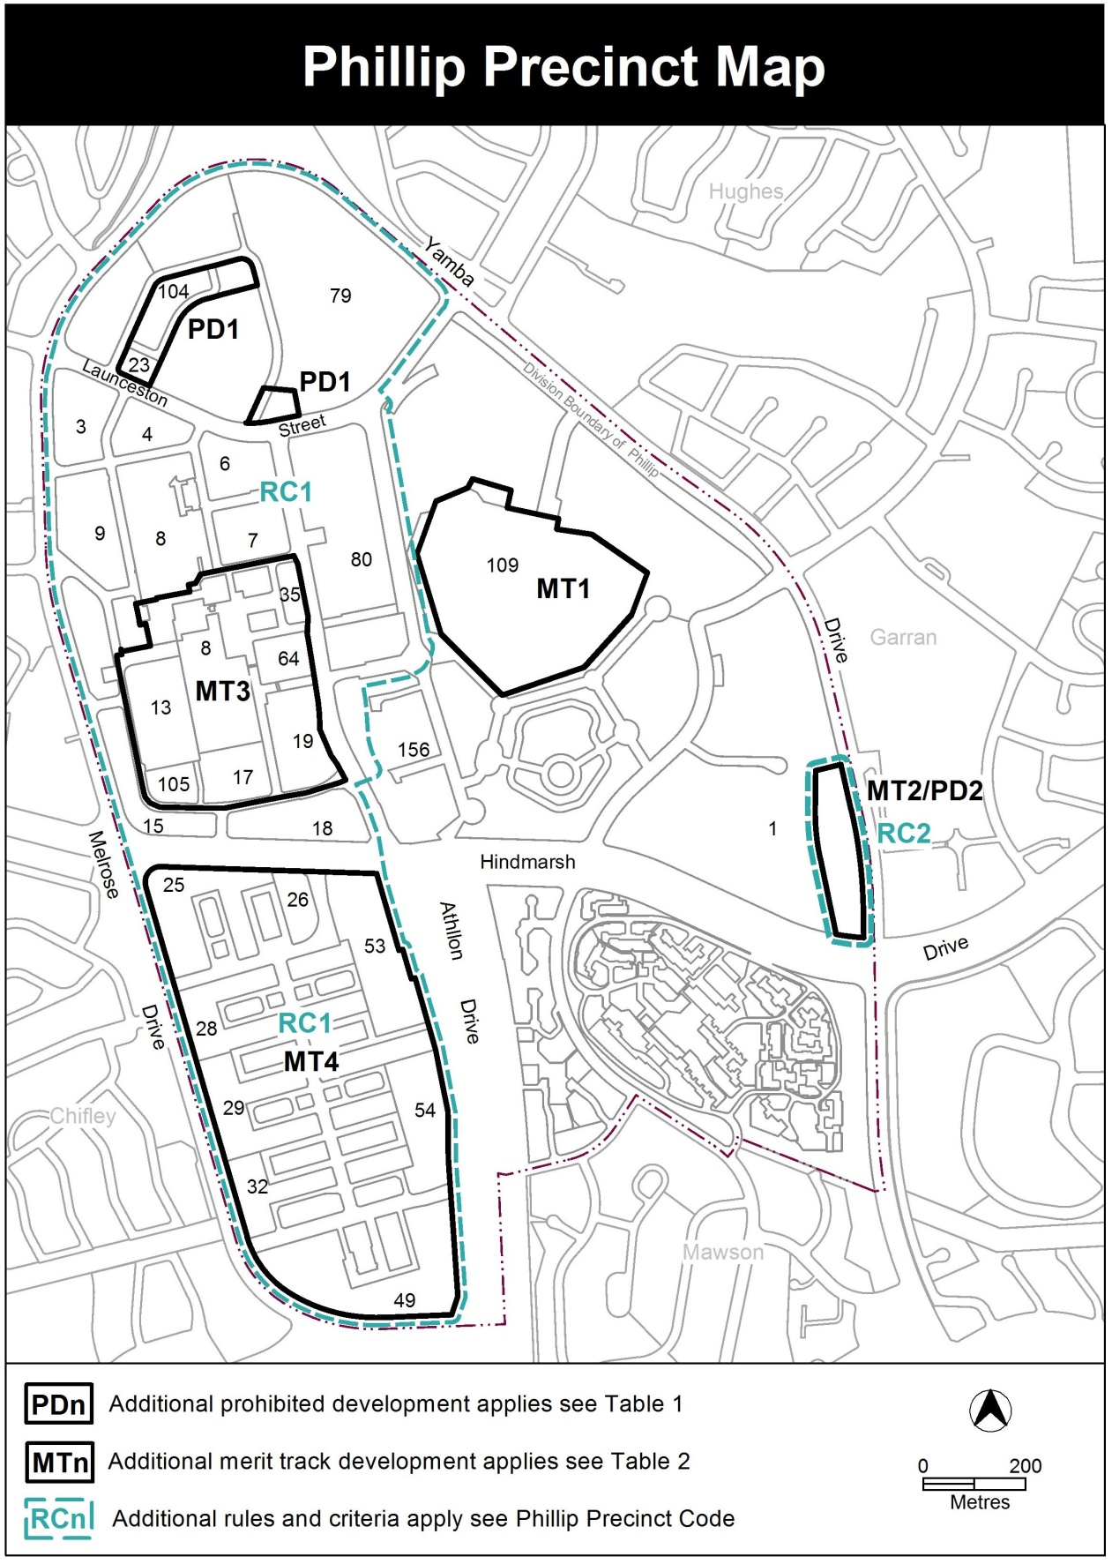
Interpretation service
