Australian Capital Territory

Planning and Development (Technical Amendment—Casey) Plan Variation 2014 (No 4)*

Notifiable Instrument NI2014—474
Technical Amendment No 2014—19
made under the
Planning and Development Act 2007, section 89 (Making technical amendments) s96 (land ceases to be in future urban area)

This plan variation commences on the day after it is notified.

Variation No 2014—19 to the Territory Plan has been approved by the Planning and Land Authority.

Variation to the Territory Plan
The Territory Plan map is varied as indicated in pages one to four of Annexure A to identify the zones that apply to the land ceasing to be in a future urban area.

Variation to the Precinct Map and Code
Pages one to five of Annexure B indicate the changes to the Casey Precinct Map and Code incorporating the ongoing block specific provisions for the area:
- Substitute Casey Precinct Map
- Insert new pages for RC4 – Residential and Figure 3 after RC3 of the Casey Precinct Map and Code.
- Insert new pages RC5 – Commercial Local Centre and Figure 4 after Figure 3 of the Casey Precinct Map and Code.
- Replace OP3 ongoing provisions of the Casey Precinct Map and Code.
- Replace OP4 ongoing provisions of the Casey Precinct Map and Code

Jim Corrigan
Delegate of the Planning and Land Authority
Date 26.09.14

THIS IS PAGE ONE OF ANNEXURE A
TO NOTIFIABLE INSTRUMENT NI2014–474
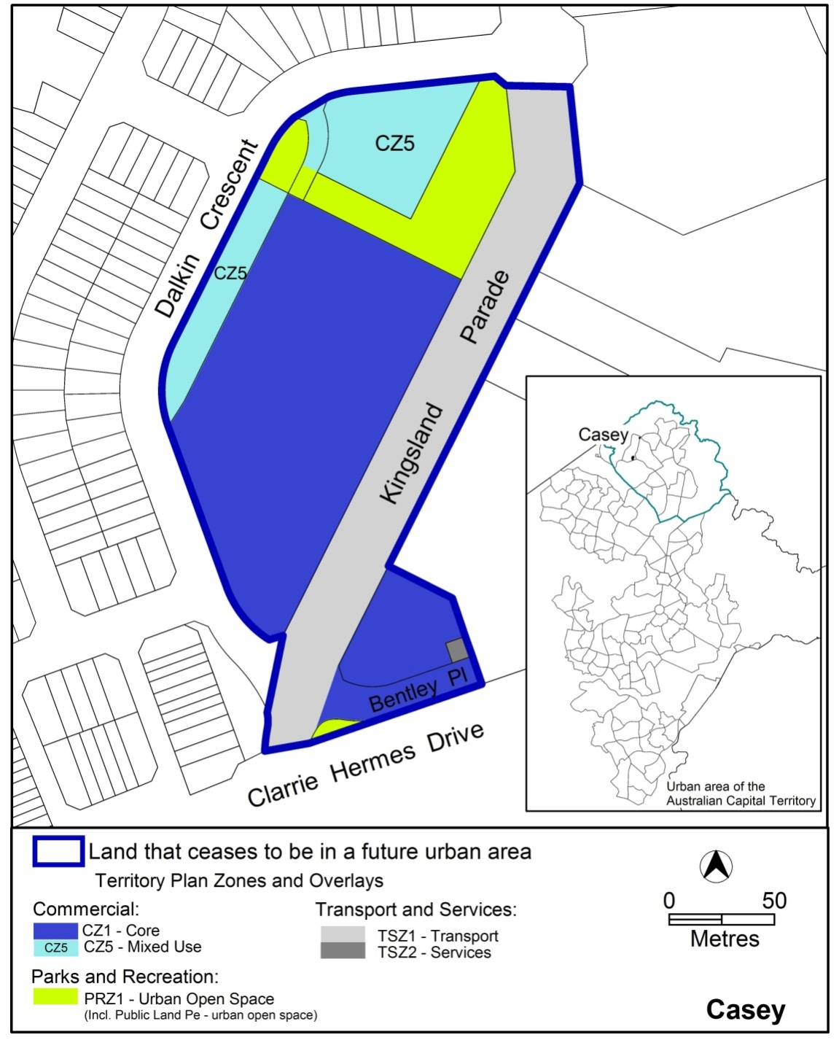

Jim Corrigan
Delegate of the Planning and Land Authority
Date 26.09.14
THIS IS PAGE TWO OF ANNEXURE A
TO NOTIFIABLE INSTRUMENT NI2014–474
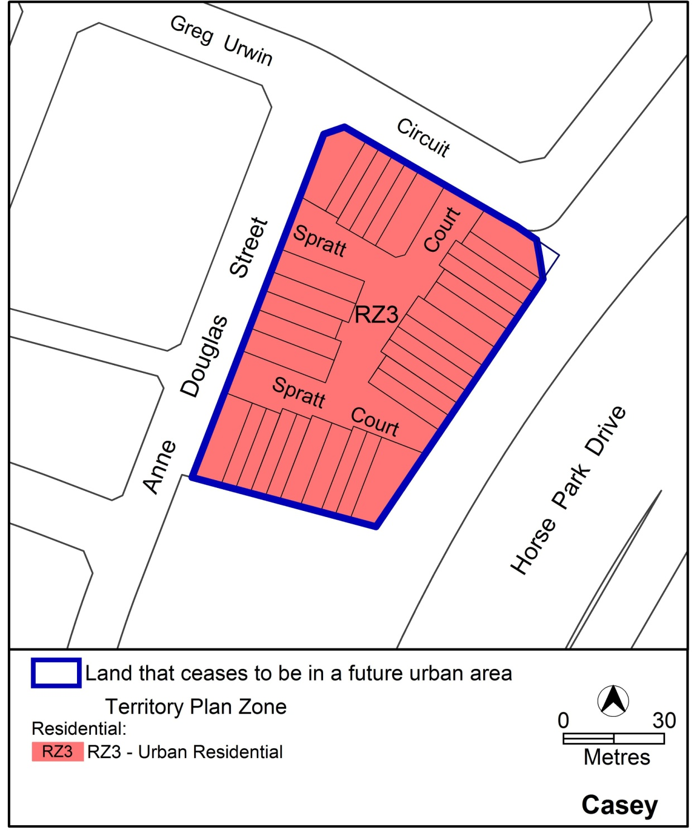

Jim Corrigan
Delegate of the Planning and Land Authority
Date 26.09.14

THIS IS PAGE THREE OF ANNEXURE A
TO NOTIFIABLE INSTRUMENT NI2014–474

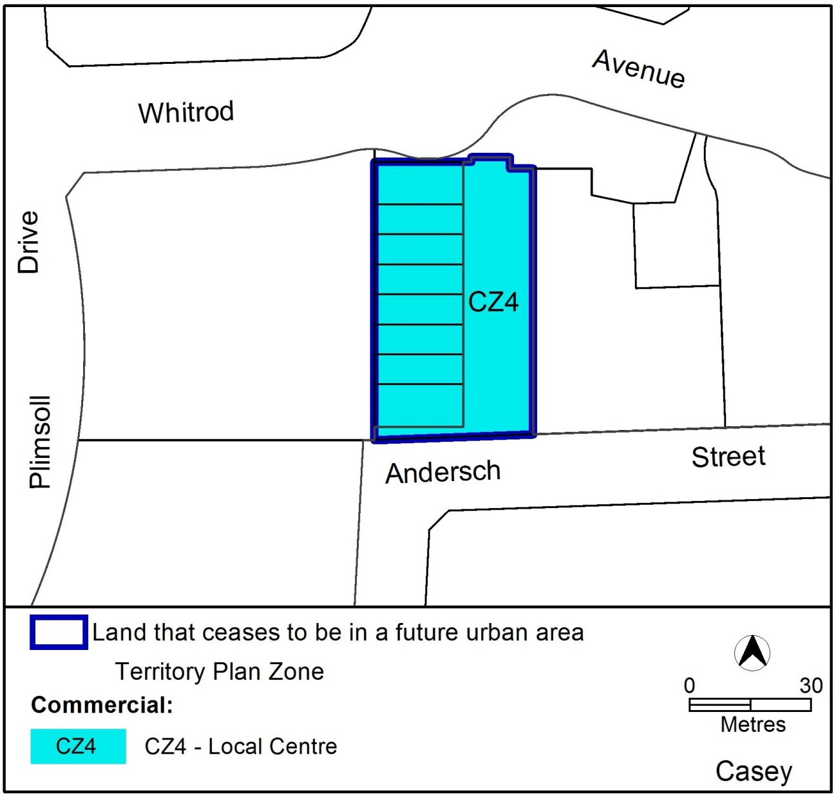

Jim Corrigan
Delegate of the Planning and Land Authority
Date 26.09.14

THIS IS PAGE ONE OF ANNEXURE B
TO NOTIFIABLE INSTRUMENT NI2014–474
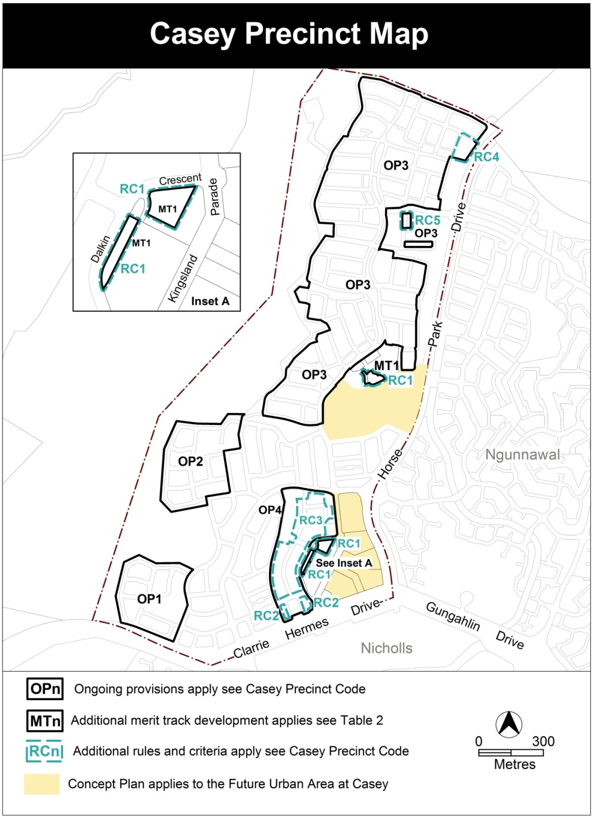

Jim Corrigan
Delegate of the Planning and Land Authority
Date 26.09.14
THIS IS PAGE TWO OF ANNEXURE B
TO NOTIFIABLE INSTRUMENT NI2014-474
RC4 – Residential
This part applies to blocks and parcels identified in area RC4 shown on the Casey Precinct Map.
- Building and site controls
Rules | Criteria
1.1 Setbacks
R13  This rule applies to details shown in figure 3. Minimum front setbacks for lower and upper floor levels:  at A is 2m  at B is 3m | This is a mandatory requirement. There is no applicable criterion.
R14  This rule applies to details shown in figure 3.  Minimum side setback for lower and upper floor levels at C is 0m. | This is a mandatory requirement. There is no applicable criterion.
R15  This rule applies to details shown in figure 3.  Mandatory setback of 0m applies to garages. | This is a mandatory requirement. There is no applicable criterion.
R16  This rule applies to details shown in figure 3.  Minimum setback of 0.5m applies on selected blocks for front courtyard walls. | This is a mandatory requirement. There is no applicable criterion.
R17  This rule applies to details shown in figure 3.  Mandatory setback of 0m applies on selected blocks for courtyard walls to the community area. | This is a mandatory requirement. There is no applicable criterion.
1.2 Principal private open space
R18  This rule applies to details shown in figure 3.  Minimum dimensions for principal private open space are:  - For blocks marked * - 3m x 3m  - For blocks marked ● - 6m x 6m | This is a mandatory requirement. There is no applicable criterion.

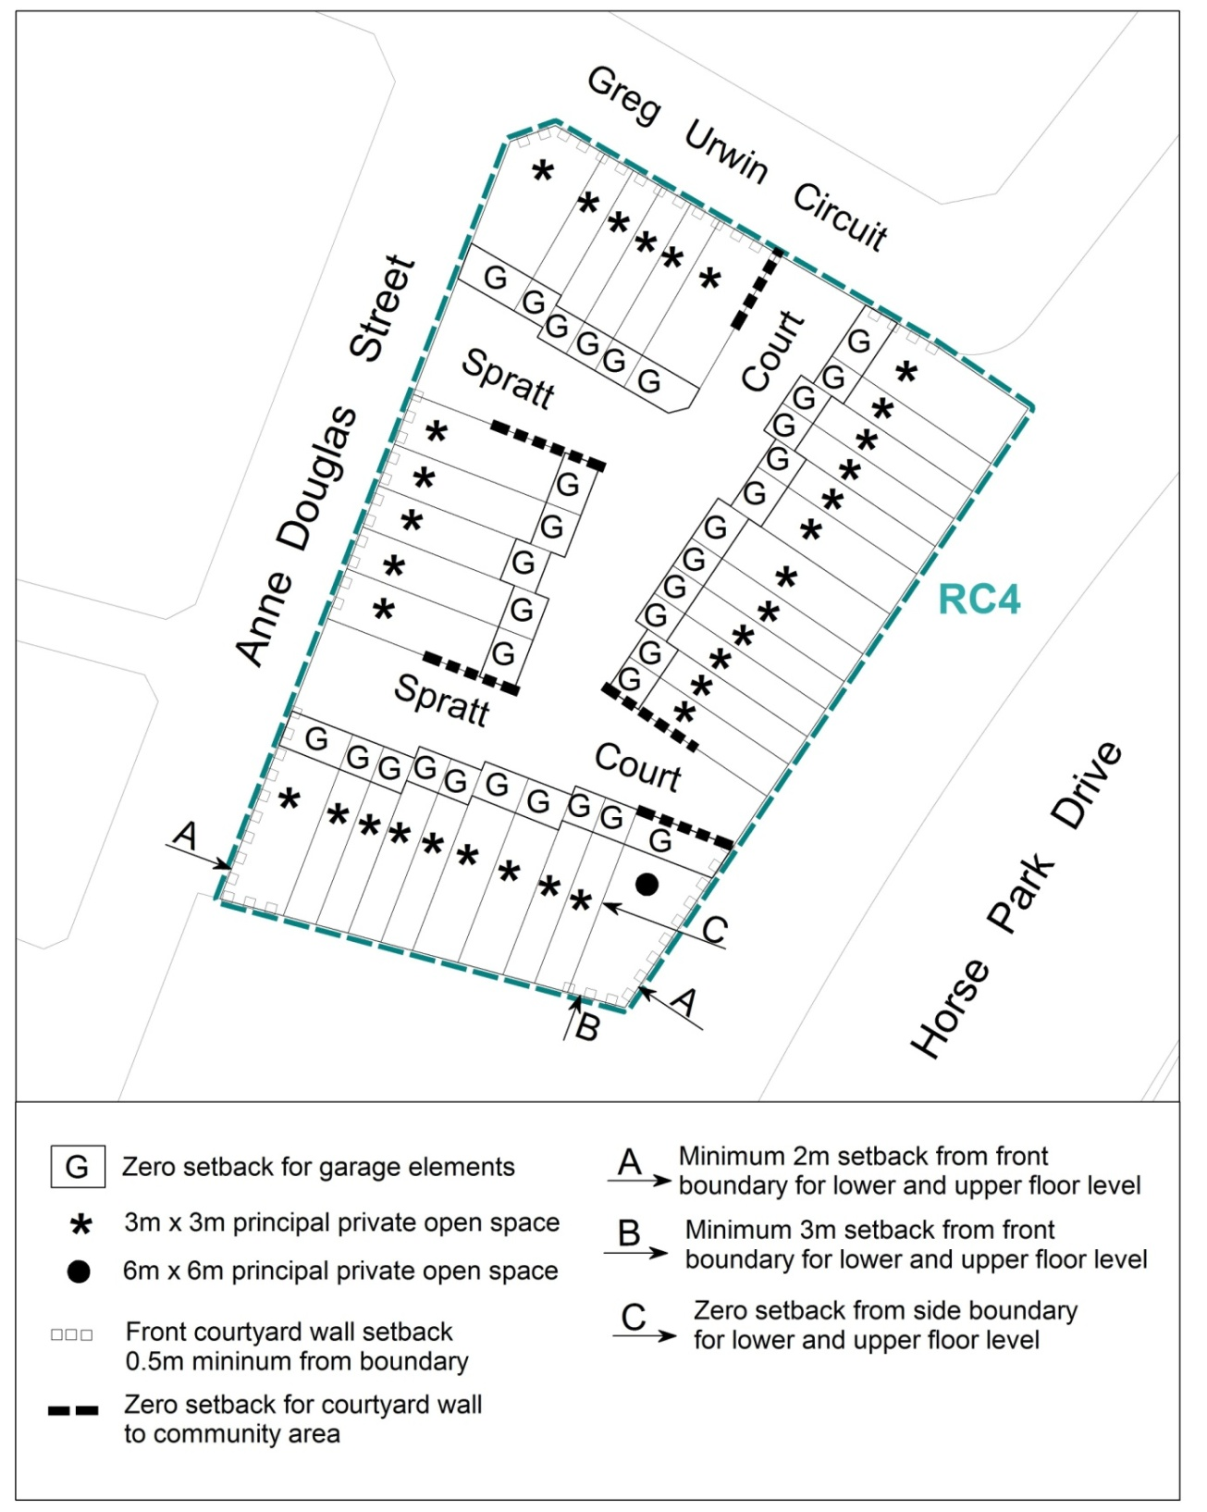
Figure 3 Building and site controls – RC4 Residential area

Jim Corrigan
Delegate of the Planning and Land Authority
Date 26.09.14
THIS IS PAGE THREE OF ANNEXURE B
TO NOTIFIABLE INSTRUMENT NI2014–474
RC5 – Commercial Local Centre
This part applies to blocks and parcels identified in area RC5 shown on the Casey Precinct Map.
- Building and site controls
Rules | Criteria
  - Setbacks
R19  This rule applies to blocks marked A in figure 4.  Mandatory 0m side setback applies to blocks marked A. | This is a mandatory requirement. There is no applicable criterion.
  - Building design
R20  This rule applies to blocks marked A in figure 4.  Dwellings comply with all of the following:  - ground floor level is adaptable for commercial uses  - minimum floor to ceiling height at ground floor level is 3.0m.  - ability to be retrofitted to meet fireproofing standards for commercial use  - ability to be retrofitted to meet noise mitigation requirements for commercial use | This is a mandatory requirement. There is no applicable criterion.
  - Pedestrian access
R21  This rule applies to details shown in figure 4.  Mandatory pedestrian access is required to buildings at the locations shown. | This is a mandatory requirement. There is no applicable criterion.

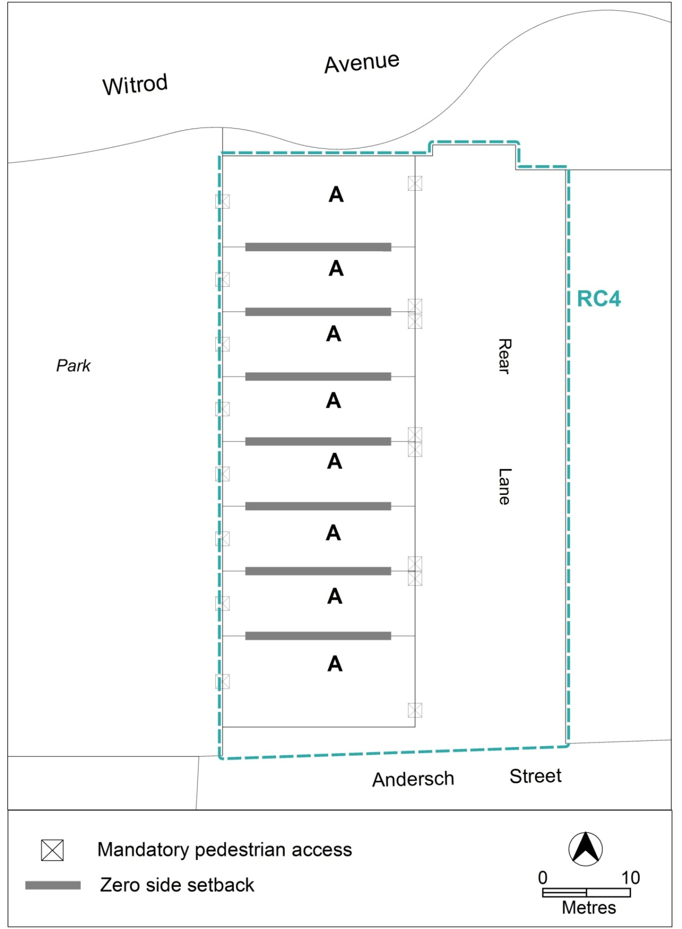

Figure 4 Building and site controls – RC5 Commercial local centre area

Jim Corrigan
Delegate of the Planning and Land Authority
Date 26.09.14
THIS IS PAGE FOUR OF ANNEXURE B
TO NOTIFIABLE INSTRUMENT NI2014–474
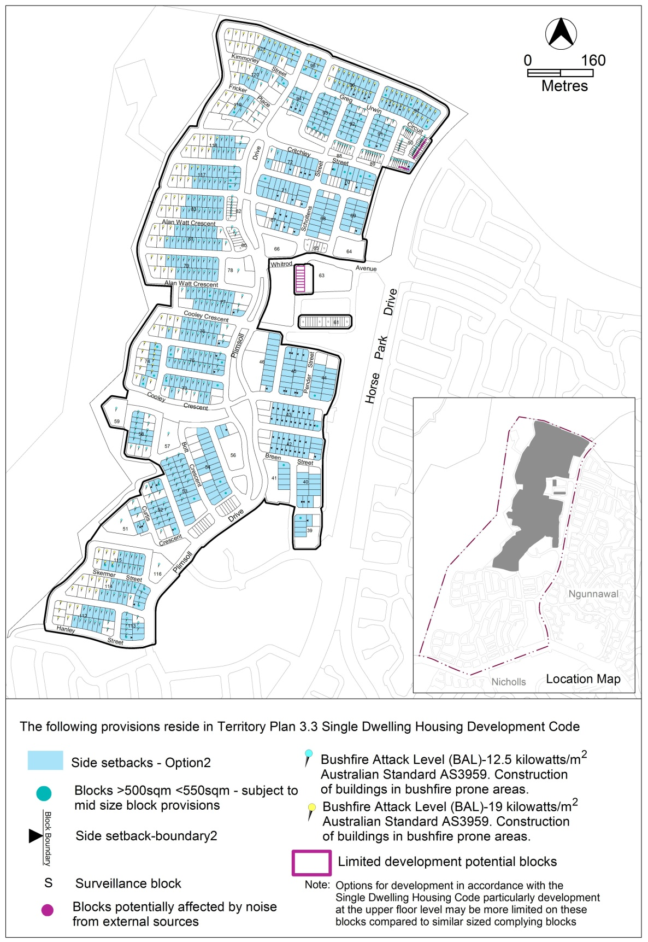

Jim Corrigan
Delegate of the Planning and Land Authority
Date 26.09.14
THIS IS PAGE FIVE OF ANNEXURE B
TO NOTIFIABLE INSTRUMENT NI2014–474
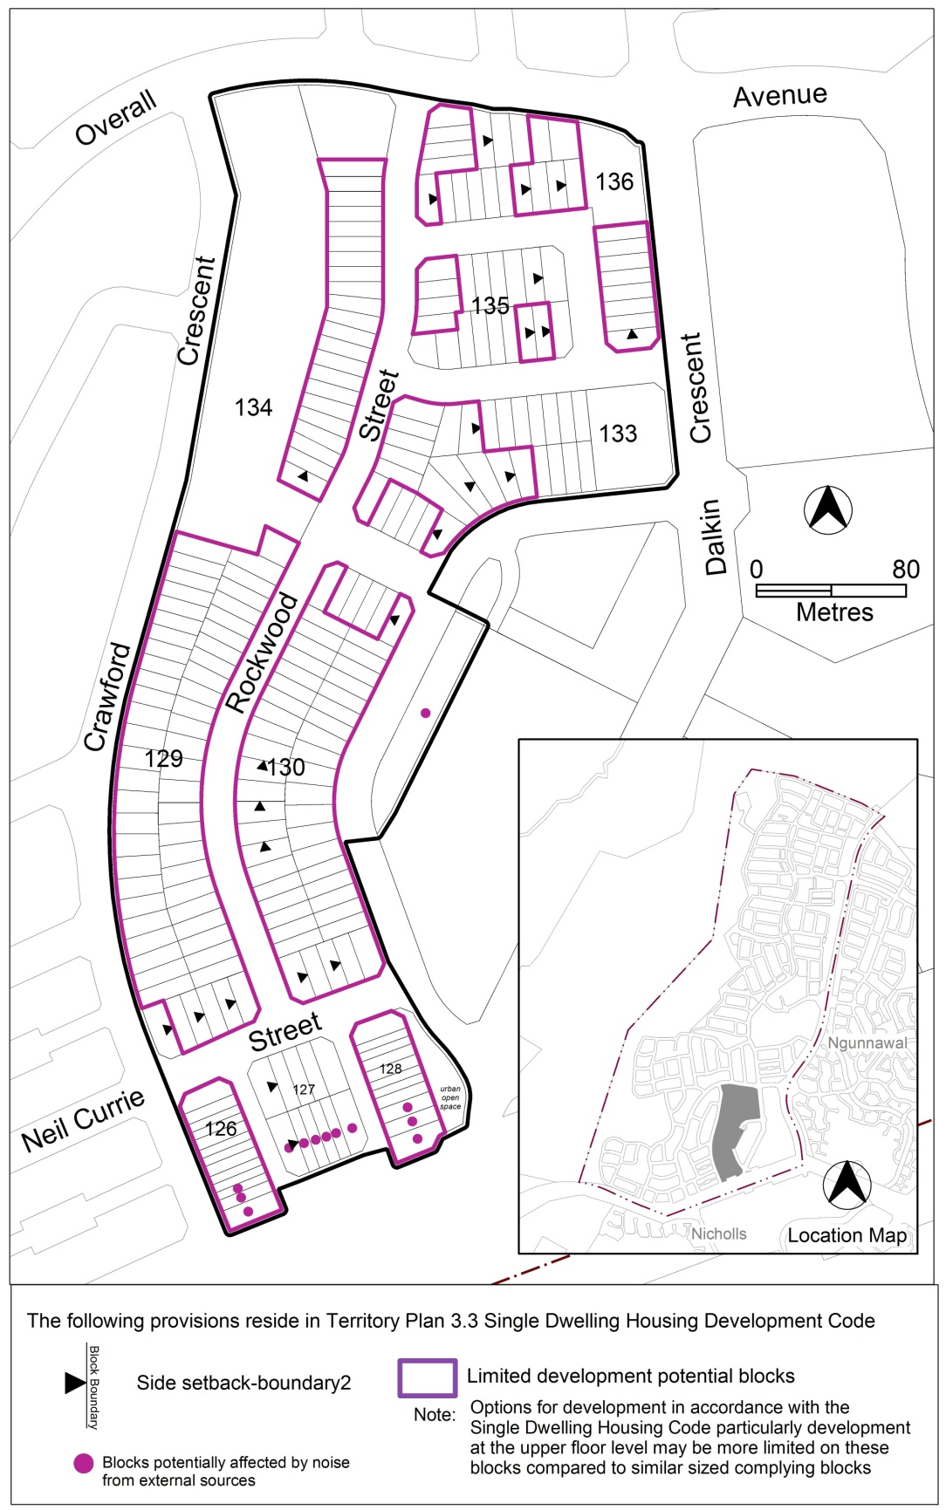

Jim Corrigan
Delegate of the Planning and Land Authority
Date 26.09.14

