Australian Capital Territory

Planning and Development (Draft Plan Variation No 304) Direction 2014 (No 2)
Draft Variation to the Territory Plan No 304 (DV304) Commercial Zones
Notifiable Instrument NI2014—615
made under the
Planning and Development Act 2007, section 76 (Minister’s powers in relation to draft plan variations)

Under the Planning and Development Act 2007, s76(3)(b)(iv), the Minister responsible for planning returned draft variation No 304 – Commercial Zones to the planning and land authority, within the Environment and Planning Directorate, and on 12 November 2014 directed the authority to make changes as stated in Annexure A.

Jim Corrigan
Delegate of the planning and land authority
27 November 2014

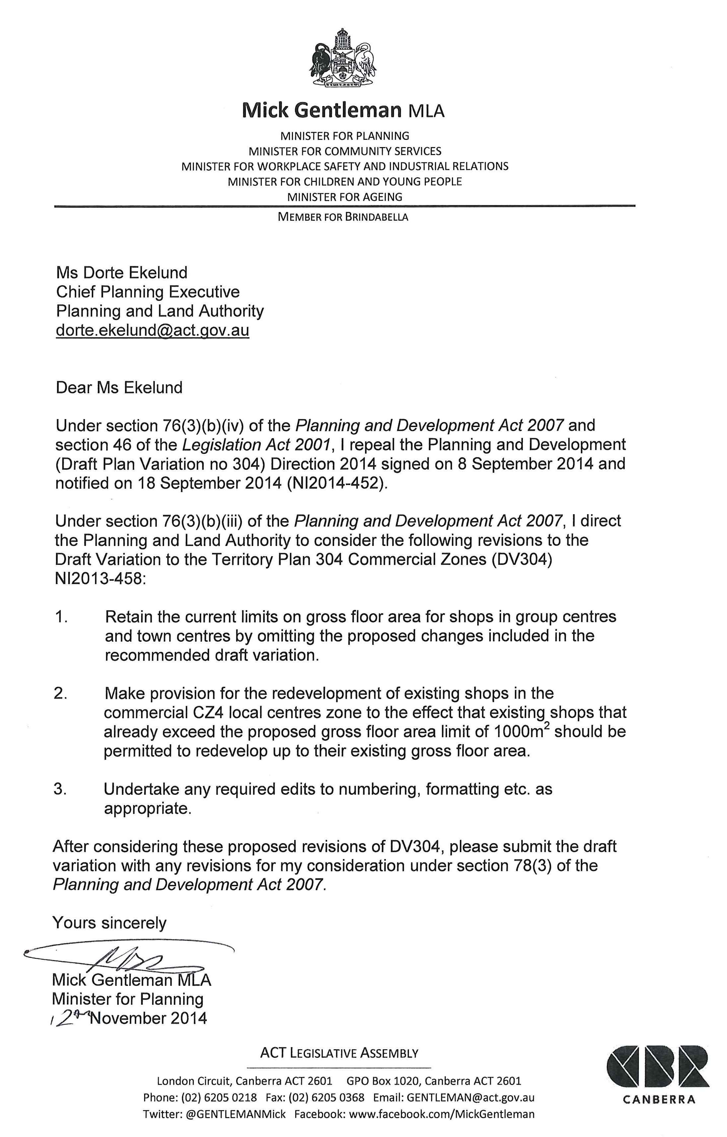
Annexure A

