Australian Capital Territory

Planning and Development (Technical Amendment—Miscellaneous Amendment) Plan Variation 2014 (No 4)*

Notifiable Instrument NI2014—656

Technical Amendment No 2014—14
made under the
Planning and Development Act 2007, section 89 (Making technical amendments)

This technical amendment commences on 19 December 2014.

Variation No 2014—14 to the Territory Plan has been approved by the planning and land authority.

Jim Corrigan
Delegate of the planning and land authority
16 December 2014

Planning & Developmen t Act 2007

Technical Amendment
to the Territory Plan
Variation 2014-14

Various amendments including code, clarification and miscellaneous changes

December 2014

This page is left intentionally blank
Table of Contents

1. INTRODUCTION 1
1.1 Purpose 1
1.2 Public consultation 3
1.3 National Capital Authority 3
1.4 Process 3
1.5 Types of technical amendments under the Act 3
2. EXPLANATION 5
2.1 Single dwelling housing development code 5
2.2 Multi unit housing development code 8
2.3 Industrial zones development code 9
2.4 Aranda precinct map 10
2.5 City precinct map and code 10
2.6 Greenway precinct map and code 11
2.7 Kingston precinct map and code 14
2.8 Inner north precinct code 16
2.9 Northbourne Avenue precinct code 20
2.10 Definitions 21
3. TECHNICAL AMENDMENT 22
3.1 Single dwelling housing development code 22
3.2 Multi unit housing development code 23
3.3 Industrial zones development code 24
3.4 Aranda precinct map and code 24
3.5 City precinct map and code 26
3.6 Greenway precinct map and code 27
3.7 Kingston precinct map and code 29
3.8 Inner north precinct code 31
3.9 Northbourne Avenue precinct code 34
3.10 Definitions 34

This page is left intentionally blank

- INTRODUCTION
  - Purpose

This technical amendment makes the following changes to the Territory Plan:

Single dwelling housing development code
- Remove Note from Table 6A
- Adjust rule R8 to state that this rule does not apply to blocks which are subject to a precinct code

Multi unit housing development code
- Correct rule R9 to include reference to RZ4 blocks in the first sentence
- Amend rule R14 to clarify that rule R2 does not apply in cases where the requirements pertaining to R14 apply

Industrial zones development code
- Correction to refer to ‘industrial zones’ in the ‘Relevant Codes’ part of the code on page 3

Aranda precinct map and code
- Correction to page 1 of Aranda Precinct Map – incorrect reference to ‘Greenway Precinct Code’.

City precinct map and code
- Amend criterion C25(b), C27(b) and C31 to bring into line with the Special Requirements in the National Capital Plan regarding building heights in the City centre.

Greenway precinct map and code
- Amend criteria C1 and C4 to more clearly outline requirements for stormwater runoff in RC1 and RC2 areas west of Athllon Drive in Tuggeranong.

Inner North precinct code
- Update references in R31 regarding Lyneham Section 49

Kingston precinct map and code
- Rectify C36, R37, R38, R41, R42, R43, R44, R47, R48 and R49 to refer to correct Figures 4,5 and 6

Northbourne Avenue precinct code
- Update references in R18 regarding the multi unit housing development code

Definitions
- Clarify that the definition of subdivision has the same meaning as in Section 7 of the Planning and Development Act 2007.

  - Public consultation
Under section 88 of the Planning and Development Act 2007 (the Act) this type of technical amendment is subject to limited public consultation.
Written comments will be received until COB 21 November 2014.
Written comments, quoting TA2014-14, may be submitted in one of the following ways:
- Emailed to | ta.comments@act.gov.au
- Hand delivered to: | Territory Plan Section  Environment and Planning Directorate  Customer Service Centre  16 Challis Street, DICKSON
- Posted to: | Territory Plan Section  Environment and Planning Directorate  GPO Box 158  CANBERRA ACT 2601
  - National Capital Authority
The National Capital Authority has been advised of this technical amendment.

  - Process
This technical amendment has been prepared in accordance with section 87 of the Planning and Development Act 2007 (the Act).

Comments received from the public and the National Capital Authority will be taken into account before the planning and land authority “makes” the technical amendment under section 89 of the Act. The planning and land authority must then notify the public of its decision.

  - Types of technical amendments under the Act
The following categories of technical amendments are provided under section 87 of the Act:
(a) a variation (an error variation) that –
- would not adversely affect anyone’s rights if approved; and
- has as its only object the correction of a formal error in the plan
(b) a variation (a code variation) that –
- would only change a code; and
- is consistent with the policy purpose and policy framework of the code; and
- is not an error variation
(c) a variation in relation to a future urban area under section 95 (Technical amendments – future urban areas);
(d) a variation in relation to an estate development plan under section 96 (Effect of approval of estate development plan);
(e) a variation to change the boundary of a zone or overlay under section 96A (Rezoning – boundary changes);
(f) a variation required to bring the territory plan into line with the national capital plan;
(g) a variation to omit something that is obsolete or redundant in the territory plan;
(h) a variation to clarify the language in the territory plan if it does not change the substance of the plan;
(i) a variation to relocate a provision within the territory plan if the substance of the provision is not changed.
Following each item in Part 2 Explanation of this technical amendment is a statement of compliance against the specific criteria for the relevant category of technical amendment.
TA2014-14 has been prepared in accordance with sections 87 (a), (b), (f) and (h) of the Act.

- EXPLANATION
This part of the technical amendment document explains the changes to be made to the Territory Plan, the reasons for the change, and a statement of compliance against the relevant section of the Act.

  - Single dwelling housing development code

Removal of Note from Table 6A
Table 6A in the single dwelling housing development code refers to side and rear setbacks to mid sized blocks in subdivisions approved before 2 October 2009. The Note under Table 6A refers to minimum side boundary setback requirements for blocks greater than 800m². The Note is an anomaly as it does not form part of the requirements for mid sized blocks and therefore has been removed.

Statement of compliance with the Planning and Development Act 2007

Section | Statement
s87(a)  would not adversely affect anyone’s rights if approved; and  has as its only object the correction of a formal error in the plan | Compliant. The Note does not relate to requirements for mid-sized blocks and is considered a formal error in the plan.

Adjustment to Rule R8

In the Single Dwelling Housing Development Code (SDHDC) rule R6 applies the building envelope requirements to all large blocks, mid sized blocks approved after 5 July 2013 (when Variation 306 – changes to the residential codes – commenced) and integrated housing development parcels, but does not apply to that part of the building on a single dwelling block that is required to be built to a boundary of the block by a precinct code.

Similarly, Rule 7 applies the sun angle building envelope requirements to all large blocks, mid sized blocks approved after 5 July 2013, compact blocks approved after 5 July 2013 and integrated housing development parcels, but does not apply to that part of the building on a single dwelling block that is required to be built to a boundary of the block by a precinct code.

However Rule 8 applies the building envelope requirements to mid sized blocks approved before 5 July 2013 without any exclusion for single dwelling blocks which are required to be built to a boundary of a block by a precinct code. This has been identified in the suburb of Casey, where a number of blocks approved before 5 July 2013 and are identified in the Casey precinct code as built to boundary blocks are still subject to rule R8, thereby triggering the requirement for a development application (DA), which is not the preferred process for development which would otherwise be exempt from DA.

This technical amendment rectifies this anomaly by amending Rule R8 as follows:

Existing provision

1.7 Building envelope – mid sized blocks approved before 5 July 2013
R8  This rule applies to mid sized blocks with one of the following characteristics:  - approved under an estate development plan before 5 July 2013  - for which a lease was granted before 5 July 2013  Buildings are sited wholly within the building envelope formed by projecting planes over the subject block comprising:  - within the primary building zone -  - lines projected at 45º to the horizontal from an infinite number of points on a line of infinite length 4.5m above each side boundary, except for north facing boundaries of adjoining residential blocks  - from north facing boundaries of adjoining residential blocks, lines projected at 45º to the horizontal from an infinite number of points on a line of infinite length 2m above these boundaries.  - despite item ii), where a wall is located on a north facing boundary of an adjoining residential block, lines projected at 30º to the horizontal from an infinite number of points on a line of infinite length 3m above these boundaries.  - within the rear zone -  - lines projected at 30º to the horizontal from an infinite number of points on a line of infinite length 3.5m above each side and rear boundary, except for north facing boundaries of adjoining residential blocks  - from north facing boundaries of adjoining residential blocks, lines projected at 30º to the horizontal from an infinite number of points on a line of infinite length 2m above these boundaries.  Refer Figure 2.  Note: North facing boundary means a boundary of a block where a line drawn perpendicular to the boundary outwards is orientated between north 20 degrees west and north 30 degrees east. | C8  Buildings achieve all of the following:  - consistency with the desired character  - reasonable levels of privacy for dwellings and their associated private open space on adjoining residential blocks  - reasonable solar access to dwellings and their associated private open space on adjoining residential blocks.

Proposed provision

1.7 Building envelope – mid sized blocks approved before 5 July 2013
R8  This rule applies to mid sized blocks with one of the following characteristics:  - approved under an estate development plan before 5 July 2013  - for which a lease was granted before 5 July 2013  but does not apply to that part of the building on a single dwelling block that is required by a precinct code to be built to a boundary of the block.  Buildings are sited wholly within the building envelope formed by projecting planes over the subject block comprising:  - within the primary building zone -  - lines projected at 45º to the horizontal from an infinite number of points on a line of infinite length 4.5m above each side boundary, except for north facing boundaries of adjoining residential blocks  - from north facing boundaries of adjoining residential blocks, lines projected at 45º to the horizontal from an infinite number of points on a line of infinite length 2m above these boundaries.  - despite item ii), where a wall is located on a north facing boundary of an adjoining residential block, lines projected at 30º to the horizontal from an infinite number of points on a line of infinite length 3m above these boundaries.  - within the rear zone -  - lines projected at 30º to the horizontal from an infinite number of points on a line of infinite length 3.5m above each side and rear boundary, except for north facing boundaries of adjoining residential blocks  - from north facing boundaries of adjoining residential blocks, lines projected at 30º to the horizontal from an infinite number of points on a line of infinite length 2m above these boundaries.  Refer Figure 2.  Note: North facing boundary means a boundary of a block where a line drawn perpendicular to the boundary outwards is orientated between north 20 degrees west and north 30 degrees east. | C8  Buildings achieve all of the following:  - consistency with the desired character  - reasonable levels of privacy for dwellings and their associated private open space on adjoining residential blocks  - reasonable solar access to dwellings and their associated private open space on adjoining residential blocks.

Statement of compliance with the Planning and Development Act 2007

Section | Statement
s87(b) a variation (a code variation) that –  - would only change a code  - is consistent with the policy purpose and policy framework of the code; and  - is not an error variation. | Compliant. This amendment would remove any confusion with conflicting rules in the SDHDC (namely rule R8 in this instance) and any associated precinct code.

  - Multi unit housing development code
Correction to R9 to include reference to RZ4 in first sentence of rule

The first sentence in rule R9 needs to include reference to RZ4 – this appears to have been inadvertently omitted and this technical amendment rectifies this situation.

The first sentence of rule R9 has been amended to read:
“This rule applies to blocks other than single dwelling blocks in RZ1, RZ2, RZ3 and RZ4.”

Section | Statement
s87(a)  would not adversely affect anyone’s rights if approved; and  has as its only object the correction of a formal error in the plan | Compliant. The amendment corrects a formal error (omission) in the code.

Amendment to R14 to clarify reference to block sizes for adaptable housing

Rule R14 in the multi unit housing development code provides for the minimum block size and corresponding maximum number of dwellings for adaptable housing on single dwelling blocks in the RZ2 zone. Table A3 referred to in the rule provides for a lesser block size for dual occupancy and multi unit housing where adaptable housing is proposed in the RZ2 zone compared with blocks where no adaptable housing is proposed. Rules R2 and R12 do not apply when adaptable housing on a single dwelling block in RZ2 is proposed, however only R12 is identified as being not applicable in R14. To avoid any further confusion a reference to R2 being not applicable in R14 is included.

Existing provision

3.10 Residential density – adaptable housing – single dwelling blocks – RZ2
Rules | Criteria
R14  This rule applies to single dwelling blocks in RZ2 where all dwellings comply with Australian Standard AS4299 Adaptable Housing (Class C).  Despite R12, the maximum number of dwellings is shown in table A3. | This is a mandatory requirement. There is no applicable criterion.

Proposed provision

3.10 Residential density – adaptable housing – single dwelling blocks – RZ2
Rules | Criteria
R14  This rule applies to single dwelling blocks in RZ2 where all dwellings comply with Australian Standard AS4299 Adaptable Housing (Class C).  Despite R2 and R12, the maximum number of dwellings is shown in table A3. | This is a mandatory requirement. There is no applicable criterion.

Statement of compliance with the Planning and Development Act 2007

Section | Statement
s87(b) a variation (a code variation) that –  - would only change a code  - is consistent with the policy purpose and policy framework of the code; and  - is not an error variation. | Compliant. This amendment would remove any confusion with conflicting rules R2 and R12. Rule 14 only applies to single dwelling blocks in the RZ2 zone where adaptable housing is proposed.

  - Industrial zones development code
Page 3 of the industrial zones development code provides the information on the relevant codes that may be applicable to development proposals in the industrial zones. The third paragraph identifies the relevant general codes, however there is an error in the first sentence where reference is made to development in ‘residential’ zones. This should refer to development in ‘industrial’ zones. This has been corrected in this technical amendment.

Statement of compliance with the Planning and Development Act 2007

Section | Statement
s87(a)  would not adversely affect anyone’s rights if approved; and  has as its only object the correction of a formal error in the plan | Compliant. The change is a correction of a formal error in the plan.

  - Aranda precinct map

Page 1 of the Aranda Precinct Map incorrectly states: ‘Additional rules and criteria apply see Greenway Precinct Code’. This should read ‘Additional rules and criteria apply see Aranda Precinct Code’. The error has been rectified through this technical amendment.

Section | Statement
s87(a)  would not adversely affect anyone’s rights if approved; and  has as its only object the correction of a formal error in the plan | Compliant. The change is a correction of a formal error in the plan.

  - City precinct map and code

Amend criteria C25(b), C27(b) and C31 to bring into line with National Capital Plan

In 2005, the National Capital Plan (NCP) was amended via Amendment 49: Civic Principles and Policies to enable the implementation of the City West master plan; the removal of requirements for development control plans for parts of Civic and changes to the urban design principles and policies for Civic. Limitations on building height were altered so that permissible heights generally may be not more than 9 storeys, but one or more taller building(s) per section may be considered up to a maximum height of RL617m, in accordance with an approved comprehensive design for the whole section.

Areas 5, 6 and 7 in the City precinct code are not consistent with the NCP changes introduced in Amendment 49. Criteria 25(b), C27(b) and C31 (associated with Areas 5, 6 and 7 respectively) currently restrict development to only one building up to RL617m per section, rather than one or more buildings per section.

With the number of potential development and redevelopment opportunities to revitalise the city centre, the Environment and Planning Directorate recognises the need to amend the City precinct map and code to bring the Territory Plan in line with the NCP for the parts of the city centre where these specific principles and policies apply. The change will allow one or more taller buildings per section provided that a comprehensive design for the whole section is submitted with the proposal, whereas the existing wording only allows a maximum of one taller building per section.

The changes will provide for a greater variety of building form and also to contribute to a diverse, lively and attractive character for the city centre, as envisaged in the Principles for Civic in the NCP.

Criteria C25(b), C27(b) and C31 have been amended to allow “one or more taller buildings” per section up to RL617m (approximately 12 storeys)...where forming part of a comprehensive design for the whole section identified in a Planning Report under section 97 of the Planning and Development Act 2007.”

Statement of compliance with the Planning and Development Act 2007

Section | Statement
s87(f)  a variation required to bring the territory plan into line with the national capital plan | Compliant. The change brings the Territory Plan – City precinct code – into line with the National Capital Plan with regard to Civic Principles and Policies relating to taller buildings per section.

  - Greenway precinct map and code

As part of the agency consultation on Variation 318 (Tuggeranong Town Centre) the Conservator of Flora and Fauna and the Environment Protection Authority identified the need to refine clause C4 of the Greenway precinct code regarding stormwater runoff from the RC2 leisure and accommodation (CZ6) zones to protect the Murrumbidgee River from direct runoff from developments. The Planning Delivery division of the Environment and Planning Directorate (EPD) has been in discussions with representatives from the water policy and environment protection areas of the EPD and it has been ascertained that both criterion C1 (pertaining to the RC1 areas in the precinct code) and criterion C4 (pertaining to the RC2 areas in the precinct code) require amending to more clearly explain the requirements for dealing with stormwater runoff from these areas west of Athllon Drive in Tuggeranong.

The criteria have been adjusted to better explain that stormwater runoff from these sites is to be either diverted to Lake Tuggeranong (via existing stormwater infrastructure or a pump over option), or intercepted by a pond or equivalent, designed in accordance with the requirements of the Water Sensitive Urban Design General Code, before entering the Murrumbidgee River.

Existing provisions

1.1 Campsite and tourist facility
Rules | Criteria
There is no applicable rule. | C1  Development is of low intensity on large blocks permitting point source retention of storm water runoff and opportunities for large scale landscaping. Stormwater runoff should be containable on site.

3.1 Protection of water quality
Rules | Criteria
There is no applicable rule. | C4  Development achieves one of the following:  - containment of stormwater runoff on-site  - diversion of stormwater runoff to Lake Tuggeranong.  Compliance with this criterion is demonstrated by a report by a suitably qualified person.

Proposed provisions

1.1 Campsite and tourist facility
Rules | Criteria
There is no applicable rule. | C1  Development achieves all of the following:  - is of low intensity on large blocks permitting point source retention of stormwater runoff and opportunities for large scale landscaping  - stormwater runoff meets all the following requirements before entering the Murrumbidgee River:  - is intercepted by a pond or equivalent designed in accordance with the requirements for ponds or equivalent in the Water Sensitive Urban Design General Code  - meets the stormwater quality requirements of the commercial zones development code.  Note: This provision is in addition to the WSUD requirements of other applicable codes.

3.1 Protection of water quality
Rules | Criteria
There is no applicable rule. | C4  Development achieves one of the following:  - stormwater runoff meets all the following requirements before entering the Murrumbidgee River:  - is intercepted by a pond or equivalent, designed in accordance with the requirements for ponds or equivalent in the Water Sensitive Urban Design General Code  - meets the stormwater quality requirements of the commercial zones development code.  - diversion of stormwater runoff to Lake Tuggeranong.  Note: Diversion of stormwater runoff to Lake Tuggeranong may be achieved using existing stormwater infrastructure or pump option.  Note: Compliance with this criterion is demonstrated by a water sensitive urban design outcomes plan endorsed by a suitably qualified person.  Note: This provision is in addition to the WSUD requirements of other applicable codes.

Statement of compliance with the Planning and Development Act 2007

Section | Statement
s87(b) a variation (a code variation) that –  - would only change a code  - is consistent with the policy purpose and policy framework of the code; and  - is not an error variation. | Compliant.

  - Kingston precinct map and code

Criteria C36 and Rules R37, R37, R38, R41, R42, R43, R44, R47, R48 and R49 refer to the incorrect figures. This technical amendment rectifies these errors to refer to the correct figures.

Proposed provisions

7.3 Residential use and office
Rules | Criteria
There is no applicable rule. | C36  This rule applies to the area c shown in figure 4.  Buildings at the ground floor level achieve all of the following:  - avoid office and RESIDENTIAL USE in areas fronting main pedestrian areas and routes  - adaptable for commercial use
R37  This rule applies to the areas b, c and e shown in figure 4.  The maximum gross floor area of office complies with all of the following  - 500m² per tenancy  - 2000m² per lease | This is a mandatory requirement. There is no applicable criterion.
R38  This rule applies to the area d shown in figure 4.  The maximum gross floor area of office per  lease is 2000m² | This is a mandatory requirement. There is no applicable criterion.

8.3 Kerridge Street
Rules | Criteria
R41  This rule applies to each area A shown in figure 5.  The maximum number of storeys is 6.  The maximum height of building is the lesser of RL578 and 20m.  The maximum floor area for storey 5 is 300m².  The maximum floor area for storey 6 is 300m².  The maximum external horizontal dimension for any part of the building over 4 storeys is 20m.  The minimum front boundary setback for that part of the building with more than 4 storeys is 2m.  Rule 18 does not apply. | This is a mandatory requirement. There is no applicable criterion.
R42  This rule applies to each area B shown in figure 5.  The maximum number of storeys is 4.  The maximum external horizontal depth is 18m (including enclosed building area and articulation elements but excluding awnings over footpaths and basements). | C42  4 storey building elements achieve all of the following:  - alignment to the block perimeter  - high levels of natural daylight, ventilation and solar access to dwellings  - central courtyards sized to meet the reasonable needs of residents.
8.4 Trevillian Quay
R43  This rule applies to each area A shown in figure 6.  The maximum dimensions for each area A are 20m x 15m.  The maximum number of storeys is 6.  The maximum height of building is the lesser of RL578 and 20m  The minimum setback from Trevillian Quay and Headland Park for that part of the building with more than 4 storeys is 2m.  Rule 18 does not apply. | This is a mandatory requirement. There is no applicable criterion.
R44  This rule applies to each area B shown in figure 6.  The maximum number of storeys is 4. | This is a mandatory requirement. There is no applicable criterion.
9.2 Kerridge Street – deep soil landscape zones
R47  This rule applies to the hatched areas identified as deep soil landscape zones in figure 5.  The location of deep soil landscape zones are indicatively shown in figure 5.  Deep soil landscape zones represent a minimum of 10% of the total site area. | C47  Provision is made for sufficient soil to allow planting and growth of healthy canopy trees in the central courtyards.
9.3 Trevillian Quay – shared zone
R48  Ground level shared zone access easements are provided in accordance with figure 6. | C48  Shared zones achieve all of the following:  - safe and convenient public pedestrian access to buildings on the site and the foreshore  - reasonable vehicular access to the foreshore.
9.4 Trevillian Quay – pedestrian areas
R49  Ground level pedestrian access easements are provided in accordance with figure 6. | C49  Pedestrian access easements achieve all of the following:  - safe and convenient public pedestrian access to buildings on the site and the foreshore  - provision for small scale ancillary buildings and structures associated with harbour operations.

Statement of compliance with the Planning and Development Act 2007

Section | Statement
s87(a)  would not adversely affect anyone’s rights if approved; and  has as its only object the correction of a formal error in the plan | Compliant. The changes rectify the incorrect reference to the relevant figure in the provisions.

  - Inner north precinct code

The Inner North precinct code requires updating as two blocks in Lyneham (Blocks 7 and 8 Section 49 Lyneham) which are subject to specific setback requirements in the precinct code have been consolidated into one block (now known as Block 13 Section 49 Lyneham). Figure A: Area subject to Inner North Precinct Code; Item 2.1 pertaining to Lyneham Section 49, Rule R31 and Part B: Control Plan – Lyneham have been adjusted accordingly to reflect the current subdivision arrangement.

Furthermore, the numbering of Items and Rules after Item 2.1 and Rule R31 are incorrect and are rectified through this technical amendment process.

Existing provision

2.1 Setbacks in Lyneham Section 49 Blocks 5-10
Rules | Criteria
R31  Minimum front setback is 5 m for Lyneham Section 49 Blocks 5-10. | This is a mandatory requirement. There is no applicable criterion.

Proposed provision

2.1 Setbacks in Lyneham Section 49
Rules | Criteria
R31  The minimum front building setback for development on blocks in Lyneham Section 49 adjoining De Burgh Street is 5 metres. | This is a mandatory requirement. There is no applicable criterion.

Proposed diagrams

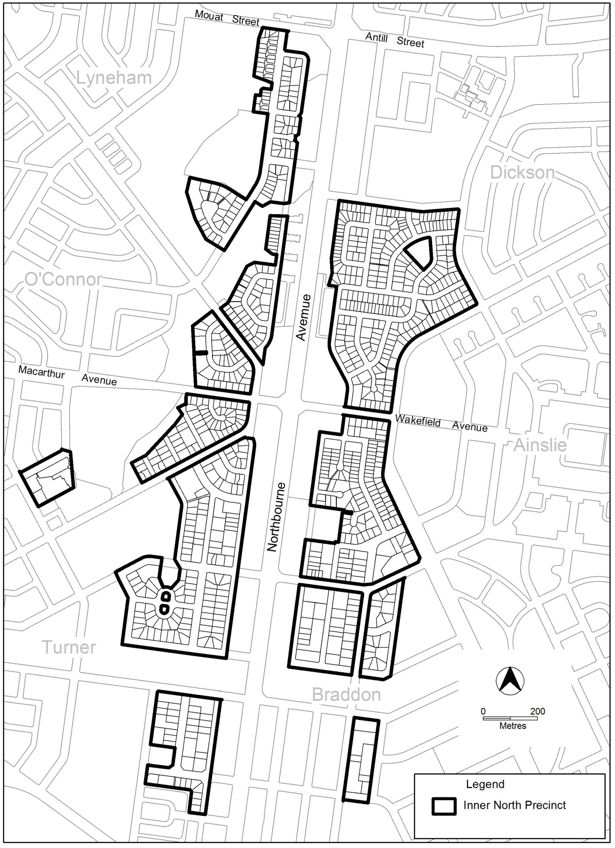

Figure A Area subject to Inner North Precinct Code

Part B – Control Plans

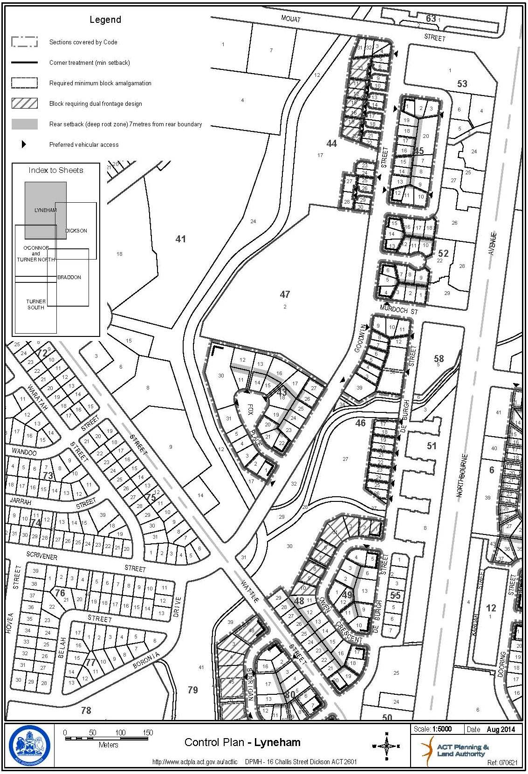

Statement of compliance with the Planning and Development Act 2007

Section | Statement
s87(a)  would not adversely affect anyone’s rights if approved; and  has as its only object the correction of a formal error in the plan.  s87(b) a variation (a code variation) that –  - would only change a code  - is consistent with the policy purpose and policy framework of the code; and  - is not an error variation. | The changes in numbering are a correction of a formal error in the plan.  Compliant. The Inner north precinct code is updated to reflect the consolidation of blocks in Section 49 Lyneham.

  - Northbourne Avenue precinct code

The Northbourne Avenue precinct code Rule R18 contains outdated references to the Residential Zones Multi Unit Housing Development Code. This technical amendment seeks to amend the wording to bring in line with the most recent wording. Redevelopment of land in Section 55 Lyneham is incorporated into this requirement.

Existing provision

1.1 Residential Use
Rules | Criteria
R18  All multi unit housing is designed to comply with Part C(5) of the Residential Zones Multi Unit Housing Development Code except for Lyneham Section 55 where Part C(3) applies. | This is a mandatory requirement. There is no applicable criterion.

Proposed provision

1.1 Residential Use
Rules | Criteria
R18  All multi unit housing is designed to comply with the Residential Zones - Multi Unit Housing Development Code. | This is a mandatory requirement. There is no applicable criterion.

Statement of compliance with the Planning and Development Act 2007

Section | Statement
s87(b) a variation (a code variation) that –  - would only change a code  - is consistent with the policy purpose and policy framework of the code; and  - is not an error variation. | Compliant. The rule is updated to reflect the current and correct wording of the applicable code and redevelopment of land in Section 55 Lyneham is incorporated into this requirement.

  - Definitions

Some confusion has arisen among proponents regarding the definition of subdivision that is applied in Territory Plan development related matters in terms of the relevant section of the Planning and Development Act 2007 (the Act). The Act refers to different types of subdivision at Section 7 and Section 234 of the Act. However, the definition of ‘development’ is contained in Section 7 of the Act, and subdivision is defined at Section 7(2). This is the correct definition of subdivision to be applied and the definition of subdivision in the Territory Plan is clarified to avoid further misinterpretation.

Existing definition

‘Subdivision has the same meaning as in the Planning and Development Act 2007.’

Proposed definition

‘Subdivision has the same meaning as in Section 7 of the Planning and Development Act 2007.’

Statement of compliance with the Planning and Development Act 2007

Section | Statement
s87(h) a variation to clarify the language in the territory plan if it does not change the substance of the plan. | Compliant. This amendment removes any uncertainty regarding which part of the Planning and Development Act 2007 applies to the definition of subdivision.

- TECHNICAL AMENDMENT
This section of the technical amendment document provides the actual instructions for implementing the changes to the Territory Plan.

  - Single dwelling housing development code

- Table 6A: Side and rear setbacks – mid sized blocks in subdivisions approved before 2 October 2009 (refer appendix 1 diagrams 4, 5 and 6)

Delete

Note: Minimum side boundary setbacks requirements apply to buildings and Class 10 structures, except for side boundary 2 on blocks >800m², where the minimum side boundary setback for Class 10 structures is 1.5m.

- Element 1: Building and site controls; Item 1.7 Building envelope – mid sized blocks approved before 5 July 2013, Rule R8

Substitute

1.7 Building envelope – mid sized blocks approved before 5 July 2013
R8  This rule applies to mid sized blocks with one of the following characteristics:  - approved under an estate development plan before 5 July 2013  - for which a lease was granted before 5 July 2013  but does not apply to that part of the building on a single dwelling block that is required by a precinct code to be built to a boundary of the block.  Buildings are sited wholly within the building envelope formed by projecting planes over the subject block comprising:  - within the primary building zone -  - lines projected at 45º to the horizontal from an infinite number of points on a line of infinite length 4.5m above each side boundary, except for north facing boundaries of adjoining residential blocks  - from north facing boundaries of adjoining residential blocks, lines projected at 45º to the horizontal from an infinite number of points on a line of infinite length 2m above these boundaries.  - despite item ii), where a wall is located on a north facing boundary of an adjoining residential block, lines projected at 30º to the horizontal from an infinite number of points on a line of infinite length 3m above these boundaries.  - within the rear zone -  - lines projected at 30º to the horizontal from an infinite number of points on a line of infinite length 3.5m above each side and rear boundary, except for north facing boundaries of adjoining residential blocks  - from north facing boundaries of adjoining residential blocks, lines projected at 30º to the horizontal from an infinite number of points on a line of infinite length 2m above these boundaries.  Refer Figure 2.  Note: North facing boundary means a boundary of a block where a line drawn perpendicular to the boundary outwards is orientated between north 20 degrees west and north 30 degrees east. | C8  Buildings achieve all of the following:  - consistency with the desired character  - reasonable levels of privacy for dwellings and their associated private open space on adjoining residential blocks  - reasonable solar access to dwellings and their associated private open space on adjoining residential blocks.

  - Multi unit housing development code

- Part A – General controls; Element 3: Building and site controls; Item 3.5 Plot ratio – other than single dwelling blocks – RZ1, RZ2, RZ3 and RZ4

Substitute the first sentence in rule R9 with:

This rule applies to blocks other than single dwelling blocks in RZ1, RZ2, RZ3 and RZ4.

- Part A – General controls; Element 3: Building and site controls; Item 3.10 Residential density – adaptable housing –single dwelling blocks – RZ2; Rule R14

Substitute

3.10 Residential density – adaptable housing – single dwelling blocks – RZ2
Rules | Criteria
R14  This rule applies to single dwelling blocks in RZ2 where all dwellings comply with Australian Standard AS4299 Adaptable Housing (Class C).  Despite R2 and R12, the maximum number of dwellings is shown in table A3. | This is a mandatory requirement. There is no applicable criterion.

  - Industrial zones development code

- Relevant codes; 3rd sentence on page

Substitute

The following general codes, in particular, may be relevant to development in industrial zones.

  - Aranda precinct map and code

- Aranda Precinct Map

Substitute

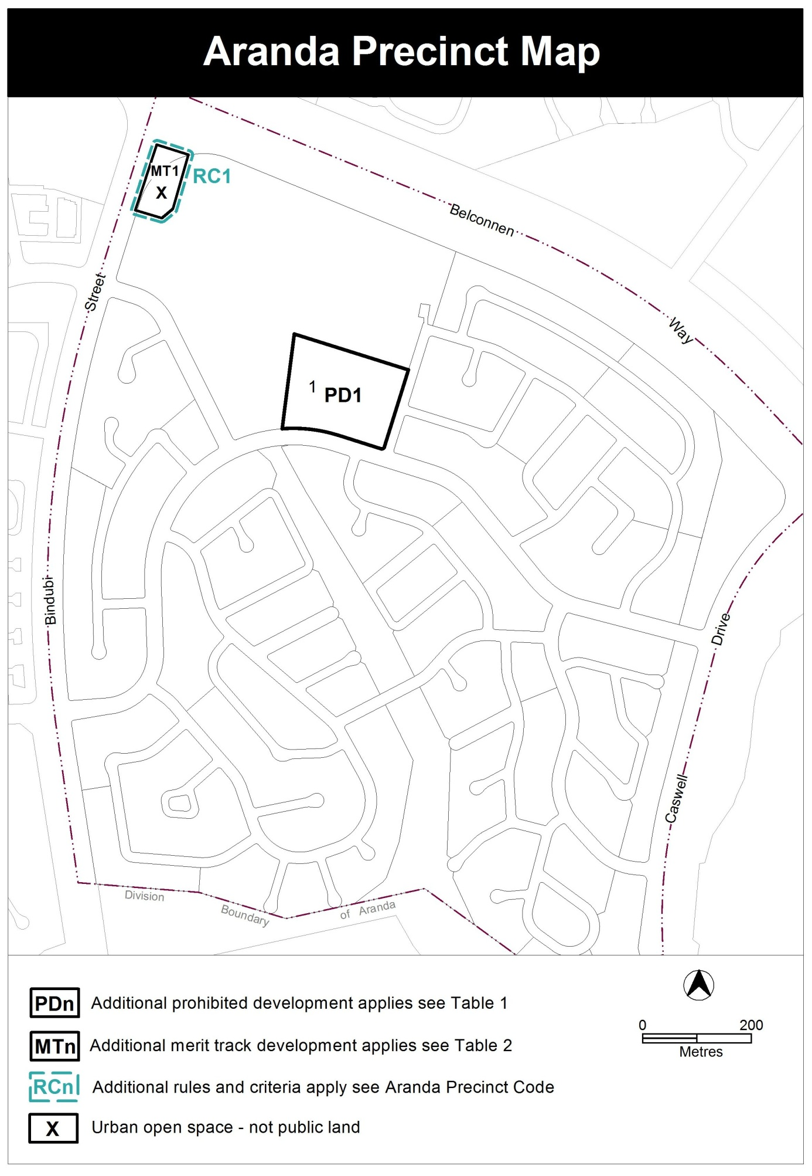

  - City precinct map and code

- RC1 – City Centre (part); Element 8: City area 5; Item 8.1 East of Northbourne Avenue and London Circuit; Criterion C25

Substitute

Rules | Criteria
8.1 East of Northbourne Avenue and London Circuit
There is no applicable rule. | C25  Building height is no higher than the heights of existing approved buildings except that:  - Minor variations of building heights may be permitted in special circumstances such as to allow for special architectural features to enhance building facades.  - One or more taller building per section up to RL617m (approximately 12 storeys) may be considered where forming part of a comprehensive design for the whole section identified in a Planning Report under section 97 of the Planning and Development Act 2007.

- RC1 – City Centre (part); Element 9: City area 6; Item 9.1 East of Northbourne Avenue and London Circuit; Criterion C27

Substitute

Rules | Criteria
9.1 East of Northbourne Avenue and London Circuit
R27  - The height of a building to its main parapet line (i.e. the top part of the building at its block frontage) does not exceed the relevant maximum building height shown on figure 4.  - No part of any building at the ground surface at the centre of its block frontage is more than:  - 28 metres and up to 8 storeys including roof top plant, or  - 23 metres for City section 15 blocks 1, 2, 5 and 12. | C27  - Minor variations of building heights and setbacks may be permitted in special circumstances such as to allow for special architectural features to enhance building facades.  - One or more taller buildings per section up to RL617m (approximately 12 storeys) may be considered where forming part of a comprehensive design for the whole section identified in a Planning Report under section 97 of the Planning and Development Act 2007.  - Rebuilding up to the existing approved height limit is permitted.

- RC1 – City Centre (part); Element 10: City area 7; Item 10.2 East of Genge Street and Bunda Street; Criterion C31

Substitute

Rules | Criteria
10.2 East of Genge Street and Bunda Street
R31  Buildings are no higher than the heights of existing approved buildings. | C31  One or more buildings per section up to RL617m (approximately 12 storeys) may be considered where forming part of a comprehensive design for the whole section identified in a Planning Report under section 97 of the Planning and Development Act 2007.

  - Greenway precinct map and code

- RC1 – Murrumbidgee River corridor; Element 1: Use; Item 1.1 Campsite and tourist facility; Criterion C1

Substitute

1.1 Campsite and tourist facility
Rules | Criteria
There is no applicable rule. | C1  Development achieves all of the following:  is of low intensity on large blocks permitting point source retention of stormwater runoff and opportunities for large scale landscaping  - stormwater runoff meets all the following requirements before entering the Murrumbidgee River:  - is intercepted by a pond or equivalent designed in accordance with the requirements for ponds or equivalent in the Water Sensitive Urban Design General Code  - meets the stormwater quality requirements of the commercial zones development code.  Note: This provision is in addition to the WSUD requirements of other applicable codes.

- RC2 – Leisure and accommodation area; Element 3: Environment; Item 3.1 Protection of water quality; Criterion C4

Substitute

3.1 Protection of water quality
Rules | Criteria
There is no applicable rule. | C4  Development achieves one of the following:  - stormwater runoff meets all the following requirements before entering the Murrumbidgee River:  - is intercepted by a pond or equivalent, designed in accordance with the requirements for ponds or equivalent in the Water Sensitive Urban Design General Code  - meets the stormwater quality requirements of the commercial zones development code.  - diversion of stormwater runoff to Lake Tuggeranong.  Note: Diversion of stormwater runoff to Lake Tuggeranong may be achieved using existing stormwater infrastructure or pump option.  Note: Compliance with this criterion is demonstrated by a water sensitive urban design outcomes plan endorsed by a suitably qualified person.  Note: This provision is in addition to the WSUD requirements of other applicable codes.

  - Kingston precinct map and code

- RC4 – Kingston Foreshore; Element 8: Buildings; Item 8.3 Kerridge Street; Rules R41 and R42

Substitute

7.3 Residential use and office
Rules | Criteria
There is no applicable rule. | C36  This rule applies to the area c shown in figure 4.  Buildings at the ground floor level achieve all of the following:  - avoid office and RESIDENTIAL USE in areas fronting main pedestrian areas and routes  - adaptable for commercial use
R37  This rule applies to the areas b, c and e shown in figure 4.  The maximum gross floor area of office complies with all of the following  - 500m² per tenancy  - 2000m² per lease | This is a mandatory requirement. There is no applicable criterion.
R38  This rule applies to the area d shown in figure 4.  The maximum gross floor area of office per  lease is 2000m² | This is a mandatory requirement. There is no applicable criterion.

8.3 Kerridge Street
Rules | Criteria
R41  This rule applies to each area A shown in figure 5.  The maximum number of storeys is 6.  The maximum height of building is the lesser of RL578 and 20m.  The maximum floor area for storey 5 is 300m².  The maximum floor area for storey 6 is 300m².  The maximum external horizontal dimension for any part of the building over 4 storeys is 20m.  The minimum front boundary setback for that part of the building with more than 4 storeys is 2m.  Rule 18 does not apply. | This is a mandatory requirement. There is no applicable criterion.
R42  This rule applies to each area B shown in figure 5.  The maximum number of storeys is 4.  The maximum external horizontal depth is 18m (including enclosed building area and articulation elements but excluding awnings over footpaths and basements). | C42  4 storey building elements achieve all of the following:  - alignment to the block perimeter  - high levels of natural daylight, ventilation and solar access to dwellings  - central courtyards sized to meet the reasonable needs of residents.
8.4 Trevillian Quay
R43  This rule applies to each area A shown in figure 6.  The maximum dimensions for each area A are 20m x 15m.  The maximum number of storeys is 6.  The maximum height of building is the lesser of RL578 and 20m  The minimum setback from Trevillian Quay and Headland Park for that part of the building with more than 4 storeys is 2m.  Rule 18 does not apply. | This is a mandatory requirement. There is no applicable criterion.
R44  This rule applies to each area B shown in figure 6.  The maximum number of storeys is 4. | This is a mandatory requirement. There is no applicable criterion.

9.2 Kerridge Street – deep soil landscape zones
Rules | Criteria
R47  This rule applies to the hatched areas identified as deep soil landscape zones in figure 5.  The location of deep soil landscape zones are indicatively shown in figure 5.  Deep soil landscape zones represent a minimum of 10% of the total site area. | C47  Provision is made for sufficient soil to allow planting and growth of healthy canopy trees in the central courtyards.
9.3 Trevillian Quay – shared zone
R48  Ground level shared zone access easements are provided in accordance with figure 6. | C48  Shared zones achieve all of the following:  - safe and convenient public pedestrian access to buildings on the site and the foreshore  - reasonable vehicular access to the foreshore.
9.4 Trevillian Quay – pedestrian areas
R49  Ground level pedestrian access easements are provided in accordance with figure 6. | C49  Pedestrian access easements achieve all of the following:  - safe and convenient public pedestrian access to buildings on the site and the foreshore  - provision for small scale ancillary buildings and structures associated with harbour operations.

  - Inner north precinct code

- Introduction; Application of this code; Figure A: Area subject to Inner North Precinct Code

Substitute

Figure A Area subject to Inner North Precinct Code

- Part B – Control Plans

Substitute

- Part C(3) – Lyneham; Element 2: Building and Site Controls; Item 2.1

Substitute

2.1 Setbacks in Lyneham Section 49
Rules | Criteria
R31  The minimum front building setback for development on blocks in Lyneham Section 49 adjoining De Burgh Street is 5 metres. | This is a mandatory requirement. There is no applicable criterion.

- Part C(3) – Lyneham

Renumber items and rules from 2.1 Setbacks in Lyneham Section 49 Rule 31 to end of precinct code

  - Northbourne Avenue precinct code

- Part B – General Development Controls; Element 1: Restrictions on Use; Item 1.1 Residential use, Rule R18

Substitute

1.1 Residential Use
Rules | Criteria
R18  All multi unit housing is designed to comply with the Residential Zones - Multi Unit Housing Development Code. | This is a mandatory requirement. There is no applicable criterion.

  - Definitions

- Part A – Definitions of Development

Substitute

Subdivision has the same meaning as in Section 7 of the Planning and Development Act 2007.

Interpretation service
