Australian Capital Territory

Planning and Development (Technical Amendment—Coombs) Plan Variation 2014 (No. 2)

Notifiable Instrument NI2014—662
Technical Amendment No 2014—17
made under the
Planning and Development Act 2007, section 89 (Making technical amendments) s96 (land ceases to be in future urban area)

This plan variation commences on the day after it is notified.

Variation No 2014—17 to the Territory Plan has been approved by the Planning and Land Authority.

Variation to the Territory Plan
The Territory Plan map is proposed to be varied as indicated in pages one and two of Annexure A to identify the zones that apply to the land ceasing to be in a future urban area.

Variation to the Precinct Map and Code
Pages one to two of Annexure B indicate the changes to the Coombs Precinct Map and Code incorporating the ongoing block specific provisions for the area:

The following amendments to the Coombs Precinct Map and Code:
- Replace Coombs Precinct Map;
- Replace Figure 4 Coombs residential area 3.

Jim Corrigan
Delegate of the Planning and Land Authority
Date 16.12.14

THIS IS PAGE ONE OF ANNEXURE A
TO NOTIFIABLE INSTRUMENT NI2014–662

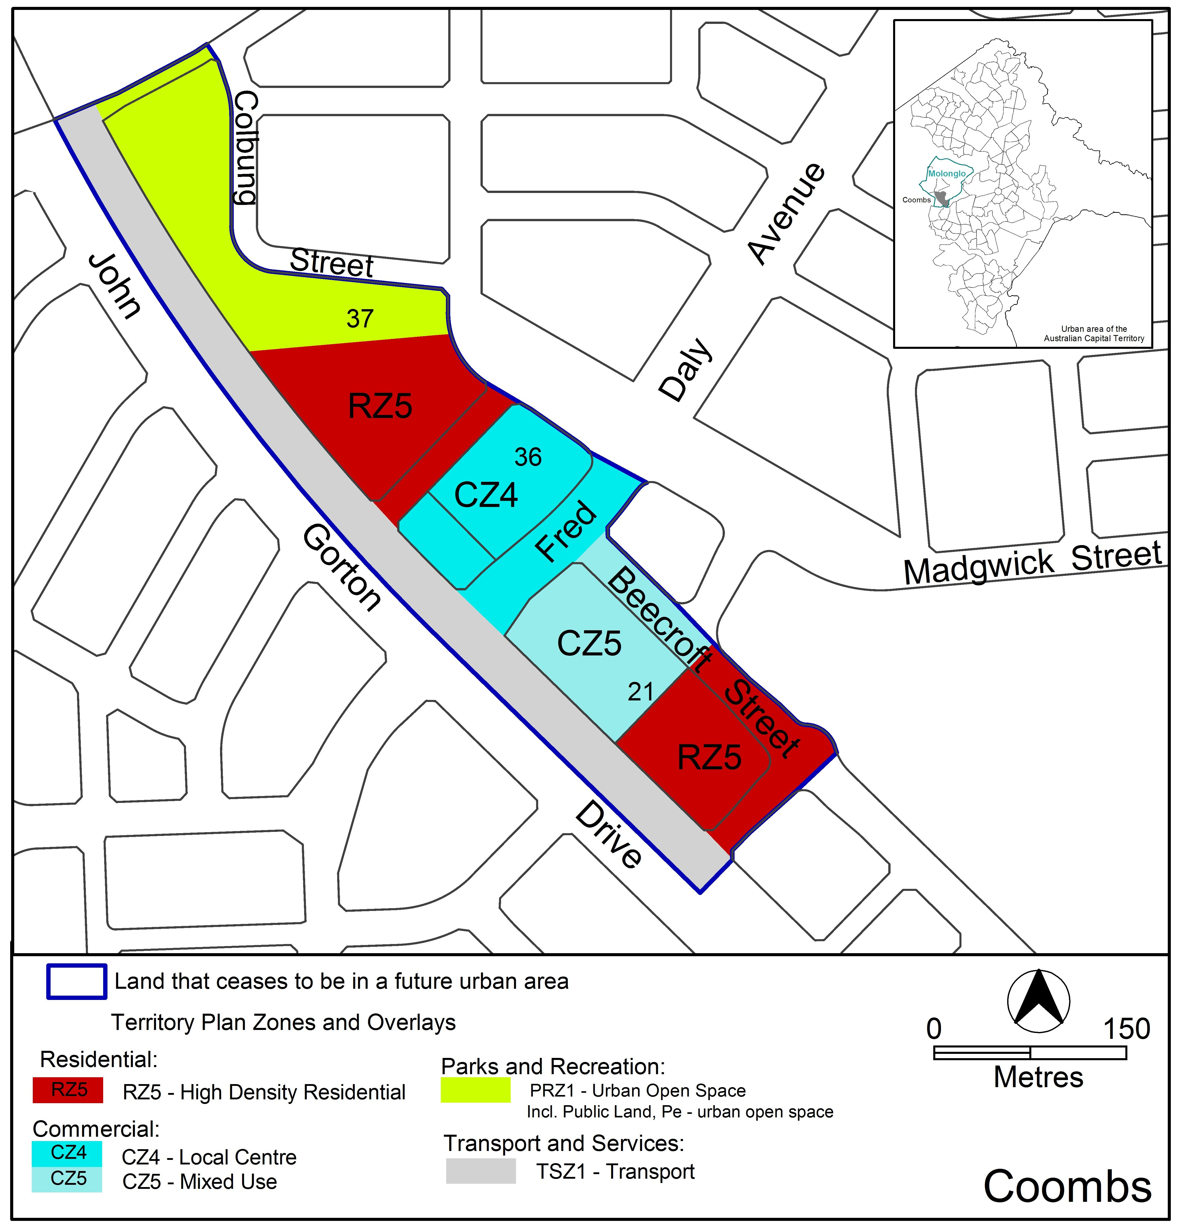

Jim Corrigan
Delegate of the Planning and Land Authority
Date 16.12.14

THIS IS PAGE TWO OF ANNEXURE A
TO NOTIFIABLE INSTRUMENT NI2014–662

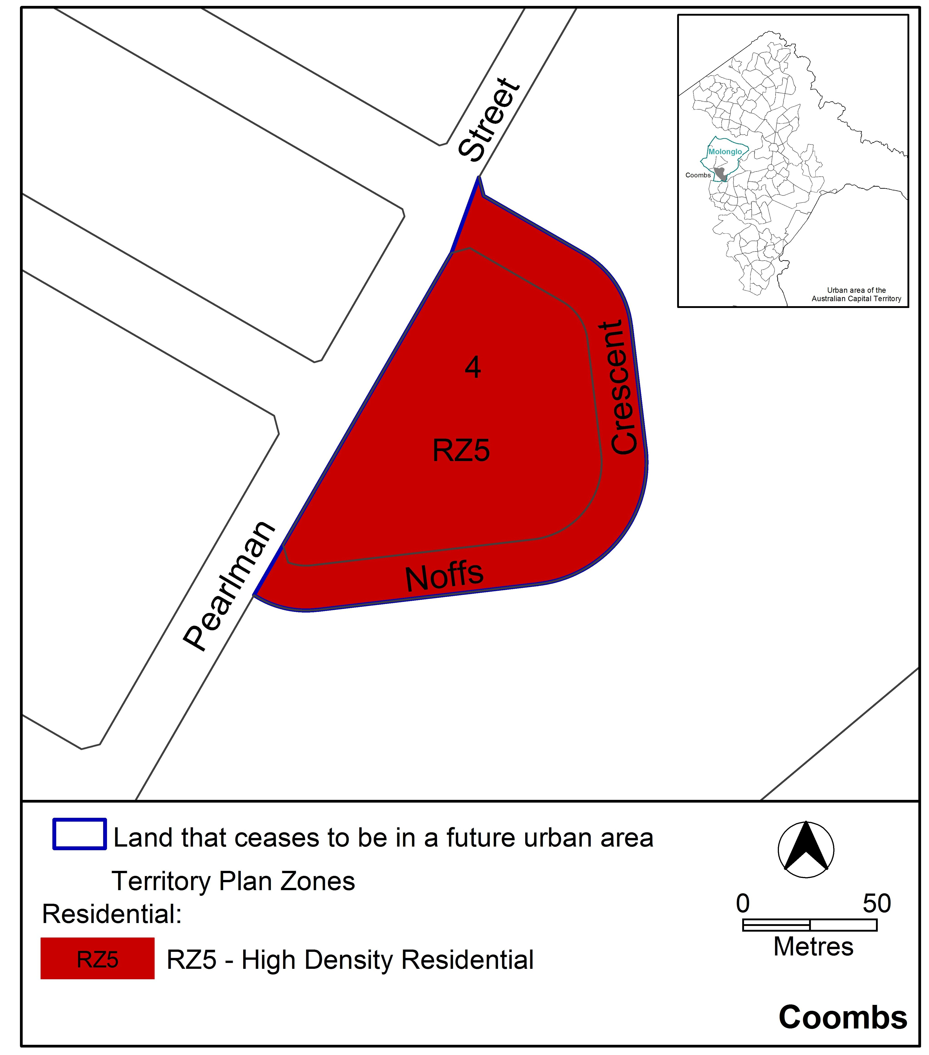

Jim Corrigan
Delegate of the Planning and Land Authority
Date 16.12.14
THIS IS PAGE ONE OF ANNEXURE B
TO NOTIFIABLE INSTRUMENT NI2014–662

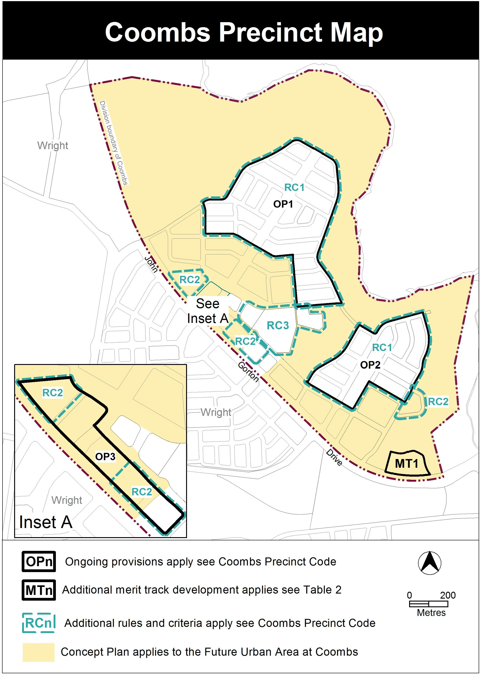

Jim Corrigan
Delegate of the Planning and Land Authority
Date 16.12.14
THIS IS PAGE TWO OF ANNEXURE B
TO NOTIFIABLE INSTRUMENT NI2014–662

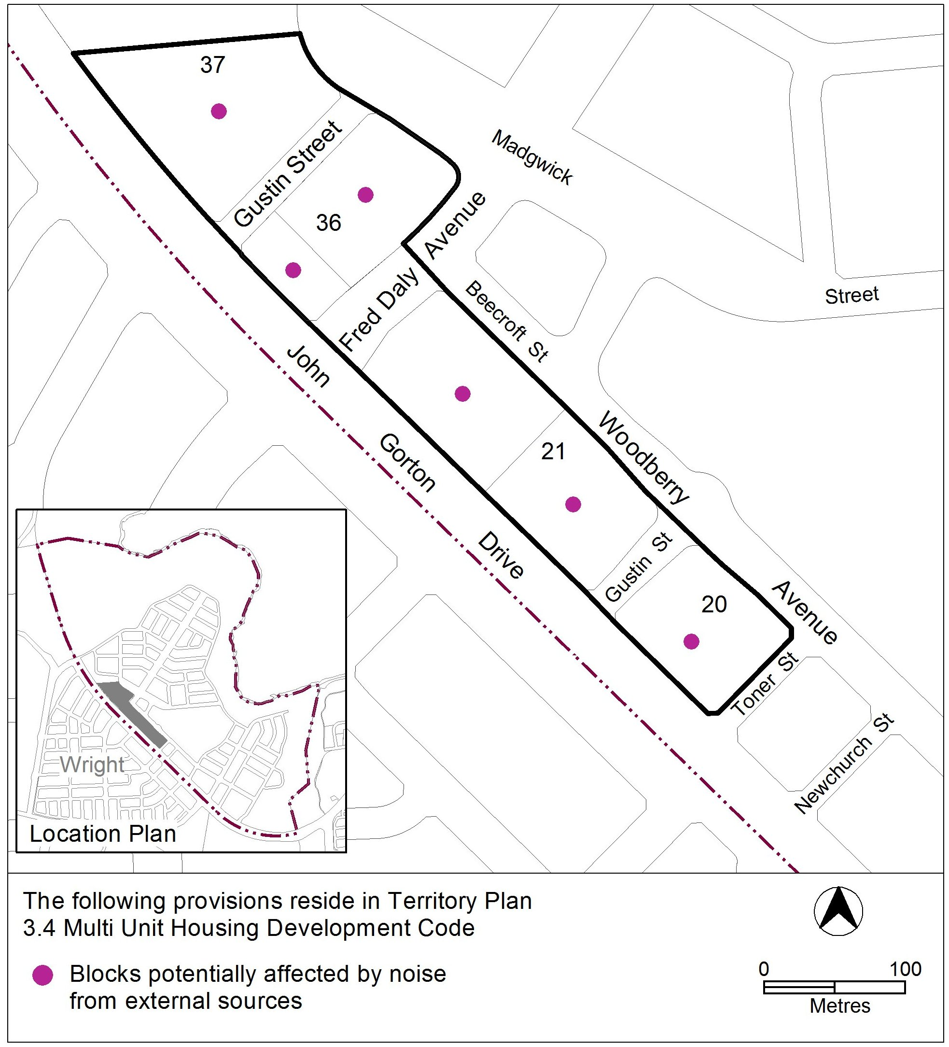

Jim Corrigan
Delegate of the Planning and Land Authority
Date 16.12.14

