Australian Capital Territory

Planning and Development (Technical Amendment—Miscellaneous Amendment) Plan Variation 2014 (No 1)

Notifiable Instrument NI2014—90

Technical Amendment No 2014—01
made under the
Planning and Development Act 2007, section 89 (Making technical amendments)

This technical amendment commences on 21 March 2014.

Variation No 2014—01 to the Territory Plan has been approved by the planning and land authority.

Jim Corrigan
Delegate of the Planning and Land Authority
18 March 2014

Planning & Development Act 2007

Technical Amendment
to the Territory Plan
Variation 2014-01

Miscellaneous general technical amendment

March 2014

This page is left intentionally blank
Table of Contents

1. INTRODUCTION 1
Purpose 1
Public consultation 3
Process 3
ACT Planning Strategy 3
Compliance with the Act 3
2. EXPLANATION 4
2.1 Residential zones development tables 4
2.2 Residential zones development code 4
2.3 Multi unit housing development code 4
2.4 Various zone development tables 5
2.5 Coombs precinct map and code 6
2.6 Griffith precinct map and code 6
2.7 Gungahlin precinct map and code 6
2.8 Macgregor precinct map and code 7
2.9 Molonglo Valley district precinct map 7
2.10 Coombs and Wright Concept Plan 7
3. TECHNICAL AMENDMENT 8
3.1 Residential zones development tables 8
3.2 Residential zones development code 9
3.3 Multi unit housing development code 9
3.4 Various zone development tables 11
3.5 Coombs precinct map and code 14
3.6 Griffith precinct map and code 14
3.7 Gungahlin precinct map and code 14
3.8 Macgregor precinct map and code 15
3.9 Molonglo Valley district precinct map 16
3.10 Coombs and Wright concept plan 18

This page is left intentionally blank

- INTRODUCTION

Purpose
This technical amendment makes the following changes to the Territory Plan:

Residential zones development tables
- Re-insert ‘minor road’ into all residential zones development tables as merit track assessable development

Residential zones development code
- Rectify omissions and incorrect references in text in Introduction

Multi unit housing development code
- Remove item 3.26, rule R35 and criterion C35– duplication of rule R32 and C32
- Rectify omission in text of rule R41
- Rectify incorrect reference for a general code in criterion C41
- Rectify minor omission in text of rule R42 e)
- Reword to use correct terminology in item 5.6
- Correct typographical error in Rule R54
- Rectify omission in text of rule R58
- Rectify typographical error in rule R63
- Rectify typographical error in R64 b)
- Rectify typographical error in C69 b) iii)
- Rectify incorrect reference in criterion C72
- Rectify omission in text of rule R78

Various zones development tables
- Remove redundant terms ‘relocatable unit’ and ‘habitable suite’ and add ‘secondary residence’ in zones development tables where rectification required.

Coombs precinct map and code
- Rectify omissions in Coombs precinct map

Griffith precinct map and code
- Clarification of wording in criteria C14 to apply to area b in Figure 3

Gungahlin precinct map and code
- Correction of error in Gungahlin town centre – Rule R66

Macgregor precinct map and code
- Correction to Figure 4 Macgregor West residential area 4

Molonglo Valley district precinct map
- Remove inadvertent inclusions on Molonglo Valley precinct map

Coombs and Wright concept plan
- Rectify inadvertent omissions in technical amendment TA2013-16

Public consultation
Under section 88 of the Planning and Development Act 2007 (the Act) this type of technical amendment is not subject to public consultation.

Process
This technical amendment has been prepared in accordance with section 87 of the Planning and Development Act 2007 (the Act). The planning and land authority must notify the public of the commencement of this technical amendment.

ACT Planning Strategy
This technical amendment is not inconsistent with the ACT Planning Strategy.

Compliance with the Act
This technical amendment is compliant with:
Section 87(a) of the Planning and Development Act 2007 in that:
i) would not adversely affect anyone’s rights if approved; and
ii) has as its only object the correction of a formal error in the plan.

- EXPLANATION
  - Residential zones development tables

Variation 306 modified and replaced the residential zones development codes and tables as part of the overhaul of the residential zones development policies. However, the amendments to incorporate ‘minor road’ into the residential zones development tables as part of TA2012-30 in December 2012 were inadvertently removed when the tables were replaced in the Territory Plan with the commencement of V306. These uses are re-inserted into the residential zones development tables in the merit track to rectify the omission in this TA.

Section | Statement
s87(a).  - would not adversely affect anyone’s rights if approved; and  - has as its only object the correction of a formal error in the plan | Compliant. Correction of a formal error in the residential zones development tables

  - Residential zones development code

The wording for Part D and Part E in the Introduction of the Residential zones development code has been amended to be consistent with the headings relating to these specific parts in the table of contents and code. The amended wording (underlined) is as follows: “Part D Subdivision and Consolidation” and “Part E Non-residential uses”.

Section | Statement
s87(a).  - would not adversely affect anyone’s rights if approved; and  - has as its only object the correction of a formal error in the plan | Compliant. Correction of a formal error in the residential zones development code

  - Multi unit housing development code
- Item 3.26, Rule R35 and criterion C35 have been removed as they are a duplication of rule R32 and criterion C32.
- The underlined words have been inserted into rule R41 to rectify an inadvertent omission: “Fences are permitted forward of the building line in the front zone or on the front boundary only where they comply with any of the following...”
- Criterion C41 has been amended to correctly refer to the Residential Boundary Fences General Code.
- Rule R42 e) has been amended to add the word “of” after 25%. so that the rule reads as follows: “e) constructed of brick, block or stonework, any of which may be combined with timber or metal panels that include openings not less than 25% of the surface area of the panel”
- Item 5.6 has been corrected to refer to: “...use by people with a disability”.
- The duplication of the words “to meet” has been rectified in Rule R54.
- Rule R58 has been amended to add the word “to” before apartments, so that the first sentence of the rule reads as follows: “This rule applies to apartments.”
- The typographical error in rule R63 has been corrected. “blocknot” has been changed to “block not”.
- The typographical error in rule R64 has been corrected. The word “position” has been changed to “positioned” so that the last sentence of the rule reads as follows: “For this rule obscure glass prevents printed text of 10mm high characters from being read through the glass when positioned 1m from the glass.”
- The typographical error criterion C69 b) iii) has been corrected. The word “tress” has been replaced with “trees”.
- Criterion C72 refers to “Department of Territory and Municipal Services”. This has been corrected to refer to “Territory and Municipal Services Directorate”.
- The omission of the word “of” after “distance” in the last sentence has been added to rule R78. The last sentence of the amended rule reads as follows: “Parking spaces are located within 50m walking distance of any dwelling that is sharing the space.”

Section | Statement
s87(a).  - would not adversely affect anyone’s rights if approved; and  - has as its only object the correction of a formal error in the plan | Compliant. Correction of formal errors in the multi unit housing development code

  - Various zone development tables
Variation 306 introduced the use of ‘secondary residence’ into the Territory Plan which in part replaced the uses of ‘habitable suite’ and ‘relocatable unit’. These uses were listed as merit track assessable in the residential zones but were prohibited in other zones. V306 removed ‘habitable suite’ and ‘relocatable unit’ from the definitions and residential zones development tables and added ‘secondary residence’. However these uses were inadvertently left in some of the zones development tables as part of V306, and not replaced with secondary residence. This TA rectifies this issue.

Section | Statement
s87(a).  - would not adversely affect anyone’s rights if approved; and  - has as its only object the correction of a formal error in the plan | Compliant. Correction of formal errors in various zone development tables

  - Coombs precinct map and code
The Coombs precinct map within the Coombs precinct map and code has been adjusted to include the MT1 area showing ‘Additional merit track development’ for a ‘municipal depot’. This was inadvertently included in the Molonglo Valley district precinct map. However the correct location for this information is in the specific division precinct map and code, in this case the precinct map for Coombs.

Section | Statement
s87(a).  - would not adversely affect anyone’s rights if approved; and  - has as its only object the correction of a formal error in the plan | Compliant. Correction of a formal error in the Coombs precinct map

  - Griffith precinct map and code
Criterion C14 in the Griffith precinct map and code refers to requirements for plot ratios, however it does not refer to which parts of the precinct these provisions apply. This omission has been corrected and the criterion now clarifies that these requirements apply to area b shown in Figure 3 of the code.

Section | Statement
s87(a).  - would not adversely affect anyone’s rights if approved; and  - has as its only object the correction of a formal error in the plan | Compliant. C14 is amended to ensure the correct reference to area b in Figure 3 is applied to the provision.

  - Gungahlin precinct map and code
Rule R66 has been amended to rectify an inadvertent error in the wording of the rule. In the first sentence, “on” is replaced with “above” to provide the correct context for the requirements of the rule. The amended wording (underlined) of the rule reads as follows: “One or more of the following uses are not permitted above the ground floor:”

Section | Statement
s87(a).  - would not adversely affect anyone’s rights if approved; and  - has as its only object the correction of a formal error in the plan | Compliant. Correction of a formal typographical error in the Gungahlin precinct map and code

  - Macgregor precinct map and code
Section 169 in Figure 4 (Macgregor West residential area 4) has been incorrectly identified as section 189. This has been corrected in this TA.

Section | Statement
s87(a).  - would not adversely affect anyone’s rights if approved; and  - has as its only object the correction of a formal error in the plan | Compliant. Correction of a formal typographical error in the Macgregor precinct map and code

  - Molonglo Valley district precinct map
The Molonglo Valley district precinct map has been adjusted to remove the legend and hatching/shading referring to additional merit track development and the area subject to the Concept Plan as this information has been relocated to the Coombs precinct map diagram, which is the appropriate location for this to be shown.

Section | Statement
s87(a).  - would not adversely affect anyone’s rights if approved; and  - has as its only object the correction of a formal error in the plan | Compliant.

  - Coombs and Wright Concept Plan
The description and reasons for changes to Criterion C4 a) and Rule R56 were provided in part 2 ‘Explanation’ of technical amendment TA2013-16 which commenced on 17 January 2014. However these changes were inadvertently omitted from part 3 ‘Technical Amendment’ which makes the actual changes to the concept plan. This has been rectified in this technical amendment.

Section | Statement
s87(a).  - would not adversely affect anyone’s rights if approved; and  - has as its only object the correction of a formal error in the plan | Compliant.

- TECHNICAL AMENDMENT

  - Residential zones development tables
- RZ1 – Suburban zone development table; MINIMUM ASSESSMENT TRACK MERIT

Insert
minor road

- RZ2 – Suburban core zone development table; MINIMUM ASSESSMENT TRACK MERIT

Insert
minor road

- RZ3 – Urban residential zone development table; MINIMUM ASSESSMENT TRACK MERIT

Insert
minor road

- RZ4 – Medium density residential zone development table; MINIMUM ASSESSMENT TRACK MERIT

Insert
minor road

- RZ5 – High density residential zone development table; MINIMUM ASSESSMENT TRACK MERIT

Insert
minor road

  - Residential zones development code
- Introduction – Structure – Part D and Part E

Substitute

Part D – Subdivision and Consolidation contains provisions relating to residential subdivision and consolidation that are not covered by the Estate Development Code.

Part E – Non-residential uses provides controls that are applicable to forms of non-residential development located in a residential zone, but only where such uses are authorised by the P&D Act or a lease.

  - Multi unit housing development code
- Part A – General controls; Element 3: Building and site controls

Remove

Item 3.26 Allowable setback encroachments

Rule R35

Criterion C35

- Part A – General controls; Element 4: Site design, item 4.5 Fences; rule R41

Replace the first sentence with:

Fences are permitted forward of the building line in the front zone or on the front boundary only where they comply with any of the following:

- Part A – General controls; Element 4: Site design, item 4.5 Fences; criterion C41

Substitute

Fences may be permitted where the proposal meets the requirements contained in the Residential Boundary Fences General Code.

- Part A – General controls; Element 4: Site design, item 4.6 Courtyard walls ; rule R42 e)

Insert the word “of” after “...not less than 25%”

- Part A – General controls; Element 5: Building design, item 5.6

Substitute

5.6 Adaptability of dwelling for use by people with a disability

- Part A – General controls; Element 5: Building design, item 5.6, rule R54

Remove

Duplicate wording “to meet” in second sentence.

- Part A – General controls; Element 6: Amenity, item 6.2 Solar access – apartments, rule R58

Replace the first sentence with:

This rule applies to apartments.

- Part A – General controls; Element 6: Amenity, item 6.5 Separation between external walls, rule R63

Substitute

The separation between external walls at the lower floor level on the same block or an adjoining block is not less than 1m.

- Part A – General controls; Element 6: Amenity, item 6.6 Balustrades, rule R64

Replace the word “position” with “positioned” in the last sentence of the rule.

- Part A – General controls; Element 7: Parking and vehicular access, item 7.2 Driveway verge crossings, criterion C69 b) iii)

Replace the word “tress” with “trees”.

- Part A – General controls; Element 7: Parking and vehicular access, item 7.2 Driveway verge crossings, criterion C72

Substitute

Driveway verge crossings are endorsed by the Territory and Municipal Services Directorate.

- Part A – General controls; Element 7: Parking and vehicular access, item 7.4 Residents’ car parking, rule R78

Insert the word “of” after the word “distance” in the last sentence of the rule.

  - Various zone development tables
- CZ5 – Mixed Use Zone Development Table; MINIMUM ASSESSMENT TRACK MERIT

Delete
relocatable unit

- IZ1 – General Industrial Zone Development Table; PROHIBITED DEVELOPMENT

Delete
habitable suite
relocatable unit

Insert
secondary residence

- IZ2 – Industrial Mixed Use Zone Development Table; PROHIBITED DEVELOPMENT

Delete
habitable suite
relocatable unit

Insert
secondary residence

- CFZ – Community Facility Zone Development Table; PROHIBITED DEVELOPMENT

Delete
habitable suite
relocatable unit

Insert
secondary residence

- PRZ1 – Urban Open Space Zone Development Table; PROHIBITED DEVELOPMENT

Delete
relocatable unit

- PRZ2 – Restricted Access Recreation Zone; PROHIBITED DEVELOPMENT

Delete
relocatable unit

- TSZ1 – Transport Zone Development Table; PROHIBITED DEVELOPMENT

Delete
relocatable unit

- TSZ2 – Services Zone Development Table; PROHIBITED DEVELOPMENT

Delete
relocatable unit

- NUZ1 – Broadacre Zone Development Table; PROHIBITED DEVELOPMENT

Delete
habitable suite
relocatable unit

Insert
secondary residence

- NUZ2 – Rural Zone Development Table; PROHIBITED DEVELOPMENT

Delete
relocatable unit

- NUZ3 – Hills, Ridges and Buffer Zone Development Table; PROHIBITED DEVELOPMENT

Delete
relocatable unit

- NUZ4 – River Corridor Zone Development Table; PROHIBITED DEVELOPMENT

Delete
relocatable unit

- NUZ5 – Mountains and Bushland Zone Development Table; PROHIBITED DEVELOPMENT

Delete
relocatable unit

  - Coombs precinct map and code
Substitute Coombs precinct map and code for Coombs precinct map and code at Annexure A.

  - Griffith precinct map and code
- RC3 – Manuka Group Centre – Part (Griffith); Element 5: Buildings; 5.1 Plot ratio; C14

Insert directly above the first sentence:

This applies to area b shown in Figure 3.

  - Gungahlin precinct map and code
- RC2 – Mixed use commercial development area; Element 2: Use; item 2.1 Ground floor use; Rule R66

Replace the word “on” with the word “above” in the first sentence of the rule.

  - Macgregor precinct map and code
- OP4 – Macgregor West residential area 4 – Figure 4 Macgregor West residential area 4

Substitute
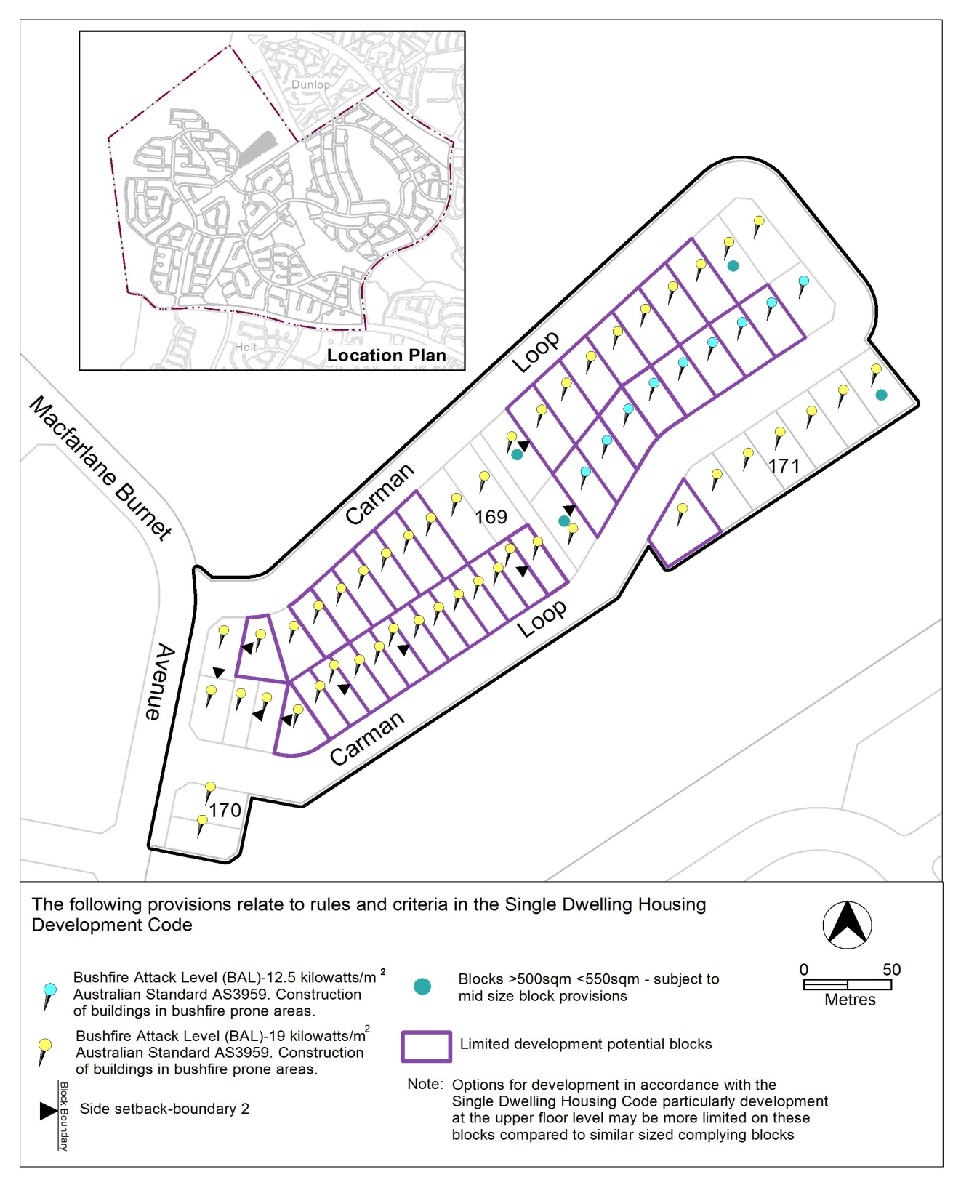

  - Molonglo Valley district precinct map
Substitute
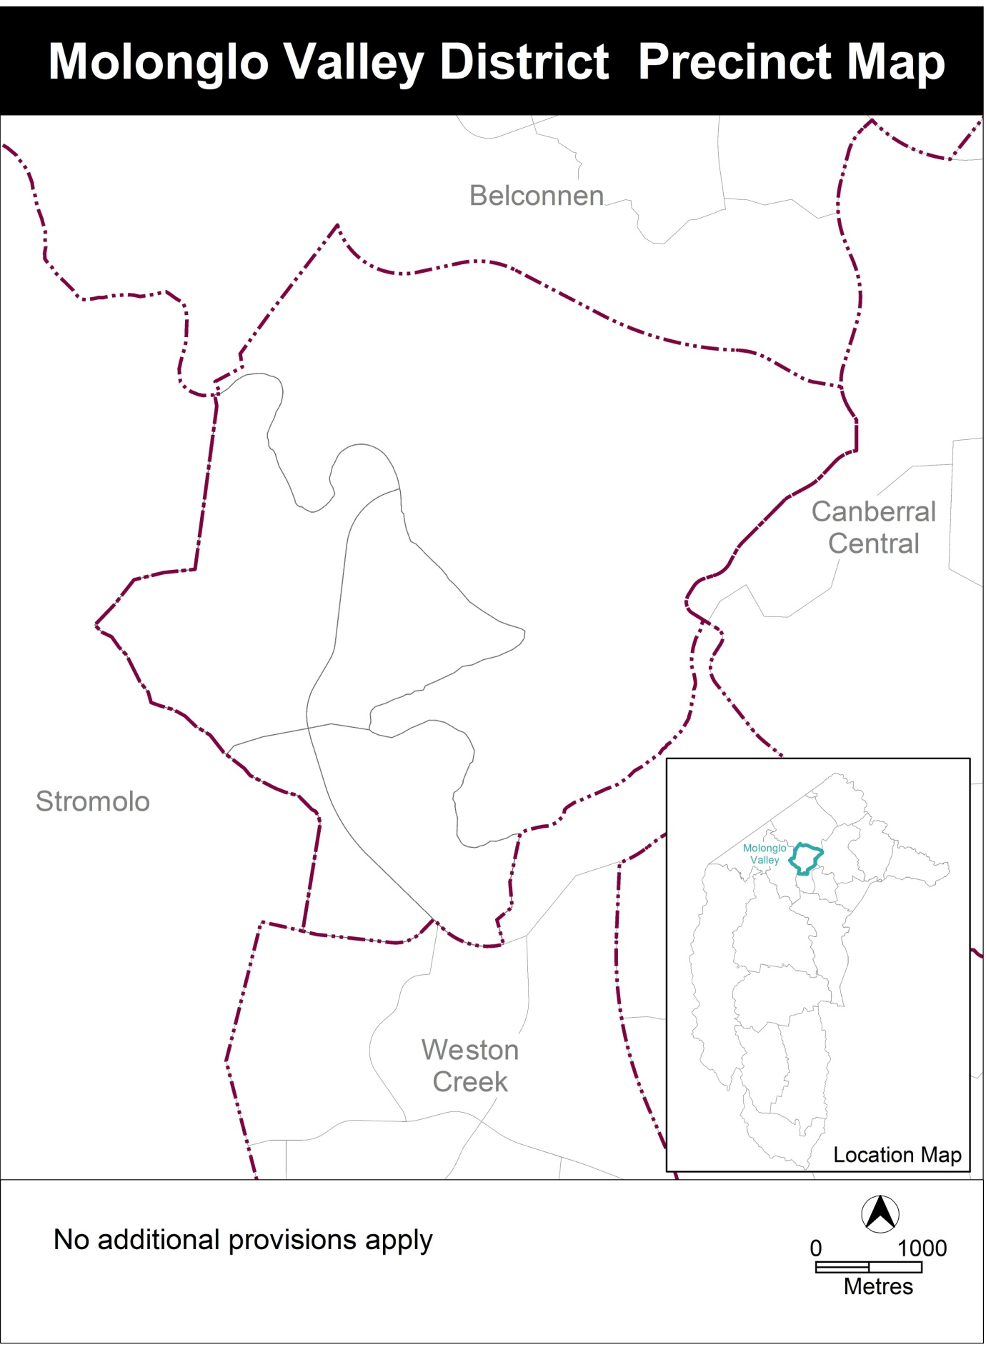

Assessment Tracks

No additional provisions apply.

  - Coombs and Wright concept plan
- Part A – Land use; Element 1: Land use plan; Criterion C4 a)

Replace ‘1.4ha’ with ‘1.0ha’

- Part C – Buildings and structures; Element 12: Local centre/mixed use node – CZ5/CZ4; Rule R56

Substitute

Buildings in CZ4 facing John Gorton Drive have a minimum building height of 3 storeys.

Interpretation service
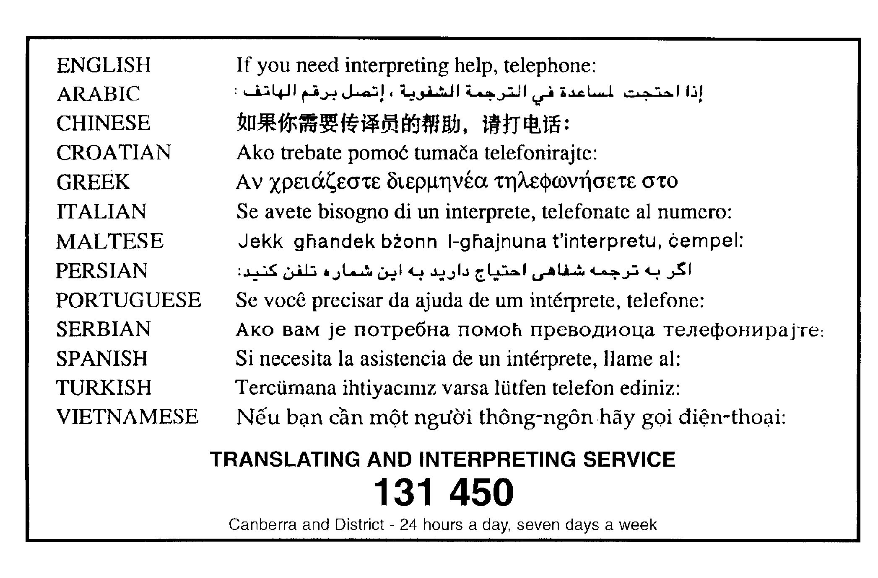

THIS IS ANNEXURE A
TO NOTIFIABLE INSTRUMENT NI2014 – 90

Jim Corrigan
Delegate of the Planning and Land Authority
18 March 2014

Coombs Precinct Map and Code

This page is intentionally blank.

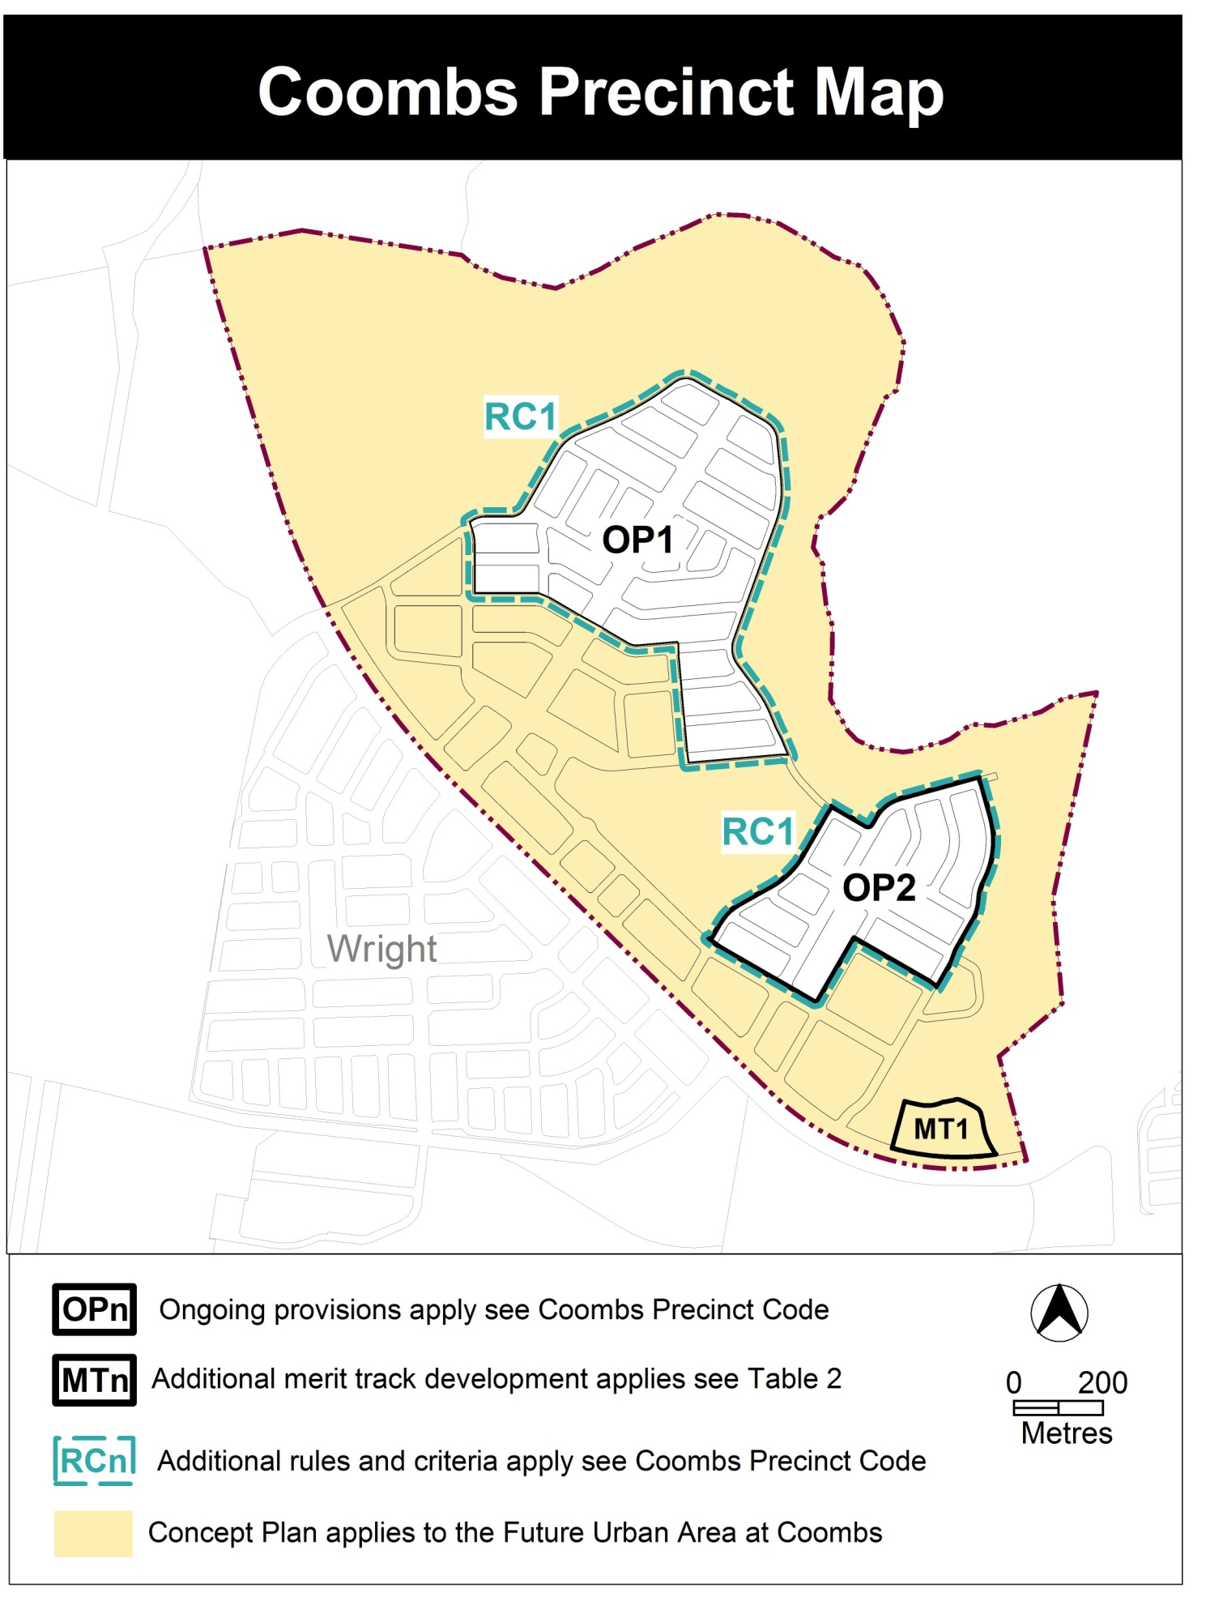

Assessment Tracks

The following tables identify the additional prohibited development and additional merit track development for blocks and parcels shown in the Coombs Precinct Map (identified as PDn or MTn). Development that is exempt from requiring development approval, other prohibited development and the minimum assessment track applicable to each development proposal is set out in the relevant zone development table.

The following table constitutes part of the relevant zone development table.

Table 2 – Additional merit track development
Additional merit track development that may be approved subject to assessment
Suburb precinct map label | Zone | Development
MT1 | CZ5 | municipal depot

Coombs Precinct Code

Contents
Introduction 2
Additional rules and criteria 4
RC1 – Residential use area 4
Element 1: Building envelope 4
Element 2: Amenity 6
Other ongoing provisions 7
OP1 – Coombs residential area 1 7
OP2 – Coombs residential area 2 8

Figures
Figure 1 Typical Building Envelope 5
Figure 2 Coombs residential area 1 7
Figure 3 Coombs residential area 2 8

Introduction
Name
The name of this code is the Coombs Precinct Code.
Application
The code applies to the Division of Coombs.
Purpose
This code provides additional planning, design and environmental controls for specific areas or blocks and may also contain references to provisions in other codes.
In conjunction with other relevant codes it will be used by the Authority to assess development applications and offer guidance to intending applicants in designing development proposals and preparing development applications.
Structure
This code contains additional rules and/or criteria for particular blocks or parcels identified as areas RCn on the precinct map, to be read in conjunction with the relevant development code. It may also contain sub-parts.
Each element has one or more rules and, unless the respective rule is mandatory, each rule has an associated criterion. Rules provide quantitative, or definitive, controls. By contrast, criteria are chiefly qualitative in nature.
In some instances rules are mandatory. Such rules are accompanied by the words “This is a mandatory requirement. There is no applicable criterion.” Non-compliance with a mandatory rule will result in the refusal of the development application. Conversely, the words “There is no applicable rule” is found where a criterion only is applicable.
Code hierarchy
Under the Planning and Development Act 2007, where more than one type of code applies to a development, the order of precedence if there is inconsistency of provisions between codes is: precinct code, development code and general code.
If more than one precinct code applies to the site, the most recent precinct code takes precedence to the extent of any inconsistency.
Definitions
Defined terms, references to legislation and other documents are italicised.
Definitions of terms used in this code are listed in part 13 of the Territory Plan or, for terms applicable only to this code, associated with the respective rule.
Acronyms
ACTPLA Planning and Land Authority within the ACT Environment and Sustainable Development Directorate
EPA ACT Environment Protection Authority
ESA ACT Emergency Services Agency
ESDD ACT Environment and Sustainable Development Directorate
NCA National Capital Authority
P&D Act Planning and Development Act 2007
TAMS ACT Territory and Municipal Services Directorate

Additional rules and criteria
This part applies to blocks and parcels identified in the Coombs Precinct Map (RCn). It should be read in conjunction with the relevant zone development code and related codes.
RC1 – Residential use area
This part applies to blocks and parcels identified in area RC1 shown on the Coombs Precinct Map.
- Building envelope
Rules | Criteria
  - Building envelope – residential buildings with three storeys or fewer
This rule applies to single dwelling housing or multi unit housing with three storeys or fewer.  Buildings are sited wholly within the building envelope formed by projecting planes over the subject block comprising lines projected at 45º to the horizontal from an infinite number of points on a line of infinite length 3.5m above each side and rear boundary, except for northern boundaries of adjoining residential blocks, which are dealt with by the next rule.  Refer Figure 1. | Buildings achieve all of the following:  a) consistency with the desired character  b) reasonable levels of privacy for dwellings on adjoining residential blocks and their associated private open space..
Buildings are sited wholly within the building envelope formed by projecting planes over the subject block comprising lines projected at Xº to the horizontal from an infinite number of points on a line of infinite length 1.8m above the northern boundary or boundaries of an adjoining residential block. Xº is the apparent sun angle at noon on the winter solstice. For the purposes of this rule values for X are given in Table 1.  Refer Figure 1.  Note: For the purposes of R1, R2, Table 1 and Figure 1, northern boundary means a boundary of a block where a line drawn perpendicular to the boundary outwards is orientated between 45° west of north and 45° east of north | This is a mandatory requirement. There is no applicable criterion

Table 1 – Apparent sun angle (X) at noon on the winter solstice (21 June)
Aspect of northern boundary or north facing window  (bearing of line drawn perpendicular to the boundary or window) | Angle  (X)
North 0<10º East  North 0<10º West | 32 º
North 10<20º East  North 10<20º West | 35 º
North 20<30º East  North 20<30º West | 37 º
North 30<40º East  North 30<40º West | 39 º
North 40-50º East  North 40-50º West | 41 º

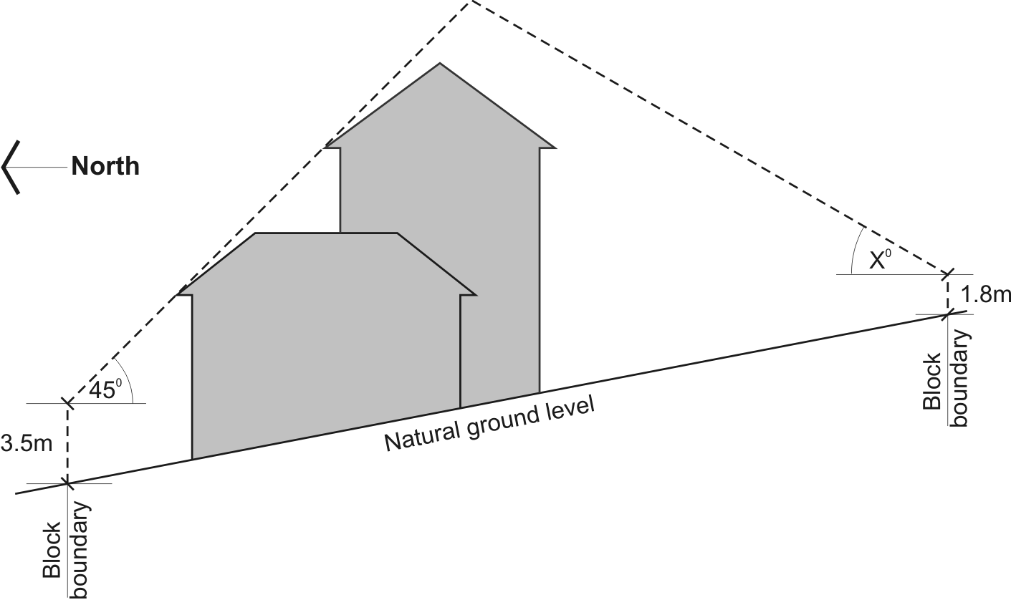

Figure 1 Typical Building Envelope
Note: height of building and boundary setback provisions also apply

- Amenity
Rules | Criteria
  - Boundaries between multi-unit residential and open space
There is no applicable rule. | C3  This criterion applies to urban blocks (other than single residential blocks) which have a common boundary with a block(s) within the PRZ1 Urban Open Space Zone and/or NUZ4 River Corridor Zone  The common boundary between urban blocks (other than single residential block) and urban open space and/or a river corridor achieves all of the following:  - ease of access to urban open space corridors  - surveillance of urban open space corridors  - avoidance of rear boundary fencing  - ground floor dwellings address to urban open space where there is no edge street.

Other ongoing provisions
This part applies to blocks and parcels identified as ongoing provisions (OPn) in the Coombs Precinct Map. It should be read in conjunction with the relevant zone development code and related codes.
OP1 – Coombs residential area 1
This part applies to blocks and parcels identified in area OP1 shown on the Coombs Precinct Map.

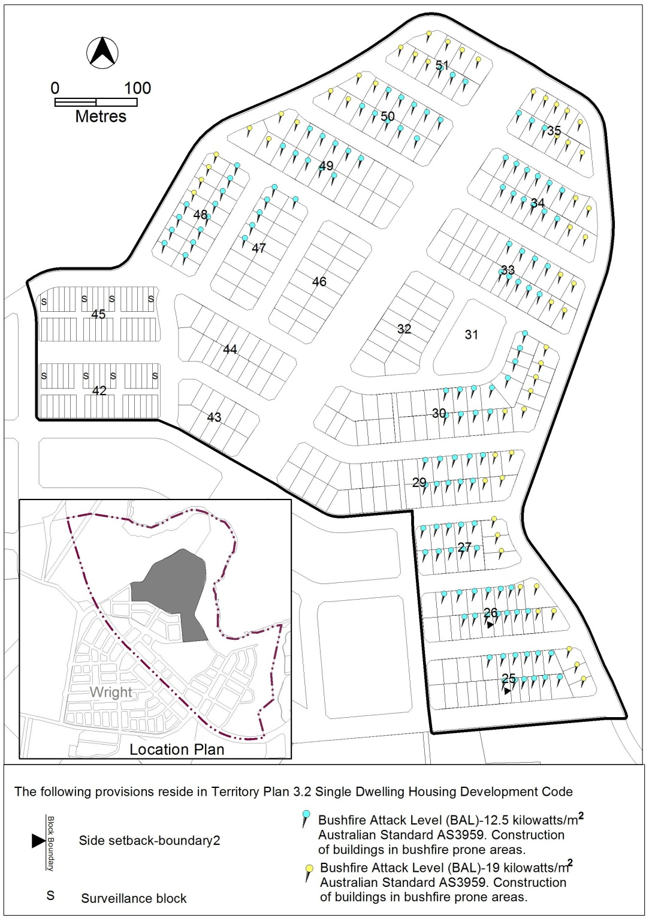
Figure 2 Coombs residential area 1
OP2 – Coombs residential area 2
This part applies to blocks and parcels identified in area OP2 shown on the Coombs Precinct Map.
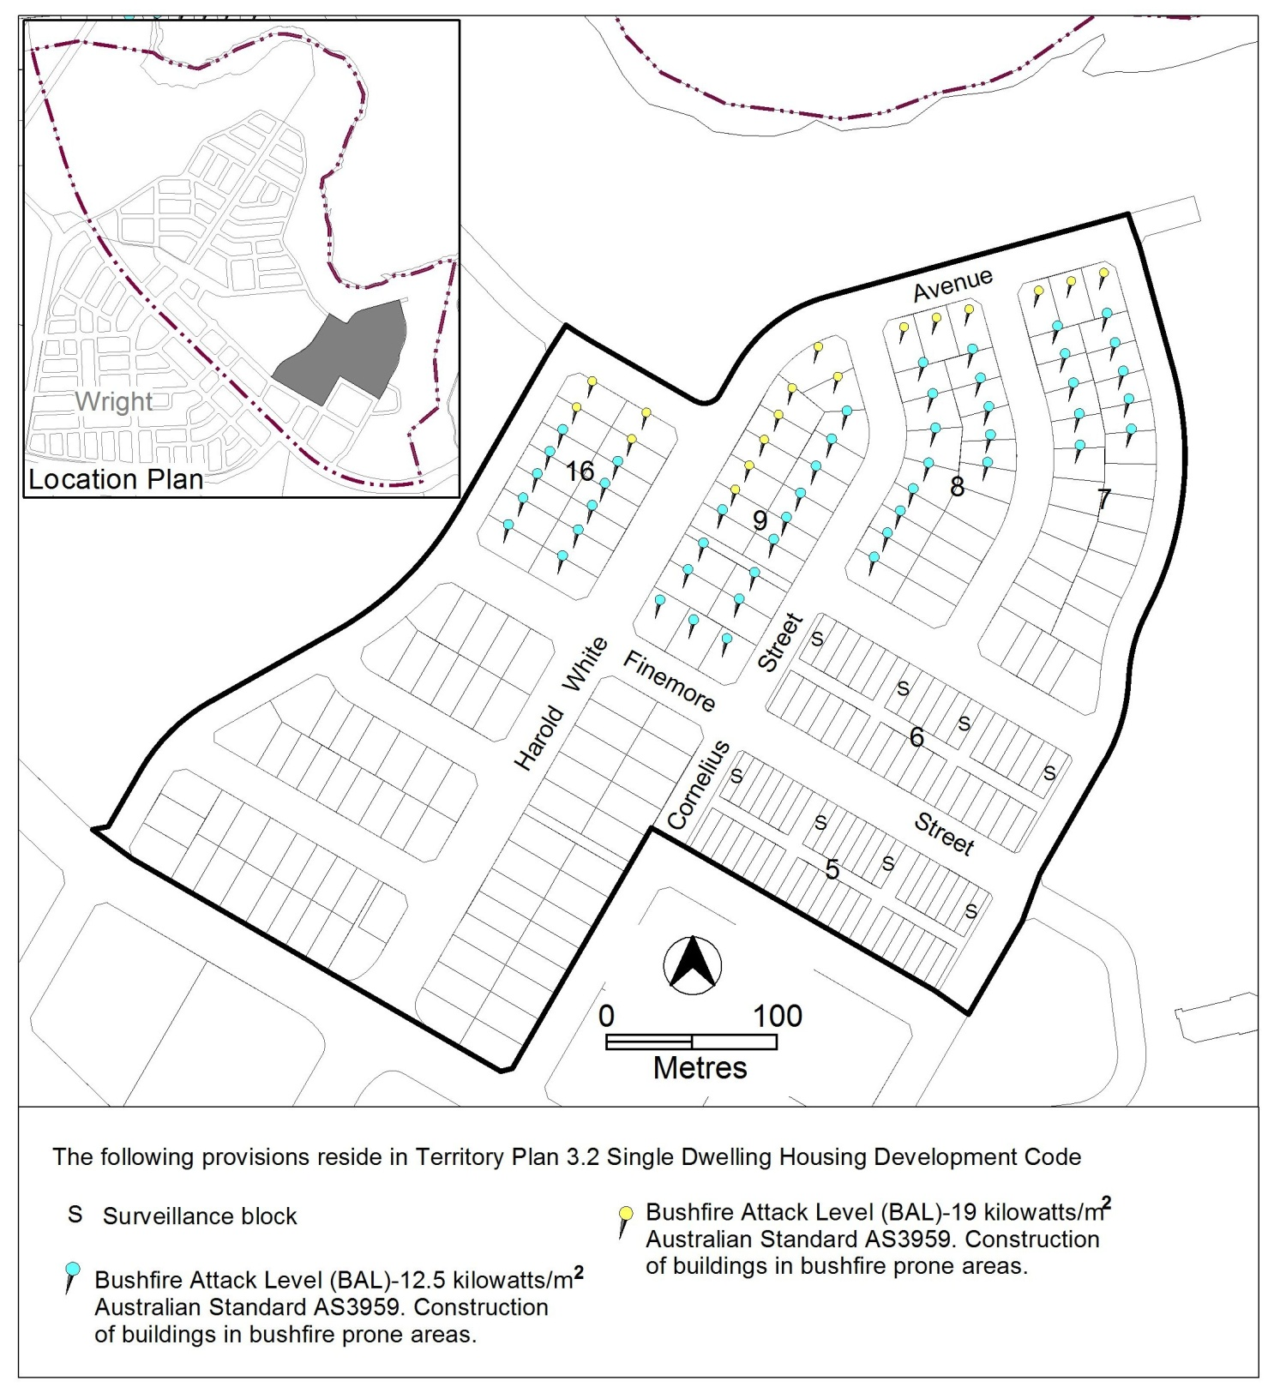
Figure 3 Coombs residential area 2

