Australian Capital Territory
Planning and Development (Plan Variation No 336) Notice 2015
Notifiable Instrument NI2015-100
made under the
Planning and Development Act 2007, section 76(3)

- Name of instrument
This instrument is the Planning and Development (Plan Variation No 336) Notice 2015*.

- Plan Variation No 336
On Monday 2 March 2015, the Minister for Planning approved a draft of the attached plan variation to the Territory Plan (Annexure A) under s76 (3).

Jim Corrigan
Delegate of the Planning and Land Authority
10 March 2015

Planning and Development Act 2007

Variation to the
Territory Plan
No 336

ACT Government Land Release Program
Symonston Section 1 Block 8 and
Section 115 Block 1
Zone changes and changes to the
Symonston precinct map and code

Final variation prepared under s76 of the
Planning and Development Act 2007

This page is intentionally blank.

Contents

1. EXPLANATORY STATEMENT 1
1.1 Background 1
1.2 Summary of the proposal 4
1.3 The National Capital Plan 4
1.4 Site Description 4
1.5 Current Territory Plan provisions 6
1.6 Changes to the Territory Plan 8
1.7 Consultation on the draft variation 8
1.8 Revisions to the draft variation placed on consultation 8
2. VARIATION 9
2.1 Variation to the Territory Plan map 9
2.2 Variation to Symonston precinct map 10

This page is intentionally blank.

- EXPLANATORY STATEMENT
  - Background
    - Land Release Program 2014-15 to 2017-18
The supply and release of land is a central part of the Government’s economic and social strategy and supports the needs of a growing population, changing households and an expanding economy. In particular, land supply has an important role in providing a range of affordable housing choices, and in meeting the needs of the commercial and industrial sectors, factors that are crucial in attracting and retaining a skilled workforce.
The leasehold system in the ACT makes it unique as it provides the Government with the ability to influence when, where and how development occurs. Land sales also provide a significant source of funding.
Each year the ACT Government prepares four year indicative land release programs which sets out the Government’s intended program of residential, commercial, industrial, community and non-urban land releases.
The four year indicative land release programs are intended to provide guidance on the Government’s land release intentions and seek to balance economic, social, financial and environmental objectives to:
- promote the economic and social development and population growth of the Territory;
- meet the demand for land in the Territory;
- allow flexibility to respond to fluctuations in the market;
- establish an appropriate inventory of serviced land;
- provide an appropriate choice of land and housing options and facilitating the provision of affordable housing; and
- achieve satisfactory returns from the sale of unleased Territory land.

The identification of blocks for release is based on an assessment of overall demand drivers. Within the individual sectors land is made available in response to factors such as:
- population growth rates including net overseas migration;
- demographic changes eg changes to living arrangements, ageing population;
- existing supply by the private sector and demand from the market eg vacancy rates and rent levels;
- ACT Government objectives eg diversifying the economic and employment base of the Territory;
- Market confidence and the availability of finance;
- Employment rates;
- Responding to private sector initiatives, such as the development and growth of the Canberra Airport;
- Local factors which can affect the demand for particular types of land; and
- National trends eg growth of innovative, emerging and creative industries eg environmental technologies, medical and bio-technologies and information technology.
The Land Development Agency (LDA) is responsible for the delivery of the land release programs. Some of the objectives of the LDA in delivering the land release programs include:
- Pursuing initiatives to deliver affordable housing consistent with the Affordable Housing Action Plan;
- Developing urban renewal and development strategies for the city centre, town centres, major transport corridors and group centres;
- Establishing an inventory of environmentally cleared, planned, release ready and serviced land that will provide flexibility and alternative release options to cover any unanticipated delays on sites otherwise identified for release in the relevant period;
- Encouraging viable and liveable communities by providing a variety of block and dwelling types and public spaces to suit the needs of residents and surrounding communities; and
- Contributing to the redevelopment of the transit corridor between Gungahlin, Civic and Lake Burley Griffin through the Capital Metro and City to the Lake projects.
More information can be found at:
http://www.economicdevelopment.act.gov.au/land and http://www.lda.act.gov.au

    - Background to the Symonston site
The objective of the amendment is to change the zoning for the remainder of the Amtech Industrial Estate (Amtech Estate). As a response to a need for a high tech industrial campus the ACT Government developed Amtech Estate in the 1990’s. The planning controls restrict industries to those which would occupy an ‘advanced technology park’.
Land was first released in the 1990’s but Amtech Estate has not reached full occupancy and the demand for ‘high tech’ industrial sites has either fallen away or is being met in other locations.
There has been a change in the nature of demand for industrial land which has reflected the general changes occurring in the industrial sector. This has affected the take up of industrial land. There is a preference for the uses permitted under industrial IZ2 – mixed use which broadens the range of uses that are permitted, including uses such as bulky goods retailing, warehouses, freight transport and distribution services. There are limited sites available within the Canberra urban area to accommodate these uses.
The reduced extent of the proposed IZ2 land use from the current IZ1 land use zoning was determined by the sites ecological and heritage values for Jerrabomberra Creek and the land area between the IZ2 land uses east to the road reserve of Hindmarsh Drive. Assessments completed over several years confirmed the significance of those values. The variation identifies this area as PRZ1 urban open space land use. This action will provide certainty to recognising and ensuring ongoing long term protection to those values. The PRZ1 urban open space land use includes the small hilltop at the north east corner of the site currently zoned NUZ1 broadacre zone.
Amtech Estate is subject to the requirements of the National Capital Plan. Amendment 13 of the National Capital Plan limited land use to ‘Advanced Technology Park’, ‘Public Utility’ and ‘Open Space’ only as well as mandating that future development of Amtech Estate was to conform to a Development Control Plan.
Amendment 82 to the National Capital Plan removes the requirement for section 1 block 8 and sections 112, 113, 115, 116 and 117 Symonston to be developed as an ‘Advanced Technology Park’. ‘Hazardous Industry’ and ‘Offensive Industry’ remain non-permitted uses to control potential conflicts with existing development. Amendment No 82 was gazetted on 15 January 2014 and has been incorporated into the National Capital Plan.
The zoning is consistent with the expanding large format commercial business centre which adjoins the site on the opposite side of Canberra Avenue. It will build on the existing businesses in Fyshwick increasing usage of existing and proposed public transport along Canberra Avenue. The changes also protect the ecological and heritage values on the site through the PRZ1 urban open space zoning.

  - Summary of the proposal
The objective of the amendment is to change the zoning for the remainder of the Amtech Industrial Estate (Amtech Estate) from IZ1 general industrial zone to IZ2 mixed use industrial zone and the PRZ1 urban open space zone. It also removes the land from the MT1/PD1 additional merit track and additional prohibited development area on the Symonston precinct map. Amtech Estate has not reached full occupancy and the demand for ‘high tech’ industrial sites has either fallen away or is being met in other locations. The changes will broaden the range of uses that are permitted on the site, including uses such as bulky goods retailing, warehouses, freight transport and distribution services. There are limited sites available within the Canberra urban area to accommodate these uses. The changes will also protect the ecological and heritage values on the site.

  - The National Capital Plan
The Australian Capital Territory (Planning and Land Management) Act 1988 established the National Capital Authority (NCA) with two of its functions being to prepare and administer a National Capital Plan (NCP) and to keep the NCP under constant review and to propose amendments to it when necessary.
The NCP, which was published in the Commonwealth Gazette on 21 January 1990 is required to ensure that Canberra and the Territory are planned and developed in accordance with their national significance. The Planning and Land Management Act 1988 also required that the Territory Plan is not inconsistent with the NCP.
In accordance with section 10 of the Australian Capital Territory (Planning and Land Management) Act 1988, the National Capital Plan defines the planning principles and policies for Canberra and the Territory, for giving effect to the object of the NCP and sets out the general policies to be implemented throughout the Territory, including the range and nature of permitted land uses.
It also sets out the detailed conditions of planning, design and development for areas that have special significance to the National Capital known as designated areas and identifies special requirements for the development of some other areas.

  - Site Description
The subject site is located in the suburb of Symonston and has an area of approximately 35 hectares. It is approximately 7 kilometres south-east from the city centre and is bounded by Canberra Avenue to the north, Hindmarsh Drive to the south, the Monaro Highway to the west and is intersected by Jerrabomberra Creek.
The subject site is unleased and undeveloped. It is managed by the Territory and Municipal Services Directorate.

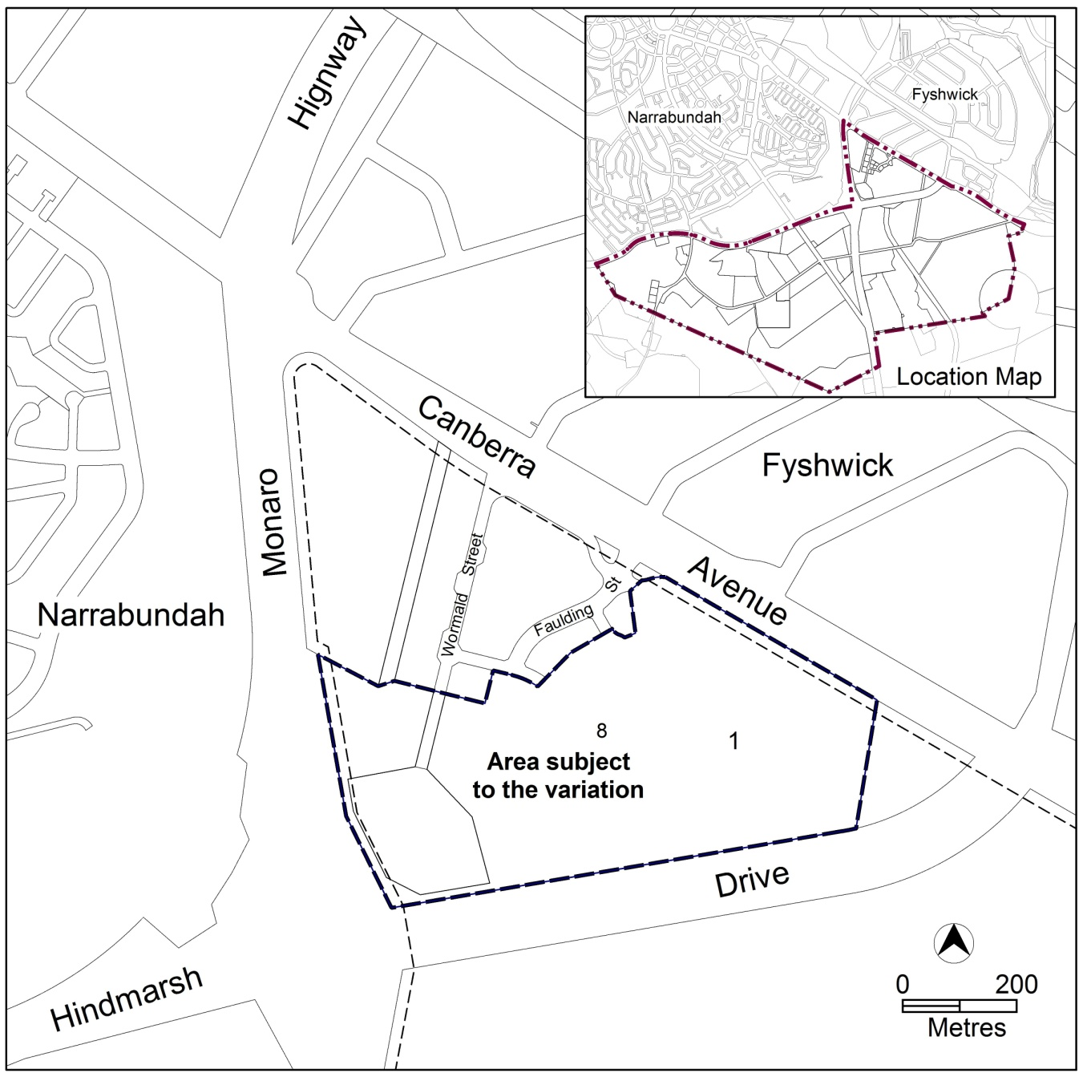
Figure 1 Site Plan

  - Current Territory Plan provisions
The current Territory Plan map zone for the area subject to this variation is shown in Figure 2. The current Symonston precinct map is shown in Figure 3.
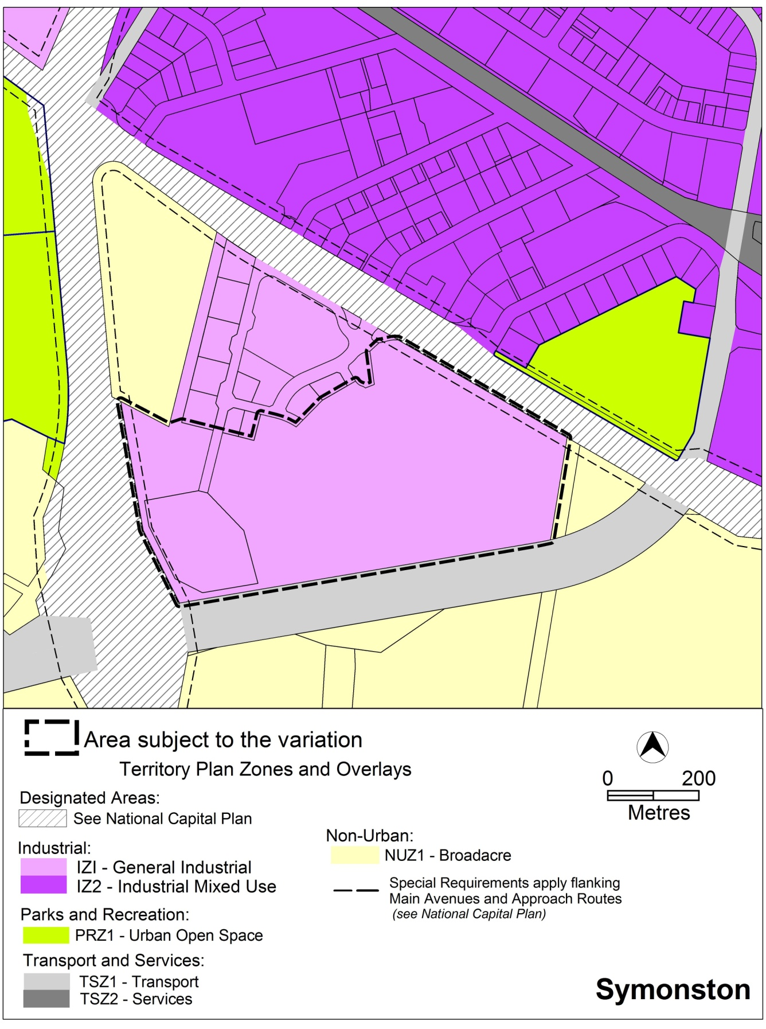
Figure 2 Territory Plan Zones Map
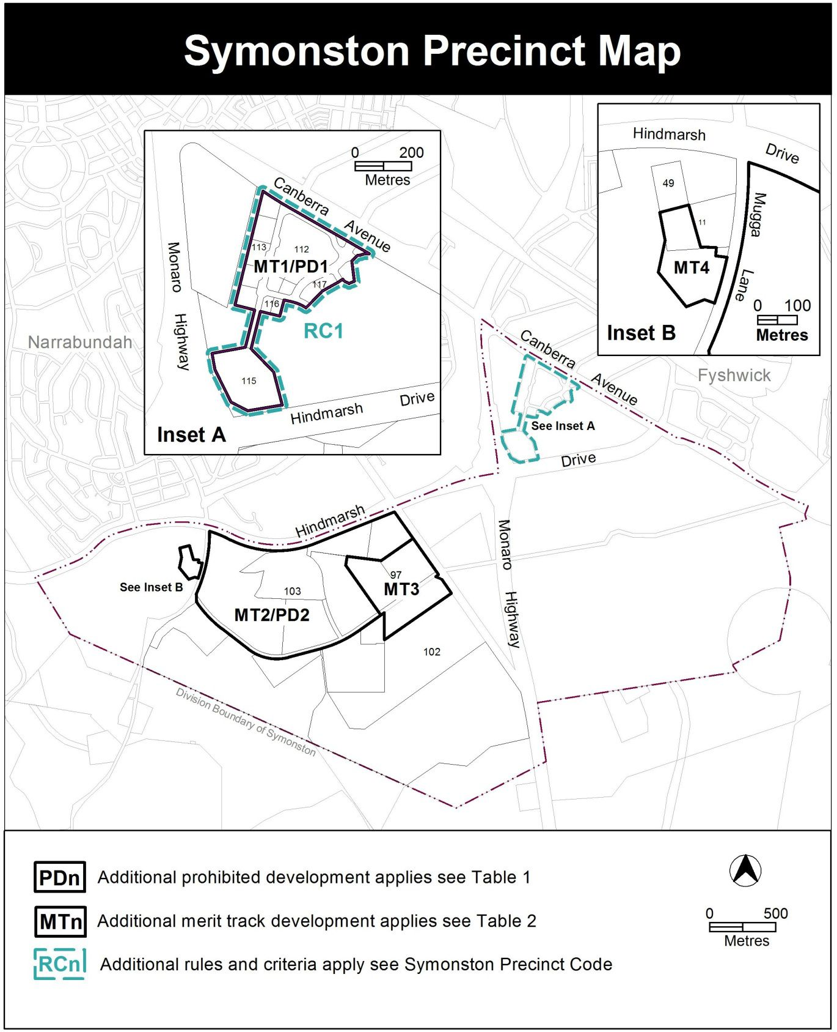
Figure 3 Current Symonston precinct map

  - Changes to the Territory Plan
    - Changes to the Territory Plan map
The changes to the Territory Plan map are indicated in Figure 4 at Part 2 of this document and include the rezoning of the site from the IZ1 general industrial zone to IZ2 mixed use industrial zone and to the PRZ1 urban open space zone.
The variation map indicates the proposed zone boundaries as accurately as possible but may be subject to adjustments following detailed surveys.
    - Changes to the Territory Plan
The changes to the Symonston precinct map are indicated in Part 2 of this document and includes the following amendments:
- remove block 1 Section 115 from the MT1/PD1 additional merit track and additional prohibited development area
- remove block 1 Section 115 from the RC1 area.
  - Consultation on the draft variation
Draft variation No 336 (DV336) was released for public comment between 7 November 2014 and 19 December 2014. A consultation notice under section 63 of the Planning and Development Act 2007 (the Act) was published on the ACT Legislation Register on 7 November 2014 and in the Canberra Times on 8 November 2014.
One (1) submission was lodged during the consultation period. This submission sought to have all of the grassland protected but supported the PRZ1 urban open space zoning for a significant portion of the grassland on the site. These comments were considered and are detailed in a report on consultation.
  - Revisions to the draft variation placed on consultation
No revisions were made to the draft variation that was placed on public consultation.

- VARIATION
  - Variation to the Territory Plan map
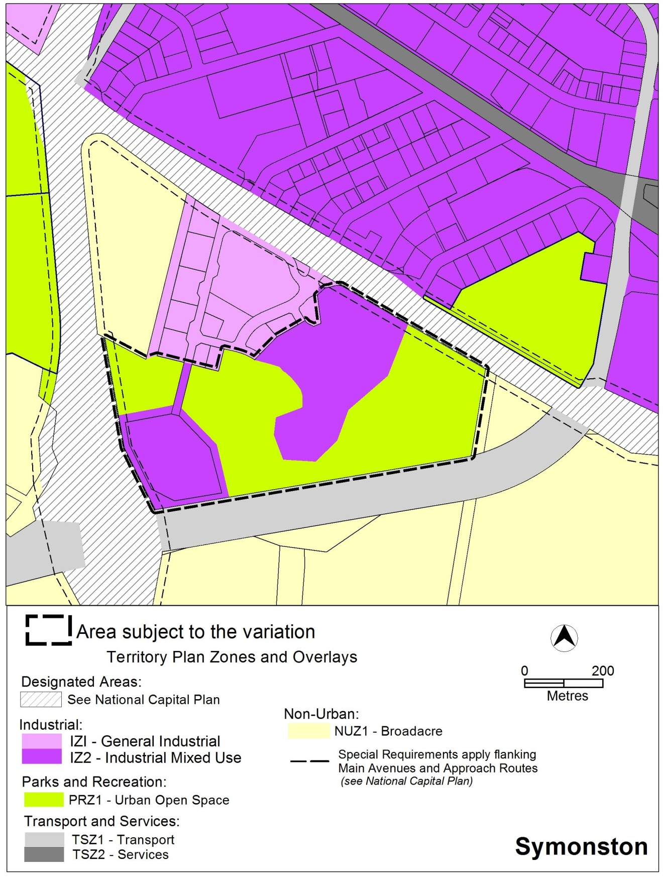
Figure 4 – Proposed Territory Plan map

  - Variation to Symonston precinct map
Substitute
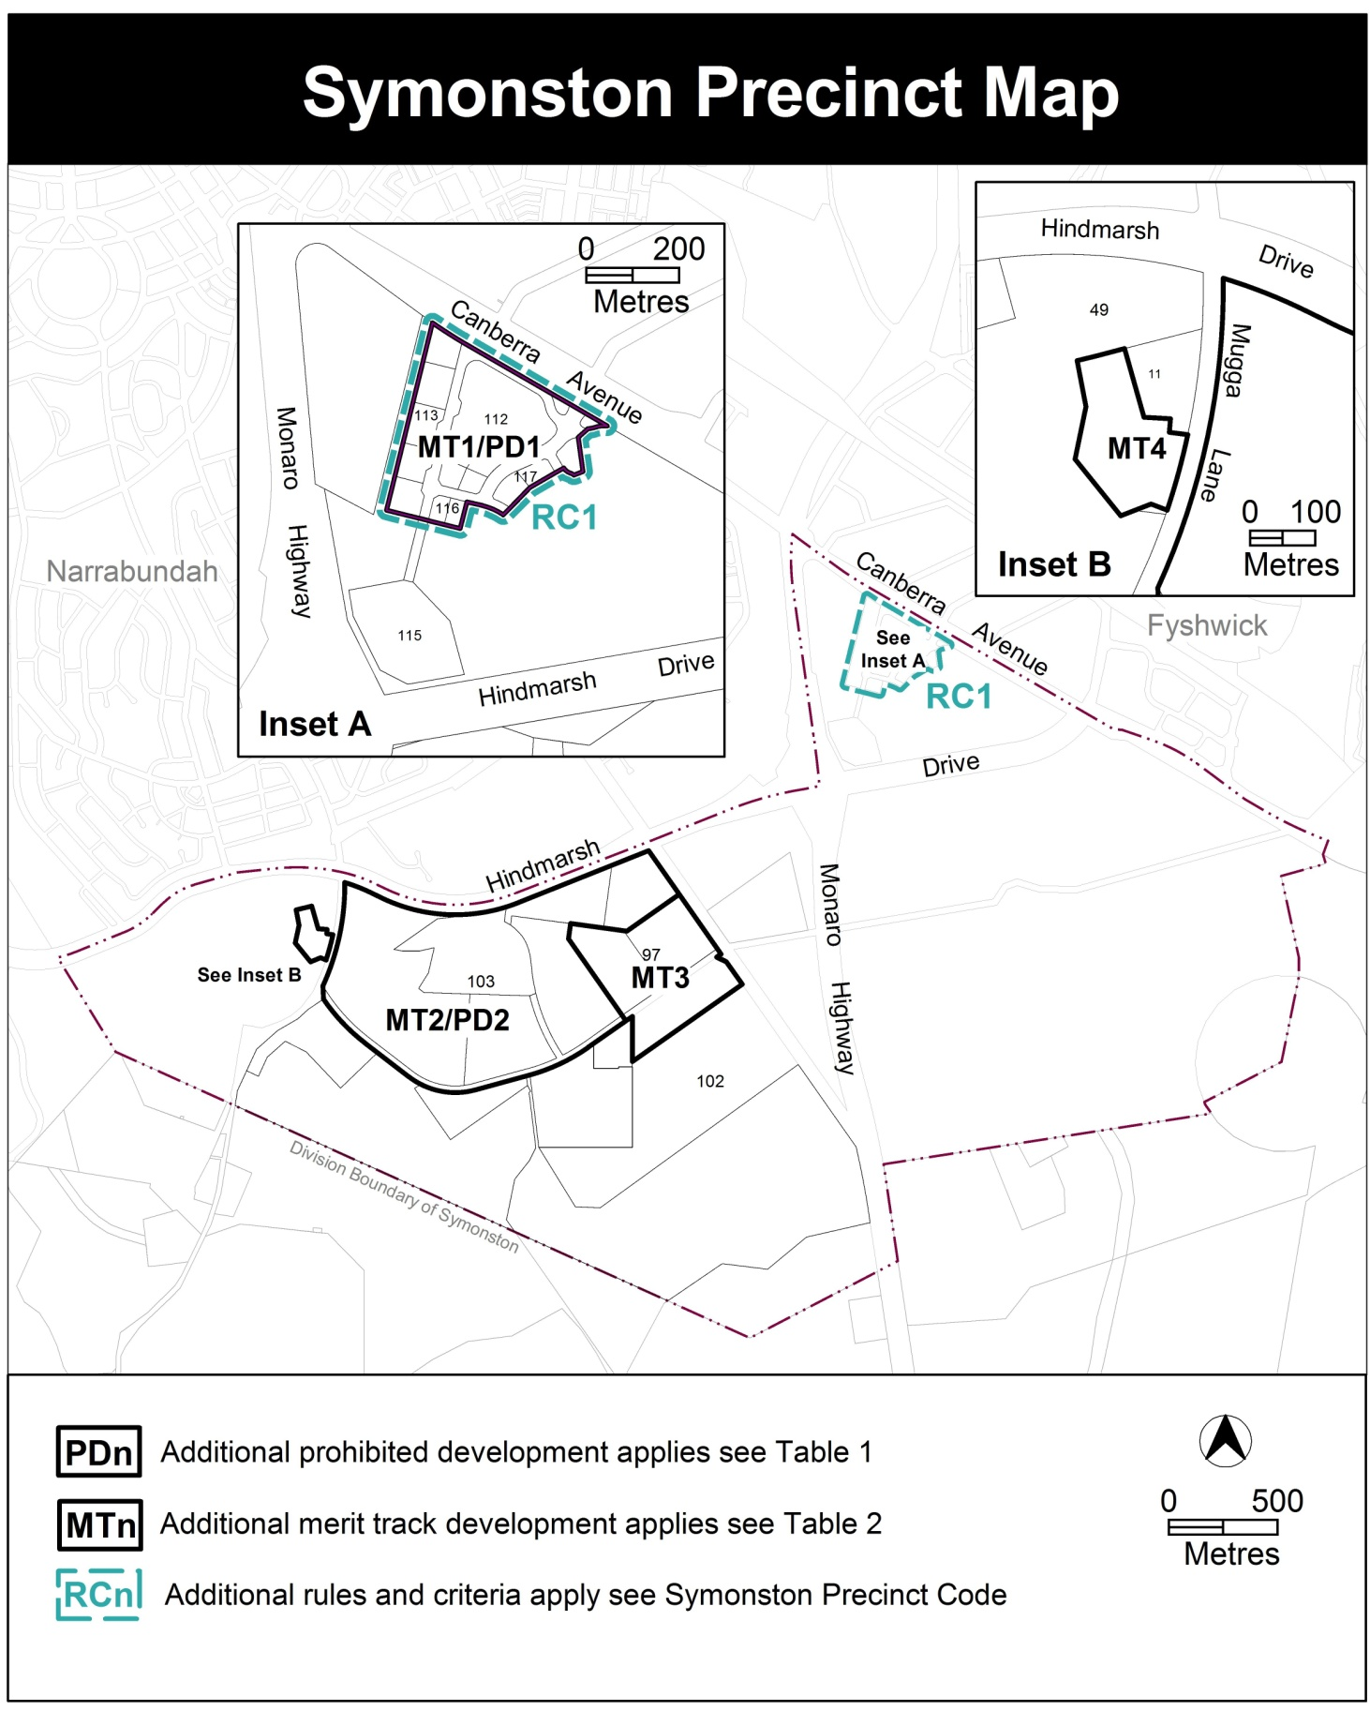

Interpretation service
