Australian Capital Territory

Planning and Development (Technical Amendment—Moncrieff) Plan Variation 2015 (No. 1)

Notifiable Instrument NI2015—148
Technical Amendment No 2015—02
made under the
Planning and Development Act 2007, section 89 (Making technical amendments) s96 (land ceases to be in future urban area)

This plan variation commences on the day after it is notified.

Variation No 2015—02 to the Territory Plan has been approved by the Planning and Land Authority.

Variation to the Territory Plan
The Territory Plan map is varied as indicated in Annexure A to identify the zones that apply to the land ceasing to be in a future urban area.

Introduction of the Precinct Map and Code
Annexure B proposes to introduce the Moncrieff Precinct Map and Code for ongoing block specific provisions for this area.

Jim Corrigan
Delegate of the Planning and Land Authority
Date 17.04.15

THIS IS PAGE ONE OF ANNEXURE A
TO NOTIFIABLE INSTRUMENT NI2015 – 148

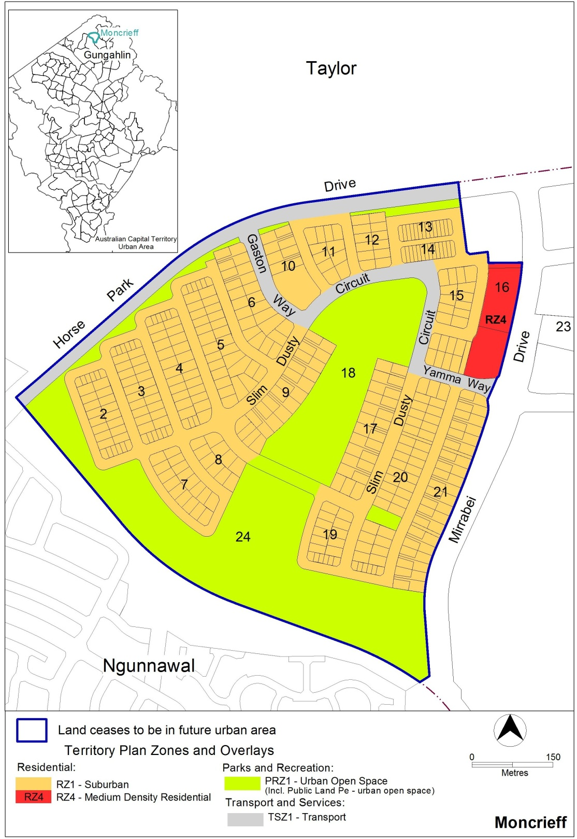

Jim Corrigan
Delegate of the Planning and Land Authority
Date 17.04.15

THIS IS ANNEXURE B
TO NOTIFIABLE INSTRUMENT NI2015 – 148

Jim Corrigan
Delegate of the Planning and Land Authority
Date 17.04.15

Moncrieff Precinct Map and Code

This page is intentionally blank.

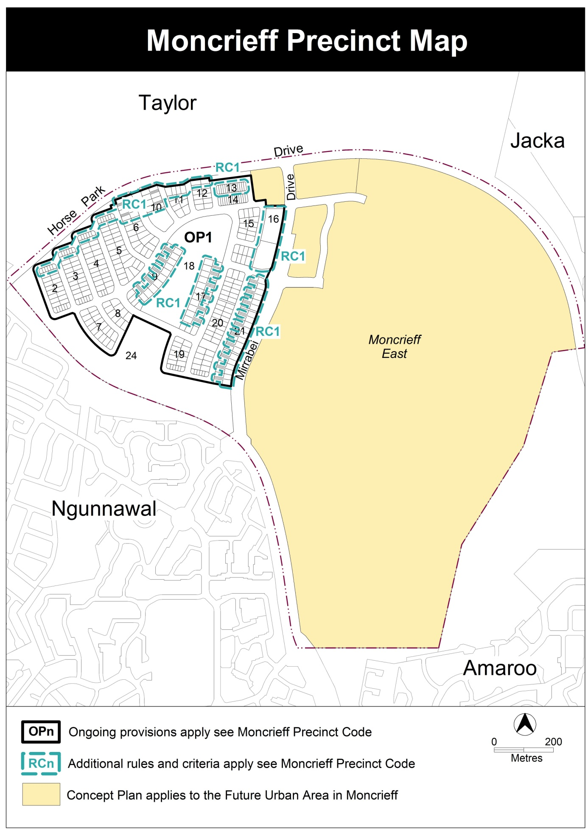

Assessment Tracks

No additional provisions apply.
Moncrieff Precinct Code

Contents
Introduction 6
Additional rules and criteria 8
RC1 – Residential 8
Element 1: Building and site controls 8
1.1 Setbacks 8
Element 2: Amenity 8
2.1 Acoustic mitigation measures 8
Other ongoing provisions 13
OP1 – Moncrieff residential area 13

Figures
Figure 1 Moncrieff residential area 1 10
Figure 2 Moncrieff residential area 2 11
Diagram 1 Elevation of acoustic privacy fence 12
Figure 3 Moncrieff residential area 3 12
Figure 4 Moncrieff residential area ongoing provisions 13

Introduction
Name
The name of this code is the Moncrieff Precinct Code.
Application
The code applies to the Division of Moncrieff.
Purpose
This code provides additional planning, design and environmental controls for specific areas or blocks and may also contain references to provisions in other codes.
In conjunction with other relevant codes it will be used by the Authority to assess development applications and offer guidance to intending applicants in designing development proposals and preparing development applications.
Structure
This code contains additional rules and/or criteria for particular blocks or parcels identified as areas RCn on the precinct map, to be read in conjunction with the relevant development code. It may also contain sub-parts.
Each element has one or more rules and, unless the respective rule is mandatory, each rule has an associated criterion. Rules provide quantitative, or definitive, controls. By contrast, criteria are chiefly qualitative in nature.
In some instances rules are mandatory. Such rules are accompanied by the words “This is a mandatory requirement. There is no applicable criterion.” Non-compliance with a mandatory rule will result in the refusal of the development application. Conversely, the words “There is no applicable rule” is found where a criterion only is applicable.
Code hierarchy
Under the Planning and Development Act 2007, where more than one type of code applies to a development, the order of precedence if there is inconsistency of provisions between codes is: precinct code, development code and general code.
If more than one precinct code applies to the site, the most recent precinct code takes precedence to the extent of any inconsistency.
Definitions
Defined terms, references to legislation and other documents are italicised.
Definitions of terms used in this code are listed in part 13 of the Territory Plan or, for terms applicable only to this code, associated with the respective rule.

Acronyms
EPA ACT Environment Protection Authority
ESA ACT Emergency Services Agency
ESDD ACT Environment and Sustainable Development Directorate
NCA National Capital Authority
P&D Act Planning and Development Act 2007
TAMS ACT Territory and Municipal Services Directorate

Additional rules and criteria
This part applies to blocks and parcels identified in the Moncrieff Precinct Map (RCn). It should be read in conjunction with the relevant zone development code and related codes.
RC1 – Residential
This part applies to blocks and parcels identified in area RC1 shown on the Moncrieff Precinct Map.
- Building and site controls
Rules | Criteria
  - Setbacks
R1  This rule applies to blocks identified in Figure 1.  Additional zero boundary setback to permit garage construction. | This is a mandatory requirement. There is no applicable criterion.
R2  This rule applies to blocks or parcels in locations identified in Figure 3.  Transparent type fencing to be provided on boundary to open space in accordance with Residential Boundary Fences General Code – part 2.5 Battle Axe Blocks and Blocks with frontages to Open Space. | This is a mandatory requirement. There is no applicable criterion.
R3  This rule applies to blocks or parcels in locations identified in Figures 2 and 3.  Access is not permitted to Mirrabei Drive from adjacent blocks. | This is a mandatory requirement. There is no applicable criterion.
- Amenity
Rules | Criteria
  - Acoustic mitigation measures
R4  This rule applies to blocks or parcels in locations identified in Figures 1 and 2.  Acoustic insulation to be provided to the upper floor level of the dwelling in accordance with AS/NZS 2107:2000 Acoustics – Recommended design sound levels and reverberation times for building interiors. | This is a mandatory requirement. There is no applicable criterion.
R5  This rule applies to blocks or parcels in locations identified in Figure 3.  Acoustic insulation to be provided to all floors of the dwelling in accordance with AS/NZS 2107:2000 Acoustics – Recommended design sound levels and reverberation times for building interiors. | This is a mandatory requirement. There is no applicable criterion.
R6  This rule applies to blocks or parcels in locations identified in Figure 2.  Multi unit site along Horse Park Drive and Mirrabei Drive to be assessed for acoustic requirements on an individual basis. | This is a mandatory requirement. There is no applicable criterion.
R7  This rule applies to blocks or parcels in locations identified in Figures 1 and 2.  Acoustic privacy fencing to be provided by the lessee.  See Diagram 1 for an elevation of a typical acoustic privacy fence | This is a mandatory requirement. There is no applicable criterion.

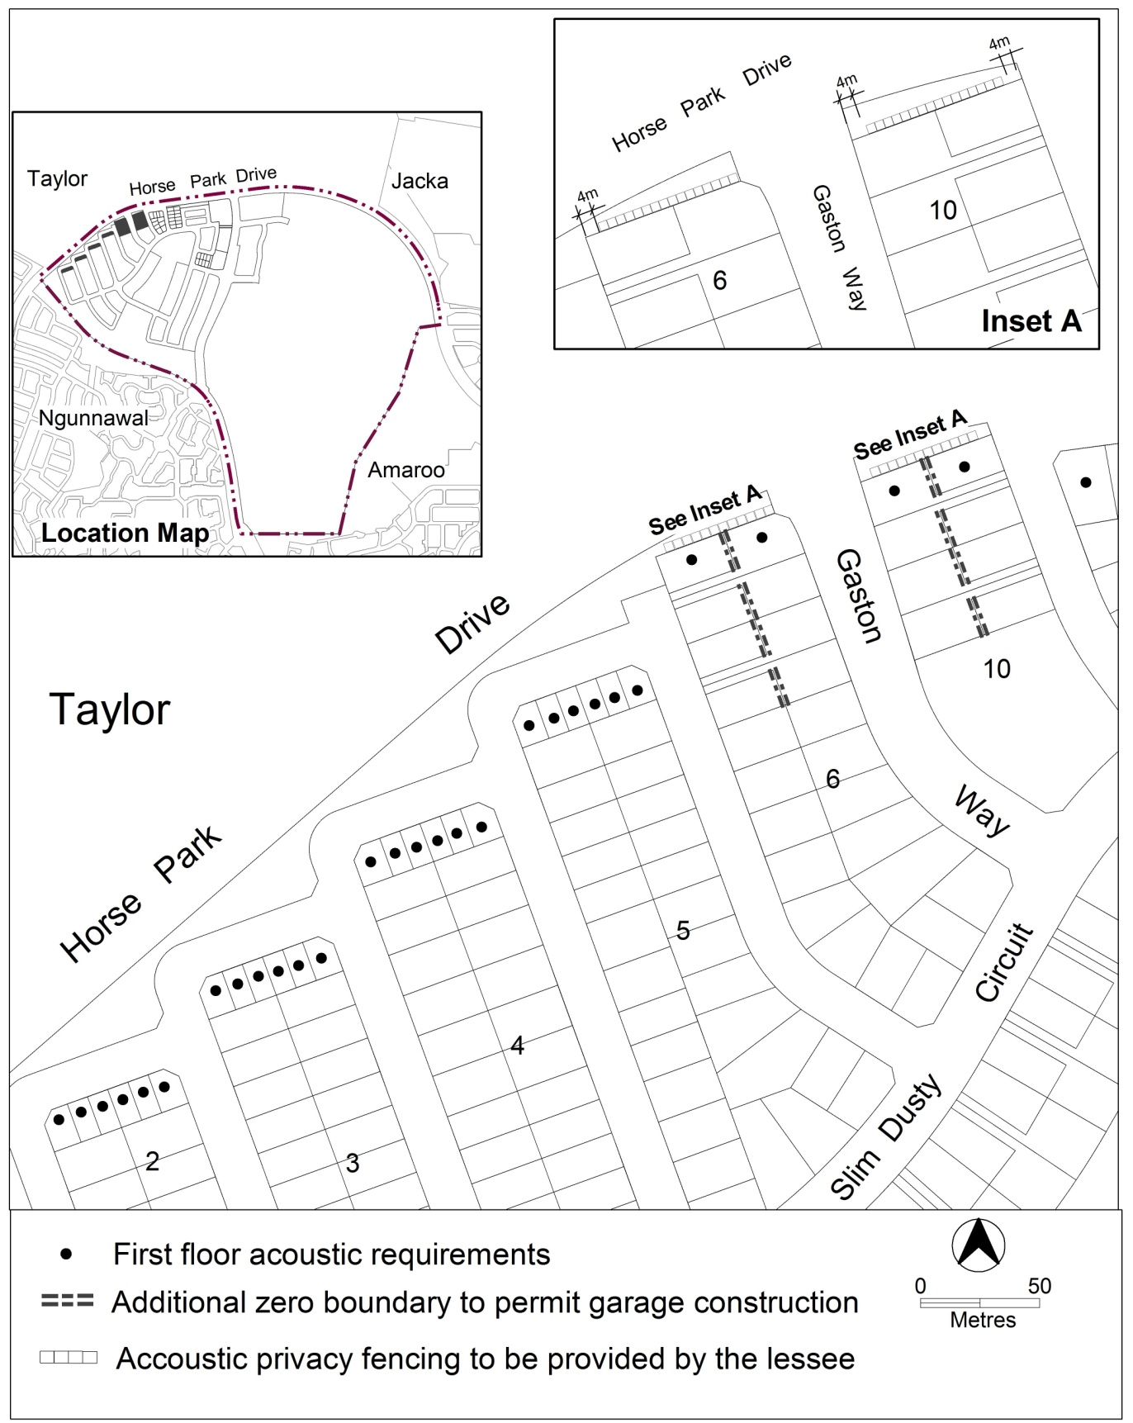
Figure 1 Moncrieff residential area 1

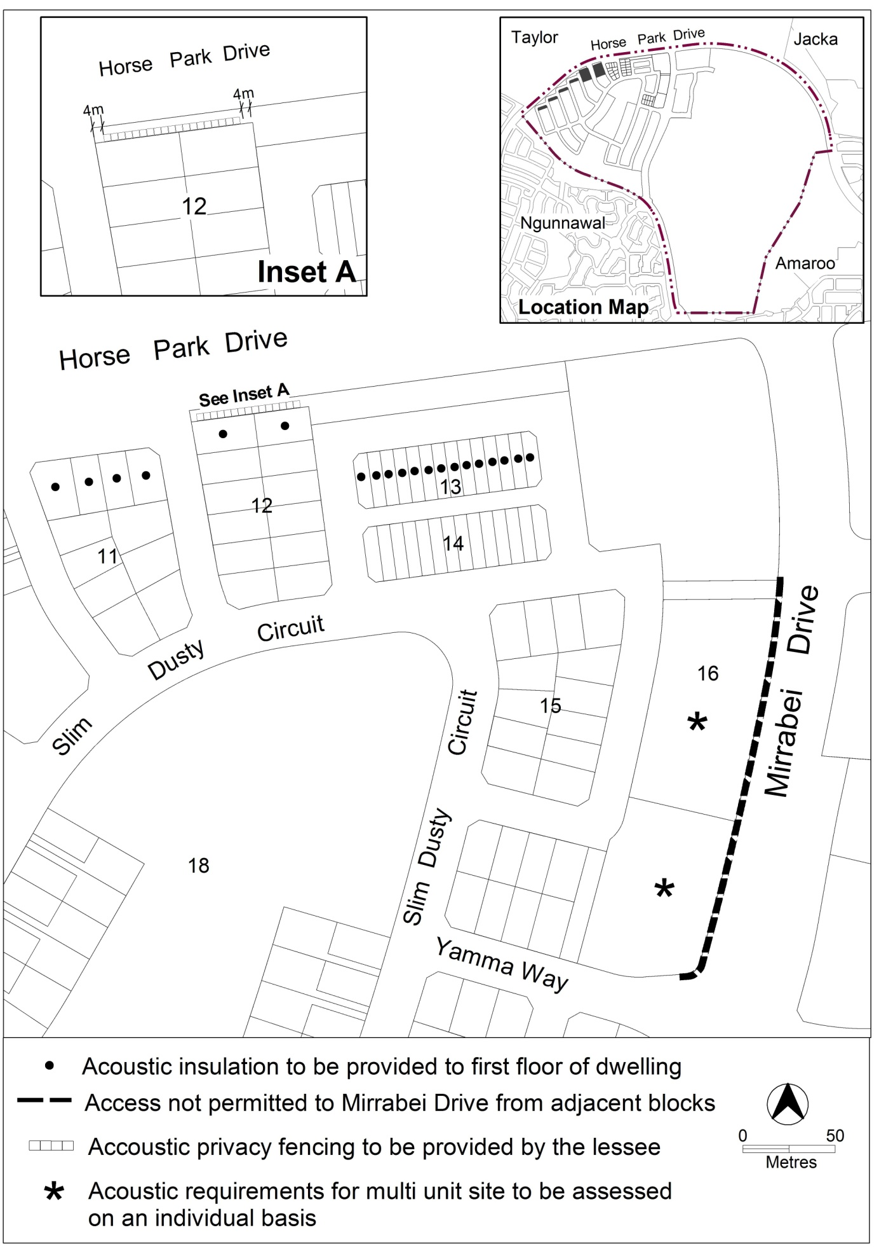
Figure 2 Moncrieff residential area 2

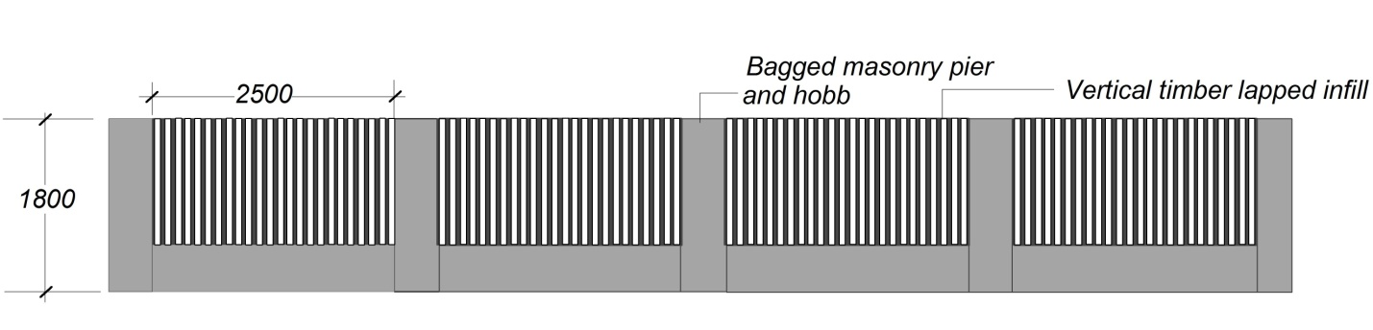
Diagram 1 Elevation of acoustic privacy fence

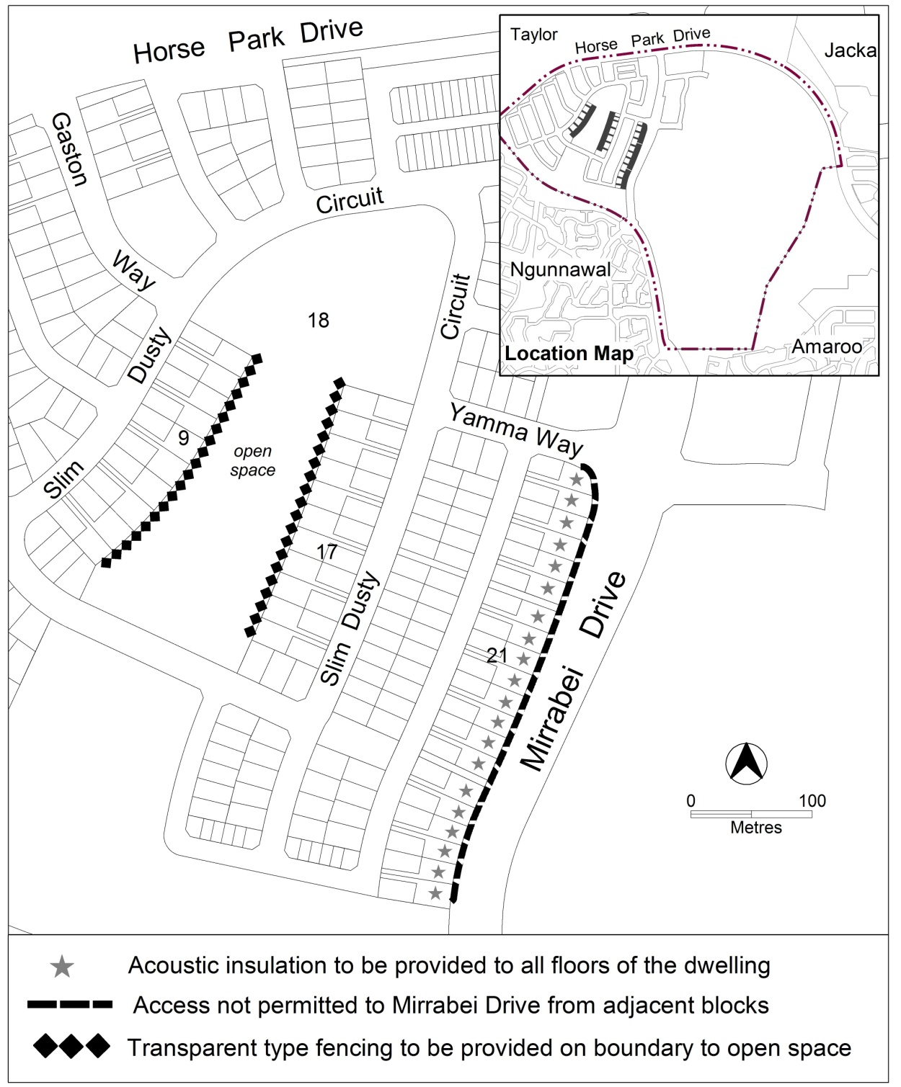
Figure 3 Moncrieff residential area 3
Other ongoing provisions
This part applies to blocks and parcels identified as ongoing provisions (OPn) in the Moncrieff Precinct Map. It should be read in conjunction with the relevant zone development code and related codes.
OP1 – Moncrieff residential area
This part applies to blocks and parcels identified in area OP1 shown on the Moncrieff Precinct Map.
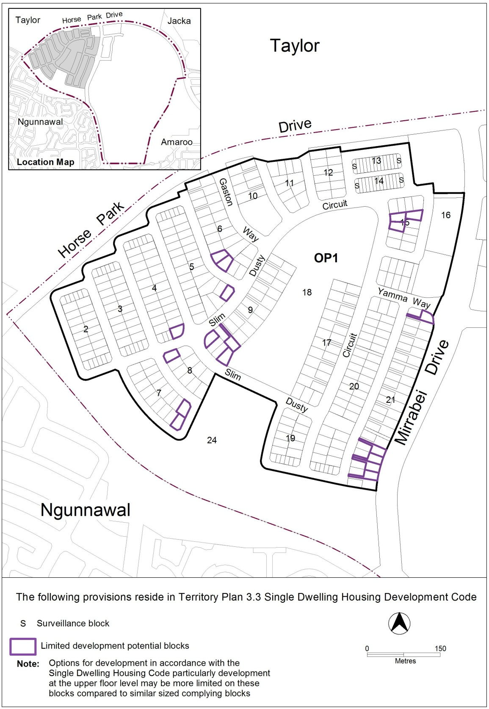
Figure 4 Moncrieff residential area ongoing provisions

