Australian Capital Territory

Planning and Development (Technical Amendment—District of Stromlo and Tuggeranong) Plan Variation 2015 (No 1)*

Notifiable Instrument NI2015—200
Technical Amendment No 2015—10
made under the
Planning and Development Act 2007, section 89 (Making technical amendments) (s96A Rezoning – boundary changes)

This plan variation commences on the day after it is notified.

Variation No 2015—10 to the Territory Plan has been approved by the Planning and Land Authority.

Variation to the Territory Plan
The Territory Plan map is varied as indicated in Annexure A this variation specifies changes to the public land overlays, Pc – a nature reserve and Pd – a special purpose reserve. The zones have been removed to give clarity to the map.

Jim Corrigan
Delegate of the Planning and Land Authority
Date 30.04.15

THIS IS PAGE ONE OF ANNEXURE A
TO NOTIFIABLE INSTRUMENT NI2015 – 200

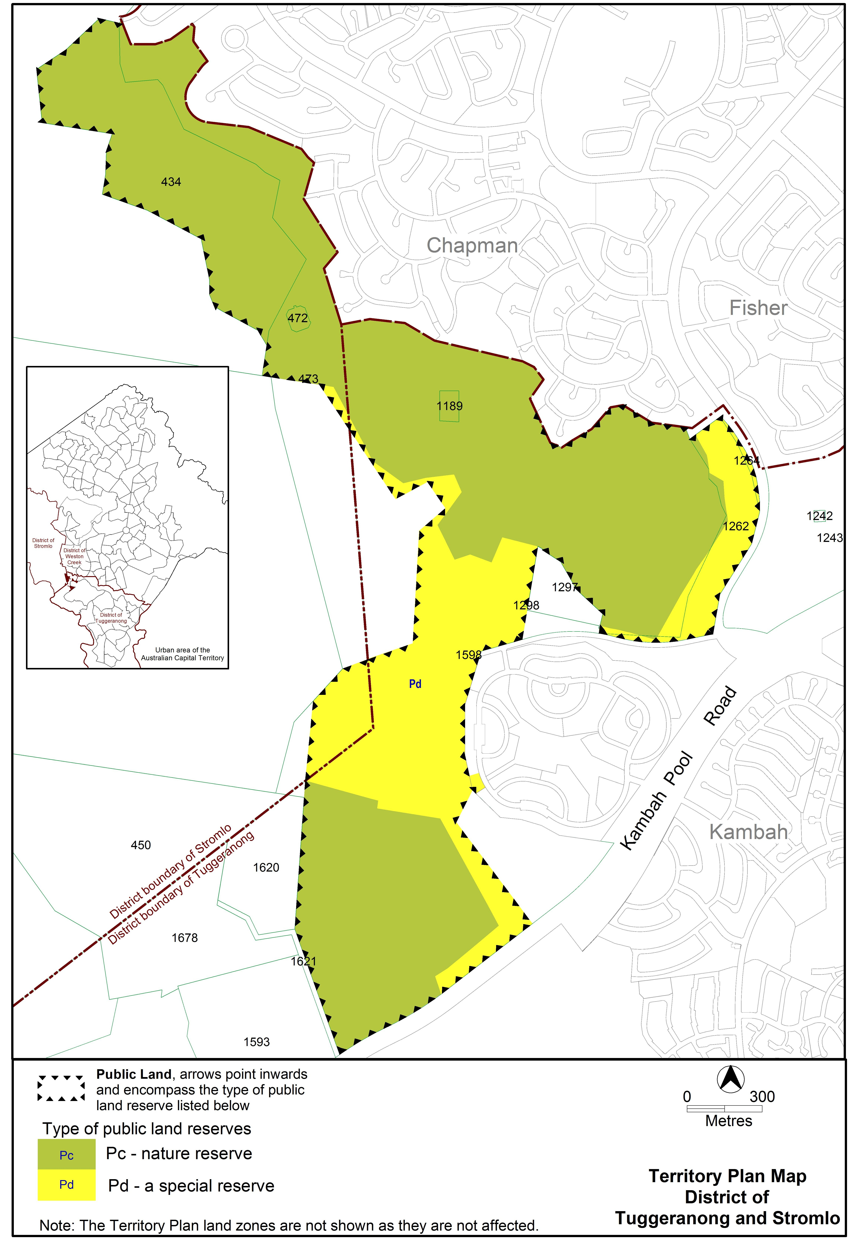

Jim Corrigan
Delegate of the Planning and Land Authority
Date 30.04.15

