Australian Capital Territory
Planning and Development (Draft Variation No 347) Consultation Notice 2015*
Notifiable Instrument NI2015—208
made under the
Planning and Development Act 2007, section 63 (Public consultation - notification) and section 64 (Public consultation – notice of interim effect etc)

Under the Planning and Development Act 2007 (the Act), section 63(1), the planning and land authority has prepared a draft variation to the Territory Plan No 347 (DV347) (Annexure A), to implement the key finding of the University of Canberra Master Plan and supporting documents.
DV347 proposes to:
- Broaden the Territory Plan uses allowed on the university site by permitting a number of uses associated with the operation of a contemporary university as merit track assessable development;
- Provisions for, and create greater, certainty in relation to building heights;
- Incorporate additional design provisions and general requirements;
- Limit the scale of non-student residential development to 3,300 dwellings;
- Limit the gross floor area of SHOP to 200m² and supermarket to 1000m²;
- Allow for an increase in the scale of third-party commercial office (e.g. non-university related commercial office development) spaces. Currently in the Community Facility Zone an office must be used for a not for profit organisation and is limited to 400m². The draft variation removes the requirement for a not for profit organisation but amends office, public agency and business agency use limit to 2000m². The draft variation introduces a criterion which allows an office to be larger than 2000m² where it can be demonstrated that the development is not of a scale which will compete unduly with the Belconnen Town Centre; and
- Allow for a more qualitative approach to assessing multi unit housing.
The draft variation is available online at www.act.gov.au/draftvariations until the closing date for written comments.
Printed copies of the draft variation and background documents are available for inspection and purchase at the Environment and Planning Customer Service Centre 16 Challis Street Dickson weekdays (except public holidays) between 8:30am and 4:30pm. Please call 6207 1923 to arrange a copy for purchase.
Written comments from the public are invited by COB Monday 29 June 2015.
Comments should include reference to the draft variation, your name and contact details and be addressed to Territory Plan Unit.
Comments can be:
- emailed to terrplan@act.gov.au
- mailed to Territory Plan Comments, GPO Box 1908, Canberra, ACT 2601
- delivered to EPD’s Customer Service Centre at the above address
Comments received will be made available 10 working days after the closing date. The comments will be available for no less than 15 working days at EPD’s customer service centre in Dickson and may be published on EPD’s website.
Comments made available will include personal contact details unless excluded under section 411 or 412 of the Planning and Development Act 2007 (the Act). A request for exclusion under this section must be in writing, clearly identifying what you are seeking to exclude and how the request satisfies the exclusion criteria.
Effect of the draft variation
Section 65 of the Planning and Development Act 2007 does not apply in relation to the draft variation so it does not have interim effect. The current Territory Plan will continue to apply while the variation remains in draft form.

Jim Corrigan
Delegate of the Planning and Land Authority
13 May 2015

Planning and Development Act 2007

Draft
Variation to the
Territory Plan
No 347

University of Canberra
Block 1 Section 3 Bruce

May 2015

Draft variation for public consultation prepared
under s60 of the Planning and Development Act 2007

This page is intentionally blank.

Contents

1. INTRODUCTION 1
1.1 Summary of the Proposal 1
1.2 Outline of the process 2
1.3 This document 3
1.4 Public Consultation 3
2. EXPLANATORY STATEMENT 4
2.1 Background 4
2.2 Site Description 5
2.3 Current Territory Plan Provisions 6
2.4 Proposed Changes 7
2.4.1 Proposed Changes to the Territory Plan Map 7
2.4.2 Proposed Changes to Territory Plan 7
2.5 Reasons for the Proposed Draft Variation 8
2.6 Planning Context 10
2.6.1 National Capital Plan 10
2.6.2 Territory Plan 10
2.7 Interim Effect 11
2.8 Consultation with Government Agencies 11
3. DRAFT VARIATION 17
3.1 Variation to the Territory Plan 17

This page is intentionally blank.

- INTRODUCTION
  - Summary of the Proposal
Draft Variation 347 implements key findings of the University of Canberra Master Plan and supporting documents. The draft variation proposes to:
- Broaden the Territory Plan uses allowed on the university site by permitting a number of uses associated with the operation of a contemporary university as merit track assessable development;
- Provisions for, and create greater, certainty in relation to building heights;
- Incorporate additional design provisions and general requirements;
- Limit the scale of non-student residential development to 3,300 dwellings;
- Limit the gross floor area of SHOP to 200m² and supermarket to 1000m²;
- Allow for an increase in the scale of third-party commercial office (e.g. non-university related commercial office development) spaces. Currently in the Community Facility Zone an office must be used for a not for profit organisation and is limited to 400m². The draft variation removes the requirement for a not for profit organisation but amends office, public agency and business agency use limit to 2000m². The draft variation introduces a criterion which allows an office to be larger than 2000m² where it can be demonstrated that the development is not of a scale which will have a material adverse impact on the Belconnen Town Centre; and
- Allow for a more qualitative approach to assessing multi unit housing

  - Outline of the process
The Commonwealth’s Australian Capital Territory (Planning and Land Management) Act 1988 allows for the Legislative Assembly to make laws to establish a Territory Planning Authority and for that Authority to prepare and administer a Territory Plan. The Planning and Development Act 2007 (the Act) establishes the planning and land authority as the Authority which prepares and administers the Territory Plan, including continually reviewing and proposing amendments as necessary. The functions of the planning and land authority are administered by the Environment and Planning Directorate (EPD).
The Territory Plan is comprised of a written statement and a map. The written statement contains a number of parts, namely governance; strategic directions; zones (including objectives and development tables and zone or centre development codes); precinct codes; general codes; overlays; definitions; structure plans, concept plans and development codes for future urban areas.
The Territory Plan Map graphically represents the applicable land use zones (under the categories of residential, commercial, industrial, community facility, urban parks and recreation, transport and services and non urban), precincts and overlays. The zone, precinct and overlay requirements are detailed in the volumes of the Territory Plan.
Draft variations to the Territory Plan are prepared in accordance with the Act. Following the release of the draft variation under section 63 of the Act, submissions from the public are invited. At the conclusion of the consultation period the EPD submits a report on consultation and a recommended final variation to the Minister responsible for planning for approval. The Minister has the discretion to determine if referral to the Legislative Assembly standing committee responsible for planning is warranted prior to approval, depending on the nature and significance of the proposal. If the draft variation is referred to the committee by the Minister or otherwise, the Minister must consider the findings of the committee before deciding whether to approve the draft variation. If the Minister approves the variation, the variation and associated documents will be tabled in the Legislative Assembly. Unless disallowed by the Legislative Assembly within five sitting days, the variation commences on a day nominated by the Minister.

  - This document
This document contains the background information in relation to the proposed variation. It comprises the following parts
Part 1 This Introduction
Part 2 An Explanatory Statement, which gives reasons for the proposed variation and describes its effect
Part 3 The Draft Variation, which details the precise changes to the Territory Plan that are proposed

  - Public Consultation
Written comments about the draft variation are invited from the public by COB Monday 29 June 2015.
Comments should include reference to the draft variation, your name and contact details, and be addressed to the Territory Plan Section.
Comments can be:
- emailed to terrplan@act.gov.au
- mailed to Territory Plan Section, GPO Box 158, Canberra, ACT 2601
- delivered to EPD’s Customer Service Centre at 16 Challis Street, Dickson
Copies of written comments will be made available (unless excluded) for public inspection for no less than 15 working days starting 10 working days after the closing date for comment. The comments will be available at EPD’s customer service centre in Dickson and may be published on EPD’s website.
Comments made available will include personal contact details unless excluded under section 411 or 412 of the Planning and Development Act 2007. A request for exclusion under these sections must be in writing, clearly identifying what you are seeking to exclude and how the request satisfies the exclusion criteria.
Further Information
The draft variation, and background documents are available online at www.act.gov.au/draftvariations until the closing date for written comments.
Printed copies of the draft variation (this document) and background documents are available for inspection and purchase at the Environment and Planning Customer Service Centre, 16 Challis Street, Dickson, Monday to Friday (except public holidays) between 8:30am and 4:30pm. Please call 6207 1923 to arrange a copy for purchase.
- EXPLANATORY STATEMENT
  - Background
The University of Canberra (UC) opened in 1968 as the Canberra College of Advanced Education, the first centre for adult education (CAE) in Australia. In 1990 the UC was re-created as a university as a part of national educational reforms. Today the UC is one of the major tertiary education establishments within the Australian Capital Territory (ACT) and Australia.
As a highly competitive market, elite universities around Australia and the world provide a range of high quality services and facilities to attract the best students and staff. These facilities include not only educational or residential accommodation but also strong links with industry and convenient commercial services. Recognising the shift in the types of services and facilities contemporary universities are providing staff, students and the wider community, UC has prepared a master plan which sets out their future vision for the campus. The Urban Plan, which is informed by the UC master plan sets out more detailed, shorter term goals which are to be achieved.
For UC to continue its growth and remain competitive as an elite education provider the planning controls which govern development on the campus will need to be broadened. This broadening of planning controls will allow UC to pursue commercial opportunities that benefit education and research on the Vruce campus as well as the broader community. Such opportunities are also pursued by other universities around Australia (and the world), such as the Australian National University, Monash University and Macquarie University.
The UC is a unique case in terms of land use planning as by virtue of the University of Canberra Act 1989 (the Act), development on the Bruce campus is also regulated under the Act. The Act sets out the powers and functions of the university. Due to UC’s importance to Canberra the Act requires involvement of the ACT Government with respects to certain functions, such as appointment to the UC Council and places controls and limitations on aspects of the universities activities. As such the ACT Government has a relatively larger degree of control over the UC and therefore the UC Bruce Campus when compared to almost all other development areas within the ACT. The UC council and other internal decision making bodies within the UC further restrict and regulate development undertaken on campus through not only the Territory Plan but also internal design standards and governance rules. This additional level of control means that the Territory Plan is not required to be as prescriptive when referring to development of the UC Bruce campus.
This draft variation to the Territory Plan is one part of a suite of changes being made to legislation and requirements which relates to the University of Canberra For instance the ACT Government has enacted legislative changes to the Act in relation to the university’s powers which will allow more flexible leasing arrangements and the ability for the UC to commercialise some of its underutilised assets.

  - Site Description
The subject area is located in the division of Bruce, specifically block 1 section 3. The site is generally bordered by Ginninderra Drive to the north, Haydon Drive to the east, College Street to the south and Aikman Drive to the west.
The site is currently occupied by the University of Canberra campus which has a number of buildings (educational, administrative and student accommodation) and open spaces (including sporting ovals and facilities).
One of the student accommodation buildings is registered on the Heritage register, as it has identified as having heritage significance.
The site is currently zoned CFZ Community Facility Zone under the Territory Plan.
The location of the site can be seen in Figure 1.
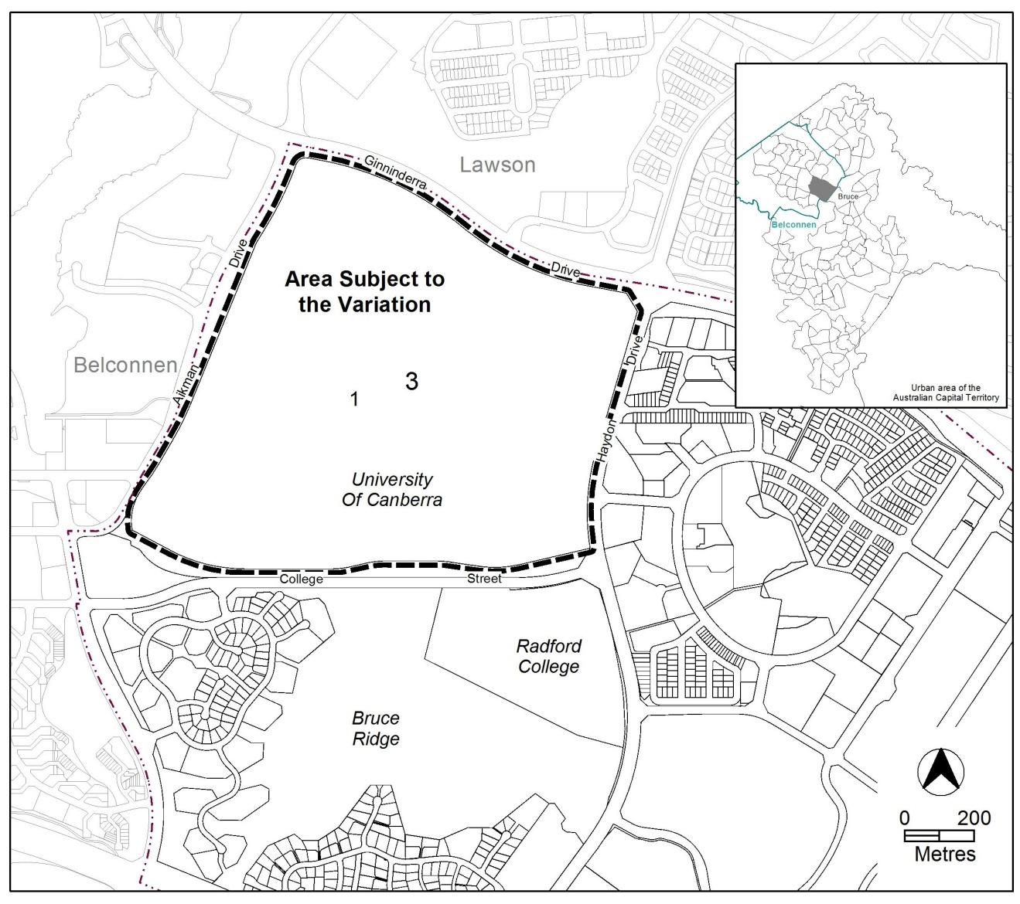
Figure 1 Location Plan
  - Current Territory Plan Provisions
The Territory Plan map zone for the area subject to this variation is shown in Figure 2.

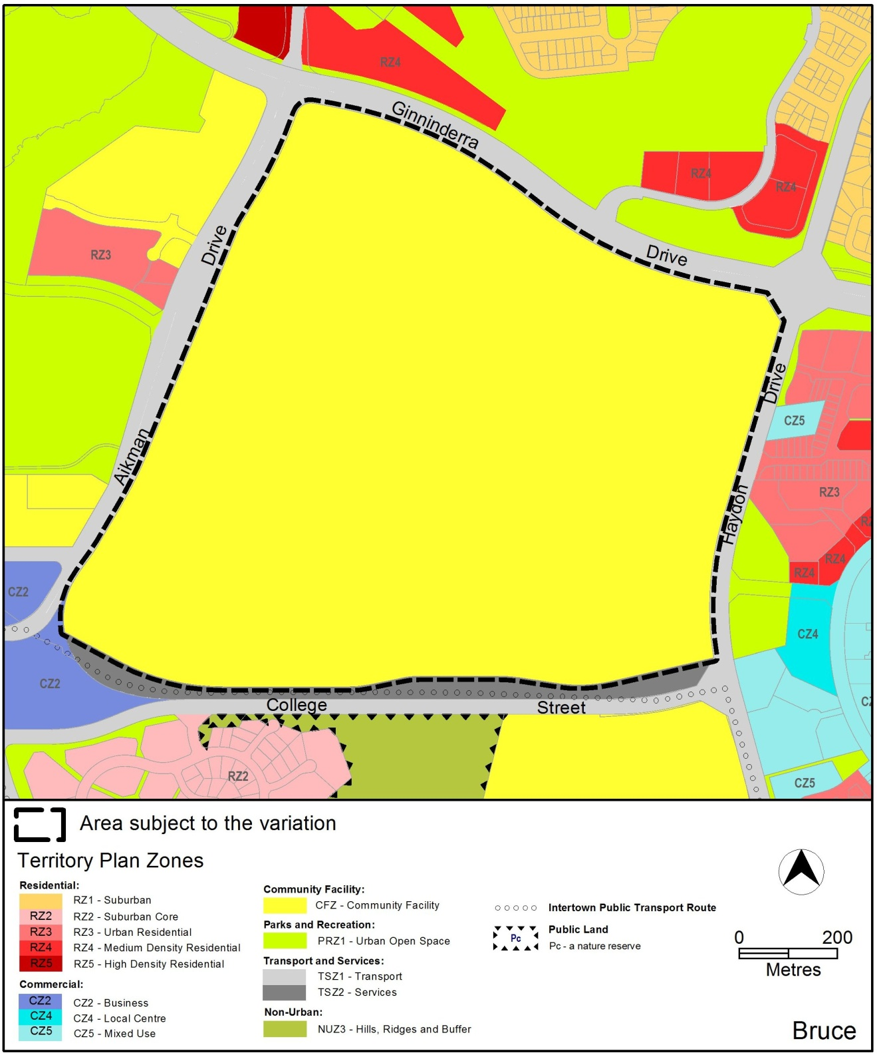Figure 2 Territory Plan Zones Map

  - Proposed Changes
    - Proposed Changes to the Territory Plan Map
There are no proposed changes to the Territory Plan Map associated with this variation.

The draft variation map indicates the proposed zone boundaries as accurately as possible but may be subject to adjustments following detailed surveys.

    - Proposed Changes to Territory Plan
It is proposed to amend the Bruce precinct map and code, in accordance with the visions of the University of Canberra Master Plan, as follows:
- Broaden the Territory Plan uses allowed on the university site by permitting a number of uses associated with the operation of a contemporary university as merit track assessable development;
- Incorporate provisions for and greater certainty in relation to building heights;
- Incorporate additional design provisions and general requirements;
- Limit the scale of non-student residential development to 3,300 dwellings;
- Limit the gross floor area of SHOP to 200m² and supermarket to 1000m²;
- Allow for an increase in the scale of third-party commercial office (e.g. non-university related commercial office development) spaces. Currently in the Community Facility Zone an office must be used for a not for profit organisation and is limited to 400m². The draft variation removes the requirement for a not for profit organisation but amends office, public agency and business agency use limit to 2000m². The draft variation introduces a criterion which allows an office to be larger than 2000m² where it can be demonstrated that the development is not of a scale which will have a material adverse impact on the Belconnen Town Centre; and
- Allow for a more qualitative approach to assessing multi unit housing

  - Reasons for the Proposed Draft Variation
The key reasons for the proposed draft variation can be seen below.

2.5.1 A Financially Sustainable and Competitive University
The draft variation implements the key visions of the University of Canberra’s Master Plan which sets out long term goals for the development of the campus in accordance with contemporary expectations of an elite university.
In the current economic and policy environment, universities must find innovative ways to differentiate themselves from their competition and secure long-term investments in their institutions. Attracting investment will create crucial sources of funding, which are required to enhance course offerings, attract world class researchers and teaching staff and provide advanced learning and research facilities for university students and staff.

2.5.2 Efficient Facilitation of University Vision
Under the current planning framework, the University of Canberra is allowed to propose and build any development it demonstrates is ancillary to the use of the site as an educational establishment. For example, if directly linked to university use, it may propose to develop student accommodation or offices even though these uses may be prohibited within the current Territory Plan zone. This draft variation proposes to permit these currently ancillary uses in their own right to create a more efficient development approval process.
The draft variation also allows for development that will facilitate achievement of the University’s greater corporate vision. For example, it will allow for the development of health, cultural and sporting facilities and industry collaborations that support the ongoing financial and educational performance of the University. Businesses, such as a veterinary hospital, dental practice and research commercialisation facilities will be able to be co-located at the campus. These new commercial enterprises will not only service the public but also allow synergies with the university providing real world training for students and enhance opportunities for knowledge sharing.

2.5.3 Enhancement of Community Benefits
This variation will allow the University of Canberra to diversify its services to provide a broad range of facilities to for staff and students as well as the ACT community. As a result, UC will be able to provide healthcare, sporting facilities and housing as well as associated amenity through retail and commercial services. Other contemporary elite universities, such as the Australian National University, already provide similar services.

2.5.4 Unique Planning Oversight and Development Controls
The above broadening and diversification of uses under the Territory Plan for the UC campus can be achieved due to the unique relationship that the UC and the ACT Government share. The ACT Government appoints members to the University of Canberra Council, which is the governing body responsible for oversight for the university planning and development framework. UC also has an internal development board, finance committee and environment and works committee which maintain their own development, financial and planning policies and oversight, in addition to Territory Plan controls. These additional layers of control allow for rigorous assessment and implementation of development proposals.

  - Planning Context
    - National Capital Plan
The Australian Capital Territory (Planning and Land Management) Act 1988 established the National Capital Authority (NCA) with two of its functions being to prepare and administer a National Capital Plan (NCP) and to keep the NCP under constant review and to propose amendments to it when necessary.
The NCP, which was published in the Commonwealth Gazette on 21 January 1990 is required to ensure that Canberra and the Territory are planned and developed in accordance with their national significance. The Planning and Land Management Act 1988 also required that the Territory Plan is not inconsistent with the NCP.

    - Territory Plan
Statement of Strategic Directions
The proposal is consistent with the Territory Plan’s statement of strategic directions in terms of environmental, economic and social sustainability and spatial planning and urban design principles.
1.9 Urban expansion will be contained in order to minimise impacts on valuable natural and rural areas
1.12 Planning policies will facilitate the widest possible range of commercial, retail, industrial, rural, tourism, and other forms of economic activity in order to promote new investment and a more diversified economy, to underpin employment growth, and to respond to changing economic opportunities.
1.20 Planning policies for community facilities and open space will encourage multiple use and flexible design to allow for changing needs.
By varying the Territory Plan to broaden the permissible uses of the current CFZ Community Facility Zoning it will allow the University of Canberra do the following:
- more efficient use of vacant space currently on block 1 section 3 Bruce to co-locate facilities which are allied to university business;
- allow for the University of Canberra to respond to changing needs by providing flexibility in use to meet current and future demands.
- Allow the facilitation of future economic activity for the University of Canberra and the ACT, both publically and privately.

  - Interim Effect
Section 65 of the Planning and Development Act 2007 does not apply in relation to the draft variation so it does not have interim effect. The current Territory Plan will continue to apply while the variation remains in draft form.

  - Consultation with Government Agencies
The EPD is required to, in preparing a draft variation under section 61(b) consult with each of the following in relation to the proposed draft variation:
- the national capital authority
- the conservator of flora and fauna
- the environment protection authority
- the heritage council
- if the draft variation would, if made, be likely to affect unleased land or leased public land – each custodian for the land likely to be affected

NATIONAL CAPITAL AUTHORITY
The National Capital Authority provided the following comments on 11 May 2015:
“Of key interest to the NCA is the proposal to allow for an increase in the scale of non-university related commercial office development and the potential impacts of this on the Belconnen Town Centre.
One of the key principles of Canberra’s urban structure has been that a hierarchy of centres has been developed, with each town having a centre acting as a focal point for higher order retail functions, commercial services, offices and community facilities. Principles of the National Capital Plan (the Plan) for urban areas require that the established hierarchy of centres is maintained.
The NCA understands that the proposed variation removes the limitation for an office in the Community Facility Zone to be not-for-profit only and of a maximum 400m² in size. Specifically, the variation makes provision for a ‘business agency’, ‘office’ or ‘public agency’ not related to university activities to be larger than 200m2 provided it meets particular criteria, including that it is not of a scale which may compromise the primacy of the Belconnen Town Centre.
The ‘University of Canberra – Development Impact Study’ indicates that there is substantial capacity for development at the university. Unlike non-university related residential use, which is capped at 3,300 dwellings, it is not evident that there is an upper limit for non-university related commercial development. The NCA is not confident that the cumulative impacts of this type of commercial development will appropriately protect the primacy of the Belconnen Town Centre. While individual developments are limited to a maximum gross floor area of 2000m2, there are no further restrictions on the total GFA of non-university related commercial development.
The NCA supports the proposed criteria limiting proposals to a scale that does not have a material adverse impact on the Belconnen Town Centre, however suggests that the Environment and Planning Directorate should explore capping non-university related commercial development to make sure that this objective can be achieved.
Balancing where development occurs in Belconnen could also assist in achieving the goals for the town centre and help address the economic development issues outlined in the Belconnen Town Centre Master Plan.”

ACT Planning and Land Authority response
The National Capital Authority’s (NCA) concerns relating to the impacts of excessive commercial development not related to the University of Canberra’s core functions are noted.
Commercial development which is not strictly related to universities functions is becoming more prevalent with Australian and around the world. The need to provide students and staff with services and facilities and to create nexus between theory and industry has driven this phenomenon.
Development of the University of Canberra over a long period is not seen as a competitor to Belconnen Town Centre but, due to location, is seen as an extension of it.
DV347 has a criteria to control office, public agency and business agency where not related to core university functions and is larger than 2000m2 so they do not have a material adverse impact on the Belconnen Town Centre.

CONSERVATOR OF FLORA AND FAUNA
The Conservator of Flora and Fauna made the following comments on 6 May 2015:
“The Variation does not include any zone boundary changes or increase the likelihood or ease by which significant biodiversity values may be destroyed. However, it must be noted that the University of Canberra campus contains:
- approximately 5 hectares of known habitat for Golden Sun Moth (Synemon plana). This species is listed as endangered under the Nature Conservation Act 1980 (NCA) and critically endangered under the Commonwealths’ Environment Protection and Biodiversity Conservation Act 1999 Act(sic) (EPBC);
- remnant patches of endangered Yellow Box – Blakely’s Red Gum Woodland, also listed as endangered under the NCA and critically endangered under EPBC;
- several hectares of native vegetation; and
- known foraging habitat of threatened woodland bird species such as the Superb Parrot.
It is likely that at least some development on the campus is likely to have significant environmental impacts as defined under Schedule 4 of the Planning and Development Act 2007, and as such will either require assessment under the impact track or an Environmental Significance Opinion from the Conservator of Flora and Fauna.
Incorporating water sensitive urban design into all new developments is important to mitigate the impacts on downstream waterways from sediments, hydrocarbons, nutrient loads and gross pollutants. The proposed variation includes special requirements for water sensitive urban design for large developments excluding multi unit (Additional Rules and Criteria Rules 6.7 R19-R22), which is supported.
I understand that the requirement for multi unit dwellings to comply is intended to be addressed under 9.3 (R 37 and C 37) however it appears to contradict 6.7 and there may be confusion in the future if the water sensitive urban design requirements are to be met as a criteria.
As the requirements in 6.7 are identical to the requirements contained in the Multi Unit Housing Development Code, an opinion would be to amend Rules 19-22 by deleting the words ‘excluding multi unit housing’. This will avoid any confusion as to whether any future multi unit housing developments are required to incorporate water sensitive urban design components.”

ACT Planning and Land Authority response
It is noted that at least some development on the campus is likely to have significant environmental impacts. These impacts will be determined and dealt with at the detailed design and development assessment phase when the location and extent, if any, impacts are known. It is also noted that if development a future development causes significant environmental impacts than the application will be assessed in the impact track (at the time of a development application) or will require an Environmental Significance Opinion to be sought and agreed to by the Conservator of Flora and Fauna.

It is also noted that there could be some confusion around what provisions apply to multi unit housing in relation to water sensitive urban design. The intention of DV347 is to apply the relevant water sensitive urban design requirements. To improve clarity as to where water sensitive urban design requirements apply the following changes have been made to the draft variation:
- Adding of a note to R19-22 confirming that multi unit housing will need to comply with the water sensitive urban design provisions under the multi unit housing development code;
- Removal of the words ‘excluding multi unit housing’ from R23. Therefore R23 will apply to all development;
- Adding a criteria (k)v.) to C37. This means that where a multi unit housing development does not choose to meet R37 and comply with the multi unit housing development code it will still need to meet the water sensitive urban design requirements of that code.

ENVIRONMENT PROTECTION AUTHORITY
The Environment Protection Authority provided the following comments on
13 May 2015:
“The EPA support the proposed variation to the Territory Plan provided the site is determined to be suitable form a contamination perspective by the EPA for the proposed uses.

The ACT Government’s ‘Strategic Plan for Contaminated Sites Management 1995’ requires that potentially contaminated land be investigated at the earliest stages of the planning process to ensure a site is suitable for the proposed development. EPA records indicate the potential for contamination to exist at the site associated with past and current uses.

Furthermore, the ongoing management of live music events may be impacted by the change in zoning. The compliance point that is currently used for live music events will likely change as a result of future development on the block. This may impact the management of future live music events at the site. A noise management assessment should be completed by the university to inform itself of any potential impacts.

ACT Planning and Land Authority response
Noted. Issues relating to contamination and noise management can be dealt with at the detail design and development application phase.

ACT HERITAGE COUNCIL
The Heritage Council provided the following comments on 4 May 2015:
“ACT Heritage advises that Block 1, Section 3, Bruce contains two registered heritage places, being the University of Canberra Student Residences Group 2 (the Student Residences) and an Aboriginal heritage place, BELC 19. A further 11 Aboriginal heritage places have also been recorded on the block, being UCPH IF 1, UC1, UC2, UC3, UC4, UC5, UC6, UC7, UC8, UC9 and UC10. In addition, two areas of potential archaeological deposit – where subsurface Aboriginal objects are considered likely to occur – have also been identified within the block.

Documents provided with the Draft Territory Plan Variation acknowledge the heritage registration of the Student Residences, which ACT Heritage understands will not be impacted by proposed development. However, documents provided do not currently acknowledge any of the registered or recorded Aboriginal heritage sites within Block 1, Section 3, Bruce; and these documents should be revised to describe the known heritage values of the locality. ACT Heritage also notes that several recorded Aboriginal heritage places may be located within proposed development areas, and anticipates that the ‘University of Canberra Development Impact Study’ will be revised to identify the constraints and opportunities in relation to heritage values of place.

In the above context, ACT Heritage does not object to DTPV347, as while the block contains several heritage places, provisions of the Heritage Act 2004 will guide the management of these places and future development applications will be referred to the ACT Heritage Council for advice.”

ACT Planning and Land Authority response
Noted. As stated by the ACT Heritage Council, places or objects, covered under the Heritage Act 2004, will be determined and managed at the development application stage. As DV347 does not propose any development within itself, it cannot be determined, at this stage, where future development will occur on the site and if it will impact places or objects of heritage significance. Therefore determining the impact on places or objects of heritage significance at the development assessment stage, will allow the ACT Heritage Council to determine if the development impacts heritage places or objects and if so, to what extent.

- DRAFT VARIATION
  - Variation to the Territory Plan
The Territory Plan is varied in all of the following ways:

Variation to the Bruce precinct map and code
- Precinct maps and codes - Bruce precinct map and code

Substitute the following for the nominated attachment
Bruce Precinct map and development tables – Attachment A

Add the nominated attachment to the end of the Bruce Precinct Code:
Bruce Precinct code RC4 Canberra University – Attachment B

Interpretation service
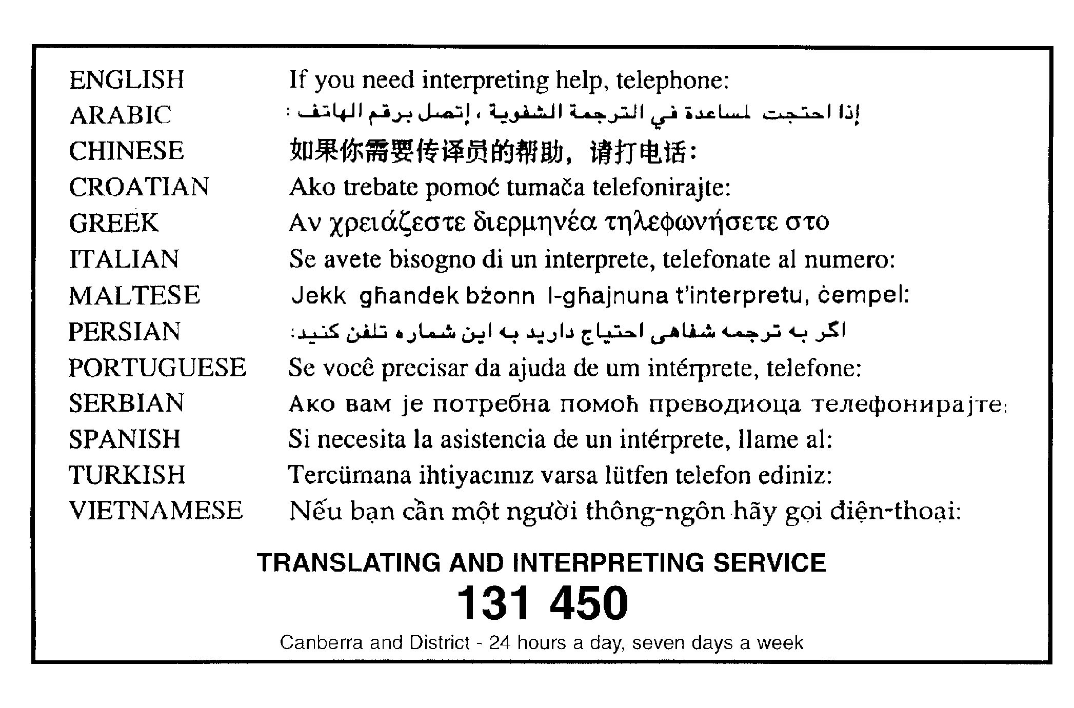

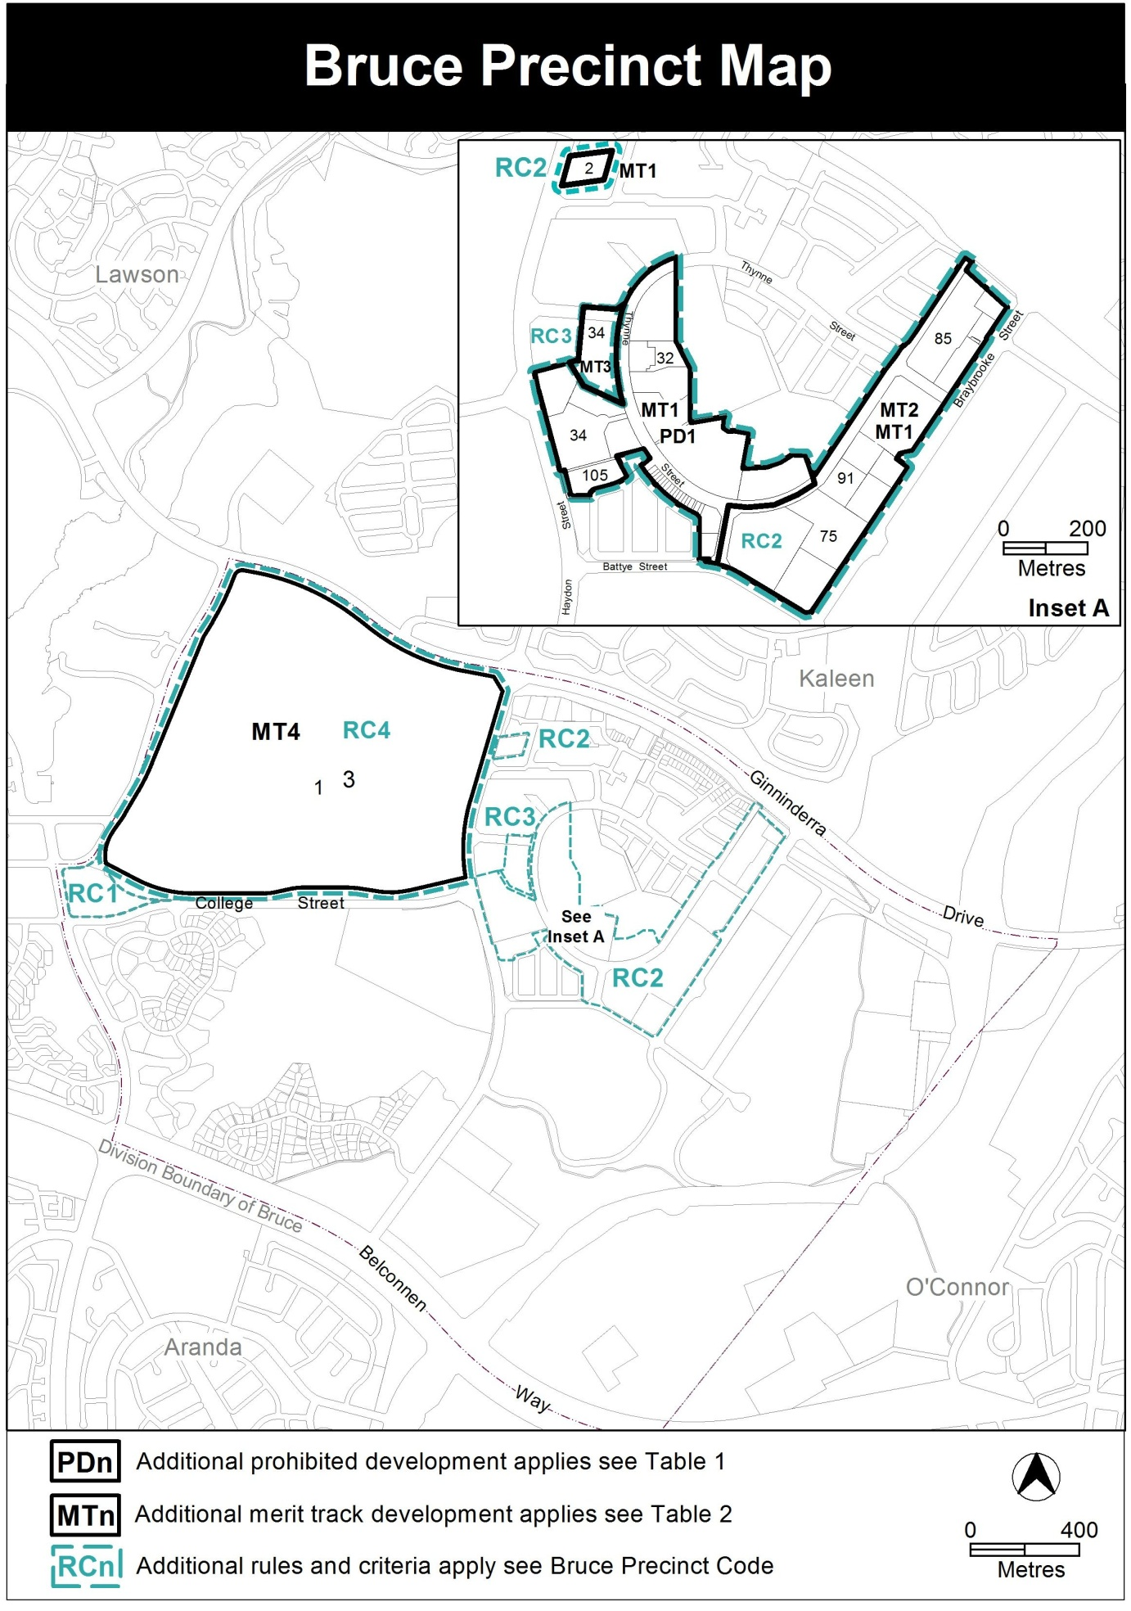

Assessment Tracks

The following tables identify the additional prohibited development and additional merit track development for blocks and parcels shown in the Bruce Precinct Map (identified as PDn or MTn). Development that is exempt from requiring development approval, other prohibited development and the minimum assessment track applicable to each development proposal is set out in the relevant zone development table.

The following tables constitute part of the relevant zone development table.

Table 1 – Additional prohibited development
Additional prohibited development
Suburb precinct map label | Zone | Development
PD1 | CZ5 | hotel

Table 2 – Additional merit track development
Additional merit track development that may be approved subject to assessment
Suburb precinct map label | Zone | Development
MT1 | CZ5 | defence installation drink establishment  light industry place of assembly  scientific research establishment  store warehouse
MT2 | CZ5 | club
MT3 | CZ4 | drink establishment
MT4 | CFZ | car park  club  commercial accommodation unit  communications facility  craft workshop  drinks establishment  financial establishment  hotel  indoor entertainment facility  light industry  motel  multi-unit housing  nature conservation area  place of assembly  playing field  pedestrian plaza  produce market  public transport facility  restaurant  scientific research establishment  service station  serviced apartment  SHOP  store  veterinary hospital

Additional rules and criteria

This part applies to blocks and parcels identified in the Bruce Precinct Map (RCn). It should be read in conjunction with the relevant zone development code and related codes.

RC4 – University of Canberra
This part applies to blocks and parcels identified in area RC4 shown on the Bruce Precinct Map.

Element 6: General Development Controls

Rules | Criteria
6.1 Storage
There is no applicable rule | C12  Where the proposed development requires open areas for storage of goods and materials, adequate provision is included in the design and layout of the site and should not encroach on car parking, driveways or landscape areas and be adequately screened from public view so it does not detract from the development or its surroundings.
  - Traffic Generation
There is no applicable rule | C13  A whole of University of Canberra campus Integrated Transport Assessment that includes all existing development must be prepared or a overall existing one be amended to include each new development proposal in order to demonstrate appropriate levels of impact of the development on the local district and transport network.
6.3 Vehicular Parking
R14  This rule applies to all development not covered by the Parking and Vehicle Access General Code for the Community Facility Zone  Development complies with the Parking and Vehicle Access General Code as if it were a ‘Commercial CZ5 mixed use zone’ | This is a mandatory requirement. There is no applicable criterion.

Rules | Criteria
6.4 Noise
R15  This rule applies to any of the following:  - club  - drinks establishment  - emergency services facility  - hotel  - indoor recreation facility  - indoor entertainment facility  - outdoor recreation facility  - restaurant  Development complies with a noise management plan prepared by a suitably qualified person and endorsed by the Environment Protection Authority (EPA).  The noise management plan will detail the proposed design, siting and construction methods that will be employed to ensure compliance with the Environment Protection Regulation 2005, based on the estimated noise levels when the facility is used. | This is a mandatory requirement. There is no applicable criterion.
  - Wind
There is no applicable rule | C16  This criterion applies to buildings with a height of building greater than 19m but less than 28m.  The wind patterns associated with the proposed building will not unreasonably reduce the safety and comfort of people in the public realm or other open spaces associated with the development, compared with a similar building on the site with a height of building of 19m.  Compliance with this criterion will be demonstrated by a wind assessment report prepared by a suitably qualified person.

Rules | Criteria
R17  This rule applies to buildings with a height of building greater than 28m  As a consequence of the proposed development wind speeds do not exceed 16 m/s for all adjacent streets, public places and pedestrian areas.  Compliance with this rule is demonstrated by a wind assessment report prepared by a suitably qualified person. | This is a mandatory requirement. There is no applicable criterion.

Rules | Criteria
  - Landscaping
There is no applicable rule | C18  This criterion applies to all uses, excluding multi unit housing.  Landscaping associated with the development achieves all of the following:  - responds to site attributes, including streetscapes and landscapes of documented heritage significance  - appropriate scale relative to the road reserve width and building bulk  - vegetation types and landscaping styles which complement the streetscape  - integration with park , reserves and public transport corridors  - does not adversely affect the structure of the proposed buildings or adjoining buildings  - contribution to energy efficiency and amenity by providing substantial shade in summer, especially to west-facing windows and open car park areas, and admitting winter sunlight to outdoor and indoor living areas  - minimises overlooking between buildings  - minimises the risk of damage to aboveground and underground utilities and screens aboveground utilities  - provides adequate site lines for vehicles and pedestrians, especially near street corners and intersections  - does not obscure or obstruct building entries, paths and driveways to reduce the actual or perceived personal safety and security.

Rules | Criteria
6.7 Water sensitive urban design
R19  This rule applies to sites 5000m2 or larger, excluding multi unit housing.  The average annual storm water pollutant export is reduced for all of the following:  - suspended solids by at least 60 percent  - total phosphorous by at least 45 percent  - total nitrogen by at least 40 percent  compared with an urban catchment with no water quality management controls.  Note: Compliance with this rule is demonstrated by a water sensitive urban design outcomes plan endorsed by a suitably qualified person.  Note: Multi unit housing will need to comply with the rules and/or criteria (where relevant) for Water sensitive urban design located in the multi unit housing development code. | This is a mandatory requirement. There is no applicable criterion
R20  This rule applies to sites 2000m2 or larger, excluding multi unit housing.  Storm water management complies with one of the following:  - the capacity of the existing pipe (minor) storm water connection is not exceeded in 1-in-10 year storm event and the capacity of the existing major overland storm water system is not exceeded in the 1-in-100 year storm event  - the 1-in-5 year and 1-in-100 year storm water peak run off does not exceed pre-development levels.  Note: Compliance with this rule is demonstrated by a water sensitive urban design outcomes plan endorsed by a suitably qualified person  Note: Multi unit housing will need to comply with the rules and/or criteria (where relevant) for Water sensitive urban design located in the multi unit housing development code. | This is a mandatory requirement. There is no applicable criterion

Rules | Criteria
R21  This rule applies to sites 2000m2 or larger, excluding multi unit housing.  Provision is made for one or more of the following:  - the storage of storm water equivalent to at least 1.kl per 100m2 of impervious area and its release over a period of 1 to 3 days  - runoff peak flow for the 3 month ARI storm to be no more than pre-development levels and release of captured flow over a period of 1 to 3 days.  Note: Compliance with this rule is demonstrated by a water sensitive urban design outcomes plan endorsed by a suitably qualified person  Note: Multi unit housing will need to comply with the rules and/or criteria (where relevant) for Water sensitive urban design located in the multi unit housing development code. | This is a mandatory requirement. There is no applicable criterion
R22  This rule applies to all development excluding multi unit housing.  Evidence is provided that shows the development achieves a minimum 40% reduction in mains water consumption compared to an equivalent development constructed in 2003 using the ACTPLA on-line assessment tool or another tool as included in the Water Ways: water Sensitive Urban Design General Code. The 40% target is met without any reliance on landscaping measures to reduce consumption.  This requirement does not apply for extensions with an increase in the combined roof area, driveway, car maneuvering areas and car parking areas of less than 25% of the original area.  Note: Multi unit housing will need to comply with the rules and/or criteria (where relevant) for Water sensitive urban design located in the multi unit housing development code. | This is a mandatory requirement. There is no applicable criterion

Rules | Criteria
There is no applicable rule. | R23  Underground piping of natural storm water overland flow paths is minimised.
6.8 Endorsement by government agencies (entities)
R24  This rule applies to all development excluding multi-unit housing.  Uses applicable to this rule complies with the Commercial Zones Development Code Part G – Endorsement by government agencies | This is a mandatory requirement. There is no applicable criterion
6.9 Tree Protection
R25  This rule applies to a development that has one or more of the following characteristics:  - requires groundwork within the tree protection zone of a protected tree  - is likely to cause damage to or removal of any protected trees  The authority shall refer the development application to the Conservator of Flora and Fauna  Notes:  1. Under the Planning and Development Regulation 2008 a  development application for a declared site under the  Tree Protection Act 2005, must be referred to the  Conservator of Flora and Fauna.  2. The authority will consider any advice from the  Conservator of Flora and Fauna before determining the application in accordance with the Planning and Development Act 2007.  3. Protected tree and declared site are defined under the Tree Protection Act 2005. | This is a mandatory requirement. There is no applicable criterion

Rules | Criteria
6.10 Heritage
R26  In accordance with section 148 of the Planning and Development Act 2007, applications for developments on land or buildings subject to provisional registration or registration under s.41 of the Heritage Act 2004 was accompanied by advice from the Heritage Council stating that the development meets the requirements of the Heritage Act 2004. | C26  If advice from the Heritage Council is required however not provided, the application will be referred to the Heritage Council and its advice considered before the determination of the application.

Element 7: Use
Rules | Criteria
7.1 SHOP – floor area limit
R27  The maximum gross floor area per SHOP (excluding supermarket) is: 200m2 | C27  SHOPs are limited to a scale appropriate to providing convenient shopping and personal services for the local workforce, students and residents.
R28  The maximum gross floor area per supermarket is: 1000m2 | This is a mandatory requirement. There is no applicable criterion.
R29  The maximum gross floor area for all SHOP’s (including supermarket): 4000m2. | This is a mandatory requirement. There is no applicable criterion.
There is no applicable rule | R30  The maximum gross floor area for all SHOP’s (including supermarket) is of a scale that is appropriate to provide convenient shopping and personal services for the local workforce, students and residents and must not have a material adverse impact on the Belconnen Town Centre.

Rules |  | Criteria
7.2 Business agency, office, public agency
R31  Rule 4 of the Community Facility Zone Development Code does not apply. | This is a mandatory requirement. There is no applicable criterion.
R32  This rules applies to any of the following:  - business agency  - office  - public agency  The maximum gross floor area per office, business agency or public agency is: 2000m2  Note: this rule applies instead of R5 of the Community Facility Zone Development Code. | C32  Where a business agency, office or public agency do not directly related to academic, educational or research purposes (including administration) of the University of Canberra it must be not of a scale or nature which is more appropriate for a town centre unless it can be demonstrated that the proposal will not have a material adverse impact on the Belconnen Town Centre.  Where an office is directly academic, educational or research purposes (including administration of the University of Canberra) there is no applicable floor area limit but must be of a scale suitable for its use and sympathetic to its surroundings

Element 8: Buildings

Rules | Criteria
8.1 Height of buildings
R33  The maximum height of building is 15m  Note: This rule applies instead of any other height rule mentioning height of building in metres or storeys. | C33  The height of a building, may be increased:  - up to 28m, where the development complies with all of the following:  - minimises detrimental impacts, including overshadowing and excessive scale; and  - provides reasonable solar access to pedestrian areas, surrounding residential dwellings and their associated private open space.  - up to 40m, where the development complies with all of the following:  - a) i. and a) ii. of this criteria;  - the building responds to topography by limiting excessive building heights in elevated areas; and  - where two or more buildings above 30m are within close proximity to one another they do not create excessive bulk and scale or are not the dominant built form.
8.2 Street Address
There is no applicable rule. | C34  All buildings within 50m of a front boundary must provide to the street frontage:  - an interesting and/or articulated façade particularly to the front boundary;  - clearly identified public pedestrian access points;  - with either no loading docks or loading docks that do not dominate the street frontage and do not conflict with parking or pedestrian movements in front of the building.

Rules | Criteria
8.3 Building design and materials
There is no applicable rule. | C35  This criterion applies to all development excluding multi unit housing.  Buildings are designed and built to achieve all of the following:  - a positive contribution to the amenity and character of adjacent public spaces  - interesting, functional and attractive facades that contribute positively to the build form and pedestrian experience  - articulated building forms  Note: This criterion applies instead of rules and criteria relating to materials and finishes in the Community Facility Zone Development Code.

Element 9: Residential Development
Rules | Criteria
9.1 Non-Student Accommodation
R36  This rule applies to multi unit housing.  This rule does not apply to hotel, motel or commercial accommodation unit.  Maximum number of dwellings that are not classified as ‘student accommodation’ for the University of Canberra’ on the site does not exceed 3 300. | This is a mandatory requirement. There is no applicable criterion.

Rules | Criteria
9.3 Multi unit housing
R37  Multi unit housing or residential components of commercial mixed use comply with the Residential Zones – Multi Unit Housing Development Code. | C37  Multi unit housing or residential components of commercial mixed use must be designed and built to comply with all of the following:  - Development is innovative, including high quality architectural design and materials, interesting facades which offer passive surveillance and easily distinguishable building entries  - Development is designed and built to a very high environmentally sustainable standard and may including the use of sustainable materials, embodied energy, renewable energy sources and rainwater capture  - Development is sensitive to its surroundings considering design, materials, height, bulk and scale  - Development provides reasonable solar access to the main daytime living areas and private open space of proposed dwellings  - Retains reasonable solar access to adjoining dwellings and their associated private open space  - Development provides suitable private open space which is easy to access and high quality landscaped area which break up excessive non-permeable surfaces  - Development provides adequate site open space, communal areas and high quality landscaping for all residents  - Development provides adequate privacy to residents of the proposal and adjoining residents  - Vehicular parking, including visitor parking and access, is not a dominant feature or are obscured from public view  - Development provides reasonable levels of residential amenity waste management and other services
Rules | Criteria
- Development must comply with the following provisions of the Multi Unit Housing Development Code that relate to:
- ‘Adaptability of dwelling for use by people with a disability’
- ‘Noise attenuation – external sources’
- ‘Heritage’
- ‘Tree Protection’
- ‘Water Sensitive Urban Design’
- Part D ‘Endorsement by government agencies (entities)

Note: If the development complies with this criterion the Multi Unit Housing Development Code, unless otherwise stated by this criterion, does not apply.

