Australian Capital Territory
Planning and Development (Plan Variation No 337) Notice 2015
Notifiable Instrument NI2015–375
made under the
Planning and Development Act 2007, section 76(3)

- Name of instrument
This instrument is the Planning and Development (Plan Variation No 337) Notice 2015*.

- Plan Variation No 337
On 1 July 2015, the Minister for Planning approved a draft of the attached plan variation to the Territory Plan (Annexure A) under s76 (3).

Jim Corrigan
Delegate of the Planning and Land Authority
6 July 2015

Planning and Development Act 2007

Variation to the
Territory Plan
No 337

ACT Government Land Release Program
Greenway section 28 block 2
Zoning changes and changes to the
Greenway precinct map and code

Final variation prepared under s76 of the
Planning and Development Act 2007

This page is intentionally blank.

Contents

1. EXPLANATORY STATEMENT 1
1.1 Background 1
1.2 Summary of the Proposal 1
1.3 The National Capital Plan 2
1.4 Site Description 2
1.5 Current Territory Plan Provisions 4
1.6 Changes to the Territory Plan 6
1.7 Consultation on the Draft Variation 6
1.8 Revisions to the Draft Variation Recommended to the Minister 6
2. VARIATION 7
2.1 Variation to the Territory Plan Map 7
2.1 Variation to the Territory Plan written statements 8

This page is intentionally blank.

- EXPLANATORY STATEMENT
  - Background
The site at Greenway section 28, block 2, is being released by the ACT government under the Land Release Program 2014-15 to 2017 – 18. The supply and release of land is a central part of the Government’s economic and social strategy and supports the needs of a growing population, changing households and an expanding economy. In particular, land supply has an important role in providing a range of affordable housing choices, and in meeting the needs of the commercial and industrial sectors, factors that are crucial in attracting and retaining a skilled workforce.
More information can be found at:
http://www.economicdevelopment.act.gov.au/land and http://www.lda.act.gov.au

  - Summary of the Proposal
This variation rezones block 2, section 28 Greenway from the commercial CZ6 leisure and accommodation zone to Residential RZ4 medium density zone.
The site, located on the eastern side of Lake Tuggeranong is currently undeveloped. There has been limited demand for development of the site for commercial CZ6 uses. There is an existing supply of CZ6 zoned land in other locations in Tuggeranong, including the town centre. The site is 1km away from the Tuggeranong town centre and is located near public transport links to both Woden and Tuggeranong.
The range of uses permitted under RZ4 medium density zoning is considered more appropriate to this site than the commercial uses permitted under the current CZ6 zoning. The RZ4 zoning is consistent with the zoning of part block 5, section 10 Greenway, also on the eastern side of Lake Tuggeranong south of Soward Way. The RZ4 zoning does allow development of the site for a child care centre or a health facility, but provides for a range of uses more compatible with the existing residential uses in the vicinity of the site.

  - The National Capital Plan
The Australian Capital Territory (Planning and Land Management) Act 1988 established the National Capital Authority (NCA) with two of its functions being to prepare and administer a National Capital Plan (NCP) and to keep the NCP under constant review and to propose amendments to it when necessary.
The NCP, which was published in the Commonwealth Gazette on 21 January 1990 is required to ensure that Canberra and the Territory are planned and developed in accordance with their national significance. The Planning and Land Management Act 1988 also required that the Territory Plan is not inconsistent with the NCP.
In accordance with section 10 of the Australian Capital Territory (Planning and Land Management) Act 1988, the National Capital Plan defines the planning principles and policies for Canberra and the Territory, for giving effect to the object of the NCP and sets out the general policies to be implemented throughout the Territory, including the range and nature of permitted land uses.
It also sets out the detailed conditions of planning, design and development for areas that have special significance to the National Capital known as designated areas and identifies special requirements for the development of some other areas.

  - Site Description
The subject site includes block 2, section 28 Greenway and is located at the eastern edge of the suburb of Greenway on Mortimer Lewis Drive approximately 1km by road from the Tuggeranong Town Centre, adjacent to the foreshore of Lake Tuggeranong and immediately east of Oxley (Figure 1 refers). The site is also adjacent to Drakeford Drive which is a major arterial road linking Tuggeranong to other parts of Canberra, with public transport stops near the subject site providing ready public transport links between Woden and Tuggeranong.
The subject site is bordered to the west and south by urban open space zone and the Lake, to the north by multi-unit residential dwellings in a residential RZ2 suburban core zone and to the east, across Drakeford Drive by dwellings in Oxley in the residential RZ1 suburban zone.
The site is approximately 44,645m2 in area and has an irregular shape primarily because it follows the lake shore. The site has a curving frontage of about 700 metres to Mortimer Lewis Drive and approximately 400 metres to Drakeford Drive.
The Tuggeranong town centre provides commercial, retail, office, education, community, government services, leisure, entertainment and residential opportunities for the broader Tuggeranong community. The site is located within reasonable proximity to the Kambah South local centre and the Erindale group centre. The subject site is also close to a range of other community facilities

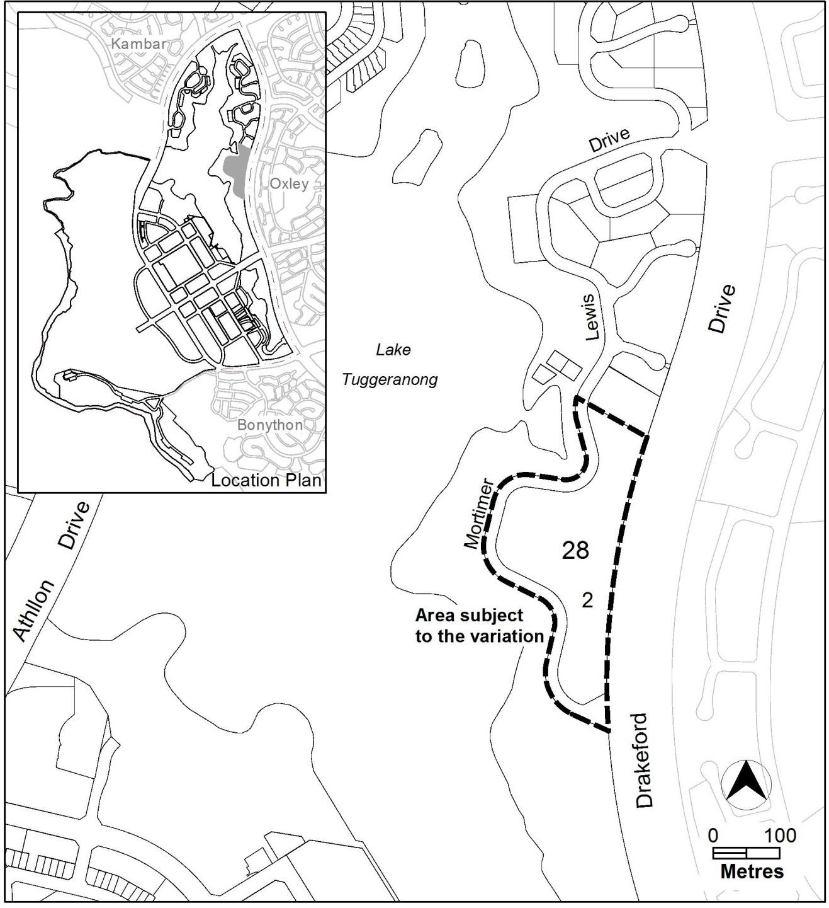

Figure 1: Site Plan

  - Current Territory Plan Provisions
The Territory Plan map zone for the area subject to this variation is shown in Figure 2

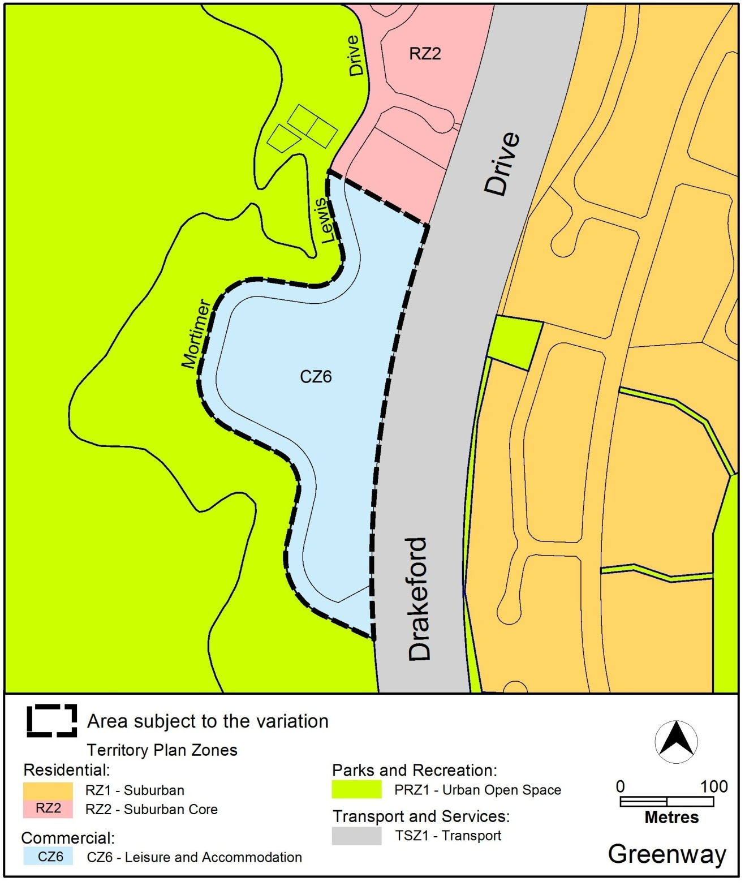
Figure 2 Territory Plan Zones Map

The Greenway precinct map for the area subject to this variation is shown in Figure 3.
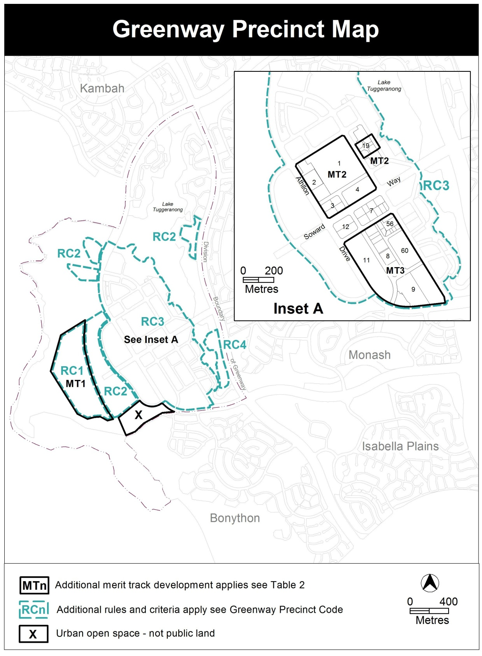
Figure 3 – Greenway precinct map.

  - Changes to the Territory Plan
Detailed changes to the Territory Plan are noted in section 2 of this document and include a change of zoning of the site as well as amendments to the Greenway precinct map and code to guide the future development of the site.

  - Consultation on the Draft Variation
Draft Variation No 337 (DV337) was released for public comment between Friday 7 November 2014 and Friday 19 December 2014. A consultation notice under section 63 of the Planning and Development Act 2007 (P&D Act) was published on the ACT Legislation Register on 7 November 2014 and in The Canberra Times on Saturday 8 November 2014.
One written submission was received in relation to the proposal. The main issues raised in the submission were water quality and run-off into the lake, increase in traffic, overflow parking, amenity, and type and impact of commercial use.
These issues were consider and are detailed in a report on consultation.

  - Revisions to the Draft Variation Recommended to the Minister
No changes were made to the draft variation recommended to the Minister.

- VARIATION
  - Variation to the Territory Plan Map
The Territory Plan map is varied in all of the following ways:
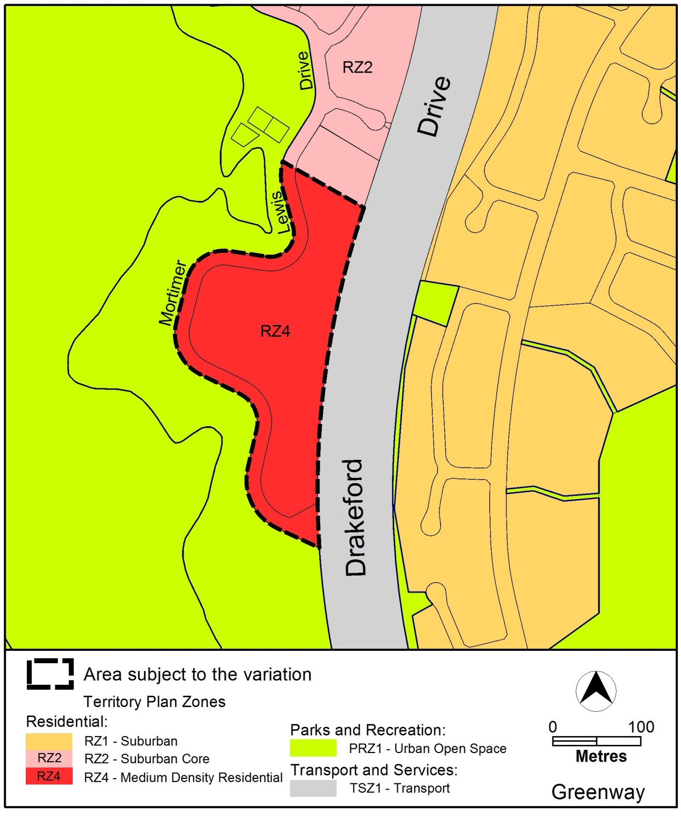

  - Variation to the Territory Plan written statements

Variation to the Greenway precinct map
- Greenway precinct map – Remove the RC2 Leisure and accommodation area and introduce new RC5 – medium density area

Substitute

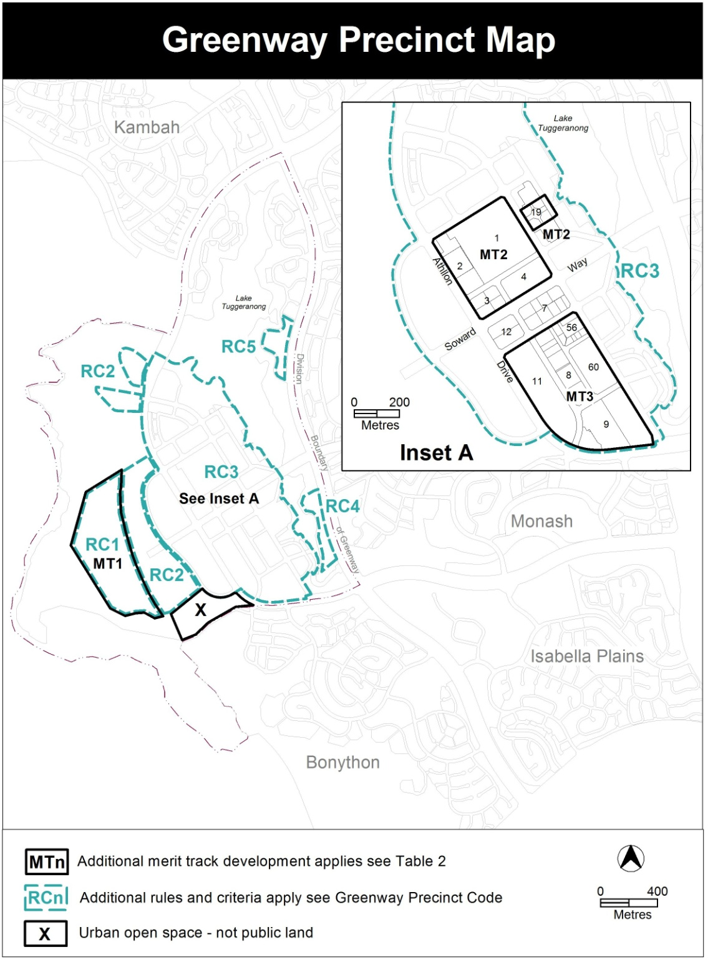

Variation to the Greenway precinct code
- RC5 – Medium density area

Insert

RC5 – Medium density area

This part applies to blocks and parcels identified in area RC5 shown on the Greenway precinct map. RC5 includes the medium density area.

Element 6 – Site

Rules | Criteria
6.1 Site Access
R20  Vehicular access or egress to the site from Drakeford Drive is not permitted. | This is a mandatory requirement. There is no applicable criterion.
6.2 Pedestrian access
R21  This rule applies to the area identified in figure 6.  A public pedestrian footpath is provided and complies with all of the following:  - is 5metres wide  - links the Drakeford Drive pedestrian underpass to the Lake Tuggeranong urban open space. | Public pedestrian access between the Drakeford Drive pedestrian underpass and the Lake foreshore is retained.

Element 7 Built form

Rules | Criteria
7.1 Height of buildings
R22  This rule applies to areas shown in figure 6  The maximum height of buildings in the areas shown on figure 6 are as follows:  - in area ‘a’ – 9.5metres  - in area ‘b’ – 13metres. Area ‘b’ is measured as a maximum depth of 27metres from the edge of the tree drip zone identified in figure 6.  For this rule the building height excludes all of the following:  - roof top plant  - lift overruns  - antennas  - photovoltaic panels  - air conditioning units  - chimneys, flues and vents  Excluded items are setback from the building facade of the floor immediately below a minimum distance of 3m. | This is a mandatory requirement. There is no applicable criterion.

Element 8 Environment

Rules | Criteria
8.1 Trees
R23  This rule applies to the drip zone area identified in figure 6.  Building and construction works do not encroach on land within the drip zone plus 2.0m of the existing trees on the eastern edge of Block 2 adjacent to Drakeford Drive. This includes any basements. | The health of existing trees on the eastern edge of Block 2 adjacent to Drakeford Drive is maintained.  Compliance with this criterion is achieved by a report that has been prepared by a suitably qualified arborist and endorsed by the Conservator of Flora and Fauna.
8.2 Landscape area

R24  This rule applies to the landscape area identified in figure 6.  No buildings or structures are located within the landscape area. This includes any basements. | The site is screened from the car park on Lewis Mortimer Drive through retention of existing vegetation and creation of a landscape area.

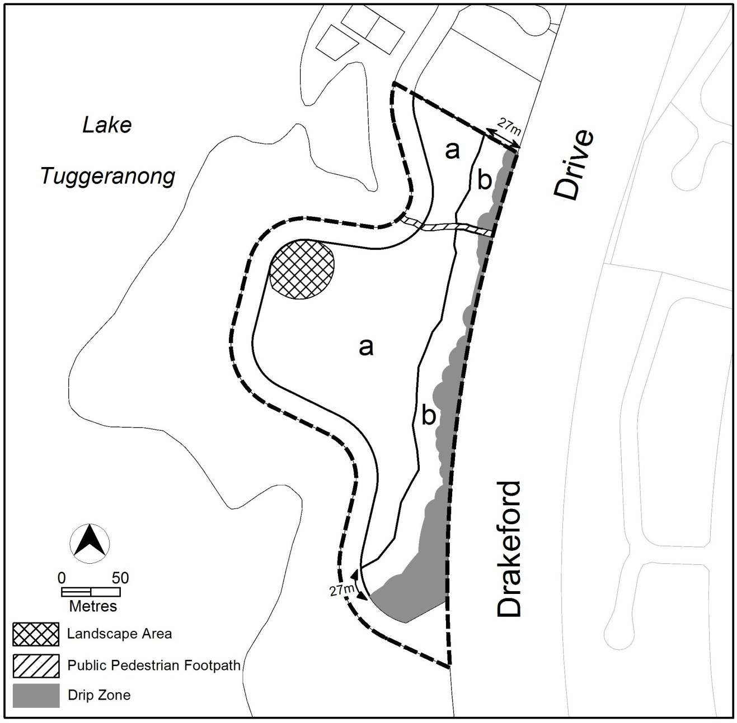
Figure 6: Site, built form and environment
Interpretation service
