Australian Capital Territory
Planning and Development (Plan Variation No 321) Notice 2015
Notifiable Instrument NI2015-446
made under the
Planning and Development Act 2007, section 76(3)

- Name of instrument
This instrument is the Planning and Development (Plan Variation No 321) Notice 2015.

- Plan Variation No 321
On 29 July 2015, the Minister for Planning approved the attached plan variation to the Territory Plan (Annexure A) under s76 (3).

Ben Ponton
Delegate of the Planning and Land Authority
30 July 2015

Planning and Development Act 2007

Variation to the
Territory Plan
No 321

Pialligo agricultural area -
Amendments to the
Pialligo precinct map and code

Final variation prepared under s76 of the
Planning and Development Act 2007

This page is intentionally blank.

Contents

1. EXPLANATORY STATEMENT 1
1.1 Background 1
1.2 Summary of the Proposal 1
1.3 The National Capital Plan 2
1.4 Site Description 2
1.5 Current Territory Plan Provisions 3
1.6 Changes to the Territory Plan 5
1.7 Consultation on the Draft Variation 5
1.8 Revisions to the Draft Variation Recommended to the Minister 5
2. VARIATION 6
2.1 Variation to the Territory Plan 6

This page is intentionally blank.

- EXPLANATORY STATEMENT
  - Background
Pialligo has a long history of human use, with numerous archaeological artefacts recording use of the area by Aboriginal people. During the development of Canberra, Pialligo was used as a food production area for the town, though over time agricultural use has declined. Pialligo still contains orchards as well as production nurseries, however these uses are slowly disappearing, with pressure for additional commercial and residential uses to be permitted to retain the economic viability of the land. The pressure to diversify the permissible uses of the land risks impacting on the existing agricultural uses. These pressures will need to be managed appropriately with controls in place to ensure existing agricultural uses, and the potential for future agricultural uses, are not overly constrained by new development within the suburb.
The Pialligo master plan was developed by the Environment and Planning Directorate (EPD) to assess the character of the existing area, consider the opportunities and constraints and develop a vision and principles for the suburb. It also provides recommendations to manage future development and infrastructure to achieve the goals of the master plan. V321 Pialligo amends the Pialligo precinct map and code to incorporate a number of the recommendations of the Pialligo master plan.
  - Summary of the Proposal
The variation amends the Pialligo precinct map and code to guide future development within the Pialligo agricultural area.
The amendments to the Pialligo precinct map and code, drawing on the recommendations of the Pialligo master plan released in November 2013, provide clear direction on the future desired character of the area while protecting the semi-rural character of the area, and ensuring the potential for agricultural uses are retained.

  - The National Capital Plan
The Australian Capital Territory (Planning and Land Management) Act 1988 established the National Capital Authority (NCA) with two of its functions being to prepare and administer a National Capital Plan (NCP) and to keep the NCP under constant review and to propose amendments to it when necessary.
The NCP, which was published in the Commonwealth Gazette on 21 January 1990 is required to ensure that Canberra and the Territory are planned and developed in accordance with their national significance. The Planning and Land Management Act 1988 also required that the Territory Plan is not inconsistent with the NCP.
In accordance with section 10 of the Australian Capital Territory (Planning and Land Management) Act 1988, the National Capital Plan defines the planning principles and policies for Canberra and the Territory, for giving effect to the object of the NCP and sets out the general policies to be implemented throughout the Territory, including the range and nature of permitted land uses.
It also sets out the detailed conditions of planning, design and development for areas that have special significance to the National Capital known as designated areas and identifies special requirements for the development of some other areas.

  - Site Description
The subject area is a portion of the suburb of Pialligo, south of Pialligo Avenue and covering blocks adjoining Beltana Road and Kallaroo Road, excluding a portion of the suburb south of the Canberra airport. The area subject to this variation is shown in Figure 1.
The land adjoins Molonglo River to the west and south, with the Canberra airport on designated land to the north east.

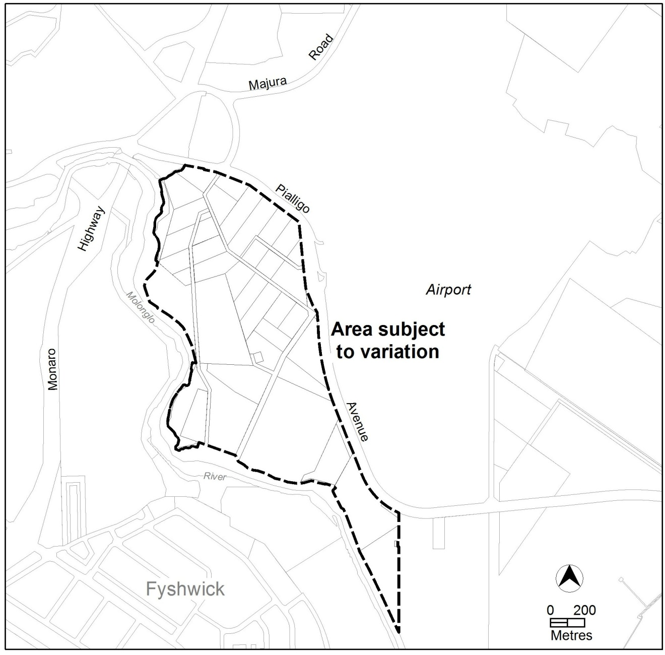
Figure 1 Area subject to the variation

  - Current Territory Plan Provisions
The Territory Plan map for the area subject to this variation is shown in Figure 2.
The area is predominately zoned NUZ1 – broadacre zone, with land adjacent to the Molonglo River zoned NUZ4 – river corridor. The Non-Urban Zones Development Code applies to development in both zones, with area specific provisions for each located in the Pialligo precinct map and code.
The NUZ1 zone is divided into Area A and Area B in the current Pialligo precinct map and code, with restrictions on uses in each area.
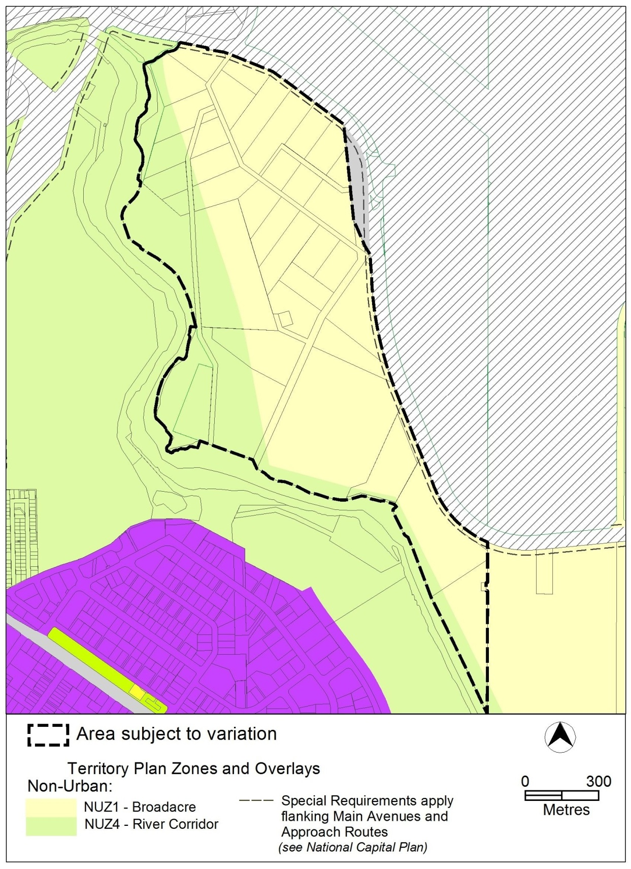
Figure 2 Territory Plan Zones Map

  - Changes to the Territory Plan
Detailed changes to the Territory Plan are noted in section 2 of this document.

  - Consultation on the Draft Variation
Draft Variation No 321 (DV321) was released for public comment between 2 May 2014 and 13 June 2014. A consultation notice under section 63 of the Planning and Development Act 2007 (P&D Act) was published on the ACT Legislation Register on 2 May 2014 and in The Canberra Times on 3 May 2014.
A total of four written submissions were received, with three submissions from local residents, and one submission on behalf of lessees of three blocks within Pialligo.
Main issues raised by submitters included:
- the restriction on gross floor area for dwellings and ancillary commercial uses is too restrictive
- Development provisions in areas close to Beltana Road will impact on the ability to undertake primary activities in these areas
- the requirement to update land management agreements will detrimentally impact blocks exempted from requiring land management agreements in the past
- the requirement for property plans adds another requirement to existing provisions
- the draft variation doesn’t provide sufficient flexibility for additional commercial uses
The above issues were considered and are detailed in a report on consultation. Changes were informed by the issues raised. The outcomes of consultation were considered by the Minister responsible for planning prior to approval of this variation.

  - Revisions to the Draft Variation Recommended to the Minister
No changes were made to the draft variation recommended to the Minister.

- VARIATION
  - Variation to the Territory Plan
The Territory Plan is varied as follows:

Variation to the Pialligo precinct map
- Precinct Maps and Codes, Pialligo precinct map and code

Substitute all of the following with the nominated attachment
Pialligo Precinct Map and development tables – Attachment A

Variation to the Pialligo precinct code
- Precinct Maps and Codes, Pialligo precinct map and code

Substitute all of the following with the nominated attachment

Pialligo Precinct Code, RC1 – Pialligo Agricultural Area – Attachment B
Renumber
RC2 – Pialligo Quarry to RC3 – Pialligo Quarry
insert
RC2 – NUZ4 River Corridor – Attachment C

Interpretation service
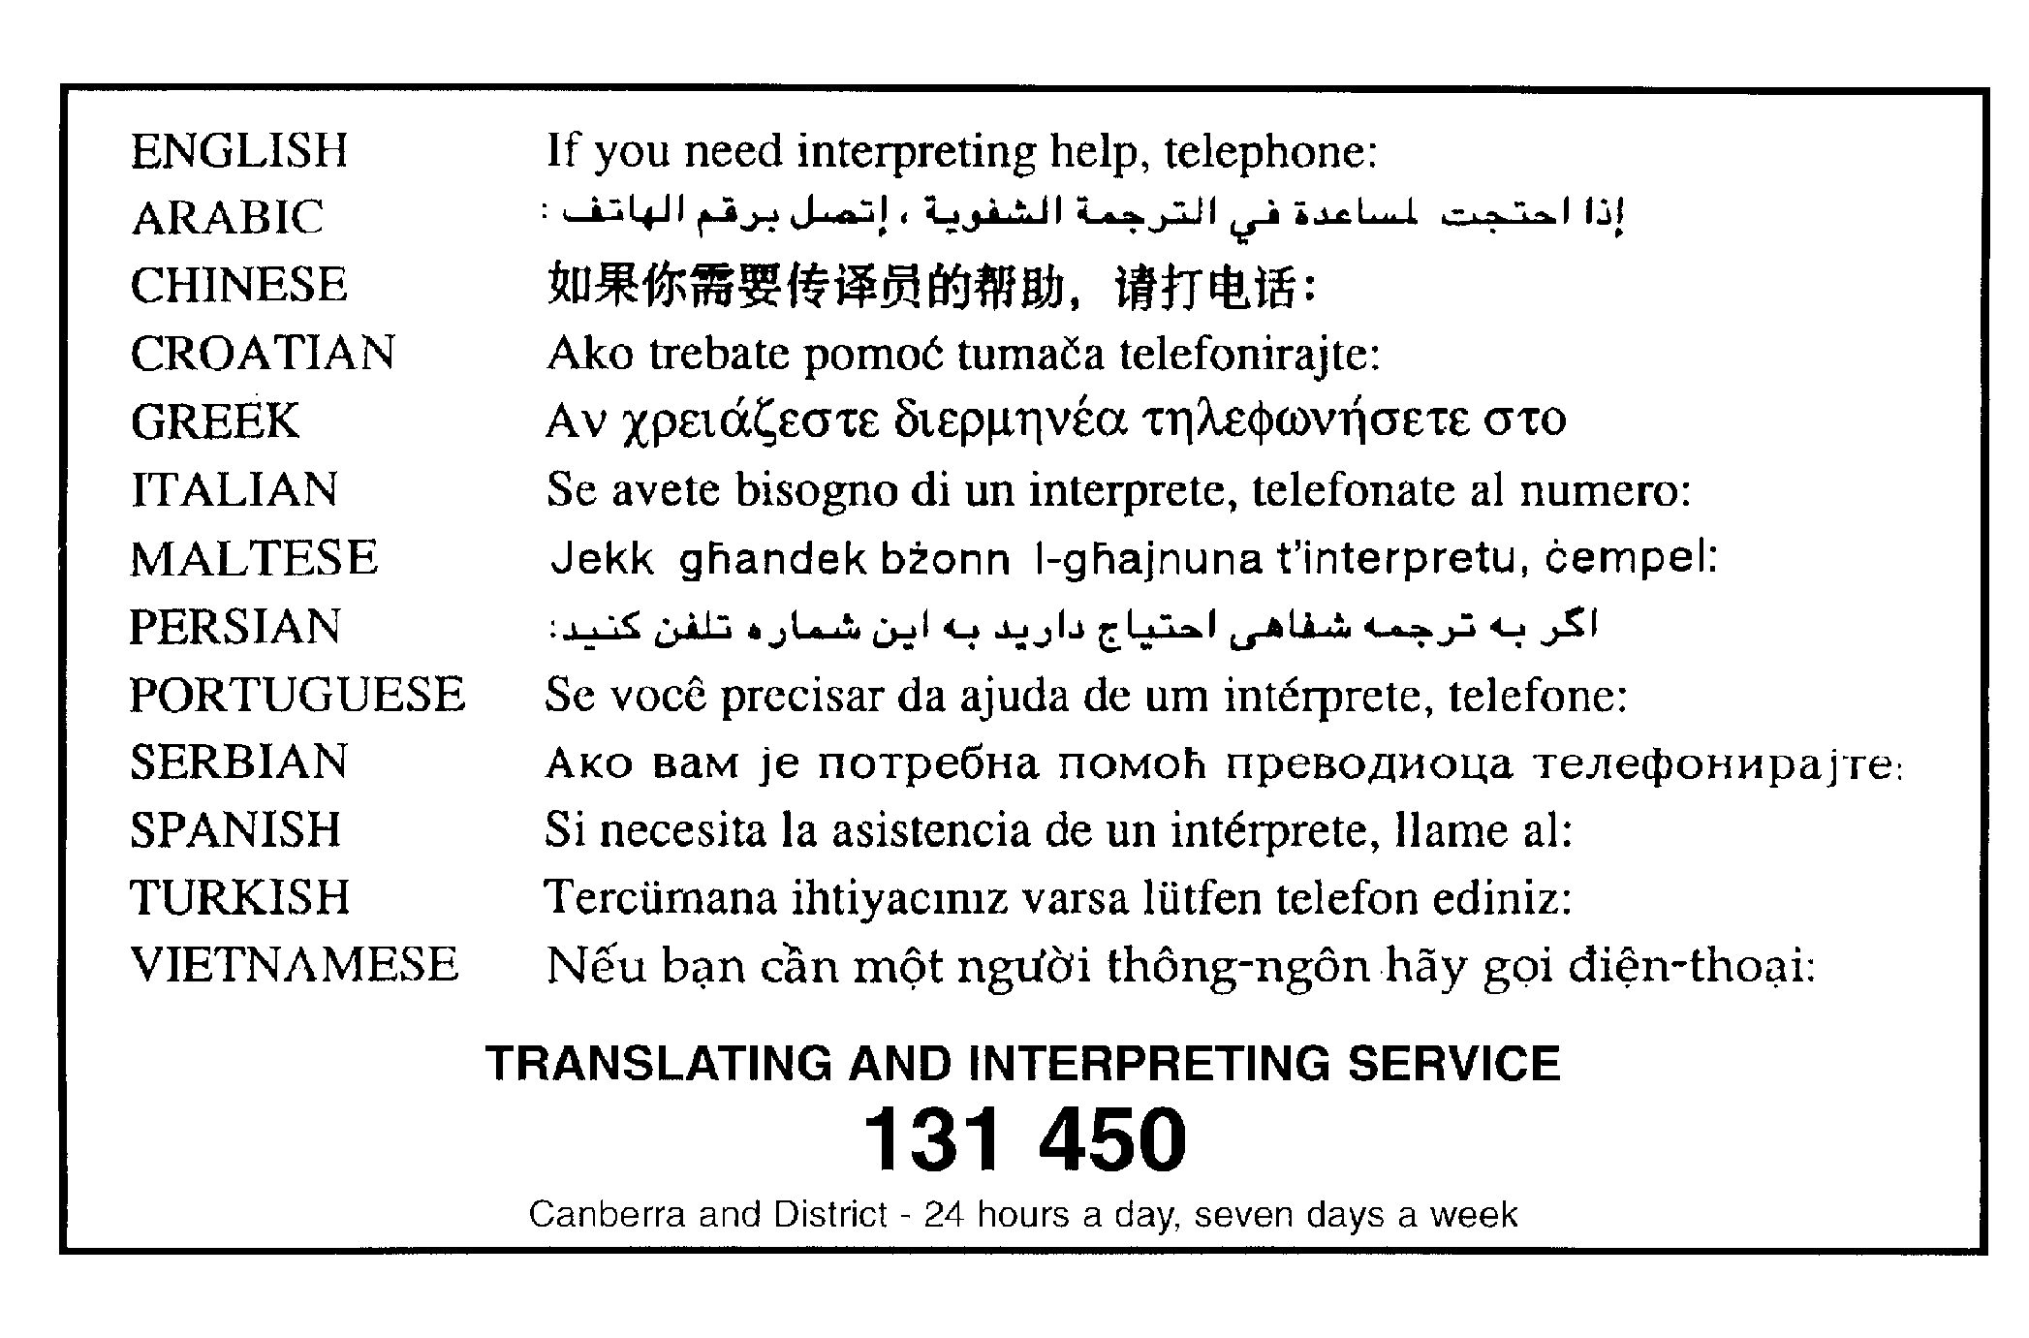

This page is intentionally blank.

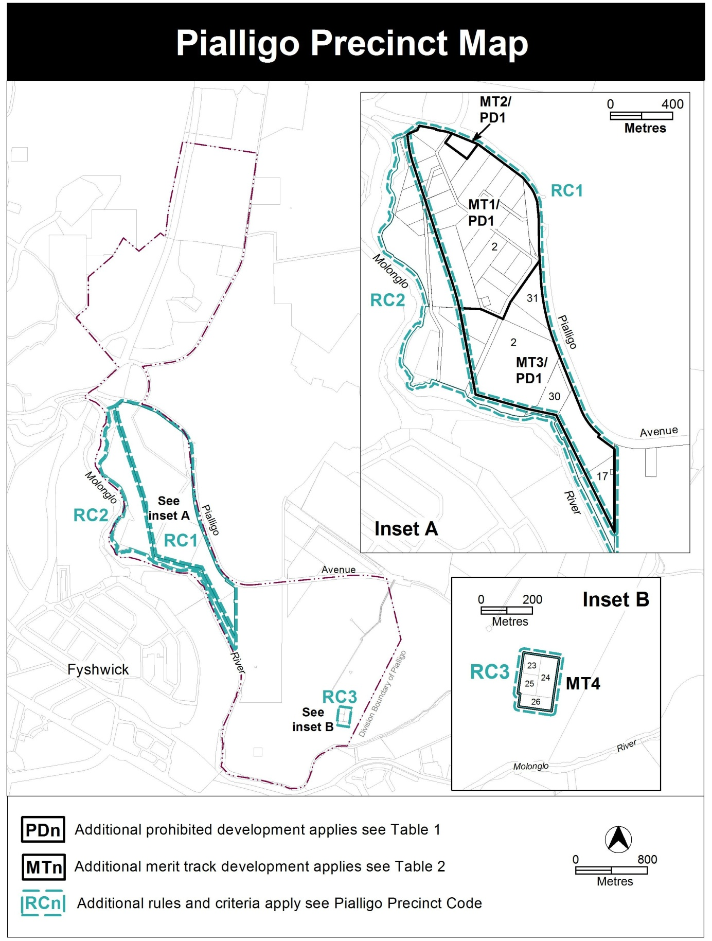

Assessment Tracks
The following tables identify the additional prohibited development and additional merit track development for blocks and parcels shown in the Pialligo Precinct Map (identified as PDn or MTn). Development that is exempt from requiring development approval, other prohibited development and the minimum assessment track applicable to each development proposal is set out in the relevant zone development table.

The following tables constitute part of the relevant zone development table.

Table 1 – Additional prohibited development
Additional prohibited development
Suburb precinct map label | Zone | Development
PD1 | NUZ1 | caravan park / camping ground  cemetery  communications facility  community activity centre  corrections facility  defence installation  educational establishment  health facility  land management facility  MAJOR UTILITY INSTALLATION  municipal depot  place of worship  residential care accommodation  scientific research establishment  service station  subdivision  supportive housing  tourist facility  transport depot  woodlot

Table 2 – Additional merit track development
Additional merit track development that may be approved subject to assessment
Suburb precinct map label | Zone | Development
MT1 | NUZ1 | retail plant nursery  produce market
MT2 | NUZ1 | emergency services facility
MT3 | NUZ1 | produce market
MT4 | NUZ1 | mining industry

RC1 – Pialligo Agricultural Area
This part applies to blocks and parcels identified in area RC1 shown on the Pialligo Precinct Map.
Desired character
The desired character of Pialligo consists of a rural landscape with nurseries and small scale shops, craft stores, restaurants and cafes sited close to Beltana Road. The majority of land in Pialligo away from Beltana Road will have an agricultural and landscape character with low scale built form sympathetic to the environment, visually and physically separated by distance and landscaping between buildings.
- Use
Rules | Criteria
  - Area A and B
Area ‘A’, shown in figure 1, is defined as leased land located within 60 metres of the Beltana Road reservation; except where the following applies:  - for block 15 section 2, area ‘A’ is not less than 60m and not more than 120m from Beltana Road  Area ‘B’, shown in figure 1, is identified as the remaining leased land excluding area ‘A’, and excluding the hatched area in figure 1. | This is a mandatory requirement. There is no applicable criterion.
  - Ancillary commercial uses – floor space limit
This rule applies to development located within area ‘A’ shown in figure 1.  The maximum gross floor area for each of the following ancillary uses in area ‘A’ is:  - craft workshop – maximum 200m² per lease with a maximum 150m² per craft workshop  - industrial trades restricted to workshops associated with rural activity – maximum 200m² per lease with a maximum 150m² per industrial trade workshop  - produce market – maximum 300m² per lease with a maximum 100m² per produce market  - restaurant – maximum 250m² per lease with a maximum 150m² per restaurant  - SHOP restricted to an art, craft or sculpture dealer – 100m² | This is a mandatory requirement. There is no applicable criterion.

Rules | Criteria
This rule applies to development:  - on blocks with a leased area of 100,000m² or less; and  - located within area ‘B’ shown in figure 1.  The maximum gross floor area for each of the following ancillary uses in area ‘B’ is:  - craft workshop – 100m²  - industrial trades restricted to workshops associated with rural activity – 100m²  - produce market – 150m²  - restaurant – 100m²  - SHOP restricted to an art, craft or sculpture dealer – 50m² | This is a mandatory requirement. There is no applicable criterion.
This rule applies to development on blocks with a leased area of more than 100,000m².  The maximum gross floor area for each of the following ancillary uses is:  - craft workshop – 150m²  - industrial trades restricted to workshops associated with rural activity – 150m²  - produce market – 200m²  - restaurant – 150m²  - SHOP restricted to an art, craft or sculpture dealer – 50m² | This is a mandatory requirement. There is no applicable criterion.
The total site coverage of all ancillary commercial development in area ‘B’ shown in figure 1 is limited to:  - 8% of the total block area for blocks less than 100,000m²,  - 6% of the total block area for blocks equal to or greater than 100,000m²  For the purposes of this rule, site coverage includes surface car parking areas required to accommodate the parking generated by the ancillary uses. | This is a mandatory requirement. There is no applicable criterion.

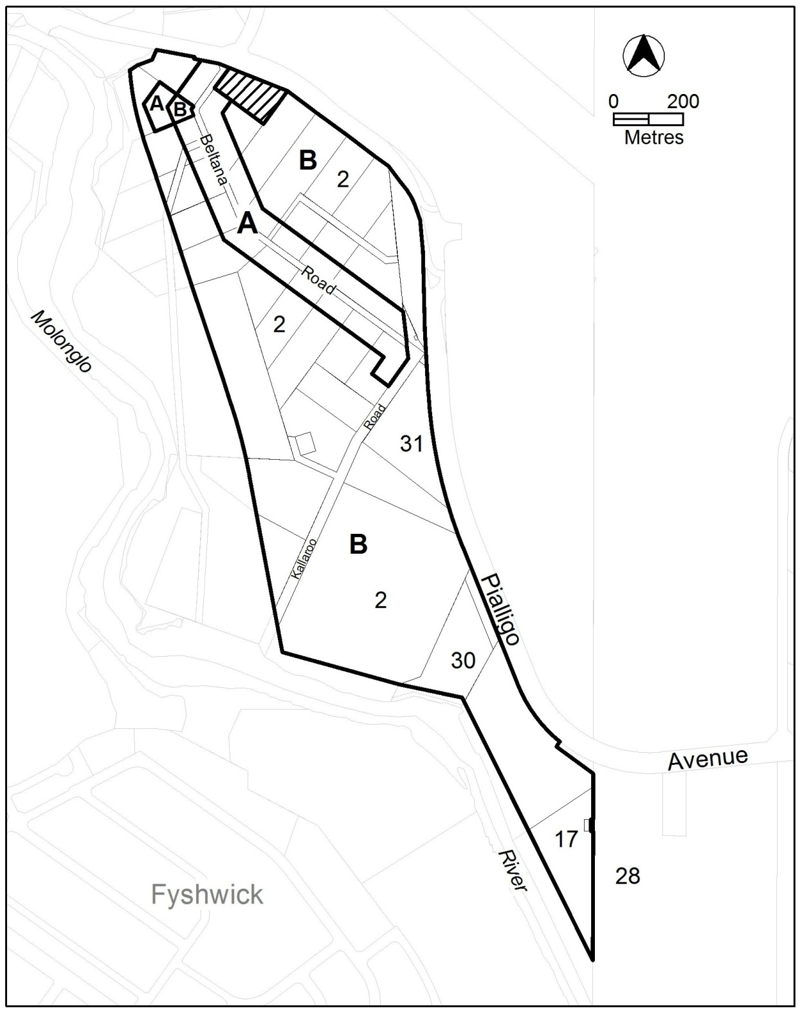

Figure 1 Pialligo agricultural area

Rules | Criteria
  - Ancillary residential use
A maximum of one ancillary dwelling is permitted per block. | Additional ancillary dwellings are demonstrated to be necessary for the management of the permitted primary uses.
Ancillary residential development is limited to 750m² gross floor area per block. | Ancillary residential development complies with all of the following:  - protects environmental and heritage values of the area  - does not detrimentally impact on the operation of adjoining agricultural uses  - does not significantly impact on the agricultural potential of the block  - is compatible with neighbouring dwellings.
  - Limits on permitted uses
Emergency services facility is limited to 1400m² gross floor area. | This is a mandatory requirement. There is no applicable criterion.
This rule applies to all blocks in section 2, except for the hatched area shown in figure 1.  Subdivision of existing leases is not permitted. | This is a mandatory requirement. There is no applicable criterion.
There is no applicable rule. | This criterion applies to the hatched area in figure 1.  Subdivision is only permitted as part of a development providing publicly accessible open space.
Animal care facility limited to dog kennels, is only permitted in the area shaded grey in figure 2. | This is a mandatory requirement. There is no applicable criterion.
Bulk landscape supplies is only permitted in the hatched area in figure 2. | This is a mandatory requirement. There is no applicable criterion.

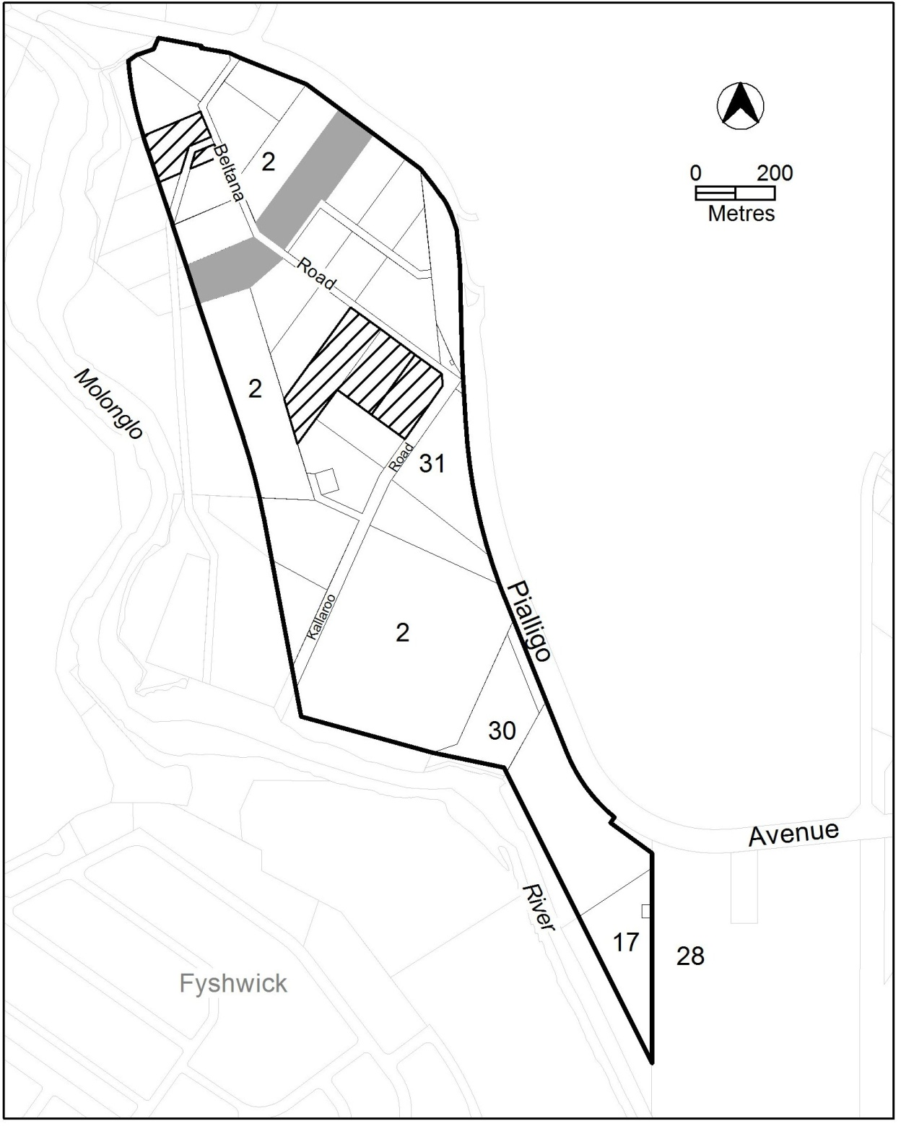

Figure 2 Permitted locations for dog kennels and bulk landscape supplies

Rules | Criteria
  - Building location
This rule applies to blocks with a front boundary adjoining Beltana Road and/or Kallaroo Road.  All new ancillary use buildings are located within 200m of the front block boundary addressing Beltana Road or Kallaroo Road. | Ancillary buildings may be located further than 200m from the front boundary where reasonable justification is provided that demonstrates the location of the building:  - reflects the existing development pattern  - protects environmental values of the area  - protects heritage values of the area  - does not detrimentally impact on the operation of adjoining agricultural uses  - does not significantly impact on the agricultural potential of the block

- Site
Rules | Criteria
  - Built form
The maximum number of storeys is two. | This is a mandatory requirement. There is no applicable criterion.
This rule applies to buildings in the hatched area shown in figure 1.  The maximum height of building is 8.5m. | Building height is consistent with the desired character.
  - Site facilities
There is no applicable rule. | Car parking areas:  - are screened from the street; and  - do not significantly reduce the agricultural potential of blocks.
There is no applicable rule. | Waste collection areas, loading docks and service areas are screened from the street and adjoining public spaces.
A maximum of two verge crossovers are provided per block frontage to Beltana Road. | This is a mandatory requirement. There is no applicable criterion.
  - Front setbacks to Beltana and Kallaroo Road
This rule applies to each block with a front boundary to Beltana Road and/or Kallaroo Road, except for the hatched area in figure 1.  The minimum front setback is 6m. | Front setbacks:  - are consistent with the desired character  - reflect the existing development pattern  - are related to the height of the building to ensure pedestrian scale at street level  - provide reasonable space between the development and front boundary to permit deep root planting.  Small produce stands selling goods produced on the block are permitted within the front setback provided vehicle sight lines from driveways are maintained.
This rule applies to buildings in the hatched area shown in figure 1.  The minimum setback to Beltana Road front boundary is 40m. | Small scale unenclosed landscape structures such as pergolas and the like may be located within the front setback provided they do not dominate the view into the block from the street.
  - Side setbacks
This rule applies to area ‘A’ in figure 1.  The minimum setback to each side boundary is 8m. | Side setbacks:  - are consistent with the desired character  - reflect the existing development pattern  - provide sufficient separation to provide a landscape buffer between development and the adjoining boundary  - do not detrimentally impact on the operation of adjoining agricultural uses
This rule applies to buildings in the hatched area shown in figure 1.  The minimum setback to each side boundary is 25m. | This is a mandatory requirement. There is no applicable criterion.
  - Setbacks to Pialligo Avenue
This rule applies to development on blocks with a boundary adjoining Pialligo Avenue road reservation, except for blocks located at the intersection of Pialligo Avenue and Beltana Road.  The minimum setback of buildings and structures to boundaries adjoining Pialligo Avenue is 20m. | This is a mandatory rule. There is no applicable criterion.
This rule applies to development on blocks located at the intersection of Pialligo Avenue and Beltana Road:  The minimum setback of buildings and structures to Pialligo Avenue front boundary is 20m. | Setbacks to Pialligo Avenue may be reduced to 10m where development:  - is consistent with any applicable development control plan, and  - incorporates a landscaped area between the building line and the boundary suitable for deep root planting that screens development from Pialligo Avenue and contributes to defining the entrance to the suburb.
  - Active frontages
This rule applies to ancillary commercial development in area A shown in figure 1 and within 20m of Beltana Road.  Street frontages and building design comply with all of the following:  - buildings incorporate clear display windows at the ground floor level  - buildings incorporate direct pedestrian access at grade with the verge level for access and egress for persons with disabilities | Development achieves all of the following:  - where building access is provided, direct pedestrian access  - provide opportunities for views into and out of the building.
  - Potentially noisy uses
This rule applies to any of the following:  - emergency services facility  - outdoor recreation facility  - restaurant  Development complies with a noise management plan prepared by a suitable qualified person and endorsed by the Environment Protection Authority (EPA).  The noise management plan will detail the proposed design, siting and construction methods that will be employed to ensure compliance with the Noise Zone Standard as detailed in the Environment Protection Regulation 2005, based on the estimated noise levels when the facility is in use.  Note: A condition of development approval may be imposed to ensure compliance with the endorsed noise management plan. | This is a mandatory rule. There is no applicable criterion.
  - Assessment of environmental effects
There is no applicable rule. | The assessment of environmental effects required by the Non Urban Zones Development Code also addresses the following matters:  - consistency with the desired character  - agricultural potential of the land.  Note: items a) to g) are contained in the Assessment of Environmental Effects criterion in the Non Urban Zones Development Code
  - Heritage – potential archaeological artefacts
This rule applies to the shaded area in figure 3.  Applications for development are accompanied by written endorsement from the Heritage Council. | Development without written endorsement will be referred to the Heritage Council, and its advice considered before the determination of the application.
  - Environment Protection – landscape buffers to agricultural uses
Applications for new ancillary dwellings and or alterations to existing ancillary dwellings are accompanied by a report from a suitably qualified person, with written endorsement from Environment Protection Authority (EPA), advising whether a vegetative buffer is required to separate the residential development from adjoining agricultural uses.  Where vegetative buffers are required to separate residential development from agricultural uses, updated Land Management Agreements must be provided with the application that:  - indicate the species and planting arrangement of vegetation to be incorporated; and  - detail the ongoing management required for the maintenance of the vegetation. | Reports without written endorsement will be referred to the EPA, and its advice considered before the determination of the application.

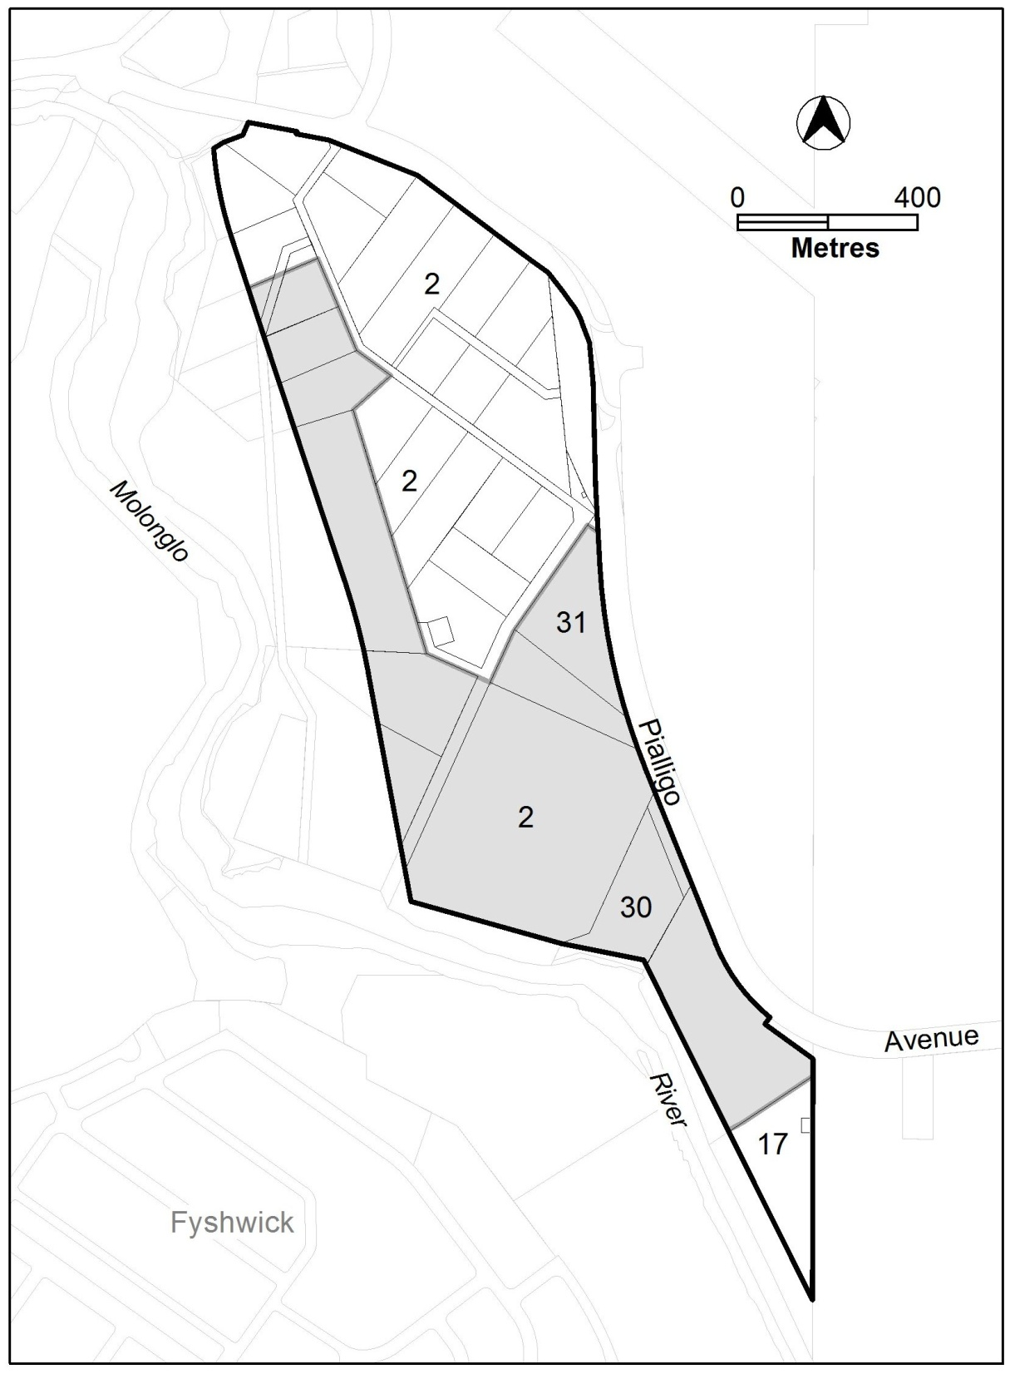
Figure 3 Areas with potential archaeological artefacts – NUZ1

RC2 – NUZ4 River corridor
This part applies to blocks and parcels identified in area RC2 shown on the Pialligo Precinct Map.

- Heritage
Rules | Criteria
  - Heritage – potential archaeological artefacts
This rule applies to the shaded area in figure 4.  Applications for development are accompanied by written endorsement from the Heritage Council. | Development without written endorsement will be referred to the Heritage Council, and its advice considered before the determination of the application.

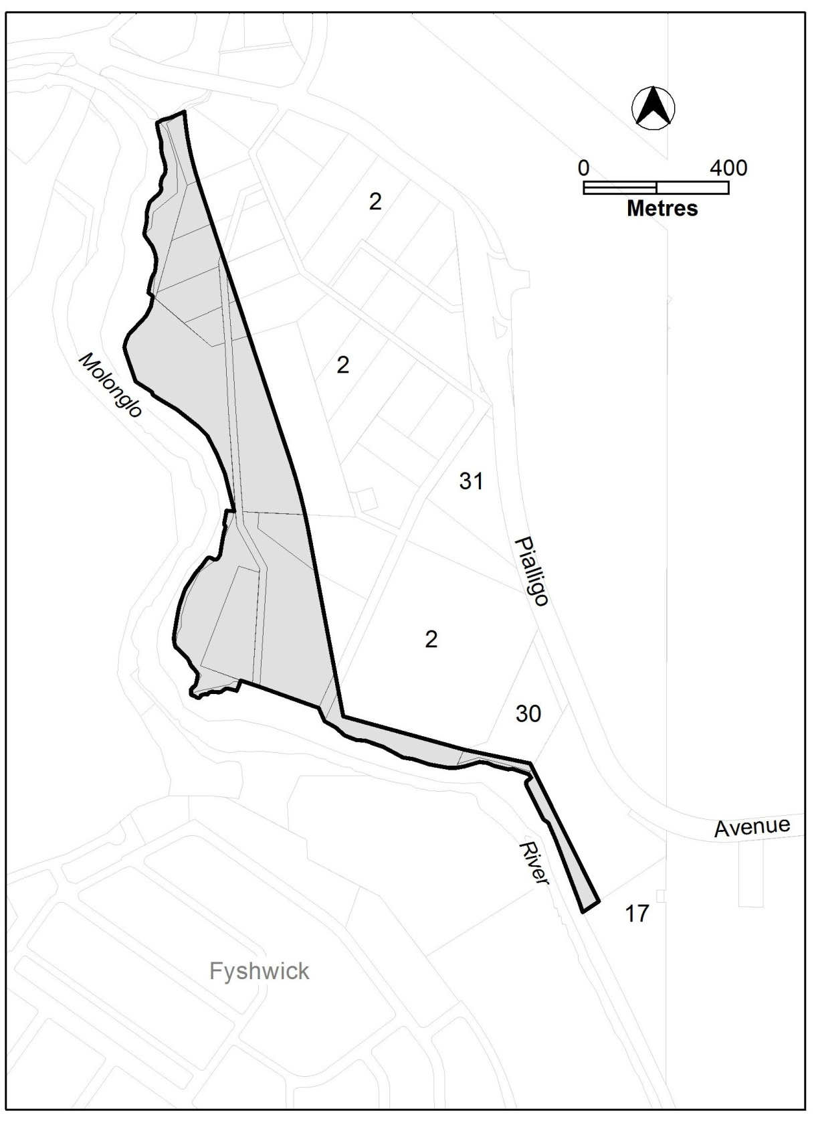
Figure 4 Areas with potential archaeological artefacts – NUZ4

