Australian Capital Territory
Planning and Development (Plan Variation No 309) Notice 2015
Notifiable Instrument NI2015-450
made under the
Planning and Development Act 2007, section 76(3)

- Name of instrument
This instrument is the Planning and Development (Plan Variation No 309) Notice 2015.*

- Plan Variation No 309
On 28 July 2015, the Minister for Planning approved the attached plan variation to the Territory Plan (Annexure A) under s76 (3).

Jim Corrigan
Delegate of the Planning and Land Authority
29 July 2015

ANNEXURE A

Planning and Development Act 2007

Variation to the
Territory Plan
No 309

Turner Bus Layover
Turner section 25 part Block 8

July 2015

Final variation prepared under s76 of the
Planning and Development Act 2007

This page is intentionally blank.

Contents

1. EXPLANATORY STATEMENT 1
1.1 Background 1
1.2 Summary of the proposal 1
1.3 The National Capital Plan 2
1.4 Site Description 2
1.5 Current Territory Plan Provisions 4
1.6 Changes to the Territory Plan 5
1.7 Consultation on the Draft Variation 5
1.8 Revisions to the Draft Variation Recommended to the Minister 5
2. VARIATION 6
2.1 Variation to the Territory Plan 6
Appendix A 1

This page is intentionally blank.

- EXPLANATORY STATEMENT
  - Background
Proposed Bus Layover – part Block 8, Section 25 Turner
There is an existing bus layover located on Marcus Clarke Street Canberra. The site has been acquired by the Australian National University and therefore the layover facilities must be removed to allow the University to utilise the site.
The subject site on part Block 8 Section 25 Turner has been identified as part of a two-site solution to replace the existing bus layover. It is proposed to be the western City bus layover site. The site adjacent to the National Convention Centre has been chosen to accommodate the eastern City bus layover.
The City bus layover sites have been chosen following extensive review of available alternate sites. Being located in close proximity to the City and key inter-town routes, the layover facilities are expected to improve the efficiency of the public transport network, reduce operating costs and improve public transport services.
Changes to the Public Land Overlay
The public land overlay will be removed from the subject site as it is no longer required as the block will be used for a bus layover facility.
  - Summary of the proposal
The intention of the variation is to enable the development of a bus layover facility on part Block 8 Section 25 Turner by amending the Territory Plan. The variation proposes the following:
- Add MT4 in the Turner Precinct Map and Code to introduce ‘Public transport facility’ as an additional merit track development on the site.
- Remove the Public Land (Pe – urban open space) Overlay from the subject site and insert an ‘X Overlay’ (Urban Open Space, not public land) to the site.
  - The National Capital Plan
The Australian Capital Territory (Planning and Land Management) Act 1988 established the National Capital Authority (NCA) with two of its functions being to prepare and administer a National Capital Plan (the Plan) and to keep the NCP under constant review and to propose amendments to it when necessary.
The Plan, which was published in the Commonwealth Gazette on 21 January 1990, is required to ensure Canberra and the Territory are planned and developed in accordance with their national significance. The Australian Capital Territory (Planning and Land Management) Act 1988 also requires the Territory Plan is not inconsistent with the Plan. The area covered by this variation is within urban areas identified in the Plan.
  - Site Description
The subject site is located on the corner of Barry Drive and Watson Street at part Block 8 Section 25 Turner. Block 8 consists of part of Sullivans Creek, an open space and a territory operated surface car park which currently provides all day paid parking for workers in surrounding areas.
The proposed site is part Block 8 as shown in Figure 1. The site is zoned PRZ1 Urban Open Space Zone.
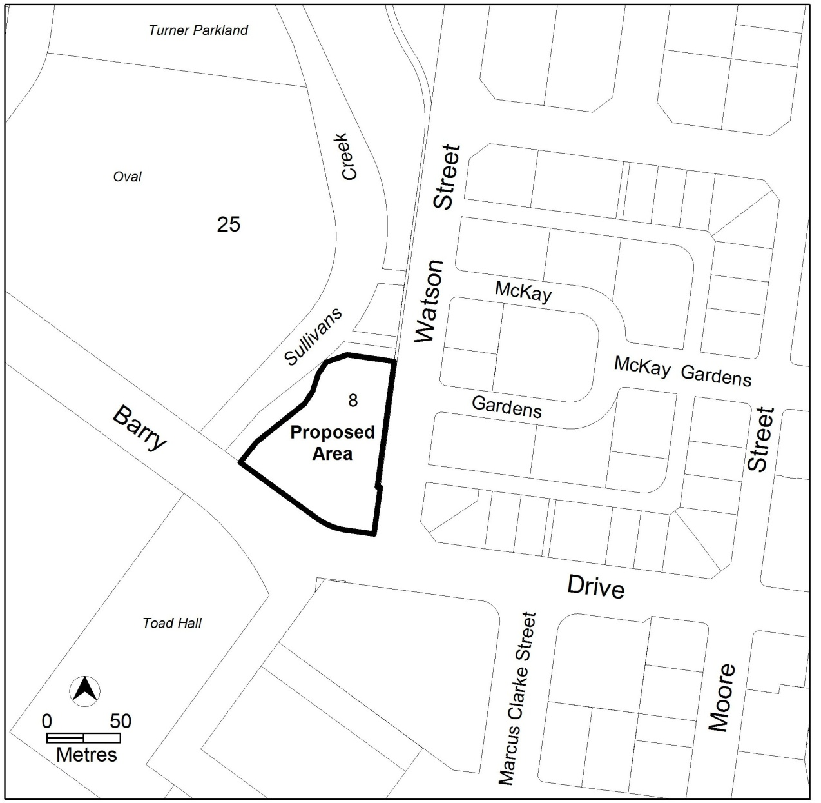
Figure 1 Site Plan

  - Current Territory Plan Provisions
The Territory Plan map zones for the area subject to this variation are shown in Figure 2. The subject site is zoned PRZ1 Urban Open Space Zone and is reserved public land, having a Pe – Urban Open Space Overlay. The development table for this zone currently lists ‘Public transport facility’ as a prohibited land use.
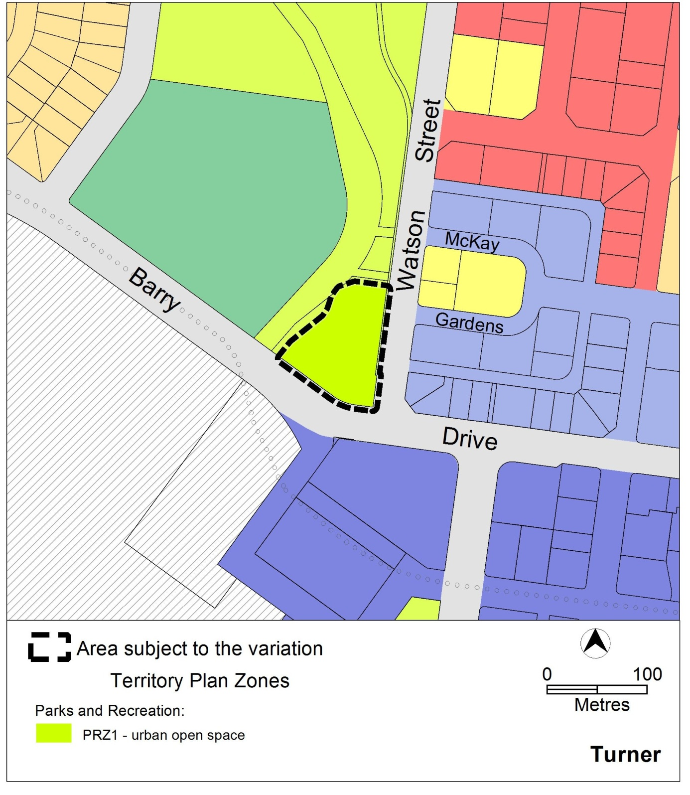
Figure 2: Current Territory Plan Zones map

  - Changes to the Territory Plan
Detailed changes to the Territory Plan are noted in section 2 of this document.
  - Consultation on the Draft Variation
Draft Variation No 309 (DV309) was released for public comment between 11 April and 28 May 2014. A consultation notice under section 63 of the Planning and Development Act 2007 (P&D Act) was published on the ACT Legislation Register on 11 April 2014 and in The Canberra Times on 12 April 2014.
A total of 46 written submissions were received during public consultation with one submission supporting the proposal and 45 submissions objecting to it. The submissions were made by 43 individuals and 3 interest groups including Turner Residents Association, North Canberra Community Council and the Executive Committee of ‘The Avenue’ (a property of 239 residential units at 77 Northbourne Ave, Turner).
The main issues raised by the submitters included:
- The loss of parkland in the context of City growth.
- Alternatives to be considered.
- Commitment to implementing the proposed landscape plan.
- The current and future use of the proposal site.
- Need for a long term master plan for the area.
- Potential impacts of the proposal on traffic and road safety.
- Compliance with noise level standards.
- The inconsistency between DV309 and other Government policies.
- Potential impacts on surrounding property values.
The above issues have been considered and are detailed in a report on consultation, which is available at www.act.gov.au/draftvariations. Changes were made following the public consultation to address the key concerns of the public.
  - Revisions to the Draft Variation Recommended to the Minister
No changes were made to the draft variation recommended to the Minister.

- VARIATION
  - Variation to the Territory Plan
The Territory Plan map is varied in all of the following ways:
Variation to the Turner Precinct Map
- Turner Precinct Map

Place MT4 to the subject site on the current Turner Precinct Map. This will enable additional merit track development to be applied to the subject site.

Substitute with Appendix A
Variation to the Turner Precinct Code
- Turner Precinct Code

Add ‘Public transport facility’ as merit track development within the MT4 boundary by amending Table 2 Additional merit track development of the Turner Precinct Map and Code.

Table 2 – Additional merit track development
Suburb precinct map label | Zone | Development
MT4 | PRZ1 | Public transport facility

Interpretation service
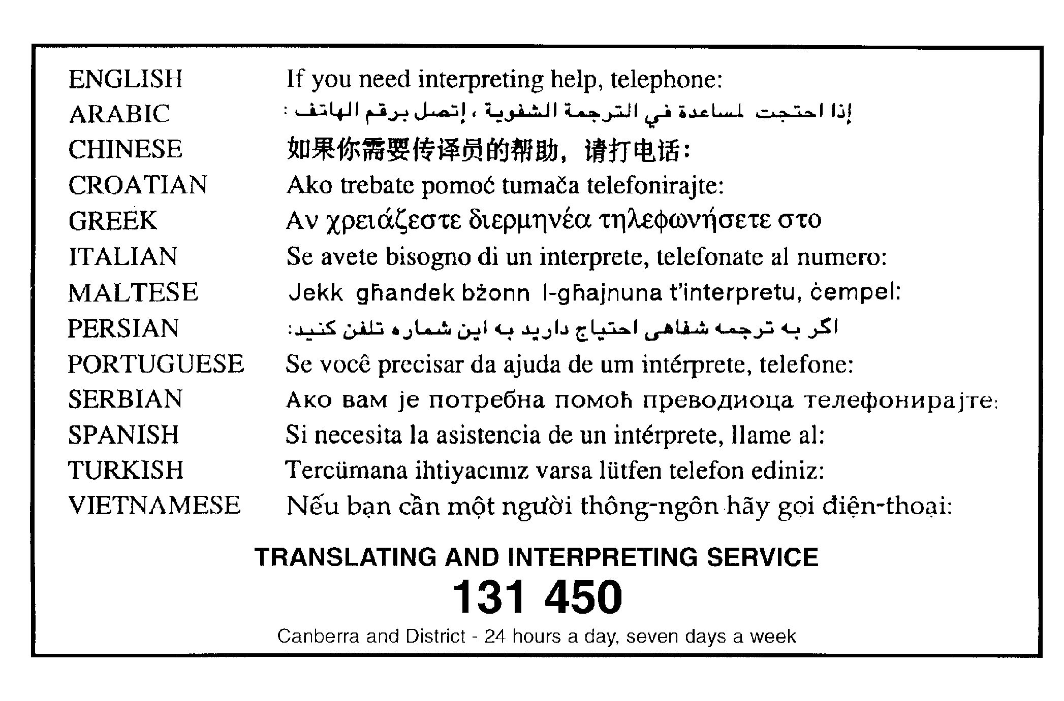

Appendix A
