Australian Capital Territory

Planning and Development (Technical Amendment—Moncrieff) Plan Variation 2015 (No 3)

Notifiable Instrument NI2015—493
Technical Amendment No 2015—13
made under the
Planning and Development Act 2007, section 89 (Making technical amendments) s96 (land ceases to be in future urban area)

This plan variation commences on the day after it is notified.

Variation No 2015—13 to the Territory Plan has been approved by the Planning and Land Authority.

Variation to the Territory Plan
The Territory Plan map is varied as indicated in Annexure A to identify the zones that apply to the land ceasing to be in a future urban area.

Variation to the Precinct Map and Code
Pages one to five of Annexure B indicate the changes to the Moncrieff Precinct Map and Code incorporating ongoing block specific provisions for the area.

- Replace Moncrieff Precinct Map
- Insert new Figure 3A of the Moncrieff Precinct Map and Code after existing Figure 3.
- Insert new OP3 - Moncrieff residential area and new Figure 7 Moncrieff residential area ongoing provisions after existing Figure 5 of the Moncrieff Precinct Map and Code.
- Insert new OP4 - Moncrieff residential area and new Figure 8 Moncrieff residential area ongoing provisions after new Figure 7 of the Moncrieff Precinct Map and Code.
- Figure 3A, 4 and 5 renumber as Figure 4, 5 and 6.
- Replace wording of Rule 5 (R5) and Rule 8 (R8) of RC1 – Residential, of the Moncrieff Precinct Map and Code.

Chris Collier
Delegate of the Planning and Land Authority
3 September 2015
THIS IS PAGE ONE OF ANNEXURE A
TO NOTIFIABLE INSTRUMENT NI2015 – 493

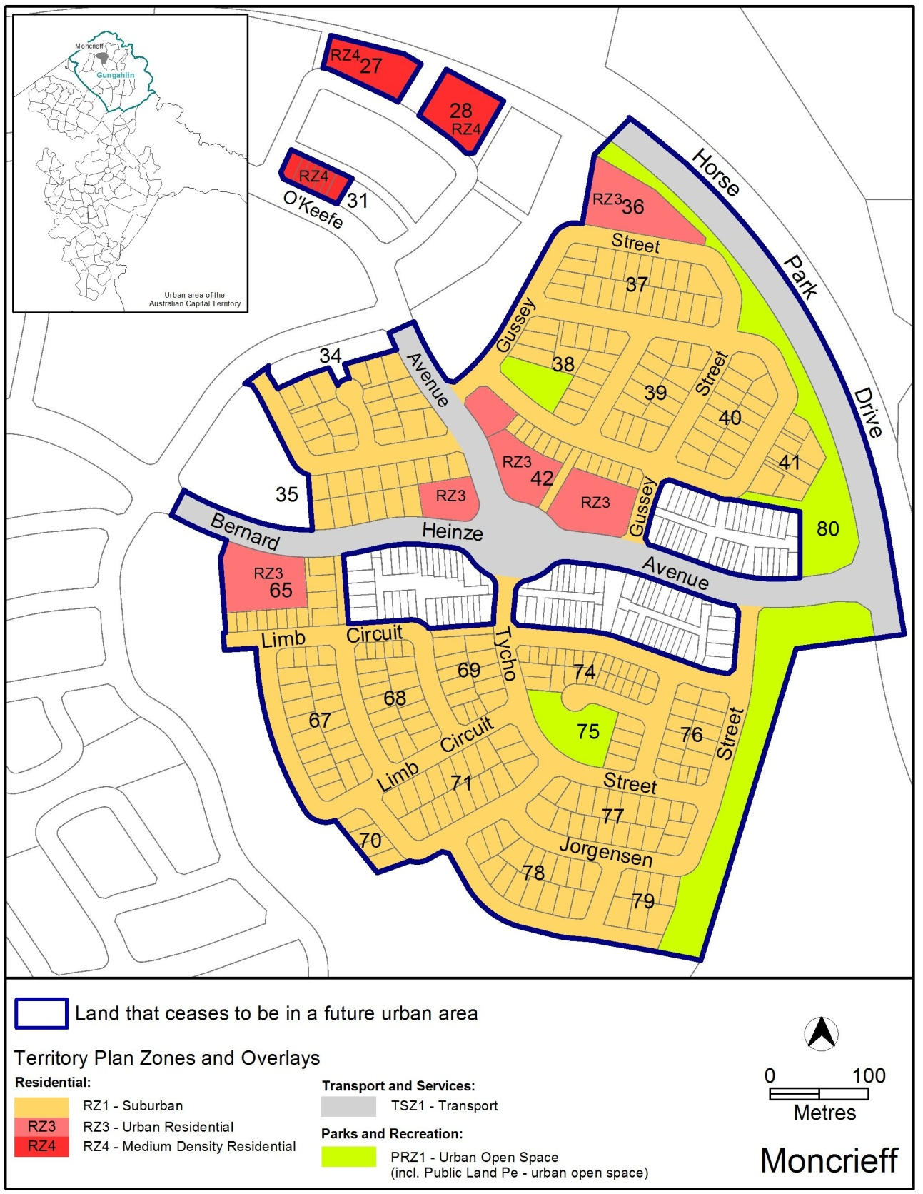

Chris Collier
Delegate of the Planning and Land Authority
3 September 2015
THIS IS PAGE ONE OF ANNEXURE B
TO NOTIFIABLE INSTRUMENT NI2015 – 493

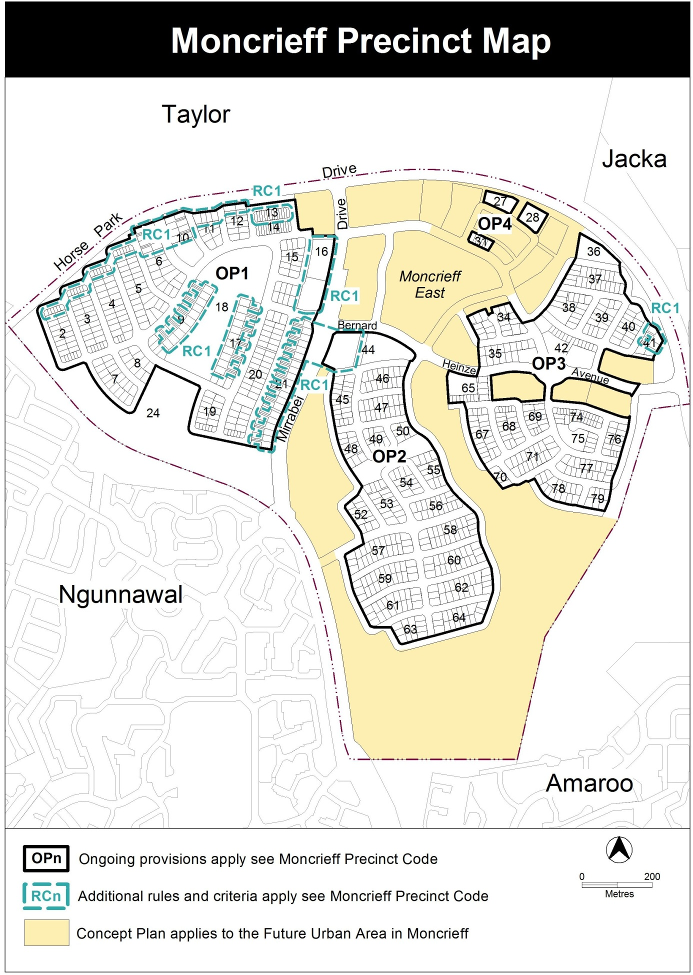

Chris Collier
Delegate of the Planning and Land Authority
3 September 2015

THIS IS PAGE TWO OF ANNEXURE B
TO NOTIFIABLE INSTRUMENT NI2015 – 493

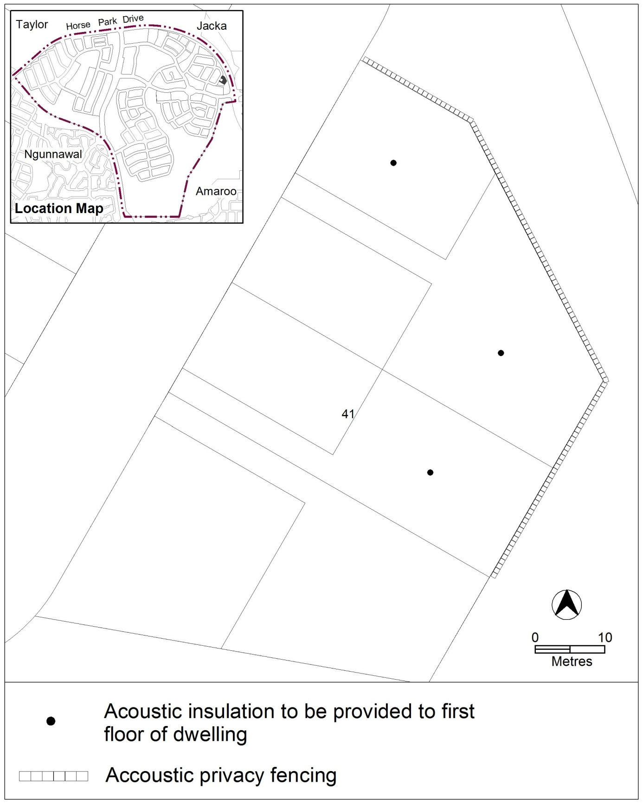
Figure 3A Moncrieff residential area 4

Chris Collier
Delegate of the Planning and Land Authority
3 September 2015
THIS IS PAGE THREE OF ANNEXURE B
TO NOTIFIABLE INSTRUMENT NI2015 – 493

OP3 – Moncrieff residential area
This part applies to blocks and parcels identified in area OP3 shown on the Moncrieff Precinct Map.
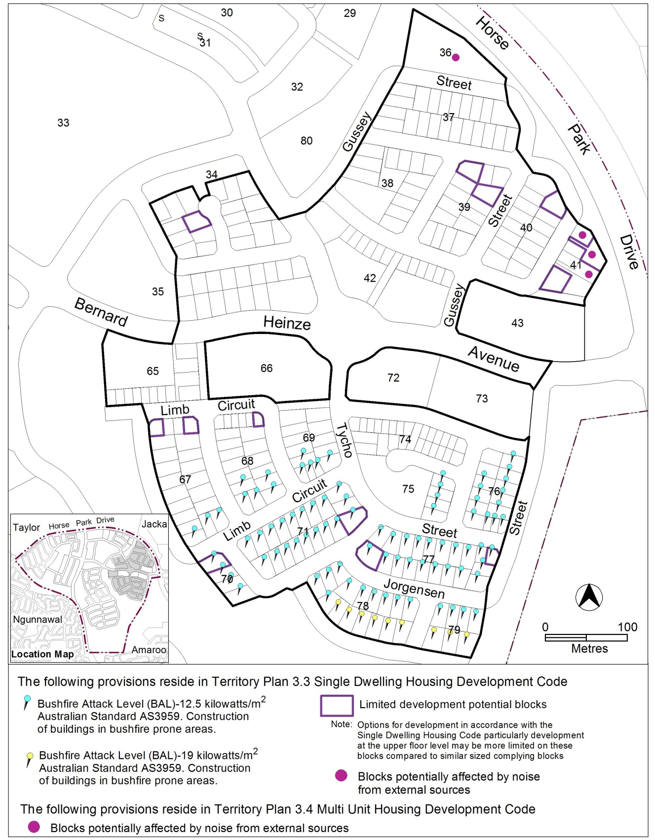
Figure 7 Moncrieff residential area ongoing provisions

Chris Collier
Delegate of the Planning and Land Authority
3 September 2015

THIS IS PAGE FOUR OF ANNEXURE B
TO NOTIFIABLE INSTRUMENT NI2015 – 493

OP4 – Moncrieff residential area
This part applies to blocks and parcels identified in area OP4 shown on the Moncrieff Precinct Map.
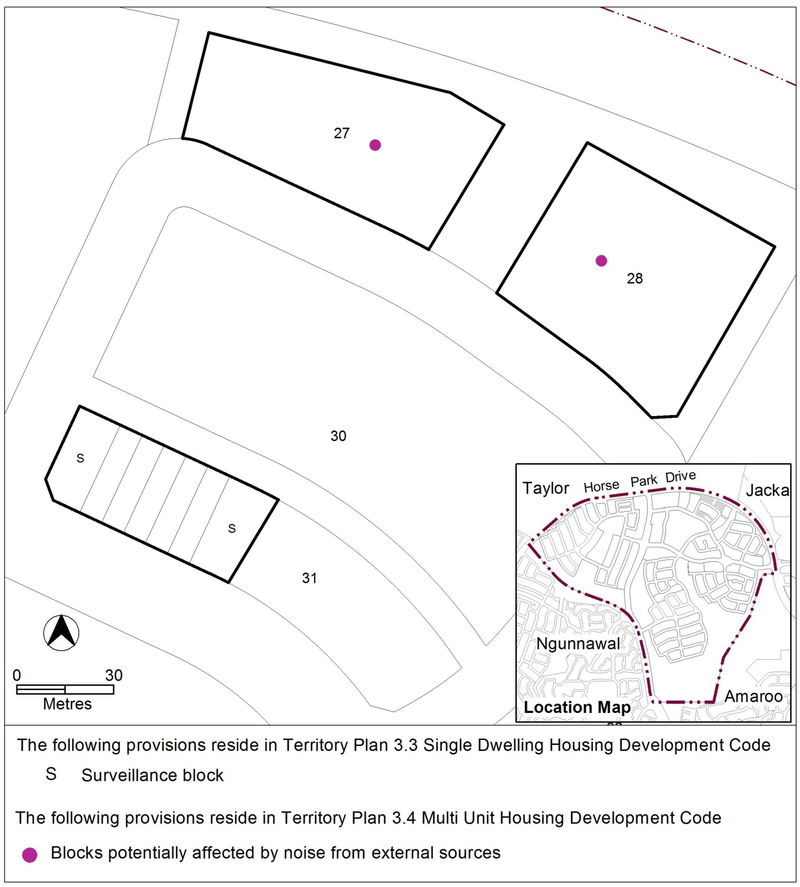
Figure 8 Moncrieff residential area ongoing provisions

Chris Collier
Delegate of the Planning and Land Authority
3 September 2015
THIS IS PAGE FIVE OF ANNEXURE B
TO NOTIFIABLE INSTRUMENT NI2015 – 493

R5  This rule applies to blocks or parcels in locations identified in Figures 1, 2 and 4.  Acoustic insulation to be provided to the upper floor level of the dwelling in accordance with AS/NZS 2107:2000 Acoustics – Recommended design sound levels and reverberation times for building interiors. | This is a mandatory requirement. There is no  applicable criterion.

R8  This rule applies to blocks or parcels in locations identified in Figures 1, 2 and 4.  Acoustic privacy fencing to be provided by the lessee.  See Diagram 1 for an elevation of a typical acoustic privacy fence | This is a mandatory requirement. There is no  applicable criterion.

Chris Collier
Delegate of the Planning and Land Authority
3 September 2015

