Australian Capital Territory
Planning and Development (Plan Variation No 335) Notice 2015
Notifiable Instrument NI2015-604
made under the
Planning and Development Act 2007, section 76(3)

- Name of instrument
This instrument is the Planning and Development (Plan Variation No 335) Notice 2015*

- Plan Variation No 335
On 16 October 2015, the Minister for Planning approved a draft of the attached plan variation to the Territory Plan (Annexure A) under s76 (3).

Jim Corrigan
Delegate of the Planning and Land Authority
20 October 2015

Planning and Development Act 2007

Variation to the
Territory Plan
No 335

ACT Government Land Release Program
Charnwood section 97 block 6
Zone changes

Final variation prepared under s76 of the
Planning and Development Act 2007

This page is intentionally blank.

Contents

1. EXPLANATORY STATEMENT 1
1.1 Background 1
1.1.1 Land Release Program 2014-15 to 2017-18 1
1.1.2 Background to the Charnwood site 3
1.2 Summary of the proposal 3
1.3 The National Capital Plan 4
1.4 Site Description 4
1.5 Current Territory Plan provisions 6
1.6 Changes to the Territory Plan 7
1.7 Consultation on the Draft Variation 7
1.8 Revisions to the Draft Variation Recommended to the Minister 7
2. VARIATION 8
2.1 Variation to the Territory Plan map 8

This page is intentionally blank.

- EXPLANATORY STATEMENT
  - Background
    - Land Release Program 2014-15 to 2017-18
The supply and release of land is a central part of the Government’s economic and social strategy and supports the needs of a growing population, changing households and an expanding economy. In particular, land supply has an important role in providing a range of affordable housing choices, and in meeting the needs of the commercial and industrial sectors, factors that are crucial in attracting and retaining a skilled workforce.
The leasehold system in the ACT makes it unique as it provides the Government with the ability to influence when, where and how development occurs. Land sales also provide a significant source of funding.
Each year the ACT Government prepares four year indicative land release programs which sets out the Government’s intended program of residential, commercial, industrial, community and non-urban land releases.
The four year indicative land release programs are intended to provide guidance on the Government’s land release intentions and seek to balance economic, social, financial and environmental objectives to:
- promote the economic and social development and population growth of the Territory;
- meet the demand for land in the Territory;
- allow flexibility to respond to fluctuations in the market;
- establish an appropriate inventory of serviced land;
- provide an appropriate choice of land and housing options and facilitating the provision of affordable housing; and
- achieve satisfactory returns from the sale of unleased Territory land.

The identification of blocks for release is based on an assessment of overall demand drivers. Within the individual sectors land is made available in response to factors such as:
- population growth rates including net overseas migration;
- demographic changes eg changes to living arrangements, ageing population;
- existing supply by the private sector and demand from the market eg vacancy rates and rent levels;
- ACT Government objectives eg diversifying the economic and employment base of the Territory;
- Market confidence and the availability of finance;
- Employment rates;
- Responding to private sector initiatives, such as the development and growth of the Canberra Airport;
- Local factors which can affect the demand for particular types of land; and
- National trends eg growth of innovative, emerging and creative industries eg environmental technologies, medical and bio-technologies and information technology.
The Land Development Agency (LDA) is responsible for the delivery of the land release programs. Some of the objectives of the LDA in delivering the land release programs include:
- Pursuing initiatives to deliver affordable housing consistent with the Affordable Housing Action Plan;
- Developing urban renewal and development strategies for the city centre, town centres, major transport corridors and group centres;
- Establishing an inventory of environmentally cleared, planned, release ready and serviced land that will provide flexibility and alternative release options to cover any unanticipated delays on sites otherwise identified for release in the relevant period;
- Encouraging viable and liveable communities by providing a variety of block and dwelling types and public spaces to suit the needs of residents and surrounding communities; and
- Contributing to the redevelopment of the transit corridor between Gungahlin, Civic and Lake Burley Griffin through the Capital Metro and City to the Lake projects.
More information can be found at:
http://www.economicdevelopment.act.gov.au/land and http://www.lda.act.gov.au

    - Background to the Charnwood site
This variation amends the zoning for block 6, section 97 Charnwood from the TSZ2 services zone to the CFZ community facility zone.
The fire brigade depot was located on the site but has been relocated to a combined ambulance and fire brigade station on block 19, section 97 Charnwood. As the land is no longer needed for the currently permitted purposes it is appropriate to review the use of the land.
The site is adjacent to land which is zoned CFZ community facility. The inclusion of this block in the CFZ community facility zone would essentially complete the section and enable it to be dedicated entirely for community uses. On the other side of Lhotsky Street is a school and there are playing fields on the other side of Florey Drive. Charnwood group centre is close by with a number of community facilities including a church and a child care centre.
The ACT Planning Strategy 2012 recognises the important role that group and local centres can play as community hubs. Locating schools, libraries, child care centres and other community facilities at the heart of suburbs ensures good access to community facilities which helps build social exchange and general wellbeing in the community.
The ultimate use of the land will be determined by the Land Development Agency in response to market conditions and consistent with the provisions of the CFZ community facilities zoning. In this regard, the subject site is of a suitable size for a range of uses that are permissible under the CFZ community facility zone such as a place of worship, health facility, supportive housing or a child care centre.
The opportunity also exists to make use of the existing facility, including the existing buildings and the car parking area.
The community and recreation facilities location guidelines general code in the Territory Plan stipulates locational criteria to be considered when establishing community facilities.
  - Summary of the proposal
This variation amends the zoning for block 6, section 97 Charnwood from the TSZ2 services zone to the CFZ community facility zone.
A fire brigade depot operated out of block 6, section 97. This has been relocated to a combined ambulance and fire brigade station on block 19 section 97 Charnwood. As the land is no longer required for the current permitted purpose it is proposed to rezone the land to CFZ community facility zone. The land adjacent to block 6 section 97 is also zoned CFZ. The inclusion of this block in the CFZ community facility zone would essentially complete the section and enable it to be dedicated entirely for community uses.
The site is located close to the Charnwood group centre with a number of community facilities nearby including a Church, school and child care centre.
  - The National Capital Plan
The Australian Capital Territory (Planning and Land Management) Act 1988 established the National Capital Authority (NCA) with two of its functions being to prepare and administer a National Capital Plan (NCP) and to keep the NCP under constant review and to propose amendments to it when necessary.
The NCP, which was published in the Commonwealth Gazette on 21 January 1990 is required to ensure that Canberra and the Territory are planned and developed in accordance with their national significance. The Planning and Land Management Act 1988 also required that the Territory Plan is not inconsistent with the NCP.
In accordance with section 10 of the Australian Capital Territory (Planning and Land Management) Act 1988, the National Capital Plan defines the planning principles and policies for Canberra and the Territory, for giving effect to the object of the NCP and sets out the general policies to be implemented throughout the Territory, including the range and nature of permitted land uses.
It also sets out the detailed conditions of planning, design and development for areas that have special significance to the National Capital known as designated areas and identifies special requirements for the development of some other areas.
  - Site Description
The subject site is block 6, section 97 Charnwood (see location map in Figure 1). It is an area of 3638m2 bounded by Florey Drive to the west and Lhotsky Street to the north east. To the south of the site is the Ginninderra Christian Church and to the east is the St Thomas Aquinas Primary School. Both of these sites are located within the CF community facility zone. To the north of the site (on the opposite side of Lhotsky Street) is the Brindabella Christian College early Learning Centre which is located on land that is zoned CZ6 leisure and accommodation.
The Charnwood sportsgrounds are located to the west of the site on the opposite side of Florey Drive. The land use zoning for the sportsgrounds is PRZ1 urban open space.
The subject site is some 600 metres away from the Charnwood group centre, about 3 kilometres to the Kippax Shopping Centre (to the south) and about 7 kilometres from Belconnen town centre to the southeast. The Charnwood group centre contains a range of shops and commercial outlets as well as community facilities, including a church and a childcare centre. The site is just north of Ginninderra drive which is a major arterial road that connects the suburbs in West Belconnen.
The subject site is conveniently located adjacent to other commercial and community facilities and services.

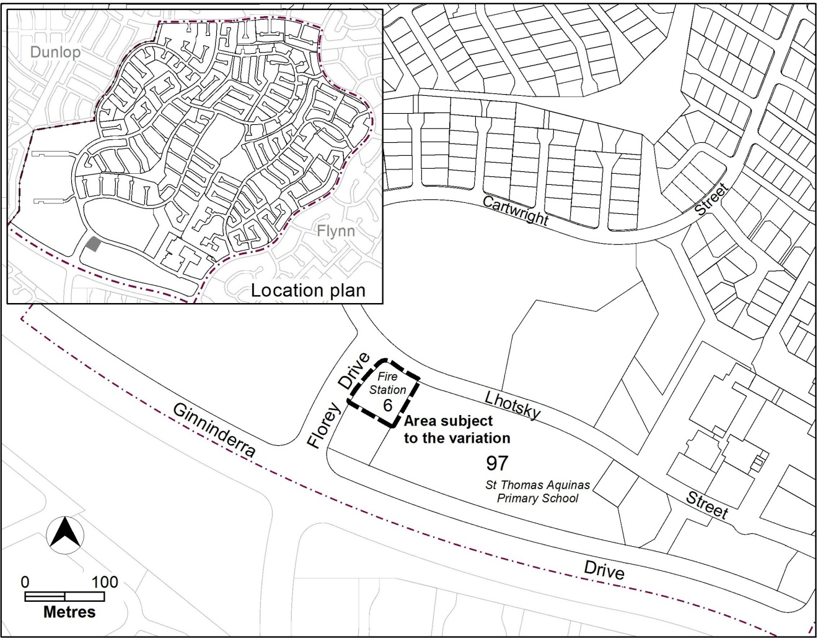
Figure 1 Site Plan

  - Current Territory Plan provisions
The Territory Plan map for the area subject to this variation is shown in Figure 2.
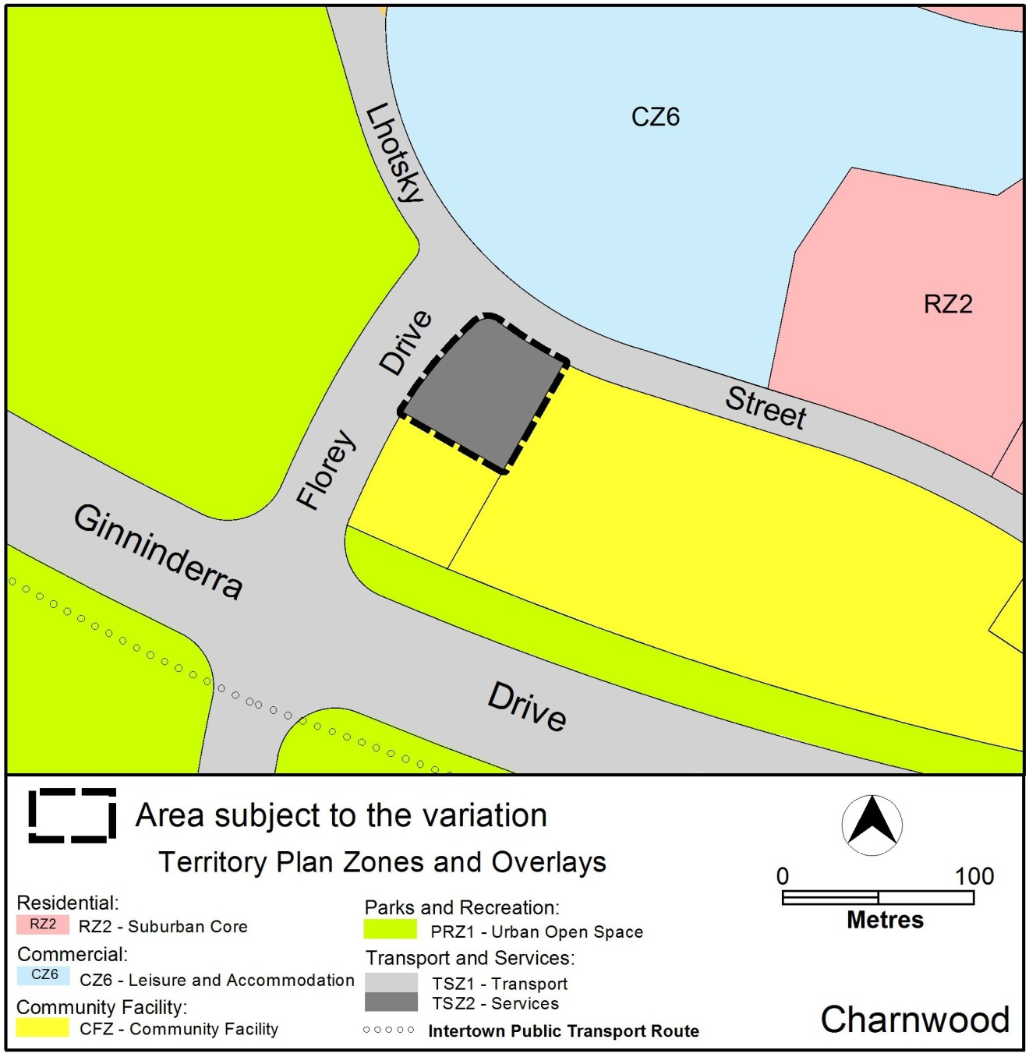
Figure 2 Territory Plan Zones Map

  - Changes to the Territory Plan
Detailed changes to the Territory Plan are noted in section 2 of this document.

  - Consultation on the Draft Variation
Draft variation No 335 (DV335) was released for public comment between 7 November 2014 and 19 December 2014. A consultation notice under section 63 of the Planning and Development Act 2007 (the Act) was published on the ACT Legislation Register on 7 November 2014 and in the Canberra Times on
8 November 2014.
No submissions were received in relation to DV335.
A report on consultation was prepared in relation to the draft variation.
A non-statutory pre-consultation with the community was carried out by the Chief Minister, Treasury and Economic Development Directorate (CMTED) on the proposed zoning change before DV335 was released for public comment. A total of three written submissions were received from the community during the non statutory consultation period. The submissions raised concerns regarding a range of issues including,
- Impact on traffic and parking on Lhostky Street and Florey Drive;
- Opposed to the proposed changes
- Possible site contamination
- Possible alternative uses
- Territory Plan variation process
A report on the non-statutory consultation (Omnibus Territory Plan Variation 1 Part A Community Feedback) was made publicly available and was considered as a background document in preparing the Omnibus Variations including DV335.

  - Revisions to the Draft Variation Recommended to the Minister
No changes were made to the draft variation recommended to the Minister.

- VARIATION
  - Variation to the Territory Plan map
The Territory Plan map is varied as indicated in Figure 3 – proposed Territory Plan Map

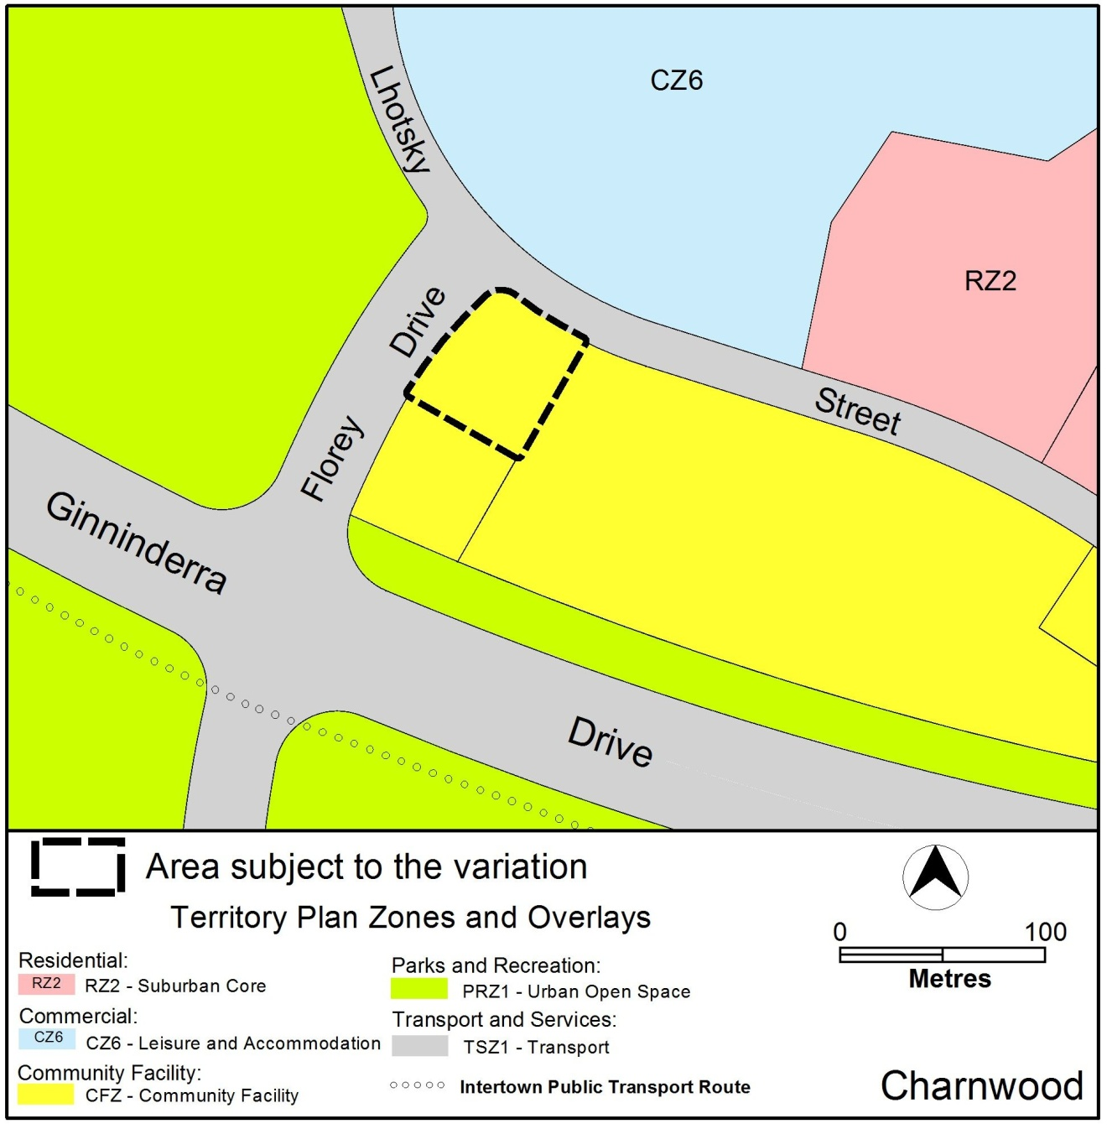
Figure 3 – Variation to the Territory Plan Map
Interpretation service
