Australian Capital Territory

Heritage (Decision about Registration of   
The former AAA Building, Braddon) Notice 2015

**Notifiable Instrument NI2015—73**

made under the

Heritage Act 2004, s42 Notice of decision about registration

**1 Revocation**

This instrument replaces NI2014—460.

**2 Name of instrument**

This instrument is the *Heritage (Decision about Registration of   
The former AAA Building, Braddon) Notice 2015*.

**3 Registration details of the place**

Registration details of the place are at Attachment A: Register entry for   
The former AAA Building, Braddon.

**4 Reason for decision**

The ACT Heritage Council has decided that The former AAA Building, Braddon meets one or more of the heritage significance criteria at s 10 of the *Heritage Act 2004*. The register entry is at Attachment A.

**5 Date of registration**

12 February 2015

Anna Gurnhill  
A/g Secretary (as delegate for)  
ACT Heritage Council  
12 February 2015



AUSTRALIAN CAPITAL TERRITORY

HERITAGE REGISTER

(Registration)

For the purposes of s. 40 of the *Heritage Act 2004*, an entry to the heritage register has been prepared by the   
ACT Heritage Council for the following place:

**The former AAA Building**

**Block 3, Section 3, Braddon**

DATE OF REGISTRATION

12 February 2015 Notifiable Instrument: 2015–73

Copies of the Register Entry are available for inspection at ACT Heritage. For further information please contact:

The Secretary

ACT Heritage Council

GPO Box 158, Canberra, ACT 2601

Telephone: 13 22 81

IDENTIFICATION OF THE PLACE

The former AAA Building

212 Northbourne Avenue, Block 3 Section 3, Braddon

This statement refers to the Heritage Significance of the place as required in s12(d) of the *Heritage Act 2004*.

STATEMENT OF HERITAGE SIGNIFICANCE

The former AAA building within its open park setting stands out as a bold and sleek metal-clad beacon of modernity amidst a setting of conventional brick and concrete structures nearby. It is an exemplar of the Late Twentieth Century Late Modern style with its supremely simple and elegant form and finish, expressing not just a high-tech quality but also considerable design skill. *[Criterion (c) and (g)]*

Designed in 1978 by Guy Maron, its bespoke wall cladding and glazing system completed in a high quality finish helps to extend the creative achievement of the design making it still appear as a modern building over three decades after its completion. *[Criterion (a)]*

FEATURES INTRINSIC TO THE HERITAGE SIGNIFICANCE OF THE PLACE

The attributes listed below are assessed as features intrinsic to the heritage significance of the place and warrant conservation:

* The original form of the building determined by simple geometry, being the arcing form of the building;
* The original glass and metal curtain walls (comprising the bespoke glazing and cladding system) and cladding panels; and
* The park-like setting.

CONSERVATION OBJECTIVE

The guiding conservation objective is that the former AAA Building shall be conserved and appropriately managed in a manner respecting its heritage significance and the features intrinsic to that heritage significance.

The ACT Heritage Council may adopt heritage guidelines applicable to the place under s25 of the *Heritage Act 2004*.

For further information on guidelines applicable to the place, or for advice on proposed works or development, please contact ACT Heritage on 13 22 81.

REASON FOR REGISTRATION

The former AAA Building has been assessed against the heritage significance criteria and been found to have heritage significance when assessed against three criteria [(a), (c), and (g)] under the *Heritage Act 2004*.

ASSESSMENT AGAINST THE HERITAGE SIGNIFICANCE CRITERIA

Pursuant to s.10 of the Heritage Act 2004,a place or object has heritage significance if it satisfies one or more of the following criteria. Significance has been determined by research as accessed in the references below. Future research may alter the findings of this assessment.

it demonstrates a high degree of technical or creative achievement (or both), by showing qualities of innovation, discovery, invention or an exceptionally fine level of application of existing techniques or approaches;

The former AAA Building, Braddon, meets this criterion.

The former AAA Building is an early example of the Late Twentieth‑Century Late Modern style which displays a high degree of technical and creative achievement. The technical achievement relates to the external wall cladding and glazing system which is a one-off design built specifically for the former AAA building so that it could include long uninterrupted strip windows on a curved façade – achieving Corbusian style strip windows. The creative achievement rests on the Late Modern style, but the design is a supremely simple and elegant form and finish, expressing not just a high-tech quality but also considerable design skill.

The broader historical context of both the technical and creative qualities is not sufficiently developed to enable conclusions to be drawn about the extent to which the design is innovative.

None the less, the former AAA Building is an exceptionally fine example of a technical achievement regarding its wall cladding and glazing system, and as a creative achievement in the Late Twentieth‑Century Late Modern style.

The building is set in an open park-like setting that enables the elegant curved western elevation to be appreciated from Northbourne Avenue, This was a NCDC’s policy to give visual prominence to the main entry to Canberra.

it exhibits outstanding design or aesthetic qualities valued by the community or a cultural group;

The former AAA Building, Braddon, does not meet this criterion.

Whilst the former AAA Building displays a crisp and sleek aesthetic that has maintained a modern look more than three decades after it was built, there is no evidence that it exhibits outstanding design or aesthetic qualities that are valued by the community or a cultural group.

it is important as evidence of a distinctive way of life, taste, tradition, religion, land use, custom, process, design or function that is no longer practised, is in danger of being lost or is of exceptional interest;

The former AAA Building, Braddon, meets this criterion.

The former AAA Building is important as evidence of a distinctive design of exceptional interest. The design rests on the Late Twentieth‑Century Late Modern style, of which it is an early example, but it is more important for extending the style with its supremely simple and elegant form and finish, expressing not just a high-tech quality but also considerable design skill.

Examples of the Late Twentieth‑Century Late Modern style in Canberra have not been comprehensively surveyed, but other known or suggested examples include the Royal Australian Mint (1964–65) and Toad Hall (1977) (based on information in the Australian Heritage Database). In comparison, the former AAA Building displays a much superior design and an aesthetic expressing a high-tech quality.

The former AAA Building was the former national headquarters of the Australian Automobile Association (AAA) which occupied the ground floor and leased the upper floors. The Australian Automobile Association represents Australian motoring bodies, such as the NRMA and RACV, and is still functioning with over 7 million members nationally. The Council considers that the body representing Australian motoring groups and the practice of leasing unused space in a building as represented in the former AAA Building are not important as evidence of a distinctive life, taste, tradition, land use, custom, process, design or function that is no longer practised, is in danger of being lost or is of exceptional interest.

The building is set in an open park-like setting and set with the curved elevation fronting Northbourne Avenue. This setting enables the building to be appreciated.

it is highly valued by the community or a cultural group for reasons of strong or special religious, spiritual, cultural, educational or social associations;

The former AAA Building, Braddon, does not meet this criterion.

The Council recognises that the Australian Automobile Association provides programs, such as ANCAP car safety ratings and AusRAP road assessments, that are of great service to the broader Australian community. However, the organisation and the programs related to it are no longer represented in the building and there is no evidence that the broader ACT community or any cultural groups highly value the former AAA Building for its former association with the Australian Automobile Association. Also, while there have been other tenants in the building, none show a significant or enduring relationship that demonstrate that the place is highly valued by the community or a cultural group for reasons of strong religious, spiritual, cultural, educational or social associations.

it is significant to the ACT because of its importance as part of local Aboriginal tradition

This criterion does not apply to the former AAA Building, Braddon.

it is a rare or unique example of its kind, or is rare or unique in its comparative intactness

The former AAA Building, Braddon, does not meet this criterion.

There is insufficient contextual information about the range of examples of the Late Twentieth‑Century Late Modern style to enable an assessment under this criterion. While the currently known examples are few, there has not been an adequate survey to establish a sound understanding of the range.

it is a notable example of a kind of place or object and demonstrates the main characteristics of that kind

The former AAA Building, Braddon, meets this criterion.

The former AAA Building is an example of the Late Twentieth‑Century Late Modern style through demonstrating the key indicator of the style, the shape of the building being determined by simple geometry, and its display of another indicator – the use of an aluminium curtain wall. However, it is a notable example because the design extends the Late Twentieth‑Century Late Modern style with a supremely simple and elegant form and finish, expressing not just a high-tech quality but also considerable design skill.

it has strong or special associations with a person, group, event, development or cultural phase in local or national history

The former AAA Building, Braddon, does not meet this criterion.

There is insufficient evidence that the former AAA building has strong or special associations with any person, group, event, development or cultural phase in local or national history. Even though the construction of the building occurred during the development of the ACT under the National Capital Development Commission (NCDC), there is no evidence that it was important in this period of development or that it influenced later development in the ACT.

Additionally, whilst the work of the Australian Automobile Association is important for the nation, there is no evidence that it, or the work it has been involved with, have a strong or special association with the former AAA Building.

it is significant for understanding the evolution of natural landscapes, including significant geological features, landforms, biota or natural processes

This criterion does not apply to the former AAA Building, Braddon.

it has provided, or is likely to provide, information that will contribute significantly to a wider understanding of the natural or cultural history of the ACT because of its use or potential use as a research site or object, teaching site or object, type locality or benchmark site

The former AAA Building, Braddon, does not meet this criterion.

Whilst it has been suggested that the former AAA Building may be an educational resource to those studying the Late Twentieth‑Century Late Modern style of architecture, there is no evidence that this is currently likely.

for a place—it exhibits unusual richness, diversity or significant transitions of flora, fauna or natural landscapes and their elements

This criterion does not apply to the former AAA Building, Braddon.

for a place—it is a significant ecological community, habitat or locality for any of the following:

1. the life cycle of native species;
2. rare, threatened or uncommon species;
3. species at the limits of their natural range;
4. distinct occurrences of species.

This criterion does not apply to the former AAA Building, Braddon.

**SUMMARY OF THE PLACE**

HISTORY AND PHYSICAL DESCRIPTION

HISTORY

The former national headquarters of the Australian Automobile Association (AAA) was designed by Guy Maron from Raffen Neill Maron Partnership in 1978 with construction completed in 1979 by Concrete Constructions.

The AAA was formed in 1924 and represents several motoring bodies throughout Australia, such as the NRMA and the RACV. The AAA represents these groups at a national level and supports or runs several programs aimed at improving road safety such as ANCAP car safety testing and AusRAP road safety assessments. Prior to moving into the AAA Building in 1979, the organisation’s headquarters was located in Sydney, but they realised the need for a national organisation to be where the federal government was seated in order to properly represent their members.

The AAA requested a building for their new national headquarters that would suit the site’s limitations, but allow for maximum return on their investment. The block required a northwest to southeast pedestrian link and to retain a small treed park in the southwest corner. The owners required a building of which they would occupy the ground floor and lease the upper floors. By situating the building at an angle across the block the architect was able to accommodate the site limitations and by adding a curve to the building was able to maximise floor space and the area the owner could lease. By using reinforced concrete floors, frames and beams the architect created an interior with a minimum of supporting columns which would allow for a great deal of flexibility in tenancy options. The building was constructed “...at no higher cost than any of the other buildings surrounding the site...” and yet it “...commanded the highest rental in Canberra of any commercial building for decades” (Maron 2014).

The clients were not the only group influencing the design; the National Capital Development Commission (NCDC) had several planning restrictions that applied to all buildings along Northbourne Avenue, as one of the ACT’s main avenues. There were several simple planning restrictions, such as a maximum building height of three stories and setbacks of 18m, but there were also high level requirements such as buildings had to be of a high national quality and have an integration of landscape and architecture. The architect’s response was to design the building in such a way that it “paid homage to the surrounding buildings in a significant urban design sense” (Maron, pers. comm., March 2014), yet it has a unique and noticeable presence along Northbourne Avenue. Mr Maron notes that the “NCDC were very supportive of the design...” and that “Unusually it was all over in one presentation meeting at the NCDC” (Maron 2014).

The building’s sleek curving facade portrays a high-tech aesthetic in a building in the Late Twentieth-Century Late Modern style (Apperly et al 1989). This style of building design is a continuation of the Late Twentieth Century International style where the simple rectangular shapes have been bent along a curve. Apperly et al describes the style as trying to convey the image of technology, but as Taylor (1990) notes it uses conventional techniques without any real technological ingenuity which, while distinctive, is an aesthetic variation on architectural modernism. The aluminium cladding on the building has been used in Australian buildings from the mid-1960s, but has been applied to great effect when used as the main facade element. Whilst it was not the first to use aluminium cladding in Australia, it was the first to use it to such an extent as the main external visual element, creating a bold new aesthetic at the time. The high quality of the finish, the originality of the design and the holistic approach that integrates landscape and setting all contribute to the building’s appeal. Although the building is over three decades old, it still looks modern.

The building received the Royal Australian Institute of Architects (RAIA, now AIA) Canberra Chapter Award of Merit in 1982.

The AAA had moved out of the building and occupied another site within the ACT by 1998.

A recent addition to the building is a black painted sun control scaffold along the northern facade. This was added as part of a refurbishment program that resulted in the building receiving a National Australian Built Environment Rating System (NABERS) energy efficiency rating of 4.5 stars, an excellent score for a building of its age and above the national average of 3.5 stars (when compared against the 2012 the Commercial Building Disclosure (CBD) Program, for which data is available). However, it should be noted that the majority of energy efficiency features of the building that contributes to this rating are part of the original design. The black painted metal frame, while contrasting with the original form and aesthetic, is somewhat sympathetic to the Late Twentieth-Century Late Modern style which can include in its exterior characteristics, "Steelwork exposed and painted" (Apperly, et al. 1994).

DESCRIPTION

The building sits diagonally across the block in a northwest-southeast orientation which allows pedestrian access across the block and which retains a pre-existing treed park in the southwest corner of the block.

It has a reinforced concrete frame supporting a reinforced concrete floor. This allows for flexible tenancy options in the open floor plan interior. The services are contained in towers at either end of the building that are made with reinforced concrete and there is a basement parking area.

It is curved so that the northern facade is minimised against direct solar radiation, while the southern side has more surface area to allow indirect light to enter, however later additions include a detached scaffolding system of sun protection along the northern facade which, while functional, somewhat detracts from the crisp aesthetic of the exterior. The strip windows are hermetically sealed double glazed units tinted a dark grey as an energy efficiency measure that also allows for expansive, uninterrupted views. The architect’s aim to have a clean, uninterrupted aesthetic was the driving force behind the creation of a bespoke cladding system that allowed the window panes to be ‘slung’ between the aluminium sections, creating a frame-free strip of window panes along the entire length of the facade.

The building is clad in aluminium panels with Corbussian style strip windows that sit flush with each other creating an aesthetically crisp and sleek facade. The aluminium facade continues over the plant area on top of the building so as not to detract from its aesthetic appeal. The external facade of aluminium panels and glazing is a bespoke system with the aluminium panels “...independently supported off the end of the slab with the glass ‘slung’ between them...” (Maron 2014) resulting in an external wall that resembles a curtain-wall, but without any framing interrupting the strip glazing.

The same panelling that is used on the exterior of the building is used as a wall covering in the lobby area.

The building is set in an open park-like setting that enables the elegant curved western elevation to be appreciated from Northbourne Avenue, This was a NCDC’s policy to give visual prominence to the main entry to Canberra.

Physical condition and integrity

A site visit by ACT Heritage on 13 September 2013 showed the building to be in excellent physical condition and integrity. Some minor staining on a few of the aluminium cladding panels was evident and an external scaffolding sun control system had been erected; neither was significantly detracting from the building or considered permanent.SITE PLAN

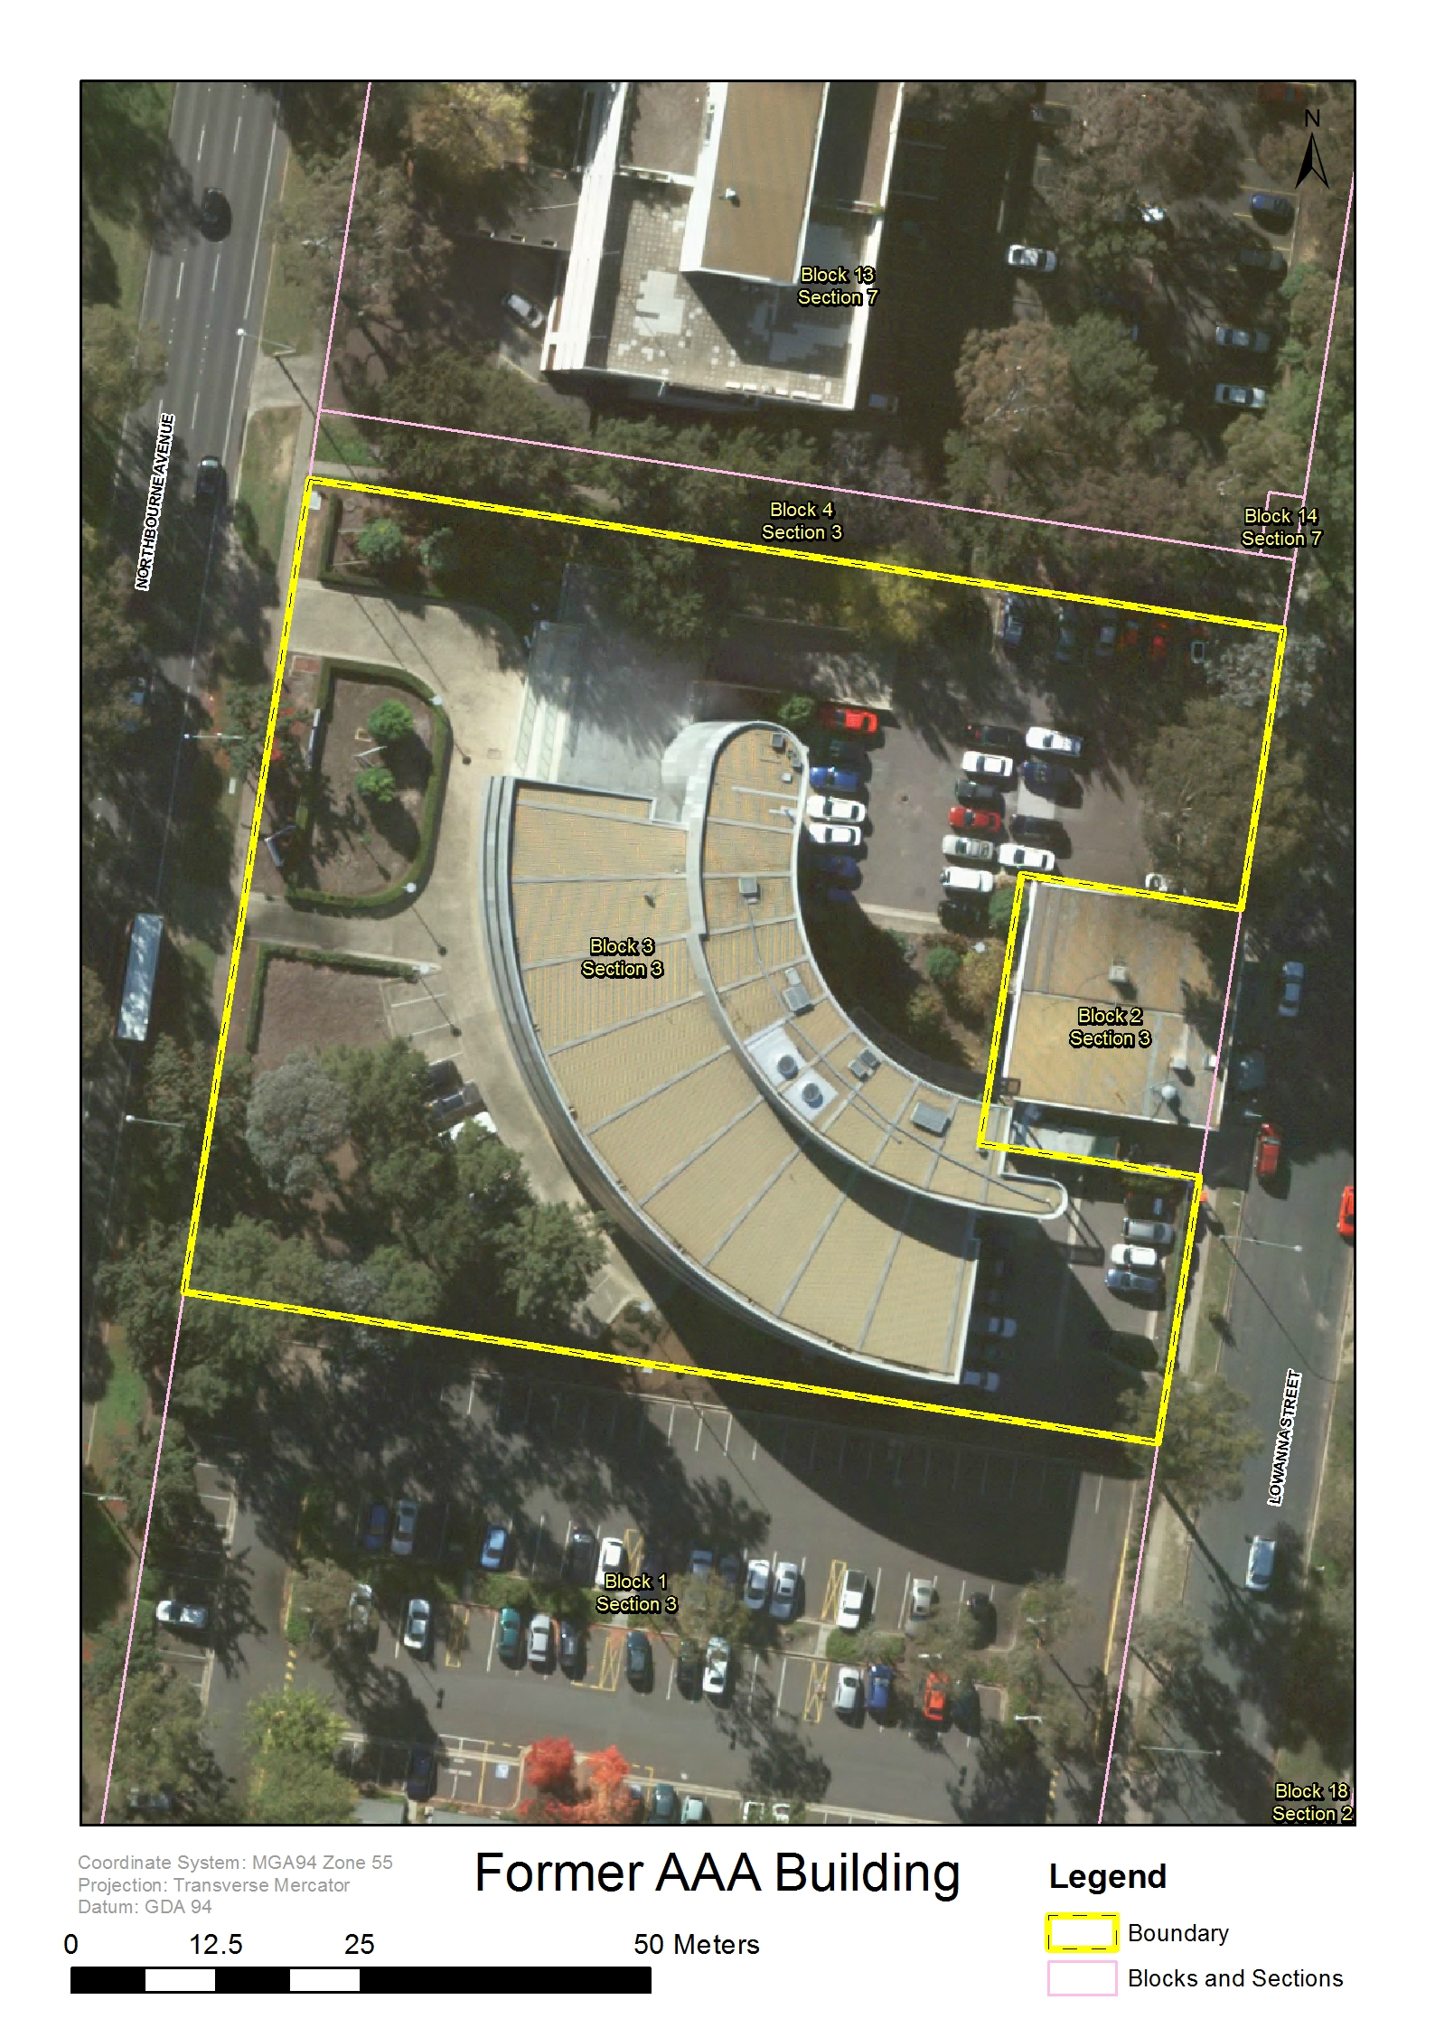

**Image 1.** Former Australian Automobile Association Building, registration boundary (NOTE: the boundary is based on the block boundary).

IMAGES



**Image 2.** Former Australian Automobile Association Building ground floor plan. (*Architecture Australia* 1982)

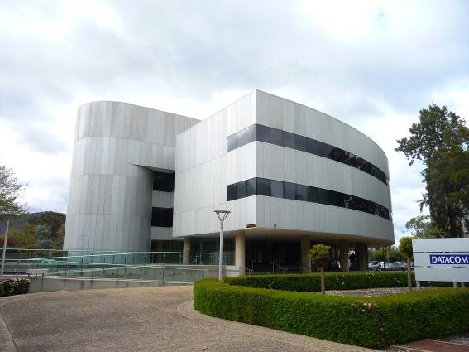

**Image 3.** FormerAustralian Automobile Association Building from Northbourne Avenue. (ACT Heritage 2013)

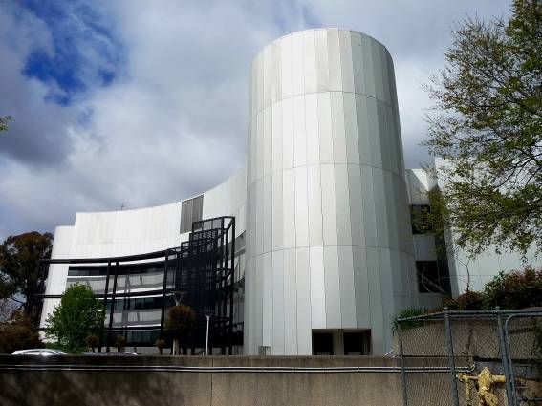

**Image 4.** FormerAustralian Automobile Association Building northern side with the black sun control scaffolding visible on the left in front of the building. (ACT Heritage 2013)

REFERENCES

Apperl0y R, Irving, R, & Reynolds P L (1994), ***A Pictorial Guide to Identifying Australian Architecture : styles and terms from 1788 to the present* (revised edition)**. Angus & Robertson, Sydney.

***Architecture Australia*** (1982), Canberra medallion Commendation. Australian Automobile Association Headquarters, Braddon.

***The Canberra Times*** (1979), The Australian Automobile Association Headquarters. September 9, pp2-3.

Maron G (2014), Personal communication via email 3 March.

Royal Australian Institute of Architects (n.d.), **Register of Significant Twentieth Century Architecture**. RSTCA No. R113. CSC Building.

Steele J (1997), ***Architecture Today***. Phaidon, London

Taylor J (1990), ***Australian Architecture Since 1960***. 2nd Ed. National Education Division, Royal Australian Institute of Architects, ACT.