Australian Capital Territory
Emergencies (Service Provider) Approval 2016 (No 4)
Notifiable instrument NI2016–181
made under the
Emergencies Act 2004, s 62 (Decision about approval)

1 Name of instrument
This instrument is the Emergencies (Service Provider) Approval 2016 (No 4).
2 Commencement
This instrument commences on 25 May 2016.
3 Approval
I approve Motorsport Safety & Rescue Pty Ltd (the approved provider) to provide firefighting and rescue services (the services) during the 2016 National Capital Rally pre event test day on 25 May 2016 and the 2016 National Capital Rally beginning on 27 May 2016 and ending on 29 May 2016:
4 Conditions on Approval
I impose the conditions in Schedule 1 on the approval.
5 Expiry
This instrument expires on 30 May 2016.

Simon Corbell MLA
Minister for Police and Emergency Services
11 April 2016

SCHEDULE 1

Conditions on Motorsport Safety & Rescue Pty Ltd for
approval under s 62(4) of the Emergencies Act 2004

- The approved provider may only perform the services within the geographical boundaries and dates for the event as defined by Diagram 1, Diagram 2, Diagram 3, Diagram 4, Diagram 5, Diagram 6 and Diagram 7 of this Schedule.

- This instrument approves only the staff nominated by the approved provider in its application for approval under s 62 of the Emergencies Act 2004.

- Staff not nominated by the approved provider in its application for approval under s 62 of the Emergencies Act 2004 may only provide the services with written approval of the Emergency Services Agency Commissioner.

- The approved provider must provide the Emergency Services Agency Commissioner with copies of any updated or renewed insurance documentation if insurance is renewed or varied before this instrument expires.

- The provider may only respond to low level fire and rescue incidents, including:
- rubbish bin fires;
- carburettor fires in vehicles;
- minor vehicle fires;
- to assist driver from vehicle if the vehicle has been involved in an accident; and
- to provide access to the driver, for first aid services, in the event of an accident.

- The approved provider may respond to and deal with the cleanup of minor oil or fuel spills during the event.

- The approved provider must immediately notify Triple Zero (000) of any incident that is beyond their response authority as provided in Schedule 1, Condition 5.

- In the event that the ACT Fire & Rescue are in attendance at an incident within the geographical boundaries and dates as outlined in this Schedule, Condition 1, the approved provider must take direction from the senior officer in attendance, including any direction about the utilisation of the approved provider’s services.

Diagram 1
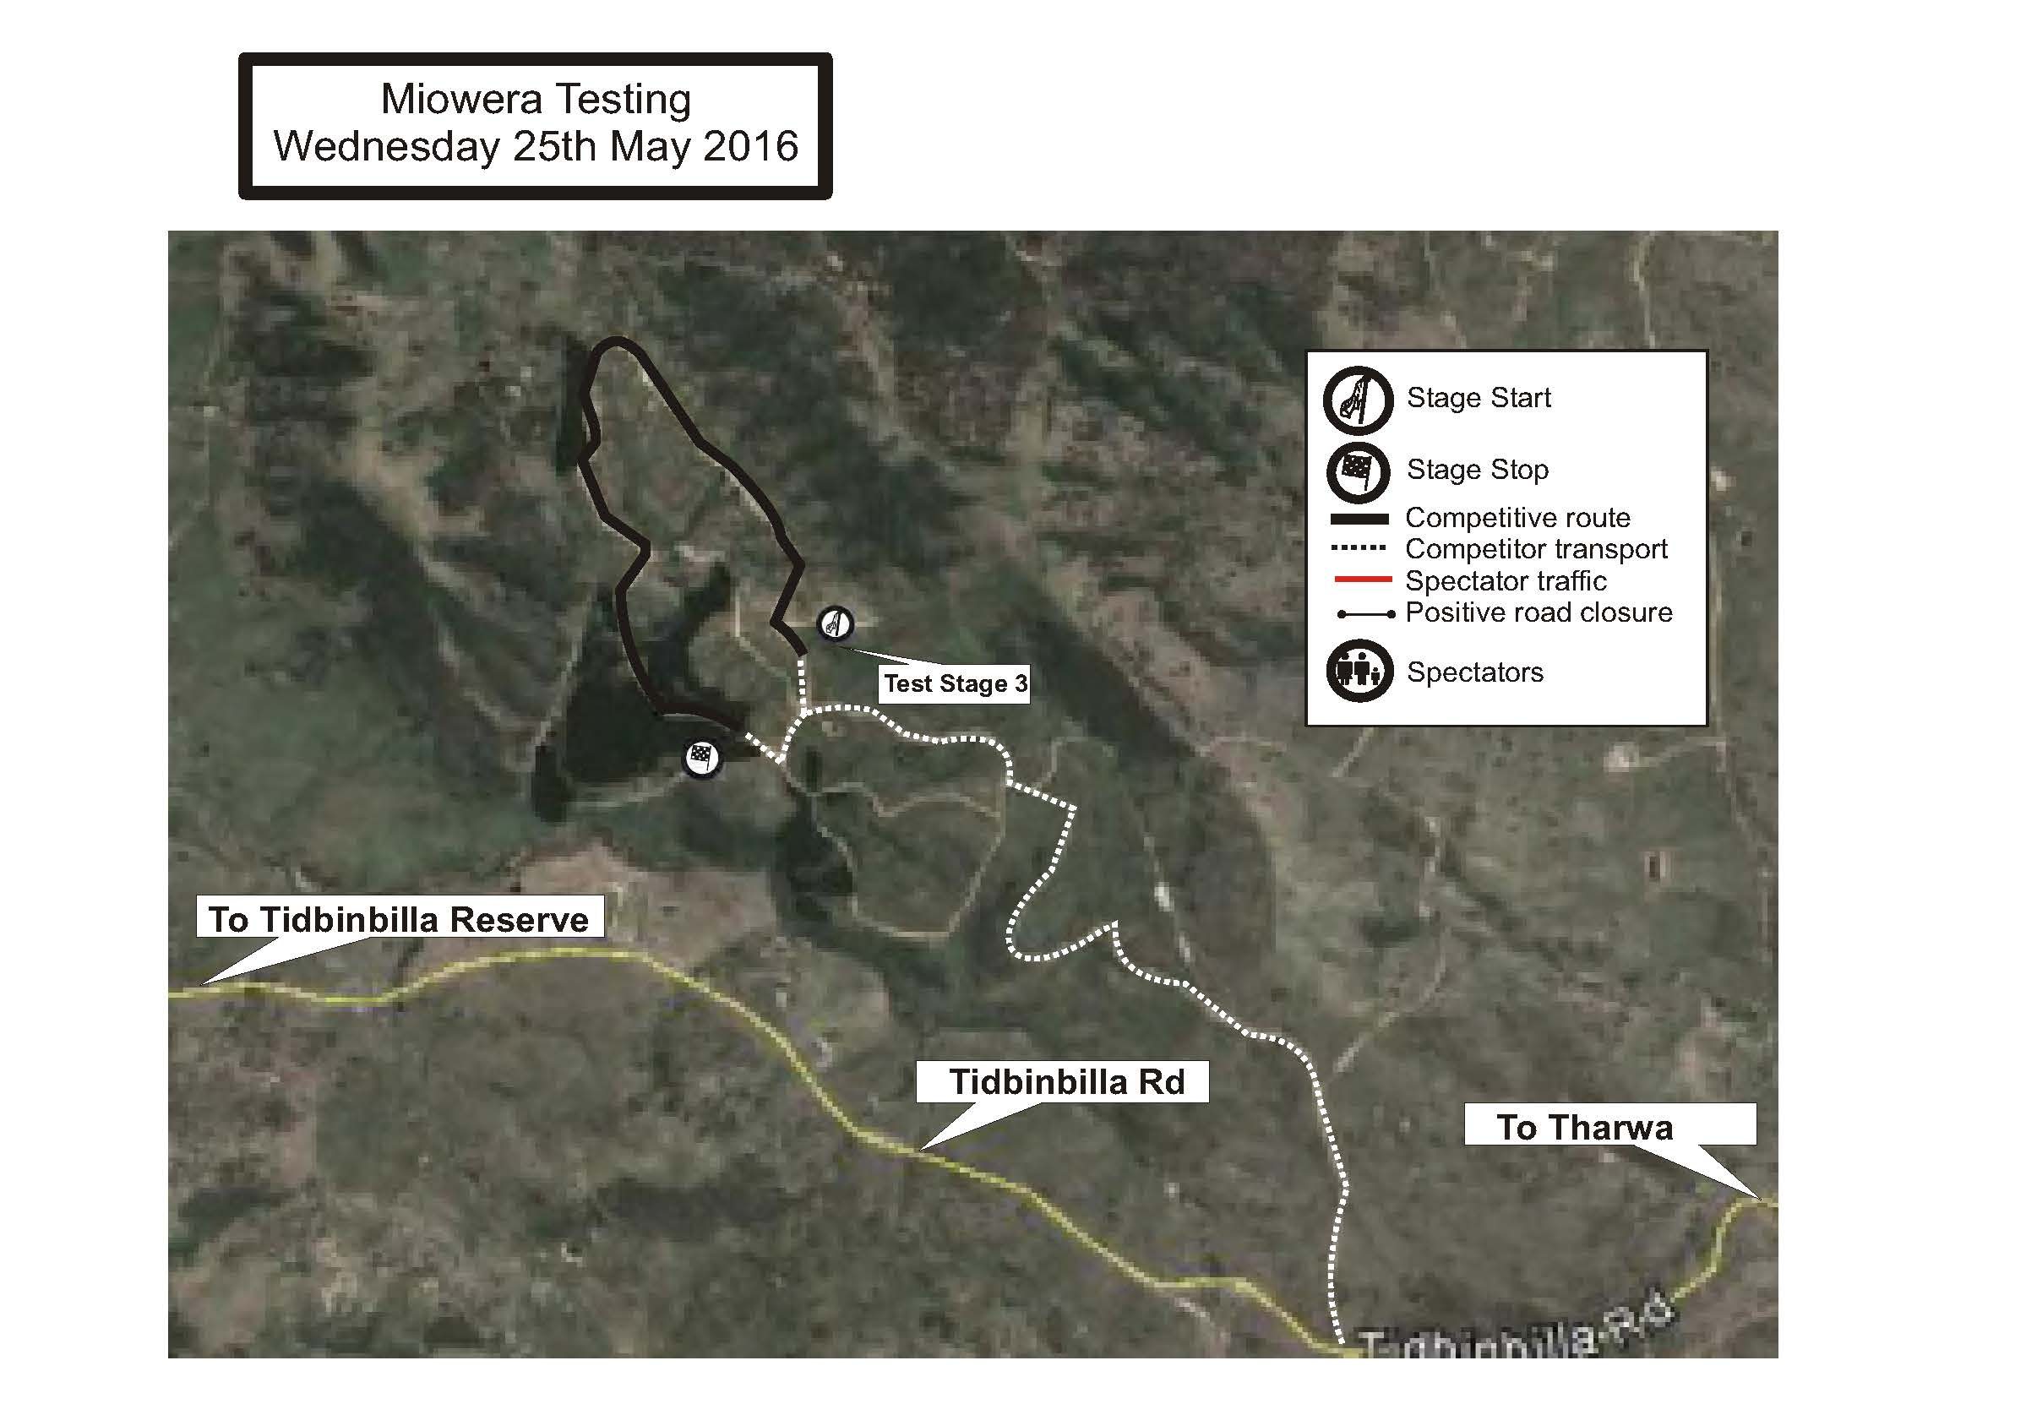
Diagram 2
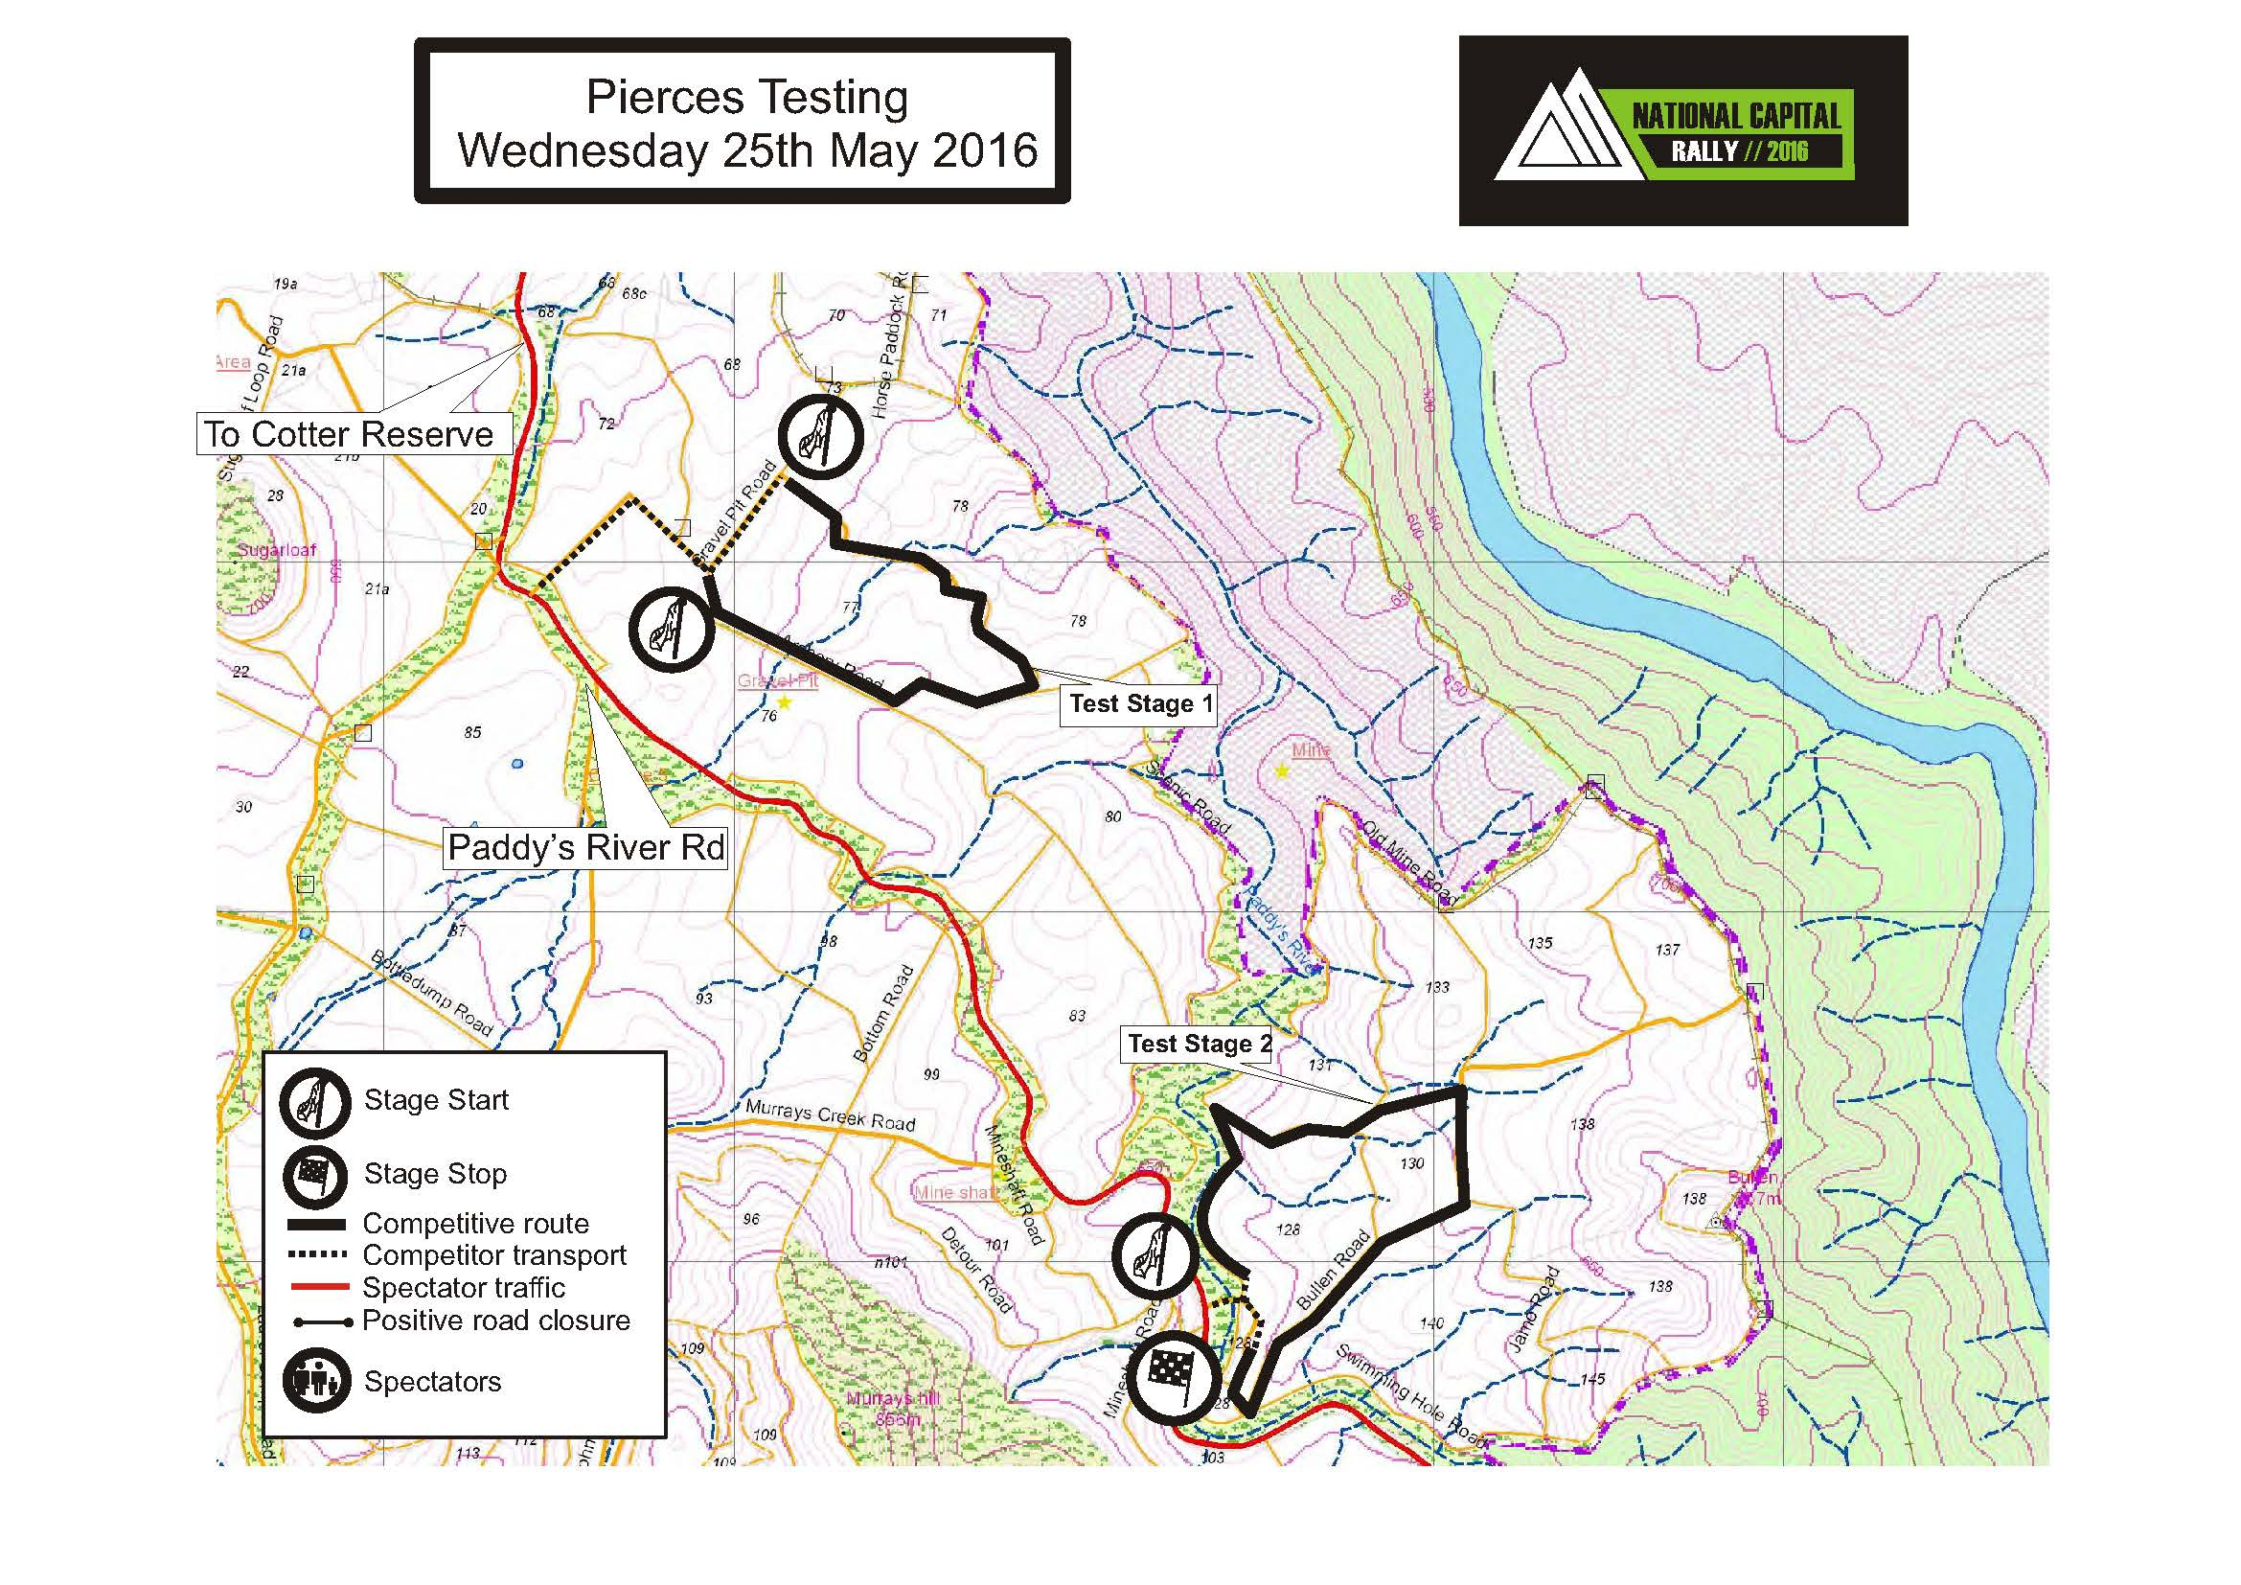
Diagram 3
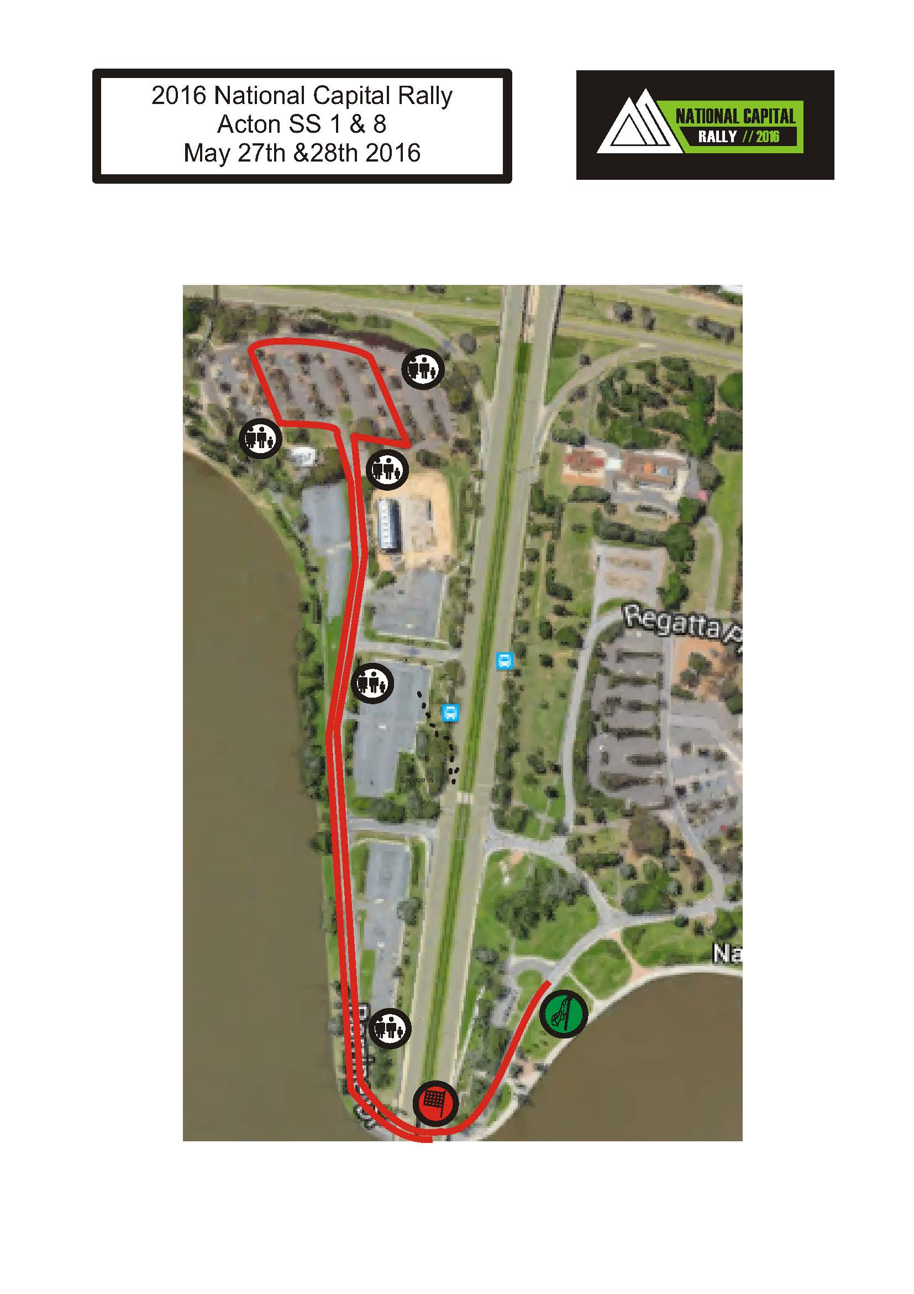

Diagram 4
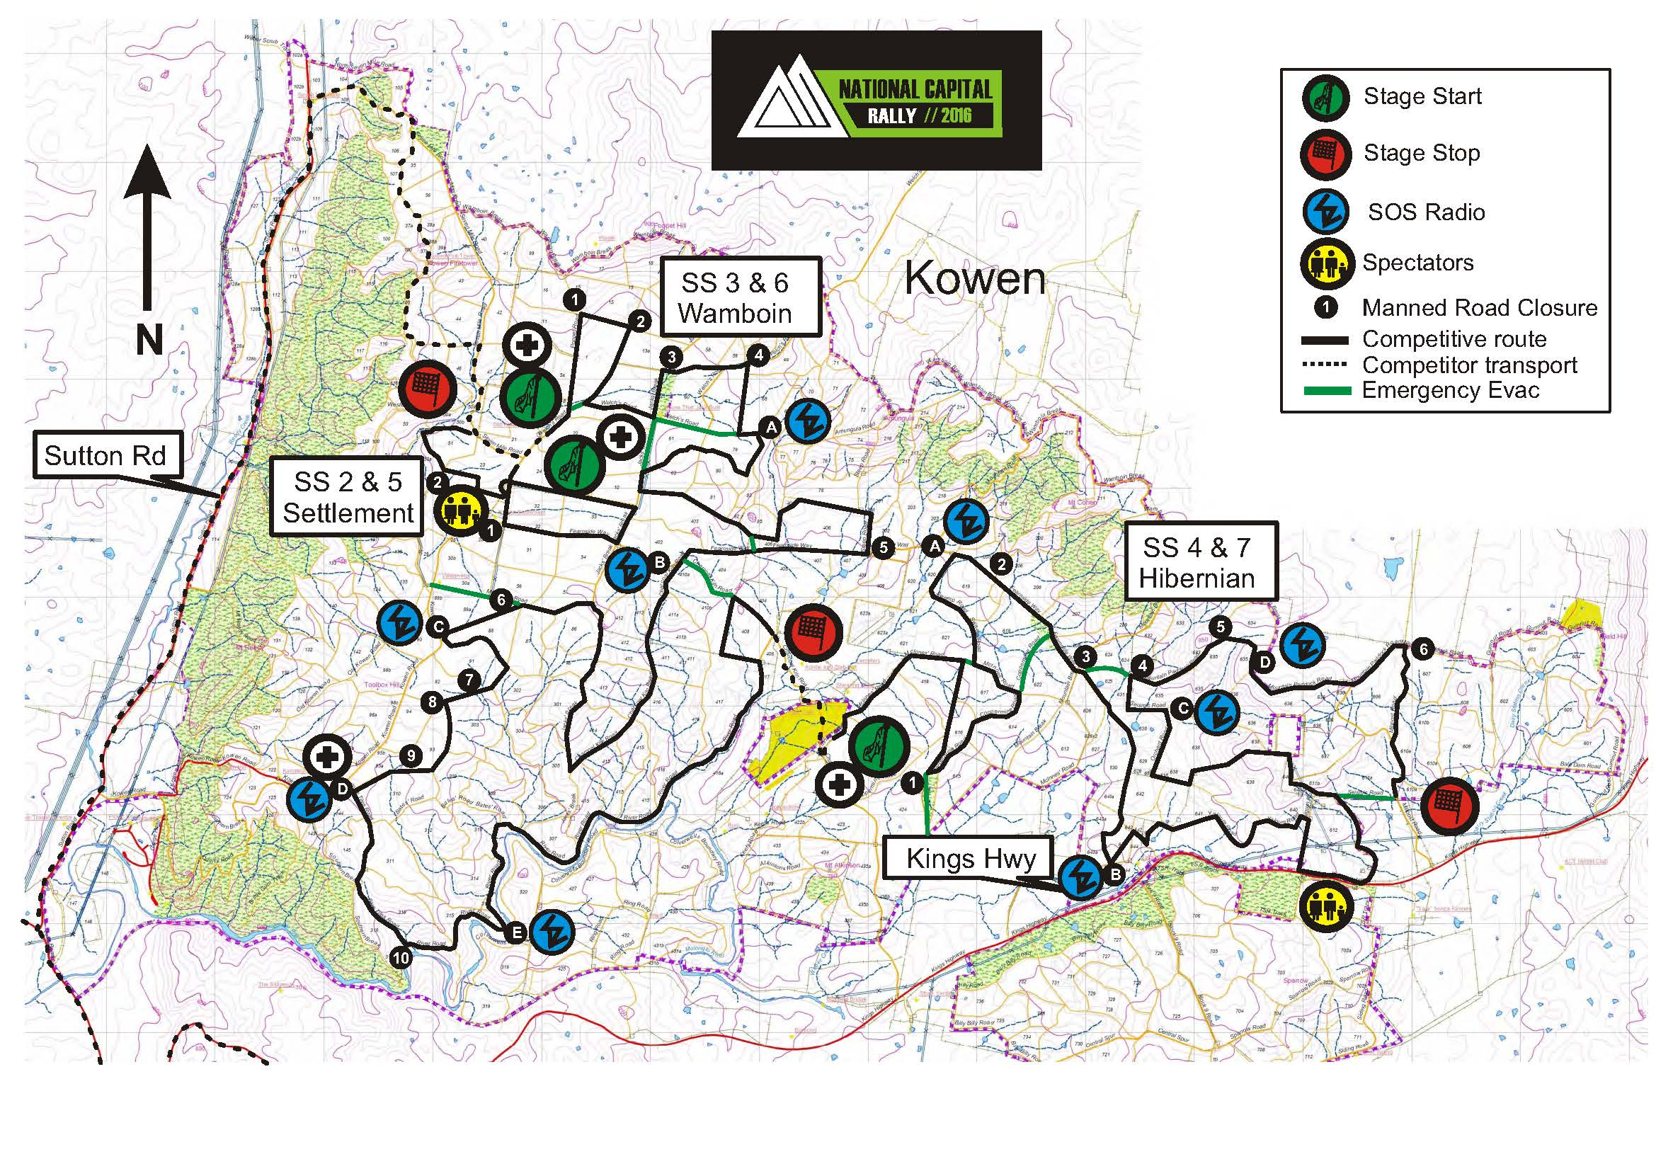
Diagram 5
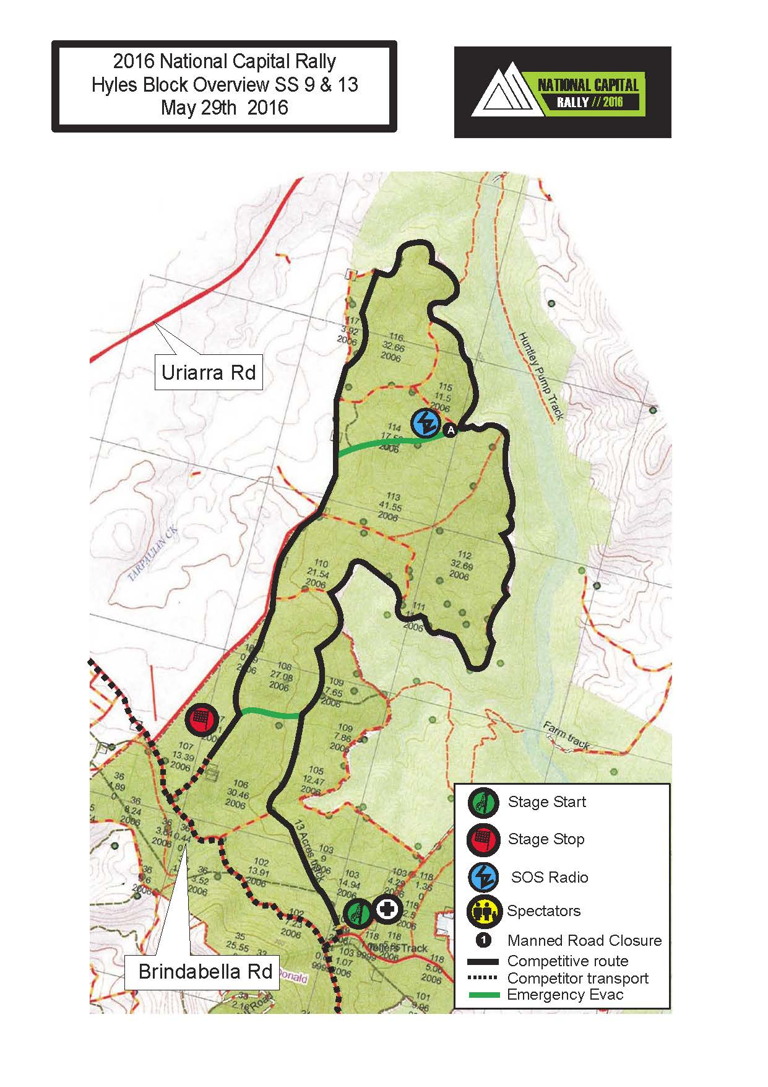
Diagram 6
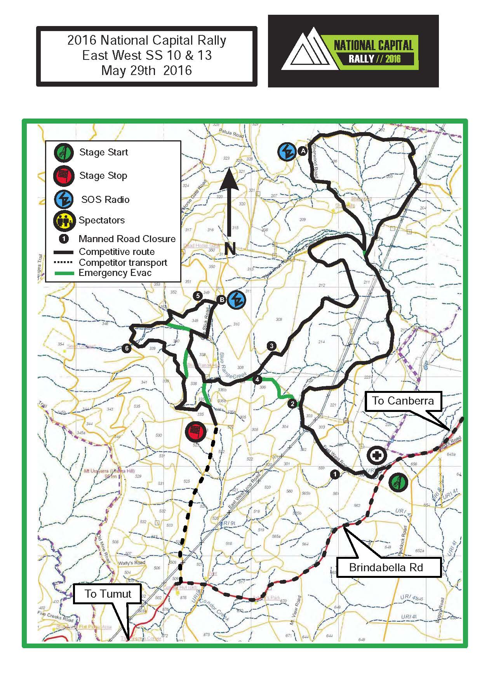
Diagram 7
