Australian Capital Territory
Planning and Development (Plan Variation No 340) Approval 2016*

Notifiable Instrument NI2016—56
Made under the
Planning and Development Act 2007, section 76(3)(a) (Minister’s powers in relation to draft plan variations)

1 Name of instrument
This instrument is the Planning and Development (Plan Variation No 340) Approval 2016.
2 Approval of draft plan variation
(1) I hereby APPROVE pursuant to section 76(3)(a) of the Planning and Development Act 2007 the draft plan variation No 340 to the Territory Plan.

(2) In this section:

Draft plan variation No 340 to the Territory Plan means the draft plan variation in the schedule.

Mick Gentleman MLA
Minister for Planning and Land Management
2 February 2016

Planning and Development Act 2007

Variation to the
Territory Plan
No 340

Structure Plan, Concept Plan, Holt
Precinct Code and Zone Changes – Holt section 99 part blocks 15 and 16
(Belconnen Golf Course)

Final variation prepared under s76 of the
Planning and Development Act 2007

This page is intentionally blank.

Contents

1. EXPLANATORY STATEMENT 1
1.1 Background 1
1.2 Summary of the Proposal 2
1.3 The National Capital Plan 3
1.4 Site Description 4
1.5 Current Territory Plan Provisions 5
1.6 Changes to the Territory Plan 6
1.7 Consultation on the Draft Variation 6
1.8 Revisions to the Draft Variation Recommended to the Minister 6
2. VARIATION 7
2.1 Variation to the Territory Plan map 7
2.2 Variation to the Territory Plan 8

This page is intentionally blank.

- EXPLANATORY STATEMENT
  - Background
The redevelopment of the site was enshrined in Territory Plan variation 298 (V298) which commenced in 2011. This variation introduced a structure plan and a concept plan for Holt section 99 block 16 (part of the retired block 11) that:
- required the relocation and undergrounding of the overhead transmission lines
- required a community activity centre to be on the site of the existing golf club house with additional use of SHOP within Holt section 99 block 16 (previously block 11).
In the intervening time period, planning for the transmission lines now means there are limited options to relocate or underground the transmissions lines as was originally intended. Additionally, plans to relocate the current golf club house have been revised. This means that the proponent no longer intends to redevelop the land within the existing transmission line corridor or to replace the existing club house with a community centre and shop. This has resulted in the need to vary the Territory Plan to reflect these changes to the proposal.
It is important to note that since V298, urban development on the surrounding land has been proposed. Planning for this development is not yet finalised or approved. However, if approved this would result in significant upgrades to Stockdill Drive and could accommodate a second access to the subject site off Stockdill Drive. While this does not directly impact on V340 which would result in a decrease in the extent of urban development on the site, it would inform the Estate Development Plan by ensuring the settlement pattern can accommodate the secondary access point in the future.
Planning for the urban development of the land surrounding the site also includes services such as schools and commercial uses. Ultimately this development, if approved, could provide greater access to services for the future residents of section 99.

  - Summary of the Proposal
The variation amends the Structure Plan, Concept Plan and zone boundaries applying to parts of blocks 15 and 16, section 99 Holt. This is based on the fact that the proponent no longer intends to redevelop the land within the existing transmission line corridor or to replace the existing club house with a community centre and shop. Rather, the land will be reverted back to the PRZ2 restricted access recreation zone. The land will be used for golf course, club house and a community activity centre, all of which are permissible development in the proposed PRZ2 restricted access recreation zone. It is important to note that the change in zoning for the transmission lines does not alter the requirements for easements to protect the corridor and to separate residential areas from the transmission lines.
The Territory Plan provisions applying to the site are revised in the following ways:
- Rezone approximately 3.4ha of part of block 16 from residential RZ1 suburban zone to the PRZ2 restricted access recreation zone.
- Rezone approximately 0.4ha of two small parts of block 15 from the PRZ2 restricted access recreation zone to the residential RZ1 suburban zone.
- Amend the future urban area boundary to reflect the proposed residential estate boundaries.
- Remove the structure plan and concept plan requirements relating to the relocation and undergrounding of the transmission lines, the relocation of the golf course club house and the previously proposed commercial elements.
- Consequentially amend the Holt precinct map to remove provisions for a shop on the site.
- Consequential amendments to the Holt precinct map and code, the structure plan and the concept plan for the site to reflect the above changes.
In addition to the above, a minor amendment has been made to the structure plan in relation to bushfire requirements. In this regard, the structure plan now has a broad requirement for buildings in bushfire areas, with the detailed requirements remaining in the concept plan. This amendment brings the wording of the structure plan up to current standards and best practice. It does not alter the policy intent, requirements or application of the bushfire provisions.
Lastly, the concept plan has been amended to allow the parks and recreation PRZ1 urban open space zoning to be implemented within the transmission line corridor. The current provisions only allow for the transport and services TZ2 zone and the PRZ2 restricted access recreation zone within this corridor. However, it is common practice to allow urban open space in these corridors and this is facilitated by the proposed changes to the concept plan.

  - The National Capital Plan
The Australian Capital Territory (Planning and Land Management) Act 1988 established the National Capital Authority (NCA) with two of its functions being to prepare and administer a National Capital Plan (NCP) and to keep the NCP under constant review and to propose amendments to it when necessary.
The NCP, which was published in the Commonwealth Gazette on 21 January 1990 is required to ensure that Canberra and the Territory are planned and developed in accordance with their national significance. The Planning and Land Management Act 1988 also required that the Territory Plan is not inconsistent with the NCP.
In accordance with section 10 of the Australian Capital Territory (Planning and Land Management) Act 1988, the National Capital Plan defines the planning principles and policies for Canberra and the Territory, for giving effect to the object of the NCP and sets out the general policies to be implemented throughout the Territory, including the range and nature of permitted land uses.
It also sets out the detailed conditions of planning, design and development for areas that have special significance to the National Capital known as designated areas and identifies special requirements for the development of some other areas.

  - Site Description
The site is identified in Figure 1 below and is part of blocks 15 and 16 (previously block11) section 99 Holt, off Stockdill Drive.

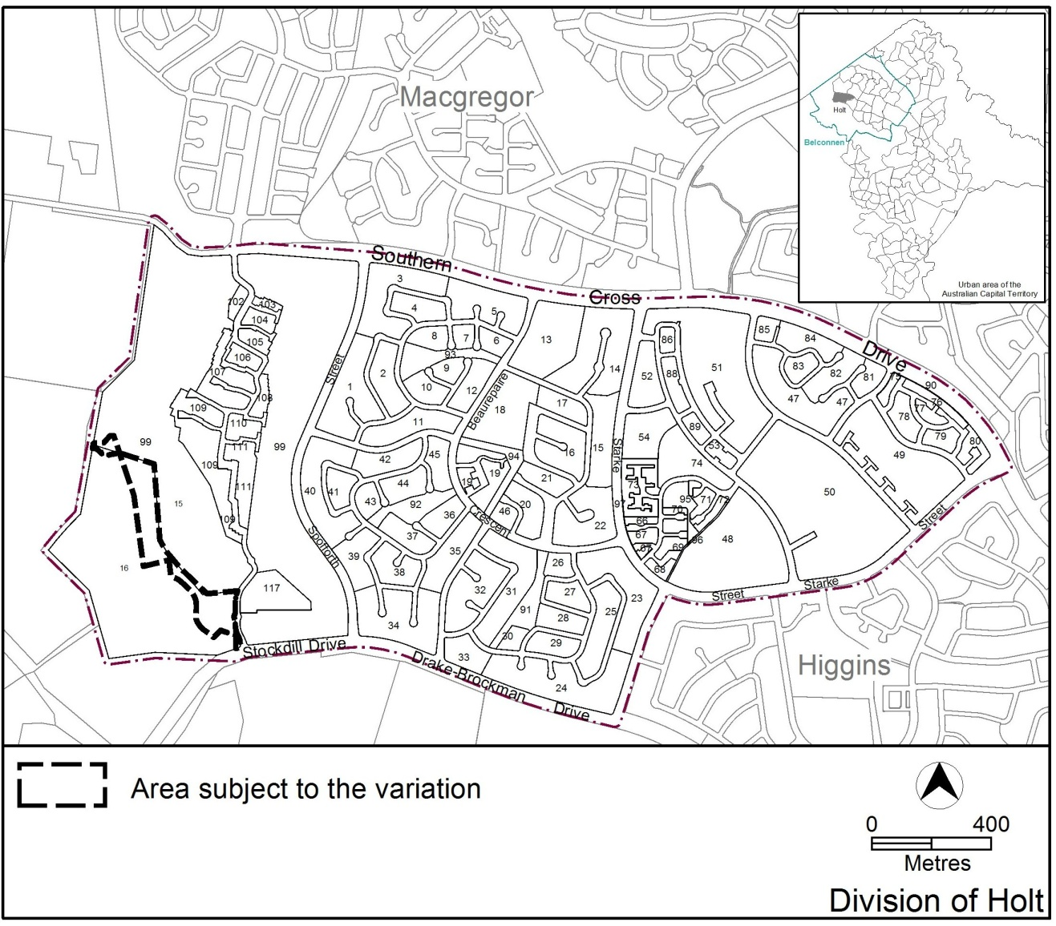

Figure 1 Site Plan

  - Current Territory Plan Provisions
The Territory Plan map for the area subject to this variation is shown in Figure 2.
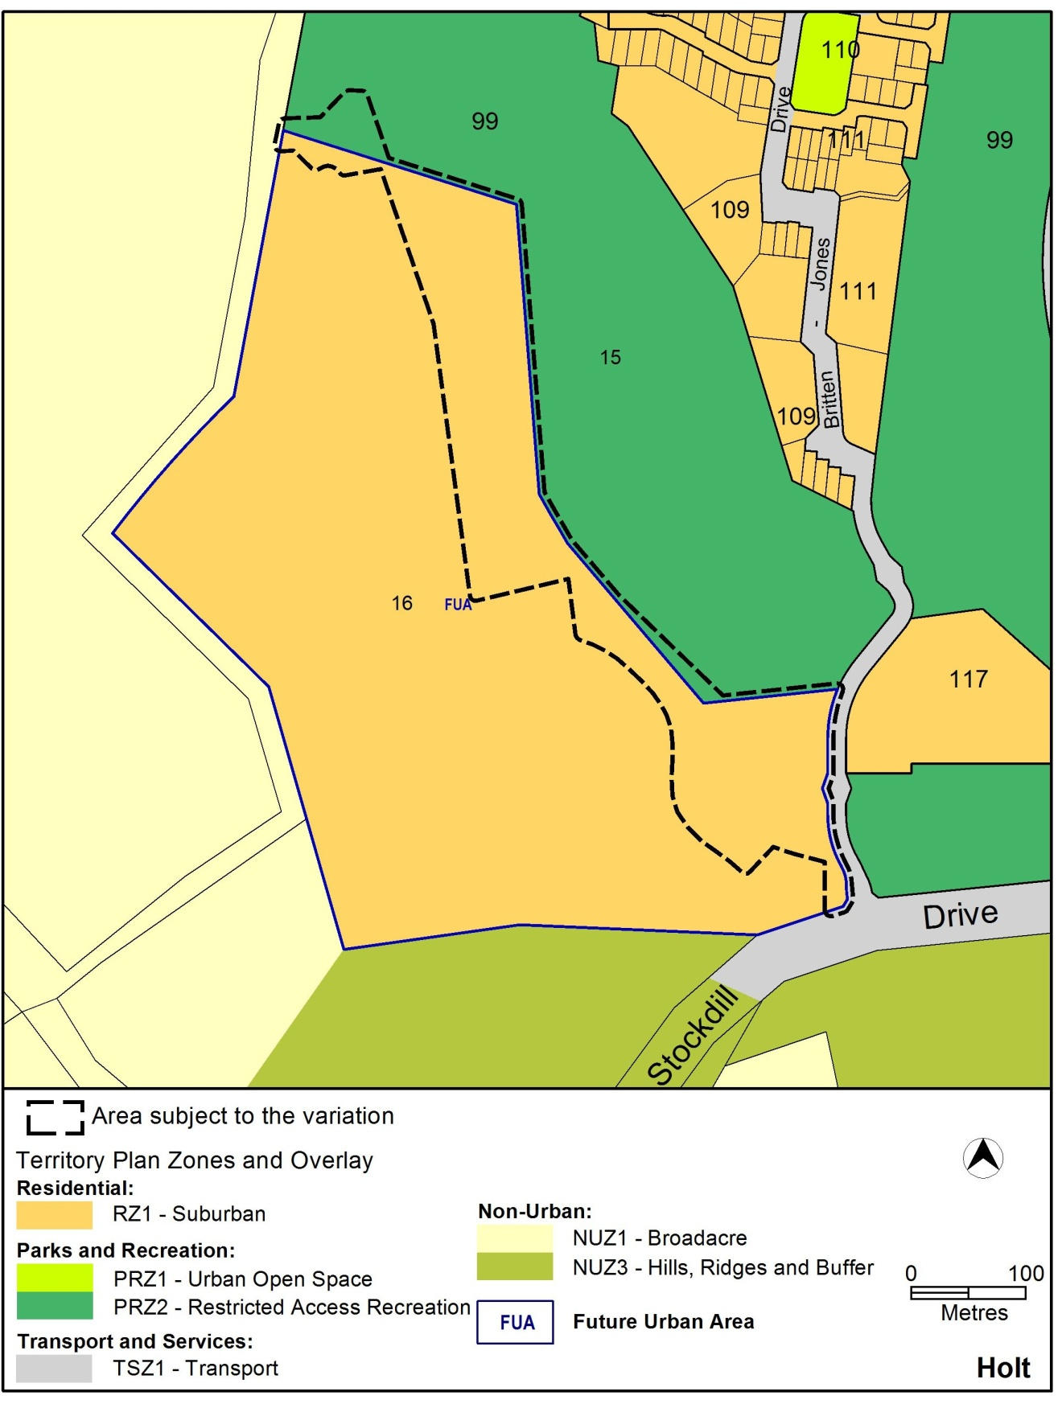
Figure 2 Territory Plan Zones Map

  - Changes to the Territory Plan
Detailed changes to the Territory Plan are noted in section 2 of this document.
  - Consultation on the Draft Variation
Draft Variation No 340 (DV340) was released for public comment between 6 November 2015 and 21 December 2015. A consultation notice under section 63 of the Planning and Development Act 2007 (P&D Act) was published on the ACT Legislation Register on 6 November 2015 and in The Canberra Times on 7 November 2015.
No written submissions were received during the public notification period. Accordingly, No changes were made as a result of consultation. The outcomes of consultation were considered by the Minister responsible for planning prior to approval of this variation.

  - Revisions to the Draft Variation Recommended to the Minister
No changes were made to the draft variation recommended to the Minister.

- VARIATION
  - Variation to the Territory Plan map
The Territory Plan map is varied in all of the following ways:
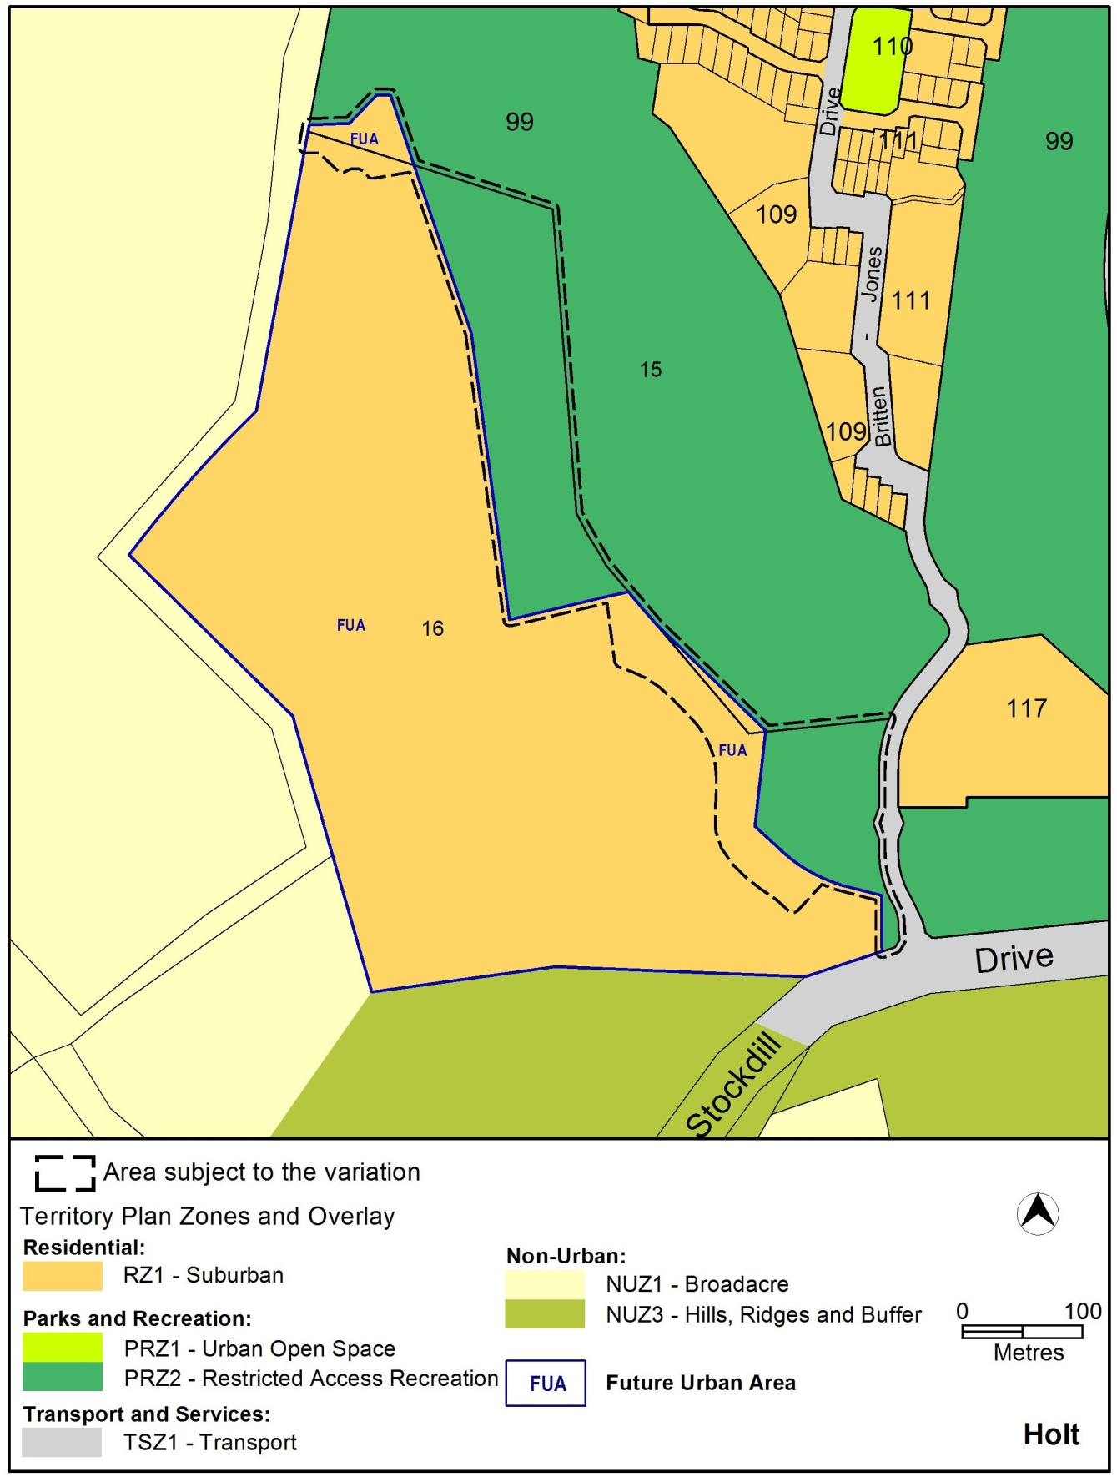

  - Variation to the Territory Plan
The Territory Plan is varied in all of the following ways:

Variation to the Structure Plan for Holt section 99 block 11 (Belconnen Golf Course)
- After structure plan for Lawson South

Substitute the existing Structure Plan with
Holt section 99 (Belconnen Golf Course) (see Appendix A)

Variation to the Concept Plan for Holt section 99 block 11 (Belconnen Golf Course)
- After concept plan for Lawson South

Substitute the existing Concept Plan with

Holt section 99 (Belconnen Golf Course) (see Appendix B)

Variation to the Holt Precinct Map and Code
- Holt precinct map

Substitute with the following
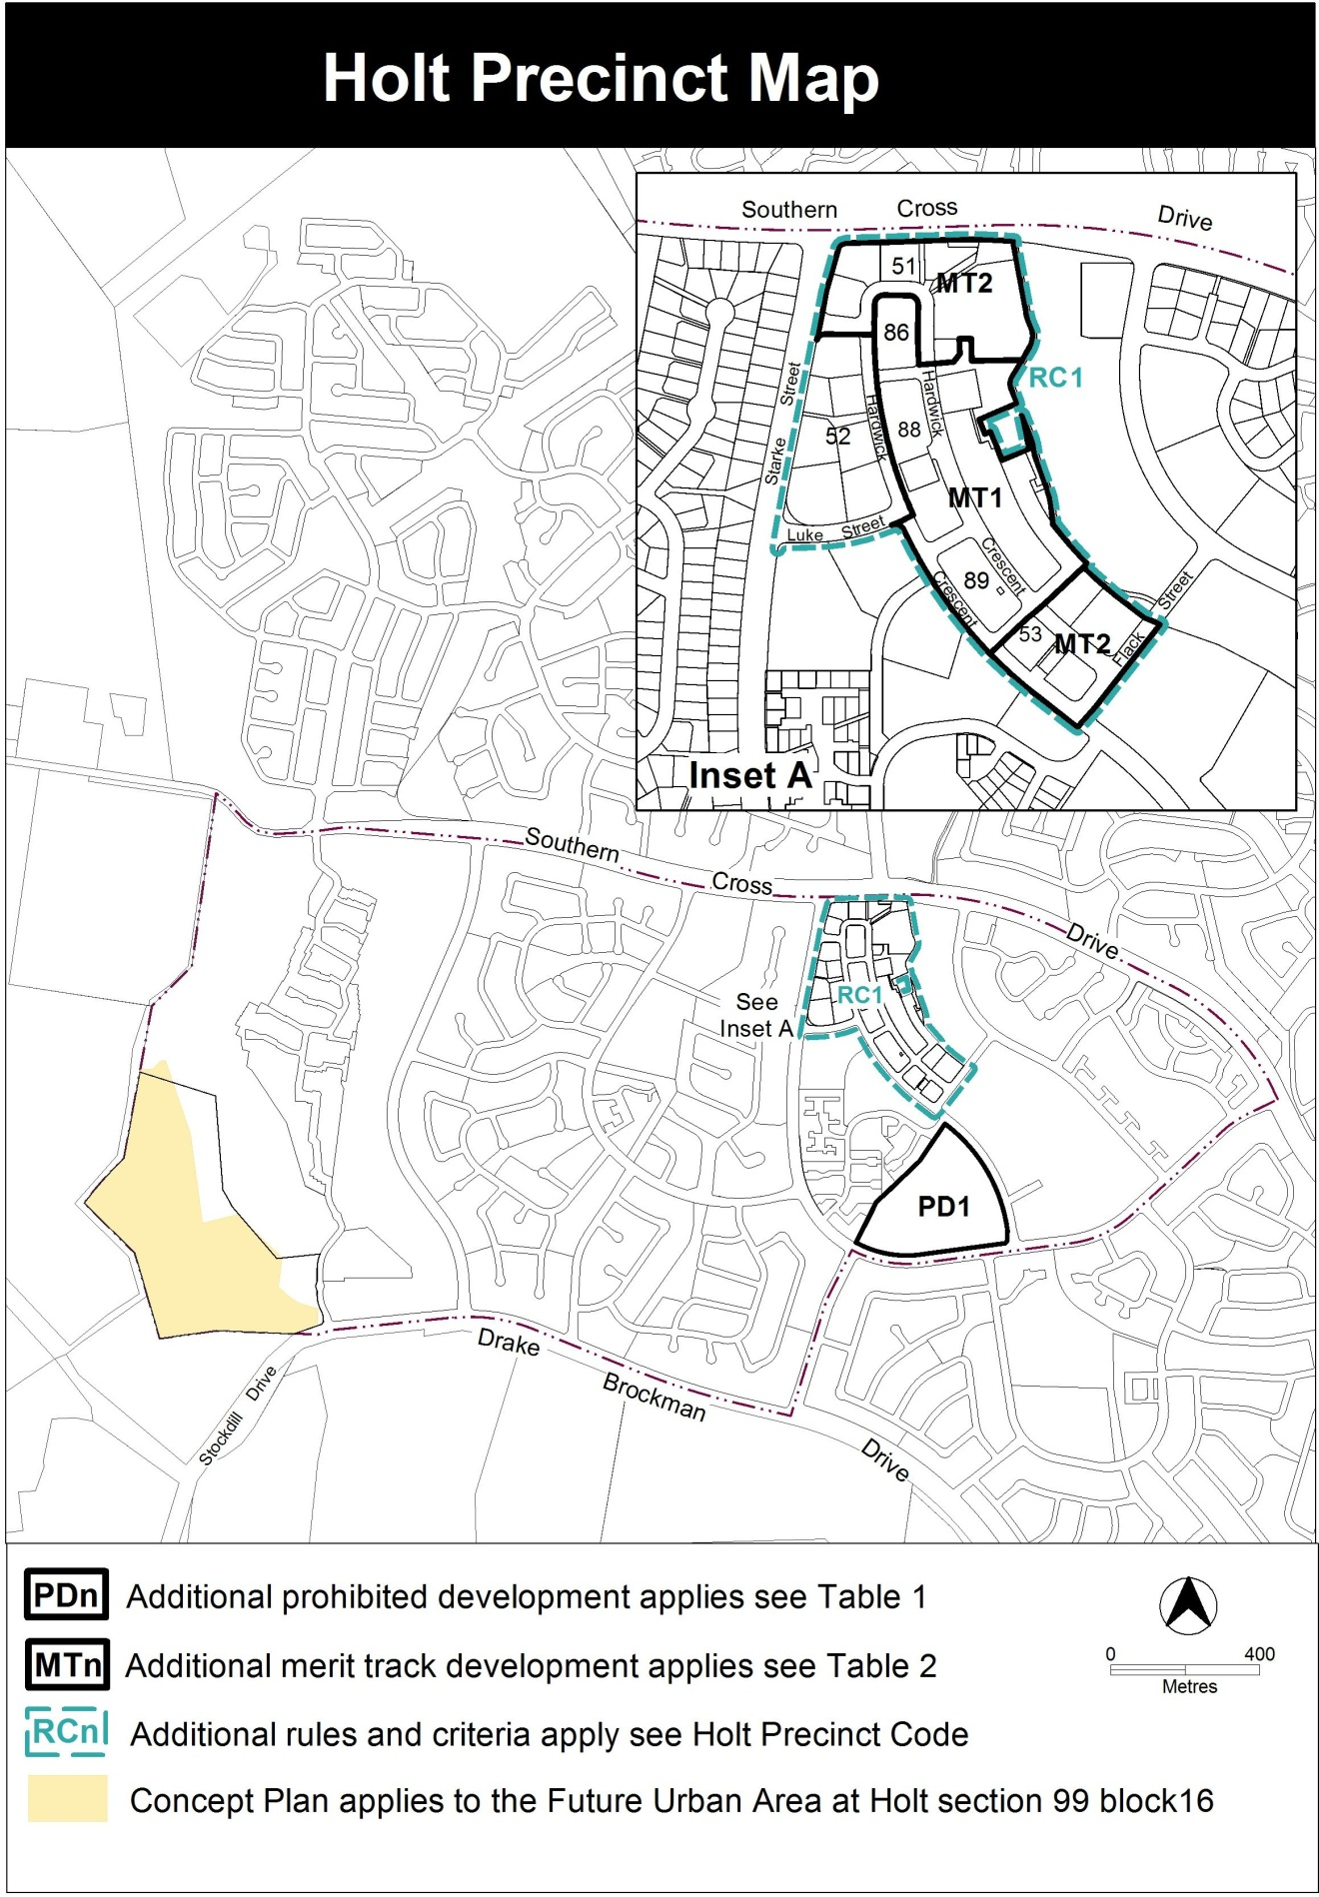

- Table 2 – additional merit track development

Substitute with the following

Table 2 – Additional merit track development
Additional merit track development that may be approved subject to assessment
Suburb precinct map label | Zone | Development
MT1 | CZ1 | industrial trades municipal depot  store
MT2 | CZ2 | funeral parlour light industry service station veterinary hospital
Interpretation service
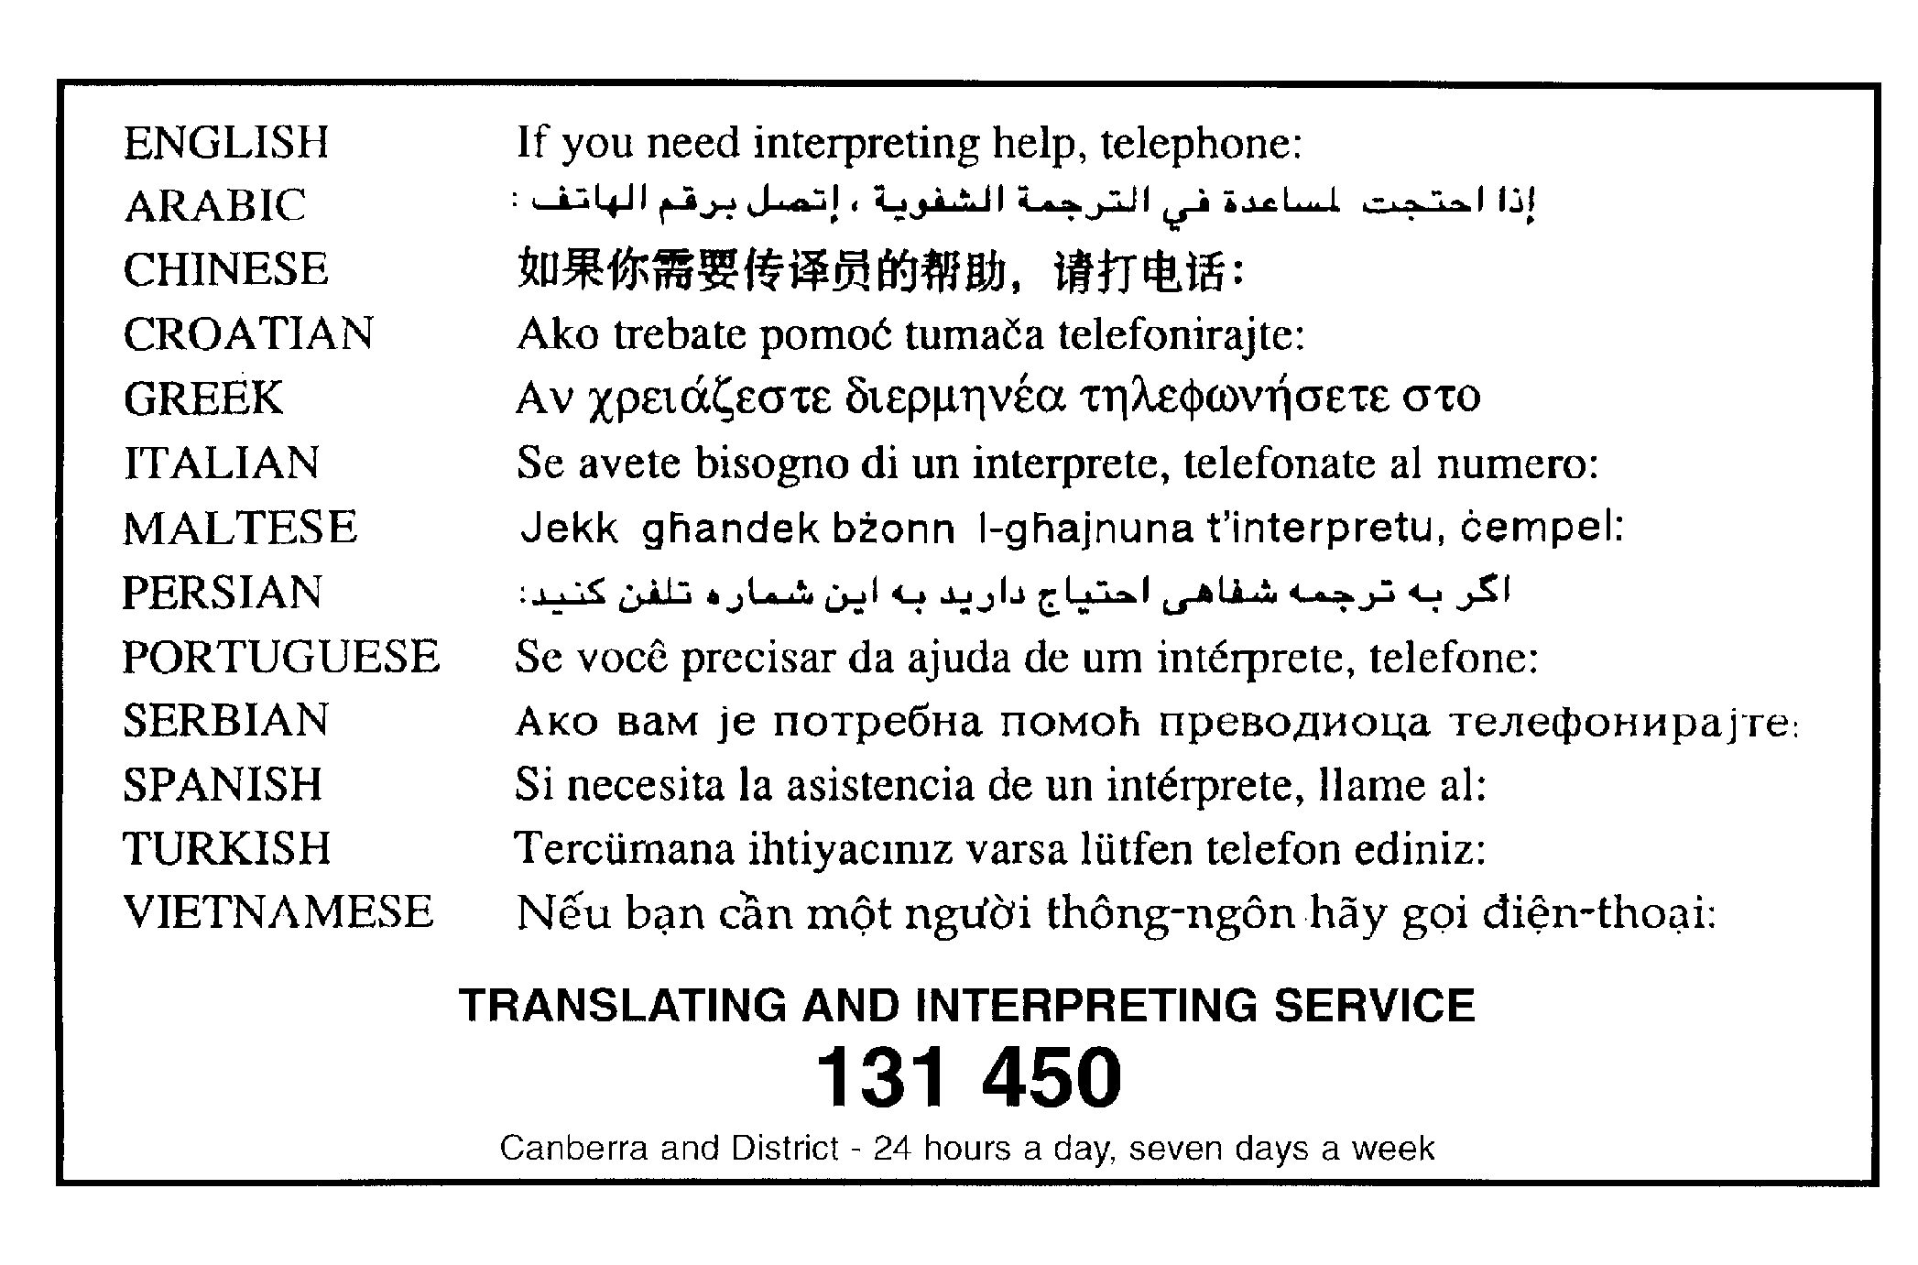

Appendix A: DV340 – Holt Section 99 Structure Plan

Holt part section 99 (Belconnen Golf Course) Structure Plan

INTRODUCTION
This structure plan sets out the principles and policies that apply to development at the future urban area on section 99 Holt in accordance with section 91 of the Planning and Development Act 2007.

APPLICATION
This structure plan applies to the future urban area shown in Figure 1. Land that ceases to be part of the future urban area after the application of section 96 of the Planning and Development Act 2007 ceases to be affected by this structure plan.

PROHIBITED DEVELOPMENT
For the purposes of section 136(2) of the Planning and Development Act 2007, development by an entity that is not the Territory or Territory entity is not prohibited.

PRINCIPLES FOR THE DEVELOPMENT OF FUTURE URBAN AREA
1. The development will accord with the principles contained in the Statement of Strategic Directions in the Territory Plan (see figure 1).

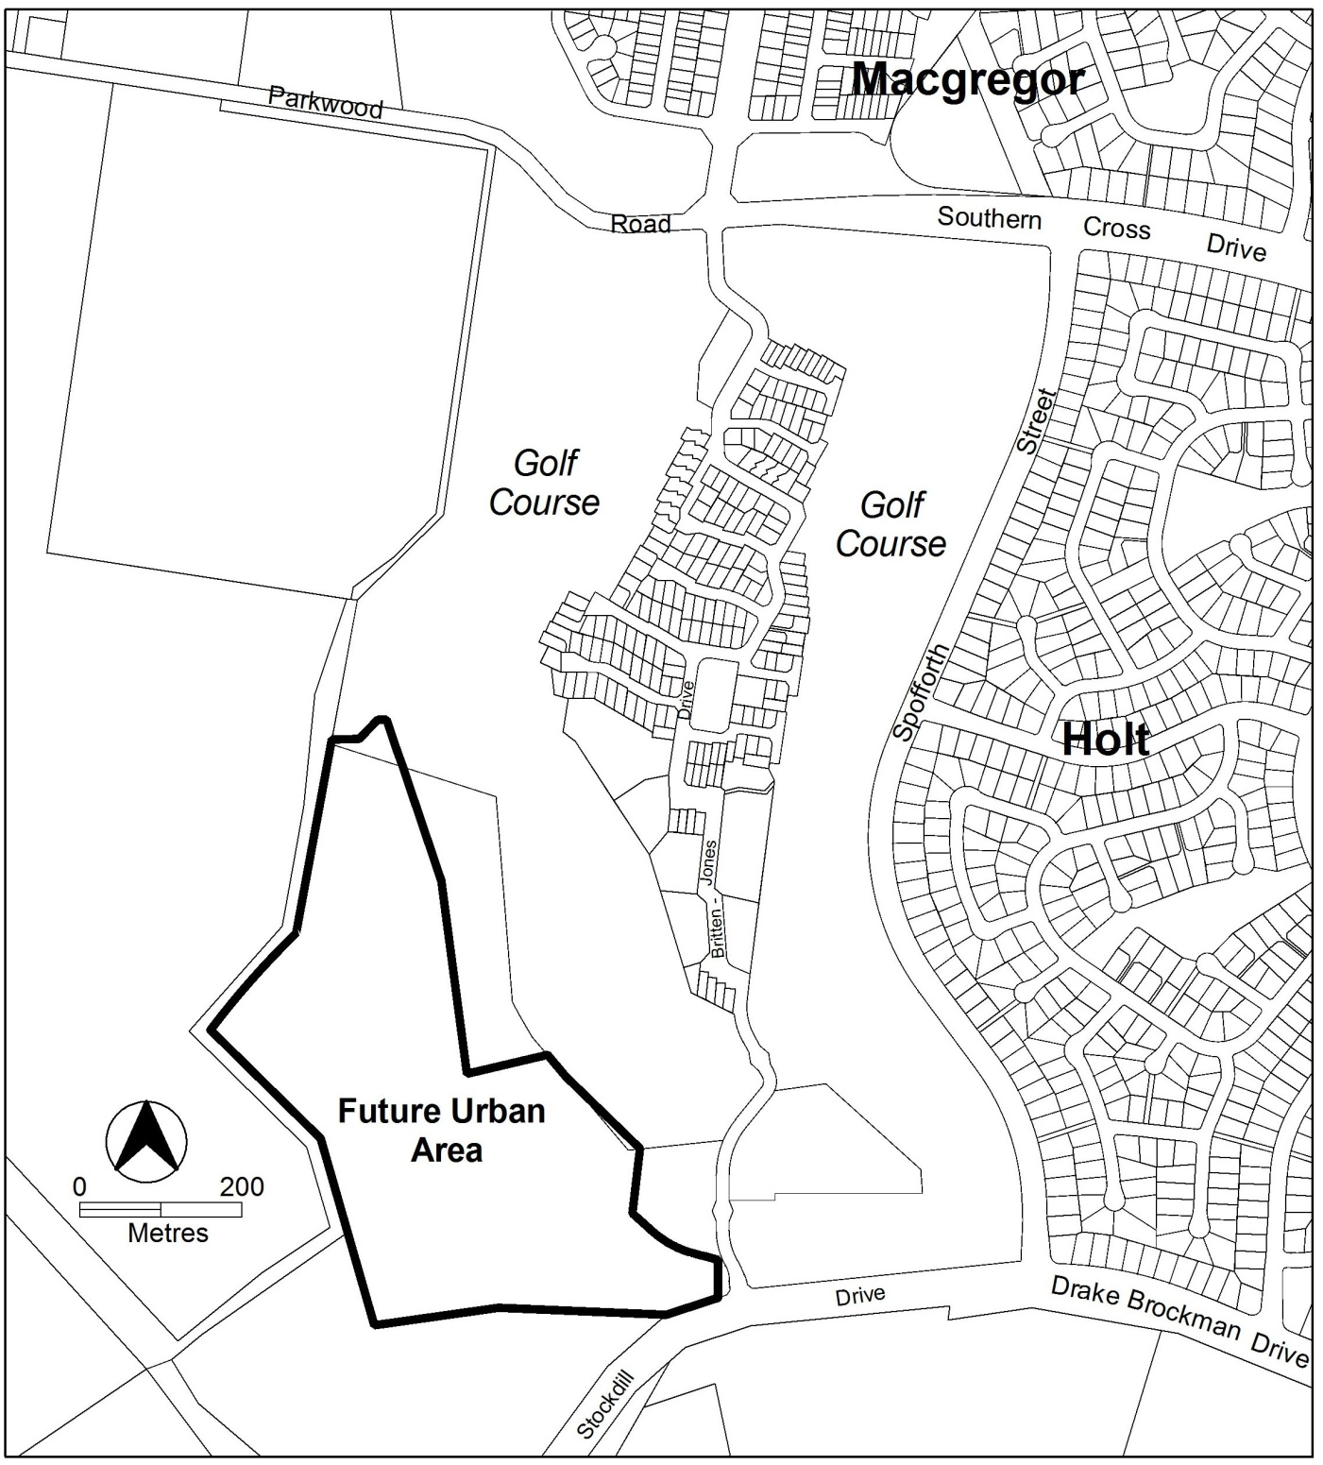

Figure 1: Future urban area at commencement of Holt section 99 Structure Plan

POLICIES FOR THE DEVELOPMENT OF FUTURE URBAN AREA
  - General
- Residential development within the future urban area shown in Figure 1 will be in accordance with the residential RZ1 suburban zone in the Territory Plan.
Notes:
  - The future urban area will diminish as development proceeds. Land that ceases to be part of the future urban area through the application of s96 of the Planning and Development Act 1997 ceases to be affected by this structure plan.

  - The nature and extent of the RZ1 zone under the Territory Plan will be confirmed after land ceases to be part of the future urban area.

Bushfire protection
3. Buffers for bushfire protection are to be provided to the satisfaction of the Emergency Services Agency (ESA) along the western and southern boundaries of the site.

Residential
4. Dwellings abutting the rural interface be constructed to satisfy the relevant Bushfire Attack Levels of Australian Standard of construction of buildings in bushfire-prone areas (AS 3959: 2009) or as agreed by the ESA.

Road and movement network
- The estate is to be provided with an entrance from Stockdill Drive and not from Britten Jones Drive.
- An access way for cycle use and pedestrians is to provide a connection between the main entry off Stockdill Drive to the nearest bus stop.
- A secondary access point to the site for emergency access and egress is to be located and constructed to the satisfaction of ESA.

Open space and landscape
- The provision for open space for active recreation will accord with the relevant Territory guidelines.
- Landscape buffers will be provided to screen urban development from Stockdill Drive.

Appendix B – DV340 – Holt, part section 99, concept plan

Holt part section 99 (Belconnen Golf Course) Concept Plan

Contents
Introduction 3
Part A – Land use 5
Part B – Subdivision 7

Introduction

Application
This plan applies to land at Holt section 99 (part) in the district of Belconnen, as shown on Figure 1.

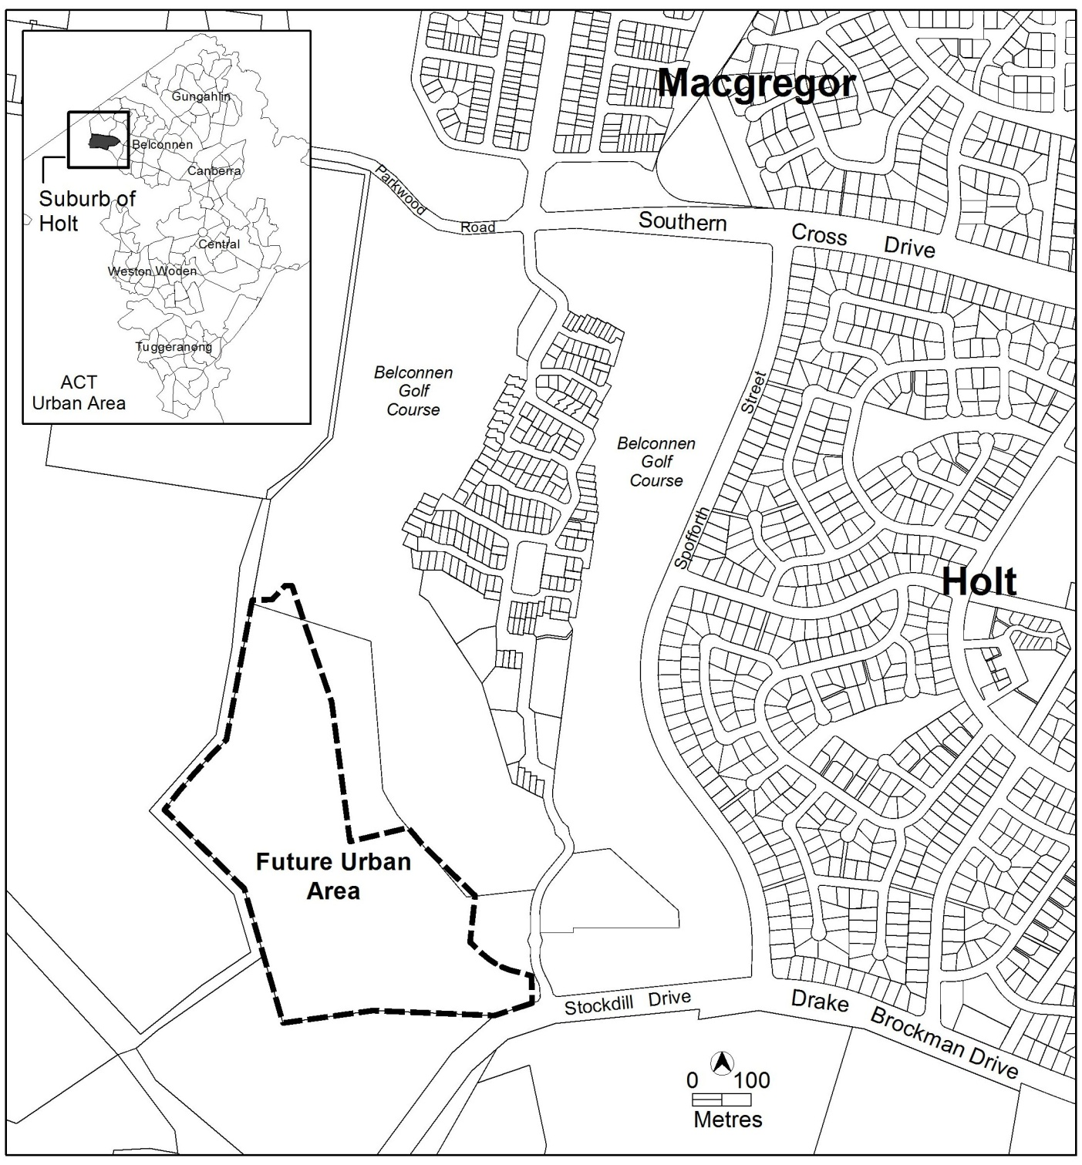

Figure 1: Location of Holt section 99 in district of Belconnen

Part A Land Use and Part B Subdivision of this plan apply only to the future urban area (FUA) within Holt section 99 (part). The FUA will be removed following the approval of the estate development plans and finalisation of the zone boundary under section 96 of the Planning and Development Act 2007.

This plan contains rules, which provide definitive controls for development, and criteria, which provide provisional controls for development. In some instances rules are mandatory. Mandatory rules are marked by the words “This is a mandatory requirement. There is no applicable criterion” in the criteria column. Non-compliance with a mandatory rule will result in the refusal of a development application. In other instances the words “There is no applicable rule”. In this case the proposal is assessed against the relevant criterion. Where both rule and criterion apply, compliance with the rule is deemed to satisfy the particular requirement.

Purpose
The purpose of this plan is to:
- guide the design and assessment of estate development plans (subdivision proposals) at Holt section 99 part.
- guide the development of individual blocks in concert with other relevant codes under the Territory Plan

Desired planning outcomes
The purpose of the development controls (i.e. rules and criteria) is to:
- provide diverse housing types, densities and affordability to meet the changing needs of households and to encourage the formation of a diverse community
- ensure the appropriate protection of existing high value trees
- incorporate principles of contemporary best practice for energy efficiency, water conservation, solar access and ecological sustainability
- provide a legible road network that integrates safe and adequate pedestrian and cycle access throughout the site and connectivity to adjacent areas
- employ stormwater management measures
- encourage efficient use of water through water sensitive urban design
- adopt bushfire protection measures appropriate to the site

Code hierarchy
This concept plan is deemed to be a precinct code under section 93 of the Planning and Development Act 2007.

More than one type of code may apply to a particular development proposal. Occasionally inconsistencies between the provisions arise, particularly where a precinct code seeks to apply special provisions in response to particular local circumstances or planning issues. Where this occurs, a precinct code prevails over a development code and a general code, but only to the extent of the inconsistency.

Part A – Land use
Note: The land referred to in this part is shown on Figure 2.
Rules | Criteria
1. Land use plan
R1  The land use plan submitted with an estate development plan (EDP) is to show an easement for the 132kV transmission line within a transport and services TSZ2 services zone, parks and recreation PRZ1 urban open space zone or PRZ2 restricted access recreation zone and the remaining land within the future urban area overlay as RZ1 suburban zone. | This is a mandatory requirement. There is no applicable criterion.

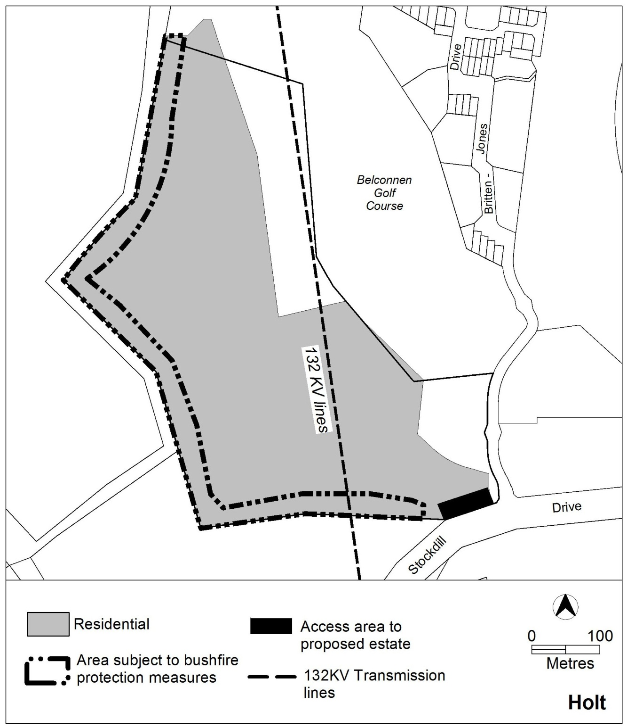

Figure 2: Concept Plan for Holt section 99

Part B – Subdivision
Note: This part should be read in conjunction with:
Estate Development Code
Guidelines for the Preparation of Estate Development Plans Water Ways: Water Sensitive Urban Design General Code.
Rules | Criteria
2. Dwelling yield
R2  The estate provides a range of dwelling types, densities and block sizes which results in the construction of between 300 and 350 dwellings. | This is a mandatory requirement. There is no applicable criterion.
3. Bushfire protection
R3  EDP identifies the bushfire protection measures, including higher construction standards required of buildings in bushfire prone areas as endorsed by the ACT Emergency Services Agency. | This is a mandatory requirement. There is no applicable criterion.
4. Road network
R4  The entrance to the estate is to be located off Stockdill Drive within the area shown in Figure 2. | This is a mandatory requirement. There is no applicable criterion.
There is no applicable rule. | C5  The development is to incorporate a continuous pathway, which provides a slope which allows access for persons with a disability, between the estate and the location of the closest bus stop.
R6  A second vehicular access point to the estate for emergency use is to be provided and endorsed by the ACT Emergency Services Agency. | This is a mandatory requirement. There is no applicable criterion.

5. Open space and landscaping
There is no applicable rule. | C7  A buffer area is provided between Stockdill Drive and residential blocks which contains landscape treatment of a similar scale and width as the existing treatment for the perimeter of the  golf course.

