Australian Capital Territory
Planning and Development (Draft Variation No 345) Consultation Notice 2017
Notifiable instrument NI2017—107
made under the
Planning and Development Act 2007, s 63 (Public consultation—notification) and s 64 (Public consultation—notice of interim effect etc)

1 Name of instrument
This instrument is the Planning and Development (Draft Variation No 345) Consultation Notice 2017.
2 Draft variation to the Territory Plan
The planning and land authority (the Authority) has prepared a draft plan variation No 345 – Mawson group centre (the Draft Variation) to vary the Territory Plan. The Draft Variation contains changes to zones within the Division of Mawson and amendments to the Mawson precinct map and code.
3 Documents available for public inspection
(1) The Authority gives notice that the following documents are available for public inspection and purchase:
(a) the Draft Variation; and
(b) the background papers relating to the Draft Variation.
(2) Copies of the documents mentioned in section 3(1) are available for inspection and purchase at Access Canberra, Environment, Planning and Sustainable Development Directorate (EPSDD) Shopfront, Ground Floor South, Dame Pattie Menzies House, 16 Challis Street, Dickson, Monday to Friday (except public holidays) between 8:30am and 4:30pm for the period commencing on the day this notice commences and ending on 21 April 2017 (the Consultation Period).
(3) Copies of the documents mentioned in section 3(1) are also available for inspection during the Consultation Period online at http://www.planning.act.gov.au/tools_resources/legislation_plans_registers/plans/territory_plan/draft_variations_to_the_territory_plan
Invitation to give written comments
(1) The Authority invites written comments about the Draft Variation during the Consultation Period. Comments should include reference to the Draft Variation and be addressed to the Territory Plan Section of the Environment, Planning and Sustainable Development Directorate. Please also provide your name and contact details to assist in the assessment of the comments provided and to enable the Authority to contact you in relation to your comments, if required.
(2) Written comments should be provided to the Authority by:
(a) email to terrplan@act.gov.au; or
(b) mail to Territory Plan Section, EPSDD, GPO Box 158, Canberra, ACT 2601; or
(c) hand delivery to Access Canberra, EPSDD Shopfront, Ground Floor South, Dame Pattie Menzies House, 16 Challis Street, Dickson.
5 Public inspection of written comments
(1) Copies of written comments about the Draft Variation given in response to the invitation in section 4, or otherwise, or received from the National Capital Authority will be available (unless exempted) for public inspection for a period of at least 15 working days starting 10 working days after the day the consultation period ends at Access Canberra, EPSDD Shopfront, Ground Floor South, Dame Pattie Menzies House, 16 Challis Street, Dickson, Monday to Friday (except public holidays) between 8:30am and 4:30pm and may be published on the EPSDD website at www.planning.act.gov.au.
(2) You may apply under section 411 of the Planning and Development Act 2007 (the Act) for part of your consultation comments to be excluded from being made available to the public. A request for exclusion under this section must be in writing, clearly identifying what you are seeking to exclude and how the request satisfies the exclusion criteria. Please note that your name and contact details and other personal information will not be made public unless you request otherwise.
6 Effect of the draft plan variation
- Section 65 of the Planning and Development Act 2007 applies to the draft variation. This means that the provisions of Draft Variation No 345 have interim effect, and apply to development applications lodged on or after 3 March 2017.
- During the period of interim effect the ACT Government must not do or approve anything that would be inconsistent with the Territory Plan as if it were amended by the draft variation. Where there is an inconsistency between provisions in the current Territory Plan and provisions in the draft variation, then the draft variation takes precedence for the extent of the inconsistency.

- Interim effect will end on the day the earliest of the following happens:
- the day the public availability notice under section 70 for the draft variation being recommended to the Minister is notified in accordance with the Legislation Act
- the day the draft variation, or the corresponding variation, is withdrawn under section 68 (1)(b) or section 76 (3)(b)(v)
- 1 year after the date of the consultation notice.
7 Obtaining further information
Further information about the Draft Variation can be obtained through email correspondence with the Territory Plan Section, EPSDD, at Terrplan@act.gov.au, a reference to the Draft Variation should be included in any email.
8 Meaning of draft plan variation No 345 – Mawson group centre
In this instrument:
Draft plan variation No 345 – Mawson group centre means the draft plan variation in the schedule.
Note 1: Your personal information will be managed in accordance with the Information Privacy Act 2014 and the EPSDD Information Privacy Policy which are available through the EPSDD website.

Brett Phillips
Delegate of the planning and land authority
01 March 2017

Planning and Development Act 2007

Draft
Variation to the
Territory Plan
No 345

Mawson Group Centre:
Zone changes and amendments to the Mawson precinct map and code

March 2017

Draft variation for public consultation prepared
under s60 of the Planning and Development Act 2007

This page is intentionally blank.

Contents

1. INTRODUCTION 1
1.1 Summary of the Proposal 1
1.2 Outline of the process 1
1.3 This document 3
1.4 Public Consultation 3
2. EXPLANATORY STATEMENT 5
2.1 Background 5
2.2 Site Description 5
2.3 Current Territory Plan Provisions 7
2.4 Proposed Changes 9
2.4.1 Proposed Changes to the Territory Plan Map 9
2.4.2 Proposed Changes to Territory Plan 9
2.5 Reasons for the Proposed Draft Variation 10
2.6 Planning Context 10
2.6.1 National Capital Plan 10
2.6.2 Territory Plan 11
2.7 Interim Effect 13
2.8 Consultation with Government Agencies 13
3. DRAFT VARIATION 20
3.1 Variation to the Territory Plan map 20
3.2 Variation to the Territory Plan written document 21

This page is intentionally blank.

- INTRODUCTION
  - Summary of the Proposal
The draft variation incorporates the recommendations of the recently approved Mawson group centre master plan into the Territory Plan to provide guidance on the desired built form and character of the centre as it develops into the future.
The centre is currently limited to two storeys. DV345 retains the two storey height limit within the central area to retain solar access to the public squares and proposes higher development of four and six storeys to the east of Heard Street and six storeys to the west of Mawson Place. DV345 also proposes an allowance for development up to eight storeys near the south eastern corner of the Athllon Drive/Mawson Drive intersection as a marker development for the centre, as recommended by the approved master plan.
DV345 rezones several areas in accordance with the approved master plan, including land along Athllon Drive proposed to be rezoned from suburban core residential and road reserve to high density residential and urban open space. The rezoning will increase the area of urban open space and ensure the existing shared path connecting Mawson to Woden town centre is retained.
DV345 rezones the CZ3 services zone between Mawson Place and Athllon Drive to CZ2 business zone, and rezones the public carpark south of Mawson Place from PRZ1 urban open space to CZ3 services zone.
DV345 also identifies main pedestrian areas within the centre and areas where active frontages are required, which provide interest and activity at the ground floor level. Locations where awnings are required for all weather protection for pedestrians are also nominated.
  - Outline of the process
The Commonwealth’s Australian Capital Territory (Planning and Land Management) Act 1988 allows for the Legislative Assembly to make laws to establish a Territory Planning Authority and for that Authority to prepare and administer a Territory Plan. The Planning and Development Act 2007 (the Act) establishes the planning and land authority as the Authority which prepares and administers the Territory Plan, including continually reviewing and proposing amendments as necessary. The functions of the planning and land authority are administered by the Environment, Planning and Sustainable Development Directorate (EPSDD).
The Territory Plan is comprised of a written statement and a map. The written statement contains a number of parts, namely governance; strategic directions; zones (including objectives and development tables and zone or centre development codes); precinct codes; general codes; overlays; definitions; structure plans, concept plans and development codes for future urban areas.
The Territory Plan Map graphically represents the applicable land use zones (under the categories of residential, commercial, industrial, community facility, urban parks and recreation, transport and services and non urban), precincts and overlays. The zone, precinct and overlay requirements are detailed in the volumes of the Territory Plan.
Draft variations to the Territory Plan are prepared in accordance with the Act. Following the release of the draft variation under section 63 of the Act, submissions from the public are invited. At the conclusion of the consultation period the EPSDD submits a report on consultation and a recommended final variation to the Minister responsible for planning for approval.
The Minister has the discretion to determine if referral to the Legislative Assembly standing committee responsible for planning is warranted prior to approval, depending on the nature and significance of the proposal. If the draft variation is referred to the committee by the Minister or otherwise, the Minister must consider the findings of the committee before deciding whether to approve the draft variation. If the Minister approves the variation, the variation and associated documents will be tabled in the Legislative Assembly. Unless disallowed by the Legislative Assembly within five sitting days, the variation commences on a day nominated by the Minister.

  - This document
This document contains the background information in relation to the proposed variation. It comprises the following parts
Part 1 This Introduction
Part 2 An Explanatory Statement, which gives reasons for the proposed variation and describes its effect
Part 3 The Draft Variation, which details the precise changes to the Territory Plan that are proposed
  - Public Consultation
Written comments about the draft variation are invited from the public by 21 April 2017.
Comments should include reference to the draft variation and be addressed to the Territory Plan Section. Please also provide your name and contact details to assist in the assessment of the comments provided, and to enable EPSDD to contact you in relation to your comments, if required. Your personal information will be managed in accordance with the Information Privacy Act 2014 and the EPSDD Information Privacy Policy, which is available for viewing on EPSDD’s website.
Comments can be:
- emailed to terrplan@act.gov.au
- mailed to Territory Plan Section, GPO Box 158, Canberra, ACT 2601
- delivered to the EPSDD Access Canberra Customer Service Centre at 16 Challis Street, Dickson
- made on the ‘Have Your Say’ website: https://www.yoursay.act.gov.au
Copies of written comments will be made available for public inspection for no less than 15 working days starting 10 working days after the closing date for comment. The comments will be available at the EPSDD Access Canberra customer service centre in Dickson and may be published on EPSDD’s website. Comments made available will not include personal contact details unless you request otherwise.
A request may be made for parts of a submission to be excluded under section 411 or 412 of the Planning and Development Act 2007. A request for exclusion under these sections must be in writing, clearly identifying what parts of your submission you are seeking to exclude and how the request satisfies the exclusion criteria.

Further Information
The draft variation and background documents are available online at www.act.gov.au/draftvariations until the closing date for written comments.
Printed copies of the draft variation (this document) and background documents are available for inspection and purchase at the EPSDD Access Canberra Customer Service Centre, 16 Challis Street, Dickson, Monday to Friday (except public holidays) between 8:30am and 4:30pm. Please call 6207 1923 to arrange a copy for purchase.
- EXPLANATORY STATEMENT
  - Background
Draft Variation 345 incorporates the recommendations of the Mawson group centre master plan, which has been undertaken as part of the ACT Government initiative for encouraging the rejuvenation of selected commercial centres, and to direct development within the centre over the next 10 to 20 years.
  - Site Description
The subject area is the Mawson group centre and surrounding land, including the land located along Athllon Drive. The group centre is located almost 2 km south of Woden Town Centre, and adjacent to the intersection of Athllon Drive and Mawson Drive. The centre is bounded by Athllon Drive to the west, Mawson Drive to the north, Mountevans Street to the east and recreational spaces to the south.
Several community clubs are located between Heard Street and Mountevans Street, and large areas of surface parking are provided along Heard Street and the southern part of Mawson Place. A line of buildings containing cafes and take away food shops along the ground floor are located along the western side of Mawson Place, bookended by petrol stations at either end, with the eastern side of Mawson Place a mix of food retailing, shops and back of business loading areas.
Development in the centre is a mix of one and two storeys, with retail uses, restaurants, cafes and personal services at the ground floor and offices and indoor recreation uses above. The surrounding land to the south contains tennis courts and playing fields, with multi unit residential housing to the east and suburban core residential to the north that is predominately detached single dwellings. To the west are Athllon Drive and a large strip of unleased Territory land that has Yarralumla Creek running through it.
The land along Athllon Drive included in this draft variation is grassed land separated from existing single dwelling blocks to the east by trees and a shared path and separated from Athllon Drive to the west by Yarralumla Creek.
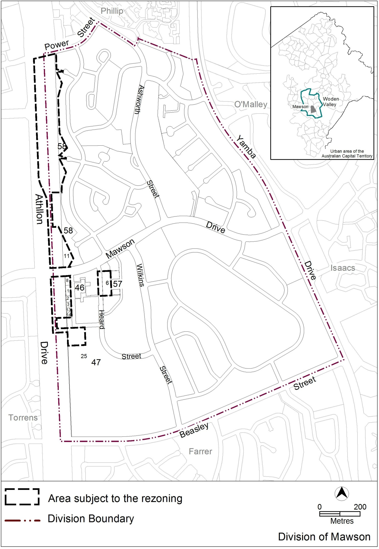
Figure 1: Location map and areas subject to rezoning
  - Current Territory Plan Provisions
The Territory Plan map zones for the area subject to this variation are shown in Figure 2.
The central area is zoned CZ1 commercial core zone, with the CZ2 commercial business zone located to the east of Heard Street, and CZ3 commercial service trades zone to the west and south of the core zone. The Athllon Drive land is predominately zoned RZ2 suburban core residential towards Phillip, and PRZ1 urban open space adjacent to the group centre, while the transport corridor is zoned TSZ1 transport zone. The existing car park south of the centre is zoned PRZ1 urban open space.
The group centre is subject to the Commercial Zone development code and the Mawson precinct map and code, while the residential areas are subject to the Residential Zones Development code, Single Dwelling Housing development code and the Multi Unit Housing development code. The adjoining open space areas are subject to the Parks and Recreation Zone development code.
The general codes may also apply.

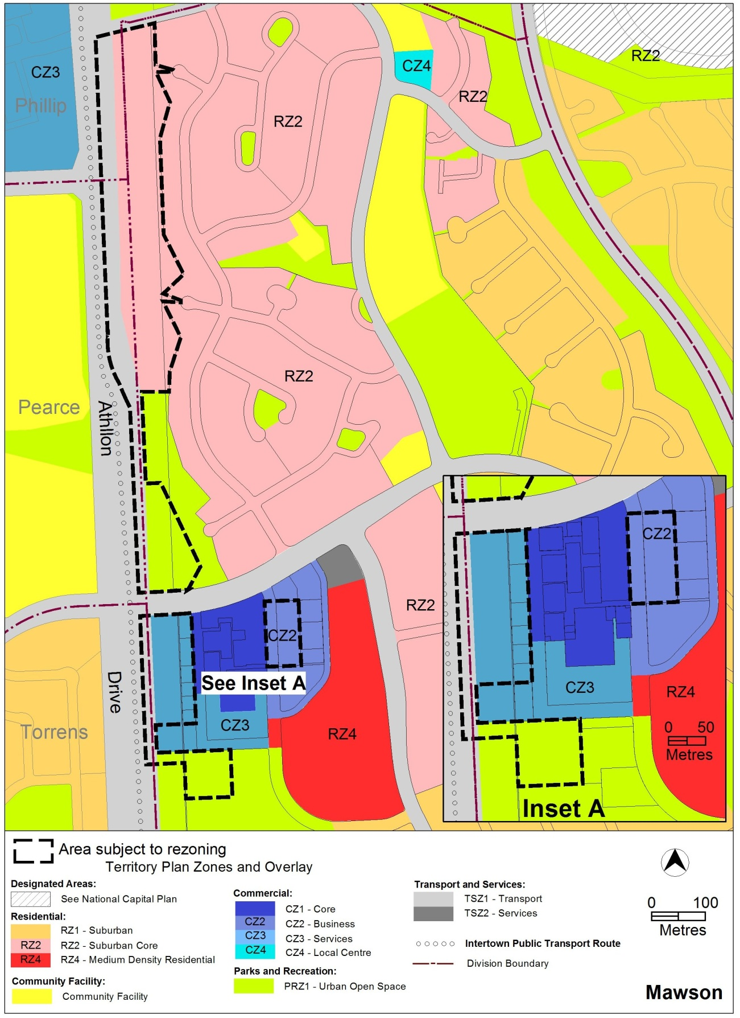
Figure 2 Territory Plan Zones Map
  - Proposed Changes
    - Proposed Changes to the Territory Plan Map
The proposed changes to the Territory Plan map are indicated in Figure 3 at Part 3 of this document and are detailed as follows:
- rezone the RZ2 suburban core residential zone and portion of the TSZ1 transport services zone along Athllon Drive to RZ5 high density residential where adjacent to Phillip service trades area, with the remainder rezoned to PRZ1 urban open space;
- rezone an area of PRZ1 urban open space and TSZ1 transport zone at the corner of Athllon Drive and Mawson Drive to RZ5 high density residential zone;
- rezone the majority of the CZ3 commercial service trades zone between Athllon Drive and Mawson Place, along with a section of the TSZ1 transport zoned land to CZ2 commercial business zone;
- rezone the portion of PRZ1 urban open space south of the centre currently occupied by a surface carpark to CZ3 service trades zone; and
- rezone the surface car park east of Heard Street from CZ2 commercial business zone to CZ1 commercial core zone.
In addition, the division boundaries of Phillip, Pearce, Torrens and Mawson will need to be realigned to accommodate the residential zone located along Athllon Drive, and the extension of the commercial business zone within the Mawson division boundaries. The process to amend the division boundaries will be undertaken separately to this draft variation.
The draft variation map indicates the proposed zone boundaries as accurately as possible but may be subject to adjustments following detailed surveys.
    - Proposed Changes to Territory Plan
It is proposed to amend the Mawson precinct map and code by:
- removing the restriction that limits shop in CZ2 commercial business zone to art, craft and sculpture dealer and personal services;
- removing the existing additional permitted uses of funeral parlour, light industry, service station and veterinary hospital from the CZ2 commercial business zone;
- nominating building heights for selected areas within the centre of 2, 4, 6 and 8 storeys;
- introducing built form provisions such as upper level setbacks, requirements for awnings and active frontages to provide pedestrian friendly areas within the centre;
- nominating pedestrian routes and laneways where development will be required to provide publicly accessible pedestrian access; and
- ensuring development retains solar access to public spaces and residential development.
  - Reasons for the Proposed Draft Variation
The reasons for the draft variation are to vary the Territory Plan in accordance with the recommendations of the Mawson group centre master plan to:
- ensure building heights within the centre are of an appropriate scale and relate to the existing centre layout without detrimentally impacting on surrounding land uses, improve the built form interface with the public realm, and to provide a measure of certainty for developers and the community as to the intended built form;
- encouraging residential development into parts of the centre to improve activity outside of business hours and take advantage of existing and future public transport along Athllon Drive;
- encourage development which promotes pedestrian activity in selected areas by providing shopfronts, glazing and entrances to the street; and to ensure these areas provide all weather protection for pedestrians through the provision of awnings; and
- provide opportunities for additional development in selected areas close to public transport and main commercial centres, including development along the intertown public transport route.
  - Planning Context
    - National Capital Plan
The Australian Capital Territory (Planning and Land Management) Act 1988 established the National Capital Authority (NCA) with two of its functions being to prepare and administer a National Capital Plan (NCP) and to keep the NCP under constant review and to propose amendments to it when necessary.
The NCP, which was published in the Commonwealth Gazette on 21 January 1990 is required to ensure that Canberra and the Territory are planned and developed in accordance with their national significance. The Australian Capital Territory (Planning and Land Management) Act 1988 also required that the Territory Plan is not inconsistent with the NCP.
    - Territory Plan
Statement of Strategic Directions
The proposal is consistent with the Territory Plan’s statement of strategic directions in terms of environmental, economic and social sustainability and spatial planning and urban design principles.
1.9 Urban expansion will be contained in order to minimise impacts on valuable natural and rural areas.
The proposal is consistent with this principle as it encourages higher density development within an existing urban area, which assists in containing the spread of the urban area to accommodate Canberra’s growing population.
1.10 Integrated land use and transport planning will seek to maximise accessibility and transport efficiency, reduce energy consumption, support the preferred pattern of development, promote safety, safeguard environmental quality, and minimise greenhouse gas emissions.
DV345 is consistent with this principle as it encourages higher density development close to an intertown public transport route and the pedestrian/cycle network, and includes provisions for passive surveillance of public areas.
2.1 Canberra will continue to develop as a series of discrete urban areas within a landscape setting of hills, ridges and other open spaces. Each town will offer a diversity of housing types; the broadest possible range of employment opportunities; and convenient, linked access to retail centres, community facilities and open space.
DV345 is consistent with this principle as it generally contains development within the existing urban area zoning, and provides additional urban open space zoned land for use by the community. The amendments to the Territory Plan will encourage additional dwelling types and encourage additional commercial development thereby improving employment opportunities within the centre.
DV345 also includes provisions to improve pedestrian connections through the centre and out to the wider public transport and shared path network connecting the centre to other areas.
2.3 Commercial and retail activity will be concentrated in centres and other planned nodes of intensive activity that are well served by public transport to ensure an efficient pattern of development. Primary emphasis will be placed on strengthening and enhancing existing and new centres and nodes, including improved urban design and encouragement of more mixed-use development.
DV345 is consistent with this principle as it contains commercial development within the existing centre, adjoining the intertown public transport route. The draft variation aims to strengthen the viability of the centre through improved urban design and providing opportunities for additional mixed use development within the centre.
2.5 A wide range of housing types will be permitted in identified residential areas close to commercial centres and some major transport routes to increase choice; maximise opportunities for affordable housing; and secure some intensification of development consistent with maintaining residential amenity. Outside of these areas, planning policies will protect the typically low density, garden city character of Canberra’s suburban areas.
DV345 is consistent with this principle as it provides opportunities for additional higher density residential development along the intertown public transport route, close to a commercial town centre and adjacent to a group centre. The proposal also limits building heights within the centre to protect the existing residential amenity in surrounding areas.
2.6 Higher density development will be encouraged within and near major centres, and in other suitable locations that are well served by public transport.
DV345 is consistent with this principle through the encouragement of higher density development within the group centre which has direct and easy access to the nearby Woden town centre through the intertown public transport route.
2.7 Development will be planned to encourage use of public transport, walking and cycling, including commuter cycling. Routes will be reserved for an enhanced intertown public transport system. Requirements for vehicle parking will be related to commercial needs and transport policy objectives.
DV345 is consistent with this principle as it encourages higher density development close to an existing intertown public transport route, and main pedestrian/cycling paths providing easy commuter and resident access to alternate forms of transport.
  - Interim Effect
Section 65 of the Planning and Development Act 2007 applies to the draft variation. This means that the provisions of Draft Variation No 345 have interim effect, and apply to development applications lodged on or after 21 April 2017.
During the period of interim effect the ACT Government must not do or approve anything that would be inconsistent with the Territory Plan as if it were amended by the draft variation. Where there is an inconsistency between provisions in the current Territory Plan and provisions in the draft variation, then the draft variation takes precedence for the extent of the inconsistency.
Interim effect will end on the day the earliest of the following happens:
- the day the public availability notice under section 70 for the draft variation being recommended to the Minister is notified in accordance with the Legislation Act
- the day the draft variation, or the corresponding variation, is withdrawn under section 68 (1)(b) or section 76 (3)(b)(v)
- 1 year after the date of the consultation notice.
  - Consultation with Government Agencies
The EPSDD is required to, in preparing a draft variation under section 61(b) consult with each of the following in relation to the proposed draft variation:
- the national capital authority
- the conservator of flora and fauna
- the environment protection authority
- the heritage council
- if the draft variation would, if made, be likely to affect unleased land or leased public land – each custodian for the land likely to be affected
Please note:
An early version of DV345, based on the draft Mawson group centre master plan, was referred to ACT Government agencies in September 2014 for comment. The revised draft variation, amended to incorporate the recommendations of the final Mawson group centre master plan, was released for comment in November 2015. The original comments have been retained, except where replaced by more recent comments.

National Capital Authority
The National Capital Authority provided the following comments on 9 October 2014:
“Draft Variation 345 – Mawson Group Centre
The subject site of DV345 is located within an Urban Area as identified in the General Policy Plan (Metropolitan Canberra) of the Plan. The site is outside Designated Areas and is not subject to Special Requirements.

The draft variation is not inconsistent with the Plan.”
Response
The comments are noted.

Conservator of Flora and Fauna
The Conservator of Flora and Fauna made the following comments on 2 December 2015:
“In accordance with Section 61(b) of the Planning and Development Act 2007, I advise that I have examined Draft Variation No 344 Woden Town Centre, Zone changes and amendments to the Phillip precinct map and code, and Draft Variation No 345 Mawson Group Centre, Zone changes and amendments to the Mawson precinct map and code.
I note that the previous Conservator, Ms Ann Lyons Wright, provided comments on these variations and I reiterate her comments as I am of the view that the retention of areas for deep rooted plantings is of paramount importance, both to provide connectivity and to ensure that the cooling effects of trees are catered for in a warming climate.
The need for shade in the public realm areas needs to be recognised, and the Precinct Codes should include a requirement for areas to be provided for deep rooted planting in the Centres. If this requirement is not mandated, then it may not occur.
Urban trees can provide a multitude of benefits apart from cooling, including leaf interception of rainfall and localised infiltration of runoff from the hard surfaces, habitat for wildlife, and aesthetic value.
Where it is intended in the Master Plans to have areas remain as either 'public space' or 'open space' for recreational and exercise activities, or the retention of pedestrian routes, then it is recommended that these areas are either shown in the Precinct Code for that purpose, or the areas are zoned as urban open space. This will ensure that these areas are protected into the future and not be subject to development.”

Response
The draft variation incorporates the recommended zoning changes from the approved master plan, including areas of open space proposed to be zoned as PRZ1 – urban open space, and areas to be retained for pedestrian activity. The draft variation includes requirements for deep root planting where noted by the master plan, though it should be noted that public works landscaping is not generally included in precinct code requirements unless it is associated with development on leased land. Public works landscaping is normally subject to TAMS requirements and budgeting.
The active travel shared path connecting Mawson to Woden is proposed to be rezoned to PRZ1 where it is currently zoned RZ2 to protect the path and adjoining trees from development. Unleased land within the group centre will remain available for deep root planting, though provision of substantial features such as large trees would be at the discretion of TAMS as other structures may be more appropriate in certain circumstances.
Environment Protection Authority
The Environment Protection Authority provided the following comments on
31 May 2016:
“The Environment Protection Authority would support the rezoning of the Road reserve between Yarralumla Creek and Swinger Hill as well as Block 11 Section 58 and Blocks 1, 2, 3, 8, 13, 14 and 25 Section 47 Mawson subject to assessment demonstrating the land is fit for the proposed new uses from a contamination perspective. The assessment must be completed by a suitably qualified and experienced environmental consultant and be endorsed by the Environment Protection Authority prior to rezoning.”
Response
The comments are noted. Any required contamination assessment will be undertaken prior to DV345 being referred to the Minister for consideration.
Heritage Council
The Heritage Council provided the following comments on 8 December 2015:
“Review of the ACT Heritage Register identifies that no registered or recorded heritage places or objects occur within the DV345 subject area.
However, ACT Heritage identifies that the "Town Centres Master Plan. Woden Town Centre. Mawson Town Centre. Aboriginal Cultural Heritage Assessment. Draft Report'' (Navin Officer Heritage Consultants, August 2014) identifies two potential archaeological deposits (PADs) within the DV345 subject area, in open space to the east of Athllon Drive.
Navin Officer Heritage Consultants has recommended that a program of archaeological survey and test excavation precede any proposed development or ground works within these PAD areas. To date, the ACT Heritage Council (the Council) has not endorsed this recommendation, as further information on PAD identification has been requested, as a prior heritage assessment of the locality concluded these areas were of low archaeological potential. Following submission of the final report, the Council may identify additional heritage assessment and management requirements for these PAD areas prior to the proposed development to the east of Athllon Drive.
ACT Heritage has no objection to DV345 for the Mawson Group Centre on the basis that the potential heritage values of the PAD areas identified by Navin Officer Heritage Consultants (August 2014) are considered and addressed prior to future development of these areas.”
Response
The comments are noted. Future development of the land along Athllon Drive will require endorsement from the ACT Heritage Council prior to any approvals being granted.
Land Custodian – Territory and Municipal Services
The land custodian provided the following comments on 13 October 2014:
“Re: Comment on:
DV 344 Woden Town Centre and
DV 345 Mawson Group Centre

General comment:

- Residential buildings within shopping precincts and transport corridors must have noise attenuation to manage noise complaints resulting from buses and general maintenance and servicing of the centre. Consideration should be given to the addition of a ‘rule and/or ‘criteria’ in the relevant precinct codes making reference to addressing potential noise conflicts arising from development.

Mawson Master Plan

The Draft Variation includes a zoning change from PRZ1 to RZ5 – adjacent to east of Athllon Drive (north of Mawson Group Centre):

- Whilst the principle of infill development is supported, it is believed that a similar rezoning proposal was previously put forward in this area and overturned due to public concern. Any previous comments made should be revisited to check their relevance to the current proposal. The development is expected to create public controversy.
- Traffic flows and access to the proposed multistorey units requires consideration, as the extension to Power Street which will join up with Athllon Drive as well as the high density residential proposal will impact on roads and traffic etc. As such vehicle access to this RZ5 site is expected to be problematic for the following reasons:
  - No vehicle access would be permitted to / from Athllon Drive north of Mawson Drive
  - The proposed rezoning appears to be in / adjacent to an existing stormwater floodway which will need to be retained in the future (and possibly improved subject to the size of future infill development)
  - TAMS would require the existing east / west community paths between Athllon Drive and the existing suburb of Mawson are retained (there are several existing structures crossing Yarralumla Creek, these connections should be reinforced as part of any development proposal).
- It was noted that the open space along Athllon Drive was previously identified for water quality improvement through installation of ponds. The replacement of proposed ponds with infill development would have a detrimental effect on water quality. Consideration should be given as to how this may affect the future development opportunities of this site.
- Covering the public open spaces as part of future development to make Mawson shops into an arcade style centre, would change the maintenance arrangements from public to privately owned areas.”
The land custodian provided additional comments on 8 December 2015:
- “All habitable development needs to be above the 1 in 100 year Average Recurrence Interval flood.
- There is to be no direct access to major arterials such Athllon Drive. If required a full signalised intersection is to be provided.
- There should be no additional access roads within 250metres of an existing intersection.
- Cullen Tenax, a rare plant, is located in one of the areas of Variation to the territory plan. The area is along Athllon Drive directly opposite Parramatta Street. TAMS would suggest that EPD may have some more input about this site.”

Response
In response to the concern regarding potential noise conflicts, it is noted that the existing Multi Unit Housing development code includes provisions requiring new residential development in or adjacent to commercial centres or adjacent to busy roads to prepare a noise management plan for noise attenuation. The existing provisions are considered sufficient to address the potential noise concerns.
In regards to a previous proposal along Athllon Drive, there was a proposal to release land in the Athllon Drive corridor in 2000 for multi and single dwelling development, which did not include rezoning. The land release was referred to the Standing Committee on Planning and Urban Services in December 2000 at the request of the Assembly. The Standing Committee recommended that the proposal not proceed for a number of reasons including poor separation from existing dwellings, poor access to public transport including pedestrian and cycling access, and densification of an area already containing higher density development (Standing Committee on Planning and Urban Services Report No. 74 July 2001 – Mawson/Athllon Drive Land Use).
The 2000 land release proposed multi unit development adjoining the existing residential blocks in Swinger Hill, and relied on existing road infrastructure for vehicle access. At the time of the proposal the Standing Committee noted there were no bus stops nearby on Athllon Drive, and the Shea Street signalized intersection had not been constructed to permit pedestrians to cross Athllon Drive easily.
This proposal varies from the 2000 initiative in that it only proposes to rezone the predominately RZ2 zoned land to RZ5, and does not include a proposal for land release. In addition, the rezoning is supported by the ACT Planning Strategy, which encourages development in areas close to commercial centres. Any future development would also be required to undergo a separate development approvals process including public consultation.
In regards to potential water improvement features, the Woden and Mawson master plans identify a potential location for a stormwater management site, either as an offline pond or wetland connected to Yarralumla Creek, which would be subject to future funding and design. The draft variation includes the rezoning of part of the existing area of RZ2 land to PRZ1 urban open space to facilitate any future water management works associated with Yarralumla Creek.
In regards to the rare plant Cullen Tenax, there are noted to be four or five specimens located south west of the Parramatta and Athllon Drive intersection, which EPSDD ecologists have requested not be mown as part of TAMS maintenance of the area, to allow the plants to seed. The seed is intended to be harvested for distribution to nearby nature reserves.
It is intended for the identified plants to be retained to permit seed collection for the time being, with further consideration of whether to retain or relocate the plants to be undertaken as part of future development of the site.
Land Custodian – Sport and Recreation Services – Chief Minister, Treasury and Economic Development
The land custodian provided the following comments on 10 December 2015:
“Rezoning Block 25 Section 47 (DV Part 3.1 Figure 3)
The proposed portion of Mawson Block 25 Section 47 to be rezoned forms part of the Mawson District Playing fields - Sport & Recreation Services is currently the land custodian. SRS supports the proposed rezoning to CZ3 on the understanding that the future use for the site will incorporate car parking (as indicated in the Mawson Group Centre master plan).
Construction on the rezoned site would need to consider necessary buffers from the adjacent playing field as per the Design Standards for Urban Infrastructure. In this instance with the rezoned block located behind the goal posts of the adjacent oval, the setback required would be 30 metres to the lease boundary.”
Response
It is noted that the 30m separation noted in the Design Standards is to residential lease boundaries. In addition, the area to be rezoned contains an existing unenclosed surface carpark that at the closest point is approximately 23m from the nearest goal posts on the district playing fields.
It is understood that the required separation is to minimise potential impacts from sports equipment, such as soccer balls, on residences or their occupants. As the likely development on the site will be a commercial building with multi storey car parking, a provision has been included in the proposed code to require development to mitigate potential impacts from the normal use of the playing fields with endorsement required from Sports and Recreation Services.
- DRAFT VARIATION
  - Variation to the Territory Plan map
The Territory Plan map is varied as indicated in figure 3
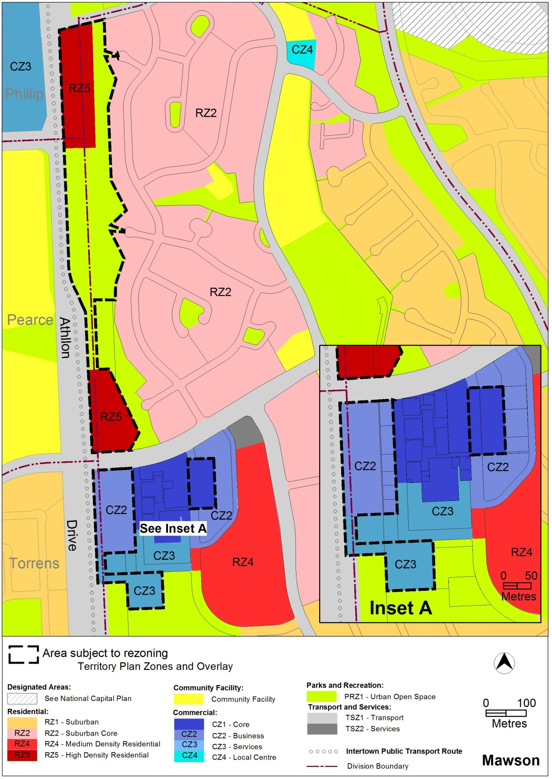
Figure 3: Areas subject to rezoning
  - Variation to the Territory Plan written document
The Territory Plan written document is varied as follows:

Variation to the Mawson precinct map and code
10. Precinct maps and codes, Mawson precinct map and code

Substitute all of the following with the nominated attachments
Mawson precinct map – Attachment A
Mawson precinct code, RC1 – Mawson Group Centre (Southlands) – Attachment B

insert after RC1
Mawson precinct code, RC2 – Athllon Drive Corridor – Attachment C

Interpretation service
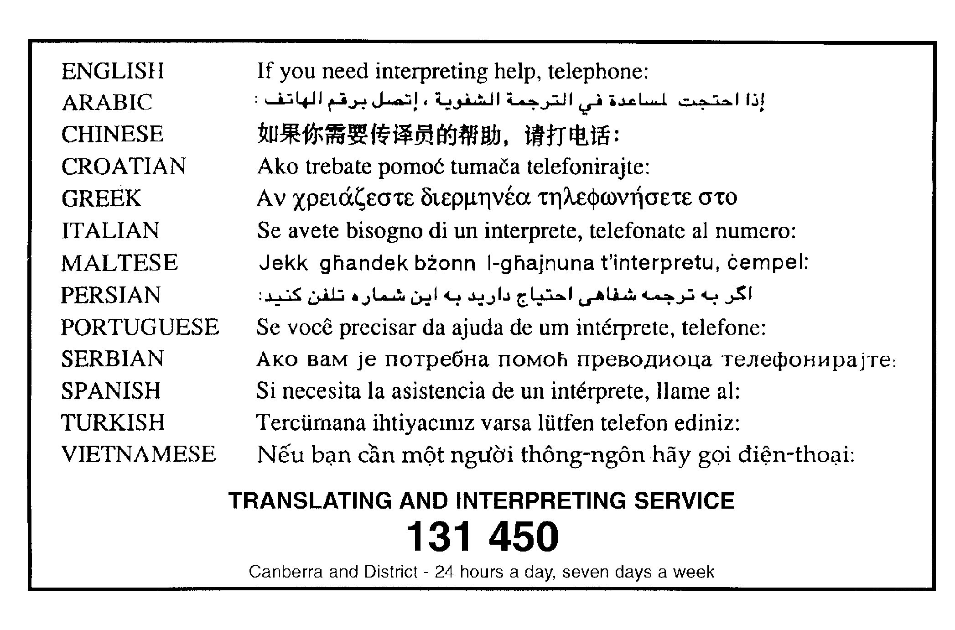

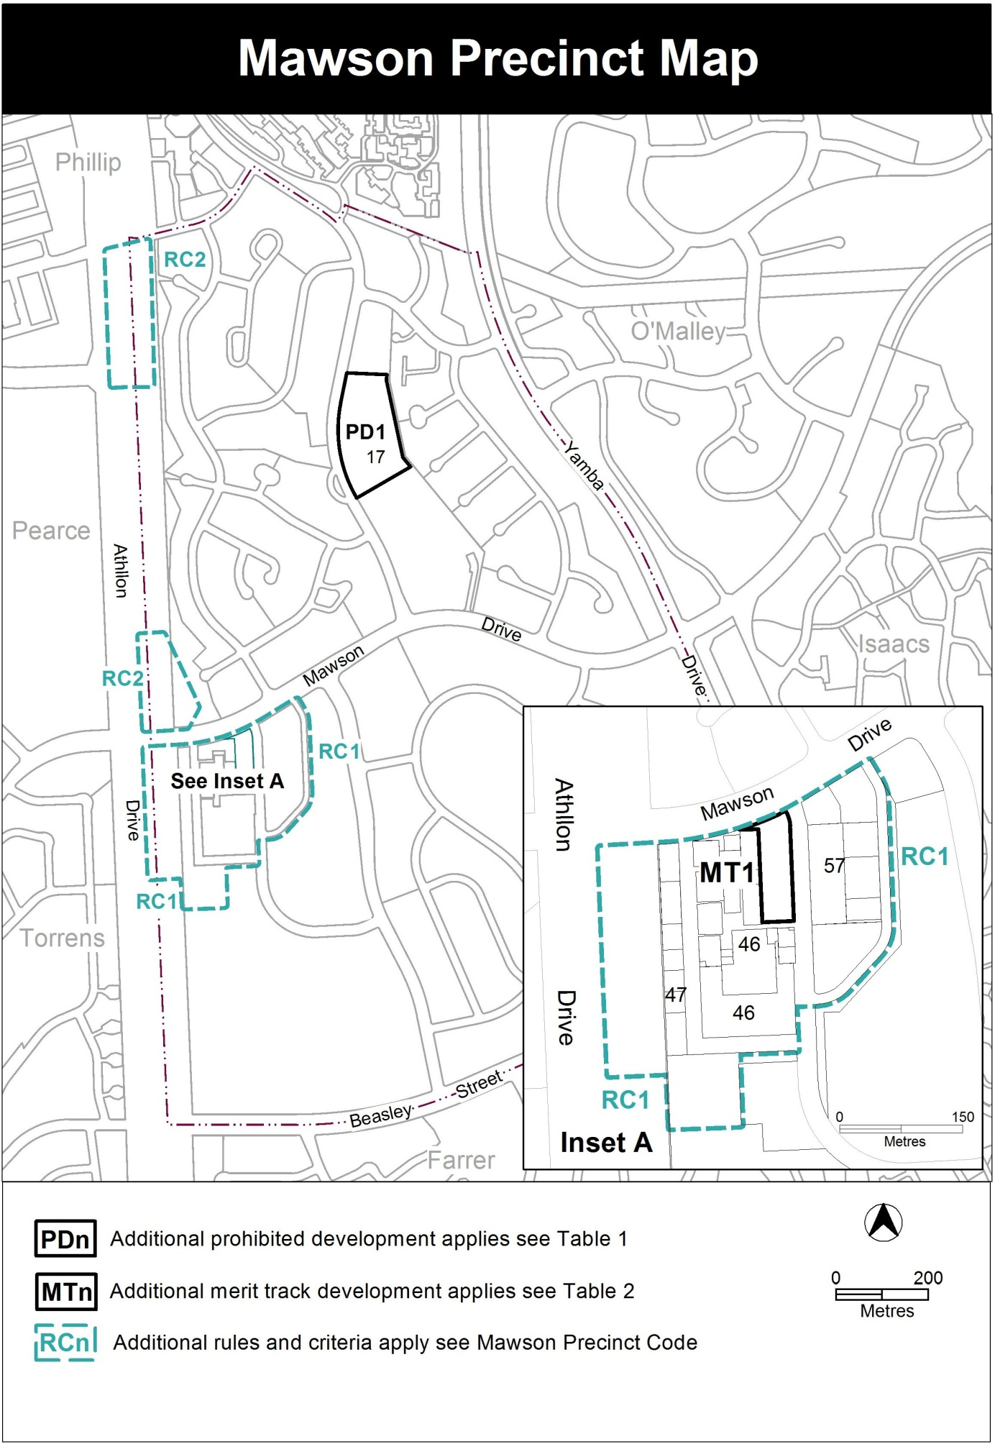

Assessment Tracks

The following tables identify the additional prohibited development and additional merit track development for blocks and parcels shown in the Mawson Precinct Map (identified as PDn or MTn). Development that is exempt from requiring development approval, other prohibited development and the minimum assessment track applicable to each development proposal is set out in the relevant zone development table.

The following tables constitute part of the relevant zone development table.

Table 1 – Additional prohibited development
Additional prohibited development
Suburb precinct map label | Zone | Development
PD1 | CFZ | retirement village  supportive housing

Table 2 – Additional merit track development
Additional merit track development that may be approved subject to assessment
Suburb precinct map label | Zone | Development
MT1 | CZ1 | industrial trades  municipal depot  store

Additional rules and criteria
This part applies to blocks and parcels identified in the Mawson Precinct Map (RCn). It should be read in conjunction with the relevant zone development code and related codes.
RC1 – Mawson Group Centre (Southlands)
This part applies to blocks and parcels identified in area RC1 shown on the Mawson Precinct Map. RC1 includes the Mawson Group Centre.

- Use
Rules | Criteria
  - Ground floor use
This rule applies to sites in CZ1 with boundaries to primary active frontages shown in figure 1.  Only the following uses are permitted along the primary active frontage at the ground floor level:  - business agency  - club  - community activity centre  - drink establishment  - financial establishment  - hotel  - indoor entertainment facility  - indoor recreation facility  - public agency  - restaurant  - SHOP | This is a mandatory requirement. There is no applicable criterion.
There is no applicable rule. | This criterion applies to sites in CZ2 and CZ3 with boundaries to primary active frontage shown in figure 1.  Buildings incorporate uses on the ground floor that generate activity in the adjoining public space.
  - Industrial trades, municipal depot and store
This rule applies to the area shaded grey in figure 1.  One or more of the following uses are permitted only in association with a structured car park:  - industrial trades  - municipal depot  - store. | This is a mandatory requirement. There is no applicable criterion.
  - Development on nominated car parking areas
This rule applies to the areas shaded grey shown on figure 2.  Development complies with all of the following:  - the existing number of car parking spaces is retained on the site and made available for public use at all times  - provides car parking that is generated by the development on site in accordance with the Parking and Vehicular Access General Code in addition to the spaces required by item a). | Development achieves all of the following:  - any additional parking provision requirements (under the Parking and Vehicular Access General Code) for the development  - makes a substantial contribution to the long term publicly accessible parking supply at the group centre.
This rule applies to development on the park and ride facility located at the south eastern corner of the Athllon Drive and Mawson Drive intersection.  Development ensures the existing number of car parking spaces is retained on the site and made available for public use at all times as a park and ride facility. | Any proposal to relocate the park and ride facility and/or amend the number of publicly available car parking spaces must include written endorsement from Territory and Municipal Services.
  - Residential use
This rule applies to development with primary active frontage as identified in figure 1.  Dwellings are not permitted at the ground floor level. | This is a mandatory requirement. There is no applicable criterion.

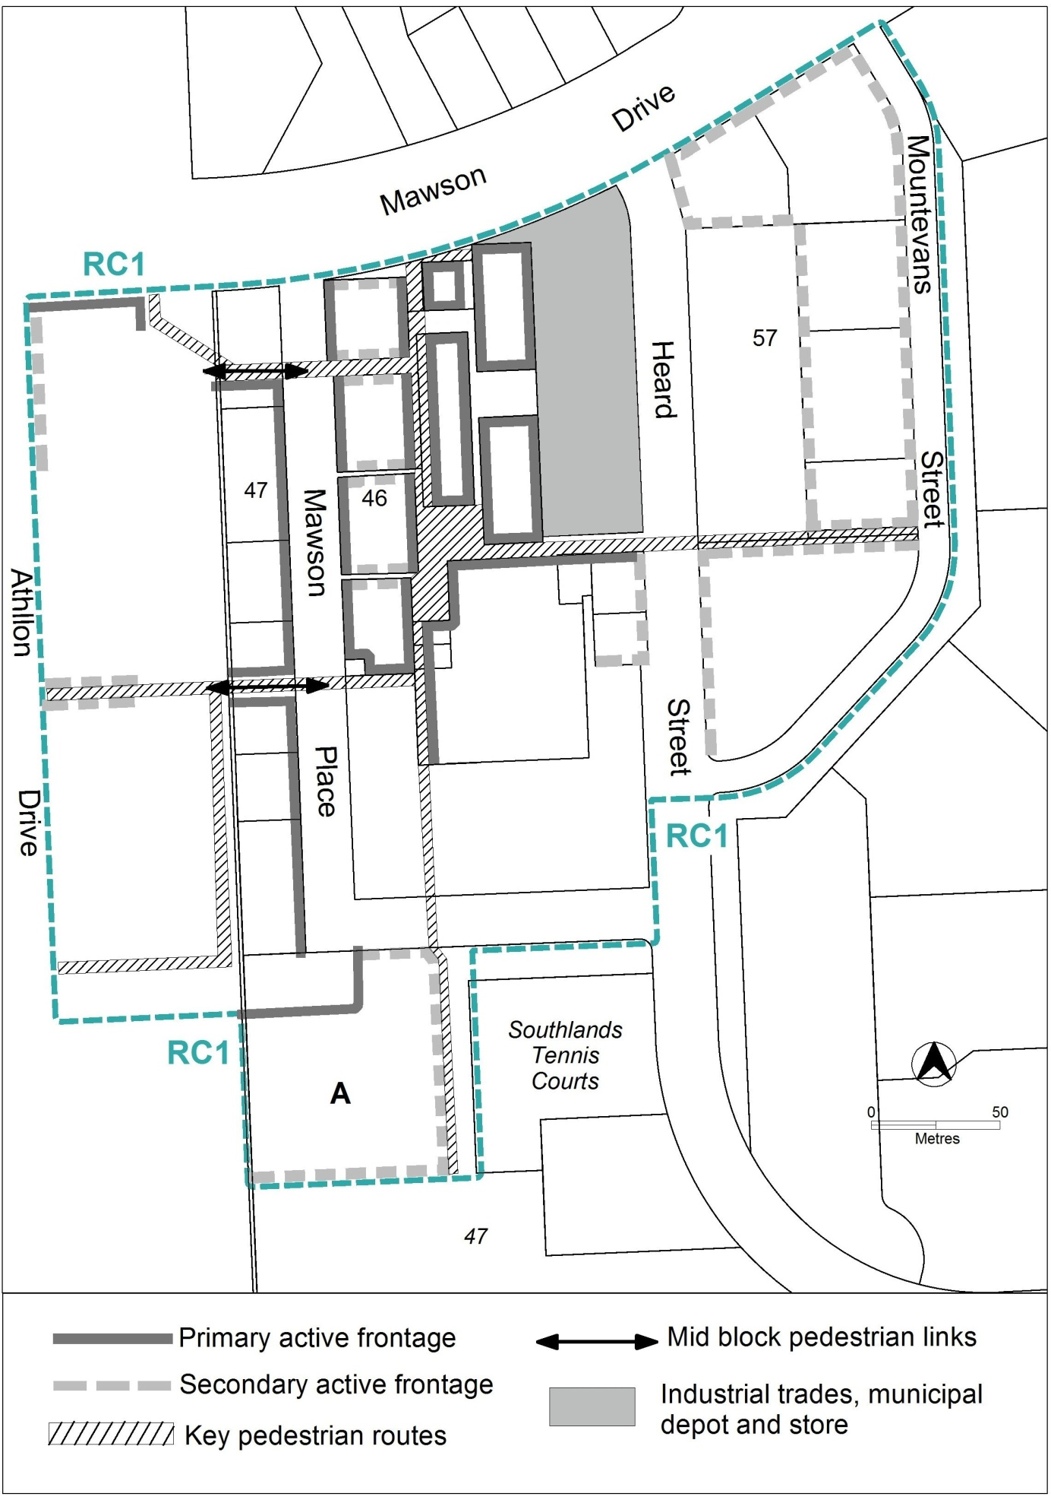
Figure 1

- Buildings
Rules | Criteria
  - Building heights
The maximum height of building is two storeys, except for the following areas shown in figure 2:  - area A: maximum height of building is four storeys  - area B: maximum height of building is six storeys  - area C: maximum height of building is eight storeys.  Plant room set back a minimum of 3m from the building facade of the floor immediately below is not included in the number of storeys. | This is a mandatory requirement. There is no applicable criterion.
The maximum height of building for area D shown in figure 2 is two storeys. | The maximum height of building may be increased to up to four storeys where development retains reasonable solar access to the adjoining public square to the east between the hours of 12pm to 2pm during 21 June (winter solstice).
  - Built form
Buildings are built to the front boundary at ground level. Above ground floor level, the minimum front setbacks are:  - 0m up to three storeys above datum ground level  - 3m for the portion of development above three storeys up to eight storeys. | Building setbacks:  - contribute to the pedestrian orientated environment  - do not prejudice the future development of adjoining sites  - provide a reduction of the visual bulk and potential overshadowing impacts of taller buildings  - allow for light penetration, air circulation and privacy.
Block 8 and block 3 section 47, or the blocks resulting from the consolidation of either block with at least one other adjoining block, provides the mid block pedestrian link shown in figure 1 as part of any redevelopment, consolidation or subdivision of the block. | This is a mandatory requirement. There is no applicable criterion.
This rule applies to development in section 47 and section 57 directly adjoining the mid block pedestrian links shown in figure 1.  The minimum side setbacks to development along the mid block pedestrian link is:  - 3 m for the first three storeys above datum ground level  - 5m for the portion of development above three storeys up to six storeys. | Building setbacks:  - provide a reduction of the visual bulk and potential overshadowing impacts of taller buildings to the mid block pedestrian links  - allow for light penetration, air circulation and privacy
This rule applies to residential development along primary active frontages shown in figure 1.  Development includes balconies and/or windows to main living areas addressing the street and public spaces. | Residential development provides opportunities for passive surveillance of public spaces.
This rule applies to CZ1 and CZ2.  The minimum floor to ceiling height at ground level is 3.6m. | Floor to ceiling heights:  - contribute to natural ventilation  - promote penetration of daylight  - are adaptable for commercial use.
This rule applies to development in area A in figure 1.  Buildings, excluding basement and/or awnings are set back a minimum of 15m from the western boundary of block 17 section 47. | Development ensures a strong physical and visual connection from Mawson Place to the Mawson District Playing Fields.
There is no applicable rule. | Structured carparks and podium car parks comply with the following:  - provide high quality architectural finishes to facades addressing public spaces  - where publicly accessible parking is provided, ensures pedestrian access and egress directly to public land.
  - Pedestrian routes
This rule applies to the blocks containing the mid block pedestrian links shown in figure 1.  Redevelopment and/or subdivision:  - provides proposed mid block pedestrian links as uncovered open laneways in the locations indicated  - retains the existing pedestrian routes. | Redevelopment and/or subdivision are consistent with the pattern of existing and proposed pedestrian links at the locations shown in figure 1.
This rule applies to the blocks containing the mid block pedestrian links shown in figure 1.  The mid block pedestrian links comply with all of the following:  - minimum unobstructed width is 6m  - remain publicly accessible at all times  - for new mid block pedestrian links, signage at each end identifying the connection provided. | Pedestrian connections achieve all of the following:  - sufficient width for pedestrian movement  - continuous public access  - identification of the available connection.
Key pedestrian routes shown in figure 1 are publicly accessible at all times, and comply with the requirements of the Crime Prevention Through Environmental Design general code. | This is a mandatory requirement. There is no applicable criterion.

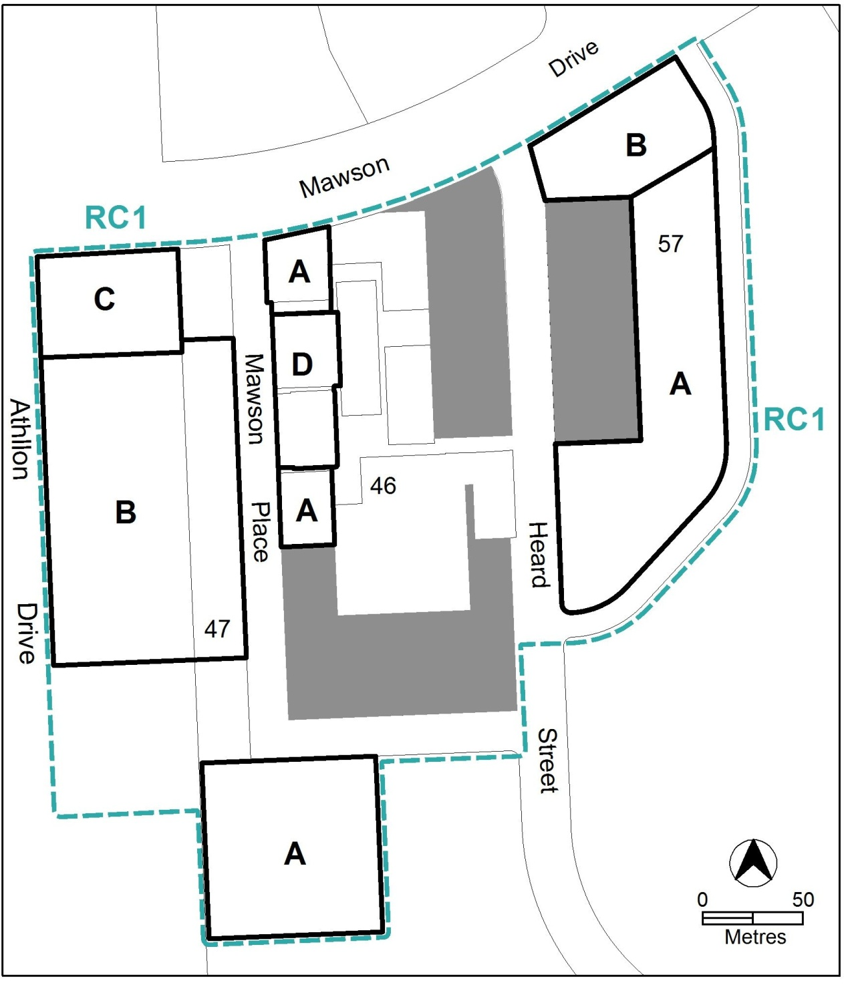
Figure 2

Rules | Criteria
  - Active frontages
For buildings located along primary active frontage areas identified in figure 1, ground floor frontages and building design comply with all of the following:  - buildings incorporate clear display windows and shop fronts at the ground level  - buildings incorporate direct pedestrian access at grade with the verge level for access and egress for persons with disabilities  - any small areas of walls without windows contain displays, showcases and/or public art, with a maximum of 30% blank frontage per tenancy | Buildings achieve all of the following:  - direct pedestrian access from main pedestrian areas  - avoid extensive lengths of blank walls unrelieved by doors, display windows or the like.
For buildings located along secondary active frontage areas identified in figure 1:  - ground floor commercial building frontages incorporate:  - clear display windows and shop fronts at the ground floor level; and  - direct pedestrian access at grade for access and egress for persons with disabilities  - ground floor residential building frontages incorporate:  - a separate access point for each ground floor dwelling; and  - commercial adaptable front facades | Development at ground level achieves all of the following:  - is adaptable for commercial uses  - where building access is provided, direct pedestrian access at street level  - provide opportunities for views into and out of the building
  - Awnings
This rule applies to buildings fronting primary active frontage areas shown in figure 1.  Buildings incorporate colonnades or awnings along the entire length of the front boundary, with a minimum height clearance of 3.2m, and a maximum height clearance of 4.3m.  NOTE:- Only cantilevered awnings (without posts) may be located outside of leased block boundaries. Colonnades (with support posts or columns) must be located within leased block boundaries. | Continuous all weather pedestrian shelter is provided in a form compatible with existing awnings or colonnades.
  - Screening
There is no applicable rule. | Waste collection areas are screened from public view.
  - Solar access
There is no applicable rule. | Development provides reasonable solar access to public and private areas of open space during winter months.
  - Separation to playing fields
This rule applies to development in area ‘A’ shown in figure 1.  Development provides a minimum 30m separation from the district playing fields. | Development within 30m of the district playing fields will be referred to the agency responsible for sportsground management, and its advice considered before the determination of the application.

RC2 – Athllon Drive Corridor
This part applies to blocks and parcels identified in area RC2 shown on the Mawson Precinct Map.
- Built form
Rules | Criteria
  - Number of storeys
This rule applies to development in area ‘a’ and area ‘b’ shown in figure 3.  The maximum number of storeys is:  - for area ‘a’- 3, except where within 25m of the front boundary addressing Athllon Drive road reserve, where the maximum number of storeys is 6  - for area ‘b’- 4, except where within 35m of the front boundary adjoining Athllon Drive or Mawson Drive road reserve, where the maximum number of storeys is 6. | This is a mandatory requirement. There is no applicable criterion.
  - Setback
This rule applies to development in area ‘b’ shown in figure 3.  The minimum front setback to Athllon Drive boundary is 10m. | Building frontages to Athllon Drive provide a landscaped setting.
  - Open space interface
This rule applies to area ‘a’ in figure 3.  Development along the open space shared path provides all of the following:  - addresses the open space with windows to habitable rooms, balconies and areas of open space adjoining the shared boundary  - openings for pedestrian access to the open space shared path. | Development provides passive surveillance and pedestrian access to the shared path open space area.
  - Vehicle access
This rule applies to area ‘a’ in figure 3.  Development incorporates the indicative road layout. | This is a mandatory requirement. There is no applicable criterion.

- Heritage
  - Potential archaeological deposits
There is no applicable rule. | Development applications will be referred to the ACT Heritage Council, and its advice considered before the determination of the application.

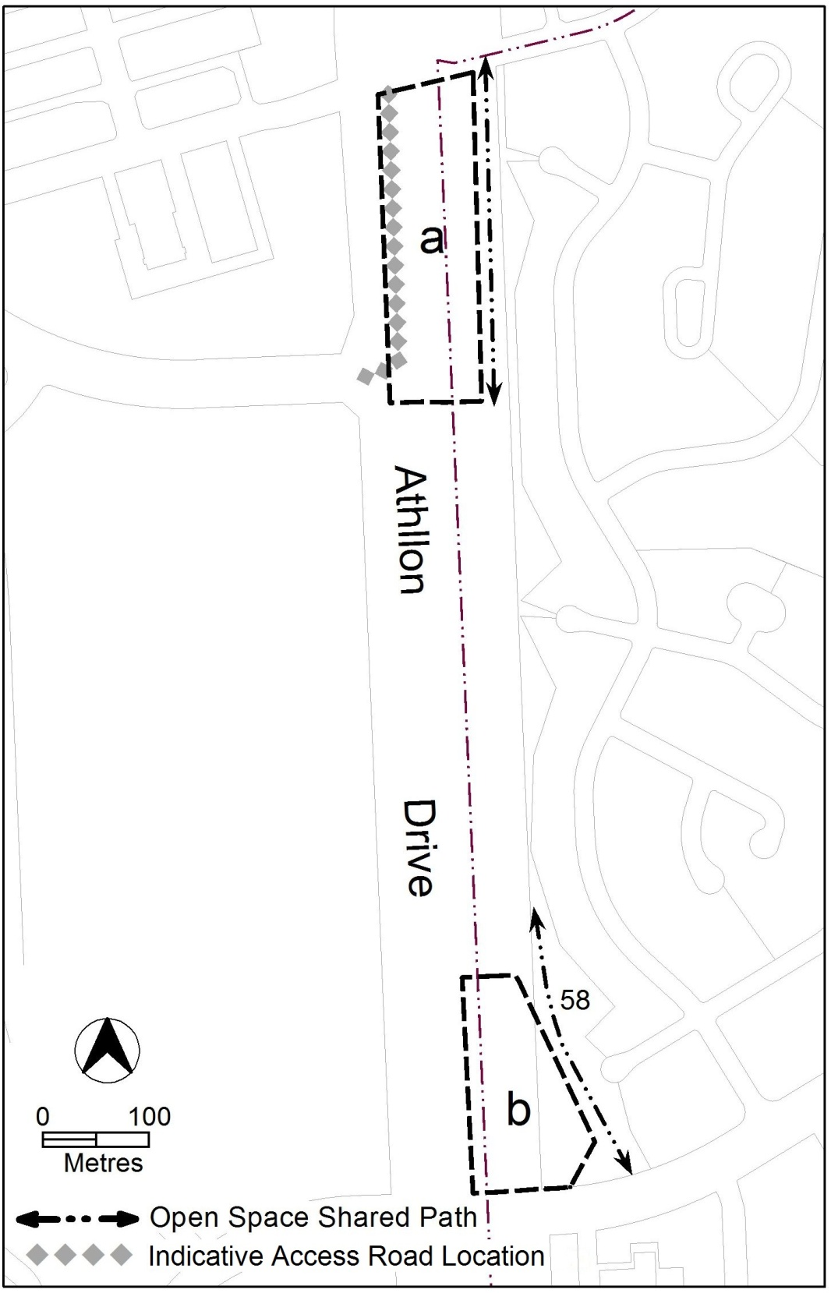
Figure 3

