Australian Capital Territory
Planning and Development (Technical Amendment—Taylor) Plan Variation 2017 (No 1)

Notifiable Instrument NI2017—254
Technical Amendment No 2017-08
made under the
Planning and Development Act 2007, section 89 (Making technical amendments) and section 96 (Effect of approval of estate development plan)

1 Name of instrument
This instrument is the Planning and Development (Technical Amendment—Taylor) Plan Variation 2017 (No 1).
2 Technical amendment
I am satisfied under section 89 (1) (a) of the Planning and Development Act 2007 (the Act) that the Taylor plan variation is a technical amendment to the Territory Plan.
3 Commencement
This instrument commences on the day after its notification day.
4 Meaning of Taylor plan variation
For this instrument:
Taylor plan variation means the technical amendment to the Territory Plan, variation 2017-08, in the schedule.
Note: No consultation was required in relation to the Taylor plan variation under section 87 of the Act.
Brett Phillips
Delegate of the planning and land authority
23 May 2017

Planning & Development Act 2007

Technical Amendment
to the Territory Plan
Variation 2017-08

Future urban area variation and introduction of the Taylor Precinct Map and Code

May 2017

This page is left intentionally blank

Table of Contents

1. INTRODUCTION 3
1.1 Purpose 3
1.2 Public consultation 3
1.3 National Capital Authority 3
1.4 Process 3
1.5 Types of technical amendments under the Act 4
2. EXPLANATION 5
2.1 Territory Plan Map 5
2.2 Taylor Precinct Map and Code 7
3. TECHNICAL AMENDMENT 8
3.1 Territory Plan Map 8
3.2 Taylor Precinct Map and Code 9

This page is left intentionally blank

1. INTRODUCTION

1.1 Purpose
This technical amendment makes the following changes to the Territory Plan:
Territory Plan Map
• The Territory Plan map is varied to remove the Future Urban Overlay from part of the Division of Taylor as indicated in section 2.1.
Taylor Precinct Map and Code
• The Taylor Precinct Map and Code is introduced.

1.2 Public consultation
Under section 87 of the Planning and Development Act 2007 (the Act) this type of technical amendment is not subject to public consultation.

1.3 National Capital Authority
The National Capital Authority does not need to be advised of this technical amendment as per 1.2.

1.4 Process
This technical amendment has been prepared in accordance with section 87 and made in accordance with section 89 of the Planning and Development Act 2007 (the Act).

1.5 Types of technical amendments under the Act
The following categories of technical amendments are provided under section 87 of the Act:
(1) Each of the following territory plan variations is a technical amendment for which no consultation is needed before it is made under section 89:
(a) a variation (an error variation) that –
(i) would not adversely affect anyone’s rights if approved; and
(ii) has as its only object the correction of a formal error in the plan;
(b) a variation to change the boundary of a zone or overlay under section 90A (Rezoning – boundary changes);
(c) a variation, other than one to which subsection (2) (d) applies, in relation to an estate development plan under section 96 (Effect of approval of estate development plan);
(d) a variation required to bring the territory plan into line with the national capital plan;
(e) a variation to omit something that is obsolete or redundant in the territory plan.
(2) Each of the following territory plan variations is a technical amendment for which only limited public consultation is needed under section 90:
(a) a variation (a code variation) that –
(i) would only change a code; and
(ii) is consistent with the policy purpose and policy framework of the code; and
(iii) is not an error variation;
(b) a variation to change the boundary of a zone under section 90B (Rezoning – development encroaching on adjoining territory land);
(c) a variation in relation to a future urban area under section 90C (Technical amendments – future urban areas);
(d) a variation in relation to an estate development plan under section 96 (Effect of approval of estate development plan) if it incorporates an ongoing provision that was not included in the plan under section 94 (3) (g);
(e) a variation to clarify the language in the territory plan if it does not change the substance of the plan;
(f) a variation to relocate a provision within the territory plan if the substance of the provision is not changed.
TA2017-08 has been prepared in accordance with section 87 (1) (c).

2. EXPLANATION
This part of the technical amendment document explains the changes to be made to the Territory Plan.

2.1 Territory Plan Map
Variation to the Territory Plan

The Territory Plan map is varied to identify the zones and overlays that apply to land ceasing to be in a future urban area.

Existing Territory Plan Map

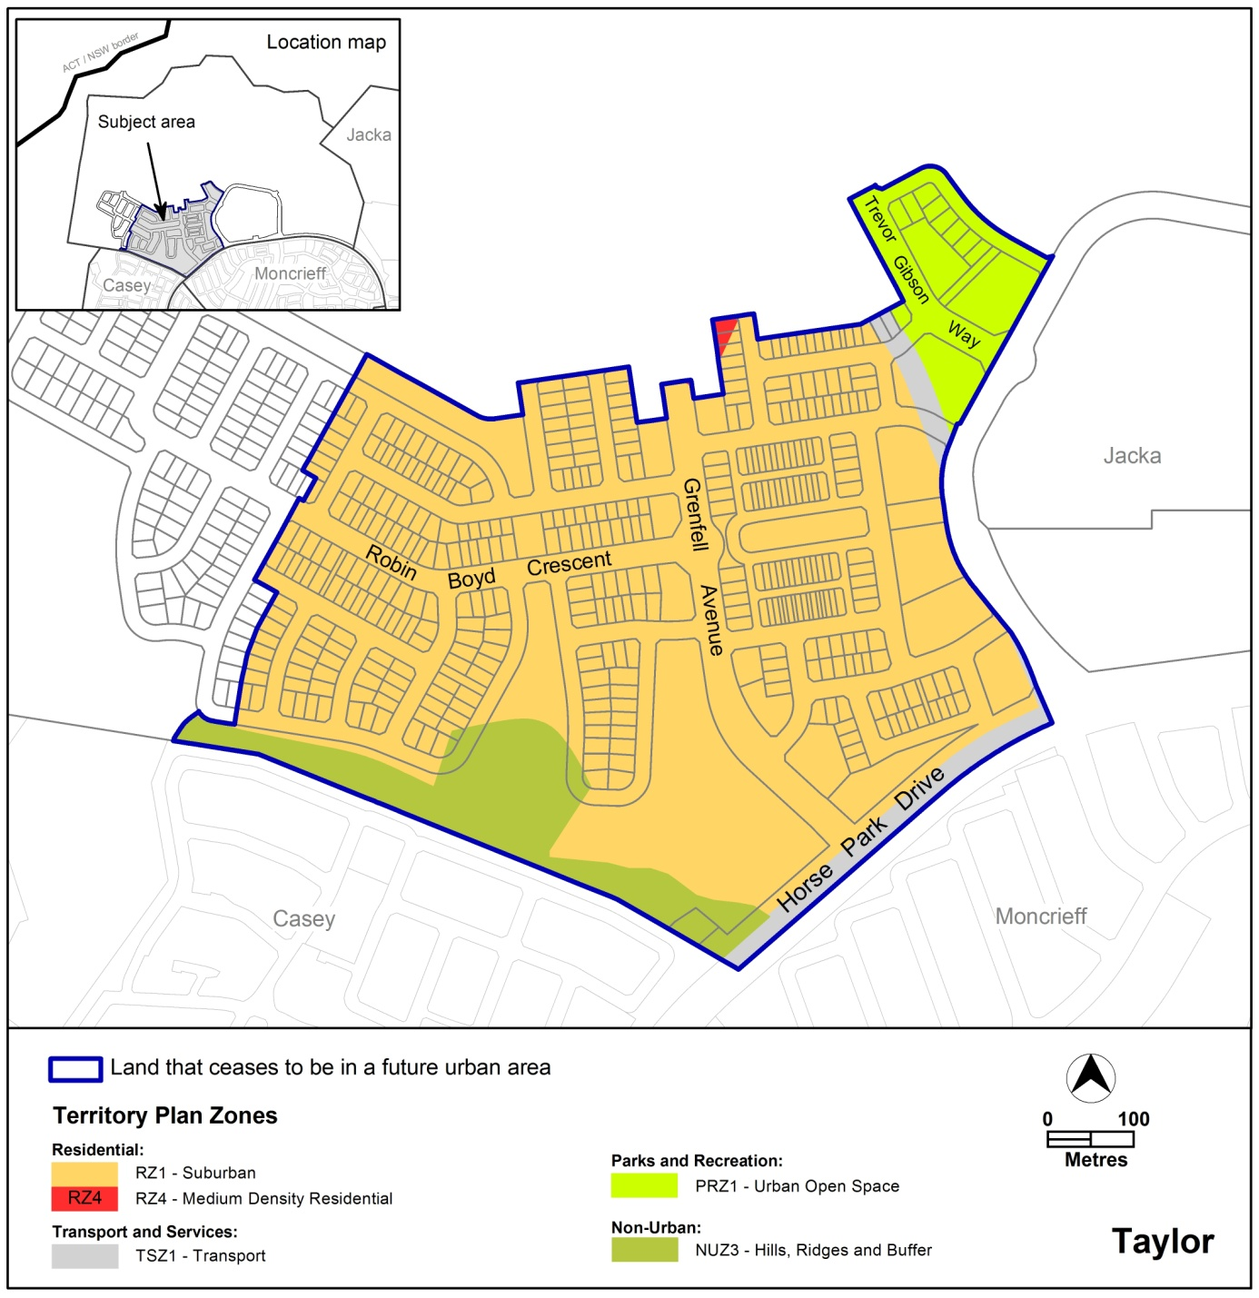

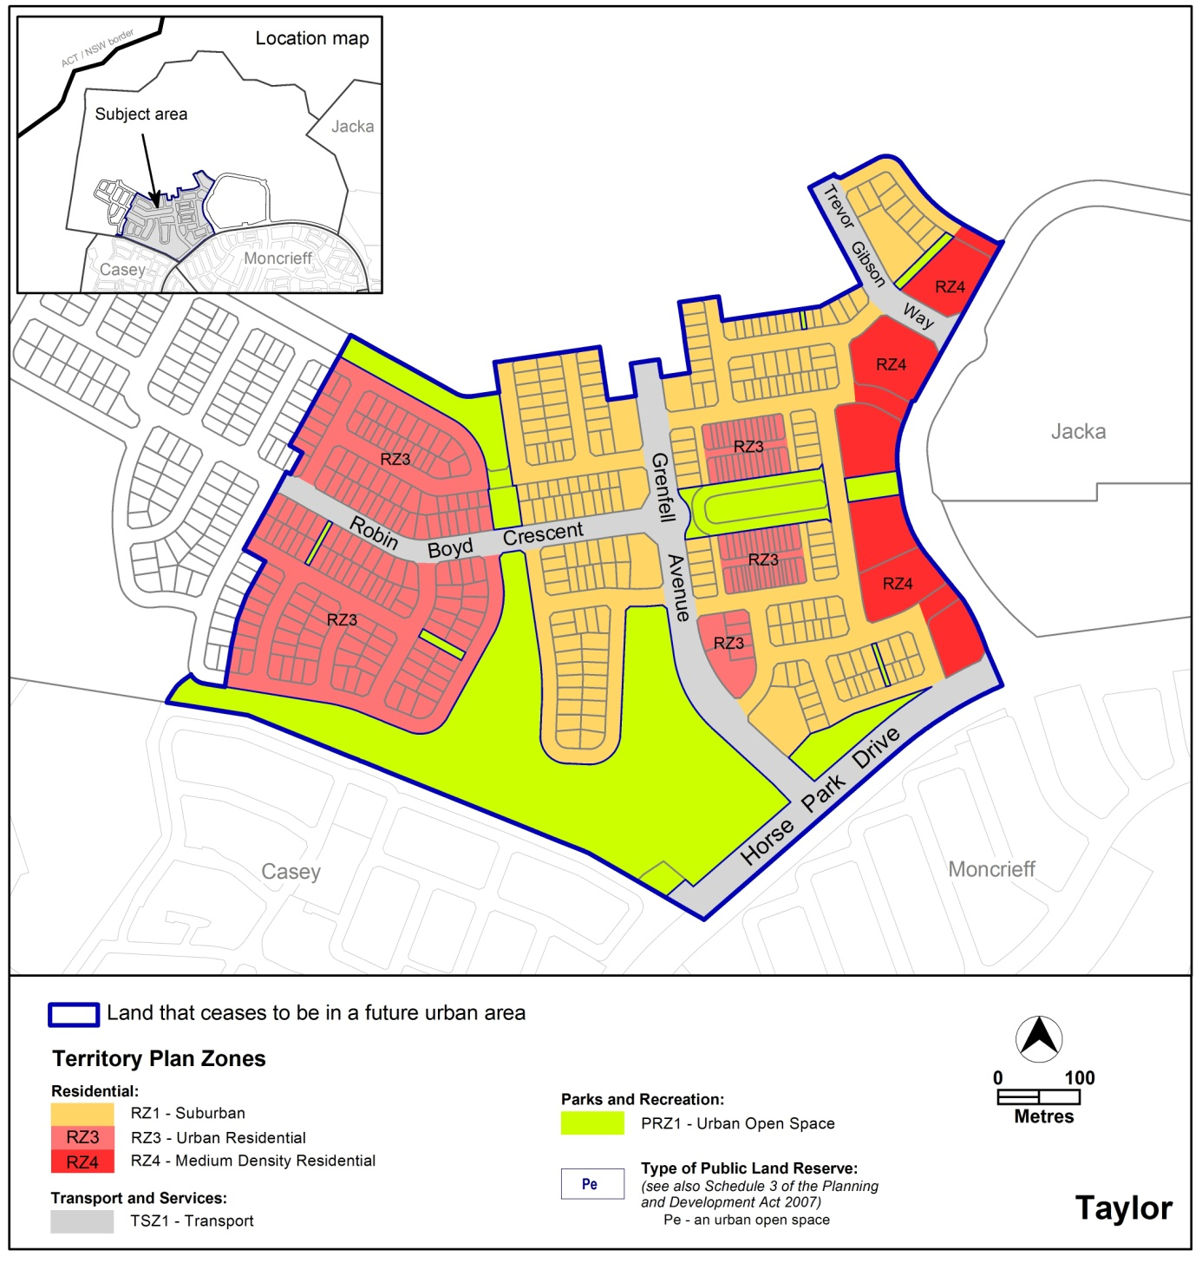

Proposed Territory Plan Map

2.2 Taylor Precinct Map and Code
Introduction of the Taylor Precinct Map and Code

The Taylor precinct map and code is introduced to incorporate ongoing block specific provisions which are consistent with the approved estate development plan.

3. TECHNICAL AMENDMENT
This section of the technical amendment document provides the actual instructions for implementing the changes to the Territory Plan.

3.1 Territory Plan Map
1. Territory Plan Map

The Territory Plan map is varied as indicated below to identify the zones and overlays that apply to the land ceasing to be in a future urban area.

3.2 Taylor Precinct Map and Code
2. Taylor Precinct Map and Code

Insert Taylor Precinct Map and Code into the Territory Plan at Appendix A.

Interpretation service
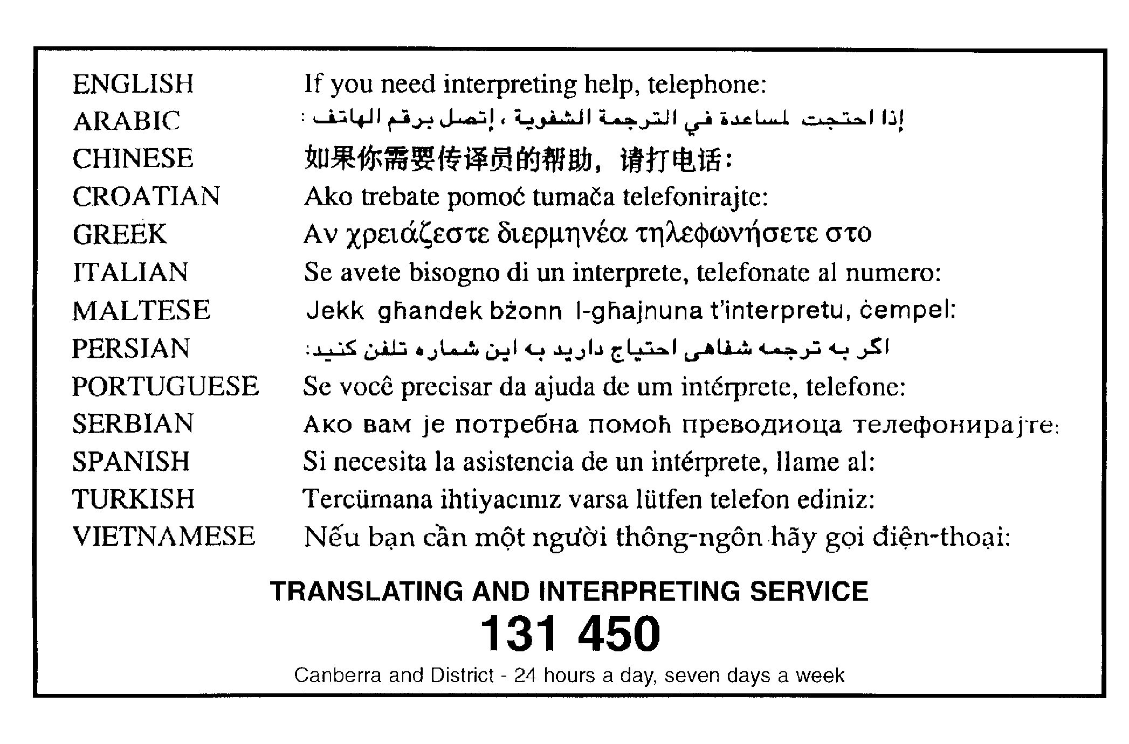

Appendix A

Taylor Precinct Map and Code

This page is intentionally blank.

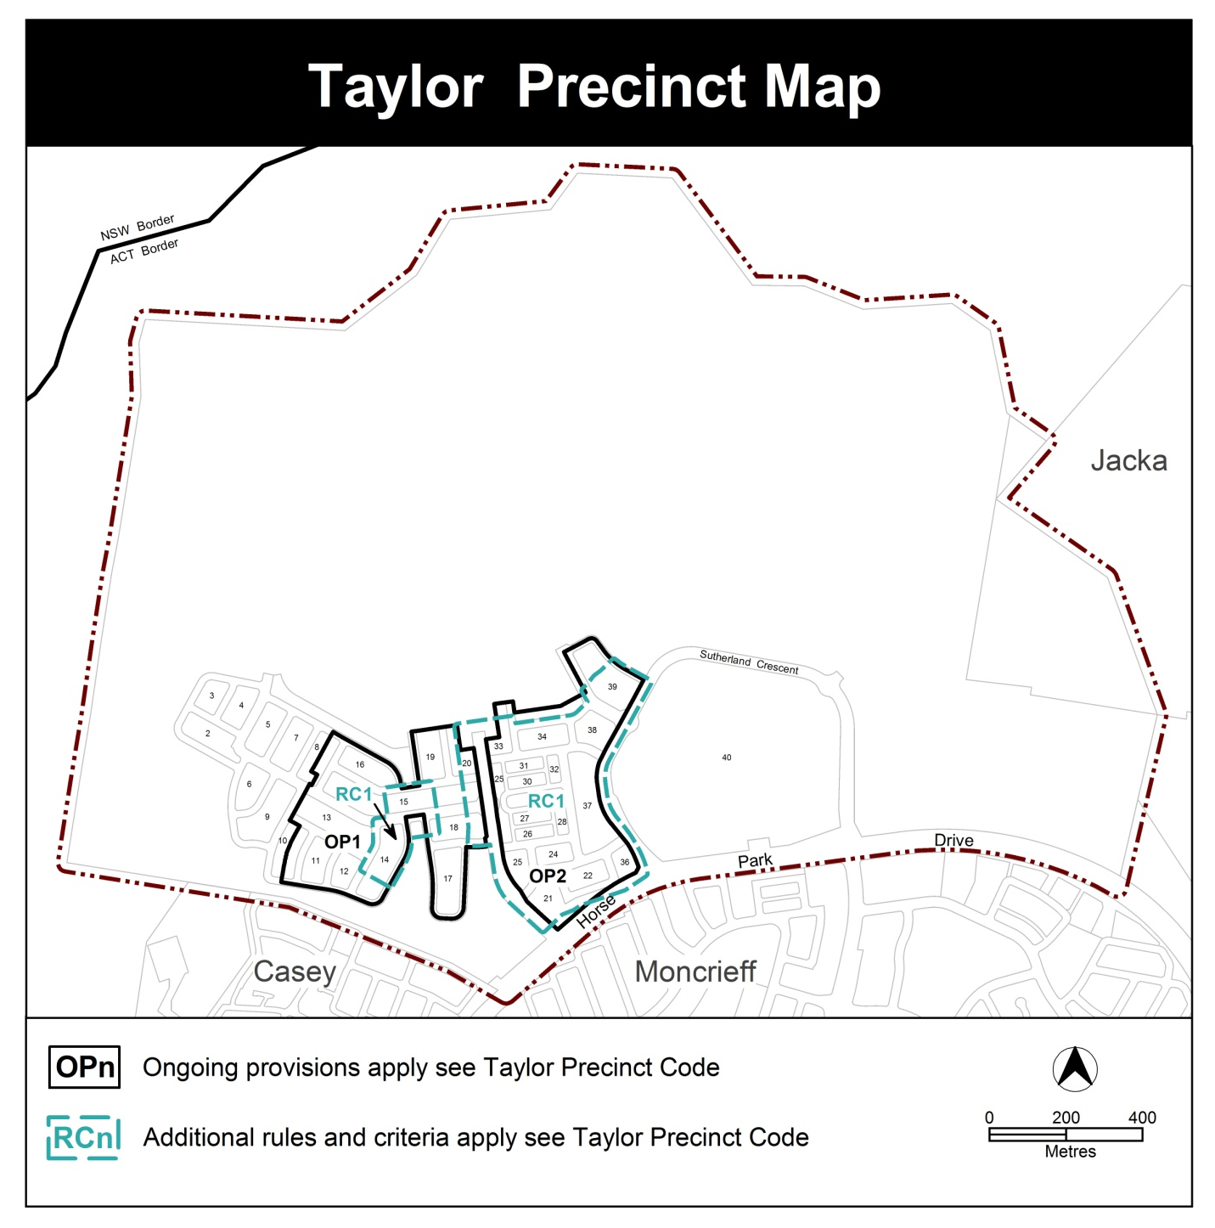

Assessment Tracks

No additional provisions apply.

Taylor Precinct Code

Contents
Introduction 4
Additional rules and criteria 6
RC1 – Taylor Residential 6
Element 1: Building and site controls 6
Element 2: Access 6
Element 3: Waste management 7
Other ongoing provisions 10
OP1 – Taylor residential area 10
OP2 – Taylor residential area 11

Figures
Diagram 1 Elevation of courtyard wall 7
Figure 1 Taylor residential area 1 8
Figure 2 Taylor residential area 2 9
Figure 3 Taylor residential area ongoing provisions 10
Figure 4 Taylor residential area ongoing provisions 11

Introduction
Name
The name of this code is the Taylor Precinct Code.
Application
The code applies to the Division of Taylor.
Purpose
This code provides additional planning, design and environmental controls for specific areas or blocks and may also contain references to provisions in other codes.
In conjunction with other relevant codes it will be used by the Authority to assess development applications and offer guidance to intending applicants in designing development proposals and preparing development applications.
Structure
This code contains additional rules and/or criteria for particular blocks or parcels identified as areas RCn on the precinct map, to be read in conjunction with the relevant development code. It may also contain sub-parts.
Each element has one or more rules and, unless the respective rule is mandatory, each rule has an associated criterion. Rules provide quantitative, or definitive, controls. By contrast, criteria are chiefly qualitative in nature.
In some instances rules are mandatory. Such rules are accompanied by the words “This is a mandatory requirement. There is no applicable criterion.” Non-compliance with a mandatory rule will result in the refusal of the development application. Conversely, the words “There is no applicable rule” are found where a criterion only is applicable.
Code hierarchy
Under the Planning and Development Act 2007, where more than one type of code applies to a development, the order of precedence if there is inconsistency of provisions between codes is: precinct code, development code and general code.
If more than one precinct code applies to the site, the most recent precinct code takes precedence to the extent of any inconsistency.
Definitions
Defined terms, references to legislation and other documents are italicised.
Definitions of terms used in this code are listed in part 13 of the Territory Plan or, for terms applicable only to this code, associated with the respective rule.

Acronyms
EPA ACT Environment Protection Authority
ESA ACT Emergency Services Agency
EPSDD ACT Environment, Planning and Sustainable Development Directorate
NCA National Capital Authority
P&D Act Planning and Development Act 2007
TCCS ACT Transport Canberra and City Services

Additional rules and criteria
This part applies to blocks and parcels identified in the Taylor Precinct Map (RCn). It should be read in conjunction with the relevant zone development code and related codes.
RC1 – Taylor Residential
This part applies to blocks and parcels identified in area RC1 shown on the Taylor Precinct Map.
Element 1: Building and site controls
Rules | Criteria
1.1 Courtyard walls
R1  This rule applies to blocks or parcels in locations identified in Figures 1 and 2.  Courtyard walls are permitted to zero setback for the nominated boundary. The length of the wall can extend along the boundary up to the minimum setback of any street frontage.  Note: See Diagram 1 for an elevation of a typical courtyard wall. | This is a mandatory requirement. There is no applicable criterion.

Element 2: Access
Rules | Criteria
2.1 Vehicular access
R2  This rule applies to blocks or parcels in locations identified in Figure 2.  Vehicular access is not permitted to or from blocks where indicated. | This is a mandatory requirement. There is no applicable criterion.

Element 3: Waste management
Rules | Criteria
3.1 Waste
R3  This rule applies to blocks or parcels in locations identified in Figure 2.  Notwithstanding that the identified blocks may contain 10 or less dwellings, for the purposes of C94 and R99 of the Multi Unit Housing Development Code, waste will be collected within the property boundary. | This is a mandatory requirement. There is no applicable criterion.

Diagram 1 Elevation of courtyard wall

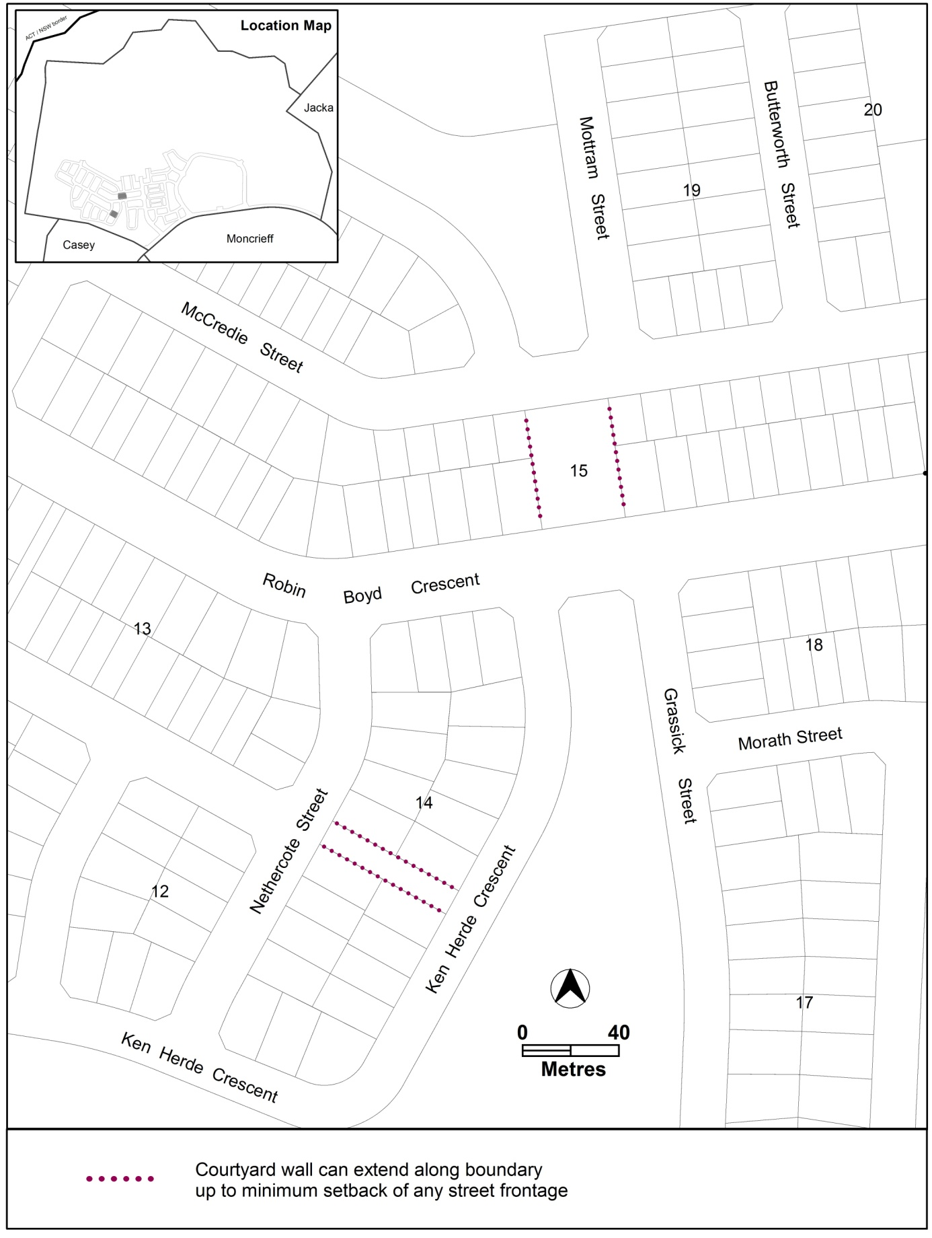
Figure 1 Taylor residential area 1

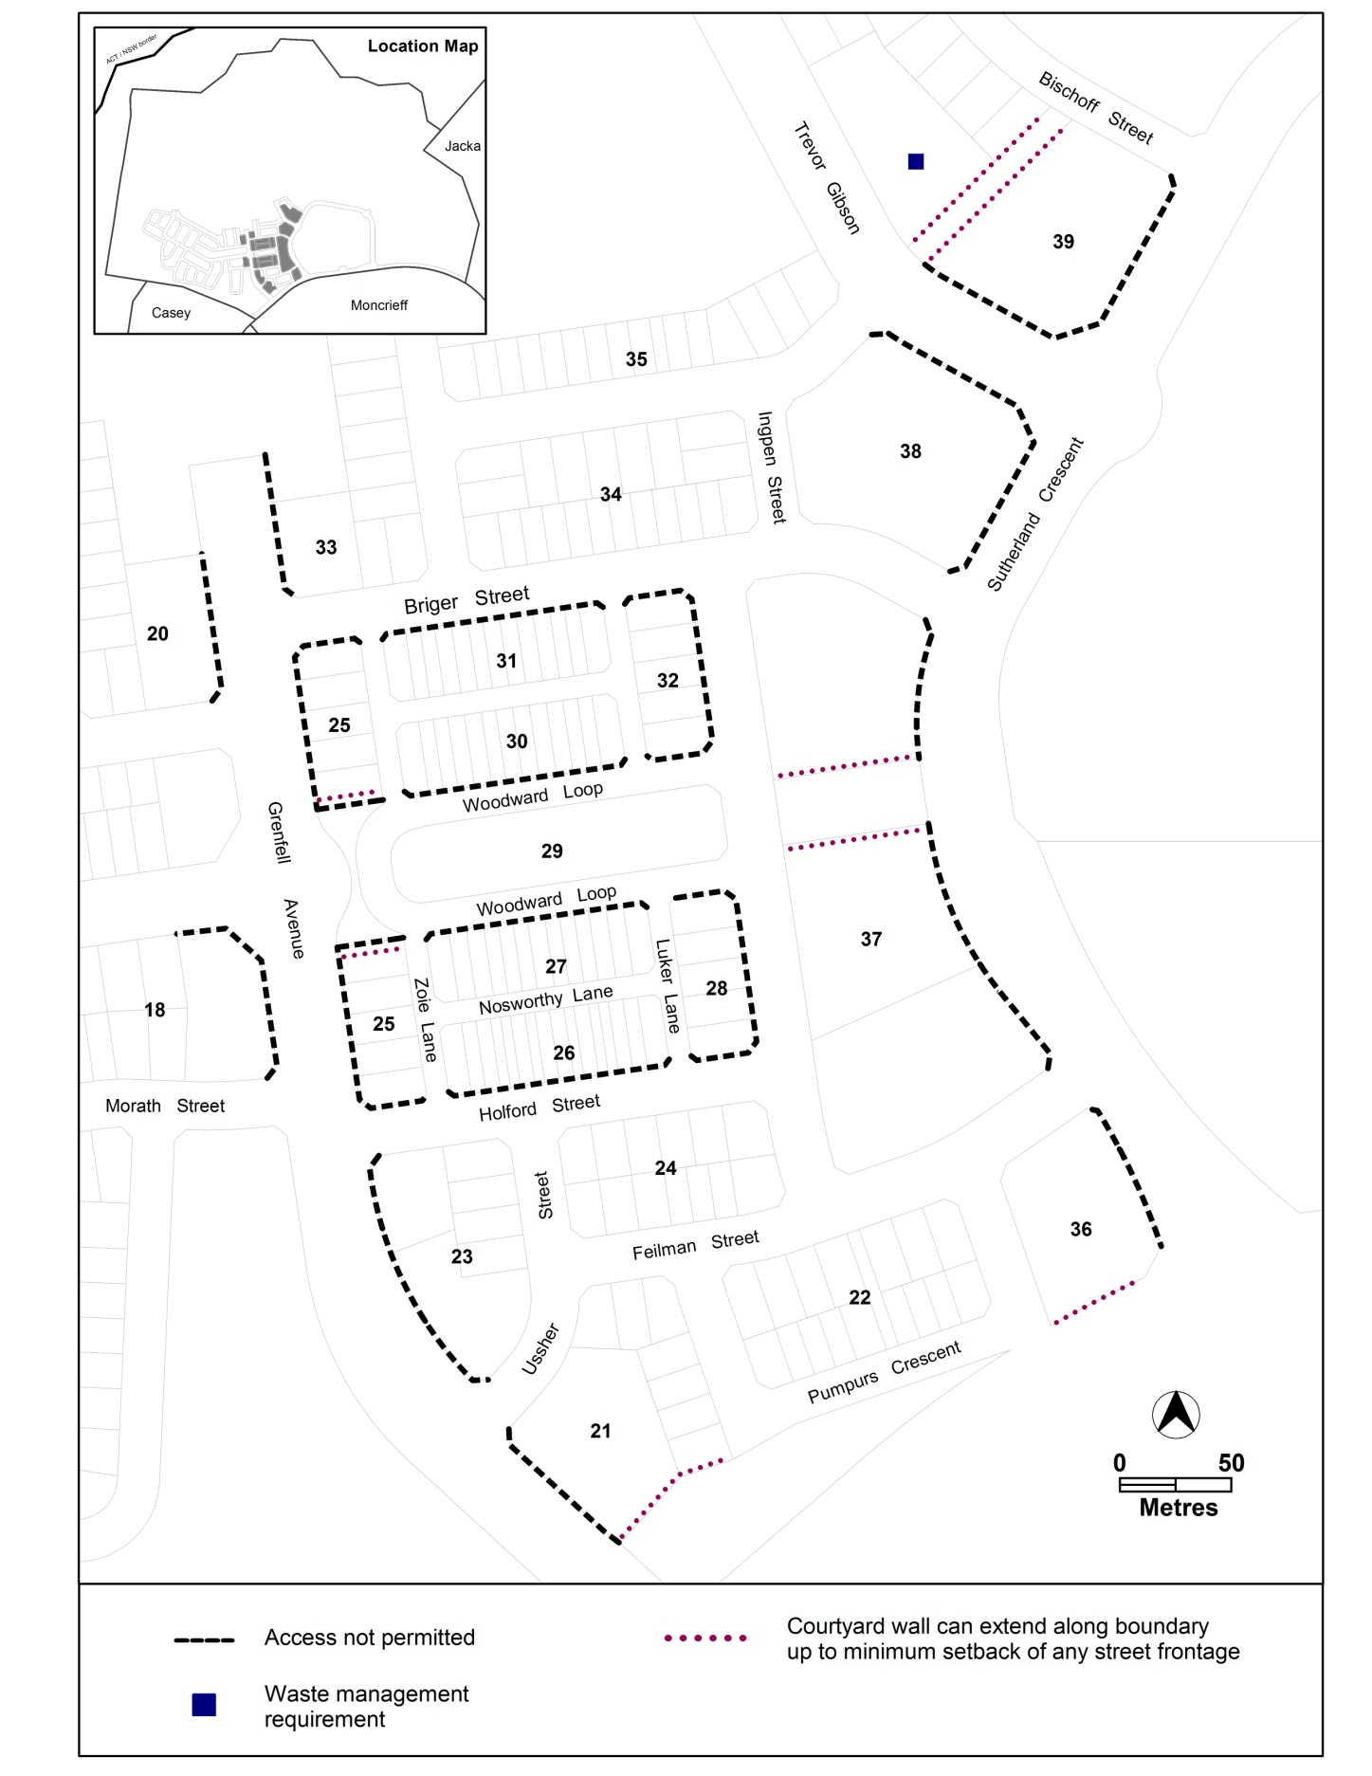

Figure 2 Taylor residential area 2

Other ongoing provisions
This part applies to blocks and parcels identified as ongoing provisions (OPn) in the Taylor Precinct Map. It should be read in conjunction with the relevant zone development code and related codes.
OP1 – Taylor residential area
This part applies to blocks and parcels identified in area OP1 shown on the Coombs Precinct Map.
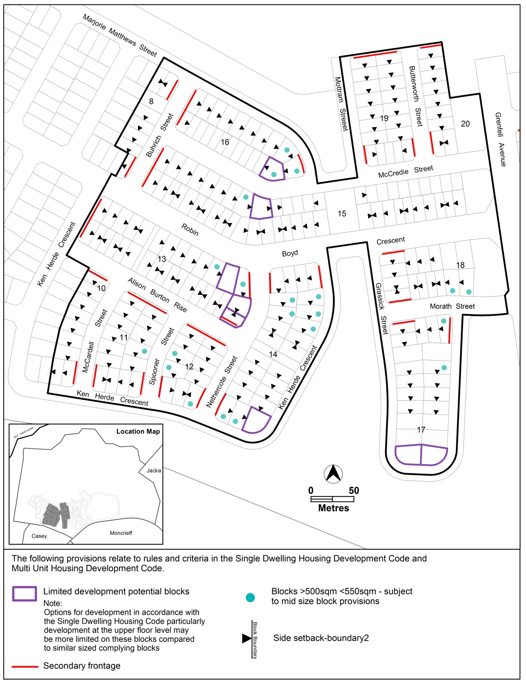
Figure 3 Taylor residential area ongoing provisions
OP2 – Taylor residential area
This part applies to blocks and parcels identified in area OP2 shown on the Taylor Precinct Map.
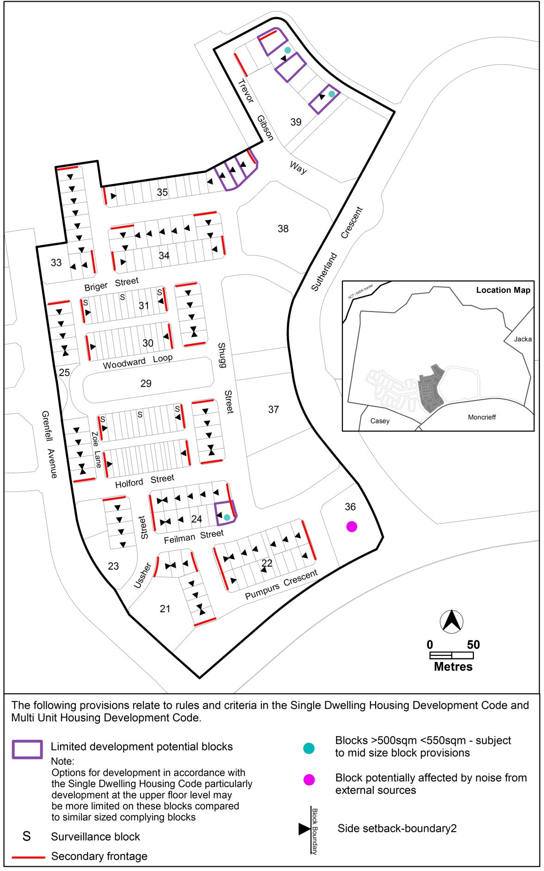

Figure 4 Taylor residential area ongoing provisions

Interpretation service

