Australian Capital Territory
Planning and Development (Draft Variation No 352) Consultation Notice 2017
Notifiable instrument NI2017—289
made under the
Planning and Development Act 2007, s 63 (Public consultation—notification) and s 64 (Public consultation—notice of interim effect etc)

1 Name of instrument
This instrument is the Planning and Development (Draft Variation No 352) Consultation Notice 2017.
2 Draft variation to the Territory plan
The planning and land authority (the Authority) has prepared a draft plan variation No 352 – changes to various development tables, codes and definitions (the Draft Variation) to vary the Territory Plan. The Draft Variation proposes some policy changes as well as some refinements and clarifications to various codes and definitions.
3 Documents available for public inspection
(1) The Authority gives notice that the following documents are available for public inspection and purchase:
(a) the Draft Variation; and
(b) the background papers relating to the Draft Variation.
(2) Copies of the documents mentioned in section 3(1) are available for inspection and purchase at Access Canberra, Environment, Planning and Sustainable Development Shopfront, Ground Floor South, Dame Pattie Menzies House, 16 Challis Street, Dickson, Monday to Friday (except public holidays) between 8:30am and 4:30pm for the period commencing on the day this notice commences and ending on 24 July 2017 (the Consultation Period).
(3) Copies of the documents mentioned in section 3(1) are also available for inspection during the Consultation Period online at http://www.planning.act.gov.au/draftvariations
4 Invitation to give written comments
(1) The Authority invites written comments about the Draft Variation during the Consultation Period. Comments should include reference to the Draft Variation and be addressed to the Territory Plan Section of the Environment, Planning and Sustainable Development Directorate (EPSDD). Please also provide your name and contact details to assist in the assessment of the comments provided and to enable the Authority to contact you in relation to your comments, if required.
(2) Written comments should be provided to the Authority by:
(a) email to terrplan@act.gov.au; or
(b) mail to Territory Plan Section, EPSDD, GPO Box 158, Canberra, ACT 2601; or
(c) hand delivery to Access Canberra, EPSDD Shopfront, Ground Floor South, Dame Pattie Menzies House, 16 Challis Street, Dickson.
5 Public inspection of written comments
(1) Copies of written comments about the Draft Variation given in response to the invitation in section 4, or otherwise, or received from the National Capital Authority will be available (unless exempted) for public inspection for a period of at least 15 working days starting 10 working days after the day the consultation period ends at Access Canberra, EPSDD Shopfront, Ground Floor South, Dame Pattie Menzies House, 16 Challis Street, Dickson, Monday to Friday (except public holidays) between 8:30am and 4:30pm and may be published on the EPSDD website at www.planning.act.gov.au.
(2) You may apply under section 411 of the Planning and Development Act 2007 (the Act) for part of your consultation comments to be excluded from being made available to the public. A request for exclusion under this section must be in writing, clearly identifying what you are seeking to exclude and how the request satisfies the exclusion criteria. Please note that your name and contact details and other personal information will not be made public unless you request otherwise.
6 Effect of the draft plan variation
Section 65 of the Act applies to parts of the draft variation. This means that, in addition to the Territory Plan, some provisions of Draft Variation No 352 apply to development applications lodged on or after 9 June 2017. The draft variation is part of the Territory Plan for a period of up to one year from this date unless the draft variation is commenced, is withdrawn or rejected by the Legislative Assembly. During this period, the ACT Government must not do or approve anything that would be inconsistent with the Territory Plan.

7 Obtaining further information
Further information about the Draft Variation can be obtained through email correspondence with the Territory Plan Section, EPSDD, at Terrplan@act.gov.au, a reference to the Draft Variation should be included in any email.

8 Meaning of draft plan variation No 352 – changes to various development tables, codes and definitions
In this instrument:
Draft plan variation No 352 – changes to various development tables, codes and definitions means the draft plan variation in the schedule.
Note Your personal information will be managed in accordance with the Information Privacy Act 2014 and the EPSDD Information Privacy Policy which are available through the EPSDD website.

Brett Phillips
Delegate of the planning and land authority
05 June 2017

Planning and Development Act 2007

Draft
Variation to the
Territory Plan
No 352

Changes to various development tables, codes and definitions
Changes include:
- introduction of animal care facility in industrial zones
- prohibition of child care centres in industrial zones
- removal of Public Land Reserve overlay on part block 510 Stromlo
- inclusion of an additional merit assessable use in the Hackett Precinct Map
- revisions to provisions in some development codes and
- clarification and refinement of some definitions

June 2017

Draft variation for public consultation prepared
under s 60 of the Planning and Development Act 2007

This page is intentionally blank.

Contents
1. INTRODUCTION 1
1.1 Summary of the Proposal 1
1.2 Outline of the process 2
1.3 Public Consultation 3
2. EXPLANATORY STATEMENT 4
2.1 Background 4
2.1.1 Territory Plan Map 4
2.1.2 Zone development tables - additional merit track and prohibited uses 6
2.1.3 Development codes 10
2.1.4 Precinct Codes 17
2.1.5 Changes to Definitions of Development 19
2.1.6 Changes to Definitions of Terms 1
2.2 Current Territory Plan provisions and proposed changes 5
2.2.1 Changes to Territory Plan map – part block 510 Stromlo 5
2.2.2 Zone Development Tables 7
2.2.3 Development Codes 10
2.2.4 Precinct Codes 28
2.2.5 Definitions of Development: 30
2.2.6 Definitions of Terms 30
2.3 Reasons for the proposed draft variation 33
2.4 Planning context 33
2.4.1 National Capital Plan 33
2.4.2 ACT planning framework 34
2.5 Interim Effect 34
2.6 Consultation with Government Agencies 36
3. DRAFT VARIATION 39
3.1 Variation to the Territory Plan 39
3.1.1 Variation to the Territory Plan Map 39
3.1.2 Variation to the Industrial Zones development tables 40
3.1.3 Variation to the Residential Zones Development Code 42
3.1.4 Variation to the Single Dwelling Housing Development Code 43
3.1.5 Variation to the Multi Unit Housing Development Code 47
3.1.6 Variation to the Commercial Zones Development Code 54
3.1.7 Variation to the Industrial Zones Development Code 54
3.1.8 Variation to Parks and Recreation Zone Development Code 55
3.1.9 Variation to the Lease Variation General Code 56
3.1.10 Variation to Parking and Vehicular Access General Code 57
3.1.11 Variation to the Hackett Precinct Map 58
3.1.12 Variation to the Territory Plan Definitions – Part A 59
3.1.13 Variation to the Territory Plan Definitions – Part B 60

This page is intentionally blank.

- INTRODUCTION
  - Summary of the Proposal
As part of the continued monitoring and updating of the Territory Plan, a number of matters have been identified across different parts of the Plan that require changes in order to better meet the needs of government, industry and the community. These include:
- changes to the types of development permitted in certain zones or in site specific instances;
- improving the understanding and functionality of some development code provisions; and
- clarification of and refinement to some definitions.
The matters to be dealt with are in the following categories:
- Territory Plan Map changes
Changes to the Territory Plan map to remove a public land overlay from part of rural block 510 Stromlo
- Zone development tables
Changes to zone development tables where new uses are proposed to be permitted and existing uses are proposed to be prohibited
- Development codes
Revisions to individual rules and criteria in certain development codes
- Precinct map and code
Changes to Hackett precinct map and code to include site-specific merit assessable use
- Definitions of Development
Amendments to certain definitions of development used in the Territory Plan
- Definitions of Terms
Changes to and clarification of certain technical terms used in the Territory Plan

  - Outline of the process
The Commonwealth’s Australian Capital Territory (Planning and Land Management) Act 1988 allows for the Legislative Assembly to make laws to establish a Territory Planning Authority and for that Authority to prepare and administer a Territory Plan. The Planning and Development Act 2007 (the Act) establishes the planning and land authority as the Authority which prepares and administers the Territory Plan, including continually reviewing and proposing amendments as necessary. The functions of the planning and land authority are administered by the Environment, Planning and Sustainable Development Directorate (EPSDD).
The Territory Plan is comprised of a written statement and a map. The written statement contains a number of parts, namely governance; strategic directions; zones (including objectives and development tables and zone or centre development codes); precinct codes; general codes; overlays; definitions; structure plans, concept plans and development codes for future urban areas.
The Territory Plan Map graphically represents the applicable land use zones (under the categories of residential, commercial, industrial, community facility, urban parks and recreation, transport and services and non urban), precincts and overlays. The zone, precinct and overlay requirements are detailed in the volumes of the Territory Plan.
Draft variations to the Territory Plan are prepared in accordance with the Act. Following the release of the draft variation under section 63 of the Act, submissions from the public are invited. At the conclusion of the consultation period the EPSDD submits a report on consultation and a recommended final variation to the Minister responsible for planning for approval. The Minister has the discretion to determine if referral to the Legislative Assembly standing committee responsible for planning is warranted prior to approval, depending on the nature and significance of the proposal. If the draft variation is referred to the committee by the Minister or otherwise, the Minister must consider the findings of the committee before deciding whether to approve the draft variation. If the Minister approves the variation, the variation and associated documents will be tabled in the Legislative Assembly. Unless disallowed by the Legislative Assembly within five sitting days, the variation commences on a day nominated by the Minister.

  - Public Consultation
Written comments about the draft variation are invited from the public by COB Monday 24 July 2017
Comments should include reference to the draft variation and be addressed to the Territory Plan Section. Please also provide your name and contact details to assist in the assessment of the comments provided, and to enable EPSDD to contact you in relation to your comments, if required. Your personal information will be managed in accordance with the Information Privacy Act 2014 and the EPSDD Information Privacy Policy, which is available for viewing on EPSDD’s website.
Comments can be:
- emailed to terrplan@act.gov.au
- mailed to Territory Plan Section, GPO Box 158, Canberra, ACT 2601
- delivered to EPSDD’s Customer Service Centre at 16 Challis Street, Dickson

Copies of written comments will be made available for public inspection for no less than 15 working days starting 10 working days after the closing date for comment. The comments will be available at EPSDD’s customer service centre in Dickson and may be published on EPSDD’s website. Comments made available will not include personal contact details unless you request otherwise.
A request may be made for parts of a submission to be excluded under section 411 or 412 of the Planning and Development Act 2007. A request for exclusion under these sections must be in writing, clearly identifying what parts of your submission you are seeking to exclude and how the request satisfies the exclusion criteria.

Further Information
The draft variation is available online at www.act.gov.au/draftvariations until the closing date for written comments.
Printed copies of the draft variation (this document) are available for inspection and purchase at the Environment, Planning and Sustainable Development Directorate Customer Service Centre, 16 Challis Street, Dickson, Monday to Friday (except public holidays) between 8:30am and 4:30pm. Please call 6207 1923 to arrange a copy for purchase.

- EXPLANATORY STATEMENT
  - Background
    - Territory Plan Map
Removal of Public Land Reserve overlay on part block 510 Stromlo

Part of rural block 510 Stromlo (see location plan below) has a Public Land Reserve ‘Pc – a nature reserve’ overlay on the northern portion adjoining Cotter Road. This part of the block was originally a separate parcel (formerly block 66) but was granted by direct sale to Greenhills Centre after the 2003 fires and incorporated into their existing lease. The purpose was to facilitate the rebuilding of the site after the fires and also that a presence closer to Cotter Road would protect both Greenhills assets and the adjoining scout camp to the east.

The Conservator of Flora and Fauna has requested that the Public Land Reserve overlay be removed from the subject site as it is likely to be developed at some point in the future, consistent with the existing non urban NUZ4 river corridor zone and any development is unlikely to be consistent with the management objectives for a public land reserve. The land is degraded and contains a small borrow pit, road formation, incidental grading, fill mounding and various informal structures. The Conservator has advised that excision of this degraded area from the reserve is appropriate.

See next page for location diagram (Figure 1)

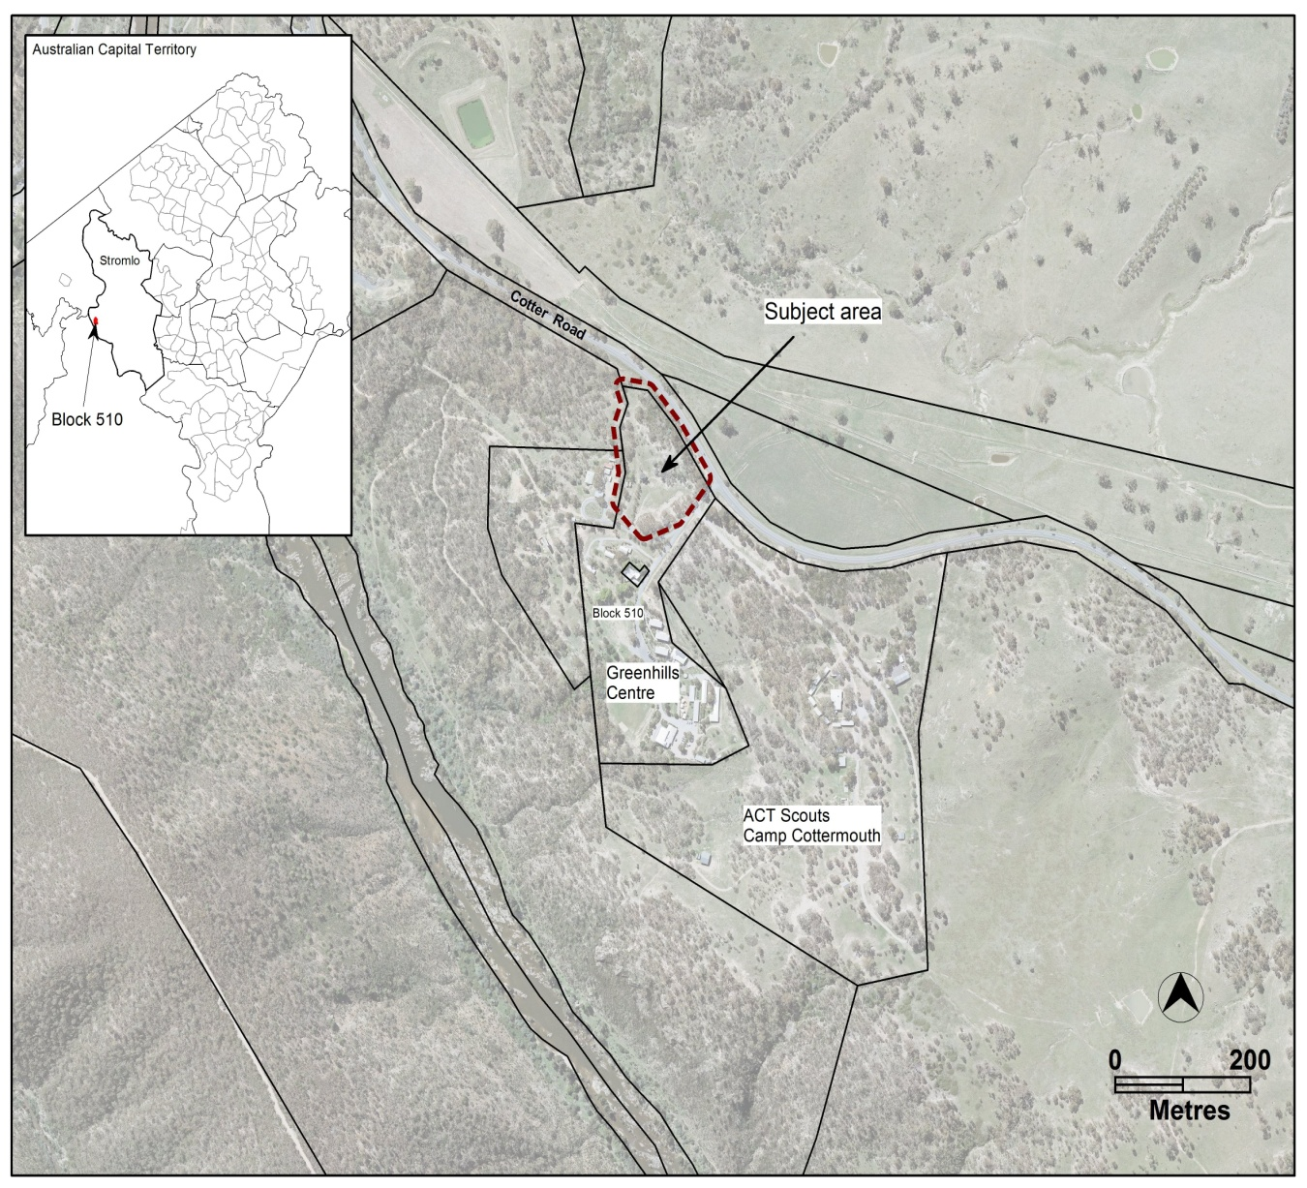

Figure 1 Location plan for part rural block 510 Stromlo

    - Zone development tables - additional merit track and prohibited uses
- Animal care facilities permitted in industrial zones

An ‘animal care facility means the use of land for the purpose of caring, boarding, breeding or raising of predominantly domestic or household animals.’

This use is currently restricted to non urban NUZ1 broadacre zoned areas only. However there is an emerging need for animal day care facilities (considered a type of animal care facility) in suitable locations within the urban area. This will provide pet owners with an option of seeking supervised care for pet animals (expected to be predominantly dogs) which are lonely, or bark or whine excessively during the day when the owners are at work. Other city jurisdictions such Melbourne, Sydney, Brisbane and Adelaide already permit these uses in urban areas as an approved domestic animal day care business.

Existing animal care facilities are generally regulated through existing codes of practice setting out the minimum standards for operation, including requirements for the welfare of animals and issues such as ventilation, waste management, hygiene and staff care and responsibilities.

The main planning related issues that are evident when considering permitting animal day care facilities in urban areas include management of noise, waste and odour, and compliance measures to respond to complaints on any of these issues should they arise.

The ACT Government is keen to support this type of emerging use and ensure that the use can operate satisfactorily in the urban environment. A number of Government agencies have been consulted with, including the Environment Protection Authority, Transport Canberra and City Services Directorate (TCCS) - Domestic Animal Services and development assessment, leasing and legislative policy areas within the Environment, Planning and Sustainable Development Directorate.

This draft variation seeks to permit an animal care facility in the industrial IZ1 general industrial and IZ2 mixed use industrial zones. This would facilitate the establishment of animal day care centre facilities in suitable locations for people who require a daily care arrangement for their pets.

It is expected that the impacts from this type of use in these locations can be managed and mitigated without unreasonably affecting noise sensitive receptor activities. Furthermore, residential use is not permitted in industrial zones. A development application for this type of use, either through a lease variation or development proposal, will require the submission of a noise management plan to address internal and external noise generation by a suitably qualified noise expert, and an emergency management plan providing details of a risk assessment and evacuation procedures for endorsement by Emergency Services.

The Animal Welfare Act 1992 (administered by Transport Canberra and City Services) also has a number of requirements that need to be met concerning the welfare and the duty of care by the proprietor for the animals in an animal care facility. Transport Canberra and City Services (TCCS) is considering the development of a specific Code of Practice under the Animal Welfare Act 1992 to provide guidance on the minimum standards of accommodation, care and management to be provided to dogs kept at an animal care facility, including hygiene, waste, noise, health, transport, and exercise.

The parking and vehicular access general code will also be amended to ensure parking requirements are adequately accounted for in any development proposal for an animal day care facility. It is considered that such parking requirements will not be dissimilar to that provided for child care centres, which require staff parking as well as provisions for daily drop off and pick up.

See sections 2.2.2.1, 2.2.3.5, 2.2.3.7 and 2.2.3.8 for proposed changes to the Territory Plan development tables and codes.

- Child care centres prohibited in industrial zones

Concerns have been raised about the appropriateness of allowing child care centres to be located in industrial areas, as well as the possible risks and impacts this may have on neighbouring industrial uses and their long term viability.

In the Territory Plan, a ‘child care centre’ is contained within the umbrella term of ‘Community Use’. Both industrial zones (IZ1 – general industrial zone and IZ2 – mixed use industrial zone) currently identify ‘community use’ as a merit track development, which includes child care facility.

There are currently provisions within the Territory Plan that seek broadly to protect industrial land uses from any significant impact from community uses. However, there are no rules or criteria that specifically address health and safety considerations of vulnerable people (which includes children). The Environment Protection Authority (EPA) has raised concerns about applications in industrial zones which may impact on the health and safety of vulnerable people (in this case, children). There is also concern regarding the potential future effect on land uses and new industrial opportunities that might locate around child care centres in the industrial zones (for instance an industrial use may not be permitted in the industrial zone due to its proximity to a child care centre).

The EPA administers a regulatory and policy framework under the Environment Protection Act 1997 and Environment Protection Regulation 2005 that seeks to protect human health and the environment from pollution. The EPA’s Air Quality, Hazardous Material and Contaminated Sites Environment Protection Policies (made under the environment protection legislation) and the recent draft Separation Distance Guidelines for Air Emissions are based on policies of other states and all contain similar policy objectives to protect sensitive receptors from hazardous substances and pollution.

These policies and guidelines detail matters and standards to be considered to protect sensitive receptors from industrial pollutants. Children and residential uses are considered the most sensitive receptors in these considerations from a human health perspective.

The location of a childcare centre within an industrial zone could have the following impacts:
- Potential risks to children’s health and safety being exposed to industrial air, soil and noise pollutants from neighbouring industrial uses.
- Potential risks to children’s health and safety being placed in a location in close proximity to hazardous industries (e.g. potential risks from chemical and gas storage facilities).
- Potential future impact on land uses and new industrial opportunities that may want to locate around child care centres in industrial zones
- Potential to limit future industrial development on adjacent and surrounding parcels.
- Potential to limit the ability of existing lessees to activate uses (currently included in their leases) which may have a negative impact on the health and wellbeing of children located in a nearby child care centre.
- Potential to affect the price of industrial land surrounding a child care centre.

The Industrial Zones Development Code in the Territory Plan is primarily concerned with protecting industrial land use and not does specifically address health concerns for sensitive community uses involving vulnerable people.

The Community and Recreation Facilities Location Guidelines General Code in the Territory Plan does however set out location guidelines for the development of a childcare centre (long day care or occasional care) by requiring inter alia buffering “from sight, smell, fumes and noise of industrial uses and from roads with high traffic volumes.

The proposed changes are for:
- ‘child care centre’ to be specifically removed from the industrial zones merit track development tables (whilst retaining all other community uses as permitted merit track uses other than child care centre by listing these uses separately in the merit track tables and not referring to the umbrella term of COMMUNITY USE); and
- child care centre specifically listed within IZ1 and IZ2 development tables as prohibited.

As the regulators of childcare services in the ACT, the Education Directorate was also provided with the draft variation during agency circulation phase and advised that they had no comments on the proposed changes.

See section 2.2.2.1 for proposed changes to the Territory Plan development tables.

    - Development codes
- Residential Zones Development Code
- Boarding houses
Rules R25 and R26 provide the design and siting requirements for the minimum gross floor areas of individual boarding rooms and the extent of communal living areas within boarding houses. These provisions are currently mandatory, and have no scope to allow consideration of proposals that meet the policy intent of the residential zones development code but which cannot meet the strict requirements of rules R25 and R26. It is proposed to introduce criteria C25 and C26 to allow for circumstances where the quantitative measures cannot be met but a suitable alternative design outcome relating to the gross floor area of building rooms and communal living areas can be satisfactorily demonstrated by the proponent.

See section 2.2.3.1 for existing and proposed changes to the residential zones development code in the Territory Plan.

- Single dwelling housing development code
- Allowable encroachments: pergolas
Provisions exist within the single dwelling housing development code (Rule R16) for certain building elements to encroach into the minimum setbacks.
Under the Planning and Development Regulation, Schedule 1, a ‘roofed, unenclosed class 10a building’ may be exempt from requiring a development application if certain requirements are met. These include maximum size and height, as well as location requirements.
Rule R16 of the code allows for a ‘pergola’ to encroach on a setback consistent with the rule, without reference to size, height, or location. Unlike the other building elements listed in Rule R16, the term ‘pergola’ may include relatively large, free-standing roofed structures, which could impact on adjoining residences.
In light of these issues, amending the wording to only permit ‘unroofed pergolas’ would serve to remove ambiguity and will limit unreasonable impacts associated with roofed pergolas.
See section 2.2.3.2 for existing and proposed changes to the single dwelling housing development code in the Territory Plan.

- Noise affected blocks
Rule R42 of the code seeks to ensure that if residential development is located adjacent to a high-volume road, more stringent noise attenuation measures are required, and less stringent requirements can apply the further away the dwelling is from the road. However, it appears that the wording of the rule is misleading by implying that the further away from the source of noise, the more stringent the noise attenuation measures. It is proposed to rearrange the wording of the rule so that the intent is clearer and less ambiguous.

In addition, certain terms (e.g. ‘adjacent’, ‘dwelling’ and ‘habitable room’) are not italicised, making it unclear whether the meanings are intended to be the same as the Territory Plan definitions. These words will be italicised to ensure they are used in the context of and consistent with Territory Plan definitions.

Currently, Criterion C42 requires a noise management plan endorsed by ‘the Transport Planning & Projects Section in ESDD’. This requires updating and future-proofing and it is proposed to change it to refer to ‘the ACT Government entity responsible for transport planning.’

See section 2.2.3.2 for existing and proposed changes to the single dwelling housing development code in the Territory Plan.

- Water sensitive urban design
Concerns have been raised regarding the requirements regarding water tanks and associated plumbing connections for residential dwellings contained in Rule R43.
The ACT Government undertook a review in 2013/2014 regarding water sensitive urban design (WSUD) and its functionality in the codes in the Territory Plan. One of the major focuses was on rainwater tanks.
The removal of the rainwater tank requirement in the Single Dwelling Development Code was not recommended as a result of the WSUD Review. However, issues regarding the installation of rainwater tanks related to useability and affordability. The rule does not currently mandate the requirement for a pump to be attached to a water tank, so the connection of tanks to plumbing is often ineffectual for potable water reduction.
Despite this, the tanks still contribute to on-site retention and reduce block run off flowing quickly into the stormwater system. To improve this situation, it is proposed to include the requirement for a pump so that the use of tank water for toilet flushing etc can be harnessed while still contributing to water usage reduction as well as on site retention.
The current requirement for water tanks to be connected to at least a toilet, laundry cold water and all external taps is considered reasonable for new dwellings and secondary residences on mid-size and large blocks. It is also considered reasonable for substantial extensions of a size over 50% of existing floor area (in line with the Building Regulation 2008) where new plumbing is intended. This requirement is proposed to be included in the revised provision, rather than the current roof area requirement.
For a minor extension or a substantial extension of a size over 50% of existing floor area with no new plumbing, the requirement in the rule for water tanks to be connected to a toilet or laundry is considered overly burdensome. It is therefore proposed to be exempted in these instances. The requirement for water tanks for water storage from roof harvesting will still be retained in the provision for dwellings on mid-sized and large blocks.
See section 2.2.3.2 for existing and proposed changes to the single dwelling housing development code in the Territory Plan.

- Multi unit housing development code
- Residential density - adaptable housing – rule R14
Both rules R14 and R54 deal with adapted housing and are mandatory. R14 deals with residential density for adapted housing on single dwelling blocks in the RZ2 suburban core zone, and R54 deals with adapted housing for multi unit housing comprising 10 or more dwellings.
R14 allows for increased density in the RZ2 zone where the dwellings comply with the adaptable housing Australian Standard AS4299 Adaptable Housing (Class C), whereas R54 states that the dwellings are designed to meet AS4299.
To date, development applications proposing adapted housing under R14 have provided pre-adaptable and post-adaptable plans to demonstrate how a dwelling can be easily modified to become an adapted dwelling suitable for the needs of an elderly person or a person with a disability.
To ensure that the dwellings are actually built as adapted dwellings, it is proposed to adjust the wording of R14 to read: “This rule applies to single dwelling blocks in RZ2 where all dwellings are built to comply with Australian Standard AS4299 Adaptable Housing Adaptable Housing (Class C)
See section 2.2.3.3 for existing and proposed changes to the multi unit housing development code in the Territory Plan.

- Site open space – RZ1 and RZ2 – stormwater runoff Criterion C38(c)
Item 4.2 ‘Site open space – RZ1 and RZ2’ of the code deals with open space requirements on blocks in the RZ1 and RZ2 zones for multi unit developments.
Criterion C38 requires sufficient open space for recreation and relaxation, planting (especially deep root planting) and provision of outdoor areas readily accessible by residents for a range of uses and activities. However, C38(c) deals with the provision for on-site infiltration of stormwater run-off on a block. This provision is related to the water sensitive urban design (WSUD) aspect of the site and is addressed through rules and criteria 86-89 in the multi unit housing development code. Since adequacy of site open space can be addressed through C38(a), (b) and (d), and stormwater retention and detention is addressed in Item 8.1 ‘Water sensitive urban design’, it is proposed to remove C38(c) from this provision.

See section 2.2.3.3 for existing and proposed changes to the multi unit housing development code in the Territory Plan.

- Courtyard wall setbacks - rule R42
Under Territory Plan Variation 306 (V306), the setback requirements for courtyard walls in the Multi Unit Housing Development Code was reduced from 2m (or 3m depending on the block) to 700mm for north facing private open spaces. The control previously limiting the total length of the courtyard wall to 50% of the width of the block was also removed.

Concerns have been raised regarding the impacts of the reduced courtyard wall setbacks especially in older established suburbs.

With future anticipated growth in the number of multi-unit developments in RZ1 and RZ2, it is likely that the reduction in the setback from 2-3m to 700mm; and the removal of maximum width requirement could alter the appearance and character of suburban streetscapes in a way that may be inconsistent with ‘Garden City’ principles.

In response to these concerns regarding established streetscape and amenity in low density areas, it is proposed that the courtyard wall provisions in the Multi Unit Housing Development Code be amended to better protect the established streetscape and neighbourhood character of RZ1 and RZ2 areas, whilst maintaining reasonable criteria for the merit- based assessment of any departure. Currently Rule R42 allows for a minimum setback to the front boundary of 0.7m where the wall encloses the principal private open space of a ground floor dwelling that is located to the west, north-west, north, north-east or east of the dwelling. It is proposed to restrict courtyard walls in RZ1 and RZ2 areas to a total length not exceeding 60% of the width of the block at the line of the wall, and allowing a minimum setback from the front boundary of not less than 2m.

See section 2.2.3.3 for existing and proposed changes to the multi unit housing development code in the Territory Plan.

- Courtyard walls – Rule R42b) i) – principal private open space at ground floor
Rule R42b) i) is ambiguous in relation to the statement “...the principal private open space of a ground floor dwellings...” as it is unclear whether the intention is to refer only to a single storey dwelling or to the ground floor of a multi-storey development. It is proposed to clarify this requirement by replacing the words “...of a ground floor dwellings...” with “...at ground floor level...” so that the intent of the provision is clearly articulated that it applies to multi-storey unit development.

Note: R42 is proposed to be renamed R42A to refer to courtyard walls in zones other than RZ1 and RZ2.

See section 2.2.3.3 for existing and proposed changes to the multi unit housing development code in the Territory Plan.

- Privacy and overlooking rules R59 and R60 and criteria C59 and C60
Rules R59 and R60 of the Multi Unit Housing Development Code relate to privacy between unscreened elements and principal private open spaces (PPOS). An issue has been raised that the rules are ambiguously worded due to sentence structure. It is also proposed that criteria C59 and C60 be amended to ensure compliance is demonstrated by the proponent.

R59 and R60 can currently be interpreted in a way that is the opposite of that intended. For example R60 may be read as follows:
‘A person (with an eye height of 1.5m) standing at any and every point on the extremity of an unscreened element of one dwelling shall not have a direct line of sight of more than 12m to more than 50% of the minimum principal private open space of any other dwelling.’

The intent of R60 is to ensure that if a neighbour’s principal private open space and an unscreened element are located within 12m of each other, no more than 50% of the neighbour’s principal private open space is visible from the unscreened element. In other words the rule requires that either: the unscreened element and the PPOS are a minimum of 12m apart, or: no more than 50% of the PPOS is visible from an unscreened element.
It is proposed to adjust the wording of R59 and R60 to ensure there is no ambiguity and misinterpretation in the understanding of the requirements contained in the provisions. Criteria C59 and C60 will also be reworded to ensure evidence is provided by the proponent demonstrating compliance with the rule or criterion.
See section 2.2.3.3 for proposed changes to the multi unit housing development code in the Territory Plan.

- Principal private open space – criterion C61
The word ‘proportionate’ in the context of describing principal private open space requirements for a dwelling is very subjective and can vary significantly in application and interpretation. It is proposed to delete the word ‘proportionate’ from the criterion C61a) and combine C61a) and C61b) as follows:
‘C61
Principal private open space for each dwelling achieves all of the following:
- an area suitable for an extension of the function of the dwelling for relaxation, dining, entertainment, recreation
- directly accessible from the dwelling
- service functions such as clothes drying and mechanical services
- reasonable privacy
- reasonable solar access.’
See section 2.2.3.3 for existing and proposed changes to the multi unit housing development code in the Territory Plan.

- Noise affected blocks – rule R67
Rule R67 of the code requires an acoustic assessment and noise management plan endorsed by ‘the Transport Planning & Projects Section in ESDD’. This term is out of date and requires updating and future-proofing. It is proposed to change the wording to ‘the ACT Government entity responsible for transport planning.’

See section 2.2.3.3 for existing and proposed changes to the multi unit housing development code in the Territory Plan.

- Neighbourhood Plans
Necessary provisions within Neighbourhood Plans were previously transferred into suburb specific Precinct Maps and Codes where appropriate when the new Territory Plan was introduced in 2008. As a result, zone development codes and area specific precinct codes no longer need to mention Neighbourhood Plans.

Currently the Commercial Zones Development Code, Parks and Recreation Zones Development Code, Northbourne Avenue Precinct Code and Inner North Precinct Code still make reference to Neighbourhood Plans. Each is in the form of a single element or item containing a single criterion which refers to the ‘key strategies’ of any relevant Neighbourhood Plan.

It is proposed to remove the reference to Neighbourhood Plans from the Commercial Zones Development Code and the Parks and Recreation Zones Development Code as part of this draft variation.

See sections 2.2.3.4 and 2.2.3.6 for proposed changes to the Territory Plan development codes.

    - Precinct Codes
Additional merit track development - Hackett Precinct Map

Block 9 Section 12 Hackett is a small 254m² parcel of land zoned PRZ1 Urban Open Space zone and contains a single storey building which almost entirely occupies the site. The block has access off Holze Place, Hackett. The current occupants, the Christian Community in Australia (CCA) have sub-leased the block from the Girl Guides Association on an informal basis for the past 20 years. The CCA use the building for religious services and community activities.

As the block is within the PRZ1 zone, a ‘place of worship’; is a prohibited use in this zone. The Crown lease purpose clause also restricts the use of the land ‘only for the purposes of the Girl Guides Association’. The proponent wishes to regularise their existing use by amending the Hackett Precinct Map Table 2 – Additional merit track development - to identify ‘place of worship’; as a merit assessable use for the site.

A planning report was submitted by the proponent justifying the proposal, which was considered and assessed by the Environment, Planning and Sustainable Development Directorate (EPSDD). The proposal was subsequently supported by EPSDD and other Government agencies.

The planning report is a background paper to this draft variation and can be found at:
http://www.planning.act.gov.au/tools_resources/legislation_plans_registers/plans/territory_plan/draft_variations_to_the_territory_plan

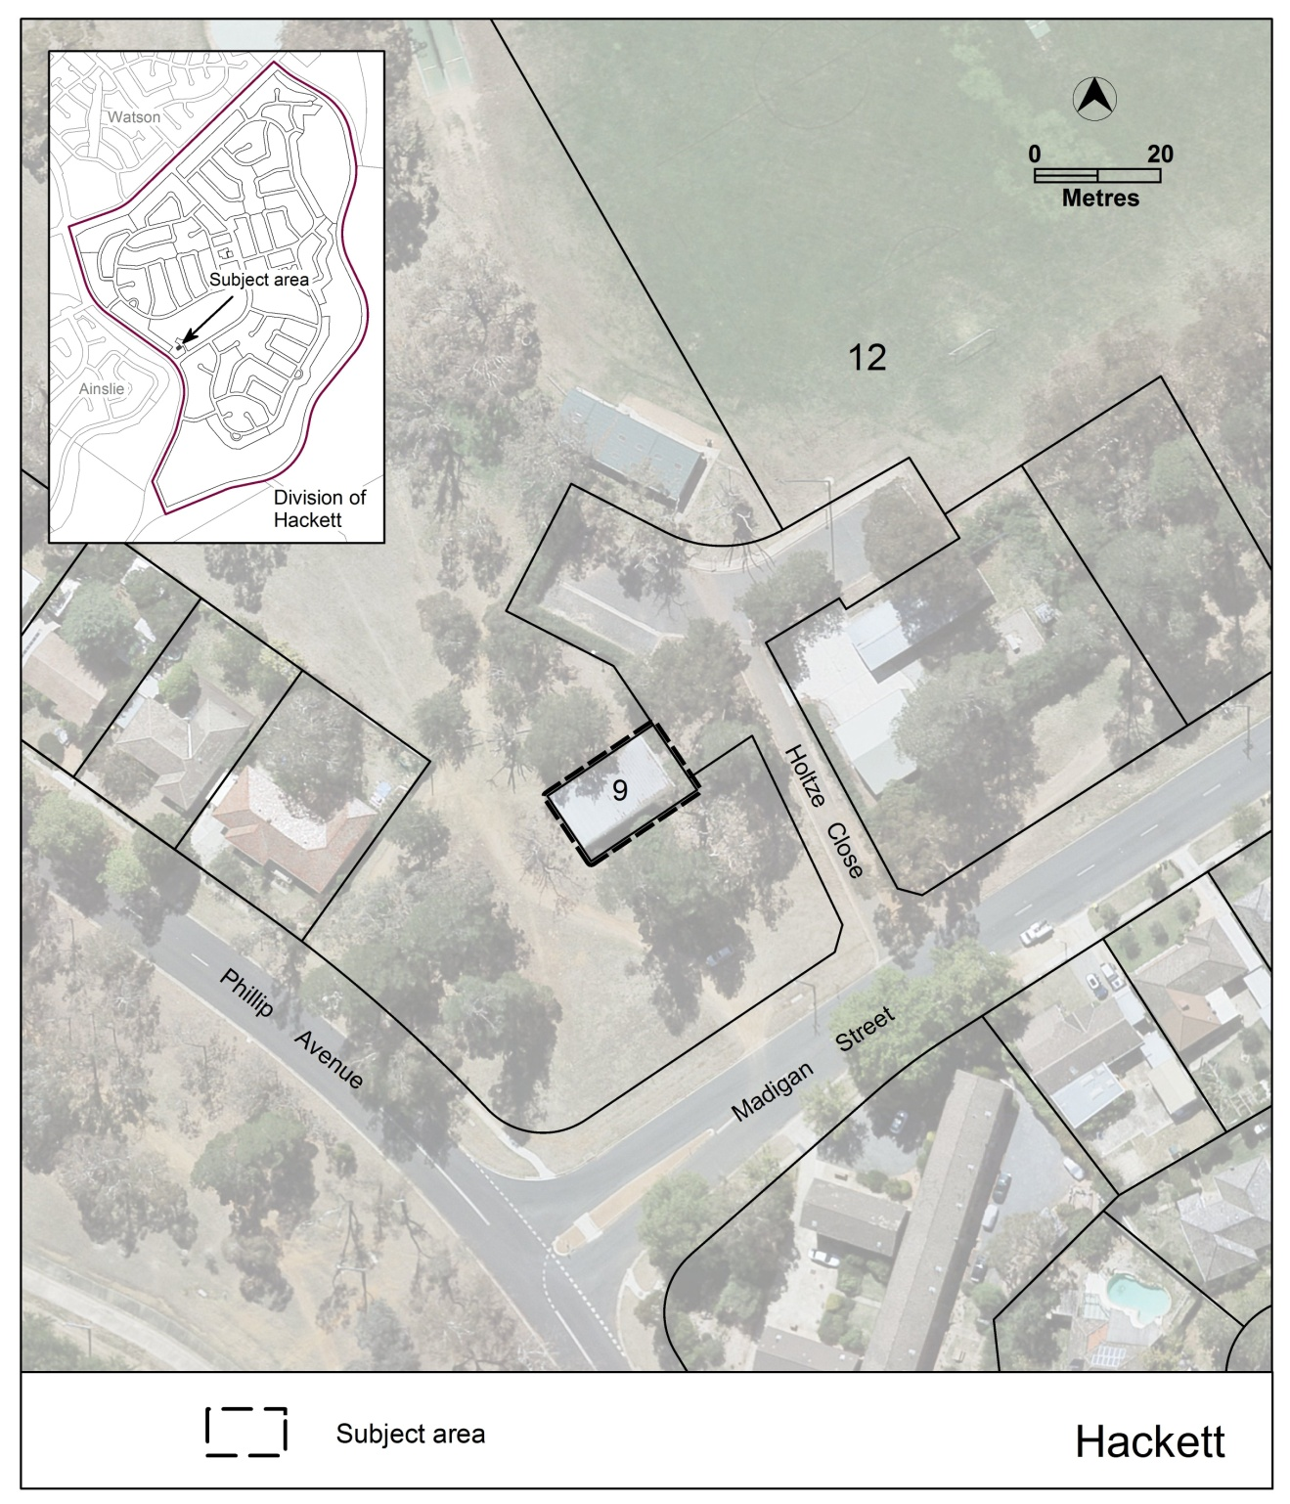
Figure 2 Location plan for Block 9 Section 12 Hackett

See section 2.2.4.1 for existing and proposed changes to the Hackett precinct map and code.

    - Changes to Definitions of Development
- Detached house and attached house
Concerns have been raised regarding the definitions and location of ‘detached house’ and ‘attached house’ in the Territory Plan Definitions.

Attached house is listed as a sub-category of Multi Unit Housing and detached house is listed as a sub-category of Single Dwelling Housing. However, an attached house may be a form of single dwelling housing, and a detached house may form part of a multi-unit housing development.

To resolve these issues, it is proposed to relocate the definitions of attached house and detached house to the Definitions of Terms and therefore avoid these contradictions when referring to these definitions for different types of residential development configurations.

- Minor use – shared areas of Community Title developments
Developments containing a mixture of commercial and residential uses within a single building generally include common internal access and circulation spaces such as lifts and staircases.

In Community Titled mixed-use developments, common access and circulation spaces are normally contained within a separate ‘block’ or ‘unit’. In the case of single-use developments, common access and circulation spaces may take on the land-use definition applying to the development as a whole. This is not possible in mixed-use developments because the surrounding uses are different.
It is therefore current practice to regard this separate access and circulation ‘block’ as being for the purpose of ‘minor use’ under the Crown lease ‘purpose clause’. The definition of ‘minor use’ in the Territory Plan includes ‘open space; public car parking; community path systems and minor service reticulation’ but does not specifically mention internal circulation spaces. It is proposed to amend the definition of ‘minor use’ in the Territory Plan to include ‘common circulation spaces’ which would incorporate lifts and staircases as well as other common access and circulation spaces.

See section 2.2.5 for existing and proposed changes to the Territory Plan Definitions of Development.

    - Changes to Definitions of Terms
- Building line
The Territory Plan and the Planning and Development Regulation 2008 use the term ‘behind the building line’ as a condition within rules and other provisions. The Regulation states that the definition of ‘building line’ is the Territory Plan definition.

A number of issues have been raised among development assessors and industry professionals regarding the Territory Plan definition of ‘building line’. The definition relies on the term ‘building’ and the definition of ‘building’ includes: ‘an addition to a building; a structure attached to a building; and a part of a building’, but is silent on what actually constitutes a ‘building’.

It is practice within EPSDD for the meaning of ‘building’ to be taken as the definition given in the Building Act 2004. Based on the Building Act definition, a courtyard wall, a fence or a retaining wall is a ‘building’ and therefore can serve to establish a ‘building line’ for a block in accordance with the Territory Plan definition of ‘building line’. This interpretation of the meaning of ‘building line’ is not consistent with EPSDD practice, which is to disregard a ‘building line’ if it is established by a courtyard wall, fence, retaining wall or similar structures.

It is proposed to amend the definition of ‘building line’ to ensure that courtyard walls etc. whilst they may technically be buildings, are not deemed to be part of the ‘building’ for the purpose of this definition, and do not establish the building line for the development.

- Datum ground level and Natural ground level
The Territory Plan currently uses two different terms to specify ground levels – ‘natural ground level’ and ‘datum ground level’.

‘Natural ground level’ means ‘the ground level at the date of grant of the lease of the block’.

In late 2010 a new term for ground level known as ‘datum ground level’ was introduced into the Territory Plan on the advice of the Surveyor-general. This was to bring the terminology in line with standard practice in other jurisdictions and address perceived problems with the use of the term ‘natural ground level’.

‘Datum ground level’ means ‘the level of the surface of the ground as defined in a field survey and authorised by a qualified surveyor at the time of operational acceptance for greenfield development or prior to any new earthworks having occurred after that time’.

‘Datum ground level’ was intended to replace ‘natural ground level’ however, certain Territory Plan codes such as the Residential Boundary Fences General Code, as well as the Planning and Development Regulation 2008 still use the term ‘natural ground level’. Unless all instances of ‘natural ground level’ are identified and amended across all relevant statutory documentation, the definition cannot be removed from the Territory Plan.

A solution is to amend the definition of ‘natural ground level’ to state that ‘natural ground level’ means the same thing as ‘datum ground level’. However this raises the issue of the practice in established areas where the ground levels at the date of grant of the lease may be the only ground levels available and/or if ground levels were not recorded as having been established at the time when all civil works were completed (when operational acceptance is granted by the ACT Government entity responsible for city services).

The definition of datum ground level aims to establish that the surface ground level at the time of operational acceptance for a new subdivision is the official ground level, whether or not a survey is conducted at that time, but before the commencement of any new earthworks.

It is also proposed to amend the definition so that the surface ground level at the date of grant of the lease of the block is acceptable if this occurred before or instead of the above requirement.

It is further proposed to include a provision for situations where neither of the above conditions can be met, so that the best estimate of surface ground level as determined by a field survey and authorised by a registered surveyor can be used.

- Front boundary, side boundary, rear boundary
An issue has been raised by industry professionals and development assessors regarding the definitions of block boundaries in the Territory Plan.
There is no Territory Plan definition of the word ‘boundary’, so for reasons of practicality the word ‘boundary’ is taken to mean ‘a line-segment that, when joined to other line-segments at defined points, describes the legal extents of a parcel of land’.
In accordance with this, a ‘boundary’ ends where it meets another ‘boundary’ at a defined point.
A problem arises with this concept when attempting to differentiate between different types of boundaries in terms of specific end-points and then assigning different setbacks to them.

There is also no definition for a ‘rear boundary’ in the Territory Plan. Any boundary other than a front boundary or side boundary is taken to be a rear boundary.
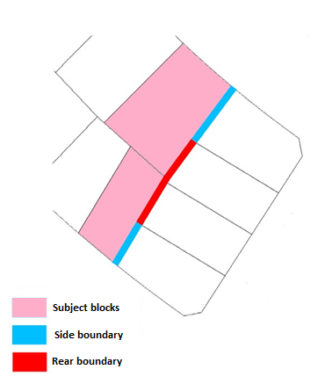
Example of where a ‘side boundary’ of a block becomes a ‘rear boundary’

In most cases, identifying a ‘side boundary’ is straightforward. Most people consider a single continuous line running along the ‘side’ of a block as a ‘side boundary’. This is usually the case; however according to the existing definition of a side boundary, a boundary ceases to be a ‘side boundary’ at the point where it touches a second adjacent block, where this happens it becomes a ‘rear boundary’.

It is proposed to address the issues raised above by modifying the definition to mean a (straight) line with a single bearing or direction.

There is a second issue with the definition of ‘side boundary’ with the use of ‘extending from a street frontage’. This means if a boundary extends from an open space frontage it cannot be a ‘side boundary’.

‘Rear boundary’ as a term is used throughout the Territory Plan but is not formally defined in the Territory Plan definitions. A new definition of ‘rear boundary’ is proposed to address this matter.

- Habitable room
The word habitable is used in the Territory Plan, either alone, or in combination with another word (e.g. ‘habitable room’, ‘habitable space’). Therefore there is a need to clarify the term ‘habitable’ whilst maintaining the ability for ‘habitable room’ to be used as a defined term. The definition could be improved by incorporating elements of the Building Code of Australia (BCA) definition:

Building Code of Australia Vol 1 Part A1.1 Definitions:
Habitable room means a room used for normal domestic activities, and—
(a) includes a bedroom, living room, lounge room, music room, television room, kitchen, dining room, sewing room, study, playroom, family room, home theatre and sunroom; but
(b) excludes a bathroom, laundry, water closet, pantry, walk-in wardrobe, corridor, hallway, lobby, photographic darkroom, clothes-drying room, and other spaces of a specialised nature occupied neither frequently nor for extended periods
The current term ‘adapted to be used’ is also problematic. Any space that is either used or capable of being used should be included, whether or not it has been ‘adapted’ for the purpose. It is normally understood that the term ‘use’ in this sense is intended to mean lawful use in accordance with the requirements of the Building Act for certification of the occupation and use of buildings or part of a building.

- Setback
Within individual provisions in the Territory Plan, certain setbacks are applied to specific objects including lower floor level, upper floor level and garage, (taken from the outside face of a wall, deck or supporting post), but also to fences, courtyard walls, and letterboxes.
Encroachments into setbacks are also specifically allowed for a number of building elements including eaves, gutters, downpipes, rainwater tanks, pergolas, sun blinds, unroofed terraces and landings.
In practice, a ‘setback’ is the distance between a block boundary and any object on the block.
The current definition appears to limit the kind of structure to which a ‘setback’ may apply. It is proposed to amend the definition to reflect the actual meaning of the term as used elsewhere in the Territory Plan.

See section 2.2.6 for existing and proposed changes to the Territory Plan Definitions of Terms.

  - Current Territory Plan provisions and proposed changes
    - Changes to Territory Plan map – part block 510 Stromlo
Existing Territory Plan Map
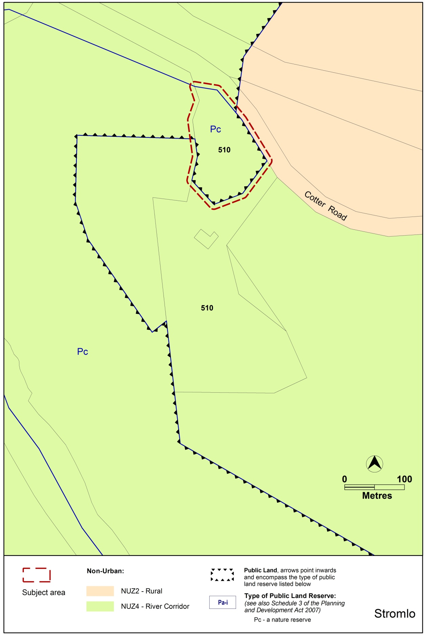

Proposed Territory Plan Map
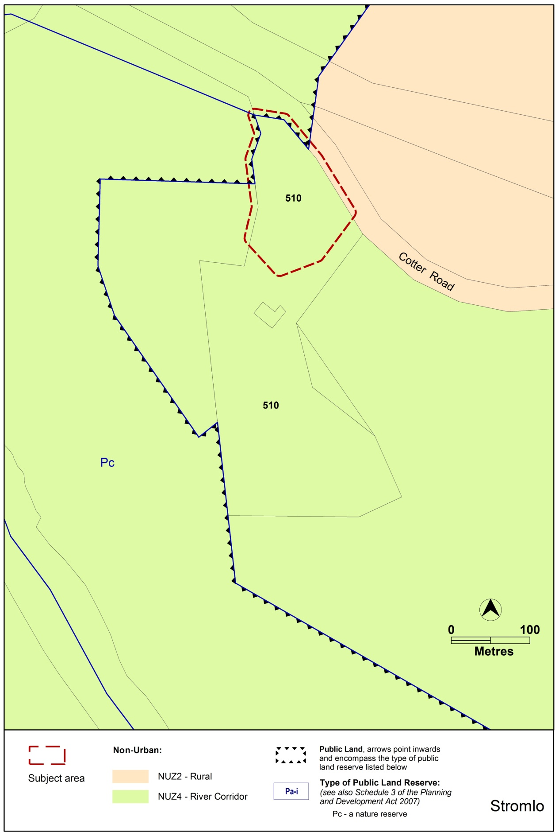

    - Zone Development Tables

      - Industrial zones development tables
IZ1 General Industrial Zone Development Tables
It is proposed to:
- remove COMMUNITY USE from Minimum Assessment Track Merit table
- add
community activity centre
community theatre
cultural facility
educational establishment
health facility
hospital
place of worship
religious associated use

- add ‘animal care facility’ to Minimum Assessment Track Merit table
- remove ‘animal care facility’ from the Prohibited Development table
- add ‘child care centre’ to the Prohibited Development table

IZ2 Mixed Use Industrial Zone Development Tables
It is proposed to:
- remove COMMUNITY USE from Minimum Assessment Track Merit table
- add
community activity centre
community theatre
cultural facility
educational establishment
health facility
hospital
place of worship
religious associated use

- add ‘animal care facility’ to the Minimum Assessment Track Merit table
- remove ‘animal care facility’ from the Prohibited Development table
- add ‘child care centre’ to the Prohibited Development table

    - Development Codes
      - Residential Zones Development Code

Existing provisions

Element 6: Boarding houses
Rules | Criteria
6.1 Design and siting
R25  The minimum gross floor area of a boarding room is:  - for a single occupant - 12m²  - for 2 or more occupants - 16m² | This is a mandatory requirement. There is no applicable criterion.
R26  If a boarding house is to be occupied by five or more adults, at least one communal living room of at least 16m² with a minimum dimension of 3 metres is to be provided. | This is a mandatory requirement. There is no applicable criterion.

Proposed provisions

Element 6: Boarding houses
Rules | Criteria
6.1 Design and siting
R25  The minimum gross floor area of a boarding room is:  - for a single occupant - 12m²  - for 2 or more occupants - 16m² | C25  It can be demonstrated that:  A boarding room is of a size sufficient to accommodate the needs of a boarding house resident. This includes space for the provision of essential items such as a bed, desk and robe. Adequate circulation space within the boarding room is also provided.
R26  If a boarding house is to be occupied by five or more adults, at least one communal living room of at least 16m² with a minimum dimension of 3 metres is to be provided. | C26  It can be demonstrated that:  Communal living space is of a size sufficient to meet the needs of the residents of the boarding house, including provision of communal facilities and adequate circulation space.

      - Single Dwelling Housing Development Code
- Allowable encroachments: pergolas
Amend rule R16 as underlined:
1.14 Allowable encroachments – setbacks
R16  Encroachments into the minimum side or rear boundary setback are permitted for any of the following building elements:  - an eave or roof overhang with a horizontal width of not more than 600mm  - fascias, gutters, downpipes, rainwater tanks, chimneys, flues, domestic fuel tanks, cooling or heating appliances, light fittings, electricity and gas meters, aerials, antennae, unroofed pergolas, sun blinds  - unroofed terraces, landings, steps or ramps, none of which are more than 1m above finished ground level. | C16  Buildings and other structures achieve all of the following:  - consistency with the desired character  - reasonable levels of privacy on adjoining residential blocks for dwellings and their associated private open space  - reasonable solar access to dwellings on adjoining residential blocks and their associated private open space.

- Noise affected blocks R42/C42
Existing provision
5.4 Noise attenuation – external sources
R42  This rule applies to all new dwellings (including in established areas), as well as extensions and alterations that add a habitable room exposed directly to the source of noise.  Where a block has one or more of the following characteristics:  - identified in a precinct code as being potentially affected by noise from external sources  - adjacent to a road carrying or forecast to carry traffic volumes greater than 12,000 vehicles per day  dwellings shall be constructed to comply with the following:  - dwelling located more than 20m from the nearside edge of a road carrying traffic volumes between 12,000 and 25,000 vpd –  - glazing is 6.38mm laminated glass or equivalent and fitted with acoustic seals other than brush seals  - any external doors are solid core and fitted with acoustic seals other than brush seals  - dwelling located more than 40m from the nearside edge of a road carrying traffic volumes greater than 25,000 vpd –  - glazing is 10.38mm laminated glass or equivalent and fitted with acoustic seals other than brush seals  - any external doors are solid core and fitted with acoustic seals other than brush seals  - in all other cases –  - AS/NZS 2107:2000 - Acoustics – Recommended design sound levels and reverberation times for building interiors (the relevant satisfactory recommended interior design sound level)  - AS/NZS 3671 - Acoustics – Road Traffic Noise Intrusion Building Siting and Design. | C42  This rule applies to all new dwellings (including in established areas), as well as extensions and alterations that add a habitable room exposed directly to the source of noise.  - For other than road traffic noise - a noise management plan prepared by a member of the Australian Acoustical Society with experience in the assessment of noise, and endorsed by the EPA. The noise level immediately adjacent to the dwelling is assumed to be the relevant noise zone standard specified in the ACT Environment Protection Regulation 2005. The plan must indicate compliance with the relevant Australian standard.  - For road traffic noise - an acoustic assessment and noise management plan, prepared by a member of the Australian Acoustical Society with experience in the assessment of road traffic noise, and endorsed by the Transport Planning & Projects Section in ESDD. The plan must indicate compliance with the relevant Australian standard.  Note: A condition of development approval may be imposed to ensure compliance with the endorsed noise management plan.

Proposed provision (see underlined text)
5.4 Noise attenuation – external sources
R42  This rule applies to all new dwellings (including in established areas), as well as extensions and alterations that add a habitable room exposed directly to the source of noise.  Where a block has one or more of the following characteristics:  - identified in a precinct code as being potentially affected by noise from external sources  - adjacent to a road carrying or forecast to carry traffic volumes greater than 12000 vehicles per day  - is otherwise identified to be noise affected  dwellings shall be constructed to comply with the following:  - road carrying traffic volumes between 12,000 and 25,000 vpd –  - dwelling located less than 20m from the nearside edge of the road:  - AS/NZS 2107:2000 - Acoustics – Recommended design sound levels and reverberation times for building interiors (the relevant satisfactory recommended interior design sound level)  - AS/NZS 3671 - Acoustics – Road Traffic Noise Intrusion Building Siting and Design.  - dwelling located more than 20m from the nearside edge of the road:  - glazing is 6.38mm laminated glass or equivalent and fitted with acoustic seals other than brush seals  - any external doors are solid core and fitted with acoustic seals other than brush seals  - road carrying traffic volumes greater than 25,000 vpd –  - dwelling located less than 40m from the nearside edge of the road:  - AS/NZS 2107:2000 - Acoustics – Recommended design sound levels and reverberation times for building interiors (the relevant satisfactory recommended interior design sound level)  - AS/NZS 3671 - Acoustics – Road Traffic Noise Intrusion Building Siting and Design.  - dwelling located more than 40m from the nearside edge of the road:  - glazing is 10.38mm laminated glass or equivalent and fitted with acoustic seals other than brush seals  - any external doors are solid core and fitted with acoustic seals other than brush seals  - in all other cases where a dwelling is affected by noise from external sources-  - AS/NZS 2107:2000 - Acoustics – Recommended design sound levels and reverberation times for building interiors (the relevant satisfactory recommended interior design sound level)  - AS/NZS 3671 - Acoustics – Road Traffic Noise Intrusion Building Siting and Design. | C42  This criterion applies to all new dwellings (including in established areas), as well as extensions and alterations that add a habitable room exposed directly to the source of noise.  A noise management plan must be provided where:  - A block is identified in a precinct code as being potentially affected by noise from external sources; or  - A dwelling is located in the first row of housing near a road carrying or forecast to carry traffic volumes greater than 12000 vehicles per day; or  - A block is otherwise identified to be noise affected  Noise management plan requirements:  - For other than road traffic noise - a noise management plan prepared by a member of the Australian Acoustical Society with experience in the assessment of noise, and endorsed by the EPA. The noise level immediately adjacent to the dwelling is assumed to be the relevant noise zone standard specified in the ACT Environment Protection Regulation 2005. The plan must indicate compliance with the relevant Australian standard.  - For road traffic noise - an acoustic assessment and noise management plan, prepared by a member of the Australian Acoustical Society with experience in the assessment of road traffic noise, and endorsed by the ACT Government entity responsible for Transport Planning. The plan must indicate compliance with the relevant Australian standard.  Note: A condition of development approval may be imposed to ensure compliance with the endorsed noise management plan.

- Water sensitive urban design

Existing provision

Rules | Criteria
6.1 Water sensitive urban design
R43  This rule applies to  - all new single dwellings  - secondary residences and  - extensions and alterations (but does not apply to minor extensions)  The development complies with one of the following:  - Option A  - Option B  For this rule  Option A is:  - on compact blocks -  - no minimum water storage requirement  - minimum WELS rated plumbing fixtures  - on mid-sized blocks -  - minimum on site water storage of water from roof harvesting is 2,000 litres  - 50% or 75m² of roof plan area, whichever is the lesser, is connected to the tank and the tank is connected to at least a toilet, laundry cold water and all external taps  - on large blocks up to 800m² -  - minimum on site water storage of water from roof harvesting is 4,000 litres  - 50% or 100m² of roof plan area, whichever is the lesser, is connected to the tank and the tank is connected to at least a toilet, laundry cold water and all external taps  - on large blocks 800m² or greater -  - minimum on site water storage of water from roof harvesting is 5,000 litres  - 50% or 125m² of roof plan area, whichever is the lesser, is connected to the tank and the tank is connected to at least a toilet, laundry cold water and all external taps.  Option B is:  A greywater system captures all bathroom and laundry greywater and treats it to Class A standard. The treated greywater is connected to all laundry cold water, toilet flushing and all external taps.  For this rule minor extension means an extension where the increase in the combined roof plan area, driveway, car manoeuvering areas and car parking areas is less than 25% of the total of the areas of these components at the date of lodgment of the development application or building application, whichever is earlier. | C43  Evidence is provided that the development achieves a minimum 40% reduction in mains water consumption compared to an equivalent development constructed in 2003, using the ACTPLA on-line assessment tool or another tool. The 40% target is met without any reliance on landscaping measures to reduce consumption.

Proposed provision (see underlined text)

Rules | Criteria
6.1 Water sensitive urban design
R43  This rule applies to  - all new single dwellings  - secondary residences and  - extensions and alterations but does not apply to:  - extensions of a size 50% or less of existing floor area  - development where no new plumbing is proposed  The development complies with one of the following:  - Option A  - Option B  For this rule  Option A is:  - on compact blocks -  - no minimum water storage requirement  - minimum WELS rated plumbing fixtures  - on mid-sized blocks -  - minimum on site water storage of water from roof harvesting is 2,000 litres  - 50% or 75m² of roof plan area, whichever is the lesser, is connected to the tank  - the tank is connected to at least a toilet, laundry cold water and all external taps. The connection will require a pump where it cannot be elevated sufficiently to give adequate pressure.  - on large blocks up to 800m² -  - minimum on site water storage of water from roof harvesting is 4,000 litres  - 50% or 100m² of roof plan area, whichever is the lesser, is connected to the tank  - the tank is connected to at least a toilet, laundry cold water and all external taps. The connection will require a pump where it cannot be elevated sufficiently to give adequate pressure.  - on large blocks 800m² or greater -  - minimum on site water storage of water from roof harvesting is 5,000 litres  - 50% or 125m² of roof plan area, whichever is the lesser, is connected to the tank  - the tank is connected to at least a toilet, laundry cold water and all external taps. The connection will require a pump where it cannot be elevated sufficiently to give adequate pressure.  Option B is:  A greywater system captures all bathroom and laundry greywater and treats it to Class A standard. The treated greywater is connected to all laundry cold water, toilet flushing and all external taps. | C43  Evidence is provided that the development achieves a minimum 40% reduction in mains water consumption compared to an equivalent development constructed in 2003, using the ACTPLA on-line assessment tool or another tool. The 40% target is met without any reliance on landscaping measures to reduce consumption.

      - Multi Unit Housing Development Code
- Residential density – adaptable housing – rule R14
Proposed additional wording (see underlined)

Rules | Criteria
3.10 Residential density – adaptable housing – single dwelling blocks – RZ2
R14  This rule applies to single dwelling blocks in RZ2 where all dwellings are built to an adapted standard in compliance with Australian Standard AS4299 Adaptable Housing (Class C).  Despite R2 and R12, the maximum number of dwellings is shown in table A3. | This is a mandatory requirement. There is no applicable criterion

- Site open space – RZ1 and RZ2 – stormwater runoff C38 c)
Wording proposed to be removed (see struck through words)

Rules | Criteria
4.2 Site open space – RZ1 and RZ2
R38  This rule applies to RZ1 and RZ2.  Not less than 40% of the total site area is allocated to one or more of the following:  - communal open space with a minimum dimension of 2.5m  - private open space that complies with all of the following -  - a minimum dimension of 2.5m  - is associated with dwellings at the lower floor level.  Not less than 20% of the total site area is planting area. | C38  Open space on the site achieves all of the following:  - sufficient space for the recreation and relaxation of residents  - sufficient space for planting, particularly trees with deep root systems  - provision for on-site infiltration of stormwater run-off  - provision of outdoor areas that are readily accessible by residents for a range of uses and activities.  One or more of the following matters may be considered when determining compliance with this criterion:  - whether the total area of upper floor level private open space contributes to the function of other open space on the site  - whether any adjoining or adjacent public open space is readily available for the use of residents.

- Changes to Rule R42 (Courtyard walls)
New rule R42 for RZ1 and RZ2 zones only
4.6 Courtyard walls – RZ1 and RZ2
R42  Courtyard walls are permitted forward of the building line where they comply with all of the following:  - a total length not exceeding 60% of the width of the block at the line of the wall  - a minimum setback from the front boundary of not less than 2m  - trees and/or shrubs between the wall and the front boundary, in accordance with an approved landscape plan  - a maximum height not exceeding 1.8m above datum ground level  - constructed of brick, block or stonework, any of which may be combined with timber or metal panels that include openings not less than 25% of the surface area of the panel  - do not obstruct sight lines for vehicles and pedestrians on public paths or driveways in accordance with Australian Standard AS2890.1- Off-Street Parking. | C42  Courtyard walls achieve all of the following:  - consistent with the desired character  - the dominance of the building’s facade in the streetscape taking all of the following aspects of the proposed courtyard wall into account:  - height  - relationship to verge footpath  - total proportion relative to the building  - width  - colour and design features  - transparency articulation  - protection of existing desirable landscape features  - tree and shrub planting forward of the wall  - do not obstruct sight lines for vehicles and pedestrians on public paths or driveways in accordance with Australian Standard AS2890.1- Off-Street Parking.

Relocate existing rule R42 and criterion C42 and rename R42A and C42A – with a minor adjustment to R42A b) – for all other zones other than RZ1 and RZ2
4.7 Courtyard walls – other than RZ1 and RZ2
R42A  Courtyard walls are permitted forward of the building line where they comply with all of the following:  - maximum height of 1.8m above datum ground level  - a minimum setback to the front boundary complying with the following:  - where the wall encloses the principal private open space at ground floor level that is located to the west, north-west, north, north-east or east of the dwelling – 0.7m  - in all other cases - half the front boundary setback nominated elsewhere in this code  - trees and/or shrubs between the wall and the front boundary, in accordance with an approved landscape plan  - a variety of materials or indentations not less than 15m apart where the indents are not less than 1m in depth and 4m in length  - constructed of brick, block or stonework, any of which may be combined with timber or metal panels that include openings not less than 25% of the surface area of the panel  - do not obstruct sight lines for vehicles and pedestrians on public paths or driveways in accordance with Australian Standard AS2890.1- Off-Street Parking. | C42A  Courtyard walls achieve all of the following:  - consistent with the desired character  - the dominance of the building’s facade in the streetscape taking all of the following aspects of the proposed courtyard wall into account:  - height  - relationship to verge footpath  - total proportion relative to the building  - width  - colour and design features  - transparency articulation  - protection of existing desirable landscape features  - tree and shrub planting forward of the wall  - do not obstruct sight lines for vehicles and pedestrians on public paths or driveways in accordance with Australian Standard AS2890.1- Off-Street Parking.

- Changes to Rules R59 and R60 and Criteria C59 and C60 (Privacy)
Existing provisions (see underlined wording):

6.3 Privacy
R59  This rule applies to dwellings on the same block.  The relationship between unscreened elements of one dwelling and the primary windows of another dwelling complies with one of the following:  - a person (with an eye height of 1.5m) standing at any and every point on the extremity of an unscreened element of one dwelling shall not have a direct line of sight into the primary window of any other dwelling  - the direct line of sight referred to in item a) is more than 12m. | C59  Reasonable privacy between dwellings on the same block is achieved.
R60  This rule applies to principal private open space on the same block and on adjacent blocks.  The relationship between unscreened elements of one dwelling and the principal private open space of another dwelling complies with one of the following:  - a person (with an eye height of 1.5m) standing at any and every point on the extremity of an unscreened element of one dwelling shall not have a direct line of sight to more than 50% of the minimum principal private open space of any other dwelling  - the direct line of sight referred to in item a) is more than 12m. | C60  Reasonable privacy of principal private open space of each dwelling is achieved.

Proposed provisions

6.3 Privacy
R59  This rule applies to dwellings on the same block.  Development complies with one of the following:  - the distance between an unscreened element of a dwelling and the primary windows of any other dwelling is at least 12m; or  - an unscreened element of a dwelling does not have a direct line of sight (based on an eye height of 1.5m) into a primary window of any other dwelling | C59  Evidence is provided demonstrating that reasonable privacy between dwellings on the same block is achieved.
R60  This rule applies to principal private open space on the subject block and on adjacent blocks.  Development complies with one of the following:  - the distance between the minimum principal private open space of a dwelling and an unscreened element of any other dwelling is at least 12m; or  - no more than 50% of the minimum principal private open space of a dwelling is within a direct line of sight (based on an eye height of 1.5m) from an unscreened element of any other dwelling. | C60  Evidence is provided demonstrating that reasonable privacy of principal private open space of each dwelling is achieved.

- Principal private open space – C61
Proposed amended criterion (see struck through and underlined words)

Rules | Criteria
6.4 Principal private open space
R61  Each dwelling has at least one area of principal private open space that complies with all of the following:  - located on the site  - has minimum area and dimensions specified in table A9  - is screened from adjoining public streets and public open space  - is directly accessible from, and adjacent to, a habitable room other than a bedroom  - is not located to the south, south-east or south-west of the dwelling, unless it achieves one or more of the following -  - not less than 3 hours of direct sunlight onto 50% of the minimum required area between the hours of 9am and 3pm on the winter solstice (21 June)  - located at an upper floor level and overlooks a public street or public open space. | C61  Principal private open space for each dwelling achieves all of the following:  - an area suitable for proportionate to the size of the dwelling an extension of the function of the dwelling for relaxation, dining, entertainment, recreation  - directly accessible from the dwelling  - service functions such as clothes drying and mechanical services  - reasonable privacy  - reasonable solar access.

- Noise affected blocks Rule R67
Existing provision

6.9 Noise attenuation – external sources
R67  Where a block has one or more of the following characteristics:  - identified in a precinct code as being potentially affected by noise from external sources  - adjacent to a road carrying or forecast to carry traffic volumes greater than 6,000 vehicles per day  - located in a commercial zone  - adjacent to a commercial or industrial zone  dwellings shall be constructed to comply with the relevant sections of all of the following:  - AS/NZS 2107:2000 - Acoustics – Recommended design sound levels and reverberation times for building interiors (the relevant satisfactory recommended interior design sound level)  - AS/NZS 3671 - Acoustics – Road Traffic Noise Intrusion Building Siting and Design.  For other than road traffic noise, compliance with this rule is demonstrated by a noise management plan prepared by a member of the Australian Acoustical Society with experience in the assessment of noise, and endorsed by the EPA. For other than road traffic noise, the noise level immediately adjacent to the dwelling is assumed to be the relevant noise zone standard specified in the ACT Environment Protection Regulation 2005.  For road traffic noise, compliance with this rule is demonstrated by an acoustic assessment and noise management plan, prepared by a member of the Australian Acoustical Society with experience in the assessment of road traffic noise, and endorsed by the Transport Planning & Projects Section in ESDD.  Note: A condition of development approval may be imposed to ensure compliance with the endorsed noise management plan. | This is a mandatory requirement. There is no applicable criterion.
Proposed provision (see underlined text)

6.9 Noise attenuation – external sources
R67  Where a block has one or more of the following characteristics:  - identified in a precinct code as being potentially affected by noise from external sources  - adjacent to a road carrying or forecast to carry traffic volumes greater than 12,000 vehicles per day  - located in a commercial zone  - adjacent to a commercial or industrial zone  dwellings shall be constructed to comply with the relevant sections of all of the following:  - AS/NZS 2107:2000 - Acoustics – Recommended design sound levels and reverberation times for building interiors (the relevant satisfactory recommended interior design sound level)  - AS/NZS 3671 - Acoustics – Road Traffic Noise Intrusion Building Siting and Design.  For other than road traffic noise, compliance with this rule is demonstrated by a noise management plan prepared by a member of the Australian Acoustical Society with experience in the assessment of noise, and endorsed by the EPA. For other than road traffic noise, the noise level immediately adjacent to the dwelling is assumed to be the relevant noise zone standard specified in the ACT Environment Protection Regulation 2005.  For road traffic noise, compliance with this rule is demonstrated by an acoustic assessment and noise management plan, prepared by a member of the Australian Acoustical Society with experience in the assessment of road traffic noise, and endorsed by the ACT Government entity responsible for transport planning.  Note: A condition of development approval may be imposed to ensure compliance with the endorsed noise management plan. | This is a mandatory requirement. There is no applicable criterion.

      - Commercial Zones Development Code
- Neighbourhood plans
It is proposed to omit Element 10: Neighbourhood plans from the Commercial Zones Development Code:
Element 10: Neighbourhood Plans
10.1 consideration
There is no applicable rule. | C36  Where a Neighbourhood Plan exists, development demonstrates a response to the key strategies of the relevant Neighbourhood Plan.

      - Industrial Zones Development Code
To ensure that ‘animal care facility’ gets recognised both as a noise generating and noise sensitive use (such as the impacts of high pitched industrial machinery on the animals) it is proposed to include a requirement for a noise management plan to mitigate noise to and from the premises, by introducing a new rule (R34A) into the Industrial Zones Development Code. This will require a noise management plan to be prepared by an accredited acoustic expert for a proposed animal day care facility in an industrial area in cases where a merit assessable development application is lodged.

Proposed provision

Element 5: Amenity

Rules | Criteria
5.2 Noise
R34A  A Noise Management Plan, prepared by an accredited acoustic specialist who is a member of the Australian Acoustic Society, is provided for an animal care facility  The Noise Management Plan details the design, siting and construction methods, which will be used to minimise the impact of noise on neighbouring uses, and reduce the intrusion of noise from industrial uses into the facility. | This is a mandatory requirement. There is no applicable criterion.

Also, due to the nature and location of the proposed use in industrial zones, it is also necessary to include a provision in the Industrial Zones Development Code requiring an emergency management plan to be prepared. This will need to include details of a risk assessment and evacuation plan for an animal day care facility that wishes to establish premises in an industrial area.

Proposed provision

5.5. Emergency Management Plan
An Emergency Management Plan is provided for an animal care facility, prepared by a suitably qualified professional, and includes details of a risk assessment and evacuation plan for the facility, and is endorsed by the Emergency Services Authority (ESA). | If an endorsed Emergency Management Plan is not provided, the application will be referred to the relevant agency in accordance with the requirements of the Planning and Development Act 2007.
      - Parks and Recreation Zone Development Code
In order to align the codes with previous changes made under Variation 306 relating to neighbourhood plans, it is proposed to remove references to neighbourhood plans in the Parks and Recreation Zone Development Code.

It is proposed to remove Item 5.4: Neighbourhood Plan from the Parks and Recreation Development Code:
5.4 Neighbourhood Plan
There is no applicable rule. | C30  Where a Neighbourhood Plan exists, development demonstrates a response to the key strategies of the relevant Neighbourhood Plan.

      - Lease Variation General Code
Due to the nature and location of the proposed use in industrial zones, it is proposed to introduce a requirement in the Lease Variation General Code for a noise management plan and an emergency management plan to be provided when an application to vary a lease to add animal care facility is lodged. These are the same provisions that apply in the Industrial Zones Development Code when a development application may be triggered for the development of an animal care facility. The emergency management plan will need to provide details of a risk assessment and evacuation plan for an animal care facility that wishes to establish operations in any of the industrial areas.

      - Parking and vehicular access general code
- Changes to 3.5 Industrial zones – Schedule 5 – Industrial zones
Add
Development | Parking provisions rates for industrial zones
Animal care facility | 1 space/facility  plus  2 spaces per 15 animals for employee parking  plus  visitor parking as follows:  2 spaces: <30 animals per facility  3 spaces: 30-59 animals per facility  4 spaces: 60-90 animals per facility  plus  1 pick-up/set-down bay per 10 animals
    - Precinct Codes
      - Hackett Precinct Map
Proposed changes to Hackett Precinct Map

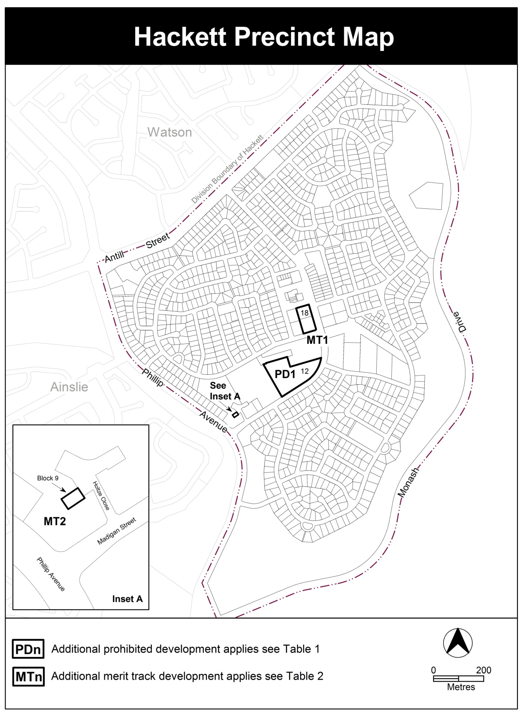

Proposed changes to: Table 2 – Additional merit track development (see underlined text)

Table 2 – Additional merit track development
Additional merit track development that may be approved subject to assessment
Suburb precinct map label | Zone | Development
MT1 | RZ2 | COMMUNITY USE
MT2 | PRZ1 | Place of worship

    - Definitions of Development:
- Detached house and attached house

Relocate the definition of attached house as a sub-category of Multi unit housing to Part B – Definition of Terms
Relocate the definition of detached house as a sub category of Single dwelling housing to Part B – Definition of Terms

- Minor use

Insert underlined text:

Minor use means the use of land for a purpose that is incidental to the use and development of land in the zone and includes but is not limited to open space; public car parking; community path systems; shared circulation spaces (such as lift wells, stair wells); minor service reticulation; other utility services that do not exclude other uses from the land; street furniture and the like

    - Definitions of Terms

- Building line

Current definition:

Building line means a line drawn parallel to any front boundary along the front face of the building or through the point on a building closest to the front boundary. Where a terrace, landing, porch, balcony or verandah is more than 1.5 metres above the adjoining finished ground level or is covered by a roof, it shall be deemed to be part of the building.

Proposed definition

Building line means a line drawn parallel to any front boundary along the front face of a building or through the point on a building closest to the front boundary. A terrace, landing, porch, balcony, deck or verandah that is more than 1.5 metres above finished ground level or is covered by a roof is deemed to be part of the building. A fence, courtyard wall or retaining wall is not deemed to be part of the building.

- Datum ground level and Natural ground level

Current definitions:

Datum ground level means the level of the surface of the ground as defined in a field survey and authorised by a qualified surveyor at the time of operational acceptance for greenfield development or prior to any new earthworks having occurred after that time

Natural ground level (NGL) means the ground level at the date of grant of the lease of the block.

Proposed definitions:
Natural ground level (NGL) has the same meaning as datum ground level

Datum ground level means the surface ground level as determined in a field survey authorised by a registered surveyor:
- at the time of Operational Acceptance for subdivision; or
- after that time mentioned at a), provided no new earthworks have occurred; or
- at the date of grant of the lease of the block; whichever is the earliest.

Where a), b) or c) is not available, datum ground level means the best estimate of the surface ground level at a), b) or c) as determined in a field survey authorised by a registered surveyor

- Front boundary, side boundary and rear boundary

Current definition:

Side boundary means a block boundary extending from a street frontage and adjacent to one other block only.

Proposed definitions:

Side boundary means a block boundary extending from a front boundary along a single bearing.

Insert a new definition for Rear boundary:

Rear boundary means a block boundary other than a front boundary or a side boundary.
- Habitable room

Current definition:

Habitable Room means any room within a dwelling used or adapted to be used for the purpose of living, sleeping, or the eating or cooking of food and includes lounge rooms, family rooms, dining rooms, rumpus rooms, bedrooms, kitchens, but does not include bathrooms, laundries, garages, or garden sheds.

Proposed definition:

Habitable (incl. habitable room) means a room within a dwelling capable of being lawfully used for the normal domestic activities of living, sleeping, cooking or eating, and—
- includes a bedroom, study, living room, family room, kitchen, dining room, home theatre, rumpus room; but
- does not include a bathroom, laundry, utility room, hallway, garage or other spaces of a specialised nature occupied neither frequently or for extended periods.

- Setback

Current definition:

Setback means the minimum horizontal distance between a building wall or the outside face of a balcony, deck or supporting posts of a carport or verandah roof and the relevant block boundary

Proposed definition:

Setback means the horizontal distance between a block boundary and the outside face of any building or structure on the block including:
- a building wall,
- a post that supports a roof,
- a balcony, deck or verandah.

  - Reasons for the proposed draft variation
The reasons for the draft variation are primarily to respond to issues raised in the ongoing monitoring and updating of the Territory Plan consistent with best planning practice. These include:
- updating of the Territory Plan map in relation to adjusting the public land overlay affecting part Block 510 Stromlo
- accommodating an emerging need for animal day care facilities in the urban area
- improved regulation of the location of child care facilities in order to protect industrial uses.
- better functionality of some provisions in the development codes and definitions in the Territory Plan
- improved clarity and reduced ambiguity of Territory Plan provisions and terms
- amendment of particular definitions to support better development outcomes for certain scenarios where appropriate
- clarification of the interpretation and application of certain definitions.
- amendment to the Hackett precinct map and code to reflect existing long term site specific use.

  - Planning context
    - National Capital Plan
The Australian Capital Territory (Planning and Land Management) Act 1988 (PALM Act) established the National Capital Authority (NCA) with two of its functions being to prepare and administer a National Capital Plan (NCP) and to keep the NCP under constant review and to propose amendments to it when necessary.
The NCP, which was published in the Commonwealth Gazette on 21 January 1990, is required to ensure that Canberra and the Territory are planned and developed in accordance with their national significance. The PALM Act also required that the Territory Plan is not inconsistent with the NCP.

    - ACT planning framework
The Territory Plan - Statement of Strategic Directions sets out the principles for giving effect to the main objective of the Territory Plan as required by the Planning and Development Act 2007. The draft variation is consistent with the following Strategic Directions in the Territory Plan:
General Principles
1.3 Economic, social and environmental objectives will be pursued in a balanced and integrated way, having regard to both short-term and long-term factors, such that present needs can be met without prejudicing the welfare of future generations, and without serious or irreversible loss of life-supporting natural resources or damage to the environment.
Social sustainability
1.21 Provision of affordable, adaptable and special-needs housing will be promoted throughout the city, as well as modification or redevelopment of existing stock to meet emerging social needs.
Urban Design
2.14 Policies and procedures to promote high quality, creative design of development, urban spaces and landscape settings will be applied throughout the Territory, and innovation encouraged, in keeping with the spirit of the National Capital as an exemplar of best practice. Particular care will be taken to ensure high-amenity, quality design outcomes within residential areas, heritage areas, major centres and activity nodes, and along principal approach routes.

  - Interim Effect
Section 65 of the Planning and Development Act 2007 applies to part of the draft variation. This means that some of the provisions of Draft Variation No 352 have interim effect, and apply to development applications lodged on or after 9 JUNE 2017.
During the period of interim effect the ACT Government must not do or approve anything that would be inconsistent with the Territory Plan as if it were amended by the draft variation. Where there is an inconsistency between provisions in the current Territory Plan and provisions in the draft variation, then the draft variation takes precedence for the extent of the inconsistency.
Interim effect will end on the day the earliest of the following happens:
- the day the public availability notice under section 70 for the draft variation being recommended to the Minister is notified in accordance with the Legislation Act
- the day the draft variation, or the corresponding variation, is withdrawn under section 68 (1)(b) or section 76 (3)(b)(v)
- 1 year after the date of the consultation notice.

Parts of DV 352 to which interim effect applies:

Industrial IZ1 and IZ2 zones development tables
- Removal of COMMUNITY USE from the IZ1 and IZ2 zones development tables under Minimum Assessment Track Merit tables
- Addition of the following community uses to the IZ1 and IZ2 zones development tables under Minimum Assessment Track Merit tables:
Community activity centre
Community theatre
Cultural facility
Educational establishment
Health facility
Hospital
Place of worship
Religious associated use

- Addition of child care facility to the IZ1 and IZ2 zones development tables under Prohibited Development

Hackett Precinct Map
- Inclusion of MT2 in Table 2 – Additional merit track development.

  - Consultation with Government Agencies
The EPD is required, in preparing a draft variation under section 61(b) of the Act, to consult with each of the following in relation to the proposed draft variation:
- the national capital authority
- the conservator of flora and fauna
- the environment protection authority
- the heritage council
- if the draft variation would, if made, be likely to affect unleased land or leased public land – each custodian for the land likely to be affected

National Capital Authority
The National Capital Authority (NCA) advised that it had no comment on DV352 on 13 January 2017.
The NCA further advised on 24 January 2017 that it had no comment to add on the additional item to be included in DV352 regarding single dwelling blocks.
Response
Noted.

Conservator of Flora and Fauna
The Conservator of Flora and Fauna advised on 2 February 2017 that “there are no issues of concern with the proposed amendments”.
Response
Noted.

Environment Protection Authority
The Environment Protection Authority provided the following comments on
23 January 2017.
“Animal care facilities in commercial and industrial zones:
It is relevant to point out that noise and other pollutants emitted into the air from animals are exempt under the Environment Protection Act 1997. Generally, it is considered appropriate that a noise and odour impact assessment and management plan would be required to be approved prior to planning approval being granted for an activity that was likely to cause an impact from the presence of animals.
Specifically in relation to the proposed ‘dog day care’, given the numbers and density of dogs and proximity to sensitive uses, it is likely that significant noise mitigation measures will be required to separate dog noise from residential and other sensitive receivers. Odour from these types of facilities may also impact on surrounding users.
It is not clear in the documentation what controls or agencies will be relied upon to ensure noise and odour is considered at the planning stage or what regulatory approaches are available following any complaints. It is suggested that the documentation be updated to provide further information in relation to these matters. The documentation also appears to rely upon the merit track assessment process for approval of this type of facility. It is noted that the Land Development Agency typically release new blocks in commercial zones with all of the merit track assessable uses in the lease purpose clause.
It is further suggested that advice should be included in the draft variation documentation outlining what planning approvals would be required for blocks that already permit the use in the lease.
Child care centres in industrial zones:
The proposal to prohibit child care centres in industrial zones is supported. It is recognised that child care centres present complex issues from a planning and assessment perspective when co-locating these sensitive facilities in close proximity or on land that permits hazardous and offensive activities.
Block 510 Stromlo:
No comments.
Hackett Precinct Map:
No comments.

Response
Animal care facility will be restricted to industrial areas only under this draft variation. This will remove any potential conflict with sensitive uses (including any residential uses) which are permitted in other zones.
The requirements for a noise management plan and an emergency management plan have been included in proposed changes to the lease variation general code and the industrial zones development code.
The requirement for a waste management plan is already included in the lease variation general code (Criterion C3) and the industrial zones development code (Rule R50/Criterion C50).
The Animal Welfare Act 1992 (administered by Transport Canberra and City Services (TCCS) Directorate) also has a number of requirements that need to be met concerning the welfare and the duty of care by the proprietor for the animals in an animal care facility. TCCS is considering the development of a specific Code of Practice under the Animal Welfare Act 1992 to provide guidance on the minimum standards of accommodation, care and management to be provided to dogs kept at an animal care facility, including hygiene, waste, noise, health, transport, and exercise.

Heritage Council
The Heritage Council provided the following advice on 25 January 2017:
“The Council does not object to any amendments to the Territory Plan proposed by DV352, as no heritage places or objects will be affected by proposed changes relating to Rural Block 510, Stromlo and Block 9, Section 12, Hackett; and as Heritage Act 2004 provisions will continue to guide the management of heritage places and objects within the ACT.“
Response
Noted.

Land custodian (for Block 510 Stromlo)
The Transport Canberra and City Services (TCCS) Directorate supported the Conservator’s request for the adjustment to the public land overlay (Pd – a special purpose reserve) for Block 510 Stromlo on 2 February 2017.
Response
Noted.
- DRAFT VARIATION
  - Variation to the Territory Plan
The Territory Plan is varied in all of the following ways:

    - Variation to the Territory Plan Map
- Part rural block 510 Stromlo

Substitute
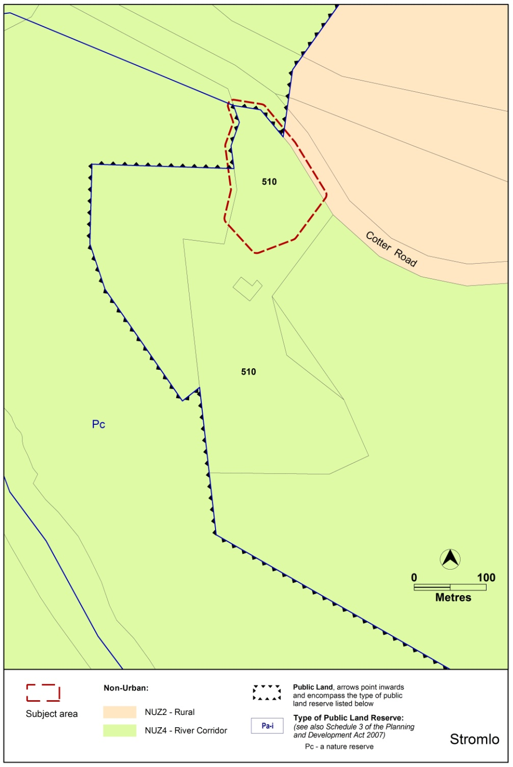
    - Variation to the Industrial Zones development tables
- IZ1 – General Industrial Zone Development Table – MINIMUM ASSESSMENT TRACK MERIT

Insert
animal care facility

Omit
COMMUNITY USE

Insert
community activity centre
community theatre
cultural facility
educational establishment
health facility
hospital
place of worship
religious associated use

- IZ1 – General Industrial Zone Development Table – PROHIBITED DEVELOPMENT

Insert
child care centre

Omit
animal care facility

- IZ2 – Mixed Use Industrial Zone Development Table – MINIMUM ASSESSMENT TRACK MERIT

Insert
animal care facility

Omit
COMMUNITY USE

Insert
community activity centre
community theatre
cultural facility
educational establishment
health facility
hospital
place of worship
religious associated use

- IZ2 – Mixed Use Industrial Zone Development Table - PROHIBITED DEVELOPMENT

Insert
child care centre

Omit
animal care facility

    - Variation to the Residential Zones Development Code
- Part B – Other forms of residential development; element 6: Boarding houses; Item 6.1 Design and siting; new criteria C25 and C26

Substitute

Rules | Criteria
6.1 Design and siting
R25  The minimum gross floor area of a boarding room is:  - for a single occupant - 12m²  - for 2 or more occupants - 16m² | C25  It can be demonstrated that:  A boarding room is of a size sufficient to accommodate the needs of a boarding house resident. This includes space for the provision of essential items such as a bed, desk and robe. Adequate circulation space within the boarding room is also provided.
R26  If a boarding house is to be occupied by five or more adults, at least one communal living room of at least 16m² with a minimum dimension of 3 metres is to be provided. | C26  It can be demonstrated that:  Communal living space is of a size sufficient to meet the needs of the residents of the boarding house, including provision of communal facilities and adequate circulation space.

    - Variation to the Single Dwelling Housing Development Code
- Element 1: Building and site controls, Item 1.14 Allowable encroachments – setbacks; Rules R16 and R17

Substitute
1.14 Allowable encroachments – setbacks
R16  Encroachments into the minimum side or rear boundary setback are permitted for any of the following building elements:  - an eave or roof overhang with a horizontal width of not more than 600mm  - fascias, gutters, downpipes, rainwater tanks, chimneys, flues, domestic fuel tanks, cooling or heating appliances, light fittings, electricity and gas meters, aerials, antennae, unroofed pergolas, sun blinds  - unroofed terraces, landings, steps or ramps, none of which are more than 1m above finished ground level. | C16  Buildings and other structures achieve all of the following:  - consistency with the desired character  - reasonable levels of privacy on adjoining residential blocks for dwellings and their associated private open space  - reasonable solar access to dwellings on adjoining residential blocks and their associated private open space.

- Element 5: Amenity; Item 5.4 Noise attenuation – external sources, Rule R42 and Criterion C42

Substitute
5.4 Noise attenuation – external sources
R42  This rule applies to all new dwellings (including in established areas), as well as extensions and alterations that add a habitable room exposed directly to the source of noise.  Where a block has one or more of the following characteristics:  - identified in a precinct code as being potentially affected by noise from external sources  - adjacent to a road carrying or forecast to carry traffic volumes greater than 12000 vehicles per day  - is otherwise identified to be noise affected  dwellings shall be constructed to comply with the following:  - road carrying traffic volumes between 12,000 and 25,000 vpd –  - dwelling located less than 20m from the nearside edge of the road:  - AS/NZS 2107:2000 - Acoustics – Recommended design sound levels and reverberation times for building interiors (the relevant satisfactory recommended interior design sound level)  - AS/NZS 3671 - Acoustics – Road Traffic Noise Intrusion Building Siting and Design.  - dwelling located more than 20m from the nearside edge of the road:  - glazing is 6.38mm laminated glass or equivalent and fitted with acoustic seals other than brush seals  - any external doors are solid core and fitted with acoustic seals other than brush seals  - road carrying traffic volumes greater than 25,000 vpd –  - dwelling located less than 40m from the nearside edge of the road:  - AS/NZS 2107:2000 - Acoustics – Recommended design sound levels and reverberation times for building interiors (the relevant satisfactory recommended interior design sound level)  - AS/NZS 3671 - Acoustics – Road Traffic Noise Intrusion Building Siting and Design.  - dwelling located more than 40m from the nearside edge of the road:  - glazing is 10.38mm laminated glass or equivalent and fitted with acoustic seals other than brush seals  - any external doors are solid core and fitted with acoustic seals other than brush seals  - in all other cases where a dwelling is affected by noise from external sources-  - AS/NZS 2107:2000 - Acoustics – Recommended design sound levels and reverberation times for building interiors (the relevant satisfactory recommended interior design sound level)  - AS/NZS 3671 - Acoustics – Road Traffic Noise Intrusion Building Siting and Design. | C42  This criterion applies to all new dwellings (including in established areas), as well as extensions and alterations that add a habitable room exposed directly to the source of noise.  A noise management plan must be provided where:  - A block is identified in a precinct code as being potentially affected by noise from external sources; or  - A dwelling is located in the first row of housing near a road carrying or forecast to carry traffic volumes greater than 12000 vehicles per day; or  - A block is otherwise identified to be noise affected  Noise management plan requirements:  - For other than road traffic noise - a noise management plan prepared by a member of the Australian Acoustical Society with experience in the assessment of noise, and endorsed by the EPA. The noise level immediately adjacent to the dwelling is assumed to be the relevant noise zone standard specified in the ACT Environment Protection Regulation 2005. The plan must indicate compliance with the relevant Australian standard.  - For road traffic noise - an acoustic assessment and noise management plan, prepared by a member of the Australian Acoustical Society with experience in the assessment of road traffic noise, and endorsed by the ACT Government entity responsible for transport planning. The plan must indicate compliance with the relevant Australian standard.  Note: A condition of development approval may be imposed to ensure compliance with the endorsed noise management plan.

- Element 6: Environment; Item 6.1 Water sensitive urban design, Rule R43

Substitute
Rules | Criteria
6.1 Water sensitive urban design
R43  This rule applies to  - all new single dwellings  - secondary residences and  - extensions and alterations but does not apply to:  - extensions of a size 50% or less of existing floor area  - development where no new plumbing is proposed  The development complies with one of the following:  - Option A  - Option B  For this rule  Option A is:  - on compact blocks -  - no minimum water storage requirement  - minimum WELS rated plumbing fixtures  - on mid-sized blocks -  - minimum on site water storage of water from roof harvesting is 2,000 litres  - 50% or 75m² of roof plan area, whichever is the lesser, is connected to the tank  - the tank is connected to at least a toilet, laundry cold water and all external taps. The connection will require a pump where it cannot be elevated sufficiently to give adequate pressure.  - on large blocks up to 800m² -  - minimum on site water storage of water from roof harvesting is 4,000 litres  - 50% or 100m² of roof plan area, whichever is the lesser, is connected to the tank  - the tank is connected to at least a toilet, laundry cold water and all external taps. The connection will require a pump where it cannot be elevated sufficiently to give adequate pressure.  - on large blocks 800m² or greater -  - minimum on site water storage of water from roof harvesting is 5,000 litres  - 50% or 125m² of roof plan area, whichever is the lesser, is connected to the tank  - the tank is connected to at least a toilet, laundry cold water and all external taps. The connection will require a pump where it cannot be elevated sufficiently to give adequate pressure.  Option B is:  A greywater system captures all bathroom and laundry greywater and treats it to Class A standard. The treated greywater is connected to all laundry cold water, toilet flushing and all external taps. | C43  Evidence is provided that the development achieves a minimum 40% reduction in mains water consumption compared to an equivalent development constructed in 2003, using the ACTPLA on-line assessment tool or another tool. The 40% target is met without any reliance on landscaping measures to reduce consumption.

    - Variation to the Multi Unit Housing Development Code
- Part A – General controls; Element 3: Building and site controls, Item 3.10; Rule R14

Substitute

Rules | Criteria
3.10 Residential density – adaptable housing – single dwelling blocks – RZ2
R14  This rule applies to single dwelling blocks in RZ2 where all dwellings are built to an adapted standard in compliance with Australian Standard AS4299 Adaptable Housing (Class C).  Despite R2 and R12, the maximum number of dwellings is shown in table A3. | This is a mandatory requirement. There is no applicable criterion

- Part A – General controls; Element 4:Site design; Item 4.2 Site open space – RZ1 and RZ2; C38

Substitute

Rules | Criteria
4.2 Site open space – RZ1 and RZ2
R38  This rule applies to RZ1 and RZ2.  Not less than 40% of the total site area is allocated to one or more of the following:  - communal open space with a minimum dimension of 2.5m  - private open space that complies with all of the following -  - a minimum dimension of 2.5m  - is associated with dwellings at the lower floor level.  Not less than 20% of the total site area is planting area. | C38  Open space on the site achieves all of the following:  - sufficient space for the recreation and relaxation of residents  - sufficient space for planting, particularly trees with deep root systems  - provision of outdoor areas that are readily accessible by residents for a range of uses and activities.  One or more of the following matters may be considered when determining compliance with this criterion:  - whether the total area of upper floor level private open space contributes to the function of other open space on the site  - whether any adjoining or adjacent public open space is readily available for the use of residents.

- Part A – General controls; Element 4: Site design; Item 4.6 Courtyard walls

Substitute
4.6 Courtyard walls – RZ1 and RZ2
R42  Courtyard walls are permitted forward of the building line where they comply with all of the following:  - a total length not exceeding 60% of the width of the block at the line of the wall  - a minimum setback from the front boundary of not less than 2m  - trees and/or shrubs between the wall and the front boundary, in accordance with an approved landscape plan  - a maximum height not exceeding 1.8m above datum ground level  - constructed of brick, block or stonework, any of which may be combined with timber or metal panels that include openings not less than 25% of the surface area of the panel  - do not obstruct sight lines for vehicles and pedestrians on public paths or driveways in accordance with Australian Standard AS2890.1- Off-Street Parking. | C42  Courtyard walls achieve all of the following:  - consistent with the desired character  - the dominance of the building’s facade in the streetscape taking all of the following aspects of the proposed courtyard wall into account:  - height  - relationship to verge footpath  - total proportion relative to the building  - width  - colour and design features  - transparency articulation  - protection of existing desirable landscape features  - tree and shrub planting forward of the wall  - do not obstruct sight lines for vehicles and pedestrians on public paths or driveways in accordance with Australian Standard AS2890.1- Off-Street Parking.

- Part A – General controls; Element 4 Site design; Item 4.6 Courtyard walls

Insert
4.7 Courtyard walls – other than RZ1 and RZ2
R42A  Courtyard walls are permitted forward of the building line where they comply with all of the following:  - maximum height of 1.8m above datum ground level  - a minimum setback to the front boundary complying with the following:  - where the wall encloses the principal private open space at ground floor level that is located to the west, north-west, north, north-east or east of the dwelling – 0.7m  - in all other cases - half the front boundary setback nominated elsewhere in this code  - trees and/or shrubs between the wall and the front boundary, in accordance with an approved landscape plan  - a variety of materials or indentations not less than 15m apart where the indents are not less than 1m in depth and 4m in length  - constructed of brick, block or stonework, any of which may be combined with timber or metal panels that include openings not less than 25% of the surface area of the panel  - do not obstruct sight lines for vehicles and pedestrians on public paths or driveways in accordance with Australian Standard AS2890.1- Off-Street Parking. | C42A  Courtyard walls achieve all of the following:  - consistent with the desired character  - the dominance of the building’s facade in the streetscape taking all of the following aspects of the proposed courtyard wall into account:  - height  - relationship to verge footpath  - total proportion relative to the building  - width  - colour and design features  - transparency articulation  - protection of existing desirable landscape features  - tree and shrub planting forward of the wall  - do not obstruct sight lines for vehicles and pedestrians on public paths or driveways in accordance with Australian Standard AS2890.1- Off-Street Parking.

- Part A – General controls; Element 6: Amenity; Item 6.3 Privacy; Rules R59 and R60 and Criteria R59 and R60

Substitute
6.3 Privacy
R59  This rule applies to dwellings on the same block.  Development complies with one of the following:  - the distance between an unscreened element of a dwelling and the primary windows of any other dwelling is at least 12m; or  - an unscreened element of a dwelling does not have a direct line of sight (based on an eye height of 1.5m) into a primary window of any other dwelling | C59  Evidence is provided demonstrating that reasonable privacy between dwellings on the same block is achieved.
R60  This rule applies to principal private open space on the subject block and on adjacent blocks.  Development complies with one of the following:  - the distance between the minimum principal private open space of a dwelling and an unscreened element of any other dwelling is at least 12m; or  - no more than 50% of the minimum principal private open space of a dwelling is within a direct line of sight (based on an eye height of 1.5m) from an unscreened element of any other dwelling. | C60  Evidence is provided demonstrating that reasonable privacy of principal private open space of each dwelling is achieved.

- Part A – General controls; Element 6: Amenity; Item 6.4 Principal private open space; C61

Substitute
Rules | Criteria
6.4 Principal private open space
R61  Each dwelling has at least one area of principal private open space that complies with all of the following:  - located on the site  - has minimum area and dimensions specified in table A9  - is screened from adjoining public streets and public open space  - is directly accessible from, and adjacent to, a habitable room other than a bedroom  - is not located to the south, south-east or south-west of the dwelling, unless it achieves one or more of the following -  - not less than 3 hours of direct sunlight onto 50% of the minimum required area between the hours of 9am and 3pm on the winter solstice (21 June)  - located at an upper floor level and overlooks a public street or public open space. | C61  Principal private open space for each dwelling achieves all of the following:  - an area suitable for an extension of the function of the dwelling for relaxation, dining, entertainment, recreation  - directly accessible from the dwelling  - service functions such as clothes drying and mechanical services  - reasonable privacy  - reasonable solar access.

- Part A – General controls; Element 6: Amenity; Item 6.9 Noise attenuation – external sources

6.9 Noise attenuation – external sources
R67  Where a block has one or more of the following characteristics:  - identified in a precinct code as being potentially affected by noise from external sources  - adjacent to a road carrying or forecast to carry traffic volumes greater than 12,000 vehicles per day  - located in a commercial zone  - adjacent to a commercial or industrial zone  dwellings shall be constructed to comply with the relevant sections of all of the following:  - AS/NZS 2107:2000 - Acoustics – Recommended design sound levels and reverberation times for building interiors (the relevant satisfactory recommended interior design sound level)  - AS/NZS 3671 - Acoustics – Road Traffic Noise Intrusion Building Siting and Design.  For other than road traffic noise, compliance with this rule is demonstrated by a noise management plan prepared by a member of the Australian Acoustical Society with experience in the assessment of noise, and endorsed by the EPA. For other than road traffic noise, the noise level immediately adjacent to the dwelling is assumed to be the relevant noise zone standard specified in the ACT Environment Protection Regulation 2005.  For road traffic noise, compliance with this rule is demonstrated by an acoustic assessment and noise management plan, prepared by a member of the Australian Acoustical Society with experience in the assessment of road traffic noise, and endorsed by the ACT Government entity responsible for Transport Planning.  Note: A condition of development approval may be imposed to ensure compliance with the endorsed noise management plan. | This is a mandatory requirement. There is no applicable criterion.

    - Variation to the Commercial Zones Development Code

- Part A - General Controls

Omit:
Element 10: Neighbourhood plans
    - Variation to the Industrial Zones Development Code

- Part B – General Development Controls, Element 5: Amenity’; Item 5.2 Noise, Rule R34

Add

Rules | Criteria
5.2 Noise
R34A  A Noise Management Plan, prepared by an accredited acoustic specialist who is a member of the Australian Acoustic Society, is provided for an animal care facility  The Noise Management Plan details the design, siting and construction methods, which will be used to minimise the impact of noise on neighbouring uses, and reduce the intrusion of noise from industrial uses into the facility. | This is a mandatory requirement. There is no applicable criterion.

- Part B – General Development Controls; Element 5: Amenity

Add

Rules | Criteria
5.5. Emergency management plan
R37A  An Emergency Management Plan is provided for an animal care facility, prepared by a suitably qualified professional, and includes details of a risk assessment and evacuation plan for the facility, and is endorsed by the Emergency Services Authority (ESA). | C37A  If an endorsed Emergency Management Plan is not provided, the application will be referred to the relevant agency in accordance with the requirements of the Planning and Development Act 2007.

    - Variation to Parks and Recreation Zone Development Code
- Part B – General Development Controls; Element 5: Amenity

Omit:
Item 5.4: Neighbourhood Plan

    - Variation to the Lease Variation General Code

- Part A – Lease variations in the merit or impact track’; Element 4: variations to add particular uses

Add

Rules | Criteria
4.4 Emergency management plan
R6A  A variation to a lease to authorise an animal care facility in the industrial zones is approved only where an emergency management plan is provided and has been endorsed by the Emergency Services Authority (ESA). | This is a mandatory requirement. There is no applicable criterion.
4.5 Noise
R6B  A Noise Management Plan, prepared by an accredited acoustic specialist who is a member of the Australian Acoustic Society, is provided for an animal care facility  The Noise Management Plan details the design, siting and construction methods, which will be used to minimise the impact of noise on neighbouring uses, and reduce the intrusion of noise from industrial uses into the facility. | This is a mandatory requirement. There is no applicable criterion.

    - Variation to Parking and Vehicular Access General Code

- 3.5 Industrial zones – Schedule 5 – Industrial zones

Add
Development | Parking provisions rates for industrial zones
Animal care facility | 1 space/facility  plus  2 spaces per 15 animals for employee parking  plus  visitor parking as follows:  2 spaces: <30 animals per facility  3 spaces: 30-59 animals per facility  4 spaces: 60-90 animals per facility  plus  1 pick-up/set-down bay per 10 animals

    - Variation to the Hackett Precinct Map
- Hackett precinct map

Substitute

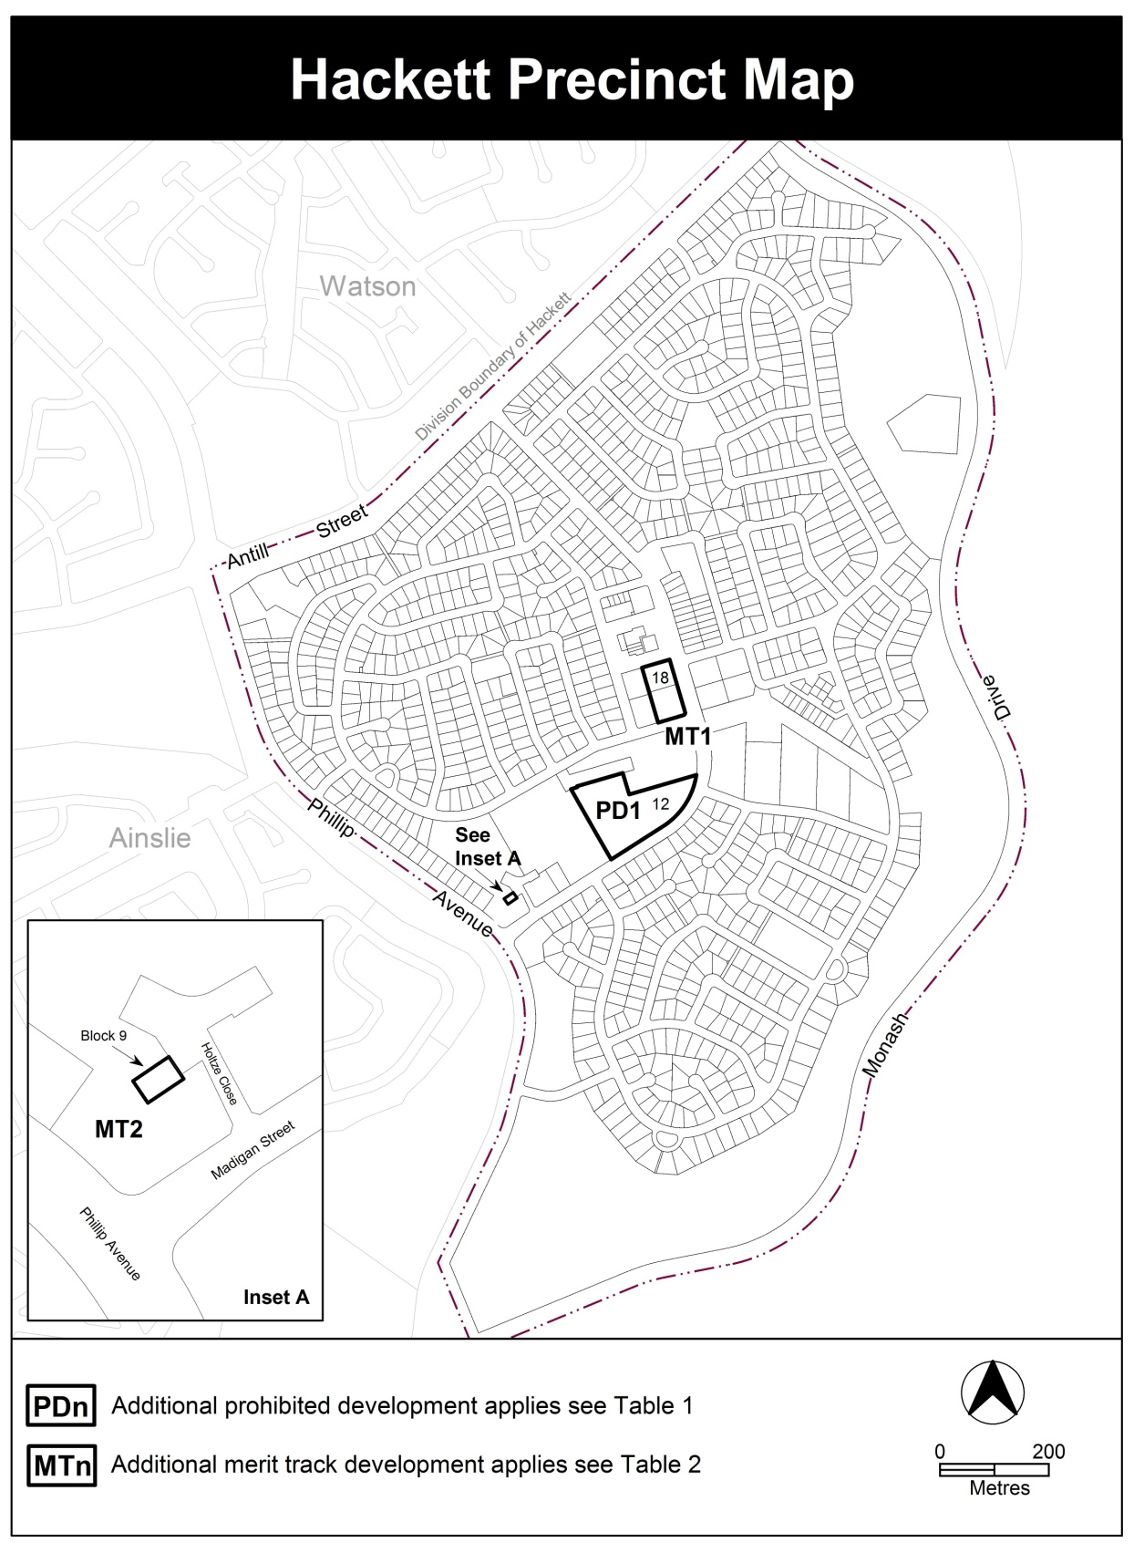

- Table 2 – Additional merit track development

Substitute

Additional merit track development that may be approved subject to assessment
Suburb precinct map label | Zone | Development
MT1 | RZ2 | COMMUNITY USE
MT2 | PRZ1 | Place of worship

    - Variation to the Territory Plan Definitions – Part A

- Detached house

Relocate
‘Attached house’ as a sub-category of Multi unit housing to Territory Plan Definitions – Part B Definition of Terms

- Attached house

Relocate
‘Detached house’ as a sub category of Single dwelling housing to Territory Plan Definitions – Part B Definition of Terms

- Minor use

Substitute

Minor use means the use of land for a purpose that is incidental to the use and development of land in the zone and includes but is not limited to open space; public car parking; community path systems; shared circulation spaces (such as lift wells, stair wells); minor service reticulation; other utility services that do not exclude other uses from the land; street furniture and the like

    - Variation to the Territory Plan Definitions – Part B

- Building line

Substitute
Building line means a line drawn parallel to any front boundary along the front face of a building or through the point on a building closest to the front boundary. A terrace, landing, porch, balcony, deck or verandah that is more than 1.5 metres above finished ground level or is covered by a roof is deemed to be part of the building. A fence, courtyard wall or retaining wall is not deemed to be part of the building.

- Natural Ground Level and Datum Ground Level

Substitute

Natural ground level (NGL) has the same meaning as datum ground level

Datum ground level means the surface ground level as determined in a field survey authorised by a registered surveyor:
- at the time of Operational Acceptance for subdivision; or
- after that time mentioned at a), provided no new earthworks have occurred; or
- at the date of grant of the lease of the block; whichever is the earliest.

Where a), b) or c) is not available, datum ground level means the best estimate of the surface ground level at a), b) or c) as determined in a field survey authorised by a registered surveyor

- Side boundary

Substitute

Side boundary means a block boundary extending from a front boundary along a single bearing.

- Rear boundary

Insert new definition

Rear boundary means a block boundary other than a front boundary or a side boundary.

- Habitable room

Substitute

Habitable (including habitable room) means a room within a dwelling capable of being lawfully used for the normal domestic activities of living, sleeping, cooking or eating, and—
- includes a bedroom, study, living room, family room, kitchen, dining room, home theatre, rumpus room; but
- does not include a bathroom, laundry, utility room, hallway, garage or other spaces of a specialised nature occupied neither frequently or for extended periods.

- Setback

Substitute

Setback means the horizontal distance between a block boundary and the outside face of any building or structure on the block including:
- a building wall,
- a post that supports a roof,
- a balcony, deck or verandah.

Interpretation service
