Australian Capital Territory
Planning and Development (Technical Amendment—Moncrieff) Plan Variation 2017

Notifiable Instrument NI2017—404
Technical Amendment No 2017-14
made under the
Planning and Development Act 2007, section 89 (Making technical amendments)

- Name of instrument
This instrument is the Planning and Development (Technical Amendment— Moncrieff) Plan Variation 2017.
2 Technical amendment
I am satisfied under section 89 (1) (a) of the Planning and Development Act 2007 (the Act) that the Moncrieff plan variation is a technical amendment to the Territory Plan.
3 Commencement
This instrument commences on the day after its notification day.
4 Meaning of Moncrieff plan variation
For this instrument:
Moncrieff plan variation means the technical amendment to the Territory Plan, variation 2017-14, in the schedule.

Fleur Flanery
Delegate of the planning and land authority
27 July 2017

Planning & Development Act 2007

Technical Amendment
to the Territory Plan

2017-14

Amendments to the Moncrieff precinct code

July 2017

Table of Contents

1. INTRODUCTION 1
Purpose 1
Public consultation 1
National Capital Authority 1
Process 1
Types of technical amendments under the Act 2
2. EXPLANATORY STATEMENT 3
2.1 Moncrieff precinct map and code 3
3. TECHNICAL AMENDMENT 7
3.1 Code Amendment 7

INTRODUCTION

Purpose
This technical amendment makes the following changes to the Moncrieff precinct code contained within the Territory Plan:
- including a note to rule R9 permitting mandatory courtyard walls to be within the 6x6m open space areas; and
- amend Figure 11 Moncrieff residential area ongoing provisions to relocate the location of the required surveillance block from block 28 section 43 to block 7 section 43.

Public consultation
Under section 87 of the Planning and Development Act 2007 (the Act) this type of technical amendment was subject to limited public consultation.
Written comments were invited from 9 June 2017 until 10 July 2017.
Written comments for TA2017-14 were invited to be submitted in one of the following ways:
- Emailed to: | ta.comments@act.gov.au
- Hand delivered to: | Territory Plan Section  Environment, Planning and Sustainable Development Directorate  Customer Service Centre  16 Challis Street, DICKSON
- Posted to: | Territory Plan Section  Environment, Planning and Sustainable Development Directorate  GPO Box 158  CANBERRA ACT 2601
No consultation comments were received during the consultation period.

National Capital Authority
The National Capital Authority has been advised of this technical amendment and it responded with nil comments on 7 July 2017.

Process
This technical amendment has been prepared in accordance with section 87 of the Planning and Development Act 2007 (the Act).
Comments received from the public and the National Capital Authority were taken into account before the planning and land authority “made” the technical amendment under section 89 of the Act. The planning and land authority must then notify the public of its decision.

Types of technical amendments under the Act
The following categories of technical amendments are provided under section 87 of the Act:
- Each of the following territory plan variations is a technical amendment for which no consultation is needed before it is made under section 89:
(a) a variation (an error variation) that –
- would not adversely affect anyone’s rights if approved; and
- has as its only object the correction of a formal error in the plan;
(b) a variation to change the boundary of a zone or overlay under section 90A (Rezoning – boundary changes);
(c) a variation, other than one to which subsection (2) (d) applies, in relation to an estate development plan under section 96 (Effect of approval of estate development plan);
(d) a variation required to bring the territory plan into line with the national capital plan;
(e) a variation to omit something that is obsolete or redundant in the territory plan.
- Each of the following territory plan variations is a technical amendment for which only limited public consultation is needed under section 90:
- a variation (a code variation) that –
- would only change a code; and
- is consistent with the policy purpose and policy framework of the code; and
- is not an error variation;
- a variation to change the boundary of a zone under section 90B (Rezoning – development encroaching on adjoining territory land);
- a variation in relation to a future urban area under section 90C (Technical amendments – future urban areas);
- a variation in relation to an estate development plan under section 96 (Effect of approval of estate development plan) if it incorporates an ongoing provision that was not included in the plan under section 94 (3) (g);
- a variation to clarify the language in the territory plan if it does not change the substance of the plan;
- a variation to relocate a provision within the territory plan if the substance of the provision is not changed.
Following each item in Part 2 Explanation of this technical amendment is a statement of compliance against the specific criteria for the relevant category of technical amendment.
TA2017-14 has been prepared in accordance with section 87(2)(a) of the Act.

EXPLANATORY STATEMENT
This part of the technical amendment document explains the changes to be made to the Territory Plan, the reasons for the change, and a statement of compliance against the relevant section of the Act.
    - Moncrieff precinct map and code
- Rule R9, Moncrieff Precinct Code
Due to the configuration of some blocks, development is not able to adequately meet the mandatory requirements for garage location, private open space size and courtyard wall setbacks. To address this, it is proposed to amend R9 to clarify that where a block requires a mandatory 6x6m open space area adjacent to a mandatory courtyard wall, the wall may be located within the 6x6m open space area.

Existing R9
Rules | Criteria
1.2 Principal private open space
R9  This rule applies to blocks or parcels in locations identified in Figures 4, 5, 6 and 7.  Minimum dimensions for principal private open space are:  - For blocks marked 3m – 3m x 3m  - For blocks marked 6m – 6m x 6m | This is a mandatory requirement. There is no applicable criterion.

Proposed R9
Rules | Criteria
1.2 Principal private open space
R9  This rule applies to blocks or parcels in locations identified in Figures 4, 5, 6 and 7.  Minimum dimensions for principal private open space are:  - For blocks marked 3m – 3m x 3m  - For blocks marked 6m – 6m x 6m  Courtyard walls are permitted to encroach into the 6x6m principal private open space by a maximum of 1m and 5% of the principal private open space area | This is a mandatory requirement. There is no applicable criterion.

Compliance with the Planning and Development Act 2007
Section | Statement
s87(2)(a)  (a) a variation (an code variation) that—  (i) would only change a code  (ii) is consistent with the policy purpose and policy framework of the code; and  (iii)is not an error variation | This code amendment is consistent with the policy purpose and policy framework of the Moncrieff precinct map and code. This amendment will clarify that small courtyard wall encroachments are permitted into principal private open space for blocks with 6m x 6m open space requirements.

- Figure 11
It is proposed to amend figure 11 to relocate the ‘S’ designating surveillance blocks from block 1 and block 28 section 43 Moncrieff to block 7 and block 8 section 43 Moncrieff. This amendment will retain the passive surveillance of Cobber Close while defining the connection to Dargin Crescent, and in the case of block 28, reduce the potential overshadowing of the dwelling or adjoining private open space area from the surveillance unit.

Compliance with the Planning and Development Act 2007
Section | Statement
s87(2)(a)  (a) a variation (an code variation) that—  (i) would only change a code  (ii) is consistent with the policy purpose and policy framework of the code; and  (iii)is not an error variation | This code amendment is consistent with the policy purpose and policy framework of the Moncrieff precinct map and code. This amendment will relocate the required surveillance unit locations to retain suitable passive surveillance opportunities for the area while ensuring solar access is retained.

Existing Figure 11
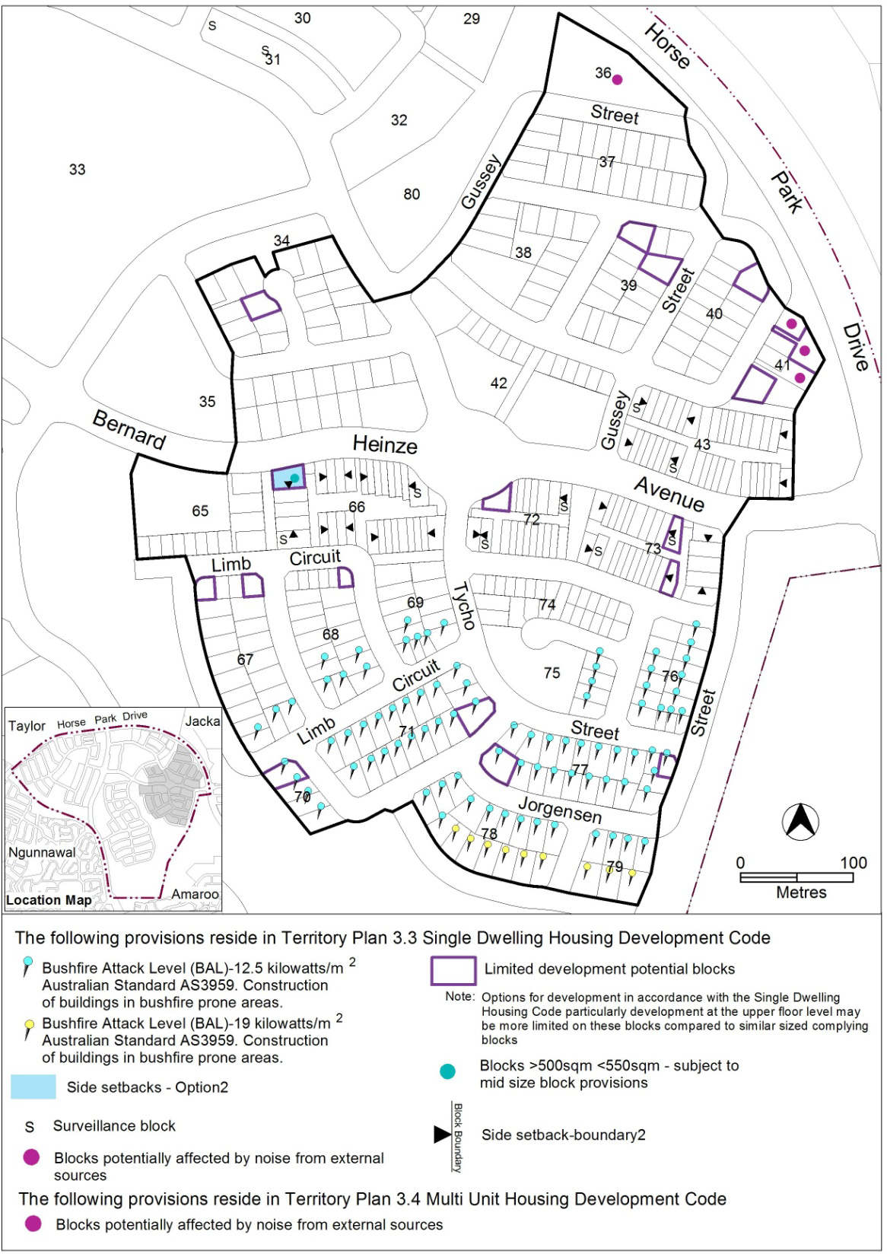

Proposed Figure 11
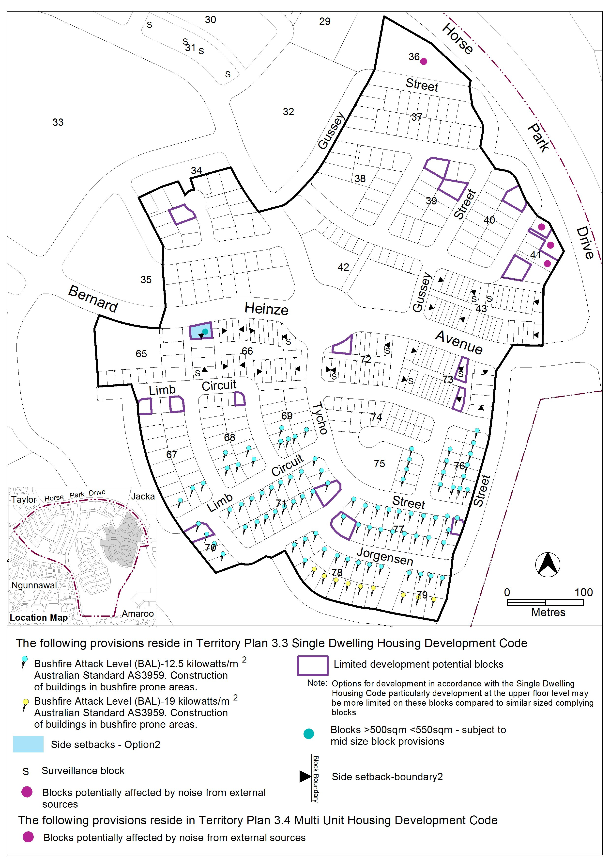

TECHNICAL AMENDMENT
    - Code Amendment

Variation to the Moncrieff Precinct Map and Code
- Item 1.2 Principal private open space; Rule R9

Substitute

Rules | Criteria
1.2 Principal private open space
R9  This rule applies to blocks or parcels in locations identified in Figures 4, 5, 6 and 7.  Minimum dimensions for principal private open space are:  - For blocks marked 3m – 3m x 3m  - For blocks marked 6m – 6m x 6m  Courtyard walls are permitted to encroach into the 6x6m principal private open space by a maximum of 1m and 5% of the principal private open space area | This is a mandatory requirement. There is no applicable criterion.

- Figure 11

Substitute

Interpretation service

