Australian Capital Territory

Nature Conservation (Bimberi Wilderness Area) Activities Declaration 2017 (No 2)

Notifiable instrument NI2017–412
made under the
Nature Conservation Act 2014, s 256 (Conservator may make activities declarations)

Name of instrument
This instrument is the Nature Conservation (Bimberi Wilderness Area) Activities Declaration 2017 (No 2).

Commencement
This instrument commences on the day after its notification day.

Application
This instrument applies to the area (the Bimberi Wilderness Area) outlined in bold and shown as ‘Bimberi Wilderness Area’ in the map in schedule 1.
Note Under section 169 of the Nature Conservation Act 2014 (the Act) the area of Bimberi Wilderness Area is a ‘reserve’ for the purposes of the Act because the area is public land reserved in the Territory Plan as a wilderness area under section 315 (a) of the Planning and Development Act 2007.

Declaration
I declare that in the Bimberi Wilderness Area—
  - an activity listed in schedule 2 is prohibited; and
  - an activity listed in schedule 3 is restricted and may only be carried out if the requirements applying to the activity are complied with.
Note 1 If an activity is a ‘prohibited activity’ it means the activity cannot be carried out under any circumstance in the reserve. For example, the ‘use of chainsaws’ is declared to be a prohibited activity. This means that chainsaws cannot be used in Bimberi Wilderness Area under any circumstance.
Note 2 If an activity is a ‘restricted activity’ it means that it may only be carried out in the reserve if stated directions or requirements are complied with. For example, ‘camping’ is declared to be a restricted activity. This means camping cannot be carried out in Bimberi Wilderness Area unless it is done in a way that meets the stated requirements.
Note 3 The Act includes general offences which apply to all reserves (including Bimberi Wilderness Area). The Act may be found at http://www.legislation.act.gov.au/a/2014-59/default.asp.

Revocation
The Nature Conservation (Bimberi Wilderness Area) Activities Declaration 2017 (NI2017-302) is revoked.

Definitions
In this instrument—
Camping means—
(a) setting up any tent, shelter, bivouac, swag, sleeping bag, mattress or bedding; or
(b) setting up any stationary vehicle for the purpose of lying down or sleeping in or on the vehicle; or
(c) lying down or sleeping in or on any stationary vehicle, tent, shelter, bivouac, swag, sleeping bag, mattress or bedding between sunset and 2 hours after sunrise.
Solid fuel means any fuel that is not a gas, a plasma or a liquid and includes coal, wood, plant material, humus, peat, heat beads, charcoal, briquettes and hexamite.
Dr Annie Lane
Conservator of Flora and Fauna
28 July 2017
Schedule 1 -Map
(See section 3)
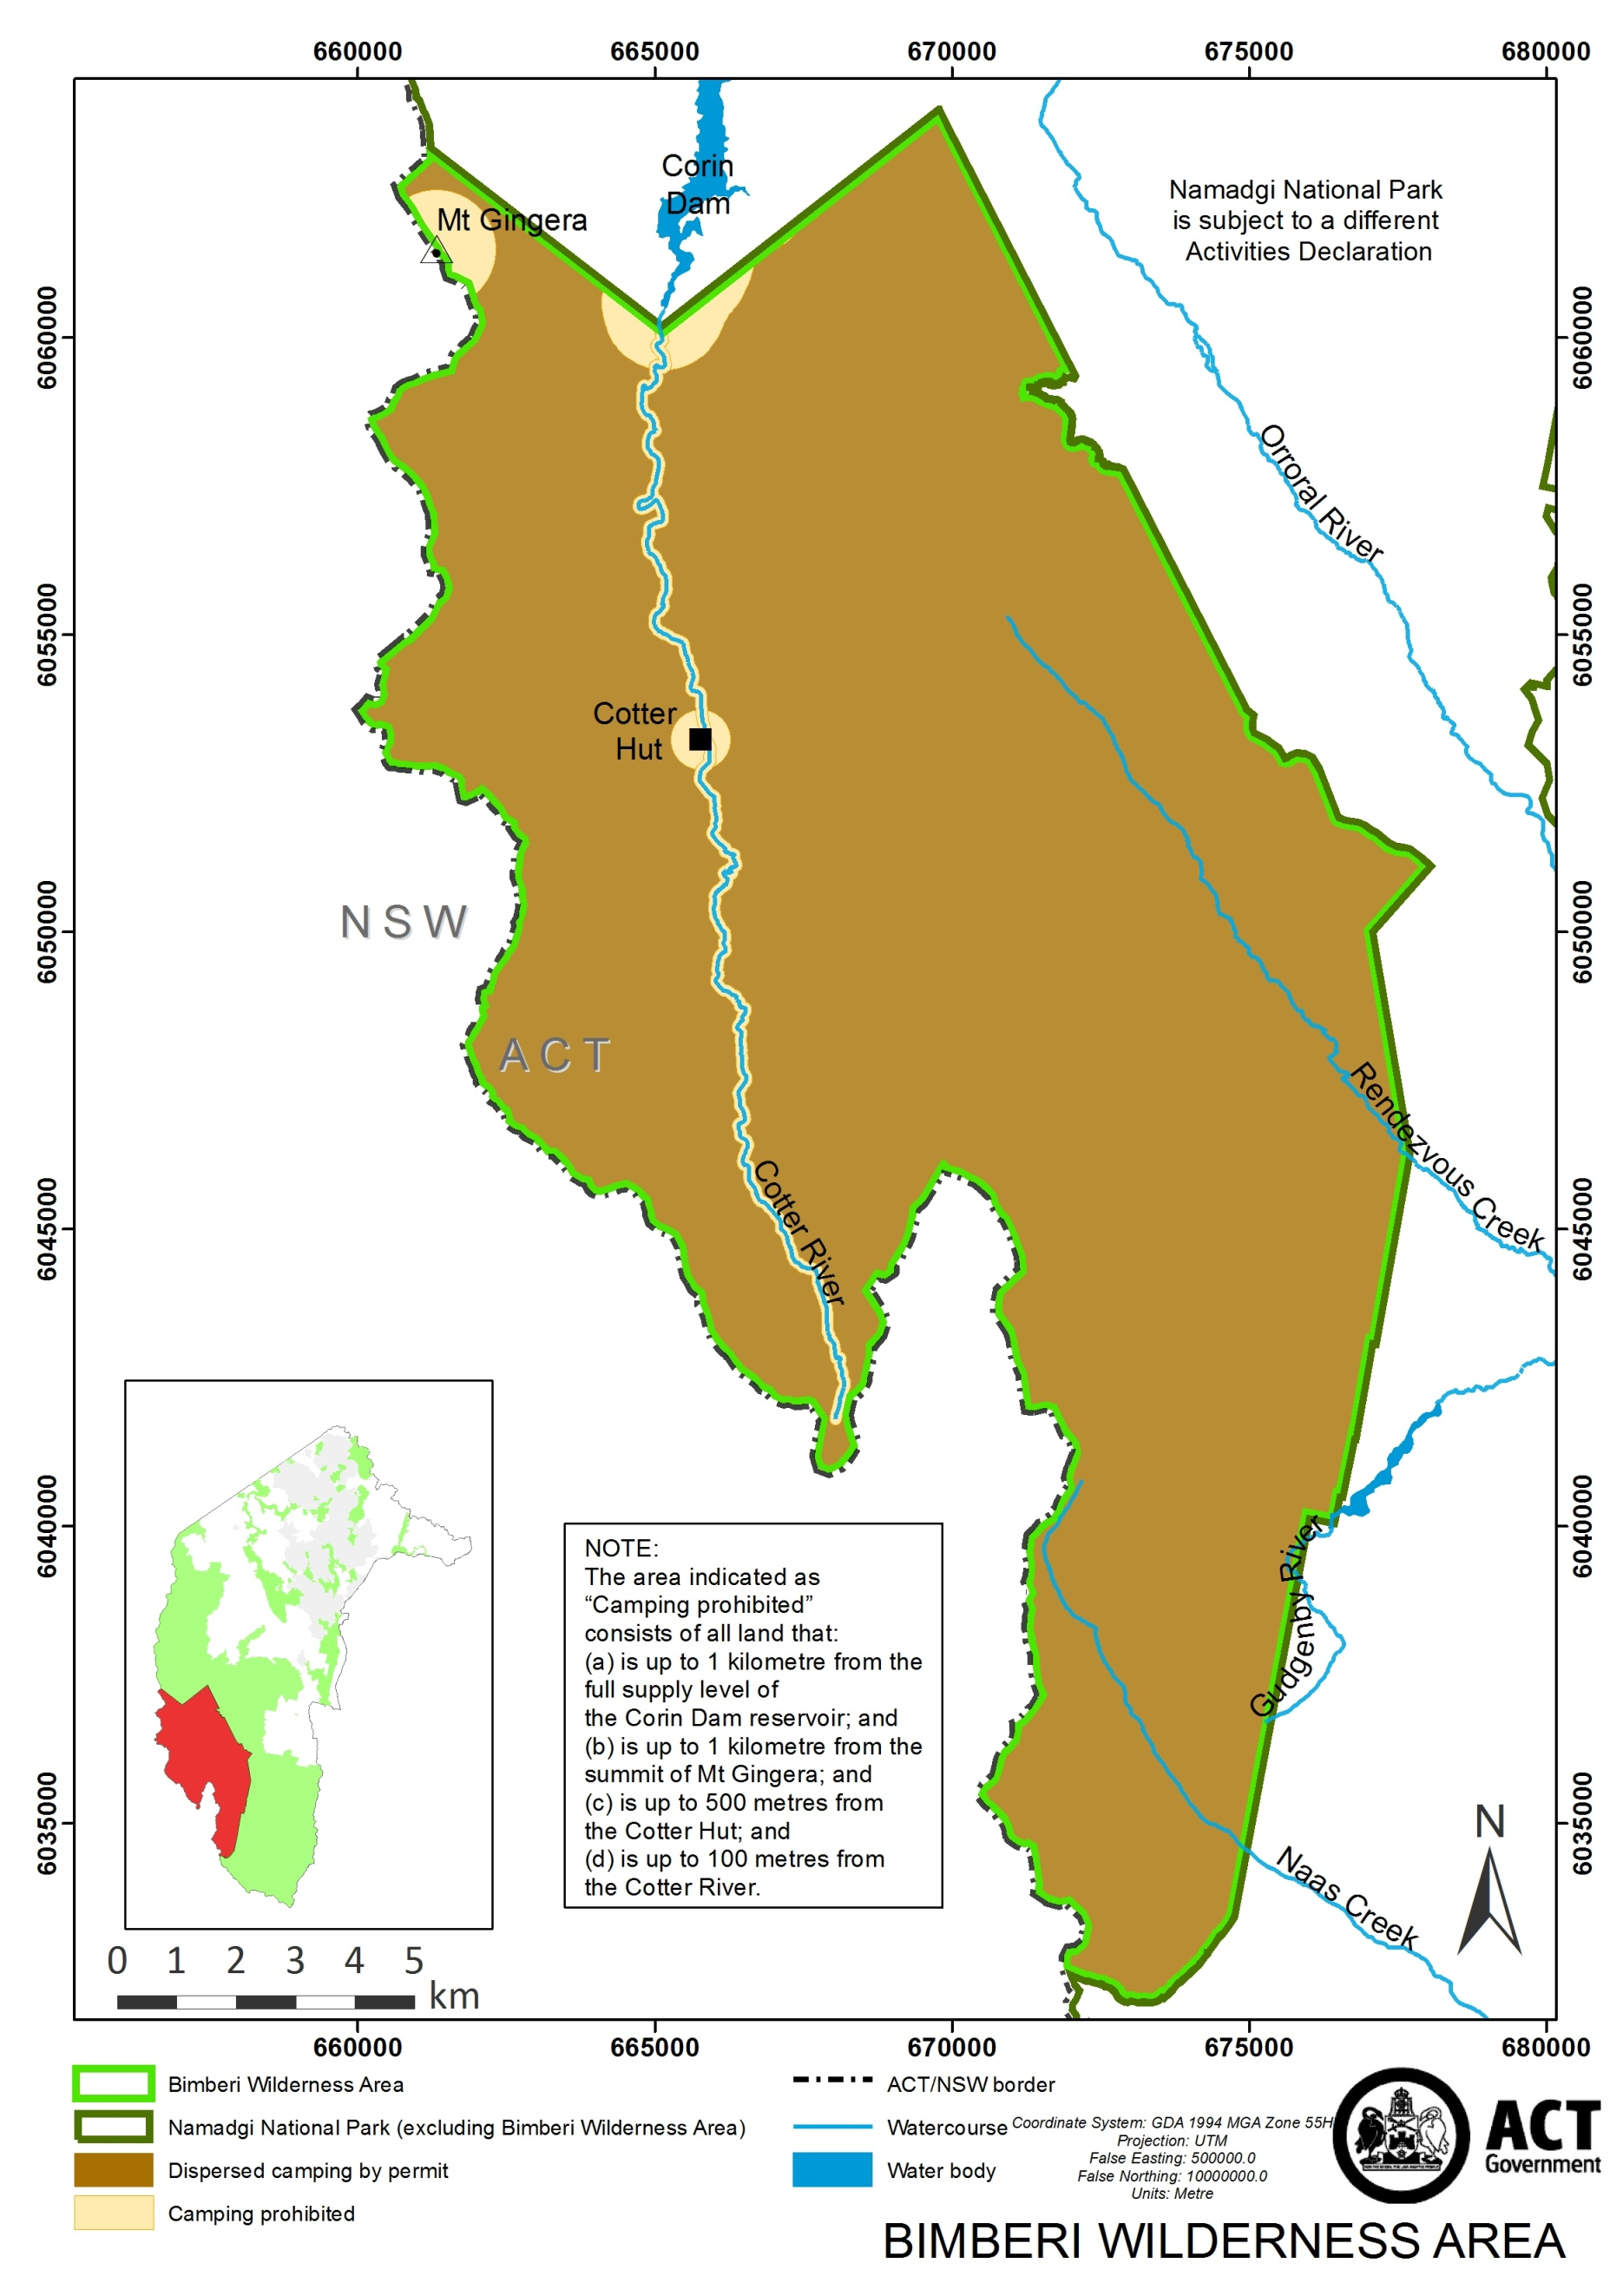

Schedule 2 –Prohibited Activities
(See section 4)

USE OF CHAINSAWS
USE OF METAL DETECTORS
USE OF MOTORISED GENERATORS
USE OF MOTORISED VEHICLES
LANDING OR TAKING-OFF AIRCRAFT, OR FLYING AIRCRAFT WITHIN 500 FEET OF THE TERRAIN OR ANY OBJECT ON THE TERRAIN
LANDING OR TAKING-OFF UNMANNED AERIAL VEHICLES, OR FLYING UNMANNED AERIAL VEHICLES WITHIN 500 FEET OF THE TERRAIN OR ANY OBJECT ON THE TERRAIN | 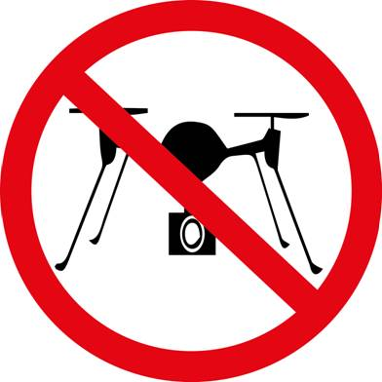
COLLECTING WOOD OR TIMBER
USE OF WATERCRAFT
USE OF NON-MOTORISED VEHICLES INCLUDING BICYCLES
SWIMMING
LIGHTING, MAINTAINING OR USING A SOLID FUEL FIRE

Schedule 3 –Restricted Activities
(See section 4)

TAKING PART IN VOLUNTEER ENVIRONMENTAL ACTIVITIES
It is a requirement that:
(a) volunteer environmental activities are carried out in accordance with an approved volunteer environmental activities program; and
(b) the program is authorised by the Parks and Conservation Service.

WALKING  It is a requirement that any person walking must not be in a party of more than 8 people while carrying out this activity. | 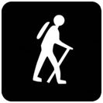
CAMPING
It is a requirement that any person carrying out camping:
(a) must first obtain an Upper Cotter Catchment–Bimberi Wilderness Area permit from the Namadgi National Park Visitor Centre; and
(b) must not be in a party of more than 8 people while carrying out this activity; and
(c) must camp only in the area indicated as “Dispersed camping by permit” in schedule 1; and
(d) must stay no longer than 3 nights in any location.

LIGHTING OR USING A GAS HEATING APPLIANCE
It is a requirement that:
(a) the gas heating appliance is being used to cook food or heat liquids; and
(b) a total fire ban is not in force; and
(c) the area around the appliance is cleared of flammable material for at least 3 metres in every direction; and
(d) the person who lights or uses the appliance does not leave the appliance (whether temporarily or not) without first extinguishing it, unless the person leaves the appliance under the control of a responsible person.

